APPENDIX B — DATASET SAMPLES

B.1 No AFB Sputum Smear Samples
This section presents representative images of sputum smear microscopy fields with no detectable acid-fast bacilli (AFB). These negative samples were collected from de-identified clinical microscopy images and used for YOLOv5 object detection training and validation.

B.2 AFB-Positive Sputum Smear Samples
This section shows sputum smear images containing visible Mycobacterium tuberculosis bacilli. Each AFB rod was annotated with a YOLO-format bounding box for object detection training, data augmentation, and AFB load grading.
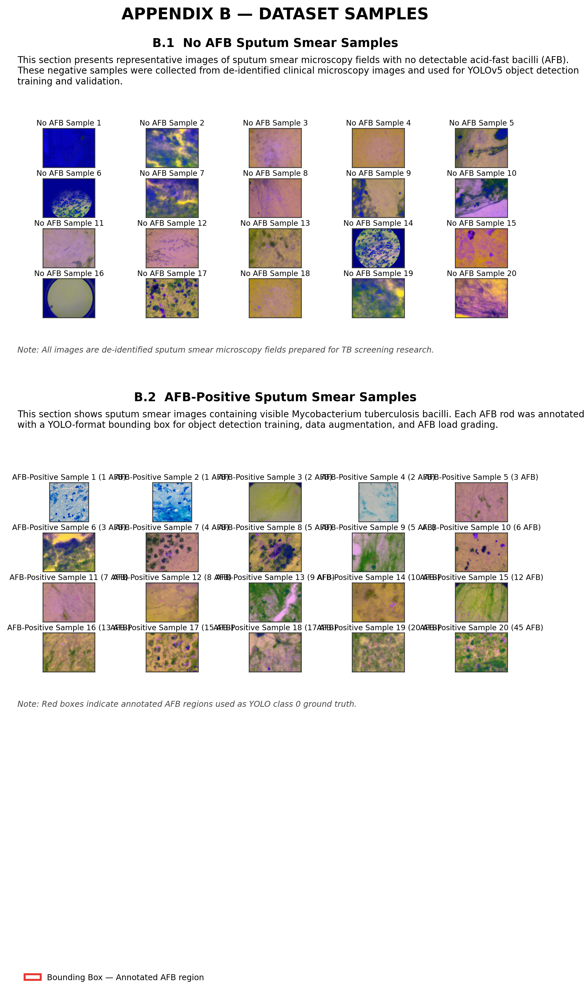
Figure B.1. Representative sputum smear dataset samples (no AFB and AFB-positive).
Legend: Red bounding boxes indicate annotated AFB regions (YOLO class 0). All images are de-identified sputum smear microscopy fields prepared for TB screening research.

