APPENDIX C — DATASET ANNOTATION DOCUMENTATION
This appendix presents evidence of dataset annotation, labeling procedures, training environment configuration, and model validation outputs for the TBhon multimodal TB pre-screening system. Sputum smear microscopy images use YOLO-format bounding-box annotations for acid-fast bacilli (AFB). Cough audio recordings use participant-level tb_status labels from the CODA TB Kaggle corpus, converted to log-mel spectrograms for CNN training.

C.1 Annotation Workflow
Sputum annotation workflow: each visible AFB rod in a microscopy field was labeled with a normalized YOLO bounding box (class 0). Per-image AFB counts were derived from label files and mapped to load grades (none, low, moderate, high) for CNN binary classification training.
Cough audio labeling workflow: recordings in the Kaggle ruchikashirsath/tb-audio dataset include tb_status metadata (0 = No-TB, 1 = TB-positive). Audio was resampled to 16 kHz, clipped or padded to a fixed duration, and transformed into log-mel spectrograms for hybrid CNN + gradient-boosted classifier training.
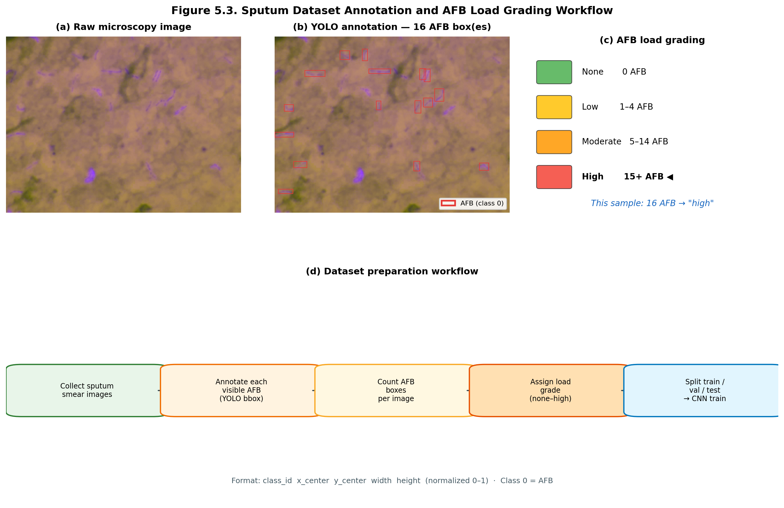
Figure C.1. Sputum dataset annotation and AFB load grading workflow.
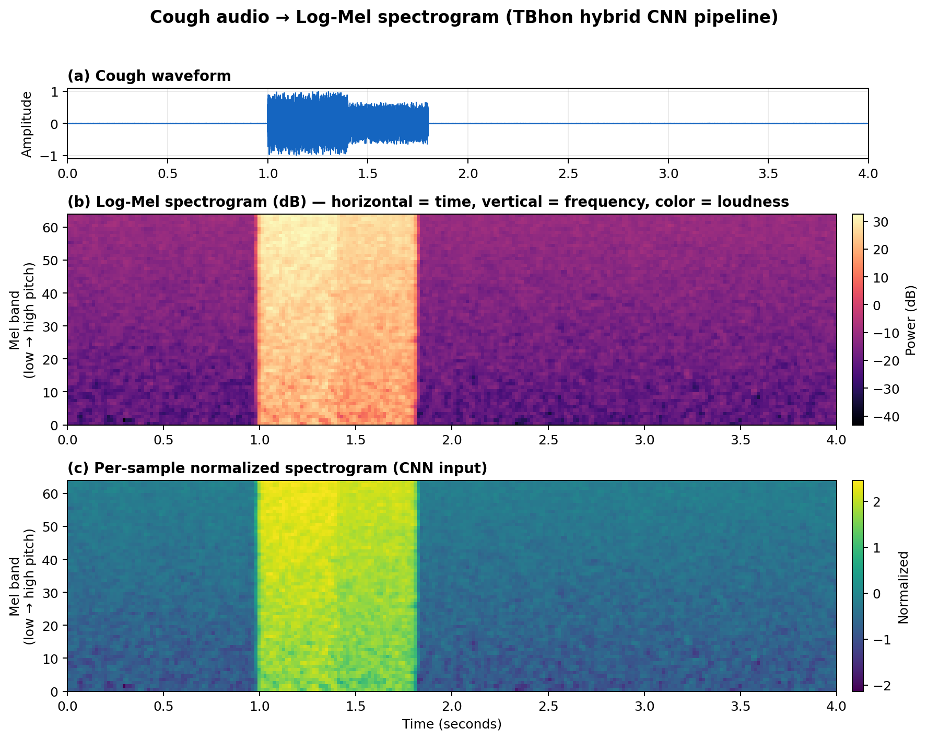
Figure C.2. Cough audio log-mel spectrogram feature representation.

C.2 Bounding Box and Labeling Samples
Representative annotated sputum smear fields showing raw microscopy images, YOLO bounding boxes around individual AFB rods, and load-grade examples used during dataset preparation.
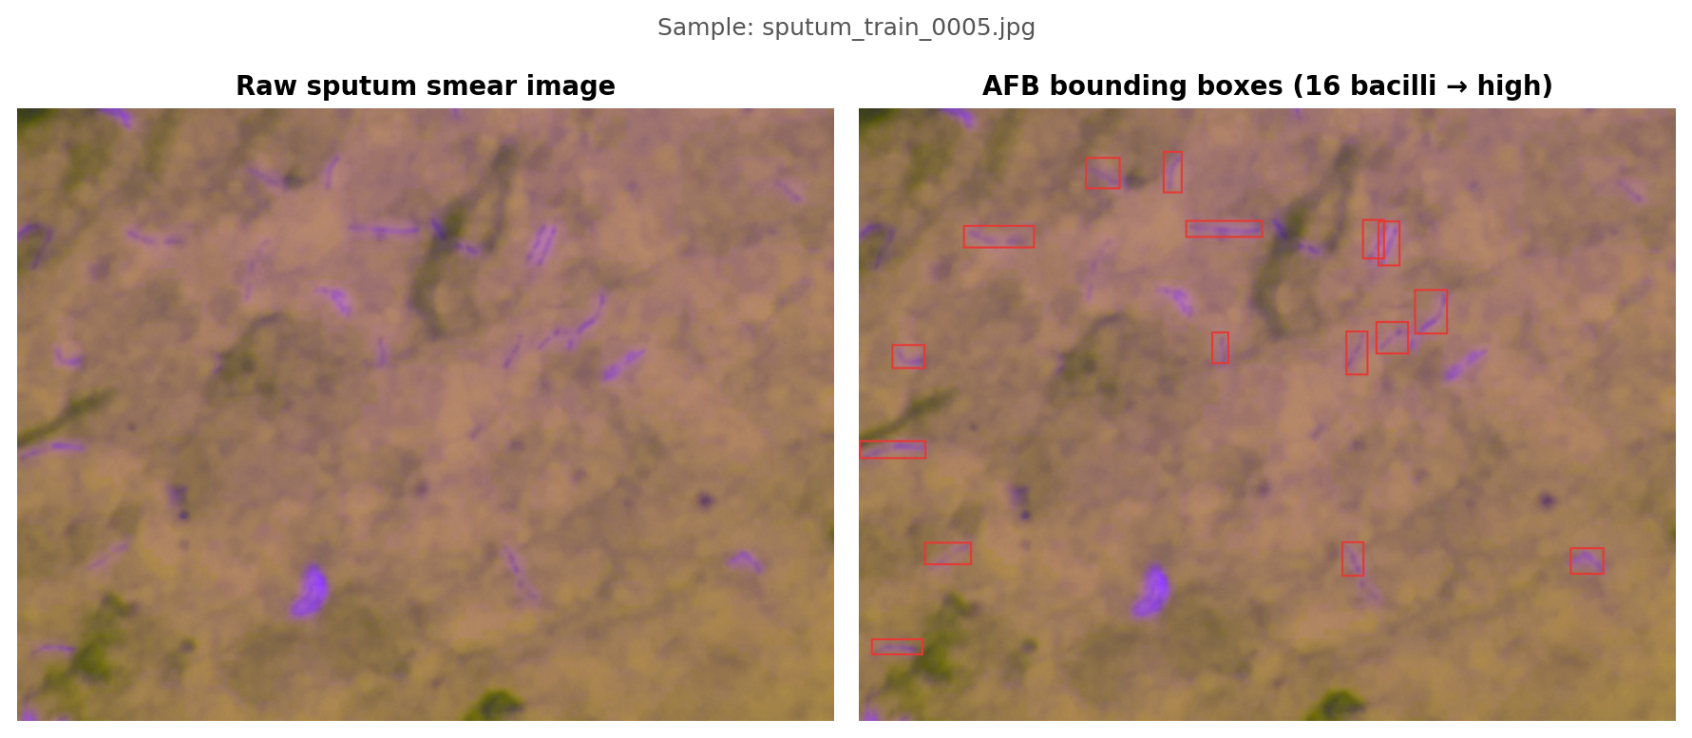
Figure C.3. Raw vs. annotated sputum smear sample (16 AFB → high load grade).
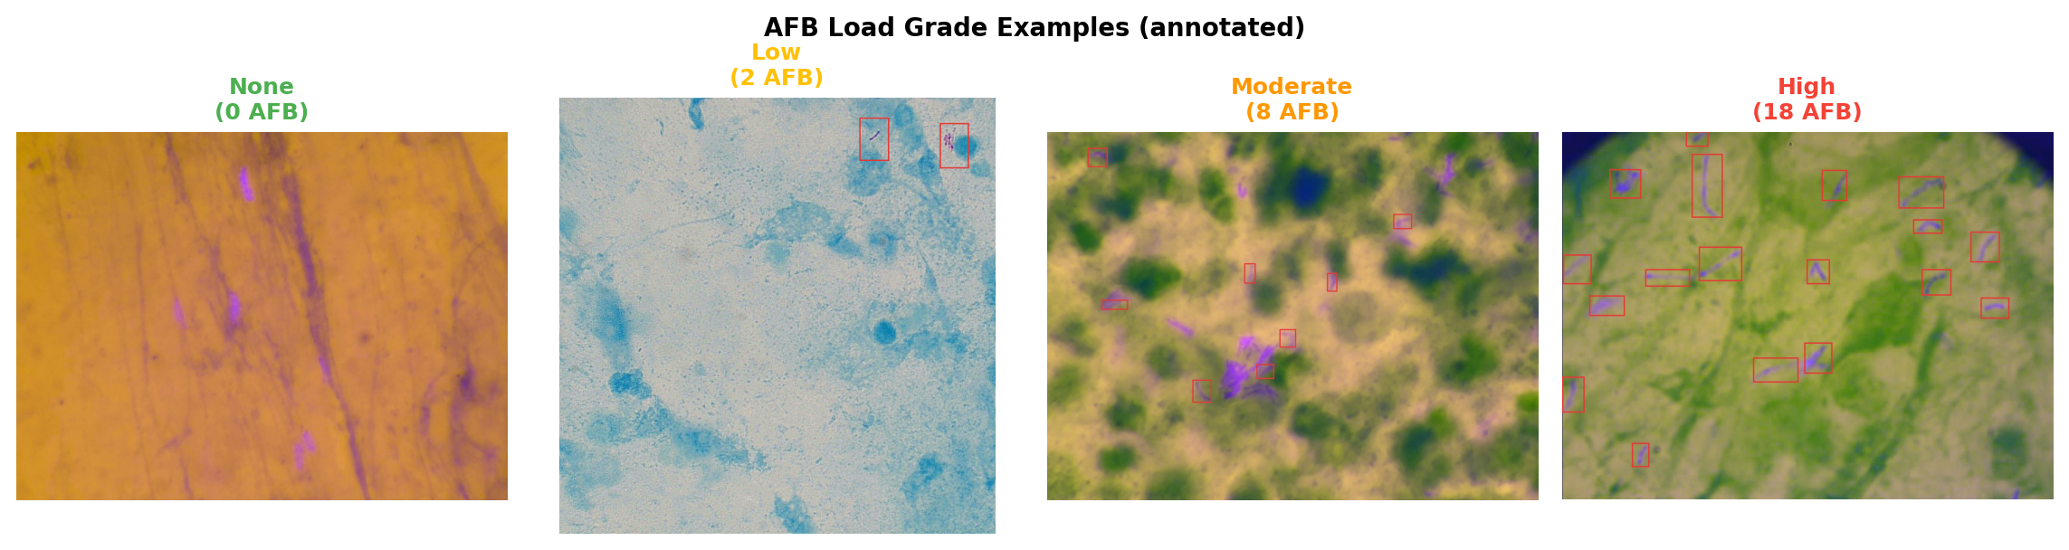
Figure C.4. AFB load grade examples across none, low, moderate, and high counts.

C.3 Label Categories and Export Format
Sputum YOLO labels use a single object class. Each line in a .txt label file stores class_id, x_center, y_center, width, and height (all normalized to 0–1).
Class ID | Label | Description
0 | AFB | Acid-fast bacillus (Mycobacterium tuberculosis rod)

YOLO dataset configuration (data.yaml):
# Ultralytics YOLO config for sputum smear AFB detection.
# Class 0 == AFB (acid-fast bacillus, Mycobacterium tuberculosis rod).
path: Raw_Sputum_Microscopy_Dataset
train: images/train
val: images/val
test: images/test

names:
0: AFB
Example label file (sputum_train_0005.txt — 16 AFB boxes):
0 0.1712622549019608 0.20915032679738563 0.08762254901960784 0.03758169934640523
0 0.38388480392156865 0.10375816993464053 0.02389705882352941 0.06862745098039216
0 0.29840686274509803 0.1053921568627451 0.0428921568627451 0.05228758169934641
0 0.44699754901960786 0.19648692810457516 0.09497549019607843 0.028594771241830064
0 0.6295955882352942 0.21323529411764705 0.027573529411764705 0.06535947712418301
... (16 lines total)
Cough audio class labels (CODA TB metadata):
tb_status | Class Name | Description
0 | No-TB | Cough recording from participant without microbiologically confirmed TB
1 | TB-Positive | Cough recording from participant with confirmed TB status

Split CSV files (X_train_Fold_N.csv, X_test_Fold_N.csv) map filename → tb_status for reproducible cross-validation during cough model training.

C.4 Annotation Validation and Training Environment
Dataset integrity was validated by checking image–label filename pairs across train, val, and test splits. Sputum labels were verified for normalized coordinate bounds and non-empty AFB-positive fields. Cough filenames in split CSVs were indexed against raw_data/*.wav.
Table C.1. Sputum CNN training configuration (ResNet18 binary classifier)
Parameter | Value
Framework | PyTorch / torchvision ResNet18
Task | binary
Image size | 224
Epochs | 30
Batch size | 32
Augmentation | True
Dataset | Raw_Sputum_Microscopy_Dataset

Table C.2. Cough hybrid CNN training configuration
Parameter | Value
Framework | PyTorch CNN + gradient-boosted features
Dataset | ruchikashirsath/tb-audio
Sample rate | 16000 Hz
Clip duration | 4.0 s
Mel bins | 64
CNN epochs | 8
Cross-validation fold | 1

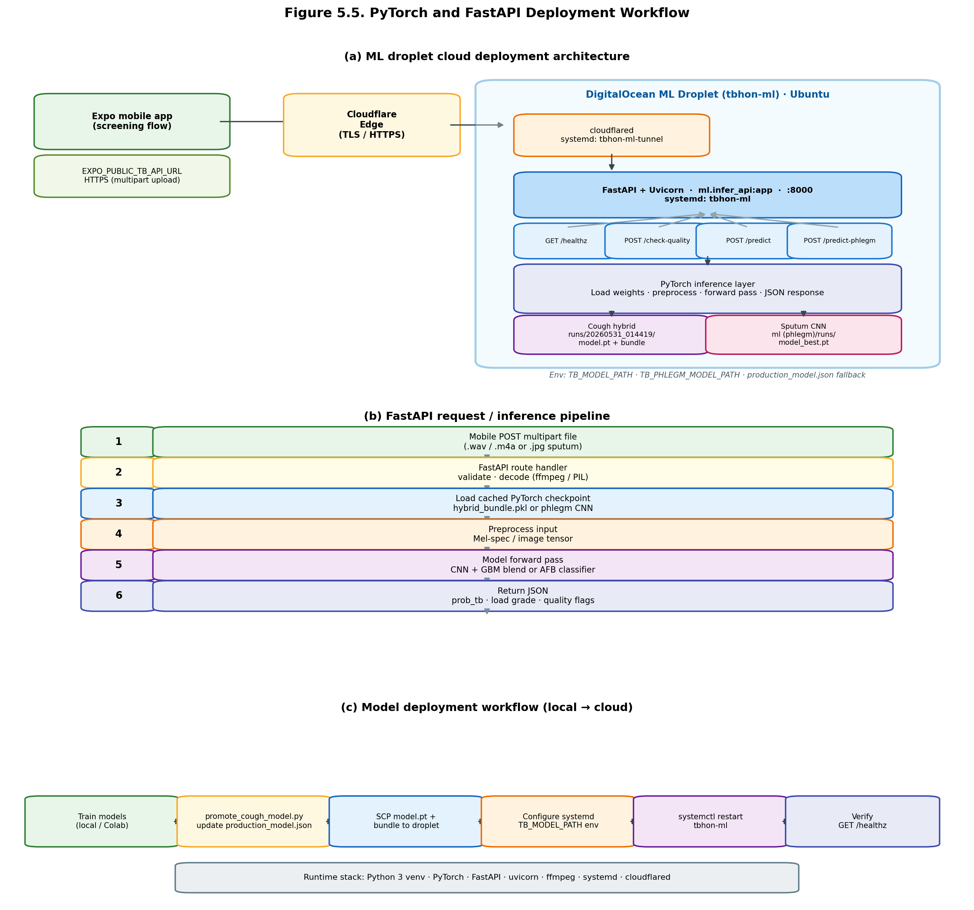
Figure C.5. PyTorch model deployment workflow (FastAPI ML droplet).
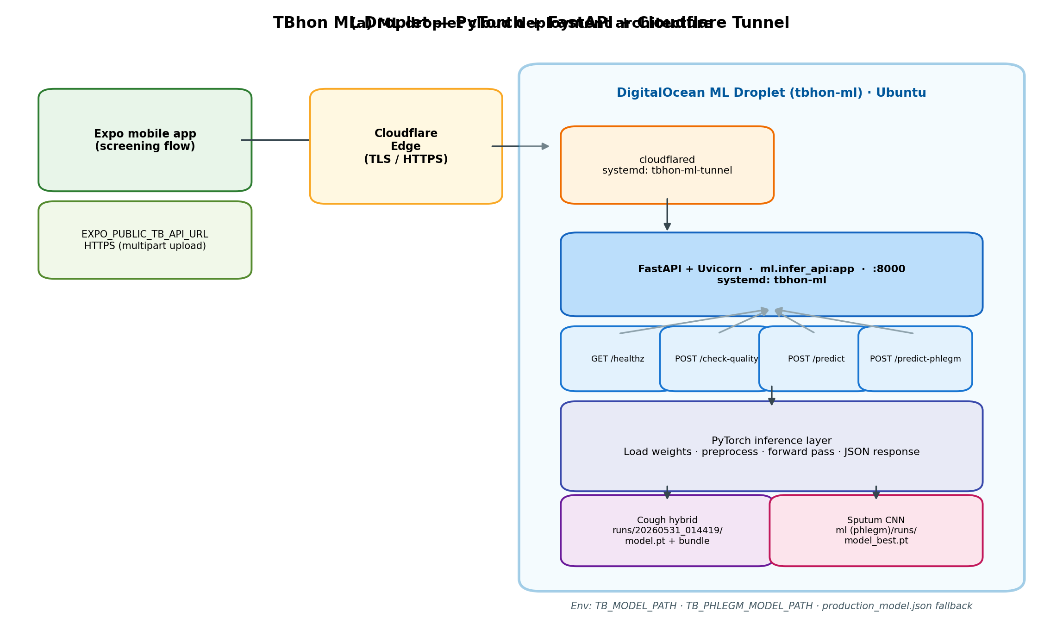
Figure C.6. Cloud ML inference architecture.

C.5 Training Progress Evidence
Training loss and validation metric curves document model learning progress for both modalities across epochs.
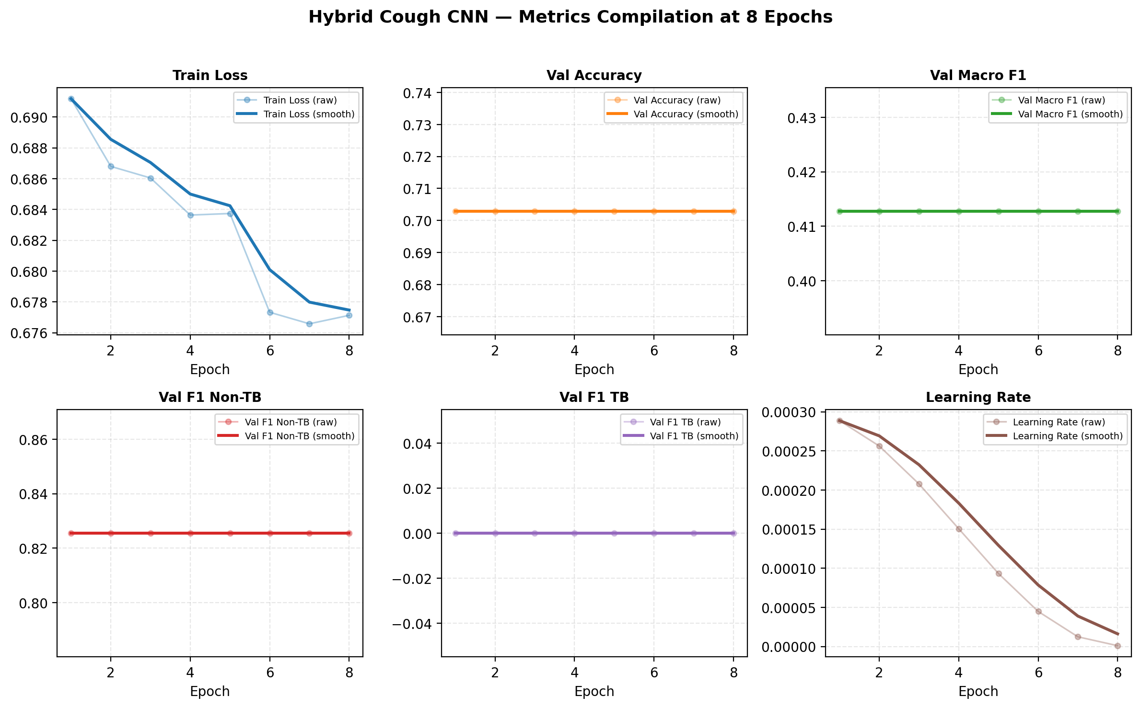
Figure C.7. Cough hybrid model metrics compilation (8 CNN epochs).
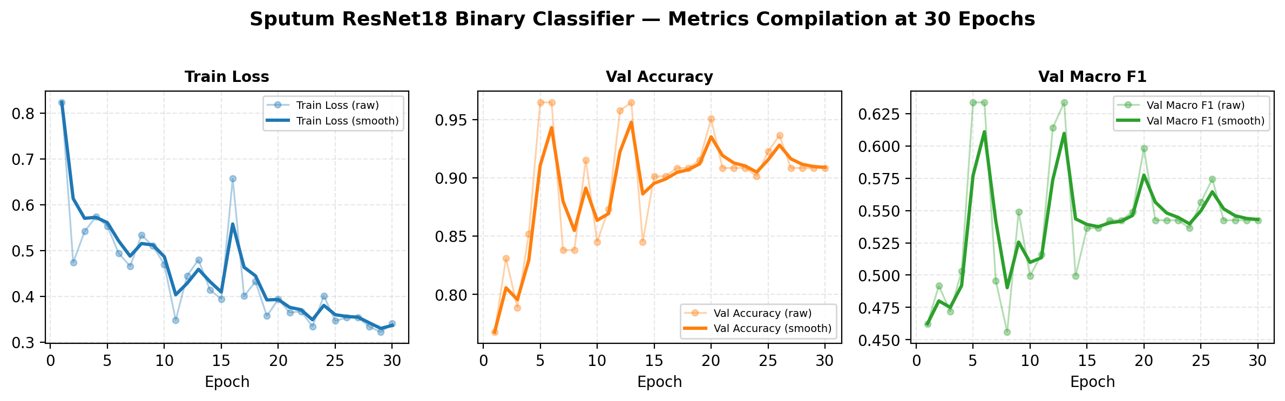
Figure C.8. Sputum ResNet18 binary classifier metrics compilation (30 epochs).
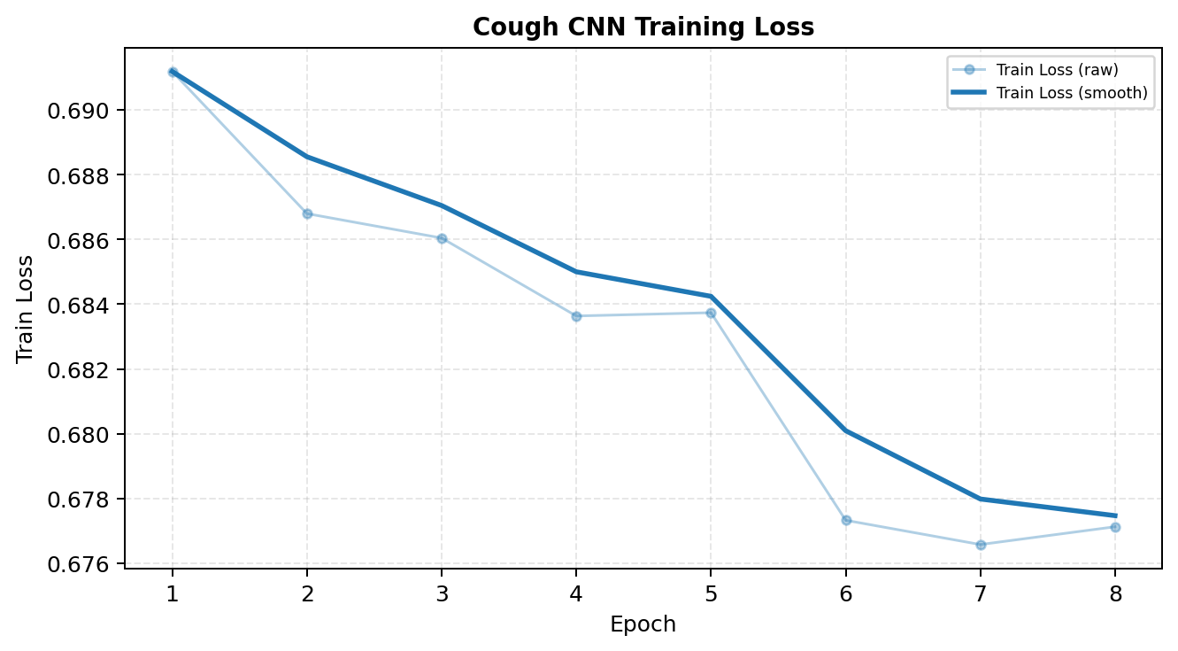
Figure C.9. Cough model training loss curve.
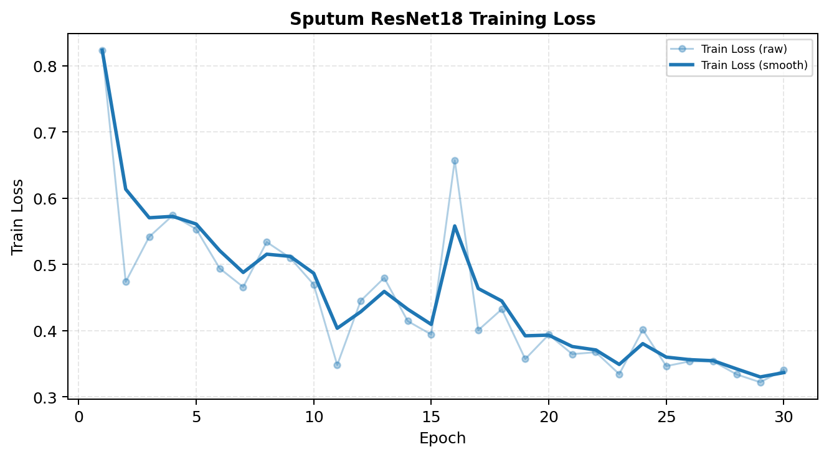
Figure C.10. Sputum model training loss curve.

C.6 Model Validation Evidence
Validation F1 and accuracy curves on held-out splits demonstrate generalization during training. Sputum validation reflects binary AFB presence; cough validation tracks macro F1 and per-class TB / No-TB performance.
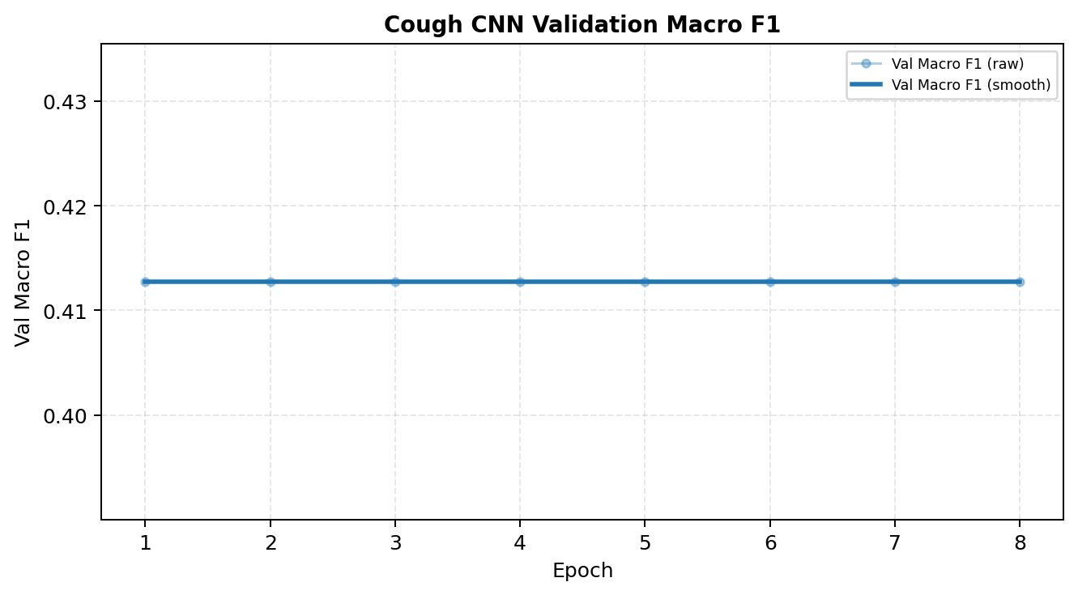
Figure C.11. Cough validation macro F1.
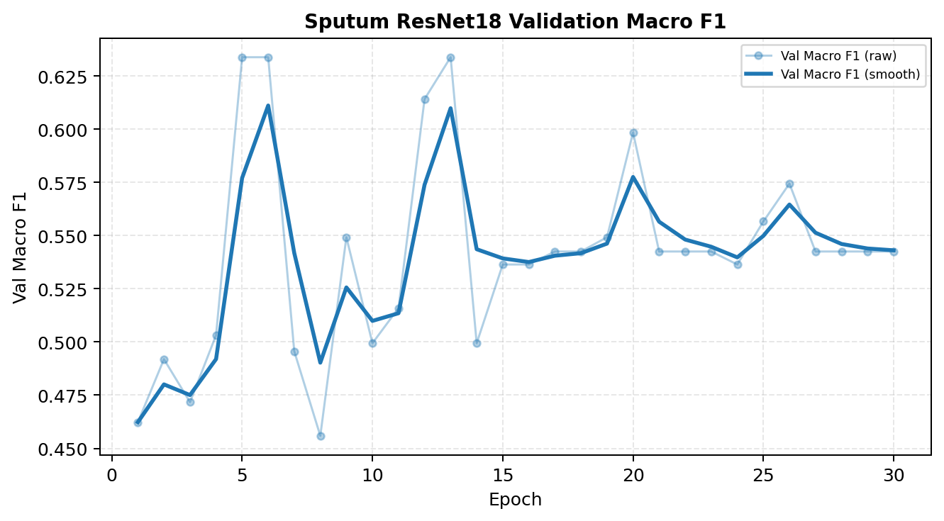
Figure C.12. Sputum validation macro F1.
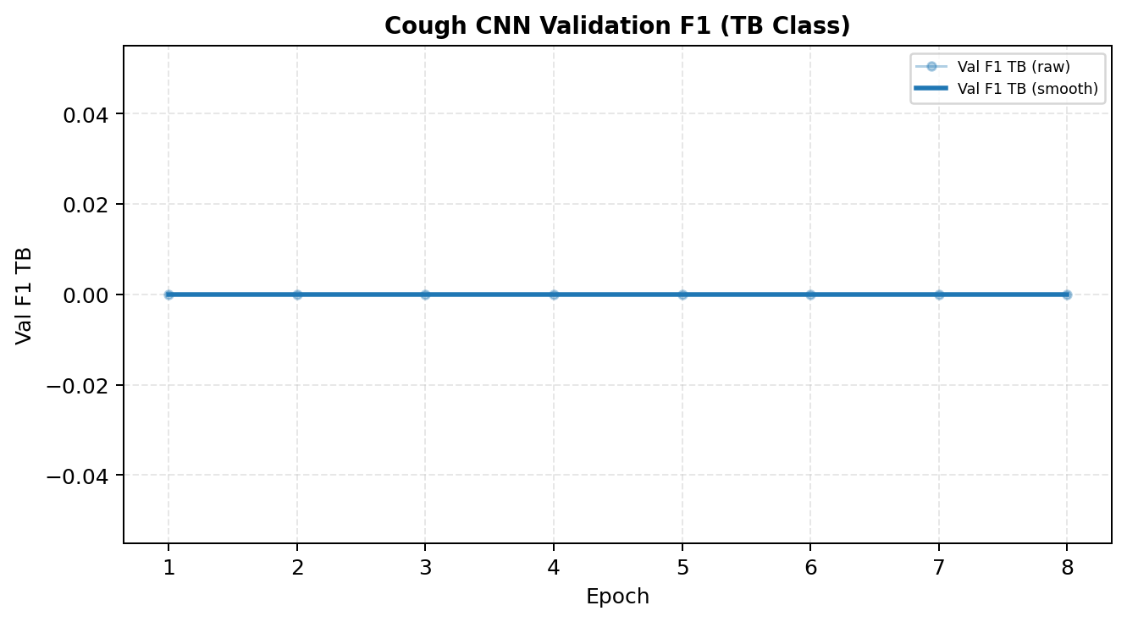
Figure C.13. Cough validation F1 — TB class.
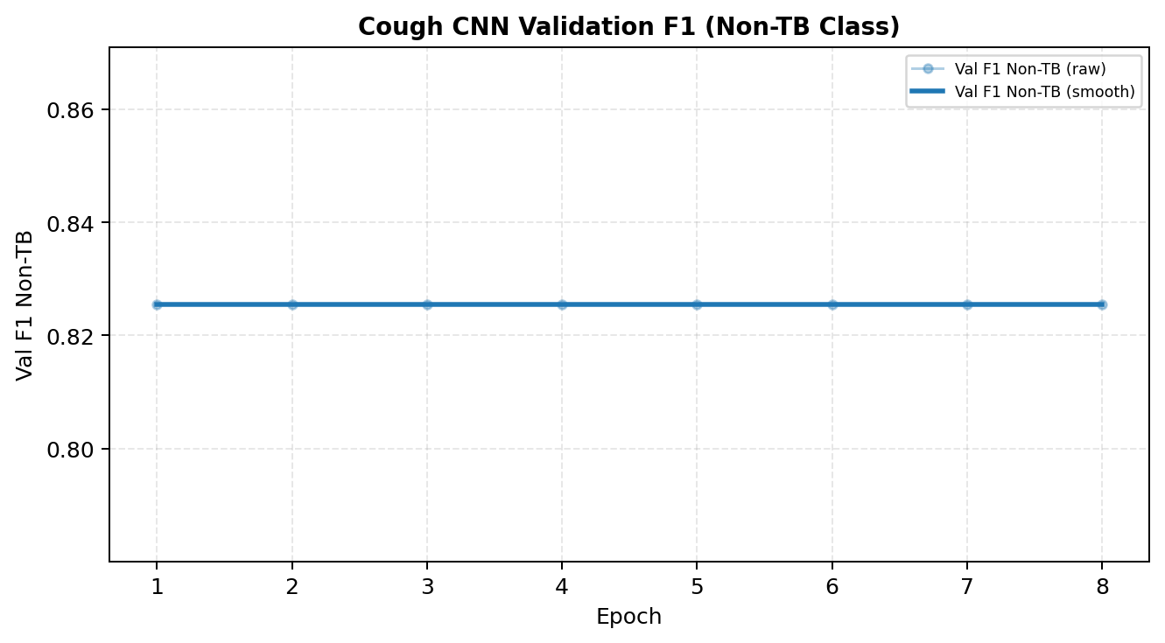
Figure C.14. Cough validation F1 — No-TB class.

C.7 Confusion Matrix and Evaluation Metrics
Final test-set confusion matrices and classification metrics for the production-promoted model runs used in TBhon inference.
Cough Model (Hybrid CNN) — Test Metrics | Value
Test accuracy | 75.75%
Macro F1 | 0.6908
Decision threshold | 0.395
Confusion matrix [[TN,FP],[FN,TP]] | [[1592, 212], [420, 382]]

Sputum Model (ResNet18 Binary) — Test Metrics | Value
Test accuracy | 94.91%
Macro F1 | 0.6632
Sensitivity | 96.19%
Specificity | 50.00%
Decision threshold | 0.63
Confusion matrix [[TN,FP],[FN,TP]] | [[3, 3], [8, 202]]

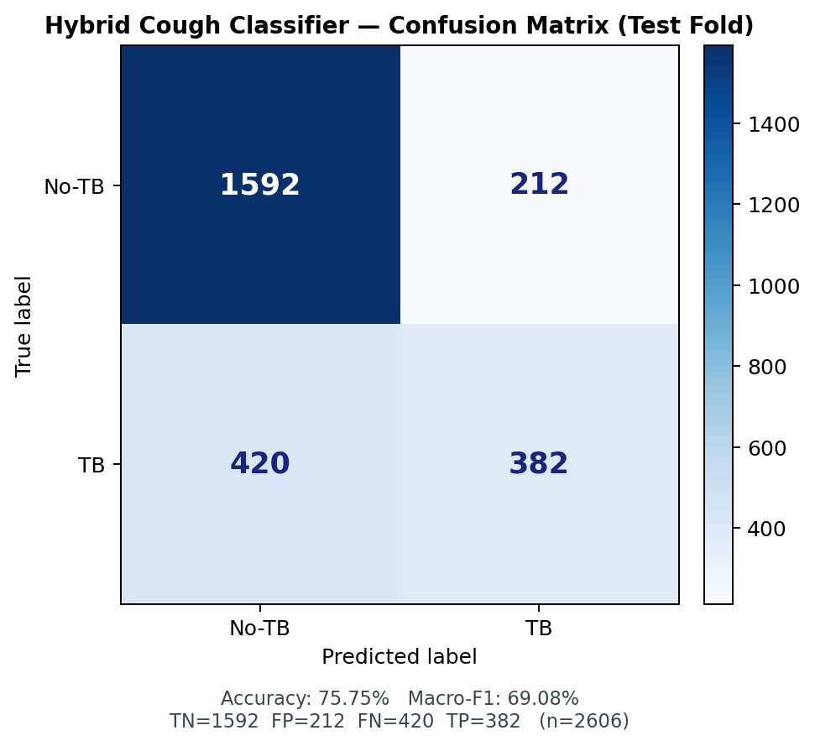
Figure C.15. Cough model confusion matrix.
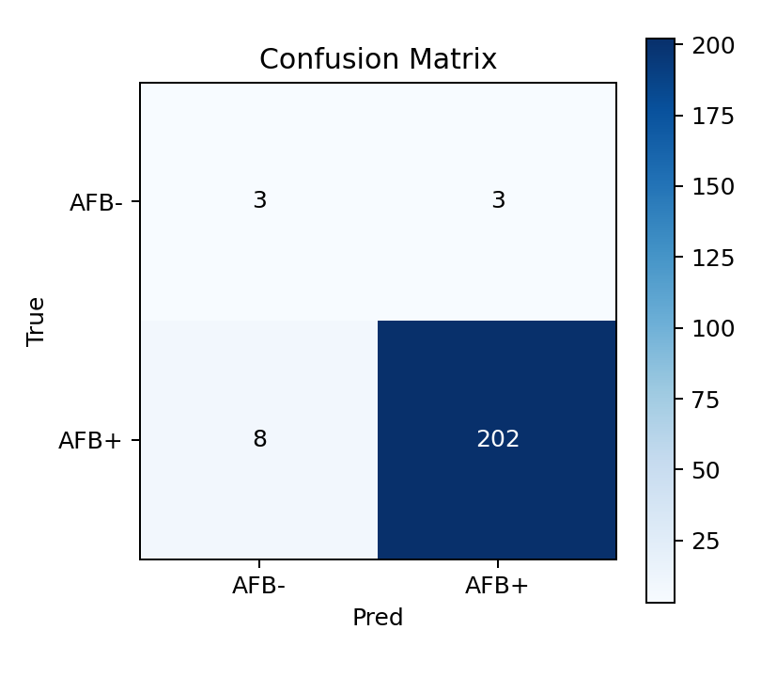
Figure C.16. Sputum model confusion matrix.
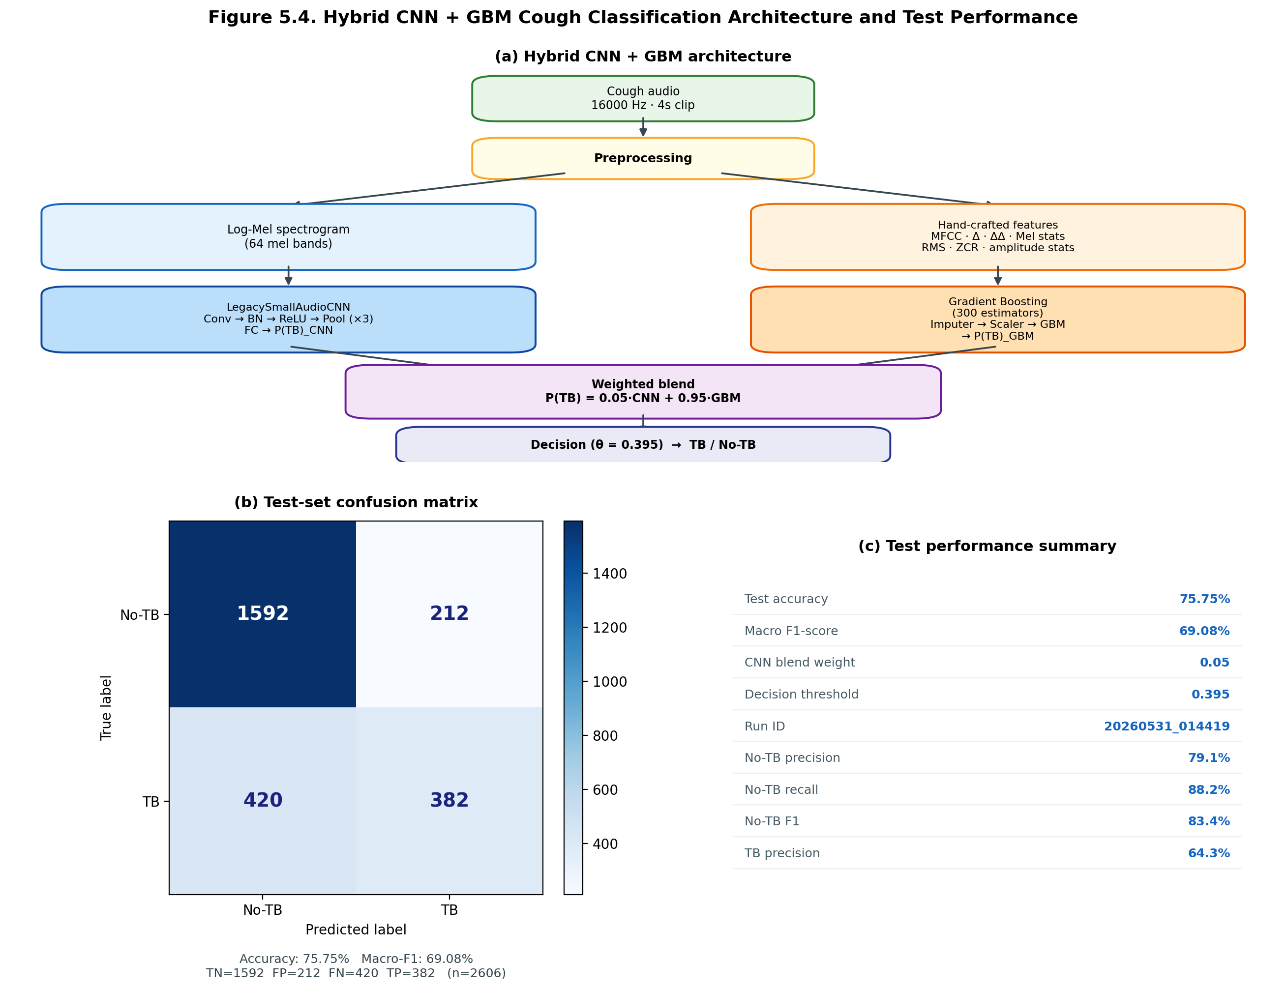
Figure C.17. Cough CNN architecture and evaluation summary.

C.8 Model Export and Deployment Preparation
Trained model weights were exported from PyTorch training runs and registered in ml/production_model.json for FastAPI inference deployment on the ML droplet. The cough hybrid bundle requires both model.pt and hybrid_bundle.pkl; the sputum classifier uses model_best.pt from the phlegm training run.
Deployment Artifact | Value
Production run ID | 20260531_014419
Cough model type | hybrid_cnn
Cough model path | runs/20260531_014419/model.pt
Cough test accuracy | 75.75%
Cough macro F1 | 0.6908
Inference API | ml/infer_api.py — /predict/cough, /predict/sputum
Sputum weights | ml (phlegm)/runs/phlegm_afb_binary_20260531_133949/model_best.pt

Note: All models are deployed for triage support only and are not certified diagnostic devices. Results require staff review and follow-up microbiological confirmation per program protocol.

