APPENDIX D — DATA AUGMENTATION DOCUMENTATION
This appendix demonstrates preprocessing and augmentation procedures applied to the TBhon training datasets. Sputum smear examples (D.1–D.4) are taken from Raw_Sputum_Microscopy_Dataset with YOLO AFB bounding boxes drawn for reference. Cough waveform noise (D.5) uses the same additive Gaussian transform as train_tb_cough_hybrid.py. All parameters below are taken directly from ml (phlegm)/train_phlegm_cnn.py and ml/train_tb_cough_hybrid.py.

D.1 Rotation Samples
RandomRotation(±15°) in train_phlegm_cnn.py simulates slight orientation differences during microscopy capture and mobile camera alignment. Three representative AFB-positive fields show original and ±15° variants.
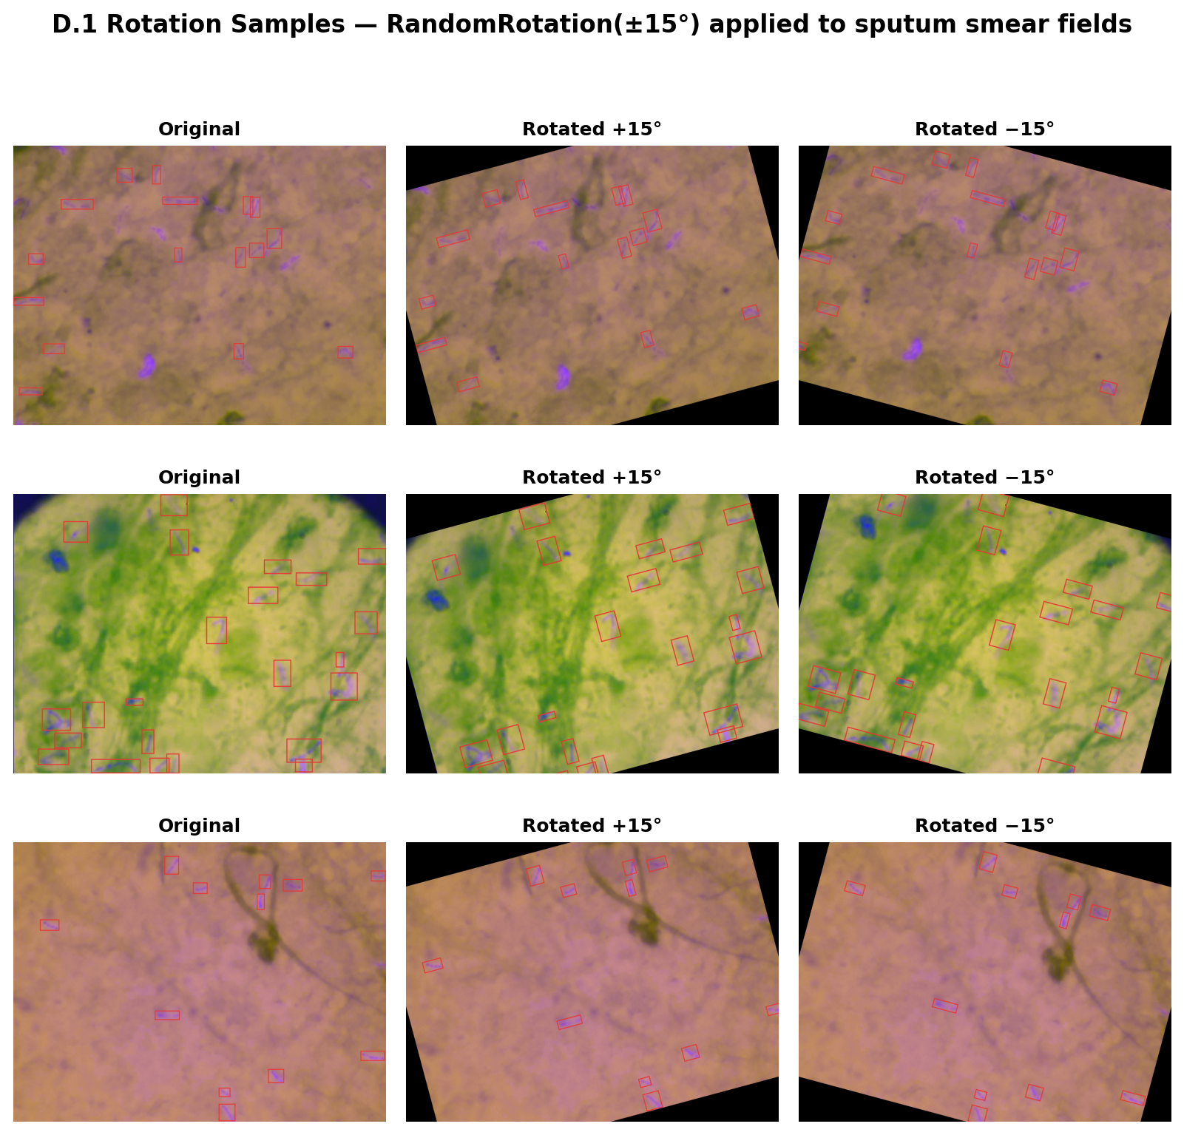
Figure D.1. Sputum rotation augmentation samples (±15°).

D.2 Flipping Samples
RandomHorizontalFlip and RandomVerticalFlip (p=0.5) increase spatial invariance. Microscopy fields have no fixed orientation, so flips are valid label-preserving transforms.
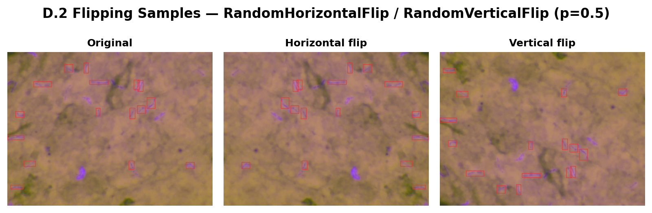
Figure D.2. Sputum horizontal and vertical flip samples.

D.3 Brightness Adjustment Samples
ColorJitter(brightness=0.15, contrast=0.15, saturation=0.15, hue=0.03) in train_phlegm_cnn.py adjusts exposure to mimic variable microscope illumination and mobile camera auto-exposure. Brightness samples show the ±15% range.
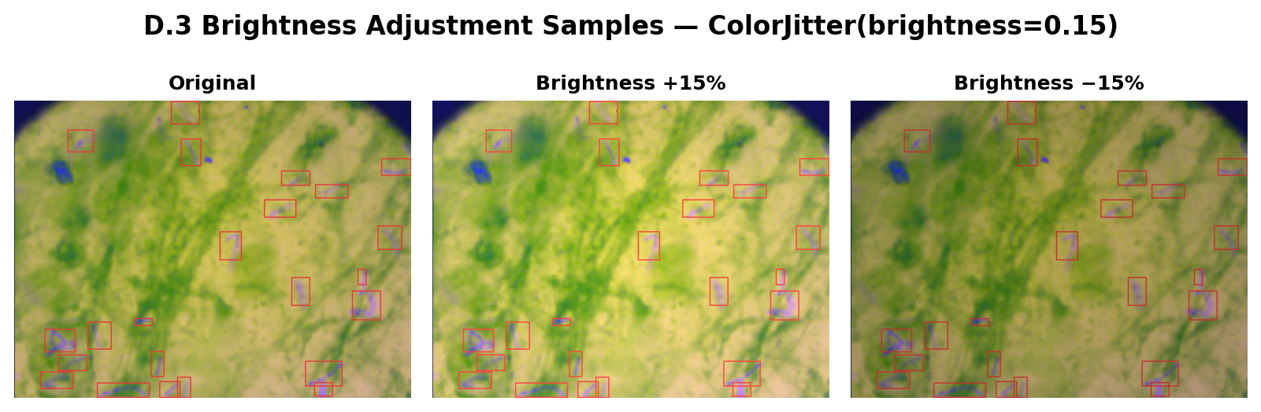
Figure D.3. Sputum brightness adjustment samples (±15%).

D.4 Saturation Adjustment Samples
The same ColorJitter block applies saturation=0.15 (and contrast=0.15, hue=0.03) to simulate differences in Ziehl–Neelsen staining intensity across preparation batches.
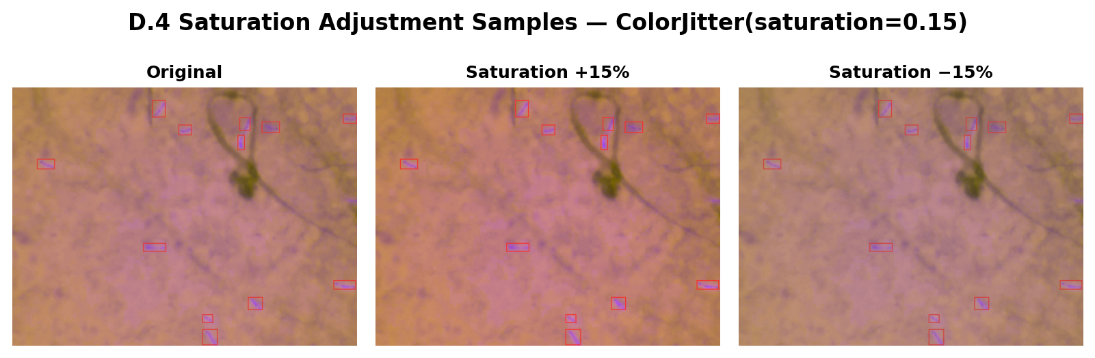
Figure D.4. Sputum saturation adjustment samples (±15%).

D.5 Gaussian Noise Samples
In train_tb_cough_hybrid.py, _augment_waveform() adds Gaussian noise to the 16 kHz cough waveform before log-mel conversion: x = x + randn * noise_std with noise_std=0.008. Sputum CNN training does not apply pixel-level noise; only ColorJitter and geometric transforms.
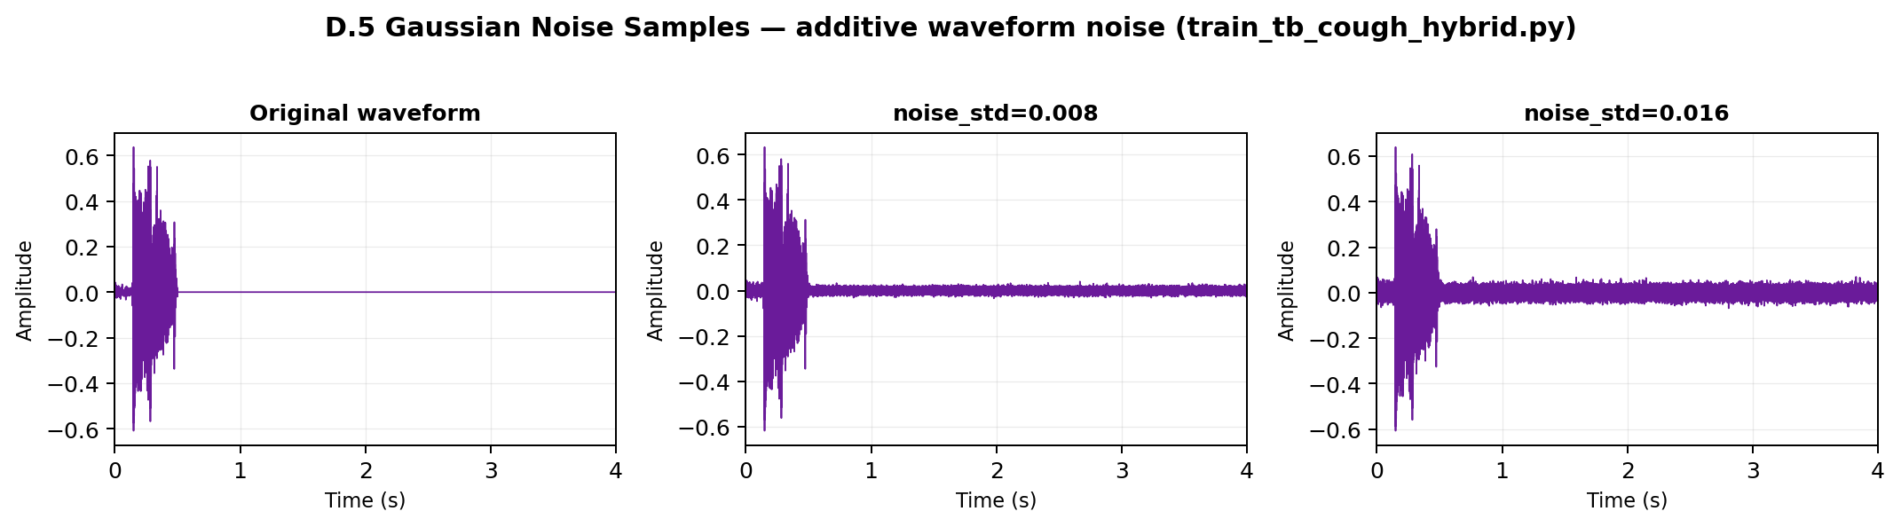
Figure D.5. Cough waveform Gaussian noise samples (noise_std=0.008, production hybrid config).

D.6 Augmentation Workflow
End-to-end augmentation workflow for both sputum CNN and cough hybrid model training pipelines.
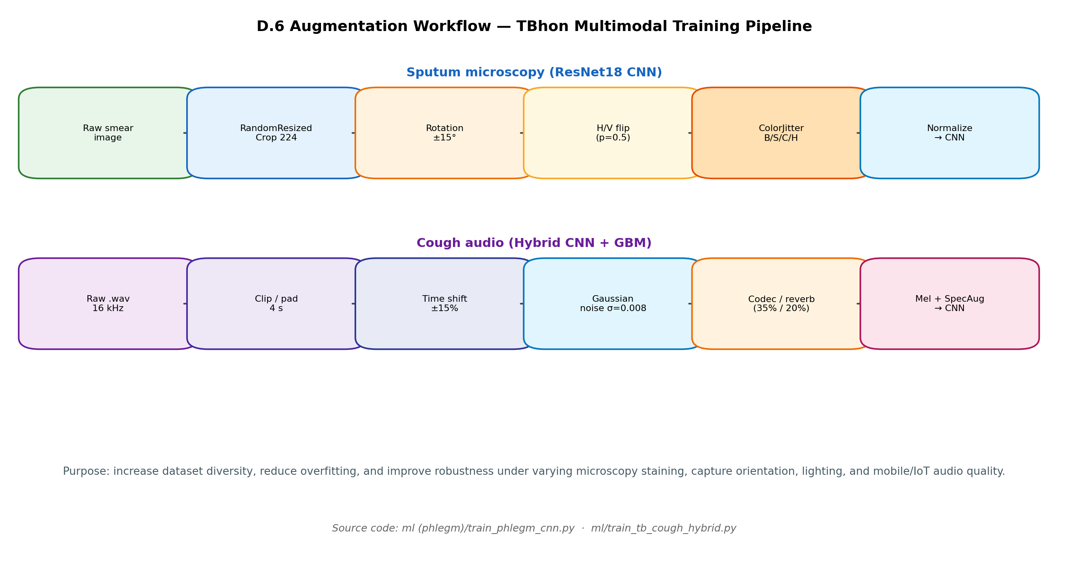
Figure D.6. TBhon multimodal data augmentation workflow.
Sputum training transforms (train_phlegm_cnn.py): RandomResizedCrop(224, scale=(0.85, 1.0), ratio=(0.9, 1.1)), RandomHorizontalFlip(0.5), RandomVerticalFlip(0.5), RandomRotation(15), ColorJitter(brightness=0.15, contrast=0.15, saturation=0.15, hue=0.03), ImageNet normalization.
Cough hybrid transforms (train_tb_cough_hybrid.py): time_shift_max=0.15, noise_std=0.008, codec_aug_prob=0.35, reverb_aug_prob=0.20, SpecAugment (2 frequency masks, param=16; 2 time masks, param=24). Augmentation is training-only; validation and test use deterministic preprocessing.

