APPENDIX E

MODEL TRAINING REPOSITORY
This appendix documents the model training repository, configuration parameters, and training environment used to produce the production cough hybrid classifier (run 20260531_014419) and sputum AFB binary ResNet18 classifier (run phlegm_afb_binary_20260531_133949) reported in Chapter VI.

E.1 Repository Structure
The TBhon machine learning assets are organized under the main project repository with separate directories for cough audio and sputum microscopy pipelines. Production checkpoints, metrics, and configuration files are stored under timestamped run folders.
Tbhon/
├── ml/
│ ├── train_tb_cough_hybrid.py
│ ├── train_tb_cough_cnn.py
│ ├── infer_api.py
│ ├── production_model.json
│ ├── runs/
│ │ └── 20260531_014419/
│ │ ├── model.pt
│ │ ├── hybrid_bundle.pkl
│ │ ├── metrics.json
│ │ └── config.json
│ └── scripts/
└── ml (phlegm)/
├── train_phlegm_cnn.py
├── Raw_Sputum_Microscopy_Dataset/
└── runs/
└── phlegm_afb_binary_20260531_133949/
├── model_best.pt
├── metrics.json
└── config.json
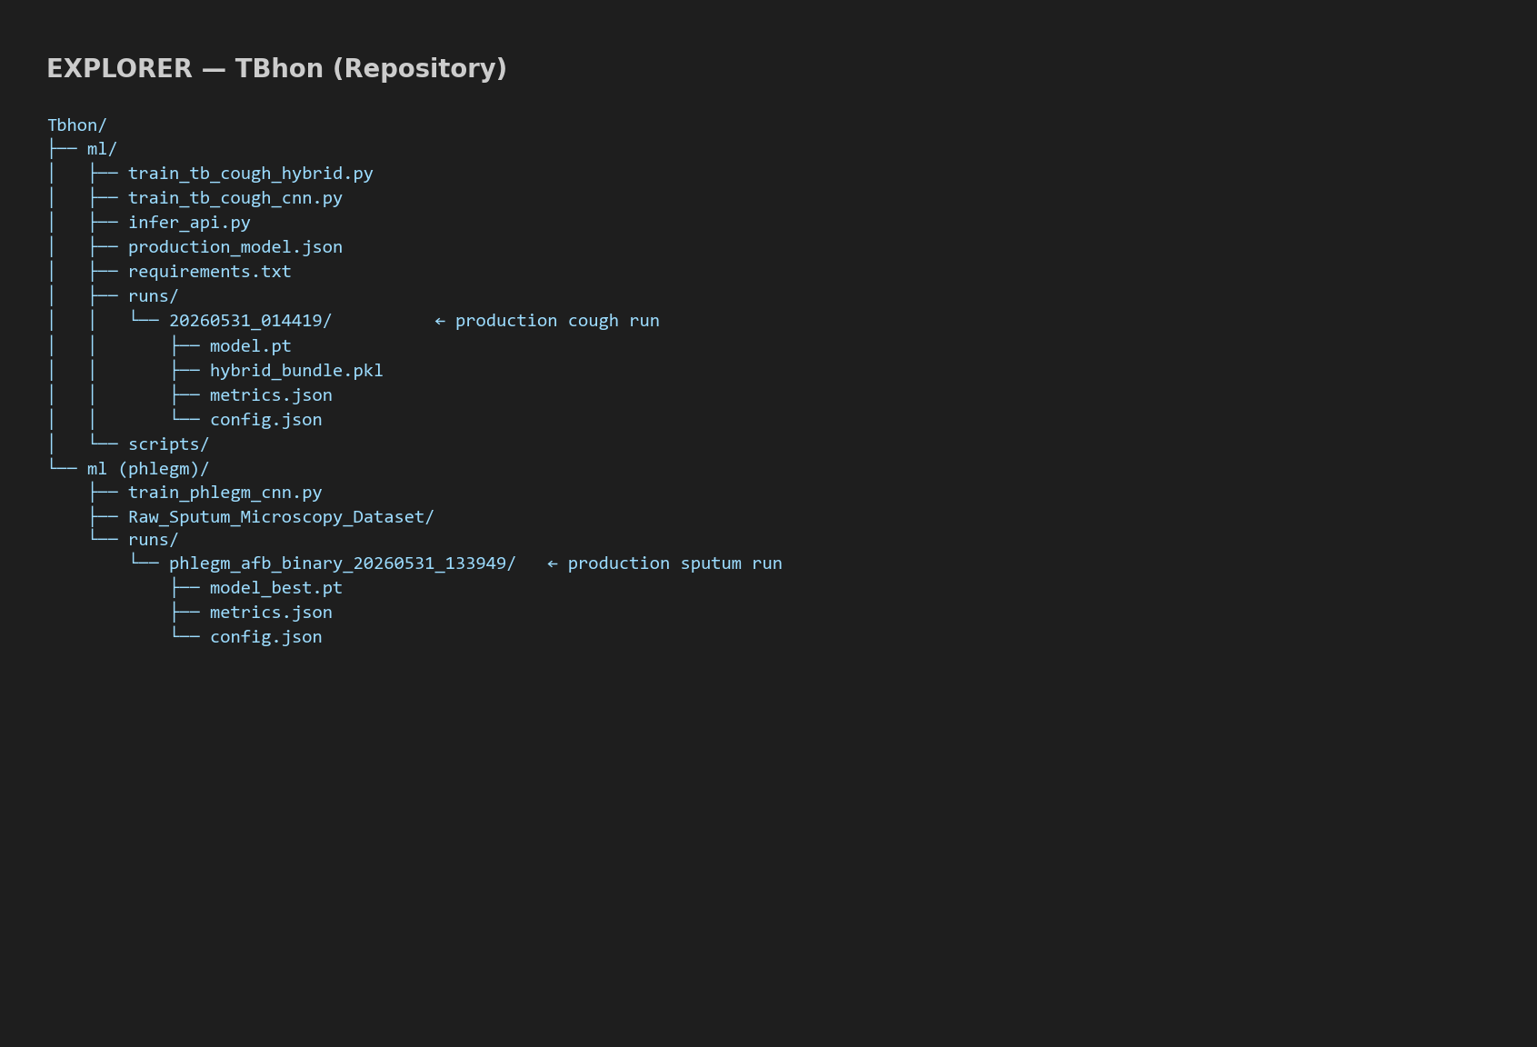
Figure E.1. TBhon Model Training Repository Structure (VS Code Explorer)

E.2 Training Configuration
Table E.2.1. Cough Hybrid Classifier — Production Training Configuration (run 20260531_014419)
Parameter | Value
Framework | PyTorch CNN + scikit-learn Gradient Boosting
Language | Python 3
Dataset | ruchikashirsath/tb-audio
Cross-validation fold | 1
Sample rate | 16000 Hz
Clip duration | 4.0 s
Mel bins | 64
CNN epochs | 8
CNN batch size | 32
CNN learning rate | 0.0003
GBM estimators | 300
Validation fraction | 0.12
Device | CPU — local Windows workstation (Visual Studio Code)

Table E.2.2. Sputum ResNet18 AFB Binary Classifier — Production Training Configuration
Parameter | Value
Framework | PyTorch / torchvision ResNet18
Language | Python 3
Task | binary
Image size | 224×224
Epochs | 30
Batch size | 32
Learning rate | 0.001
Weight decay | 0.0001
Augmentation | True
Class weighting | True
Optimizer | Adam
Device | cpu

E.3 Training Environment
All production model training documented in Chapter VI was performed on a local Windows 11 development workstation using Visual Studio Code and PowerShell. The TBhon repository was cloned from GitHub; Python dependencies were installed from ml/requirements.txt and ml (phlegm) requirements. Cough hybrid training and sputum ResNet18 training were executed as command-line scripts—no Google Colab or cloud notebook environment was used for the reported production runs.
Figure E.3.1 shows the ML repository structure in the VS Code explorer. Figure E.3.2 shows the local VS Code terminal session used to run the production cough and sputum training commands.

Figure E.3.1. Repository Screenshot — TBhon ML Directory (VS Code Explorer)
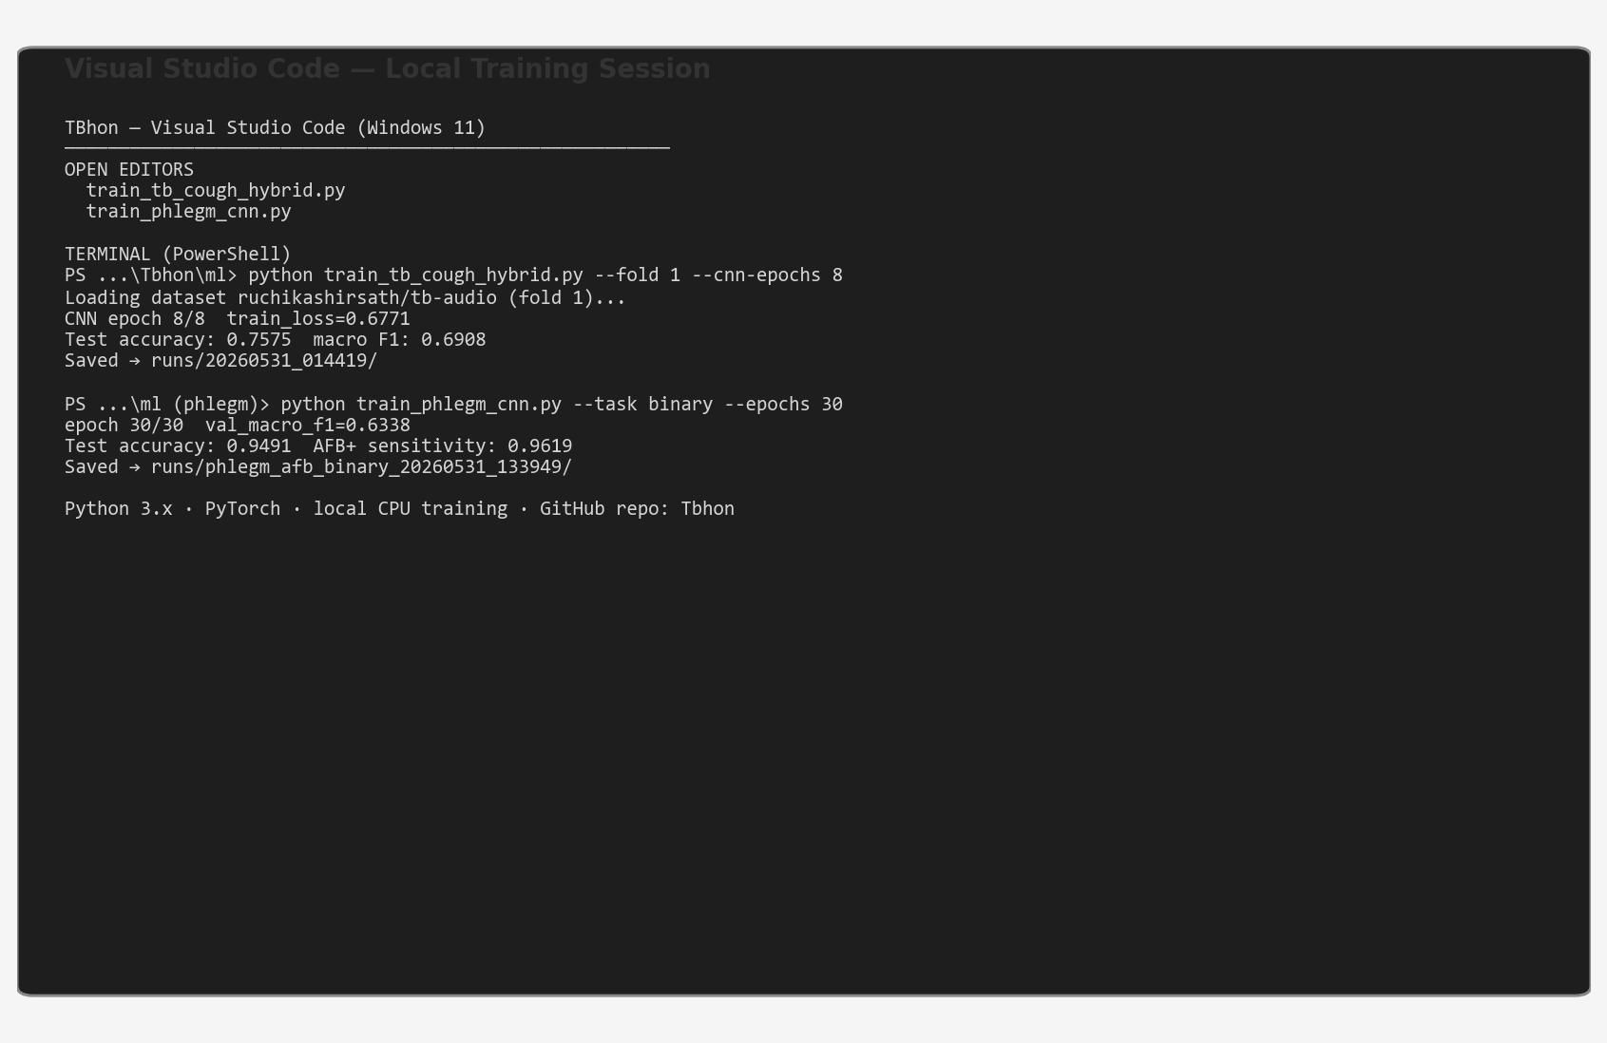
Figure E.3.2. Local Training Environment — Visual Studio Code Terminal (Windows)
Training commands (reference):
• Cough: python train_tb_cough_hybrid.py --fold 1 --cnn-epochs 8 --gbm-estimators 300
• Sputum: python train_phlegm_cnn.py --task binary --epochs 30

