APPENDIX F

MODEL PERFORMANCE OUTPUTS
This appendix presents supplementary model performance evidence supporting the Chapter VI evaluation results for the TBhon hybrid cough classifier (production run 20260531_014419, fold 1) and the sputum AFB binary ResNet18 classifier (production run phlegm_afb_binary_20260531_133949). Figures include test-set precision and recall summaries, validation macro F1 curves, training loss curves, confusion matrices, and consolidated training summary outputs.

F.1 Precision Results
Figure F.1 summarizes held-out test-set precision for the non-TB/TB cough classes and the AFB-negative/AFB-positive sputum classes. Cough non-TB precision was 79.13% and TB precision was 64.31%. Sputum AFB-positive precision was 98.54%; AFB-negative precision was 27.27% (n = 6 negatives in the test partition).
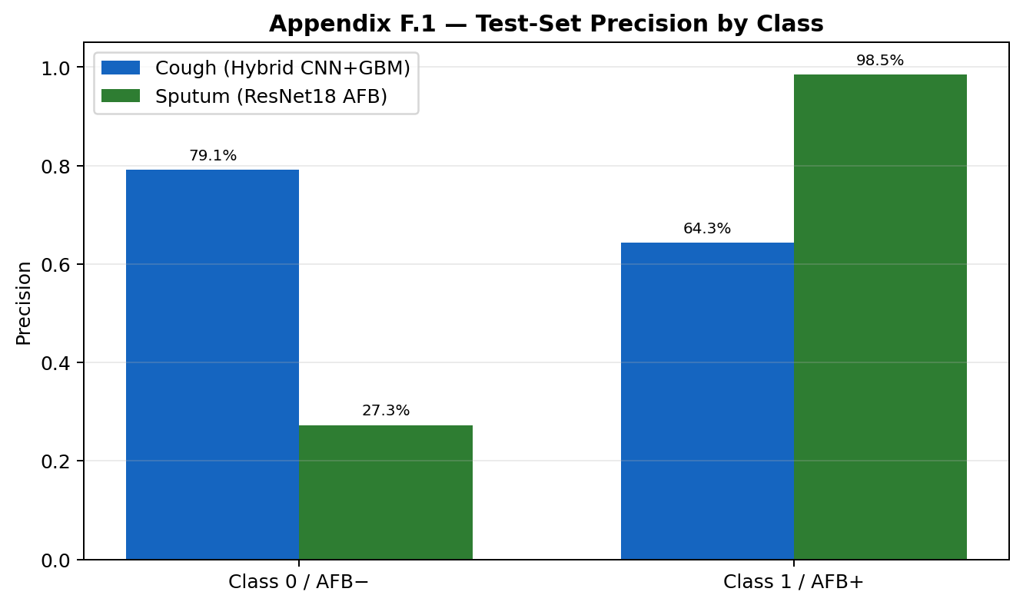
Figure F.1. Test-Set Precision by Class (Cough and Sputum Models)

F.2 Recall Results
Figure F.2 summarizes held-out test-set recall. Cough non-TB recall was 88.25% and TB recall was 47.63%. Sputum AFB-positive recall (sensitivity) was 96.19% under the validation-tuned threshold policy (decision threshold = 0.63).
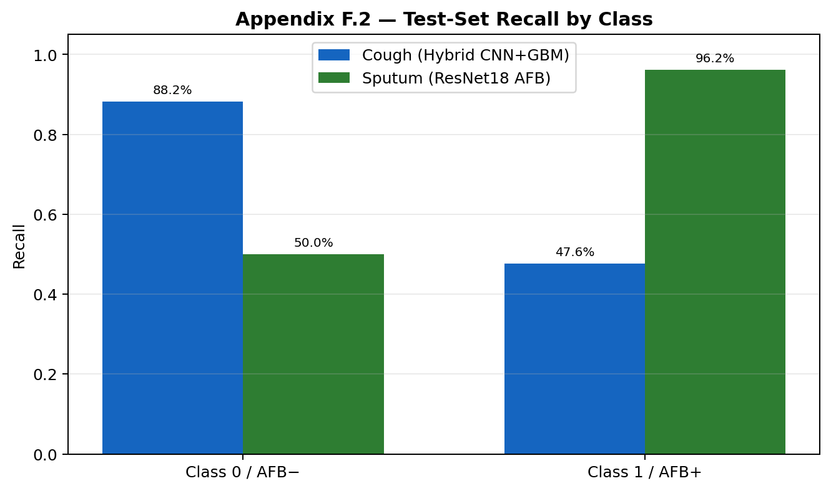
Figure F.2. Test-Set Recall by Class (Cough and Sputum Models)

F.3 Validation Macro F1 Curves
Figure F.3 presents validation macro F1 curves across training epochs for the cough CNN branch (8 epochs) and the sputum ResNet18 classifier (30 epochs). Macro F1 is used as the primary validation metric for binary classification in place of mean average precision (mAP), which applies to object-detection tasks.
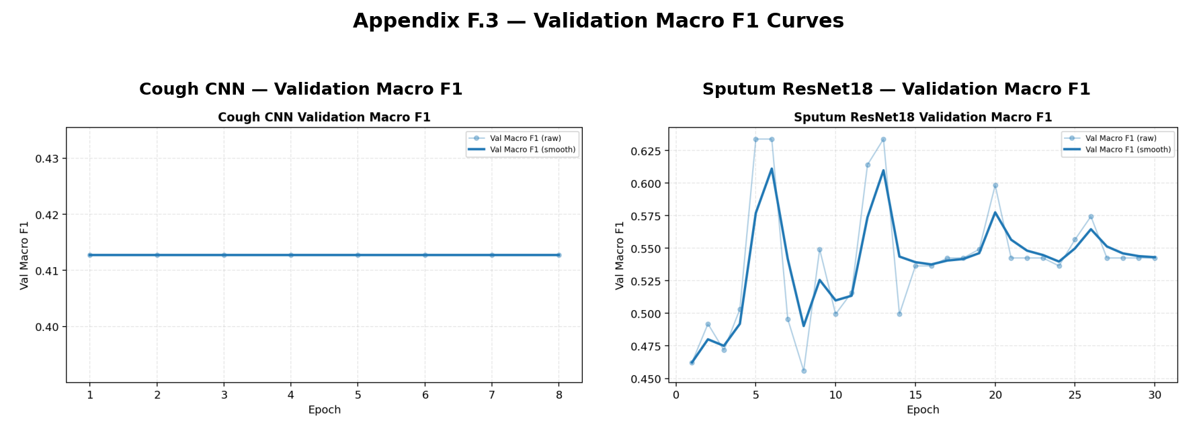
Figure F.3. Validation Macro F1 Curves

F.4 Training Loss Curves
Figure F.4 shows training loss curves for both production models. Decreasing cough CNN training loss and sputum ResNet18 training loss indicate improved fit during the reported training runs.
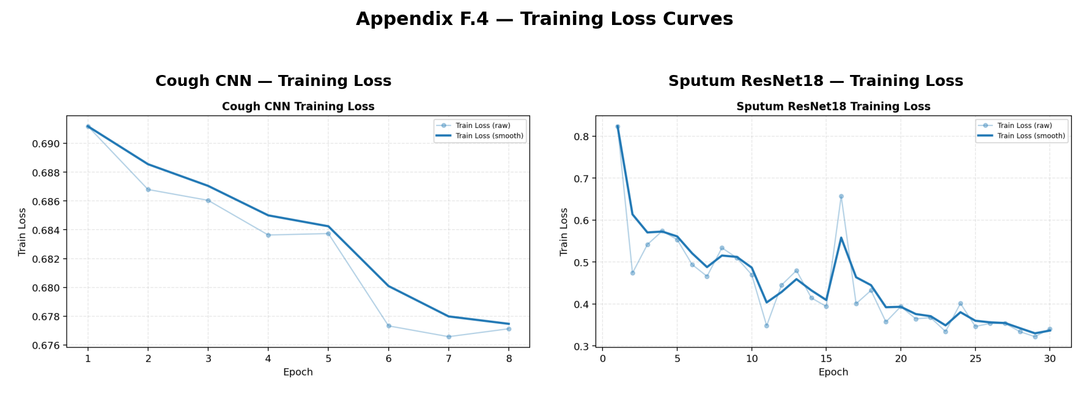
Figure F.4. Training Loss Curves

F.5 Confusion Matrices
Figure F.5 presents test-set confusion matrices for the hybrid cough classifier (n = 2,606) and the binary sputum AFB classifier (n = 216). Cough matrix: TN 1592, FP 212, FN 420, TP 382. Sputum matrix: TN 3, FP 3, FN 8, TP 202.
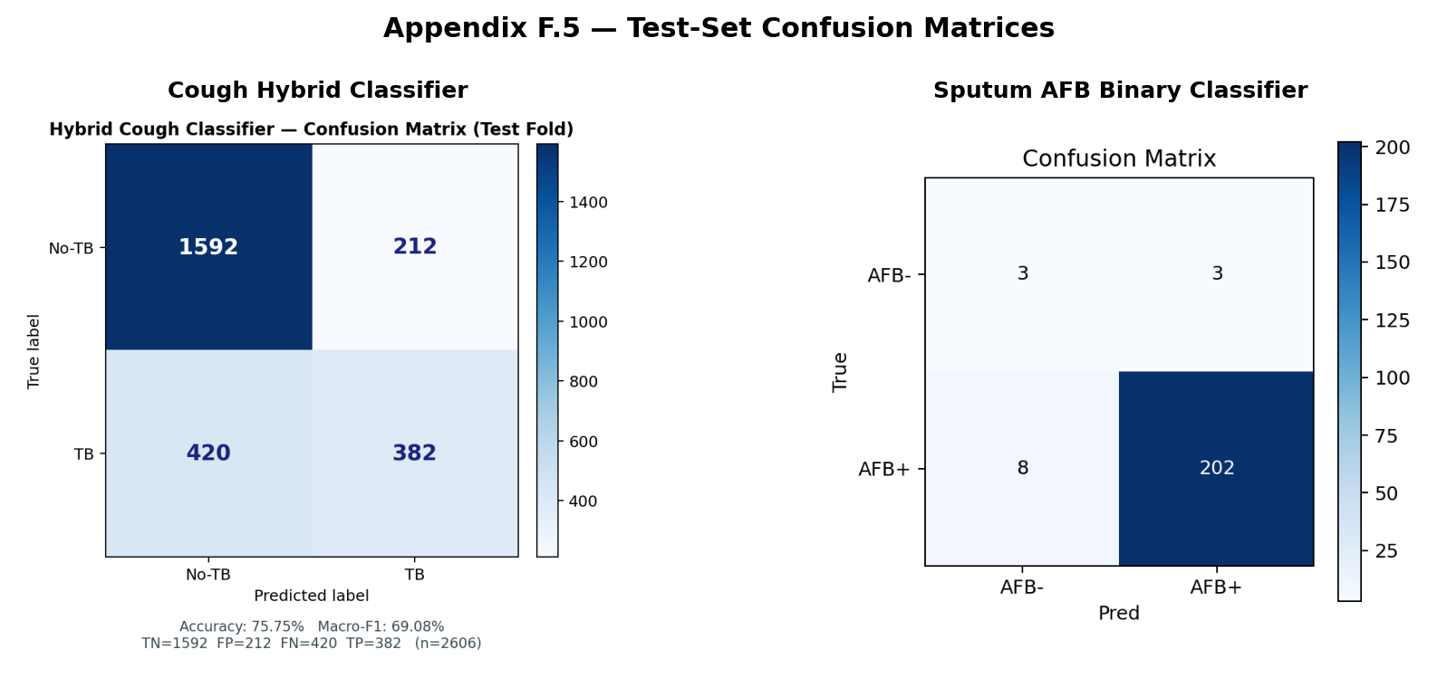
Figure F.5. Test-Set Confusion Matrices

F.6 Training Summary Output
Table F.6.1. Cough Hybrid Classifier — Production Test Summary (run 20260531_014419)
Metric | Value
Test accuracy | 75.75%
Macro F1 | 69.08%
Non-TB precision | 79.13%
TB precision | 64.31%
Non-TB recall | 88.25%
TB recall | 47.63%
CNN blend weight | 0.05
Decision threshold | 0.395
Test samples (n) | 2,606

Table F.6.2. Sputum ResNet18 AFB Binary Classifier — Production Test Summary (phlegm_afb_binary_20260531_133949)
Metric | Value
Test accuracy | 94.91%
Macro F1 | 66.32%
AFB+ sensitivity (recall) | 96.19%
AFB− specificity | 50.00%
AFB+ precision | 98.54%
Decision threshold | 0.63
Min. sensitivity constraint | 95.00%
Test samples (n) | 216

Table F.6.3. Cough CNN Branch — Per-Epoch Validation Log (8 epochs)
Epoch | Train Loss | Val Accuracy | Val Macro F1
1 | 0.6912 | 70.29% | 41.28%
2 | 0.6868 | 70.29% | 41.28%
3 | 0.6860 | 70.29% | 41.28%
4 | 0.6836 | 70.29% | 41.28%
5 | 0.6837 | 70.29% | 41.28%
6 | 0.6773 | 70.29% | 41.28%
7 | 0.6766 | 70.29% | 41.28%
8 | 0.6771 | 70.29% | 41.28%

Table F.6.4. Cough Hybrid Classifier — Per-Class Test Metrics
Class | Precision | Recall | F1-Score | Support
Non-TB (0) | 79.13% | 88.25% | 83.44% | 1,804
TB (1) | 64.31% | 47.63% | 54.73% | 802
Macro average | 71.72% | 67.94% | 69.08% | 2,606
Weighted average | 74.57% | 75.75% | 74.60% | 2,606

Table F.6.5. Sputum AFB Binary Classifier — Per-Class Test Metrics
Class | Precision | Recall | F1-Score | Support
AFB-negative | 27.27% | 50.00% | 35.29% | 6
AFB-positive | 98.54% | 96.19% | 97.11% | 210
Macro average | 62.91% | 73.10% | 66.32% | 216
Weighted average | 96.85% | 94.91% | 95.85% | 216

