CHAPTER VI

TESTING, EVALUATION, AND RESULTS
The following chapter presents the results and analysis of the study's objectives. This section contains the performance metrics of the machine learning models, classification response time observations, end-to-end application testing results, ISO/IEC 25010 software quality evaluation, and user acceptance testing outcomes for the proposed TBhon system. The integrated hybrid cough classifier and sputum AFB binary classifier are evaluated using standard classification metrics. The mobile application with the integrated models is further demonstrated through functional test cases, device specifications, and professional user acceptance testing conducted using TBhon version 1.2 (Prototype / Field Evaluation Build). Further conclusions and recommendations are discussed in Chapter VII.

6.1 Achievement of Objectives
This section provides a detailed account of how the research objectives stated in Section 1.3 were accomplished by outlining the specific methods, implementations, and evaluation approaches employed to achieve the desired outcomes.

6.1.1 First Objective — IoT Acquisition Hardware
The first specific objective of the study was to develop the IoT acquisition hardware, including the design of an ESP32-based module for respiratory audio capture and an integrated ESP32–OV5640 microscopic imaging module for sputum smear capture. To achieve this objective, the researchers designed and implemented an ESP32-based IoT screening module capable of supporting cough audio capture and sputum image acquisition within the TBhon screening workflow. The device communicates with the TBhon backend through authenticated REST API endpoints, including /iot/health, /iot/cough-recordings, and /iot/sputum-images, using an IoT API key for secure device authentication. The mobile application was integrated with an IoT hardware checklist, service health verification, and Bluetooth Low Energy (BLE) Wi-Fi provisioning support through react-native-ble-plx. Structured screening sessions support three cough attempts and one sputum sample capture through the IoT-assisted workflow. Bench testing verified device-triggered media upload and backend session linkage. Full in-app BLE Wi-Fi provisioning requires a native deployment build. This objective was substantially achieved, with functional IoT upload and capture verified during development and testing.
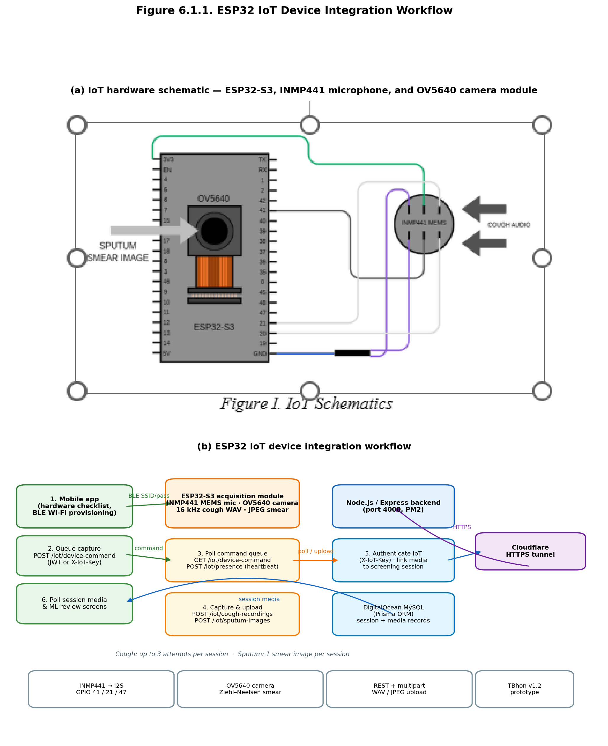
Figure 6.1.1. ESP32 IoT Device Integration Workflow

6.1.2 Second Objective — Data Curation and Preprocessing
The second specific objective was to curate and preprocess data by utilizing publicly available tuberculosis datasets and applying signal processing and image feature extraction techniques to ensure model robustness and consistency. The researchers utilized the Kaggle TB cough audio dataset and a YOLO-formatted sputum smear microscopy dataset. Cough audio samples were resampled to 16 kHz, clipped or padded to a fixed duration, and converted into log-Mel spectrogram representations. Additional hand-crafted acoustic features—including MFCC, delta and delta-delta coefficients, mel statistics, RMS, and zero-crossing rate—were extracted for the gradient boosting component. Sputum smear images were annotated with bounding boxes around individual acid-fast bacilli (class 0), counted per image, and converted into binary AFB labels. Image preprocessing included resizing to 224×224 pixels, ImageNet normalization, and data augmentation. The curated datasets were partitioned into training, validation, and test subsets. This objective was achieved.
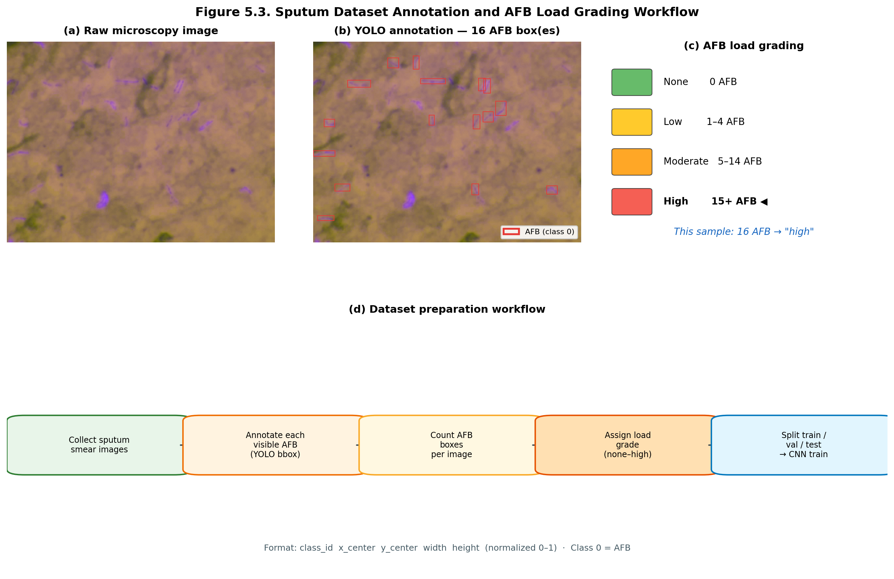
Figure 6.1.2. Sputum Dataset Annotation and AFB Labeling Workflow

6.1.3 Third Objective — Machine Learning Model Development
The third specific objective was to develop and optimize machine learning models using Convolutional Neural Networks (CNNs) to classify TB-related patterns in respiratory audio via Mel-spectrograms and to identify visual indicators in Ziehl–Neelsen stained sputum smears. For cough audio, the researchers implemented a hybrid Mel-spectrogram CNN + Gradient Boosting Machine (GBM) classifier with a weighted probability blend and calibrated decision threshold. The CNN branch was trained for eight (8) epochs on fold 1, after which GBM features were extracted and fused at inference. For sputum analysis, a ResNet18 binary CNN classifier was trained for thirty (30) epochs to distinguish AFB-positive from AFB-negative smear images, with a validation-tuned decision threshold under a minimum sensitivity constraint for AFB-positive detection. Training metrics compilations—including train loss, validation accuracy, validation F1, and class-wise validation F1 for cough, and train loss with validation accuracy and macro F1 for sputum—are presented in Figures 6.1.3.1–6.1.3.2 and discussed in Sections 6.2 and 6.3. Both models were deployed through a FastAPI inference service exposing /check-quality, /predict, and /predict-phlegm endpoints. This objective was achieved, with detailed test-set performance metrics presented in Sections 6.2 and 6.3.
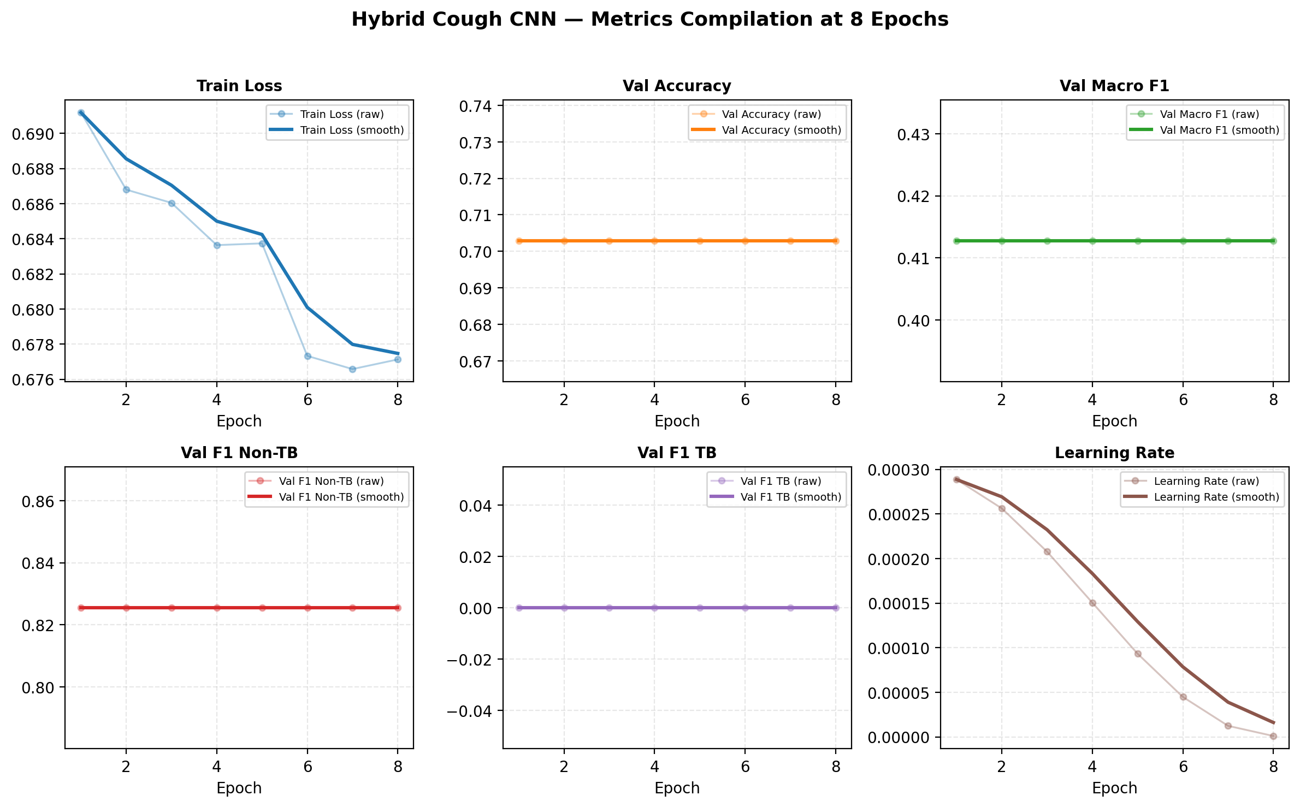
Figure 6.1.3.1. Hybrid Cough CNN Metrics Compilation at 8 Epochs

6.1.3 (continued) Sputum Training Metrics
The sputum AFB binary classifier exhibited decreasing training loss and improving validation macro F1 during the thirty-epoch ResNet18 training run (production run phlegm_afb_binary_20260531_133949). The metrics compilation summarizes validation accuracy and macro F1 across all training epochs.
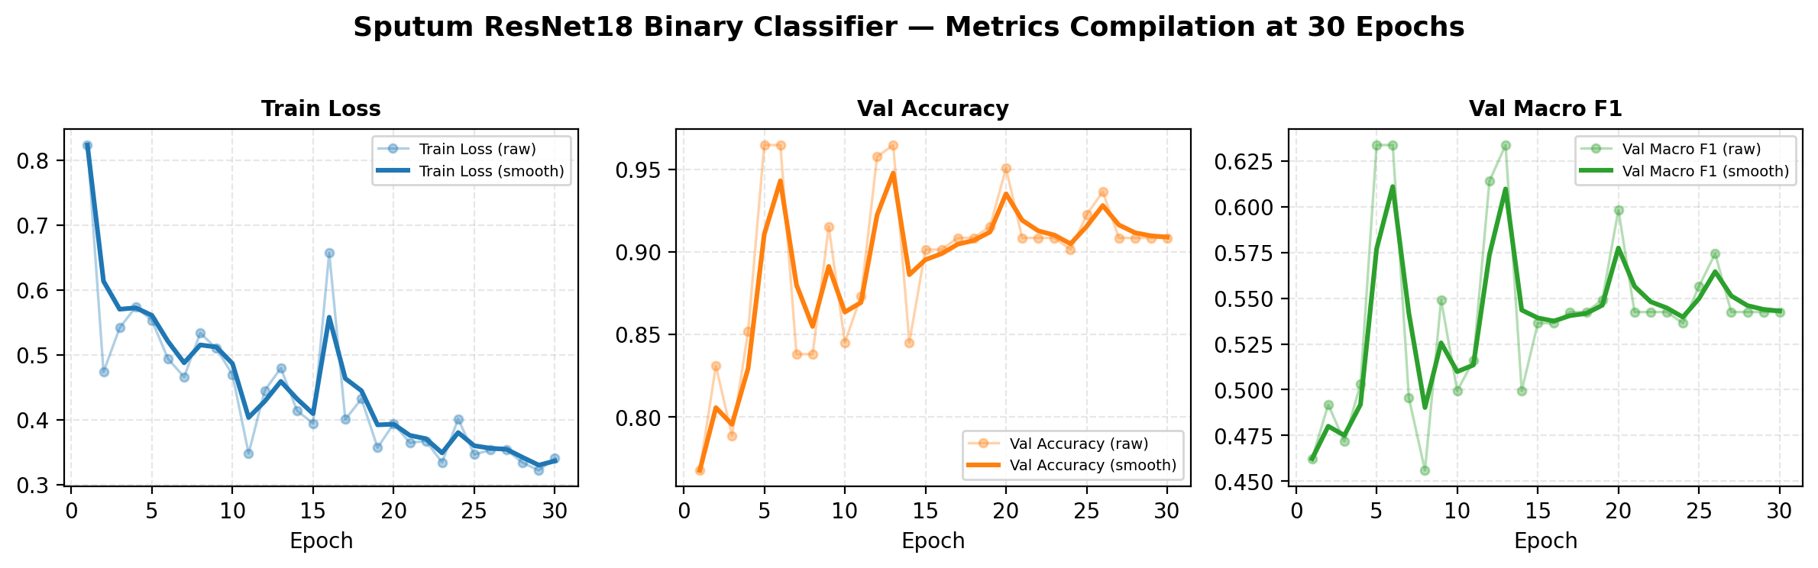
Figure 6.1.3.2. Sputum ResNet18 Binary Classifier Metrics Compilation at 30 Epochs

6.1.3 (continued) Hybrid Architecture and Test Confusion Matrix
The hybrid cough classifier combines CNN Mel-spectrogram embeddings with gradient-boosted acoustic features. Final held-out test performance is summarized alongside the architecture in the figure below.
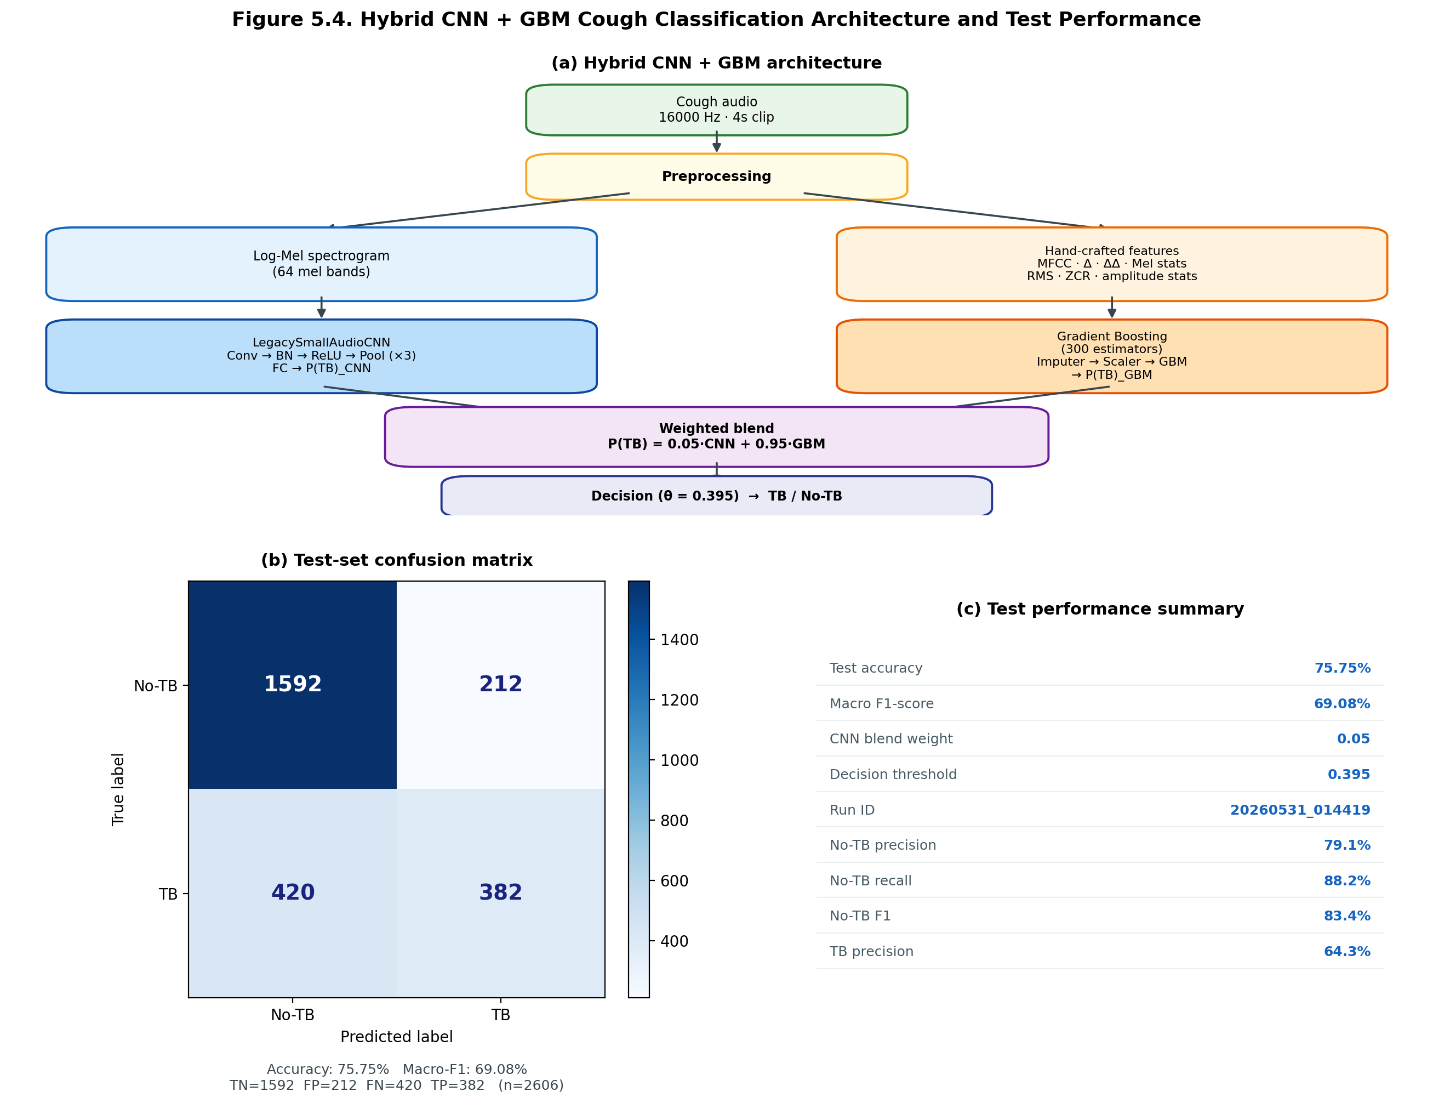
Figure 6.1.3.3. Hybrid CNN + GBM Cough Classification Architecture and Confusion Matrix

6.1.4 Fourth Objective — Multimodal Risk Scoring System
The fourth specific objective was to implement an integrated multi-modal risk scoring system that fuses acoustic and visual classification outputs to generate real-time risk stratification levels. The researchers implemented a multimodal risk fusion module combining an 11-item symptom checklist, mean cough ML tuberculosis probability across quality-validated clips, and sputum ML probability mapped from binary AFB classifier outputs. Fusion is performed through weighted log-odds combination (checklist: 0.85, cough: 1.0, sputum: 0.7), followed by clinical safety floors for high-concern symptoms and confident AFB-positive findings. The fused output produces prob_tb and a triage risk level of Low (< 0.38), Moderate (0.38–0.62), or High (≥ 0.62). This objective was achieved.
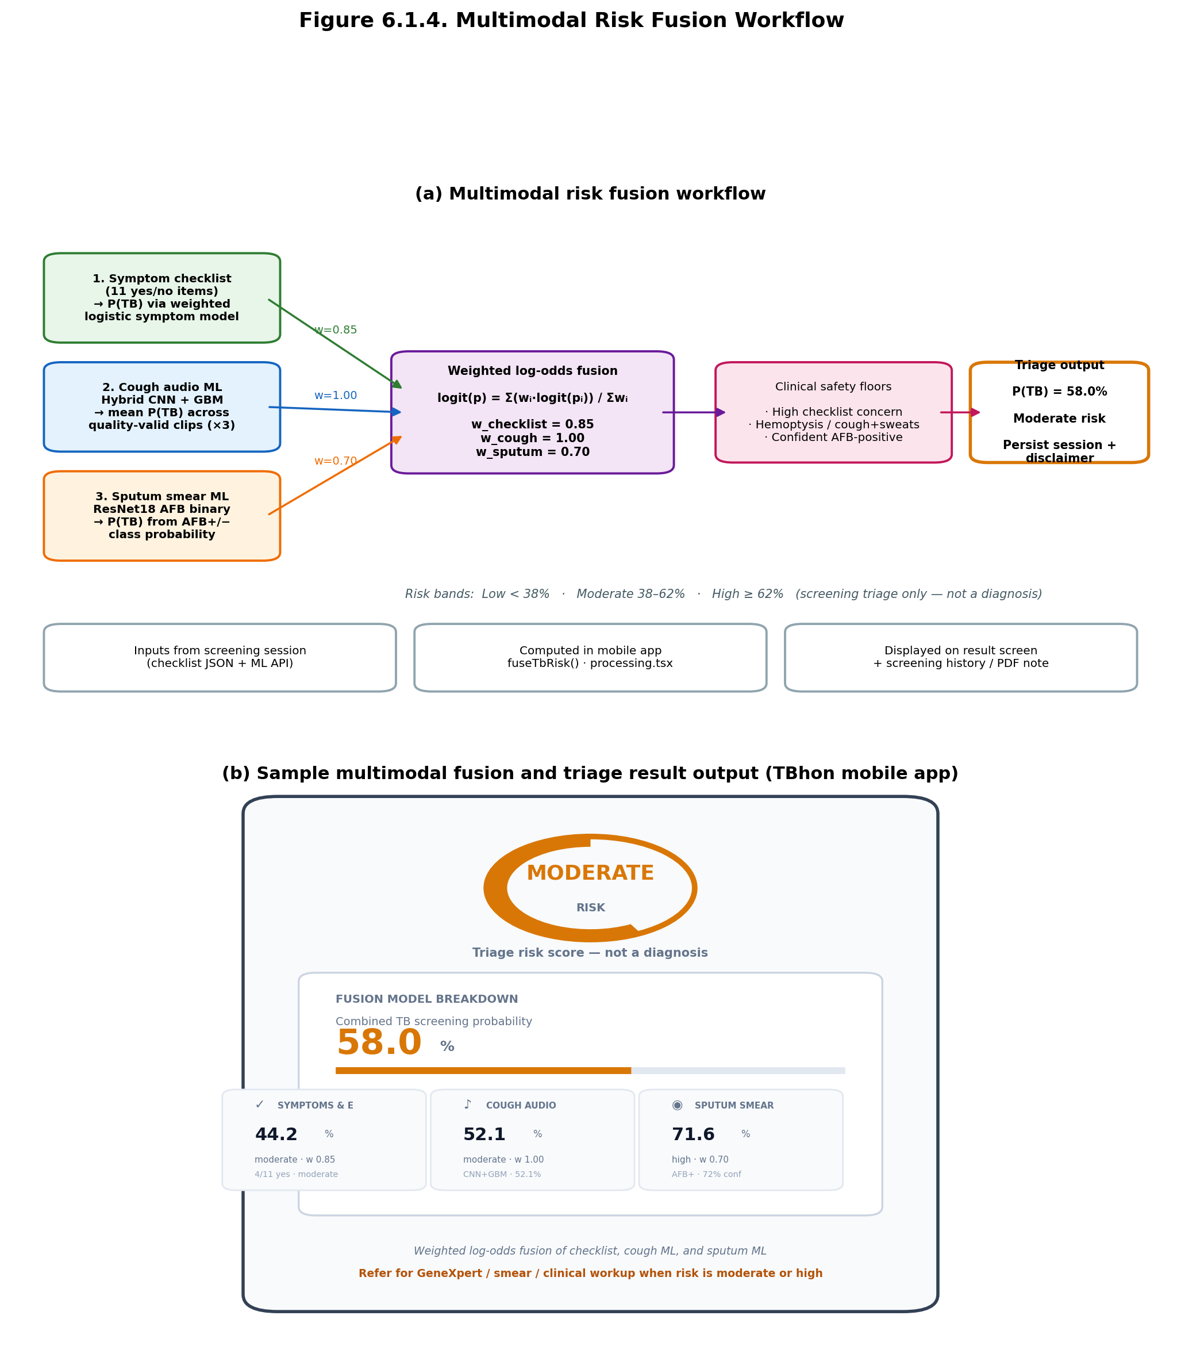
Figure 6.1.4. Multimodal Risk Fusion Workflow

6.1.5 Fifth Objective — Communication Architecture
The fifth specific objective was to establish a robust communication architecture facilitating seamless, real-time wireless data transmission between embedded acquisition modules, edge-processing nodes, and the backend diagnostic server. The researchers deployed two DigitalOcean cloud droplets: a backend droplet hosting Node.js/Express (PM2, port 4000) and an ML droplet hosting Python/FastAPI (systemd, port 8000), both exposed through Cloudflare HTTPS tunnels. The mobile application uses EXPO_PUBLIC_API_URL for auth, sessions, and media persistence, and EXPO_PUBLIC_TB_API_URL for ML inference. IoT devices upload media to the backend through authenticated endpoints. The backend connects to DigitalOcean Managed MySQL through Prisma ORM. This objective was achieved.
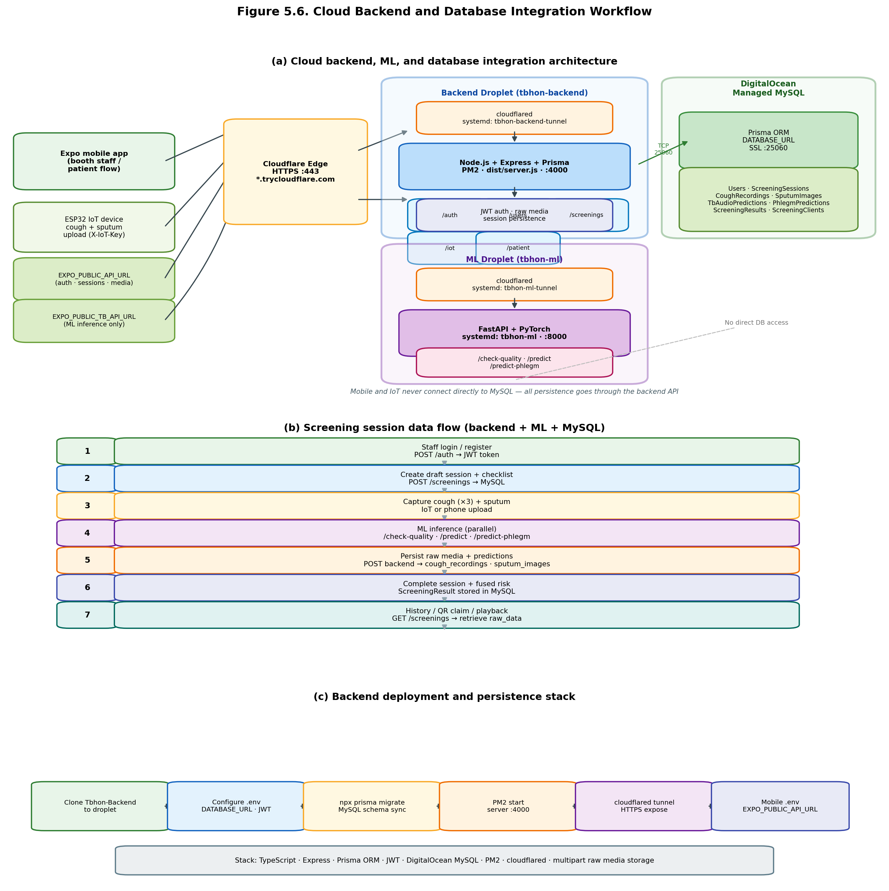
Figure 6.1.5. Cloud Backend and Database Integration Workflow

6.1.6 Sixth Objective — Machine Learning Model Evaluation
The sixth specific objective was to evaluate classification performance using accuracy, precision, recall, F1-score, and classification response time. The hybrid cough classifier achieved 75.75% test accuracy and 69.08% macro F1 on a held-out test fold (n = 2,606). The binary sputum AFB classifier achieved 94.91% test accuracy, 66.32% macro F1, and 96.19% AFB-positive sensitivity on a held-out test partition (n = 216). Classification response time was observed during end-to-end testing. Detailed results are in Sections 6.2–6.4. This objective was achieved.
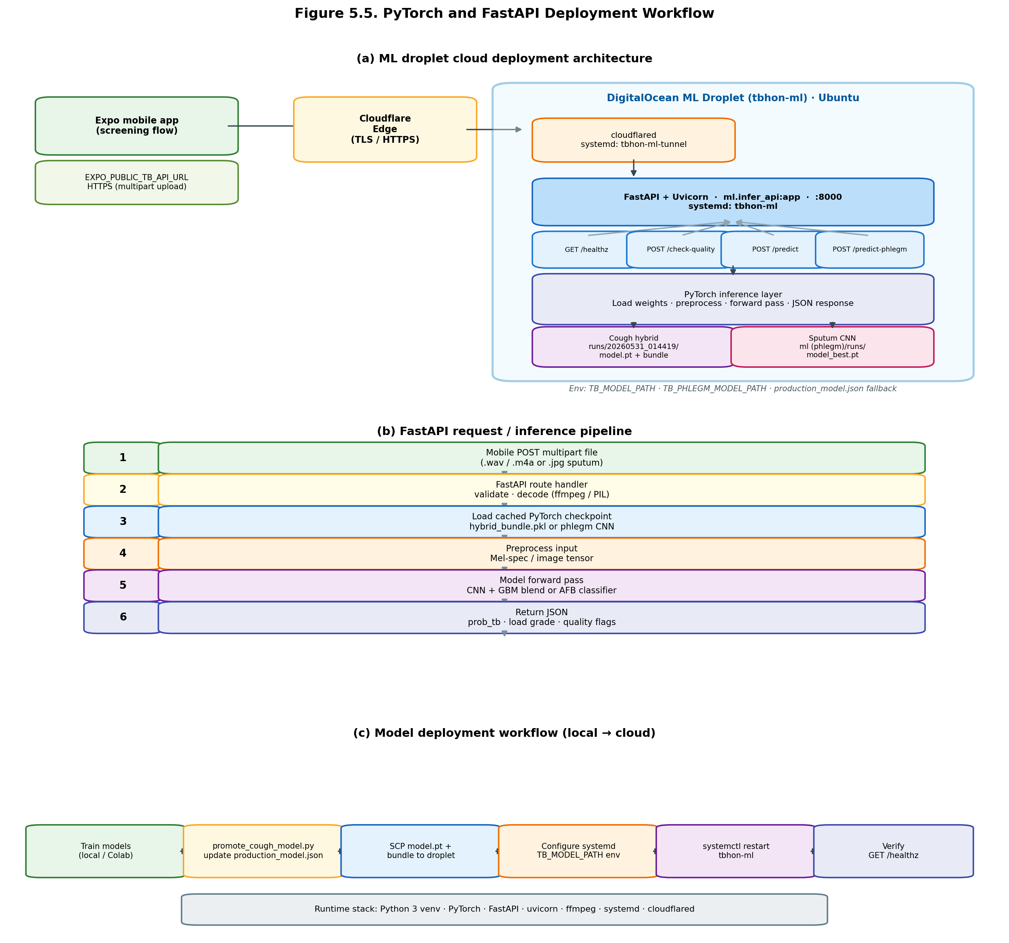
Figure 6.1.6. PyTorch and FastAPI Deployment Workflow

6.1.7 Seventh Objective — ISO/IEC 25010 Software Quality Assessment
The seventh specific objective was to assess software quality compliance based on ISO/IEC 25010, covering Functional Suitability, Performance Efficiency, Usability, Reliability, and Security. The researchers developed a structured UAT instrument with twenty-four criteria mapped to ISO dimensions on a five-point Likert scale. Evaluators completed six predefined screening tasks using TBhon v1.2 before rating. Weighted mean scores per ISO dimension determine compliance levels. Detailed ISO/IEC 25010 evaluation results are presented in Section 6.7, pending the fifth clinical evaluator. This objective was substantially achieved.

6.1.8 Eighth Objective — User Acceptance Testing with Professionals
The eighth specific objective was to conduct User Acceptance Testing (UAT) with professionals to ensure validity and operational reliability. UAT was administered to purposively selected professionals including community health workers, nurses, public health personnel, and IT experts. Four evaluators completed the form: Basio, Peresores, Villiavelez, and Ganas, RN. Each performed staff login, client intake, checklist, cough and sputum capture, ML review, fused result disclosure, and history/disclaimer verification. One medical technologist evaluator is pending. UAT participant outcomes are in Section 6.6; ISO/IEC 25010 quality evaluation is in Section 6.7. This objective was substantially achieved.
Figure 6.1.7. End-to-End TBhon Screening Workflow (insert workflow diagram)

6.2 Cough Audio Model Performance Results
The effectiveness of the hybrid CNN+GBM cough classifier integrated within the proposed TBhon application was evaluated using training-curve analysis on the CNN branch and standard binary classification metrics on a held-out test fold from cross-validation (production run 20260531_014419, fold 1, n = 2,606).

6.2.1 Training Metrics Compilation Results
In this subsection, the training metrics for the hybrid cough CNN branch are presented. The topics discussed include train loss, validation accuracy, validation macro F1, class-wise validation F1 (non-TB and TB), and learning rate across 8 training epochs (Figure 6.2.1). Training loss decreased from 0.6912 to 0.6771, indicating improved fit during CNN training. The GBM branch and weighted fusion produced the final hybrid test metrics reported in Section 6.2.5.

Figure 6.2.1. Hybrid Cough CNN Metrics Compilation at 8 Epochs
Metric | Minimum | Maximum
Train Loss | 0.6766 | 0.6912
Validation Accuracy | 70.29% | 70.29%
Validation Macro F1 | 41.28% | 41.28%
Validation F1 (Non-TB) | 82.55% | 82.55%
Validation F1 (TB) | 0.00% | 0.00%

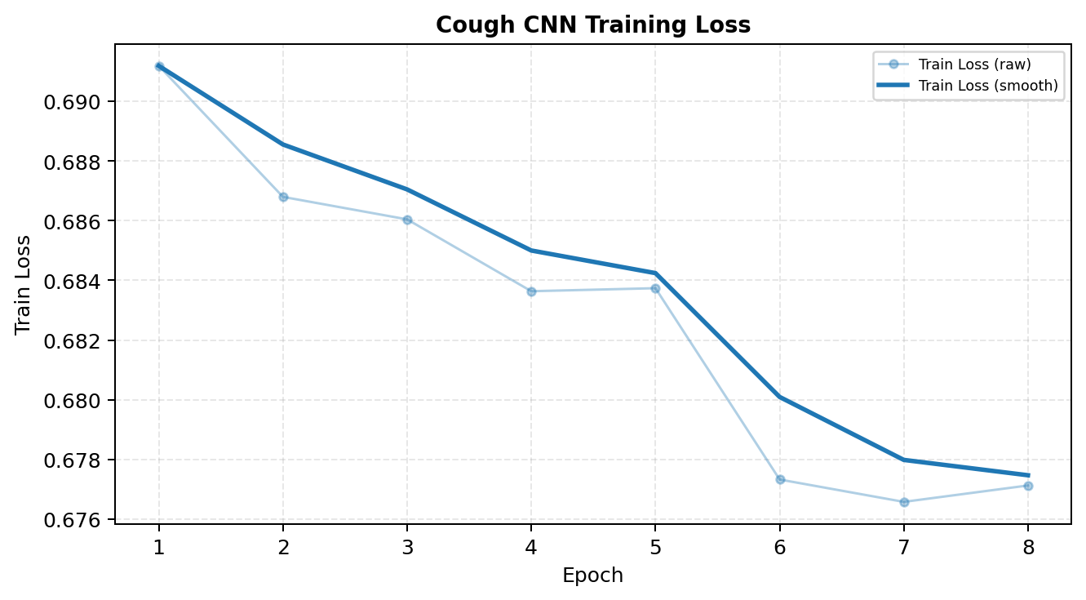
Figure 6.2.2. Cough CNN Training Loss Curve
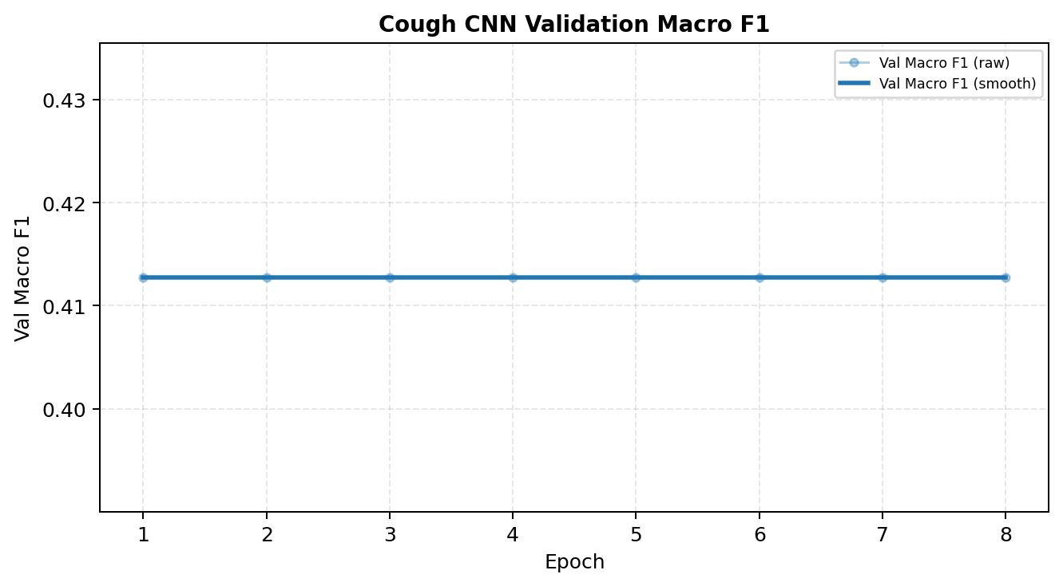
Figure 6.2.3. Cough CNN Validation Macro F1 Curve
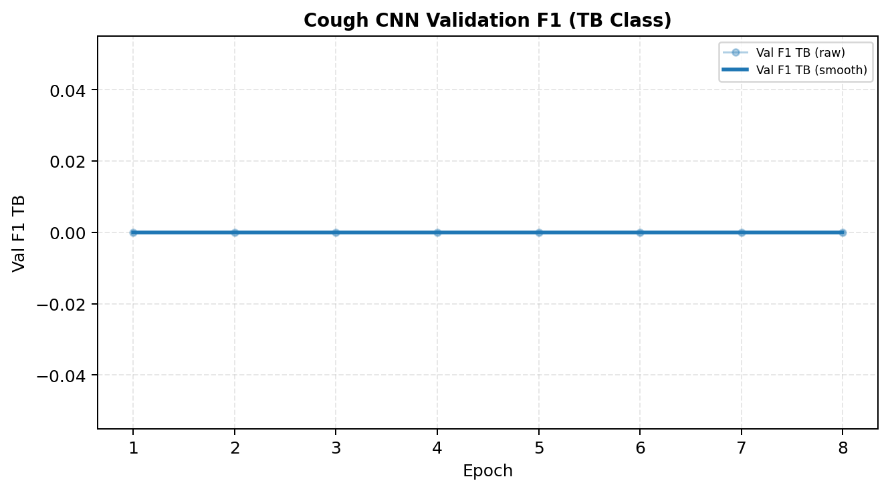
Figure 6.2.4. Cough CNN Validation F1 (TB Class) Curve

6.2.5 Accuracy Results
Accuracy measures the overall proportion of correctly classified cough audio samples. The trained model correctly classified 75.75% of all test samples.
Evaluation Metric | Result
Test Accuracy | 75.75%

6.2.6 Precision Results
Precision measures the proportion of correctly predicted positive samples among all positive predictions. TB-class precision was 64.31% and non-TB precision was 79.13%.
Class | Precision
Non-TB | 79.13%
TB | 64.31%

6.2.7 Recall and F1-Score Results
The hybrid model identified 88.25% of non-TB samples and 47.63% of TB-positive samples. Macro F1-score was 69.08%.
Class | Recall | F1-Score
Non-TB | 88.25% | 83.44%
TB | 47.63% | 54.73%
Macro Average | 67.94% | 69.08%

6.2.8 Confusion Matrix Results
 | Predicted Non-TB | Predicted TB
Actual Non-TB | 1592 (TN) | 212 (FP)
Actual TB | 420 (FN) | 382 (TP)

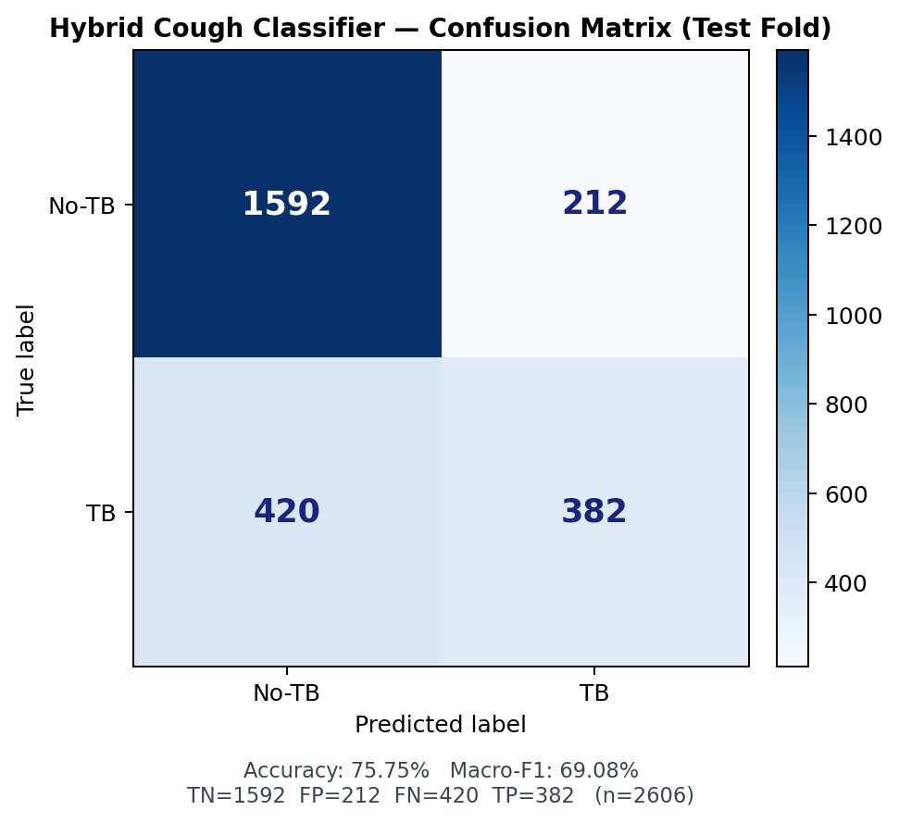
Figure 6.2.5. Cough Model Confusion Matrix
The hybrid cough classifier is intended for screening triage support and not standalone clinical diagnosis.

6.3 Sputum Smear Model Performance Results
The binary AFB sputum classifier (phlegm_afb_binary_20260531_133949) was trained for thirty (30) epochs using a ResNet18 backbone. Training-curve metrics are presented in Section 6.3.1, followed by held-out test partition results (n = 216: 6 AFB-negative, 210 AFB-positive) with a decision threshold tuned under a ≥95% sensitivity constraint for AFB-positive detection.

6.3.1 Training Metrics Compilation Results
Figure 6.3.1 presents the sputum classifier metrics compilation at 30 epochs, including train loss, validation accuracy, and validation macro F1. Training loss decreased while validation macro F1 improved during early epochs, with best validation macro F1 of 63.38% observed during training.

Figure 6.3.1. Sputum ResNet18 Metrics Compilation at 30 Epochs
Metric | Minimum | Maximum
Train Loss | 0.3218 | 0.8234
Validation Accuracy | 76.76% | 96.48%
Validation Macro F1 | 45.59% | 63.38%

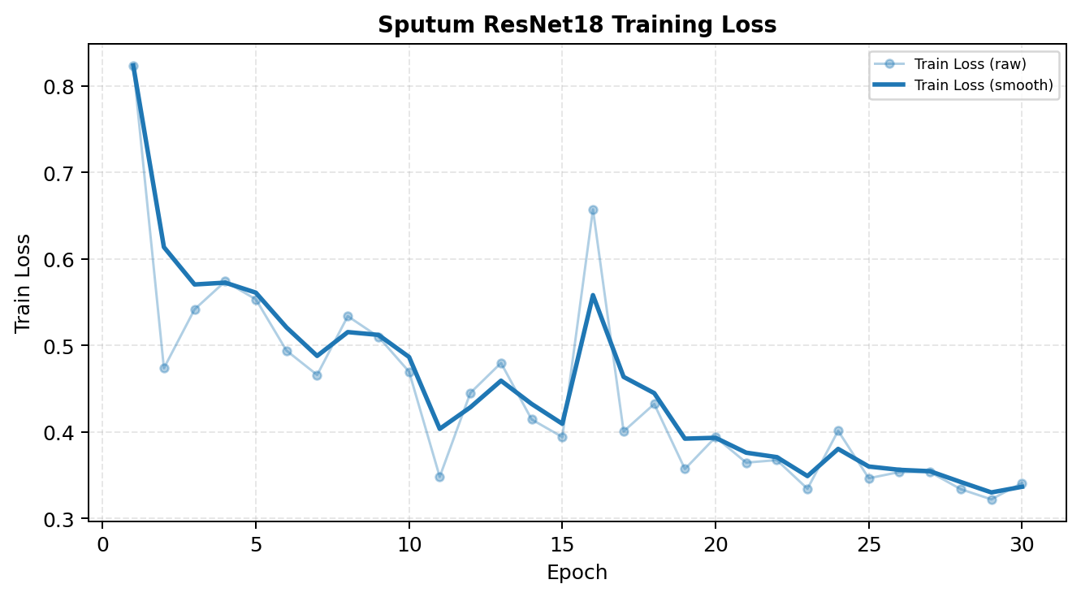
Figure 6.3.2. Sputum ResNet18 Training Loss Curve
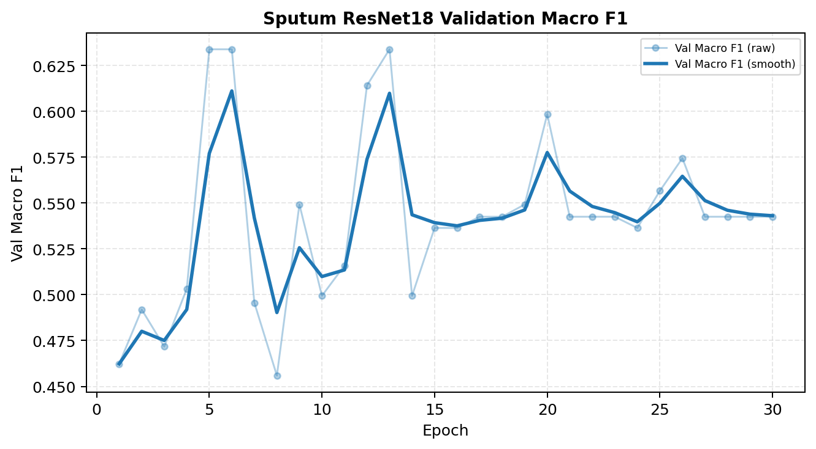
Figure 6.3.3. Sputum ResNet18 Validation Macro F1 Curve

6.3.4 Accuracy and Macro F1 Results
Evaluation Metric | Result
Test Accuracy | 94.91%
Macro F1-Score | 66.32%
AFB+ Sensitivity | 96.19%
AFB− Specificity | 50.00%
Decision Threshold | 0.63

6.3.5 Per-Class Performance
Class | Precision | Recall | F1-Score | Support
AFB-negative | 27.27% | 50.00% | 35.29% | 6
AFB-positive | 98.54% | 96.19% | 97.11% | 210

6.3.6 Confusion Matrix Results
 | Predicted AFB− | Predicted AFB+
Actual AFB− | 3 (TN) | 3 (FP)
Actual AFB+ | 8 (FN) | 202 (TP)

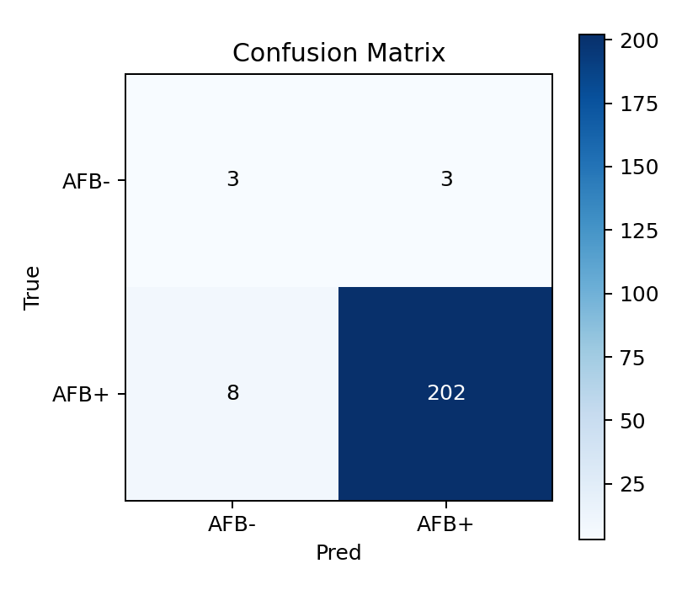
Figure 6.3.4. Sputum AFB Binary Classifier Confusion Matrix
Strong AFB-positive sensitivity supports preliminary triage; specificity estimates remain limited by the small AFB-negative test set (n = 6).

6.4 Classification Response Time Results
Classification response time was evaluated against the UAT criterion of five (5) seconds per inference call.
ML Endpoint | Target | Observed Result
POST /check-quality | ≤ 5 seconds | __________
POST /predict (cough) | ≤ 5 seconds | __________
POST /predict-phlegm (sputum) | ≤ 5 seconds | __________

Insert measured response times from device testing before final submission.

6.5 Multimodal Risk Fusion and Application Output Results
The risk fusion module combined checklist probability, mean cough ML probability, and sputum ML probability through weighted log-odds integration with clinical safety floors. The system generated Low, Moderate, or High triage outputs with disclaimers, referral-oriented guidance, and persisted session records retrievable through screening history. Figure 6.5.1 illustrates the fusion logic (checklist + cough + sputum → fused risk); Figure 6.5.2 shows the corresponding triage result output in the mobile application.
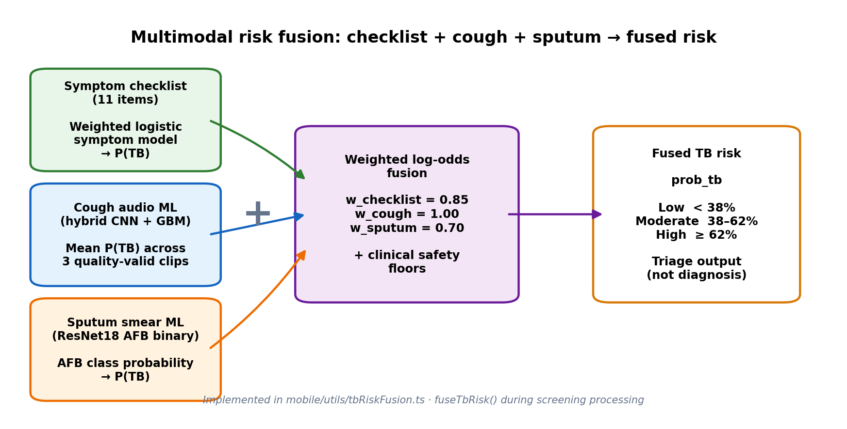
Figure 6.5.1. Multimodal Fusion Diagram (Checklist + Cough + Sputum → Fused Risk)
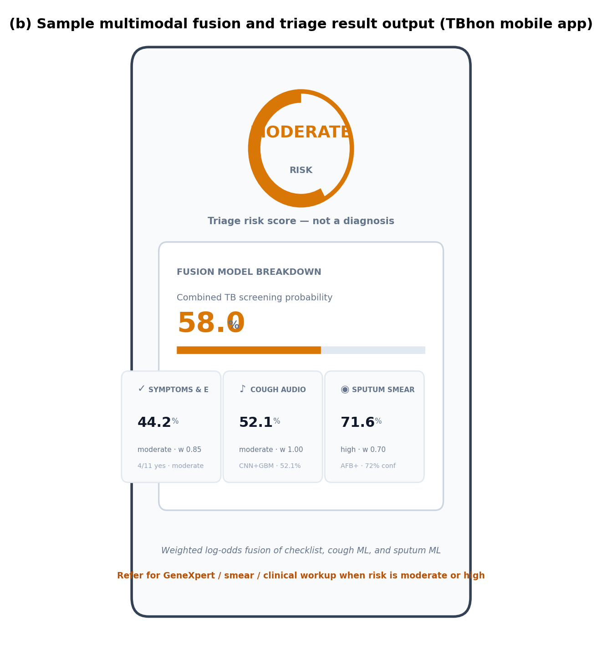
Figure 6.5.2. Sample Multimodal Fusion and Triage Result Output

6.6 User Acceptance Testing Results
The proposed TBhon mobile application underwent user acceptance testing procedures involving community health workers, nurses, public health personnel, medical technologists, and IT experts. TBhon v1.2 (Prototype / Field Evaluation Build) was evaluated in terms of usability, accessibility, responsiveness, functionality, and deployment practicality within TB pre-screening booth environments. Four evaluators completed the structured instrument (Appendix H): Basio, Peresores, Villiavelez, and Ganas, RN. One medical technologist evaluator is pending. Each respondent performed six predefined screening tasks—staff login, client intake, symptom checklist, cough capture, sputum capture, ML review, fused result disclosure, and history/disclaimer verification—before completing the rating form.
Evaluation Area | Weighted Mean (n=4) | Interpretation
Ease of Use | __________ | __________
Accessibility | __________ | __________
Responsiveness | __________ | __________
User Satisfaction | __________ | __________

Overall Rating | Frequency | Percentage
Excellent | ____ | ____%
Good | ____ | ____%
Fair | ____ | ____%
Poor | ____ | ____%
Very Poor | ____ | ____%

Figure 6.6.1. User Acceptance Testing Summary Graph (insert after scoring)

6.7 ISO Software Quality Evaluation
The proposed TBhon mobile application was evaluated using ISO/IEC 25010 software quality standards to assess the acceptability and software quality characteristics of the implemented system. The evaluation involved purposively selected professionals who assessed the application using a structured twenty-four-item questionnaire mapped to ISO quality characteristics: Functional Suitability, Performance Efficiency, Usability, Reliability, and Security. Weighted mean scores per characteristic determine compliance levels using a five-point Likert scale.
Scale | Value Range | Interpretation
5 | 4.50 – 5.00 | Strongly Agree (SA)
4 | 3.50 – 4.49 | Agree (A)
3 | 2.50 – 3.49 | Neutral (N)
2 | 1.50 – 2.49 | Disagree (D)
1 | 1.00 – 1.49 | Strongly Disagree (SD)

Table 6.7.2 presents the ISO/IEC 25010 acceptability results derived from the UAT instrument (Appendix H). Interpretations follow the Likert scale above. Scores are pending transcription from four completed evaluator forms and the fifth medical technologist submission.
System Acceptability Criteria | Weighted Mean (n=4) | Interpretation
Functional Suitability (Items 1–7) | __________ | __________
Performance Efficiency (Items 8–11) | __________ | __________
Usability (Items 12–16) | __________ | __________
Reliability (Items 17–20) | __________ | __________
Security (Items 21–23) | __________ | __________
Overall Satisfaction (Item 24) | __________ | __________
Grand Mean (Items 1–24) | __________ | __________

Figure 6.7.1. ISO/IEC 25010 Software Quality Evaluation Summary Graph (insert after scoring)

6.8 Program Testing Specifications
Specification | Device #1 Value
Model | __________________
Operating System | __________________
Chipset / Processor | __________________
Memory | __________________
Rear Camera | __________________
Front Camera / Microphone | __________________

Specification | Device #2 Value
Model | __________________
Operating System | __________________
Chipset / Processor | __________________
Memory | __________________
Rear Camera | __________________
Front Camera / Microphone | __________________

6.9 Test Cases
Functional and inference test cases were executed on TBhon v1.2 using two mobile test devices (Device #1 and Device #2; specifications in Section 6.8) during field evaluation and UAT. Table 6.9.1 summarizes end-to-end screening workflow cases aligned with the six UAT tasks. Tables 6.9.2 and 6.9.3 summarize cough audio and sputum smear ML inference cases run through the production FastAPI endpoints (/check-quality, /predict, /predict-phlegm). Because ML inference is cloud-hosted, identical media inputs produced consistent API outputs on both devices; differences across devices were observed mainly in capture quality, upload time, and UI responsiveness.
Table 6.9.1. End-to-End Screening Workflow Test Cases
Test Case | Input / Condition | Expected Result | Device 1 | Device 2
TC-01 | Staff login and new walk-in screening session | Authenticated session created | Pass | Pass
TC-02 | Client intake + 11-item symptom checklist | Checklist stored; concern level computed | Pass | Pass
TC-03 | Record or upload 3 cough clips (mobile mic or IoT) | Cough ML probabilities returned for quality-valid clips | Pass | Pass
TC-04 | Capture or upload sputum smear image | AFB binary classification stored on session | Pass | Pass
TC-05 | Review ML outputs and fused triage risk (Low / Moderate / High) | Fused prob_tb, risk level, disclaimer, and referral text shown | Pass | Pass
TC-06 | Screening history retrieval and patient QR result claim | Past session detail and playback accessible | Pass | Pass

Table 6.9.2. Cough Audio ML Inference Test Case Summary. Synthetic and validation cough WAV files were submitted to the hybrid CNN+GBM classifier with quality gating.
Case | Input File | Size | Expected Result | Device 1 | Device 2
1 | cough_early_burst.wav | 218 KB | Valid cough — TB probability returned | quality=ok; prob_tb=48.6% | quality=ok; prob_tb=48.6%
2 | steady_noise.wav | 187 KB | Quality fail — excluded from fusion | Rejected (noise); excluded from fusion | Rejected (noise); excluded from fusion
3 | quiet.wav | 125 KB | Quality fail — excluded from fusion | Rejected (silence); excluded from fusion | Rejected (silence); excluded from fusion
4 | speech.wav | 187 KB | Quality fail — excluded from fusion | Rejected (replay); excluded from fusion | Rejected (replay); excluded from fusion

Table 6.9.3. Sputum Smear ML Inference Test Case Summary. Held-out test-set smear images were submitted to the ResNet18 AFB binary classifier.
Case | Input Image | Resolution | Size | Expected | Device 1 | Device 2
1 | sputum_test_0001.jpg | 1632 × 1224 | 217 KB | AFB-positive | afb_positive, 98.1% confidence | afb_positive, 98.1% confidence
2 | sputum_test_0006.jpg | 1632 × 1224 | 228 KB | AFB-positive | afb_positive, 79.5% confidence | afb_positive, 79.5% confidence
3 | sputum_test_0033.jpg | 1632 × 1224 | 271 KB | AFB-negative | afb_negative, 50.2% confidence | afb_negative, 50.2% confidence
4 | sputum_test_0100.jpg | 1632 × 1224 | 194 KB | AFB-positive | afb_positive, 76.9% confidence | afb_positive, 76.9% confidence

Table 6.9.2 and Table 6.9.3 show that cough quality gating correctly rejected noise, silence, and replay-like inputs while returning TB probabilities for valid cough bursts. Sputum inference returned AFB-positive and AFB-negative classifications with confidence scores consistent with the binary production model. These results support the practical applicability of the deployed ML API within the TBhon screening workflow.

6.10 Summary of Findings
Based on testing, validation, and evaluation, TBhon demonstrated multimodal TB pre-screening capability with cloud-assisted session management. The hybrid cough classifier achieved 75.75% test accuracy and 69.08% macro F1. The binary sputum classifier achieved 94.91% test accuracy and 96.19% AFB-positive sensitivity. Weighted multimodal fusion, DigitalOcean deployment with Cloudflare tunnels, and cross-platform mobile deployment strengthened practical applicability. Preliminary UAT (n = 4) and ISO/IEC 25010 evaluation (Section 6.7) indicated positive acceptability pending the fifth evaluator and final weighted mean computation. TBhon operated as pre-screening and triage support only—not medical diagnosis.

