5. AI/ML Validation Metrics
This section summarizes held-out test performance of the TBhon machine learning classifiers. Metrics were computed on data excluded from training and validation tuning. Macro-averaged precision, recall, and F1 treat both classes equally.
Model Performance Metrics — Hybrid Cough Classifier
Metric | Result
Accuracy | 75.7%
Precision | 71.7%
Recall | 67.9%
F1 Score | 69.1%

These metrics indicate that the hybrid cough classifier demonstrates measurable tuberculosis-related discrimination on the held-out audio test partition (n = 2,606). Performance may degrade under low signal-to-noise conditions, conversational interference, and non-cough audio submissions; pre-inference quality filtering and domain augmentations were applied to mitigate these effects.
Confusion Matrix — Hybrid Cough Classifier
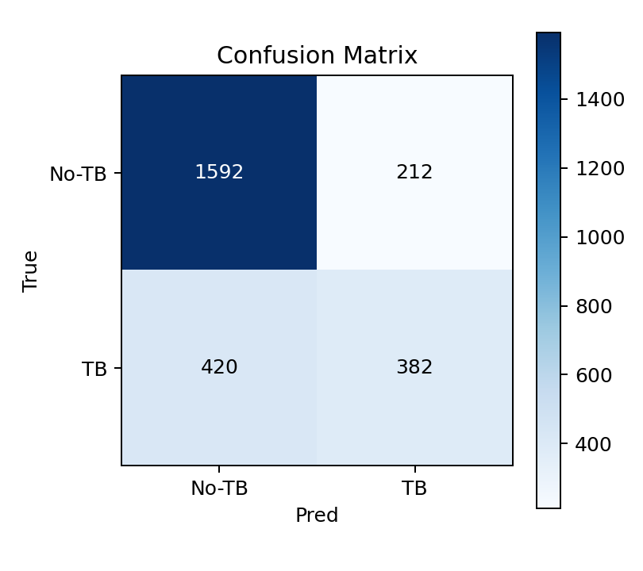
Figure 1. Confusion matrix for the hybrid cough classifier on the held-out test set.
Model Performance Metrics — Sputum AFB Binary Classifier
Metric | Result
Accuracy | 94.9%
Precision | 63.0%
Recall | 73.0%
F1 Score | 66.3%
Sensitivity (AFB+) | 96.2%
Specificity (AFB-) | 50.0%
Decision threshold | 0.63

The sputum classifier uses a stratified held-out test partition with roughly six AFB-negative and two hundred ten AFB-positive examples after in-memory class-balanced splitting. The positive-class decision threshold was tuned on validation under a ≥95% AFB+ sensitivity constraint (policy: max_specificity_min_sensitivity), prioritizing specificity among feasible thresholds rather than macro-F1 alone. Macro-F1 and the confusion matrix below should be interpreted alongside sensitivity and specificity; specificity remains a noisy estimate until more field-collected negative smears are available.
Confusion Matrix — Sputum AFB Binary Classifier
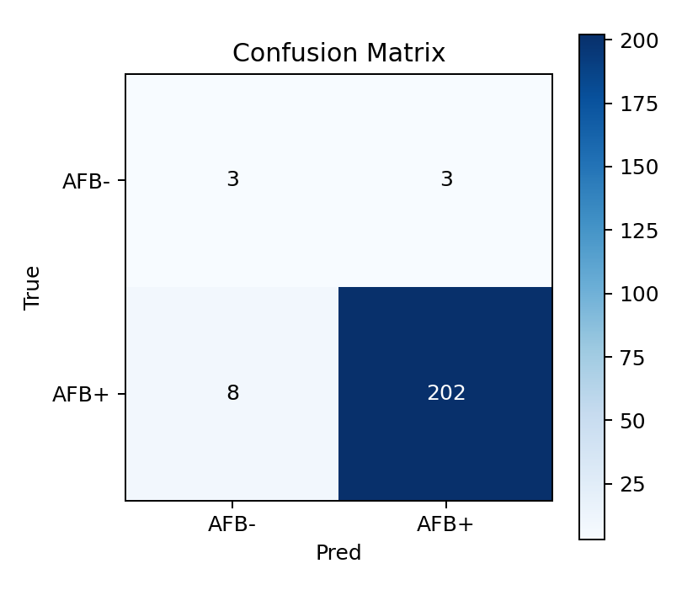
Figure 2. Confusion matrix for the sputum AFB binary classifier on the held-out test set.

