TBhon: An IoT-Enabled Mobile-Based Multimodal Diagnostic Support System Using Respiratory Audio and Sputum Image Analysis for Tuberculosis Pre-screening

Micaela Ysabel B. Ganas
College of Computer and Information Science
Mapua Malayan Colleges Mindanao
Davao City, Philippines
myGanas@mcm.edu.ph
Alyssa Nicole Argoncillo
College of Computer and Information Science
Mapua Malayan Colleges Mindanao
Davao City, Philippines
anArgoncillo@mcm.edu.ph
Jeric B. Mata
College of Computer and Information Science
Mapua Malayan Colleges Mindanao
Davao City, Philippines
jMata@mcm.edu.ph

Abstract—[]
Keywords— Tuberculosis, CNN, Edge Computing, Cough Audio, Sputum Smears

Introduction

1.1 Background of the Study
Tuberculosis (TB) is one of the most serious public health issues, particularly in the modern world, for many people in low- and middle-income countries lack access to formal diagnostic services regularly. The bacteria Mycobacterium tuberculosis continues to cause a large number of morbidities and mortalities all over the world. The Philippines is also always listed among the countries with the greatest TB burden. Delays in detection contribute to continued transmission, worsen clinical outcomes, and increase mortality rates; however, conventional confirmatory techniques - chest radiography, sputum smear microscopy, and molecular testing (e.g., GeneXpert), all of which rely on having sufficient laboratory facilities, appropriately trained personnel, and operational funding - cannot be uniformly relied upon by those living in remote/rural or under-resourced areas.
1.1 Background of the Study
Although active TB public health programs continue to be implemented, there remains a number of gaps in the early detection of TB in resource-limited settings:
- Persistent delays in identifying presumptive TB cases due to accessibility barriers and limitations in existing screening practices.
- Healthcare worker workload and resource constraints that reduce the efficiency of preliminary TB screening activities.
- Insufficient screening support mechanisms capable of identifying potentially overlooked TB cases prior to confirmatory diagnosis.
- Limited availability of integrated, low-cost, AI-assisted platforms for multimodal TB pre-screening and risk assessment.
Therefore, this study aims to develop a multimodal support system for TB pre-screening using a designated IoT device which is able to perform preliminary risk assessment and decision-support recommendations, using audio classification of cough signals and microscopic image classification of sputum smears, with the help of a low-cost hardware rig and a smartphone application. Specifically, the study seeks to answer the following questions.
1.3 Objectives of the Study
The primary objective of this study is to develop TBhon, an IoT-enabled, mobile-based diagnostic support system for tuberculosis pre-screening that utilizes machine learning and deep learning to analyze respiratory audio and microscopic sputum images, providing a multi-modal assessment of tuberculosis risk. This will be judged on the following:
- Develop the IoT acquisition hardware, including the design of an ESP32-based module for respiratory audio capture and an integrated ESP32-OV5640 microscopic imaging module for sputum smear capture.
- Curate and preprocess data, utilizing publicly available tuberculosis datasets, and apply signal processing and image feature extraction techniques to ensure model robustness and consistency.
- Develop and optimize machine learning models using Convolutional Neural Networks (CNNs) to classify TB-related patterns in respiratory audio via Mel-spectrograms and identify visual indicators in Ziehl–Neelsen stained sputum smears.
- Implement an integrated multi-modal risk scoring system that fuses acoustic and visual classification outputs to generate real-time risk stratification levels based on multimodal classification confidence and fusion outputs.
- Establish a robust communication architecture that facilitates seamless, real-time wireless data transmission between the embedded acquisition modules, edge-processing nodes, and the backend diagnostic server.
- Evaluate the classification performance of the machine learning models using standard metrics:
  - Accuracy;
  - Precision;
  - Recall;
  - F1-Score; and
  - Classification Response Time.
- Assess software quality compliance based on the ISO/IEC 25010 standard (Functional Suitability, Performance Efficiency, Usability, Reliability, and Security); and
- Conduct User Acceptance Testing (UAAT) with professionals to ensure validity and operational reliability.
1.4 Significance of the Study
The study helps the following stakeholders:
- At risk populations and individuals. TBhon can be utilized as an early warning device for potential TB risk, prompting early consultation which helps minimize the transmission of TB in the household and community.
- Community health workers and primary health care units. The system can be used as a triage tool to determine those people who require confirmatory test, particularly when laboratory access is limited.
- Healthcare system and public health programmes. The system may help to lower the cost of TB pre-screening and potentially expand the use of screening in regions which complement national TB elimination programmes, like the Philippine Strategic TB Elimination Plan.
- Researchers and developers. The study forms part of a suite of working reference designs for multimodal (audio + image) ML pipelines that can be used on low-cost embedded devices, including those that capture images using microscopy, which will inform ongoing and future work in mobile health and AI-aided screening.
- Academic institutions and students. In the study, a combination of embedded systems, computer vision, sound machine learning and mobile application development are combined in a healthcare context, making this an excellent practical guide.
1.5 Scope and Limitation
The study was targeted at the development of an IoT-based multimodal tuberculosis (TB) pre-screening diagnostic support system, TBhon, that classifies the risk of TB in its initial stages with audio inputs from respiratory cough images from a microscopic smear of sputum. It features embedded sensing, wireless communication, edge computing, and machine learning, enabling TB risk assessment in a portable, non-invasive way in community settings.
The architecture of the system incorporates an ESP32 microcontroller, which is used to read the audio of the cough and an I2S MEMS microphone. An OV5640 camera module is mounted on a compound microscope to capture the images of the sputum smear. Data collected are sent to a FastAPI server via Wi-Fi where they are processed by Convolutional Neural Network (CNN) models deployed on a Raspberry Pi 4 edge-computing platform. A multimodal TB risk classification, Low Risk, Moderate Risk or High Risk, is determined by a probability mechanism with fusion.
This study is centered on the two modalities, respiratory cough audio modality, and the sputum smear microscopy images. The imaging of X-ray, molecular testing using GeneXpert, and the integration of laboratory culture analysis and hospital information systems is not covered. The system also is limited in its ability to make preliminary diagnosis, suggest treatment options and monitor patients, and cannot carry out clinical diagnosis, treatment recommendation, and patient monitoring.
In the study, the model training and evaluation were done with public cough audio and sputum smear image database. Variability of the datasets, class imbalance, and variability in the environment of the audio acquisition, inconsistencies of image quality and light in the microscopy limit the performance of the system. Moreover, the computational power of the ESP32 and Raspberry Pi hardware platforms in the prototype implementation limit the system performance and scalability.
Moreover, due to the constraints of prototype development for such IoT systems, budget and time constraints, the experimental prototype of the study was built with the use of readily available embedded components as well as publicly available datasets and was of a small size. Thus, no large-scale clinical validation, no deployment in the field, and no long-term real-world testing in different healthcare settings were done. This may affect the overall and diverse use of the system.
Despite the various limitations discussed, the study provides a general framework leveraging embedded sensing, edge computing and machine learning in a single portable architecture to pre-screen TB.
1.6 Algorithm Concepts
The proposed TBhon system is developed by implementing a multimodal machine learning approach with three main algorithmic components: cough audio classification, sputum smear image classification, and multimodal risk fusion. These algorithms are used to produce a preliminary tuberculosis risk level (Low, Moderate, or High Risk).
The first algorithm is a cough audio classification algorithm. The system is designed to monitor cough audio by connecting the ESP32 microcontroller with an I2S MEMS microphone. The acoustic cough signal is preprocessed by noise reduction, trimming, and standardization. This sound is then transformed into a Mel spectrogram—showing how the frequency of coughs change with time. This spectrogram serves as the input for a Convolutional Neural Network (CNN) model that classifies the cough pattern and gives the audio-based tuberculosis probability (Paudio).
The second algorithm is the classification algorithm of the sputum smear image. The microscopic images of the sputum smear are acquired by the system that comprises an OV2640 camera module attached to a compound microscope. The captured image is pre-processed by resizing, normalizing, and image enhancing. A CNN model is then used to extract visual features from the image of the sputum smear and classify the image according to the indicators of AFB or abnormal smear patterns.
The result of this model is an image-based probability of tuberculosis which is referred to as Pimage. The multimodal fusion algorithm is the third algorithm. The probability is obtained by summing the probabilities of the audio model and the image model weighted by a soft combination function: TB_risk = (w1 × Paudio) + (w2 × Pimage) In this equation, w1 is the weight of the cough audio model and w2 is the weight of the sputum smear image model.
TB_risk = (w1 × Paudio) + (w2 × Pimage)
In this equation, w1 is the weight of the cough audio model, and w2 is the weight of the sputum smear image model. This study provides an evaluation, and the audio model of the cough could be slightly more important since it had better performance in testing. Lastly, the algorithm to classify the decision processes the computed TB_risk score to a final risk category. A score of less than 0.33 is considered a Low-Risk score. If the score is in the range of 0.33 to less than 0.66, then the result is considered a Moderate Risk. A score of 0.66 or above is considered to be High Risk.
If TB_risk < 0.33 → Low Risk
If 0.33 ≤ TB_risk < 0.66 → Moderate Risk
If TB_risk ≥ 0.66 → High Risk
In brief, the algorithm idea behind TBhon is a fusion of two classifiers, namely, a cough audio classifier, and a sputum smear image classifier, based on CNN. The outputs of these are combined into one probability score that is then mapped to a preliminary TB risk level to be displayed in the mobile application.

RELATED WORKS
In healthcare, the adoption of the Internet of Things (IoT) has paved the way for the creation of IoT-based intelligent respiratory monitoring and tuberculosis (TB) screening systems that can gather data in real-time, remotely monitor patients, and analyze data automatically. Typical IoT healthcare ecosystems include a variety of interconnected sensors and embedded microcontrollers, wireless communication modules, cloud or edge processing systems, and intelligent analytics frameworks, all working together to enable healthcare decision-making and patient monitoring.
Naufal et al. created an artificial intelligence based portable prototype for early diagnosis of tuberculosis by breath analysis which integrates with the internet of things (IoT) technologies [1]. The approach relied on an ESP32-S3 microcontroller paired with a metal oxide semiconductor (MOS) gas-sensor array to detect chemical signatures in the breath related to TB infection. Feature reduction was done using Principal Component Analysis (PCA) and classification was performed using machine learning algorithms including Support Vector Machine (SVM), Random Forest, Gradient Boosting and Artificial Neural Network (ANN). The study showed that embedding sensing technologies, wireless communication, and AI-driven analysis in a portable screening platform for TB is possible.
Likewise, Sharma et al. suggested an IoT solution that monitors patients and detects adverse drug reactions to enhance treatment adherence by TB patients [2]. They used a microcontroller called NodeMCU (ESP8266) which is a wireless module, and they built their own system to constantly track patient conditions with temperature, pulse, cough, and laboratory-value sensors. The system facilitated remote monitoring of healthcare parameters and automated symptom tracking through rule-based evaluation and integration with the IoT server. The study highlighted the importance of IoT ecosystems in the provision of healthcare services beyond traditional healthcare settings, with the ability to monitor and communicate with a patient's physiology on an ongoing basis.
In the context of healthcare IoT systems, the sensing layer is one of the most critical components in respiratory disease monitoring systems, where physiological signals need to be continually captured and processed. Embedded microcontrollers and hand-held sensors are now being increasingly used to monitor respiratory behavior, airflow patterns, and pulmonary function, according to recent studies.
Lavanya designed a respiratory monitoring system with the help of microcontroller, Arduino UNO, and a sensor which was based on thermistor which was used to monitor the patient's breathing for a continuous period [5]. The system worked by measuring the periodic temperature variations produced during the inhalation and exhalation cycles to determine the respiratory rates and using threshold-based algorithms to identify abnormal respiratory activity. The study showed that the lightweight embedded system could successfully be used to monitor the respiration in the real-time environment of portable healthcare apparatus.
Likewise, Simić et al. developed a portable respiration monitoring system based on capacitive facemask sensor which were embroidered and attached to a portable system based on microcontroller [7]. The system was based around signal processing techniques to analyse the changes in airflow and chest motion to estimate breathing patterns and respiratory rates. The non-invasive and wearable nature of the device showcased the growing need for portable respiratory sensing technologies in healthcare applications.
Azzahra et al. later designed an Arduino Mega-based portable peak expiratory flow rate measurement system that incorporates an MPX5100GP pressure sensor [8]. The system was deployed to convert pressure measurements to PFM to evaluate lung health and pulmonary function in respiratory diseases. The results obtained from their work demonstrated the potential of embedded sensors and microcontroller platforms in respiratory monitoring and evaluation.
The analytical capabilities of IoT health systems have been greatly enhanced with recent developments in edge computing and AI. By moving AI-powered decisions and analytics to the edge, Edge Computing reduces reliance on centralized cloud platforms, improves portability, rapid response time, and real-time monitoring.
Rivas-Navarrete et al. [9] have proposed an edge computing system for automatic detection of chronic respiratory diseases, based on audio analysis. The system was based on the use of smartphones and raspberry pi devices, and the processing of the audio signals from the breathing was done locally. Respiratory sounds were analysed using Machine Learning techniques, such as Mel Frequency Cepstral Coefficients (MFCC) and chromagram feature extraction, with the aim of classifying respiratory conditions. The research showed that edge processing is a strong prospect to enhance real-time respiratory condition analysis without the need for cloud services.
Likewise, Suda investigated the detection of tuberculosis using audio analysis of coughs by a ML based machine learning application on a smart phone [10]. Two-dimensional Convolutional Neural Network (2D-CNN) and XGBoost were used as the ensemble system to classify TB with mel-spectrogram representations of cough sounds. The findings showed that respiratory sound analysis using AI can be used as a non-invasive method and is easily accessible for initial screening for TB.

Paul et al. also demonstrated the possibility of using Edge AI for the monitoring of respiratory diseases by creating a device to predict whooping cough using an Arduino Nano RP2040 microcontroller [11]. The system will feature a light-weight CNN that will be integrated to process the respiratory-related signals directly in embedded devices. The research highlighted the potential for using intelligent artificial intelligence (AI) models on microcontroller devices with limited computational power to accurately predict respiratory diseases in real-time and monitor health conditions.
The role of AI in the detection and diagnostic improvement of TB in different health care systems is becoming increasingly important. In the medical imaging domain, deep learning and machine learning have already found applications in numerous aspects related to automatic disease screening, diagnostic support in respiratory signal analysis, and physiological data understanding.
Sigit et al. designed a motorized microscope system using YOLOv8 object detection algorithm for automated detection of TB bacteria [12]. The deep learning-based image processing techniques were used to automatically localize TB bacilli in the sputum smear images. The study indicated that the AI microscopy systems can support laboratory diagnosis of TB by automatically identifying and categorizing the objects from the microscopy image.
In the meantime, Hansun et al. have carried out a systematic evaluation of the tuberculosis detection approaches based on AI, where they determined the wide use of deep learning architectures like VGG-16, ResNet-50, and DenseNet-121 on radiographical, molecular, and physiological datasets [15]. Their review pointed to improved diagnostic accuracy and effectiveness of AI models for TB screening and analysis of respiratory diseases.
The literature examined shows that IoT healthcare ecosystems are designed with embedded sensing devices, microcontroller platforms, physiological monitoring technologies, edge computing frameworks, wireless communication systems and artificial intelligence algorithms in order to facilitate intelligent respiratory healthcare applications. Previous research has successfully integrated respiratory sensing, audio analysis of coughs, AI support for diagnostics, and remote healthcare monitoring into portable healthcare systems.

III. MATERIALS AND METHODS
This section describes the tools, techniques, and methods that will be used in this study. The procedures for evaluation of data and results will be discussed in this section.

3.1 System Development Methodology
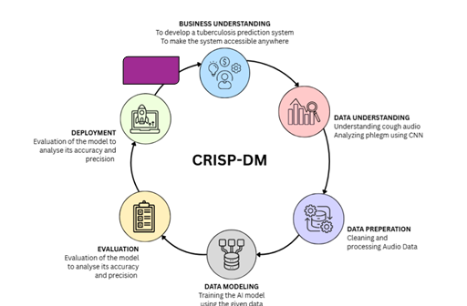Figure I. CRISP-DM TBhon Diagram
The first phase, Business Understanding, defines the primary objective of the system, which is to develop a mobile-based TB pre-screening diagnostic support tool capable of identifying potential tuberculosis risk using cough audio and sputum images. This phase establishes the problem context of delayed TB detection in low-resource communities and guides the system requirements for accessible and early-stage screening.
The second phase, Data Understanding, involves gathering and analyzing relevant datasets such as cough recordings, sputum smear images, and supporting medical references. This stage focuses on identifying patterns and characteristics associated with TB indicators, as well as understanding the structure, quality, and limitations of available data.
The third phase, Data Preparation, involves cleaning and transforming raw audio and image data into machine-learning-ready formats. This includes audio preprocessing such as Mel-spectrogram conversion using Torchaudio, and image preprocessing techniques such as resizing, normalization, and enhancement to improve feature quality and model performance.
The fourth phase, Modeling, focuses on the development and training of machine learning models using PyTorch. CNN-based architectures are applied separately for cough audio and sputum image classification, with iterative training used to optimize accuracy and improve generalization due to variability in respiratory sounds and image conditions.
The fifth phase, Evaluation, assesses model performance using metrics such as accuracy, precision, recall, and F1-score. This ensures that both audio and image classifiers produce reliable predictions before integration into the final system. Validation tests are also conducted to verify consistency and robustness of the TB risk classification outputs.
The final phase, Deployment, involves integrating the trained models into a mobile-accessible application through a FastAPI-based inference system. This enables real-time TB risk prediction based on user inputs. Feedback from users and testing environments is considered for continuous improvement, allowing the system to be refined iteratively, which aligns with the cyclical nature of CRISP-DM.
The closing phase, Iteration and Improvement, ensures consistency with CRISP-DM principles. This phase assesses that the system supports iterative refinement based on model performance evaluation and testing feedback. This allows continuous improvement of classification accuracy and robustness under varying real-world conditions.

3.2 Conceptual Framework
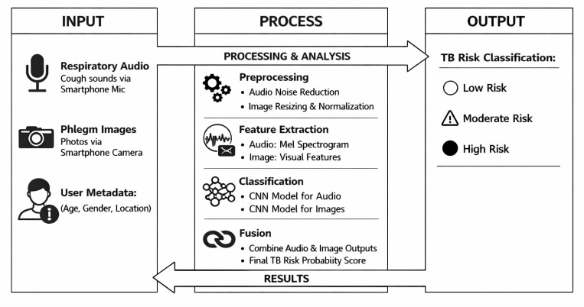
Figure II. Tbhon Screening Framework
The proposed system integrates three main algorithms to process and classify tuberculosis risk. First, the audio classification algorithm takes the cough audio signal as input, applies noise reduction, converts it into a Mel spectrogram, and feeds it into the CNN model to output the probability of TB-related cough (Paudio). The utilization of Mel spectrogram along with CNNs has been already validated as an effective and efficient approach to automated respiratory decease detection from cough noise [16]. Second, the image classification algorithm processes sputum smear images by performing preprocessing (resizing and normalization), followed by feature extraction using the CNN,[13][14] and classification into abnormal or normal indicators, producing an image-based probability (Pimage). Third, a multimodal fusion algorithm combines both outputs using a weighted equation: TB_risk = (w1 × Paudio) + (w2 × Pimage), where w1 and w2 represent the assigned weights for each modality. Finally, a decision algorithm classifies the overall risk level based on the computed TB_risk value: low risk if TB_risk < 0.33, moderate risk if 0.33 ≤ TB_risk < 0.66, and high risk if TB_risk ≥ 0.66. Multimodial fusion is perfect in this scenario as it allows for better accuracy in terms prediction and analysis based on multiple sources of data such as images and audio compared to a unimodal which only uses a single source of data for prediction.[3][4][6]
3.3 System Architecture
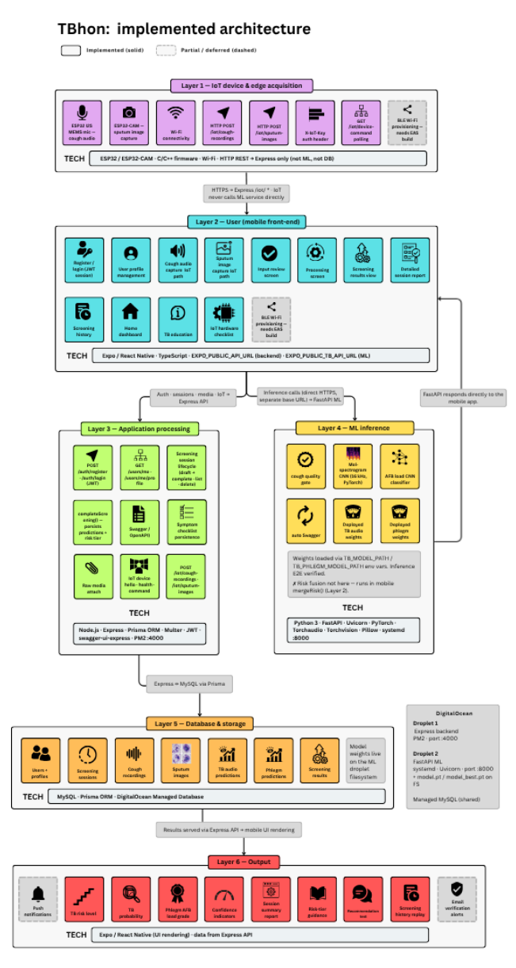
Figure III. System Architecture Diagram
The proposed Tuberculosis screening architecture is designed as a multi-level architecture that seamlessly transitions between hardware data acquisition with deep learning-driven risk assessment. As shown in figure V, the system is organized into six functional layers. At the starting point is the IoT Device and Edge Acquisition Layer which are the ones responsible for handling diagnostic data collection via IoT hardware components and modules such as the ESP32 integrated with the I2S MEMS microphone for cough recording, and the OV5640 camera module handles capturing sputum smear images. These functional modules utilize WIFI to transmit data via HTTP and MQTT which is passed through the User layer. This layer is where the frontend of the application sits and where the data reflets so that the user can see the data that they gathered during screening.
While the user sees the UI and the entire process itself on a more visual level, the actual process runs behind the Application Processing layer. This layer validates the incoming information received from the IoT which is then passed unto the Machine Learning Layer, this layer is like the brains of the process as it uses PyTorch-based CNNs to process the data in parallel, the audio evaluates 128-band Mel-spectograms at 16 khz to detect acoustic TB signatures, while the image classifier assesses digitized smears for Acid-Fast Bacilli (AFB) detection based on the ODS1 dataset indicators. The dedicated fusion module handles the overall analysis, calculating a unified percentage that becomes the final verdict for the screening shown as TB risk level categorized as low, moderate, and high as shown in 3.2 conceptual frameworks.
After the screening has been settled screening data are stored in the Data Management Layer, which stores every data captured by the application to the database such as account details, user information, screening data etc. Both the Machine Learning and the Database Layer are both connected to the Digital Ocean domains where it is seperated to two droplets which is the Backend and the Machine Learning, which are running on specific online servers with their own IP address as to make the functionality migrate from a local entry point to an accessible server for development. Finally, the Output Layer is the overall data/information that are displayed to the user itself that translates the model inferences into readable.
3.4 IoT Integration
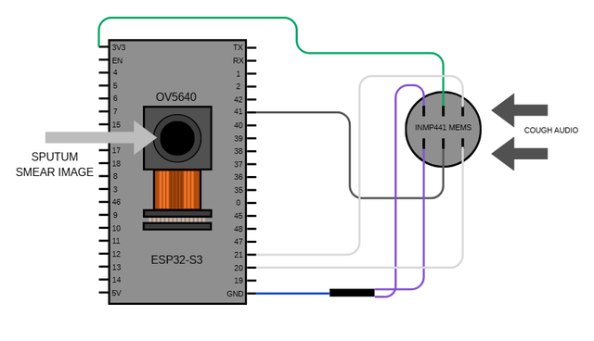Figure IV. IoT Schematics
Using audio processing and image classification techniques it is possible to recognize tuberculosis risks through audio and images. The process of tuberculosis detection is divided into cough noise analysis and sputum smear classification. The ESP32 is intended for IoT communication and sensor integration, along with the INMP441 MEMS microphone sensor and the OV5640 as the camera module. Using the camera module, the system takes a picture of the smear sample, which is then analyzed to detect acid-fast bacilli associated with Mycobacterium tuberculosis. And the microphone sensor is used to record the cough audio that is then converted into Mel Spectograms that represents frequency patterns over time for feature extraction and classification. According to Naufal et al., ESP32 was utilized for sensor integration and wireless communication to explore detection of tuberculosis using exhaled breath analysis. While artificial neural networks we utilized to classify tuberculosis-related patterns from sensor data [1]. This proves that ESP32 is capable of handling tasks like integration of systems to the IOT itself.
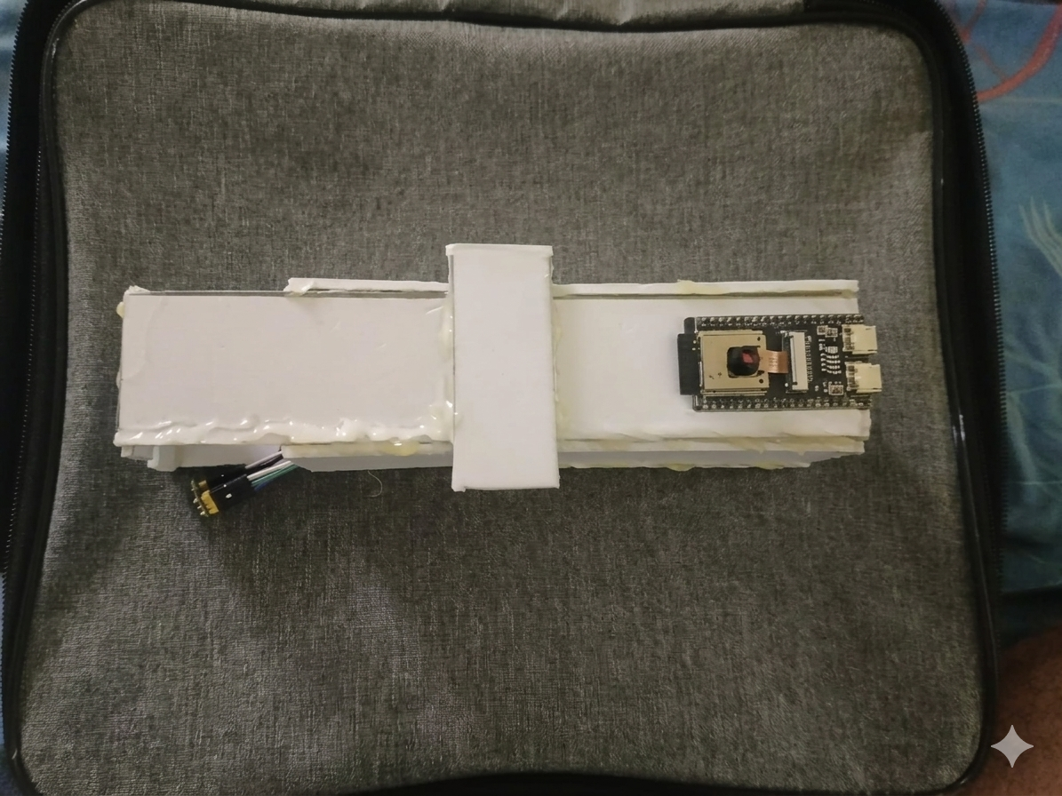
Figure V. IoT attachment
As shown in figure II. The IoT attachment is the entire IoT component that contains all the hardware such as the ESP32 and the modular sensors, which is encased in a custom-made container made of Sintra board. This makes it cheap to assemble since this is the first prototype.
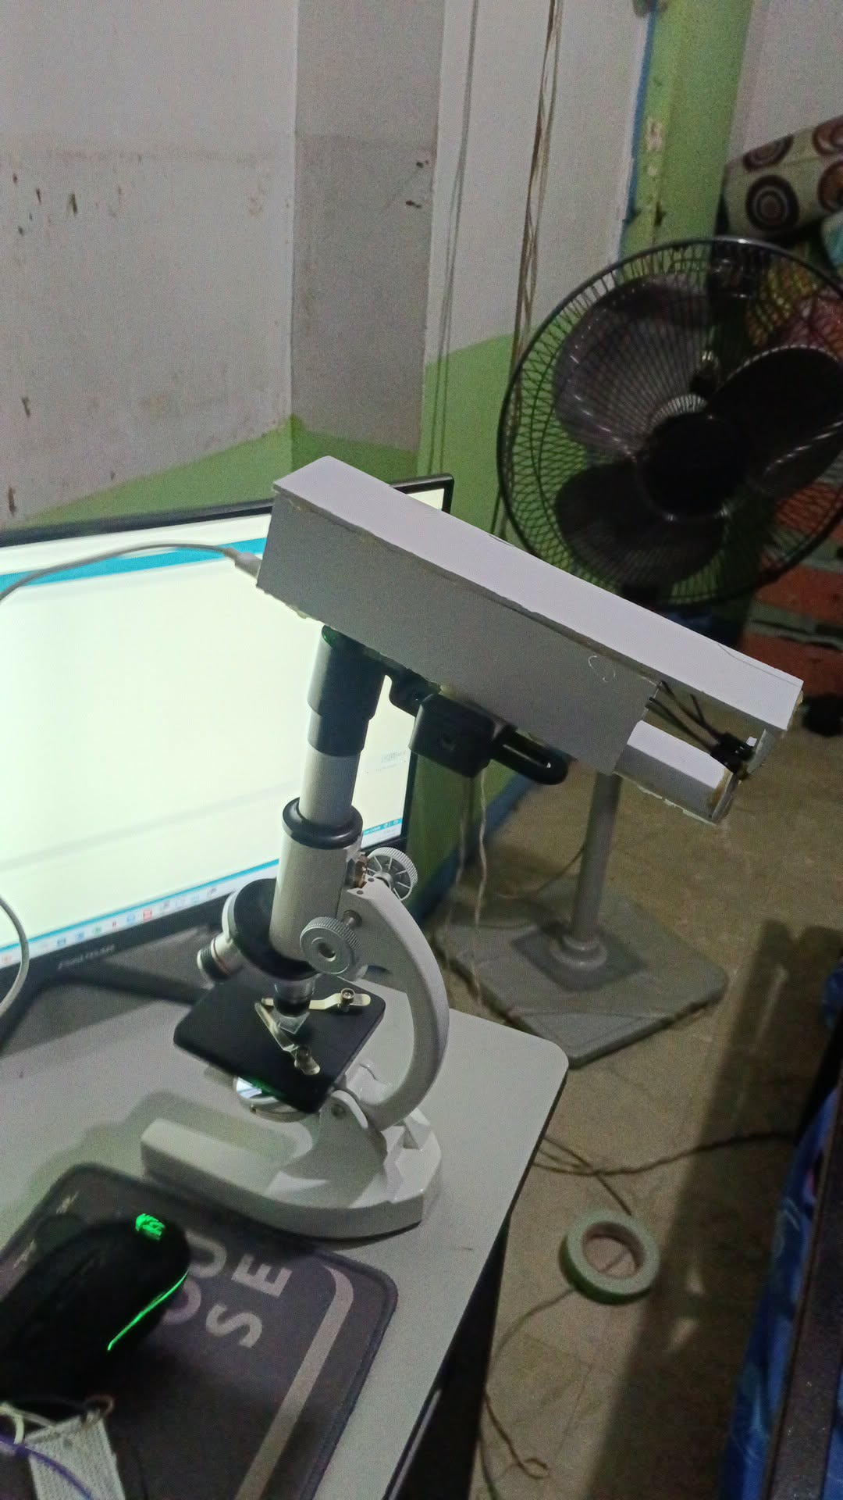
Figure VI. IoT full setup
As seen in figure III. The full setup of the IoT consists of the IoT attachment as well as an actual microscope since part of the required data is sputum smear images. The IoT attachment is placed on top specifically on the phone holder of the microscope which is where the ESP32 sits as well as the OV5640 camera which has a microscopic view of the sputum smear which is then taken by the camera module and registered in the screening session. The INMP441 MEMS microphone sensor sits at the edge of the microscope which is placed at the front of the attachment similar to an actual microphone.

IV. EXPERIMENTAL RESULTS
This section reports datasets, experimental apparatus, training procedures, and quantitative findings for the TBhon multimodal tuberculosis pre-screening system. Evaluation encompassed unimodal cough and sputum classifiers, three-fold cross-validation, architectural ablation (convolutional baseline versus hybrid CNN+gradient-boosted ensemble), operating-point calibration, pre-inference cough quality control, and end-to-end API response behavior. Screening-level multimodal risk integration is described qualitatively; a dedicated held-out evaluation of the full fused triage score against microbiological ground truth was not completed and is noted as a limitation in Section IV-G.

A. Datasets and Experimental Setup
The evaluation employed two publicly available data sources aligned with the TBhon training pipeline.
Cough audio. The open Kaggle tuberculosis audio corpus provided 7,817 labeled respiratory recordings. All waveforms were converted to mono, resampled to 16 kHz, and normalized to a fixed temporal window before feature extraction. The deployed hybrid classifier used four-second clips and sixty-four Mel frequency bins. Labels were binary (tuberculosis-positive versus tuberculosis-negative). The publisher supplied three predefined cross-validation folds, each allocating approximately 5,211 recordings to training and 2,606 to testing.
Sputum smear images. A curated set of 1,438 Ziehl-Neelsen stained microscopy fields was partitioned into 1,149 training, 142 validation, and 147 test images (approximately 80% / 10% / 10%). Acid-fast bacillus (AFB) labels were derived from bounding-box annotations by counting visible bacilli per field. Binary AFB classification (production path) used 224 x 224-pixel ResNet-18 inputs.
Prototype acquisition used an ESP32-S3 with INMP441 microphone and microscope-mounted camera (640 x 480 JPEG). Compute environment: Intel Core i5, 8 GB RAM, CUDA GPU, PyTorch 2.x; production inference on a DigitalOcean FastAPI ML droplet (/check-quality, /predict, /predict-phlegm).

B. Cough Audio Classification
Two cough classifiers were compared on held-out fold 0 (n = 2,606). The baseline was a CNN on log-Mel spectrograms (128 bins, six-second clips), trained with AdamW (3 x 10^-4), batch size 32, and early stopping. The production hybrid combined a CNN branch (64 Mel bins, four-second clips, eight epochs) with a gradient-boosted ensemble on MFCC and summary features, fused by validation-tuned weighted averaging.
Table I summarizes the fold-0 ablation. The hybrid model improved macro-F1 by 17.8 percentage points over the convolutional baseline (50.6% to 68.3%).
- TABLE I
COUGH CLASSIFIER ABLATION ON FOLD 0 (HELD-OUT TEST, n = 2,606)
Model | Fold | Test n | Accuracy | Precision | Recall | Macro-F1
Convolutional network (baseline) | 0 | 2,606 | 50.6% | 60.4% | 60.7% | 50.6%
Hybrid CNN+GBM (ablation) | 0 | 2,606 | 73.9% | 68.3% | 68.4% | 68.3%

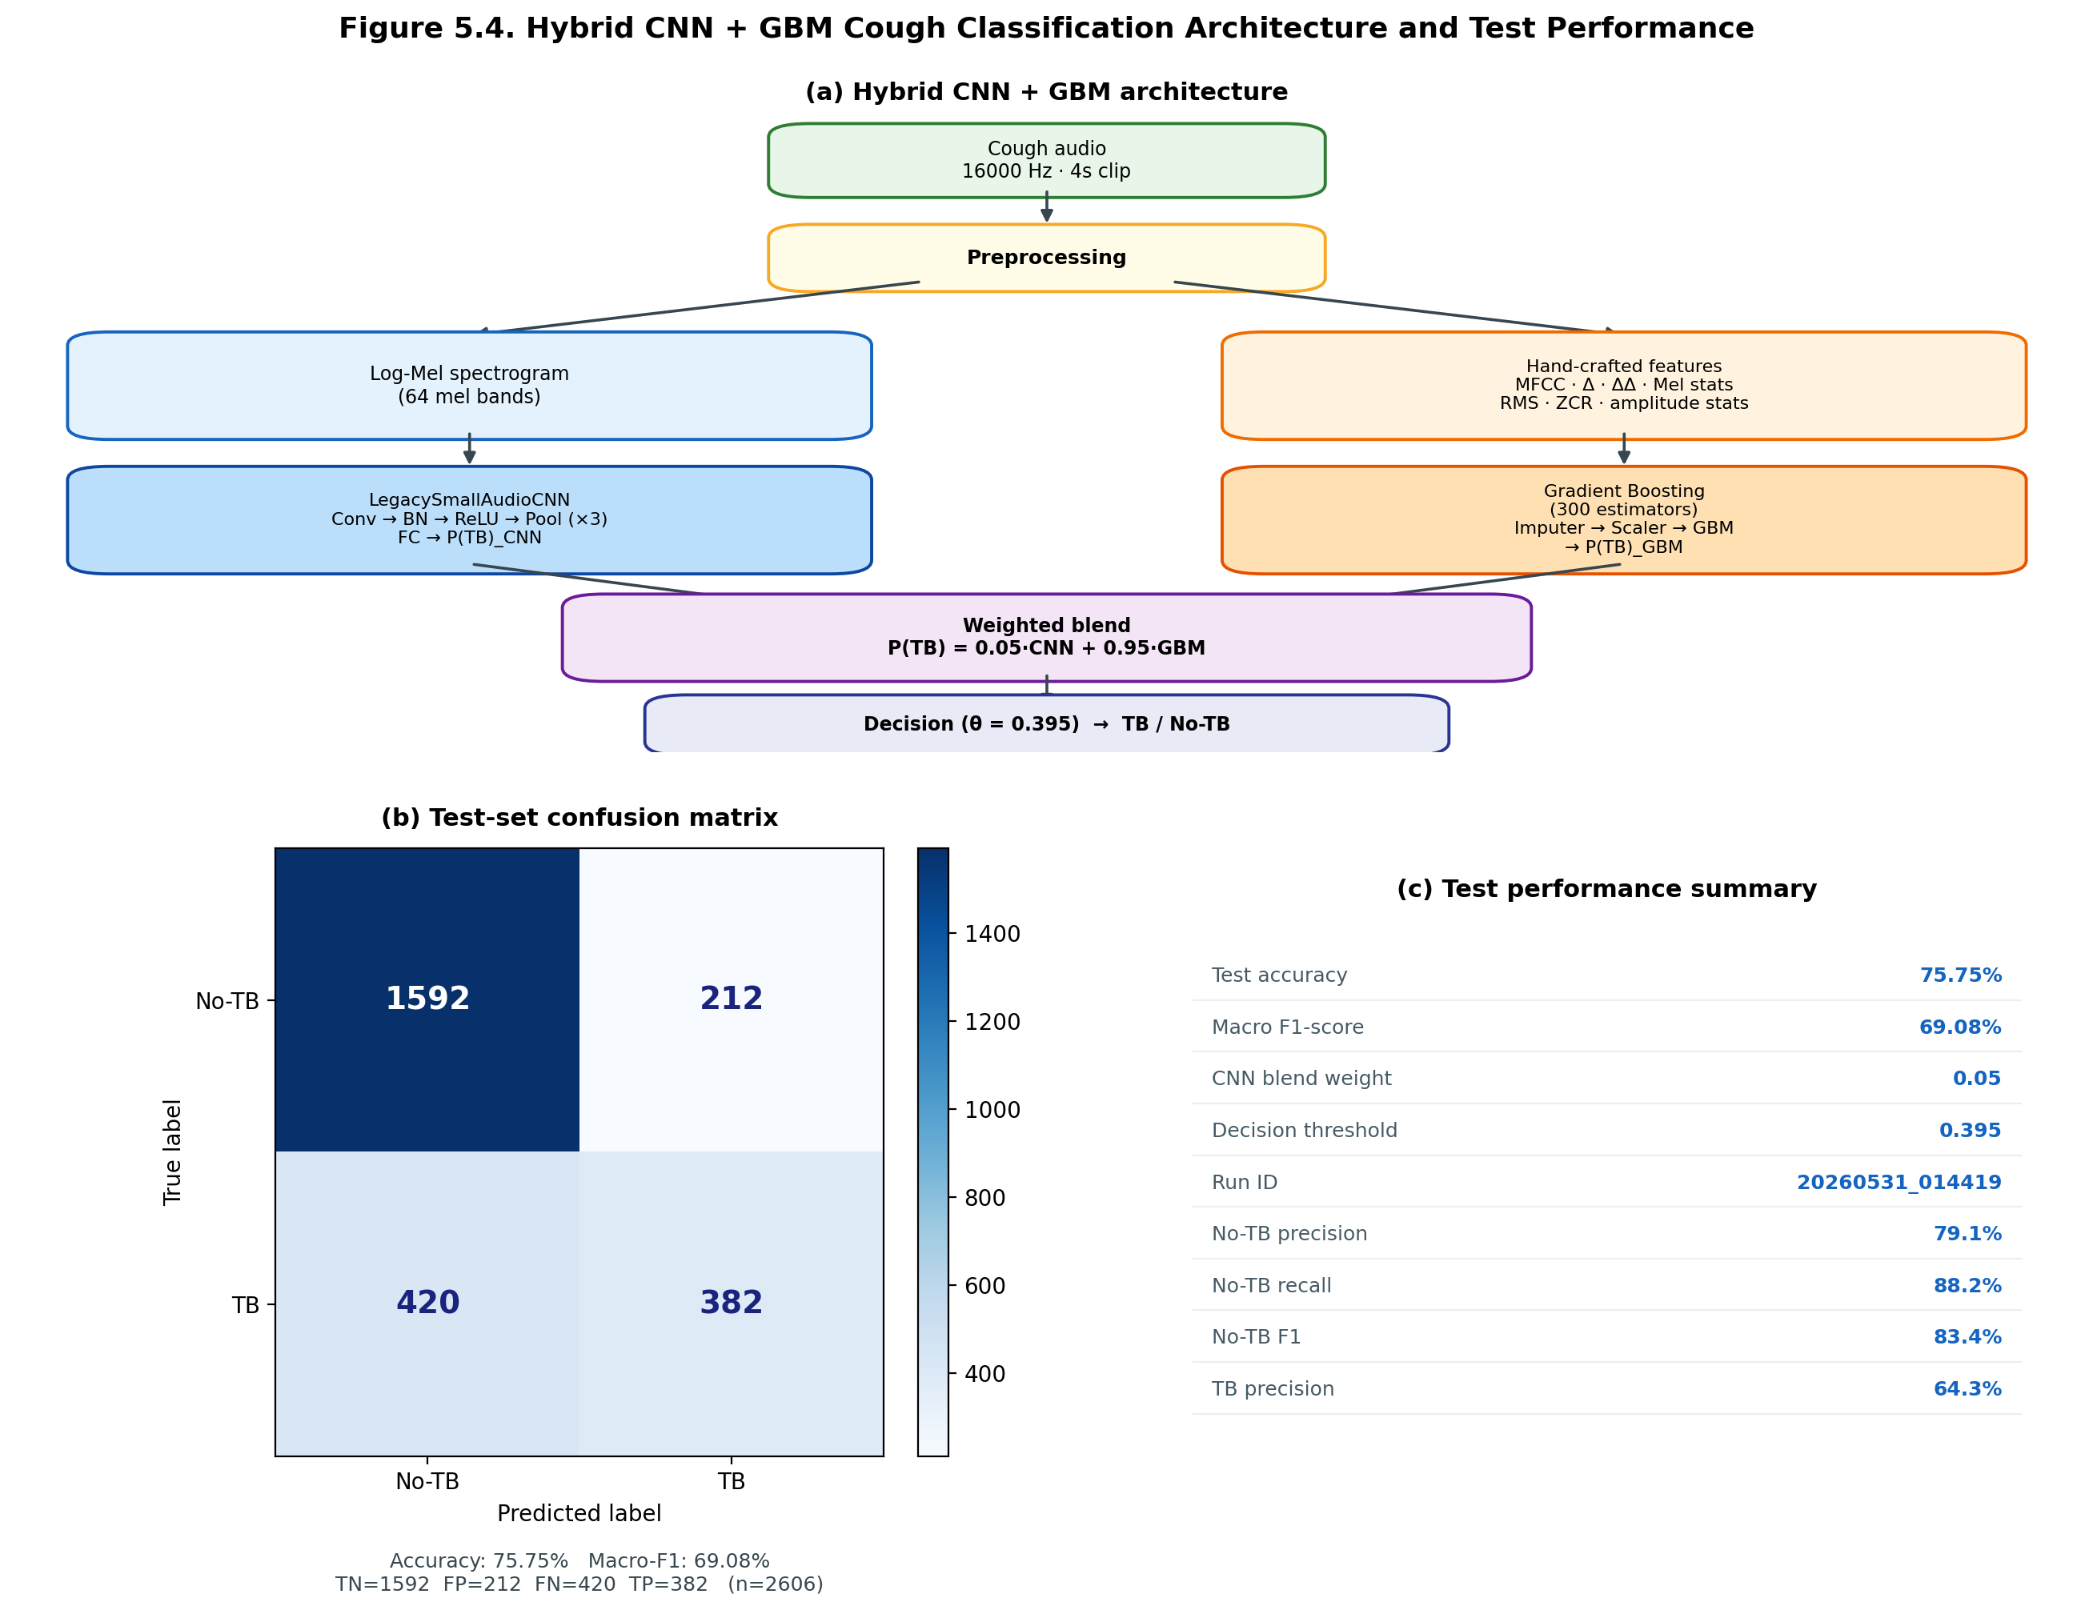
Figure VII. Hybrid CNN + GBM Cough Classification Architecture and Confusion Matrix

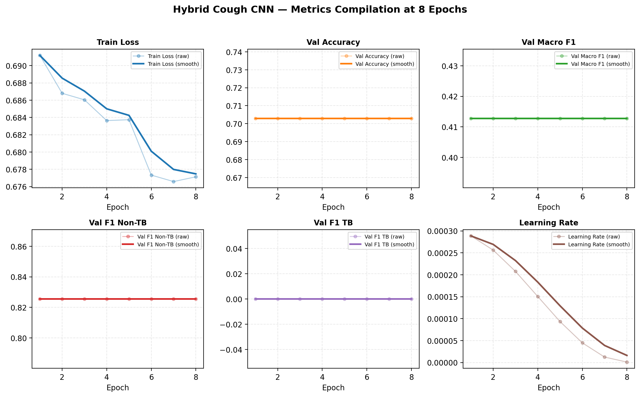
Figure VIII. Hybrid Cough CNN Metrics Compilation at 8 Epochs

C. Cross-Fold Generalization
The hybrid architecture was independently trained and evaluated on all three cross-validation folds (Table II). Mean macro-F1 was 68.6% (range 68.3-69.1 pp). Fold 1 achieved the highest macro-F1 (69.1%) and was selected for production deployment.
- HYBRID COUGH CLASSIFIER CROSS-FOLD TEST PERFORMANCE
Fold | Test n | Accuracy | Macro-F1 | TB Recall | Non-TB Recall
0 | 2,606 | 73.9% | 68.3% | 55.2% | 81.5%
1 (production) | 2,606 | 75.8% | 69.1% | 47.6% | 88.3%
2 | 2,605 | 76.0% | 68.3% | 44.0% | 90.0%
Mean | N/A | 75.2% | 68.6% | 48.9% | 86.6%

D. Sputum Smear Classification
The binary AFB classifier used a ResNet-18 backbone fine-tuned for thirty epochs (AdamW, 1 x 10^-3, class-weighted loss). The decision threshold was tuned on validation data under a >=95% AFB-positive sensitivity constraint (production threshold = 0.63).
On the held-out test partition (n = 216; 6 AFB-negative, 210 AFB-positive), the production model (phlegm_afb_binary_20260531_133949) achieved 94.91% accuracy, 66.32% macro-F1, and 96.19% AFB-positive sensitivity (Table III). AFB-negative specificity was 50.00% (3 TN, 3 FP), reflecting screening-oriented thresholding and the small negative test cohort.
- TABLE III
PRODUCTION UNIMODAL CLASSIFIER PERFORMANCE ON HELD-OUT TEST DATA
Production Model | Test n | Accuracy | Macro Precision | Macro Recall | Macro-F1
Hybrid cough CNN+GBM (fold 1) | 2,606 | 75.8% | 71.7% | 67.9% | 69.1%
ResNet-18 AFB binary (sputum) | 216 | 94.9% | 62.6% | 73.0% | 66.3%
AFB+ sensitivity (sputum) | 210 positives | N/A | 98.5% | 96.2% | 97.1%

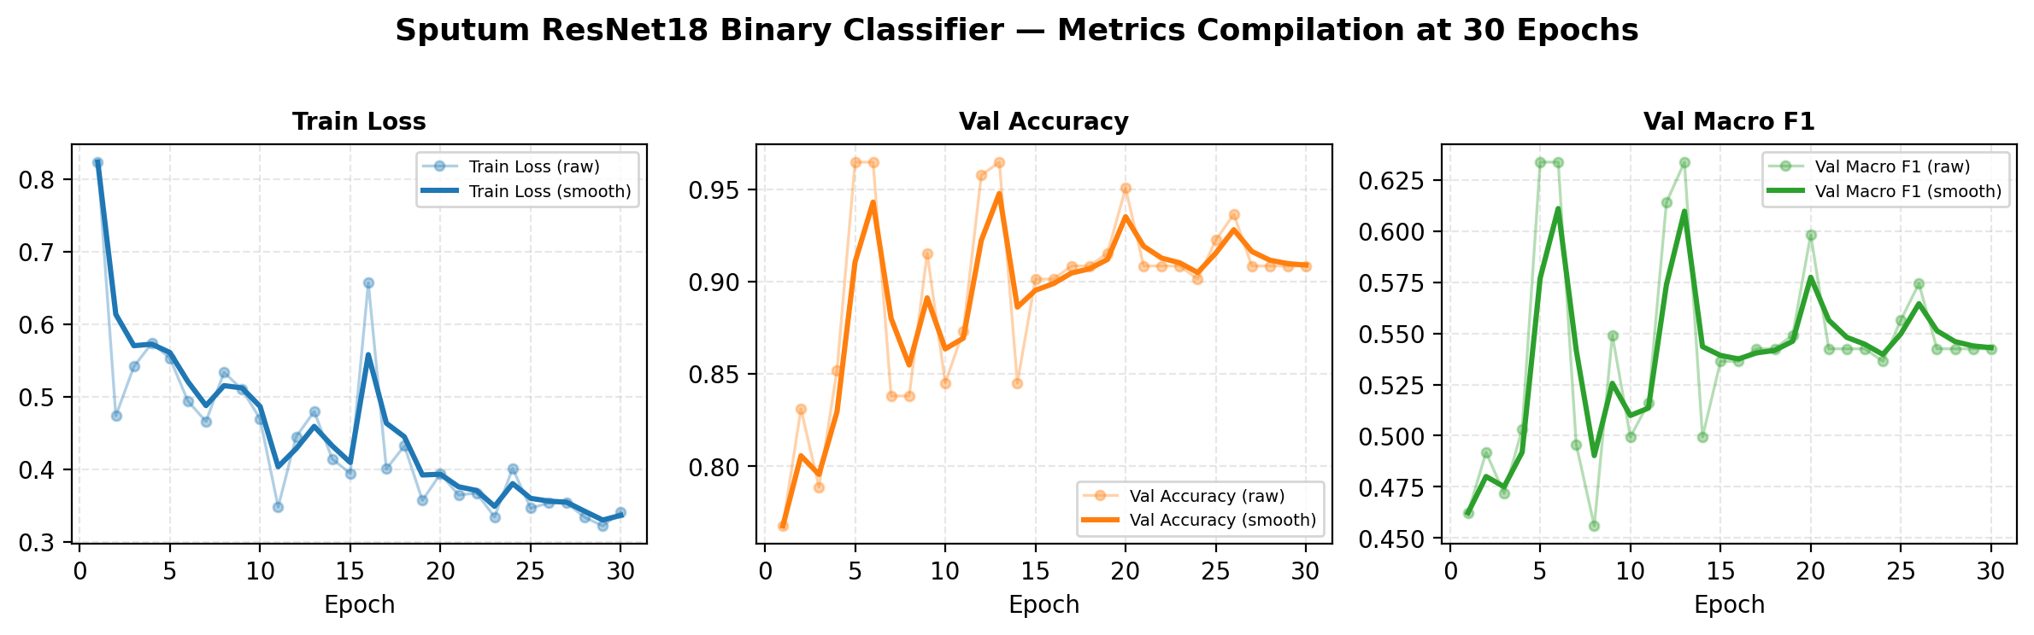
Figure IX. Sputum ResNet18 Binary Classifier Metrics Compilation at 30 Epochs

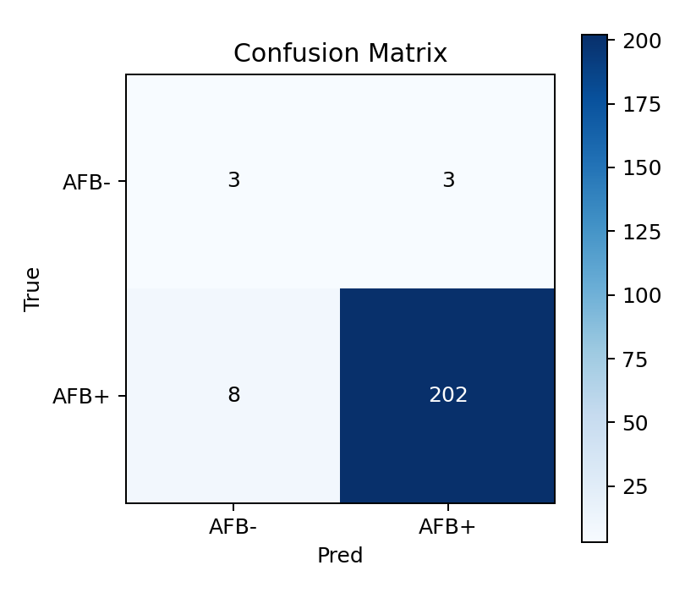
Figure X. Sputum AFB Binary Classifier Confusion Matrix

E. Pre-Inference Quality Control
Each cough recording passes a heuristic /check-quality gate (RMS, crest factor, spectral flatness, periodicity, dynamic range) before classification. Invalid clips are excluded from fusion. Functional testing confirmed rejection of noise, silence, and speech-like inputs while accepting cough bursts.

F. Multimodal Screening Fusion
Tablr
- TABLE IV
MULTIMODAL FUSION MODALITY RELIABILITY WEIGHTS
Modality | Reliability Weight
Symptom and exposure checklist | 0.85
Cough machine learning probability | 1.00
Sputum machine learning probability | 0.70

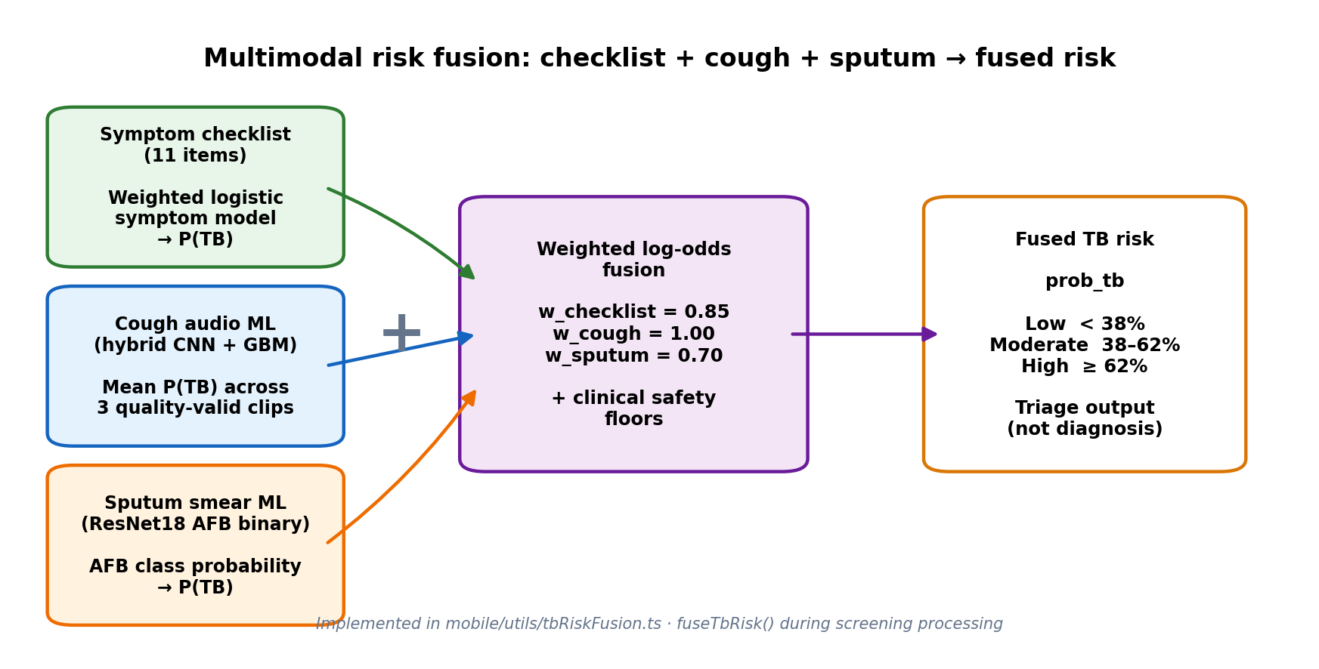
Figure XI. Multimodal Fusion Diagram (Checklist + Cough + Sputum)

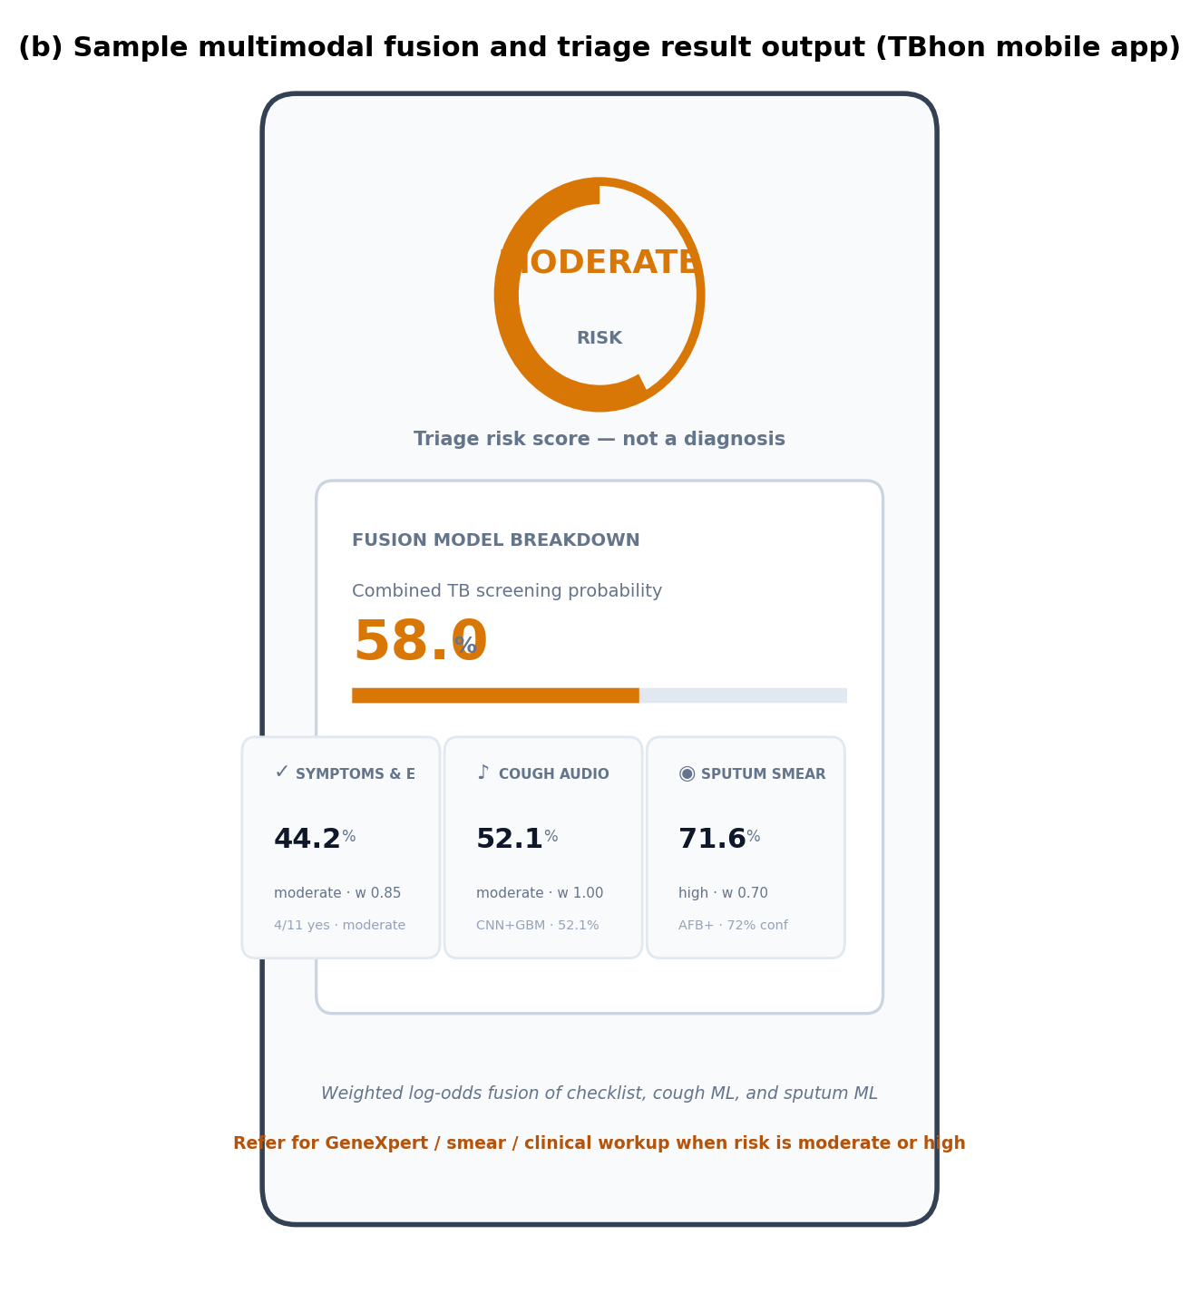
Figure XII. Sample Multimodal Fusion and Triage Result Output

G. Evaluation Metrics, System Response, and Discussion
Metrics: accuracy, precision, recall, and macro-F1 on held-out test partitions. Response time was evaluated against the five-second per-inference target; fou of six UAT evaluators rated inference speed as Agree or Strongly Agree under stable Wi-Fi, with occasional delays on unstable networks.
Production cough hybrid: 75.8% accuracy, 69.1% macro-F1, 88.3% non-TB recall, 47.6% TB recall. Sputum: 94.9% accuracy, 96.2% AFB+ sensitivity. All six end-to-end workflow test cases passed on iPhone 15 and Redmi Note 12 Pro 5G. Limitations: public datasets only, low cough TB recall for standalone use, unstable sputum specificity estimates (n=6 negatives), no held-out fused-score benchmark, observational latency only.

CONCLUSION AND RECOMMENDATION
Conclusion
The study successfully developed TBhon, an IoT-enabled mobile-based multimodal tuberculosis pre-screening and triage support system integrating a React Native mobile application, a cloud-hosted backend, machine learning inference services, and optional ESP32-S3 IoT acquisition hardware. By combining symptom assessment, cough audio analysis, sputum smear image analysis, and weighted multimodal risk fusion, the system provides Low, Moderate, and High triage recommendations intended to support community health workers during TB pre-screening while emphasizing that it is not a replacement for clinical diagnosis.

The proposed system achieved the study objectives by implementing IoT-assisted respiratory audio and sputum image acquisition, developing and deploying machine learning models for cough and sputum analysis, integrating cloud-based communication and inference services, and implementing an interpretable multimodal risk-scoring framework. Functional validation demonstrated successful end-to-end operation across supported mobile devices, while software quality assessment based on ISO/IEC 25010 and professional user acceptance testing indicated high levels of functional suitability, usability, security, and overall user satisfaction. These findings demonstrate the technical feasibility and practical usability of the integrated prototype within booth-operated and community-based TB screening workflows.

Although the developed models achieved performance appropriate for prototype pre-screening applications, the system remains intended solely as a decision-support tool. Evaluation was conducted using publicly available datasets and controlled prototype deployment conditions rather than prospective clinical studies. Consequently, the reported results demonstrate engineering feasibility and user acceptability rather than clinical effectiveness. Additional validation using larger and more diverse local populations, particularly in rural and resource-limited settings, is necessary before wider deployment.

Overall, the study demonstrates that integrating multimodal artificial intelligence, mobile computing, cloud infrastructure, and IoT-assisted data acquisition can provide a practical and accessible approach for supporting early tuberculosis pre-screening and referral. The proposed TBhon system establishes a foundation for future research on AI-assisted public health screening technologies that complement existing diagnostic pathways and contribute to earlier identification and more organized TB screening initiatives.

Recommendation

First, future developers should implement offline or low-bandwidth operations with local request queuing and synchronization when connectivity is restored. UAT evaluators consistently identified unstable Wi-Fi and rural network conditions as the primary limitation (Item 20, weighted mean 3.83), and this enhancement would improve reliability for barangay health stations and remote screening booths.
Second, the mobile application should include a structured onboarding tutorial, illustrated capture guidance, and clearer ML processing status indicators for first-time booth staff. Evaluators from clinical and medical laboratory science backgrounds noted that non-technical users require additional instructional support before independent operation.

Third, referral outputs should integrate location-based mapping to the nearest accredited TB DOTS clinic, RHU, or GeneXpert-capable facility. Clinical evaluators recommended that triage results explicitly link patients to geographically relevant follow-up pathways rather than generic referral text alone.

Fourth, the cough ML pipeline should be expanded with additional training data including female cough recordings, diverse acoustic environments, and improved quality-gate feedback that highlights rejected segments rather than full replay loops to improve TB-class recall and user trust in audio-based triage signals.

Fifth, the sputum analysis module should be enhanced with on-screen AFB bounding-box visualization, expanded AFB-negative training samples, and prospective field validation using institution-approved clinical smear images to strengthen specificity estimates beyond the limited six-sample negative test partition.

Sixth, the symptom checklist may be extended with additional clinical risk factors suggested during UAT such as comorbid conditions, smoking exposure, and allergy-related cough differentiators while preserving a concise staff-operated workflow suitable for booth throughput.

Seventh, IoT deployment should be completed through native or EAS builds enabling full BLE Wi-Fi provisioning, on-device status LEDs or display feedback, and field troubleshooting guides to reduce setup friction for ESP32-S3 cough and sputum capture modules.

Eighth, a multi-site field pilot with LGU, RHU, or NGO partners should be conducted to measure real screening volume, referral follow-through, cloud inference latency under production load, and long-term model drift using logged prediction data from the deployed FastAPI service.

Ninth, future researchers may integrate supplementary modalities such as chest X-ray CAD interfaces or GeneXpert result logging as optional triage inputs only, maintaining honest pre-screening scope and avoiding presentation of the fused risk score as a standalone diagnostic conclusion.

Finally, multilingual support (e.g., Filipino and Cebuano/Bisaya) for checklist items, learn content, result counseling, and disclaimers is recommended to improve accessibility for diverse clients in Mindanao screening environments and to align with community-oriented tuberculosis elimination initiatives.
The researchers strongly recommend the continuous exploration and integration of emerging technologies within community TB pre-screening and public health monitoring environments to improve multimodal triage efficiency, booth-operated screening capability, and technology-assisted tuberculosis elimination sustainability in resource-limited settings.

Acknowledgment (Heading 5)
The preferred spelling of the word “acknowledgment” in America is without an “e” after the “g”. Avoid the stilted expression “one of us (R. B. G.) thanks ...”. Instead, try “R. B. G. thanks...”. Put sponsor acknowledgments in the unnumbered footnote on the first page.

References

- M. A. Naufal, R. Nusair, and T. F. Duta, “Development of an Artificial Intelligence–Based portable prototype for early tuberculosis detection using exhaled breath analysis and IoT integration: A feasibility study,” JIMKI Jurnal Ilmiah Mahasiswa Kedokteran Indonesia, vol. 18, 2025. doi: 10.53366/jimki.vi.978.
- A. Sharma, A. Sharma, and R. Malhotra, “IoT-Based monitoring system for diagnosing adverse drug reactions and enhancing drug compliance in TB patients,” SHILAP Revista De Lepidopterología, 2023. doi: 10.24423/cames.451.
- Alloqmani, A., & Abushark, Y. B. (2026). Comparison between early and intermediate fusion of multimodal techniques: Lung disease diagnosis. AI, 7(1), 16. https://doi.org/10.3390/ai7010016
- Cui, C., Yang, H., Wang, Y., Zhao, S., Asad, Z., Coburn, L. A., Wilson, K. T., Landman, B. A., & Huo, Y. (2023). Deep multimodal fusion of image and non-image data in disease diagnosis and prognosis: a review. Progress in Biomedical Engineering, 5(2), 022001. https://doi.org/10.1088/2516-1091/acc2fe
- L. R., “A microcontroller-based respiratory monitoring system for∑iwi⋅logit(pi continuous patient breathing assessment,” International Journal of Zoology and Applied Biosciences, vol. 10, no. 6S, pp. 635–639, 2025. doi: 10.55126/ijzab.2025.v10.i06.sp130.
- Li, T., Song, S., Pan, Y., Song, W., Fong, S., Gao, J., Wang, Q., Zhang, X., & Mohammed, S. (2025). Deep learning in multi-modal breast cancer data fusion: a literature review. Quantitative Imaging in Medicine and Surgery, 15(11), 11578–11610. https://doi.org/10.21037/qims-2024-2903
- M. Simić, A. K. Stavrakis, A. Sinha, V. Premčevski, B. Markoski, and G. M. Stojanović, “Portable Respiration Monitoring System with an Embroidered Capacitive Facemask Sensor,” Biosensors, vol. 12, no. 5, p. 339, 2022. doi: 10.3390/bios12050339.
- N. F. Azzahra, P. C. Nugraha, T. Hamzah, K. O. Lawal, and A. D. Larasati, “Implementation of a microcontroller Arduino for portable peak expiratory flow rate to examine the lung health,” International Journal of Advanced Health Science and Technology, vol. 2, no. 2, pp. 54–59, 2022. doi: 10.35882/ijahst.v2i2.1.
- J. A. Rivas-Navarrete, H. Pérez-Espinosa, A. L. Padilla-Ortiz, A. Y. Rodríguez-González, and D. C. García-Cambero, “Edge computing system for automatic detection of chronic respiratory diseases using audio analysis,” Journal of Medical Systems, vol. 49, no. 1, p. 33, 2025. doi: 10.1007/s10916-025-02154-7.
- C. Suda, “Early Detection of Tuberculosis with Machine Learning Cough Audio Analysis: Towards More Accessible Global Triaging Usage,” arXiv (Cornell University), 2023. doi: 10.48550/arxiv.2310.17675.
- A. Paul, A. Srivastava, N. Verma, A. Iqbal, S. K. Maity, and H. S. Das, “Whooping cough prediction using edge artificial intelligence for real-time health monitoring,” ES Gen, vol. 9, p. 1649, 2025. doi: 10.30919/esg1649.
- R. Sigit, H. Yuniarti, T. Karlita, and R. Kusumawati, “Automatic Detection Of Tuberculosis Bacteria Using Microscope Imaging System Based On Motorized Servo And Deep Learning Techniques,” International Journal of Innovative Computing, Information and Control, vol. 21, no. 2, p. 273, 2025.
- Rachmad, A., Syarief, M., Hutagalung, J., Hernawati, S., Rochman, E. M. S., & Asmara, Y. P. (2024). Comparison of CNN architectures for Mycobacterium tuberculosis classification in sputum images. Ingénierie Des Systèmes D Information, 29(1), 49–56. https://doi.org/10.18280/isi.290106
- Rulaningtyas, R., Bilhaq, F. G., Kusumaningrum, D., Eric, R., Ittaqillah, S. I., Trilaksana, H., Widhyatmoko, D. B., & Joseph, A. A. (2026). Automated Mycobacterium tuberculosis Detection in Multivariant Digitized Ziehl–Neelsen Staining Using Faster R‐CNN Method. International Journal of Biomedical Imaging, 2026(1), 6692222. https://doi.org/10.1155/ijbi/6692222
- S. Hansun, A. Argha, I. Bakhshayeshi, A. Wicaksana, H. Alinejad-Rokny, G. J. Fox, S. Liaw, B. G. Celler, and G. B. Marks, “Diagnostic Performance of Artificial Intelligence–Based Methods for Tuberculosis Detection: Systematic Review,” Journal of Medical Internet Research, vol. 27, p. e69068, 2025. doi: 10.2196/69068.
- Zhou, Q., Shan, J., Ding, W., Wang, C., Yuan, S., Sun, F., Li, H., & Fang, B. (2021). Cough recognition based on Mel-Spectrogram and convolutional neural network. Frontiers in Robotics and AI, 8, 580080. https://doi.org/10.3389/frobt.2021.580080

IEEE conference templates contain guidance text for composing and formatting conference papers. Please ensure that all template text is removed from your conference paper prior to submission to the conference. Failure to remove template text from your paper may result in your paper not being published.
We suggest that you use a text box to insert a graphic (which is ideally a 300 dpi TIFF or EPS file, with all fonts embedded) because, in an MSW document, this method is somewhat more stable than directly inserting a picture.
To have non-visible rules on your frame, use the MSWord “Format” pull-down menu, select Text Box > Colors and Lines to choose No Fill and No Line.

