# 1. 安装git

## 1.1git在window上安装

<https://git-scm.com/download/win>

下载git的exe文件后，点击安装 下一步就可以

## 1.2.git在linux上安装

安装git的依赖项

yum install curl-devel expat-devel gettext-devel openssl-devel zlib-devel

yum install gcc perl-ExtUtils-MakeMaker

下载tar包

wget <https://mirrors.edge.kernel.org/pub/software/scm/git/git-2.23.0.tar.gz>

解压tar包

tar -zxvf git-2.23.0.tar.gz

编译tar包

cd git-2.23.0

./configure --prefix=/export/server/git-2.23.0

make && make install

软连接

ln -s /export/server/git-2.23.0/bin/* /usr/bin/

查看git版本

git--version

# 2.安装sourcetree

安装参考<https://www.cnblogs.com/liuxin-673855200/p/11151835.html>

添加项目

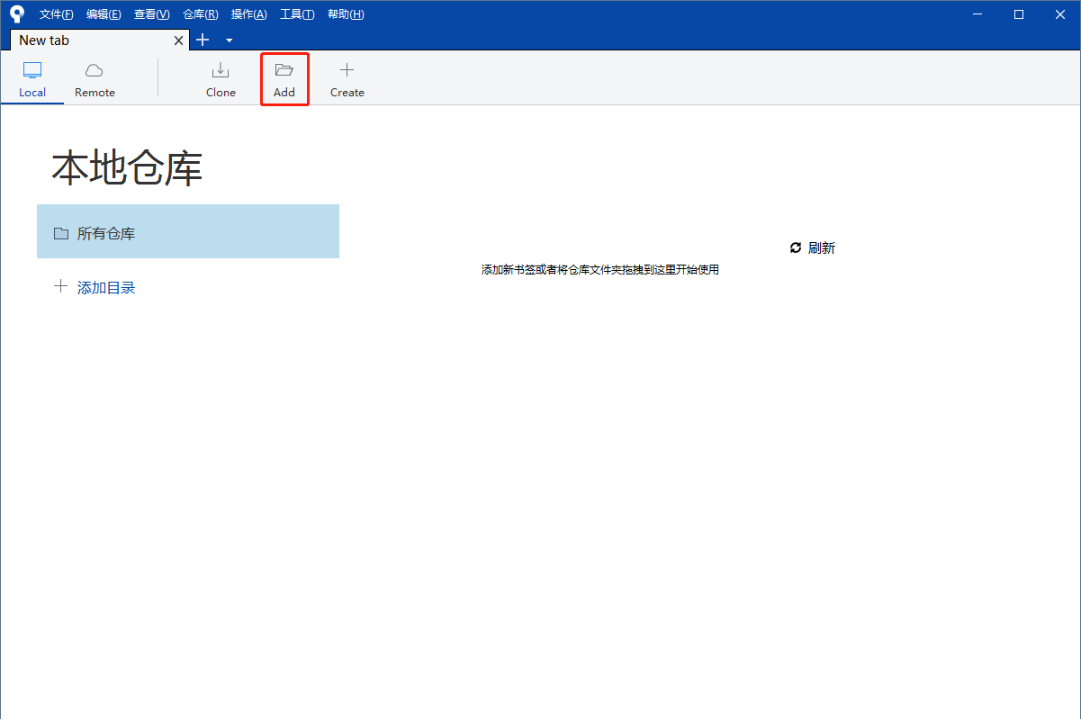

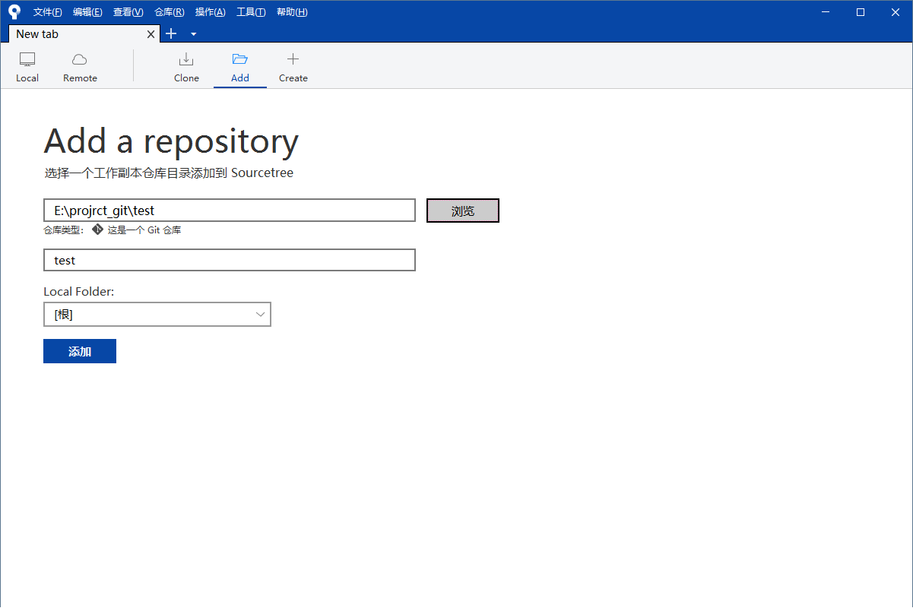

可视化界面

