Using Photoshop Actions in a Batch Automation Workflow

Cover Page

Tanner “Daf” Miller

903-348-5760

daf@oneof.productions

1241 W. Chase Ave. Chicago IL, 60626

School of the Art Institute of Chicago

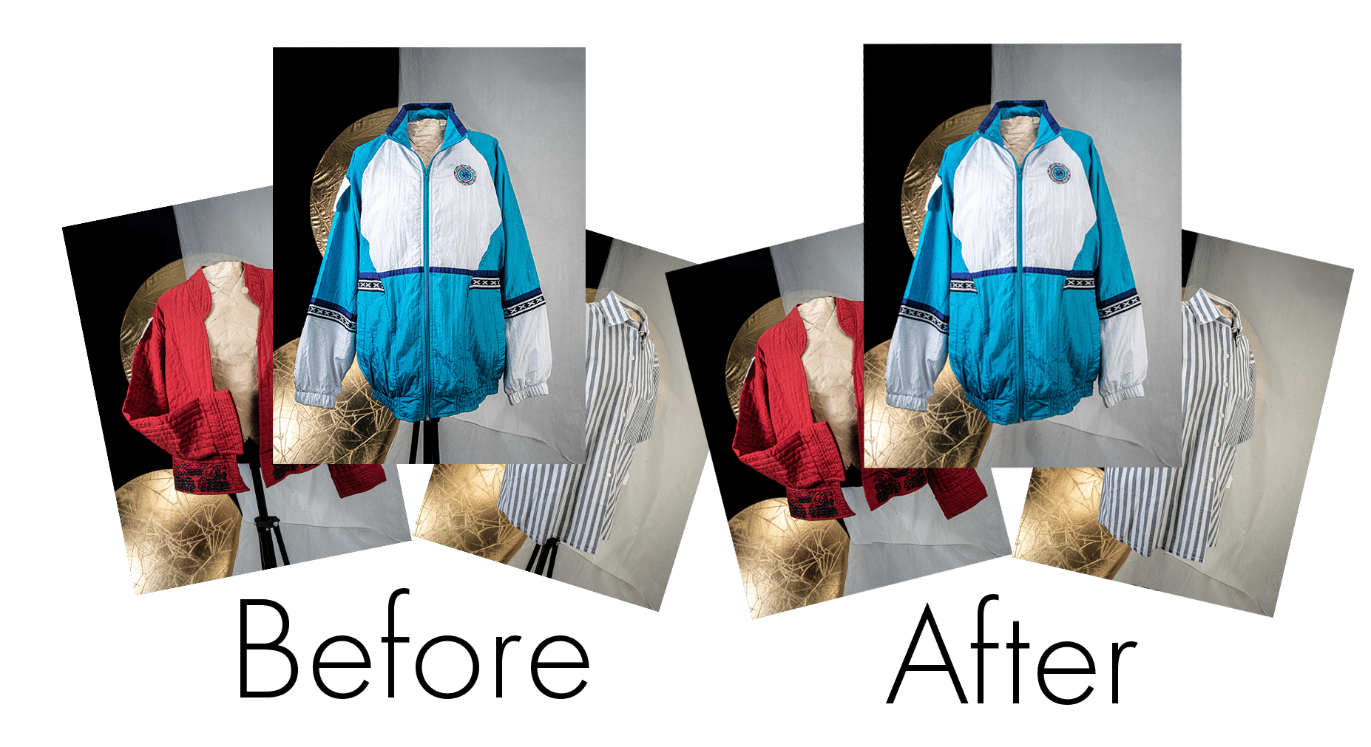

One of the biggest benefits of using photoshop is its ability to tackle tiny touch-ups and massive projects alike. Being able to quickly open an image and make adjustments as needed is great! but when working with lots of images, a 2-minute fix can turn into hours of repetitive actions. Opening each file in a batch of 200 would take way too much time, luckily Photoshop has some built-in tools that allow you to automate almost anything within Photoshop. Those tools are called Actions and I’m gonna show you how they can be put to work to save you tons of time in the editing room.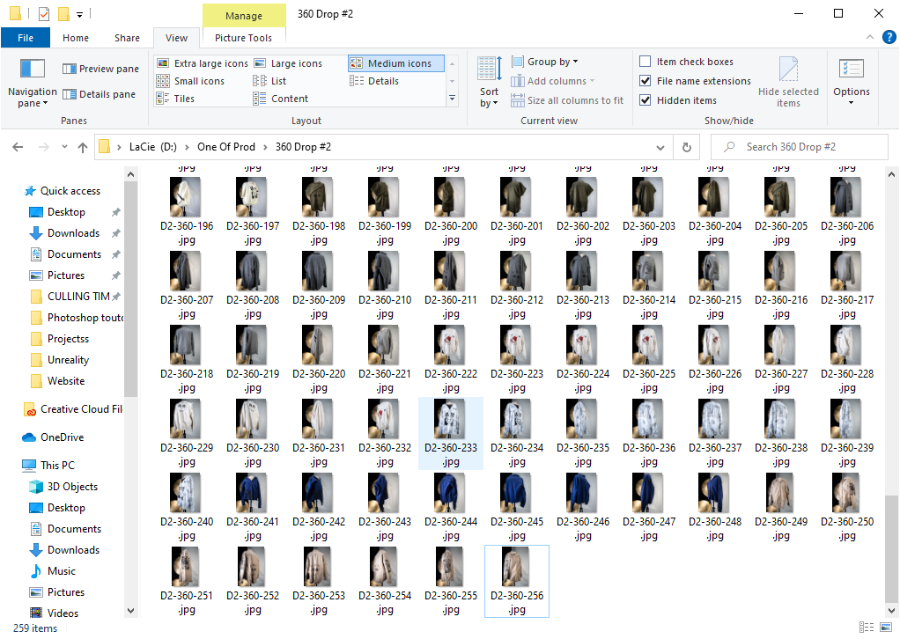

For this example project, I will be using a photoshoot I did for my recent clothing line. As you can see, I have a set of images that were all photographed on the same setup. In this case, there is a pole that was used to turn and support the clothes in each shot and I want it gone. With this many images, it would be impractical to open each image and manually mask out and fill the area. I'm going to show you my method for doing batch edits in photoshop. Using these same techniques you can automate almost anything!

(When working in batches doing individual edits is impractical)

Before you start:

* Ensure you have a set of images to work from and save these in a project folder. jump to the bottom to view the Git repository and download example files, or click [Here](https://github.com/Bear2Be2/StandOutToutorial).
* Create a destination folder for when we export images at the end of the project.

Part One: Create the Action

1. Create a new document by opening an image from the sample images. For this example, I’m going to name mine StandOut because I want to take the stand out of these pictures.
2. Next, open the actions panel (if you don’t see it click Window→Actions). Click on the three bars in the top right corner of the actions panel and ensure that Allow Tool Recording is checked. Also in this menu select Playback Options, and ensure “Accelerated” is selected.
3. Create a new action by clicking the square with a plus sign located at the bottom of the actions panel. Name the action then click Record.

Note: You are now recording an action, which means that any changes you make inside of photoshop will be recorded, and at the end, you will be able to playback all the changes you made automatically. If you accidentally do something that you don't want to be added to the action don't worry! Simply select the item from the action list and then hit the trashcan at the bottom of the window to get rid of it.

1. Now let's get started building the action! Rename the current layer to “Base” as it will be the base layer for what we are about to do.
2. Since the pole I want to remove changes its exact location but remains in roughly the same position in all of the pictures I’ll start by using the quick selection tool in the area of the image that the pole will be in.
3. Next, copy the selected area.
4. Add a new layer and paste the selection. Rename this layer to “Selection”
5. Duplicate the selection layer and rename it to “Black and White”.

Note: What we want to do next is refine the selection so that we are only changing the part of the image we are concerned with. We should leave as much of the original image as possible. Luckily the stand in these images is black. While the clothes all have color and the background is white. Because of this, we can use an adjustment layer to create a mask which we can then use to automatically locate and remove the stand anywhere in our selection.

1. Add a threshold layer and set it to where only the darkest parts of the image are visible and the rest is all white, I set mine to 28.
2. Add an invert layer so that the black parts of the image are now the white parts of the image.
3. Select both of the new adjustment layers as well as the layer named “Black and White”. Merge these layers. 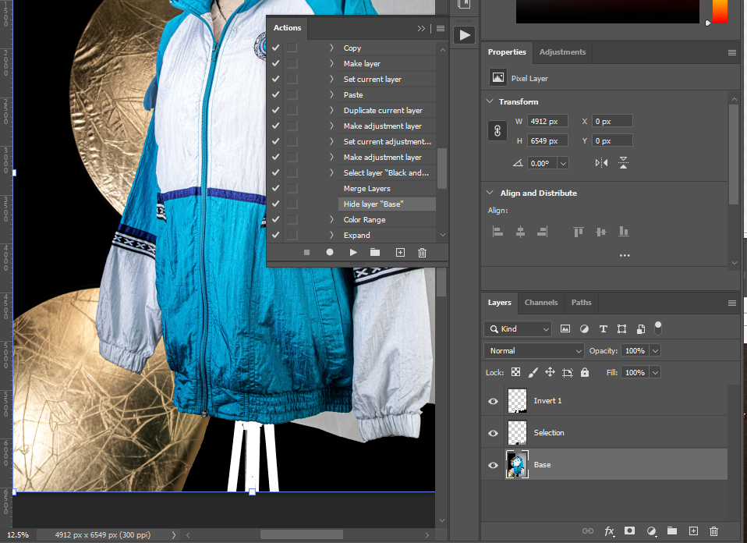

Your Layers Should look like this. ^

1. Turn off the visibility of the “Base” layer.
2. Select the layer named “Invert 1” then go to the toolbar and click Select→Color Range, use the eyedropper to choose the white pixels in the preview then click OK.
3. Expand the selection using Select→Modify→Expand. Expand Just enough to give a little bit of wiggle room for the fill we are about to do, I expanded my selection by 12 pixels.
4. Now select the “Selection” layer and Content-Aware Fill using Edit→Content-Aware Fill

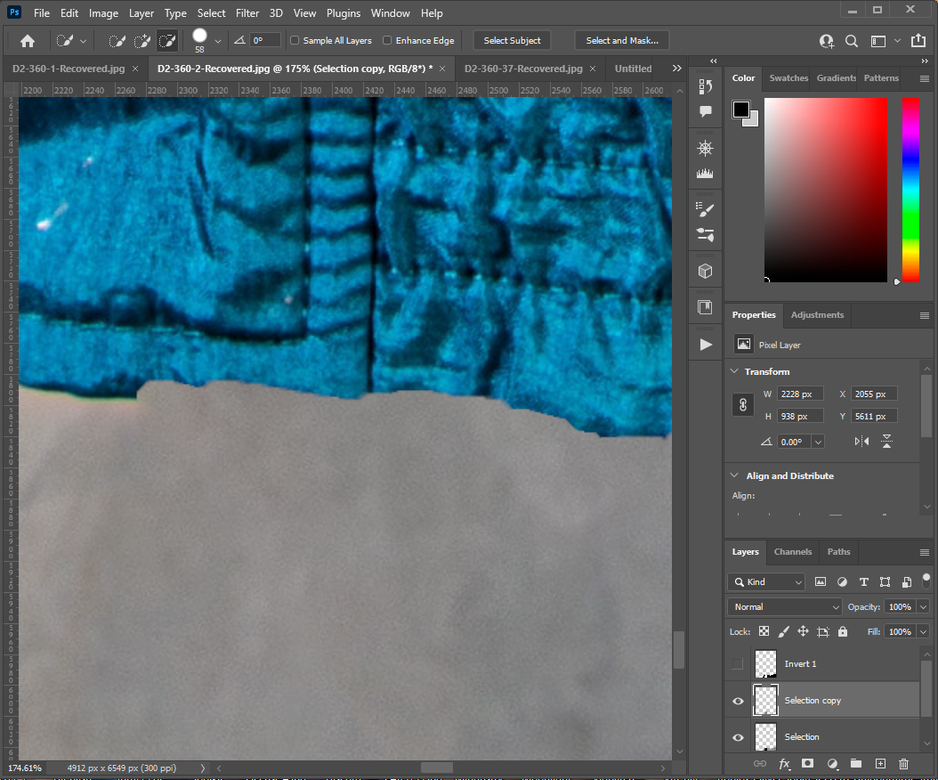

Note: We’ve covered up the stand but since we had to expand the selection it covers a bit of the clothes and we don't want that, so next we’re going to refine the content-aware fill so that it aligns with the image.

1. Select the “Invert 1” layer and select the pixels that have content in them by choosing Select→Focus Area and clicking ok on the pop-up menu.
2. Select the layer called “Selection Copy” that we put the content-aware fill on, then click on the Mask button at the bottom of the layer panel. This adds a mask to that layer and fixes the overflow from before.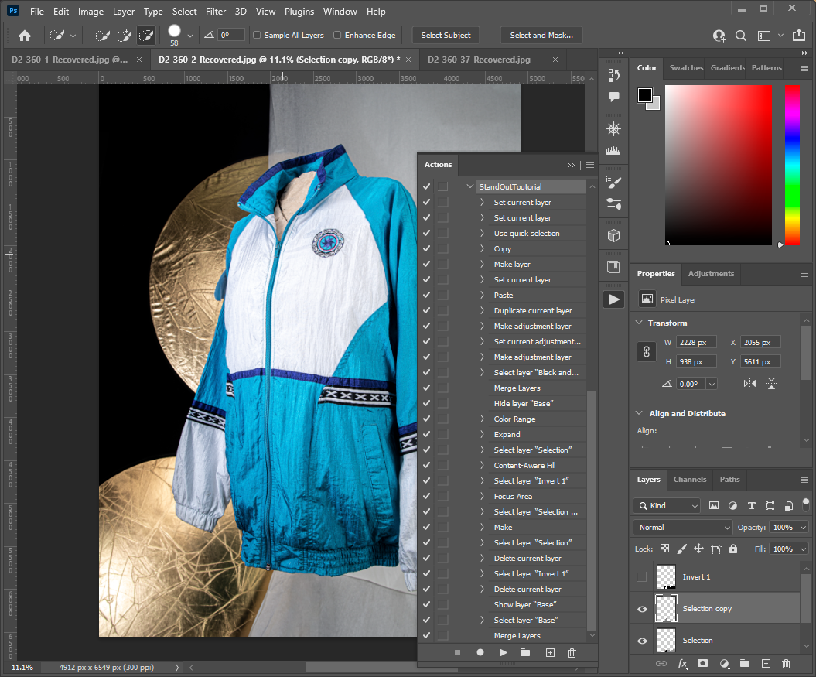
3. Delete both layers “Selection” and “Invert 1”
4. Turn on the visibility for the layer “Base”
5. Merge the layer “Base” with “Selection copy”
6. Finally, stop recording in the actions panel. You have removed the stand and created an action to do it automatically!

Part Two: Edit an entire batch of photos.

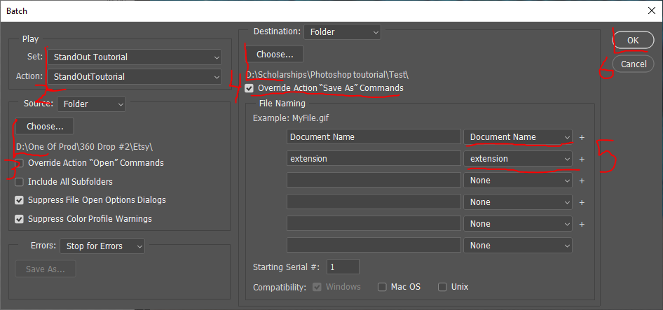

1. Luckily this step is much shorter than the last. With the photoshop document go to the toolbar and select File→Automate→Batch… from the top toolbar.
2. Select the set where you saved the action, as well as the action you created, that is StandOut Tutorial in both cases for me.
3. Select the source folder where you have saved the files you need editing.
4. Select the destination file where you want the files to be saved. Ensure “Override Action ‘Save As’ Commands” is checked.
5. Ensure your files have a name and extension in the File Naming section.
6. Finally, click OK and watch the magic happen!

As you can see, creating actions to automate a workflow doesn't take much time at all! Using these techniques of rough selection and then refining the automated selection enable you to do almost any edit any number of times. In the spirit of saving time, I have prepared a GitHub repository that holds a download of this photoshop action, as well as a copy of this tutorial and a sample set of images so that you can try this out on the same materials as me. Thank you so much for reading my entire tutorial, I wish you luck and good tidings on your photoshop journeys.

Git Repository.:<https://github.com/Bear2Be2/StandOutToutorial>