LAB2: Bài 1
BÀI TẬP 1
Chuẩn bị tài nguyên cho dự án
Tài nguyên hình ảnh
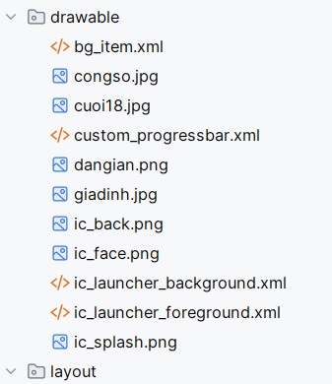
- Tài nguyên chuỗi
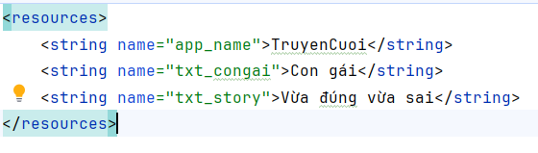
Tài nguyên màu sắc
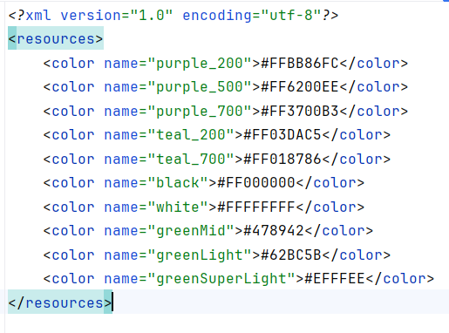
Tài nguyên về theme

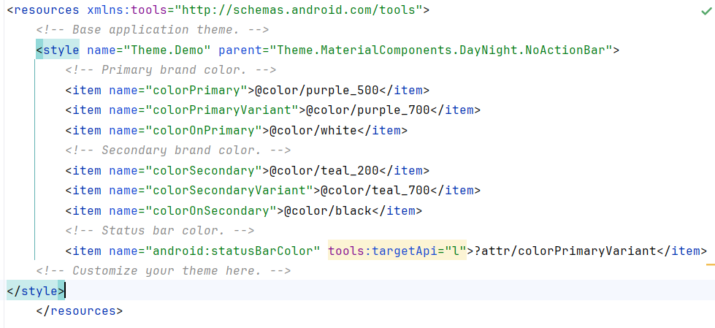
Khởi tạo các Entity danh mục truyện
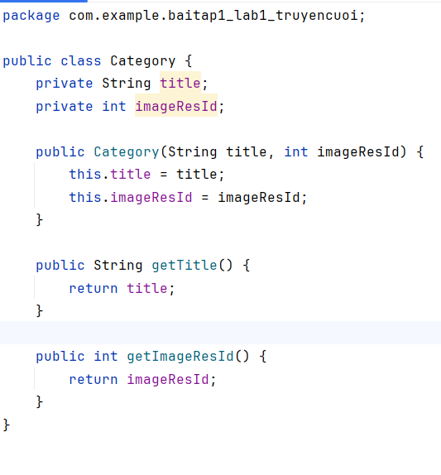
Khởi tạo entity truyện
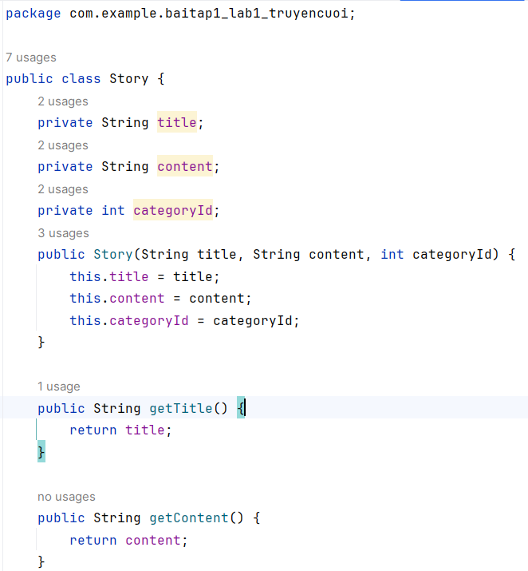
Khởi tạo layout Main Activity
<?xml version="1.0" encoding="utf-8"?>
<RelativeLayout xmlns:android="http://schemas.android.com/apk/res/android"
xmlns:tools="http://schemas.android.com/tools"
android:layout_width="match_parent"
android:layout_height="match_parent"
tools:context=".MainActivity"
android:id="@+id/ln_main">
<View
android:id="@+id/topBar"
android:layout_width="match_parent"
android:layout_height="50dp"
android:layout_alignParentTop="true"
android:background="@color/greenMid" />
<androidx.appcompat.widget.Toolbar
android:id="@+id/toolbar"
android:layout_width="match_parent"
android:layout_height="wrap_content"
android:layout_below="@id/topBar"
android:background="@color/greenLight"
android:title="Truyện cười 😁😋😄😍"
android:titleTextColor="@android:color/white" />
<androidx.recyclerview.widget.RecyclerView
android:id="@+id/recyclerView"
android:layout_width="match_parent"
android:layout_height="match_parent"
android:layout_below="@id/toolbar" />
</RelativeLayout>

Khởi tạo item_loading để làm splashScreen
<?xml version="1.0" encoding="utf-8"?>
<LinearLayout xmlns:android="http://schemas.android.com/apk/res/android"
android:layout_width="match_parent"
android:layout_height="match_parent"
android:gravity="center"
android:orientation="vertical">
<ProgressBar
android:id="@+id/progressBar"
android:layout_width="60dp"
android:layout_height="60dp"
android:indeterminate="true"
android:indeterminateDrawable="@drawable/custom_progressbar" />
<TextView
android:layout_width="wrap_content"
android:layout_height="wrap_content"
android:fontFamily="sans-serif-light"
android:text="...Loading"
android:textColor="@color/white"
android:textSize="24sp" />
</LinearLayout>
Khởi tạo SplashScreen để include item_loading
<?xml version="1.0" encoding="utf-8"?>
<FrameLayout xmlns:android="http://schemas.android.com/apk/res/android"
xmlns:tools="http://schemas.android.com/tools"
android:layout_width="match_parent"
android:layout_height="match_parent"
android:background="@color/greenMid"
android:id="@+id/layoutLoading">
<ImageView
android:layout_width="200dp"
android:layout_height="100dp"
android:layout_gravity="center"
android:src="@drawable/ic_splash"
tools:ignore="ContentDescription"/>
<include layout="@layout/item_loading" />
</FrameLayout>
Chuẩn bị item_category để hiển thị lên RecycleView
<?xml version="1.0" encoding="utf-8"?>
<RelativeLayout xmlns:android="http://schemas.android.com/apk/res/android"
android:layout_width="match_parent"
android:layout_height="wrap_content"
android:padding="8dp"
android:layout_margin="4dp"
android:background="@drawable/bg_item"
android:elevation="2dp"
android:clipToPadding="false"
android:clipChildren="false">
<ImageView
android:id="@+id/imgCategory"
android:layout_width="80dp"
android:layout_height="80dp"
android:scaleType="centerCrop"
android:src="@drawable/ic_launcher_foreground"
android:layout_alignParentStart="true"
android:layout_centerVertical="true"/>
<TextView
android:id="@+id/tvTitle"
android:layout_width="match_parent"
android:layout_height="wrap_content"
android:layout_toEndOf="@id/imgCategory"
android:layout_centerVertical="true"
android:paddingStart="12dp"
android:text="Tên danh mục"
android:textSize="18sp"
android:textStyle="bold"/>
</RelativeLayout>

Chuẩn bị CategoryAdapter để có thể render danh sách Category
package com.example.truyencuoi.Adapter;
import android.content.Context;
import android.content.Intent;
import android.view.LayoutInflater;
import android.view.View;
import android.view.ViewGroup;
import android.widget.ImageView;
import android.widget.TextView;
import androidx.annotation.NonNull;
import androidx.recyclerview.widget.RecyclerView;
import com.example.baitap1_lab1_truyencuoi.Category;
import com.example.baitap1_lab1_truyencuoi.R;
import com.example.baitap1_lab1_truyencuoi.StoryListActivity;
import java.util.List;
public class CategoryAdapter extends RecyclerView.Adapter<CategoryAdapter.ViewHolder> {
private Context context;
private List<Category> list;
public CategoryAdapter(Context context, List<Category> list) {
this.context = context;
this.list = list;
}
@NonNull
@Override
public ViewHolder onCreateViewHolder(@NonNull ViewGroup parent, int viewType) {
View view = LayoutInflater.from(context).inflate(R.layout.item_category, parent, false);
return new ViewHolder(view);
}
@Override
public void onBindViewHolder(@NonNull ViewHolder holder, int position) {
Category category = list.get(position);
holder.tvTitle.setText(category.getTitle());
holder.imgCategory.setImageResource(category.getImageResId());
}
@Override
public int getItemCount() {
return list.size();
}
public static class ViewHolder extends RecyclerView.ViewHolder {
ImageView imgCategory;
TextView tvTitle;
public ViewHolder(@NonNull View itemView) {
super(itemView);
imgCategory = itemView.findViewById(R.id.imgCategory);
tvTitle = itemView.findViewById(R.id.tvTitle);
}
}
}

Sau đó trong MainActivity
Toolbar toolbar = findViewById(R.id.toolbar);
setSupportActionBar(toolbar);
getSupportActionBar().setTitle("Truyện cười 😁😋😄😍");
list = new ArrayList<>();
list.add(new Category("Công sở", R.drawable.congso));
list.add(new Category("Cười 18", R.drawable.cuoi18));
list.add(new Category("Dân gian", R.drawable.dangian));
list.add(new Category("Gia đình", R.drawable.giadinh));
adapter = new CategoryAdapter(this, list);
recyclerView.setAdapter(adapter);

Sau đó ta tiếp tục thiết kế trang chứa danh sách câu chuyện activity_story_list
<?xml version="1.0" encoding="utf-8"?>
<RelativeLayout xmlns:android="http://schemas.android.com/apk/res/android"
android:layout_width="match_parent"
android:layout_height="match_parent">
<View
android:id="@+id/topBar"
android:layout_width="match_parent"
android:layout_height="50dp"
android:layout_alignParentTop="true"
android:background="@color/greenMid" />
<androidx.appcompat.widget.Toolbar
android:id="@+id/toolbar"
android:layout_width="match_parent"
android:layout_height="?attr/actionBarSize"
android:layout_below="@id/topBar"
android:background="@color/greenLight"
android:titleTextColor="@android:color/white" />
<androidx.recyclerview.widget.RecyclerView
android:id="@+id/recyclerViewStory"
android:layout_width="match_parent"
android:layout_height="match_parent"
android:layout_below="@id/toolbar" />
</RelativeLayout>

Và story_item để viết StoryAdapter
<RelativeLayout xmlns:android="http://schemas.android.com/apk/res/android"
android:layout_width="match_parent"
android:layout_height="wrap_content"
android:padding="12dp"
android:background="@drawable/bg_item">
<LinearLayout
android:layout_width="wrap_content"
android:layout_height="wrap_content"
android:orientation="horizontal"
android:gravity="center_vertical">
<ImageView
android:id="@+id/imgSmile"
android:layout_width="24dp"
android:layout_height="24dp"
android:src="@drawable/ic_face" />
<TextView
android:id="@+id/tvStoryTitle"
android:layout_width="wrap_content"
android:layout_height="wrap_content"
android:text="Tên truyện"
android:textSize="18sp"
android:textStyle="bold"
android:paddingStart="8dp"/>
</LinearLayout>
</RelativeLayout>

Ta tiến hành viết storyAdapter
package com.example.baitap1_lab1_truyencuoi;
import android.content.Context;
import android.content.Intent;
import android.view.LayoutInflater;
import android.view.View;
import android.view.ViewGroup;
import android.widget.ImageView;
import android.widget.TextView;
import androidx.annotation.NonNull;
import androidx.recyclerview.widget.RecyclerView;
import java.util.List;
public class StoryAdapter extends RecyclerView.Adapter<StoryAdapter.ViewHolder> {
private Context context;
private List<Story> storyList;
public StoryAdapter(Context context, List<Story> storyList) {
this.context = context;
this.storyList = storyList;
}
@NonNull
@Override
public ViewHolder onCreateViewHolder(@NonNull ViewGroup parent, int viewType) {
View view = LayoutInflater.from(context).inflate(R.layout.item_story, parent, false);
return new ViewHolder(view);
}
@Override
public void onBindViewHolder(@NonNull ViewHolder holder, int position) {
Story story = storyList.get(position);
holder.tvTitle.setText(story.getTitle());
}
@Override
public int getItemCount() {
return storyList.size();
}
public static class ViewHolder extends RecyclerView.ViewHolder {
TextView tvTitle;
public ViewHolder(@NonNull View itemView) {
super(itemView);
tvTitle = itemView.findViewById(R.id.tvStoryTitle);
}
}
}

Ta bổ sung sự kiện click và gửi tên tiêu đề cho ở CategoryAdapter hiển thị đúng
holder.itemView.setOnClickListener(v -> {
Intent intent = new Intent(context, StoryListActivity.class);
intent.putExtra("categoryTitle", category.getTitle());
context.startActivity(intent);
});

Sau đó ta nhận ở bên StoryListActivity
package com.example.baitap1_lab1_truyencuoi;
import android.content.Intent;
import android.os.Bundle;
import androidx.appcompat.widget.Toolbar;
import androidx.appcompat.app.AppCompatActivity;
import androidx.recyclerview.widget.LinearLayoutManager;
import androidx.recyclerview.widget.RecyclerView;
import java.util.ArrayList;
import java.util.List;
public class StoryListActivity extends AppCompatActivity {
private RecyclerView recyclerView;
private StoryAdapter adapter;
private List<Story> storyList;
@Override
protected void onCreate(Bundle savedInstanceState) {
super.onCreate(savedInstanceState);
setContentView(R.layout.activity_story_list);
Toolbar toolbar = findViewById(R.id.toolbar);
setSupportActionBar(toolbar);
String categoryTitle = getIntent().getStringExtra("categoryTitle");
getSupportActionBar().setTitle(categoryTitle);
getSupportActionBar().setDisplayHomeAsUpEnabled(true);
recyclerView = findViewById(R.id.recyclerViewStory);
recyclerView.setLayoutManager(new LinearLayoutManager(this));
storyList = new ArrayList<>();
if (categoryTitle.equals("Công sở")) {
storyList.add(new Story("Sếp và nhân viên", "Một ngày nọ...", 1));
storyList.add(new Story("Báo cáo trễ", "Nhân viên nói với sếp rằng...", 1));
} else if (categoryTitle.equals("Gia đình")) {
storyList.add(new Story("Con với mẹ", "Mẹ hỏi con: ...", 2));
}
adapter = new StoryAdapter(this, storyList);
recyclerView.setAdapter(adapter);
toolbar.setNavigationOnClickListener(v -> onBackPressed());
}
}

Ta tiến hành viết story detail để hiển thị chi tiết story
<?xml version="1.0" encoding="utf-8"?>
<RelativeLayout xmlns:android="http://schemas.android.com/apk/res/android"
android:layout_width="match_parent"
android:layout_height="match_parent">
<View
android:id="@+id/topBar"
android:layout_width="match_parent"
android:layout_height="50dp"
android:layout_alignParentTop="true"
android:background="@color/greenMid" />
<androidx.appcompat.widget.Toolbar
android:id="@+id/toolbar"
android:layout_width="match_parent"
android:layout_height="?attr/actionBarSize"
android:layout_below="@id/topBar"
android:background="@color/greenLight"
android:titleTextColor="@android:color/white" />
<LinearLayout
android:id="@+id/centerContainer"
android:orientation="vertical"
android:layout_width="match_parent"
android:layout_height="wrap_content"
android:layout_below="@id/toolbar"
android:layout_centerVertical="true"
android:paddingTop="16dp"
android:paddingBottom="16dp">
<TextView
android:id="@+id/tvDetailTitle"
android:layout_width="match_parent"
android:layout_height="wrap_content"
android:text="Tiêu đề"
android:textSize="24sp"
android:textStyle="bold"
android:gravity="center" />
<TextView
android:id="@+id/tvDetailDescription"
android:layout_width="match_parent"
android:layout_height="wrap_content"
android:text="Mô tả chi tiết"
android:textSize="16sp"
android:gravity="start"
android:paddingTop="8dp"
android:paddingLeft="16dp"
android:paddingRight="16dp"/>
</LinearLayout>
</RelativeLayout>

Ta tiếp tục viết sự kiện xử lý nhấn vào story để ra story detail
holder.itemView.setOnClickListener(v -> {
Intent intent = new Intent(context, StoryDetailActivity.class);
intent.putExtra("title", story.getTitle());
intent.putExtra("description", story.getContent());
context.startActivity(intent);
});

Hiển thị dữ liệu lên storyDetail
package com.example.baitap1_lab1_truyencuoi;
import android.os.Bundle;
import android.widget.TextView;
import androidx.appcompat.app.AppCompatActivity;
import androidx.appcompat.widget.Toolbar;
public class StoryDetailActivity extends AppCompatActivity {
private TextView tvTitle, tvDescription;
@Override
protected void onCreate(Bundle savedInstanceState) {
super.onCreate(savedInstanceState);
setContentView(R.layout.activity_story_detail);
Toolbar toolbar = findViewById(R.id.toolbar);
setSupportActionBar(toolbar);
getSupportActionBar().setDisplayHomeAsUpEnabled(true);
tvTitle = findViewById(R.id.tvDetailTitle);
tvDescription = findViewById(R.id.tvDetailDescription);
String title = getIntent().getStringExtra("title");
String description = getIntent().getStringExtra("description");
getSupportActionBar().setTitle(title);
tvTitle.setText(title);
tvDescription.setText(description);
}
}

Ta tiến hành viết M000SplashFrg để xử lý việc loading khi vừa vào trang chủ
package com.example.baitap1_lab1_truyencuoi;
import android.os.Bundle;
import android.os.Handler;
import android.view.LayoutInflater;
import android.view.View;
import android.view.ViewGroup;
import android.widget.FrameLayout;
import androidx.fragment.app.Fragment;
public class M000SplashFrg extends Fragment {
@Override
public View onCreateView(LayoutInflater inflater, ViewGroup container, Bundle savedInstanceState) {
View view = inflater.inflate(R.layout.m000_frg_splash, container, false);
new Handler().postDelayed(() -> gotoM001Screen(view), 2000);
return view;
}
private void gotoM001Screen(View view) {
FrameLayout loading = getActivity().findViewById(R.id.layoutLoading);
if (loading != null) {
loading.setVisibility(View.GONE);
}
((MainActivity) getActivity()).gotoM001Screen();
}
}

Ở mainActivity ta tiến hành ẩn hết và sau khi showFrg chạy xong ta tiến hành hiển thị lên lại
package com.example.baitap1_lab1_truyencuoi;
import android.content.pm.ActivityInfo;
import android.os.Bundle;
import android.widget.Button;
import android.widget.FrameLayout;
import androidx.appcompat.app.AppCompatActivity;
import androidx.appcompat.widget.Toolbar;
import androidx.fragment.app.Fragment;
import androidx.recyclerview.widget.LinearLayoutManager;
import androidx.recyclerview.widget.RecyclerView;
import com.example.truyencuoi.Adapter.CategoryAdapter;
import java.util.ArrayList;
import java.util.List;
public class MainActivity extends AppCompatActivity {
private boolean rotationEnabled = true;
RecyclerView recyclerView;
List<Category> list;
CategoryAdapter adapter;
@Override
protected void onCreate(Bundle savedInstanceState) {
super.onCreate(savedInstanceState);
setContentView(R.layout.activity_main);
if (savedInstanceState == null) {
showFrg(new M000SplashFrg());
}
recyclerView = findViewById(R.id.recyclerView);
recyclerView.setLayoutManager(new LinearLayoutManager(this));
recyclerView.setVisibility(RecyclerView.INVISIBLE);
Toolbar toolbar = findViewById(R.id.toolbar);
setSupportActionBar(toolbar);
toolbar.setVisibility(Toolbar.INVISIBLE);
getSupportActionBar().setTitle("Truyện cười 😁😋😄😍");
list = new ArrayList<>();
list.add(new Category("Công sở", R.drawable.congso));
list.add(new Category("Cười 18", R.drawable.cuoi18));
list.add(new Category("Dân gian", R.drawable.dangian));
list.add(new Category("Gia đình", R.drawable.giadinh));
adapter = new CategoryAdapter(this, list);
recyclerView.setAdapter(adapter);
}
private void showFrg(Fragment frg) {
getSupportFragmentManager()
.beginTransaction()
.replace(R.id.ln_main, frg, null)
.commit();
}
public void gotoM001Screen() {
FrameLayout loading = findViewById(R.id.layoutLoading);
if (loading != null) {
loading.setVisibility(FrameLayout.GONE);
}
if (recyclerView != null) recyclerView.setVisibility(RecyclerView.VISIBLE);
Toolbar toolbar = findViewById(R.id.toolbar);
if (toolbar != null) toolbar.setVisibility(Toolbar.VISIBLE);
}
}

ở Android Manifest ta tiến hành thêm các activity vào
<?xml version="1.0" encoding="utf-8"?>
<manifest xmlns:android="http://schemas.android.com/apk/res/android"
xmlns:tools="http://schemas.android.com/tools">
<application
android:allowBackup="true"
android:dataExtractionRules="@xml/data_extraction_rules"
android:fullBackupContent="@xml/backup_rules"
android:icon="@mipmap/ic_launcher"
android:label="@string/app_name"
android:roundIcon="@mipmap/ic_launcher_round"
android:supportsRtl="true"
android:theme="@style/Theme.Demo">
<activity
android:name=".MainActivity"
android:exported="true">
<intent-filter>
<action android:name="android.intent.action.MAIN" />
<category android:name="android.intent.category.LAUNCHER" />
</intent-filter>
</activity>
<activity android:name=".StoryListActivity"
android:parentActivityName=".MainActivity" />
<activity android:name=".StoryDetailActivity"
android:parentActivityName=".MainActivity" />
</application>
</manifest>

Sau đó ta tiến hành viết chức năng tắt và xoay bằng cách thêm button vào main activity
<Button
android:id="@+id/btnRotation"
android:layout_width="wrap_content"
android:layout_height="wrap_content"
android:text="Rotation ON"
android:layout_alignParentBottom="true"
android:layout_centerHorizontal="true"
android:layout_marginBottom="16dp"/>

Sau đó xử lý btnRotation
package com.example.baitap1_lab1_truyencuoi;
import android.content.pm.ActivityInfo;
import android.os.Bundle;
import android.widget.Button;
import android.widget.FrameLayout;
import androidx.appcompat.app.AppCompatActivity;
import androidx.appcompat.widget.Toolbar;
import androidx.fragment.app.Fragment;
import androidx.recyclerview.widget.LinearLayoutManager;
import androidx.recyclerview.widget.RecyclerView;
import com.example.truyencuoi.Adapter.CategoryAdapter;
import java.util.ArrayList;
import java.util.List;
public class MainActivity extends AppCompatActivity {
private boolean rotationEnabled = true;
RecyclerView recyclerView;
List<Category> list;
CategoryAdapter adapter;
@Override
protected void onCreate(Bundle savedInstanceState) {
super.onCreate(savedInstanceState);
setContentView(R.layout.activity_main);
if (savedInstanceState == null) {
showFrg(new M000SplashFrg());
}
Button btnRotation = findViewById(R.id.btnRotation);
btnRotation.setVisibility(Button.INVISIBLE);
recyclerView = findViewById(R.id.recyclerView);
recyclerView.setLayoutManager(new LinearLayoutManager(this));
recyclerView.setVisibility(RecyclerView.INVISIBLE);
Toolbar toolbar = findViewById(R.id.toolbar);
setSupportActionBar(toolbar);
toolbar.setVisibility(Toolbar.INVISIBLE);
getSupportActionBar().setTitle("Truyện cười 😁😋😄😍");
list = new ArrayList<>();
list.add(new Category("Công sở", R.drawable.congso));
list.add(new Category("Cười 18", R.drawable.cuoi18));
list.add(new Category("Dân gian", R.drawable.dangian));
list.add(new Category("Gia đình", R.drawable.giadinh));
adapter = new CategoryAdapter(this, list);
recyclerView.setAdapter(adapter);
btnRotation.setOnClickListener(v -> {
if (rotationEnabled) {
setRequestedOrientation(ActivityInfo.SCREEN_ORIENTATION_PORTRAIT);
btnRotation.setText("Rotation OFF");
} else {
setRequestedOrientation(ActivityInfo.SCREEN_ORIENTATION_UNSPECIFIED);
btnRotation.setText("Rotation ON");
}
rotationEnabled = !rotationEnabled;
});
}
private void showFrg(Fragment frg) {
getSupportFragmentManager()
.beginTransaction()
.replace(R.id.ln_main, frg, null)
.commit();
}
public void gotoM001Screen() {
FrameLayout loading = findViewById(R.id.layoutLoading);
if (loading != null) {
loading.setVisibility(FrameLayout.GONE);
}
if (recyclerView != null) recyclerView.setVisibility(RecyclerView.VISIBLE);
Toolbar toolbar = findViewById(R.id.toolbar);
if (toolbar != null) toolbar.setVisibility(Toolbar.VISIBLE);
Button btnRotation = findViewById(R.id.btnRotation);
if (btnRotation != null) btnRotation.setVisibility(Button.VISIBLE);
}
}

ROTATION ON thì cho phép xoay màn hình còn nếu OFF thì chỉ có thể đứng

Kết quả:
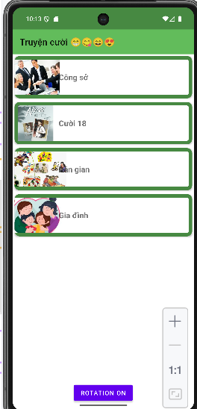
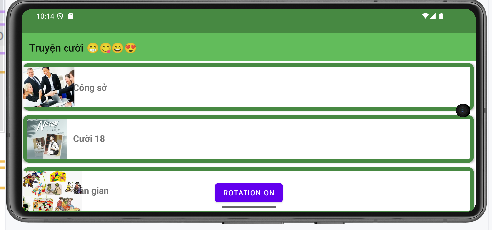
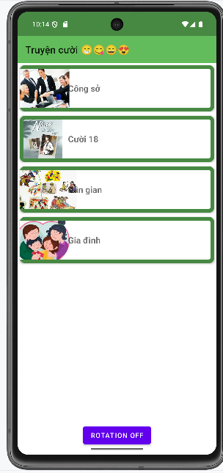
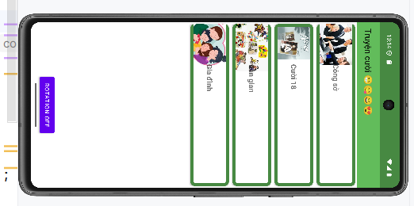

BÀI TẬP 2

Kết quả mặc định:
