**Звіт до лабораторної роботи 2**

Або як створили

**Best storage manage program**

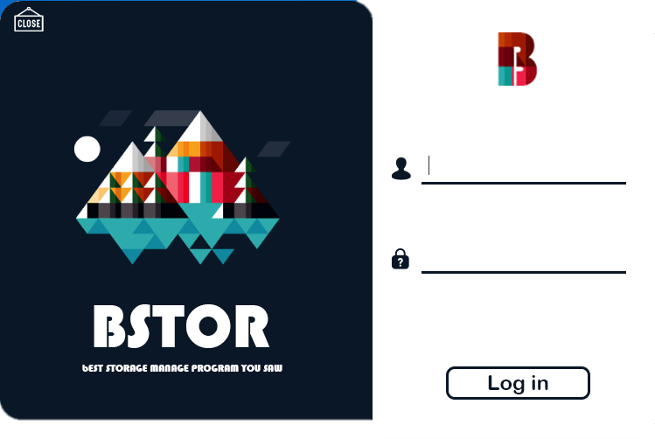

**Над проектом працювали**



**\*Медведєв Дмитро**

**\*Слободяник Максим**

**\*Євтушенко Ігор**

W O R K I N G R E S P O N S A B I L I T Y



MAKC

-Frontend

-all design

-creative picture

-work with Photoshop

-code review

The best phrase he ever said:

All will be how I will do



**Д і м а**

**-Backend**

**-Do program logic**

**-Do mathematic logic**

**-Do all buttons**

**-Create GitHub repository**

**-Do DATABASE**

**-Code review**

**The best phrase he ever said :**

**JUST CODE IT**



Ігор

-Backend

-do program logic

-do find and search system

-code review

The best phrase he ever said:

Sorry guys, I broke out program

**Errors**

**The most difficult problem was connect our code in GitHub**

**The worst problem was in Saturday at 20:17, when Igor destroyed all program**

**Where you can use our manager program?**



**Answer:**

**everywhere**

**How our homework works and what you can do**

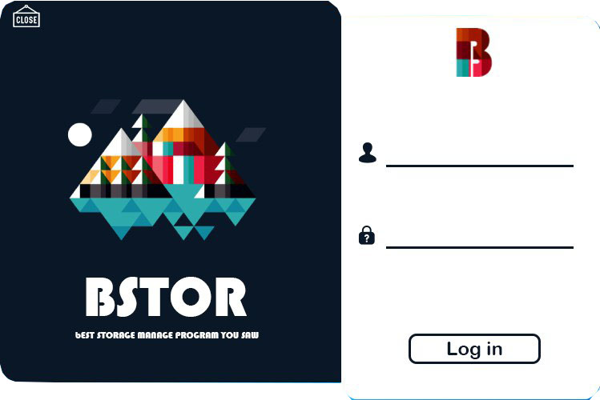

Щоб увійти в нашу програму вам спочатку потрібно зареєструватися

