Overstock.com
Pet Adoption

Zach Dyer, Mike Mai, Brendan Myers

1699-Final Deliverable

Introduction

For this deliverable, we tested the Pet Adoptions section of the website Overstock.com. Specifically, we developed a plan to test the website using both usability and selenium-based web testing. The goal of our tests was to determine the quality of the website from a user-facing perspective.
Because this is a live website, usability testing is the most appropriate way to test the quality of the site from a user perspective. The usability test was run by giving users a goal to complete on the website and observing the paths that they used. While completing this goal, the users gave input as to how they expect the site to behave and how their observations compare with these expectations. This input was used to highlight flaws in the system and possible areas for improvement. While the site is live and generally error free, there were consistent problems throughout the trials that hindered usability.
Additionally, web testing via selenium was performed to ensure solid performance of the expected services. These tests focused on areas such as search functionality and customer interaction toward the requested pets, such as requesting more information about a pet. As a live web service, it is important to guarantee the dependability of utilities.

Issues
The usability testing was performed as expected. The most difficult part of the process was limiting bias given from the observer. While we encouraged the participants at all times during the test to explore as they would if they were using the system they occasionally needed prompting to bring them to a new part of the section under test. We tried to implement a goal-oriented test to reflect the actual use case of someone on the website. While we do believe this was an effective way to exhaustively test the red routes of the system, our concern would be that the observer introduced bias into the testing by giving goals that may have limited the scope of the usability tests. However, this biased scope was also the scope of this deliverable. For more exhaustive testing, more goals should be added (e.g. more reptile testing).
The only issue encountered in web testing worth noting is that the testTweetPet will fail if Firefox blocks pop-ups. The solution is simple enough, just click allow pop-ups for OverStock.com when a notification is displayed. Rerunning that test will result in a success.

Quality Assessment
Usability
Area | Notes
Main Site Home Page | Modify Overstock.com search to point to Pet Adoption section when animals are searched
Pet Home Page | Page was liked and straightforward
Initial Pet Search | Functions as expected
Pet Results Page | Looks and functions as expected
Pet Results | All results were correct with respect to filters
Pet Details/Fields | Many users want specific ages, find ranges too vague. Fields often are too sparse
Filters | Users impressed by variety, works as expected
Individual Pet Page | Page layout is easy to understand
Pet Navigation Bar | Zip-Code lost between tabs
Pet Search Bar | Zip-Code lost on search
Error Handling | Upon finding no matches, all filters are discarded and user is brought back to home pet page, should keep filters
Shelter Integration | Users liked the “ask about me” button

From a usability standpoint, the Pet Adoptions section is definitely production ready. There are minor usability issues that may need to be reworked to further polish the system, but overall the system is intuitive and behaves as expected. Currently, the highest priority issue to fix is the location of the Pet Adoptions site on the home page of Overstock.com. Upon searching for animals, the main site should link to the Pet Adoptions site. For more details on the usability testing, consult the document “walkthroughs.docx” on github.

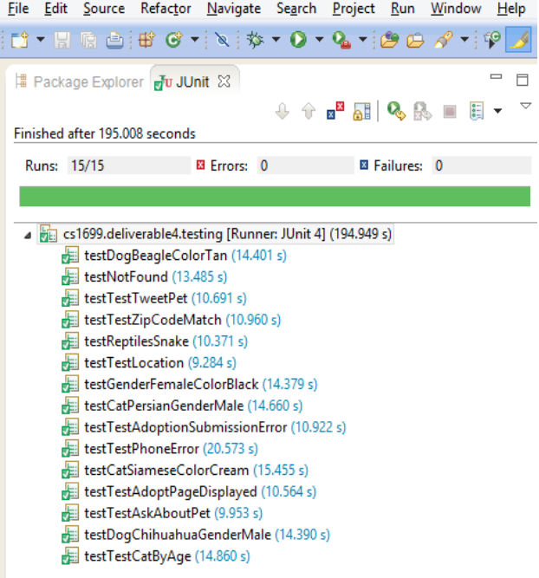
Web based testing results. The pet service from OverStock.com is reliable and I overall impressive considering most people would not think to look at OverStock for pets. The selenium testing found no major issues. Any issues found were mild and associated with general usability.

