Drone Empyre

Konstantin Tomov

40087091@napier.ac.uk

Edinburgh Napier University - Module Title (SET09103)

# 1 Introduction

Drone Empyre is a web application with the purpose of connecting RC hobbyists together and allowing them to share their experience on the topic. Although the site is mainly meant for drones it is open enough for the users to discus and share any experiment or cool ideas that they have on any related topic. The site acts almost like a snapchat or a gallery as anybody can open it and review all the posts at any time, meanwhile a logins system exist for the people that want to post and keep record of their activities. Overall a fun little app to help you keep up with what other drone hobbyists are up to.

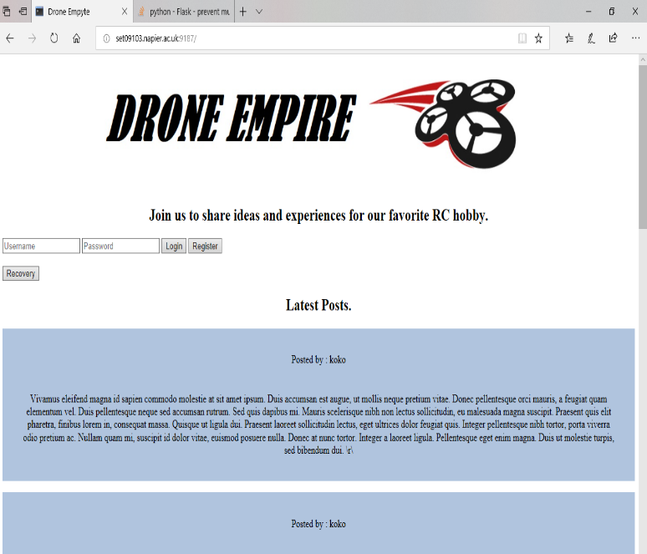

# 2 Design

The design of the site is structured around ease of use and flexibility for future improvements. The visual design is simple with dissent scalability allowing the users to enter it from large variety of devises. Background is white font making it easier to keep track of the text that the user is reading as the main stream of information will be written. That also keep the data usage very low for mobile devises.

URL hierarchy of the site is bases around two main pages, for logged and not logged users. The not logged users main page gives restricted access to the user as well as a way to register and log in. After logging in the user is navigated to clone of the main page giving the logged user access to all the futures of the site.

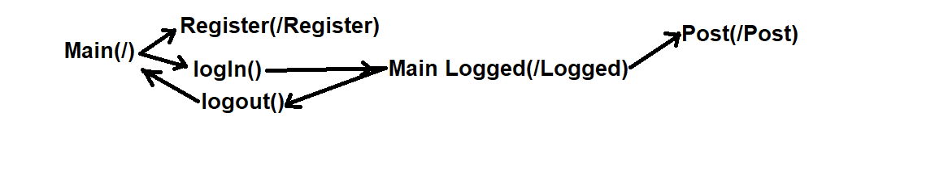



This structure allows reasonable separation between users and gests as well as easy future expansion. The User registration requires very little amount of personal data, only an email for potential credential recovery., making the protection of the personal data easer. For the security of the user credential there are two SQL data bases, one manages the user information, and a second one is handling the storage of the post. Unlike the posts data base, which has to be loaded to the user side to present the information, the user data is entirely handled on the server side preventing any militias access. There is no additional level of protection as there is no sensitive information that can be stolen. A potential scenario of stolen username or password can be achieved by interception of the packages between the server and the personal devise as the stream of data is not encoded.

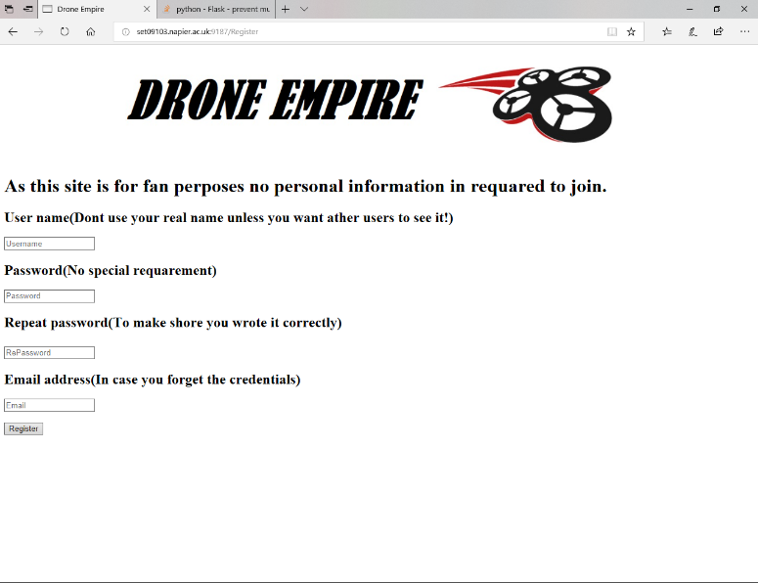

# 3 Enhancements

Future improvement on the site are separated in two groups. 1.Must have futures that are making the site more user friendly and productive. The most important of them is an image upload to be added to the post, to make them more interactive and pleasant.

The second must have improvement that will improve the quality of use is a search bar that will allow the user to filter the post and find the one most relative to him and his interests, minimising the waste of time.

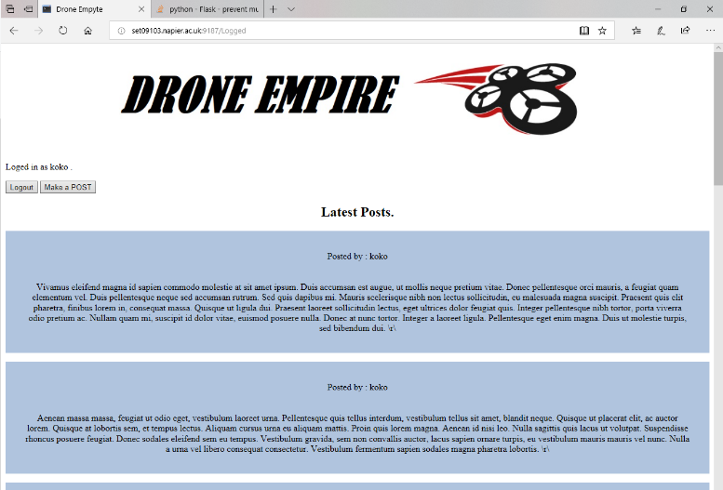

2.Some of the less important upgrades on the side are shown as list and do not affect the functionality.

- Date and time indicator on the posts

- Add to favourites

- Profile customisation

- Visual improvements

# 4 Critical Evaluation

The application is a proof of concept that shows “Instagram” like application narrowed to a specific group of people to share information and good ideas in a very fast and efficient way. The registration system works great, although it needs some refining on the user input cheeks (email for example). The post system works adequately and is in need of more work to store and display pictures making it more engaging for the user. In general, the visual part of the site requires more work and there are some functionality that could be added in the future.

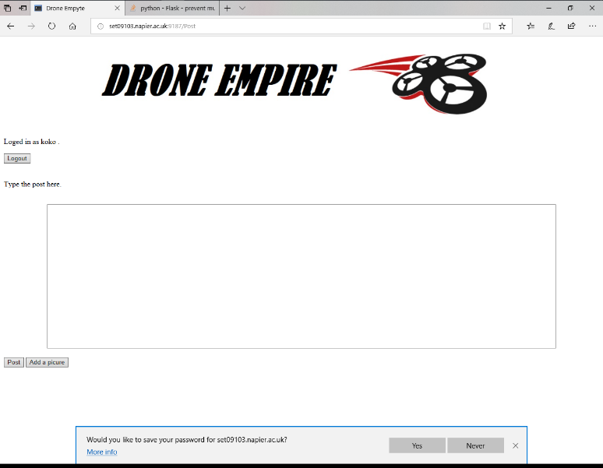

# 5 Personal Evaluation

Personal project of this size requires a lot of research that needs to be done as well as good planning before execution. Most of the time spend was in researching the different languages and tool used. The python programming language was particularly extensive as it is the main language used for this project and is very extensive giving the programmer a lot of freedom and usability #, the problem I encountered is that it is very syntax sensitive and I spend large amount of time searching for mistakes. Because of previas experience with HTML and CSS I had no problem with them. Unfortunately, I found SQL to be extremely difficult and had to spend a lot of time learning its basics before I felt confident to proceed with my work. The hardest part of this project was to keep track of any reasonable resources for references, as most of the time the information was pieced together from varies sources fount throw Google, therefore almost no direct references are added to the reference Part of the report.

# References

<https://www.w3schools.com/>

<https://www.python.org/>

<https://github.com/siwells/teaching_set09103/wiki>

<http://flask.pocoo.org/>

<https://www.sqlite.org/lang.html>

<http://jinja.pocoo.org/docs/2.10/templates/>