|  |
| --- |
| [2014][DA2] |
| Magic tactil - |
| Magic Tactil is a video game that permit you to play Magic: The gathering. Magic is a trading card game. In addition to exchange and enjoy with their friends, the player may participate to the international community life. For this, the player will talk on our forums and may organize some events. |

21/03/2013

INTRODUCTION

The aim of the project is to create a place where people can play to Magic : The gathering. This permits to the users to play like if they use real cards. The game will be available on Surface, Surface 2, Windows 8 and Android. So, the aim of the document is to give some information about this platform, and to lead the user through it.

# Description of document

|  |  |
| --- | --- |
|  |  |
| Title | [2014][DA2] User Documentation |
| Date | 21/03/2013 |
| Author | Oualid JOUHRI/Mehdi FARSI |
| Email | [magictactil@epitech.eu](mailto:magictactil@epitech.eu) |
| Version | 1.0 |

# Tableau des révisions

|  |  |  |  |  |
| --- | --- | --- | --- | --- |
| Date | Author | Section(s) | Comment |  |
| 21/03/2013 | Jouhri_o/farsi_m | All | First version |  |

Summary

# Installation & uninstallation

# Android

# Windows

# IOS

# How to use the platform

# Authentication

# Event

# Friends

# Game

# Contacts

Installation & Uninstallation

# Android

## Install app



1. Open **Google play** and locate the app **Magic Tactil**. After, push installation button.

## Uninstaller app

1. Click on **Option =>Settings**
2. Go to apps
3. Select **Manage appplication**

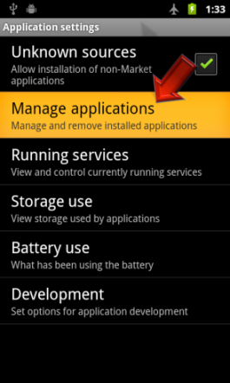

1. Sélect **Magic tactil** on list
2. Click on **Uninstall**

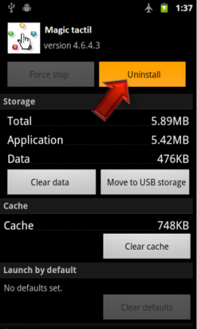

# Windows

## Install app

On Start screen, open App Store.



Find app **Magic tactil**. Click on "**Install**".

After installation, the start screen will display the app.

## Uninstall app

Find app **Magic tactil** by using the **Finder** .

Select app and click on Uninstall button.



Cliquer sur "**Uninstall**".

# 

# IOS

## Install app



1. Open **App Store** on iPhone and locate app **Magic tactil**. After, push on **Install button**.

## Uninstaller app

1. Push and maintain click on Magic tactil app icon on Home screen until icons start to shake.

2. Appuyer sur le «x» dans le coin de l'application à supprimer.



3. Push on Delete to delete all data of the app.

4. Click on **Home** **button**  to cancel the deletion.

How to use the platform

# Authentication

## Sign up

To sign up the user needs to fill in the following fields:

* + - Username
    - Email
    - Password

## Sign in

To log in the user needs to fill in the following fields:

* + - username
    - Password

## Sign out

To log out the user needs to open tab **Settings** and click on « **Log out** ».

# Event

## Create an event

To create an event the user needs to open tab **Events** and click on **Create an event**. After, just fill in the following fields:

* Title
* Date
* Description

## Participate in an event

To participate in an event the user needs to open tab **Events**, select **Events list** and pick an event on the list. After, just click on **I participate**.

# Friends

## Add a friend

To add a friend the user needs to open tab Friend and select **add friend**. After, fill in the field **Name**.

## Supprimer un ami(es)

To remove a friend the user needs to open tab Friend and select **Friend list**, pick a friend and maintain a long click on this friend. A menu is displayed. On this menu, the user select **Remove**.

# Game

## Message an opponent

To message an opponent the user needs to write his message on the chat available on the side. After, click on **Enter** to send it.

## Move cards

To move a card the user has to drag and drop the card until the wished destination spot.

Contact

To stay up to date about Magic Tactil follow these links:

Facebook: <https://www.facebook.com/pages/Magictactil/319882788114639>

Twitter: <https://twitter.com/MagicTactil>

Website: <http://eip.epitech.eu/2014/magictactil/about_fr.html>

For more information about the game Magic you can look into the explanations of the official website thanks to this link:

Game booklet:

<http://www.wizards.com/Magic/TCG/NewtoMagic.aspx?x=mtg/tcg/newtomagic/whatismagic>