
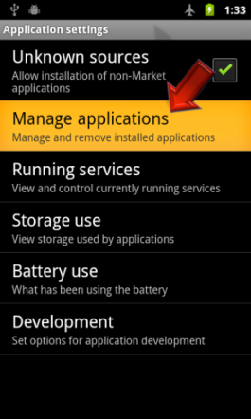
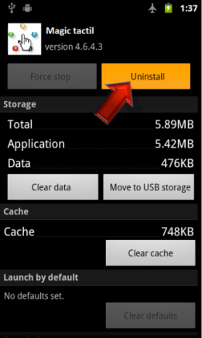

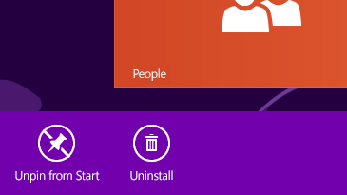


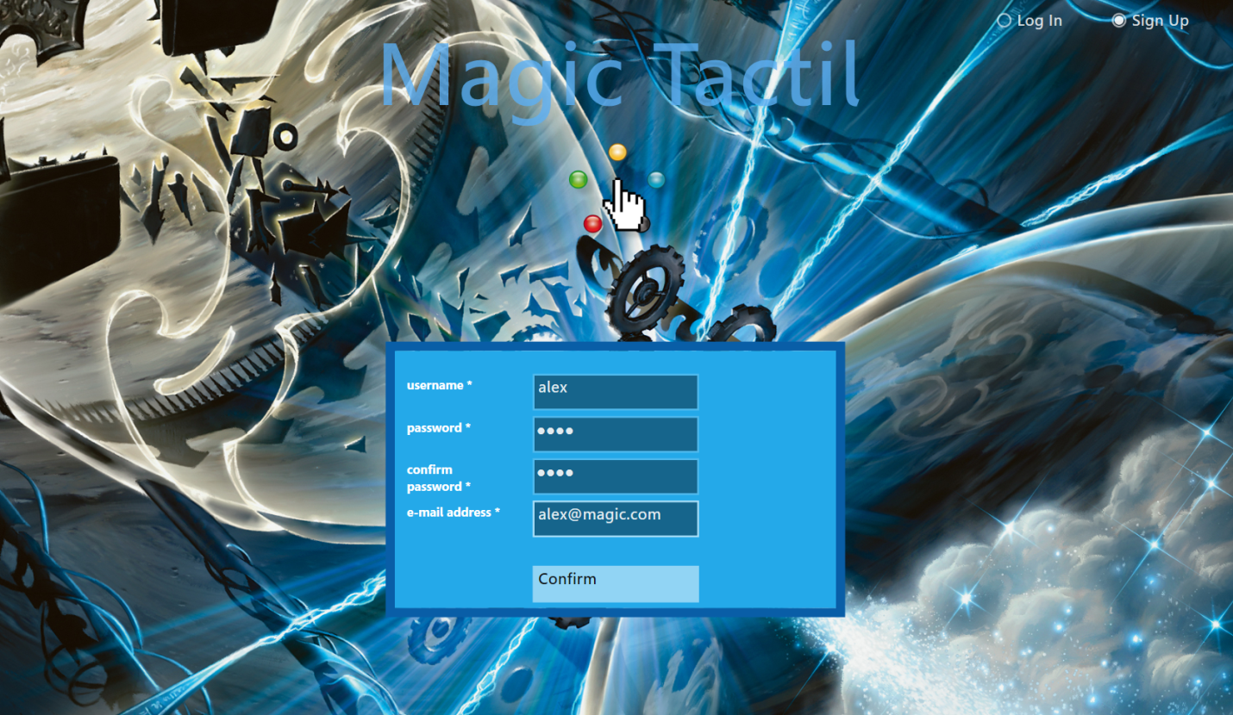
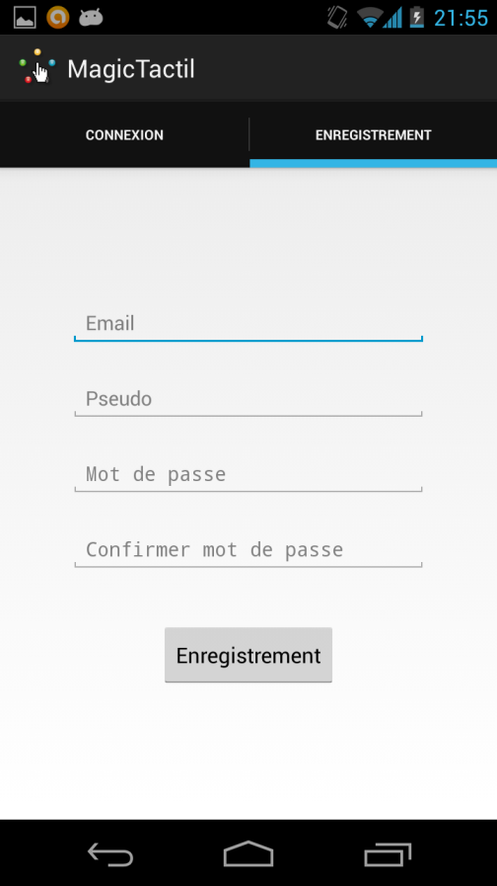
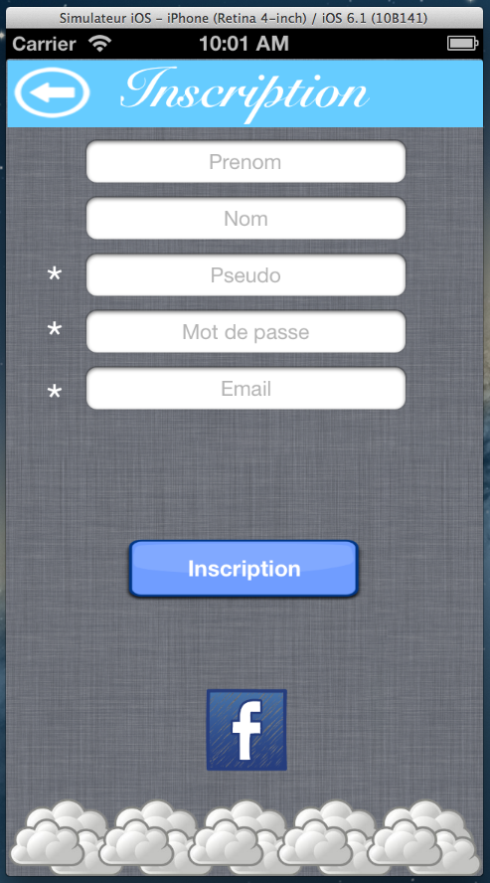
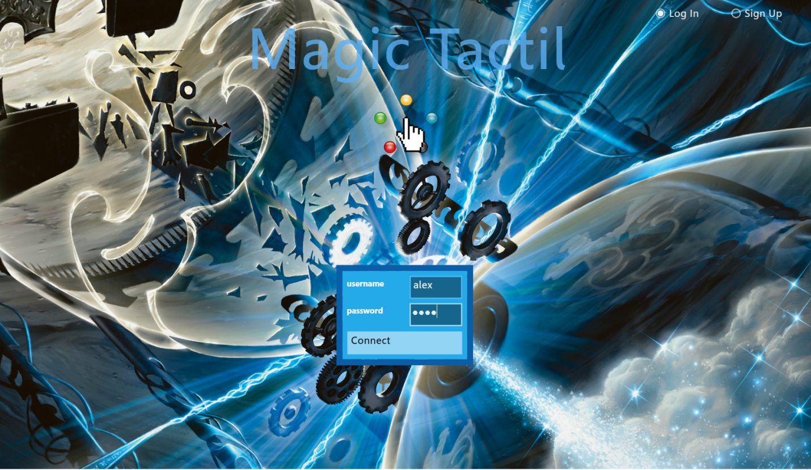
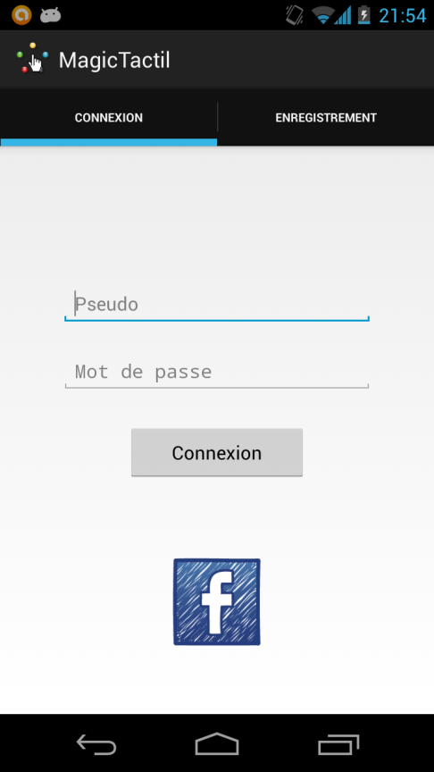
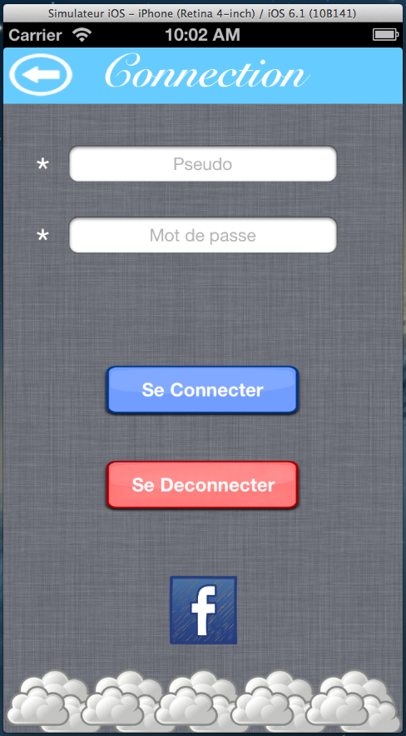
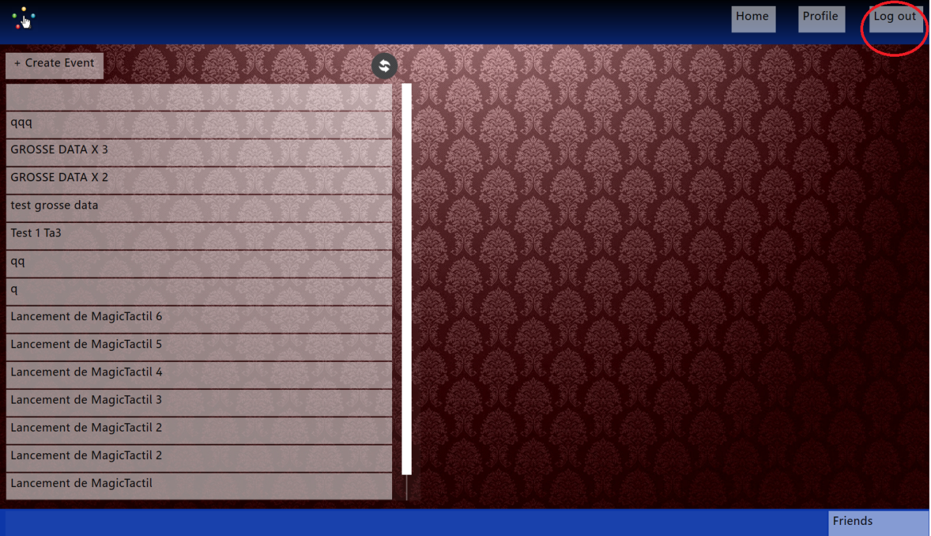
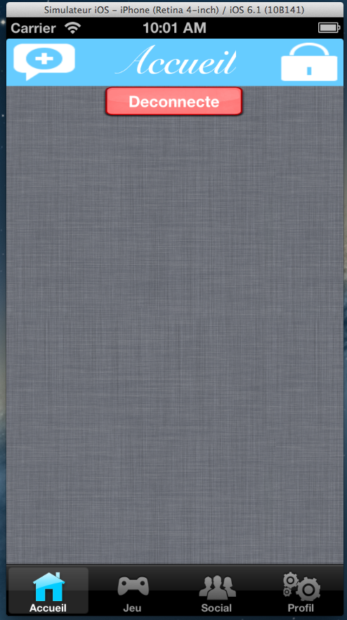
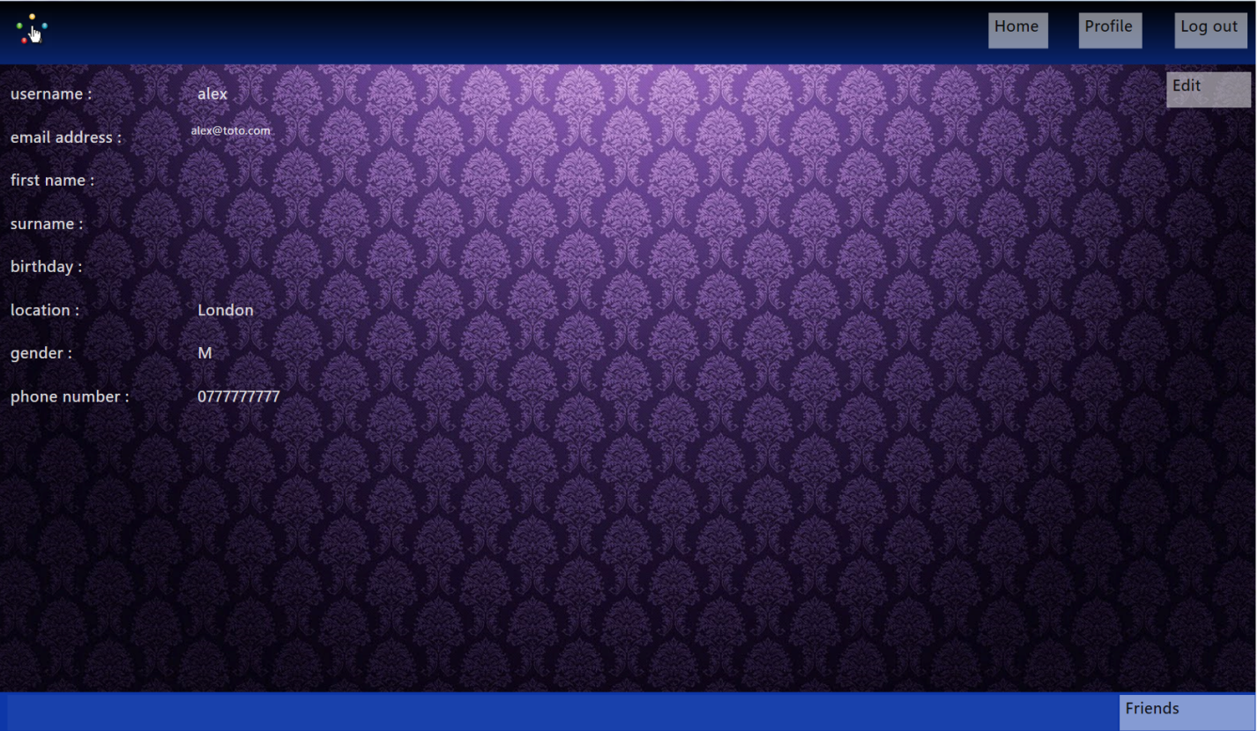
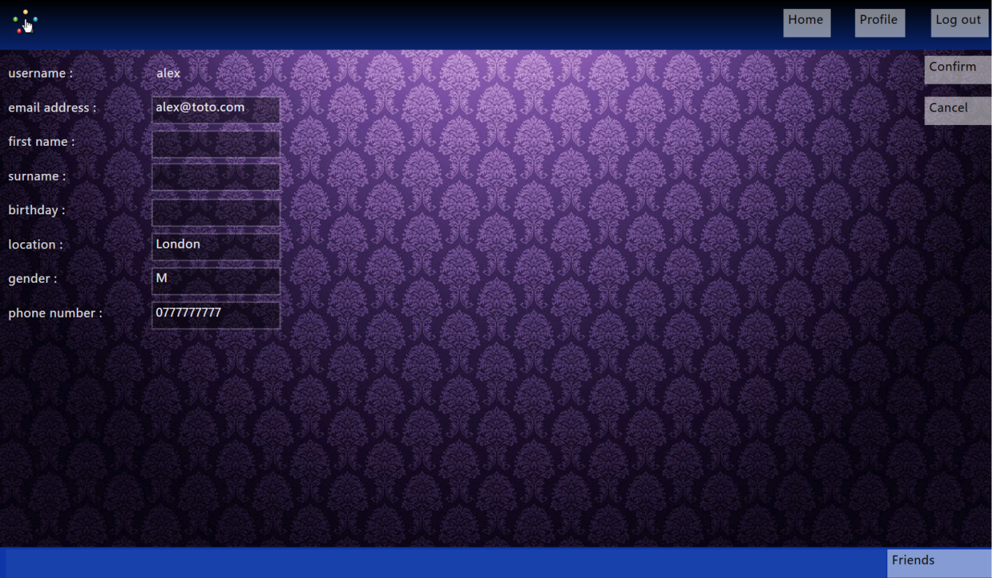
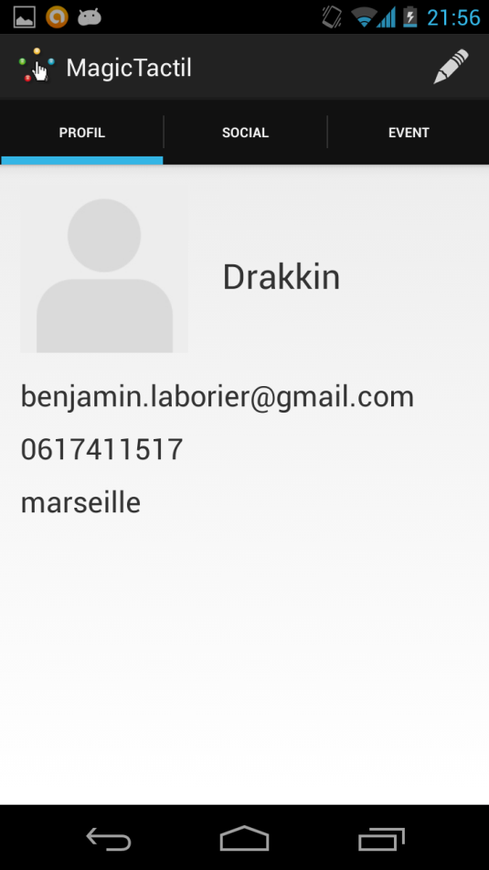
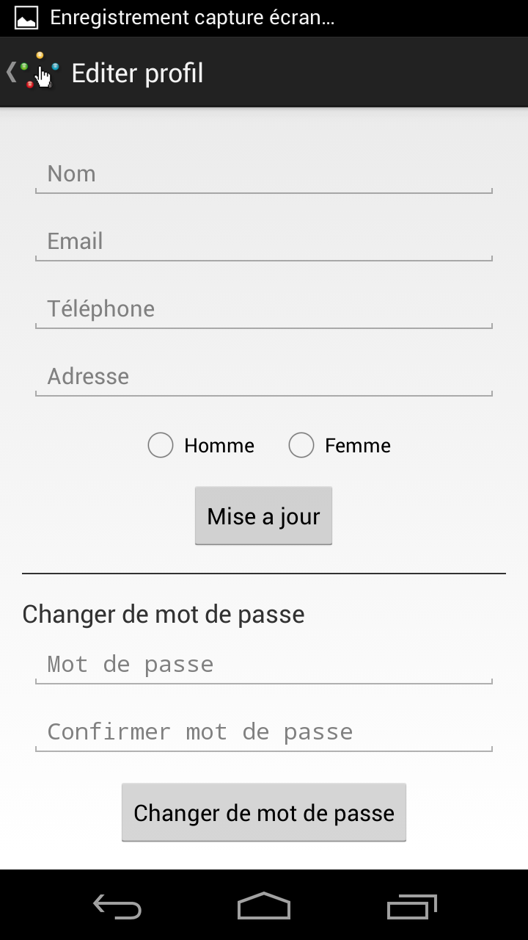
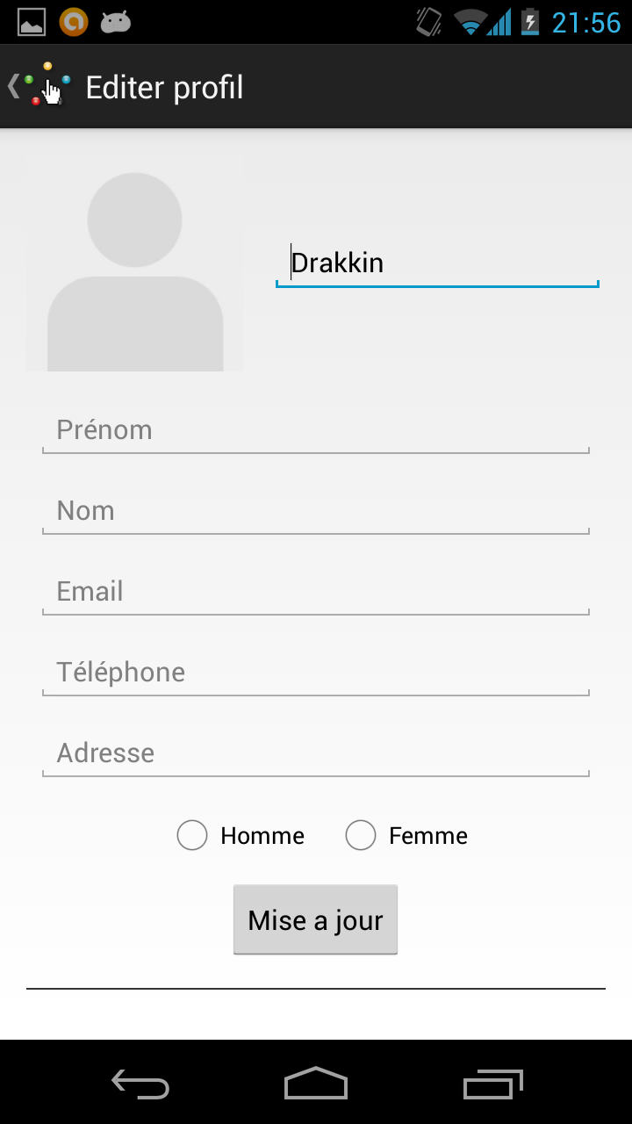
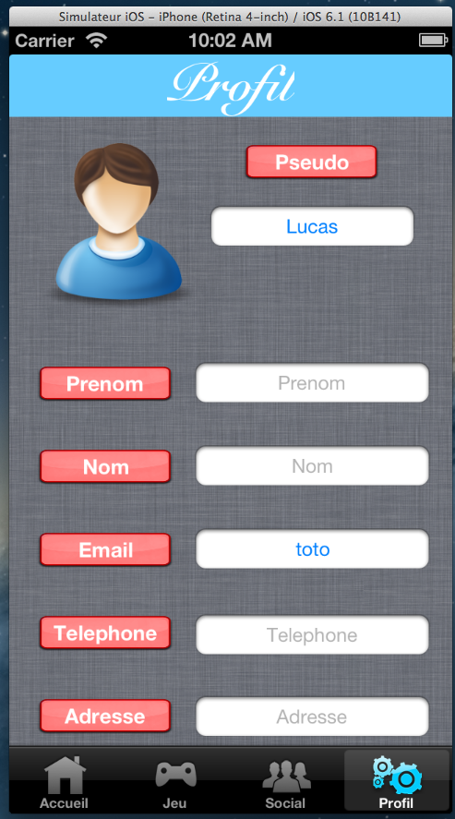
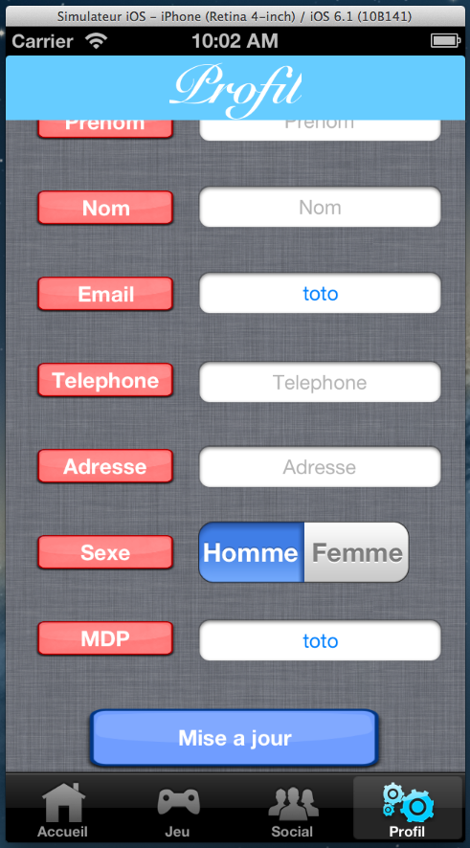
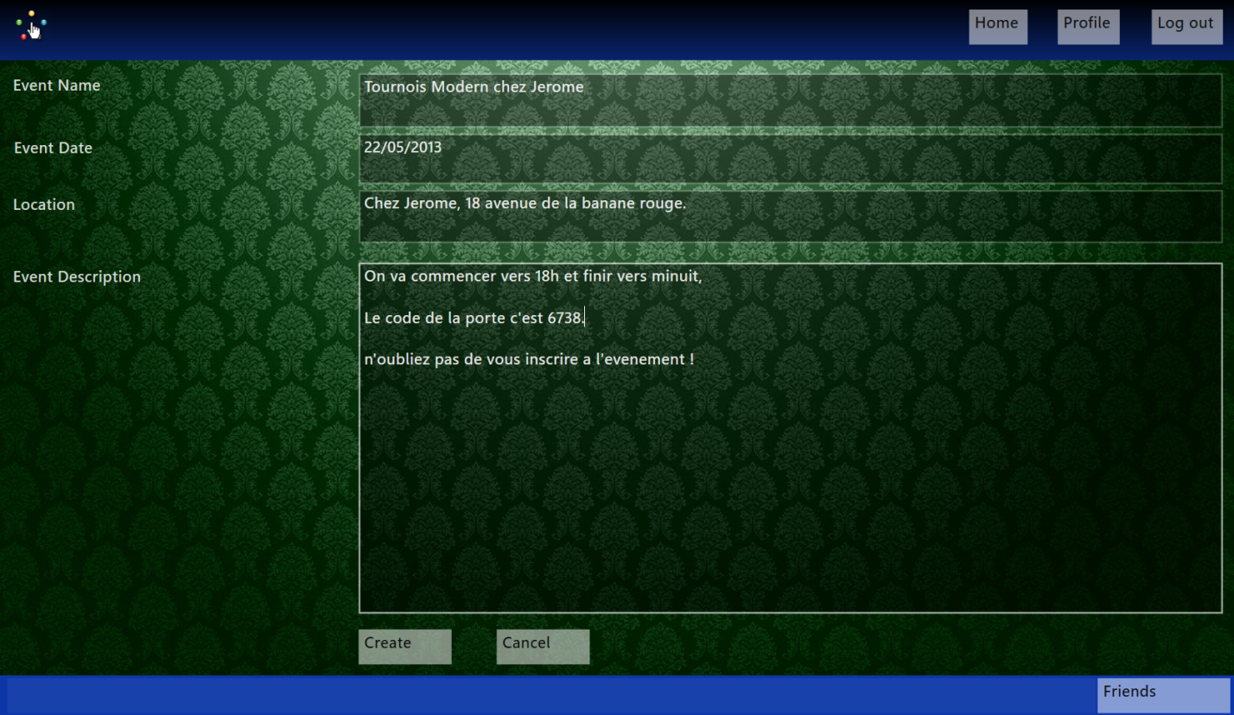
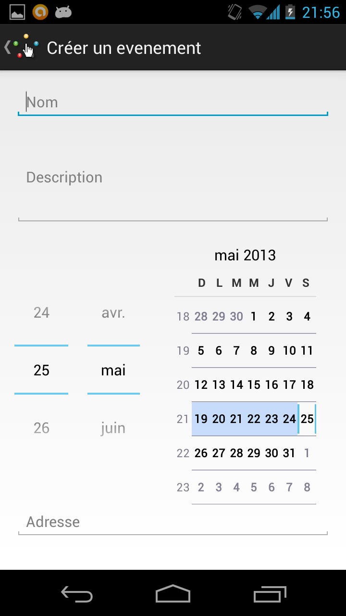
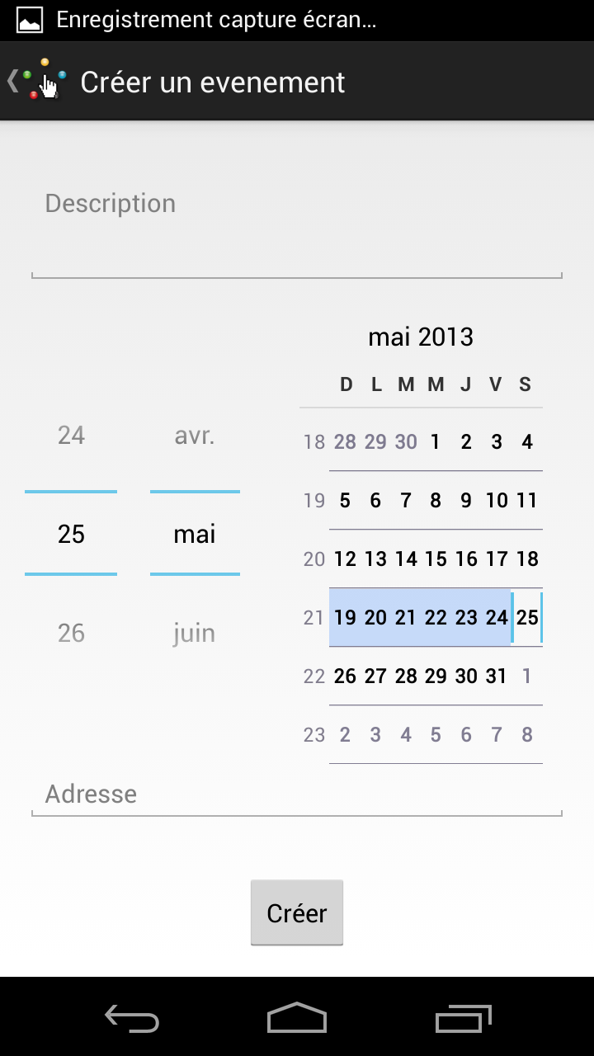
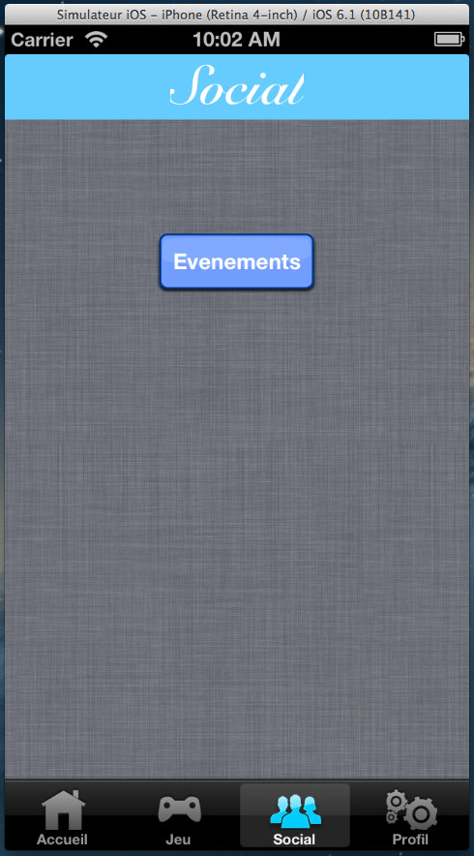
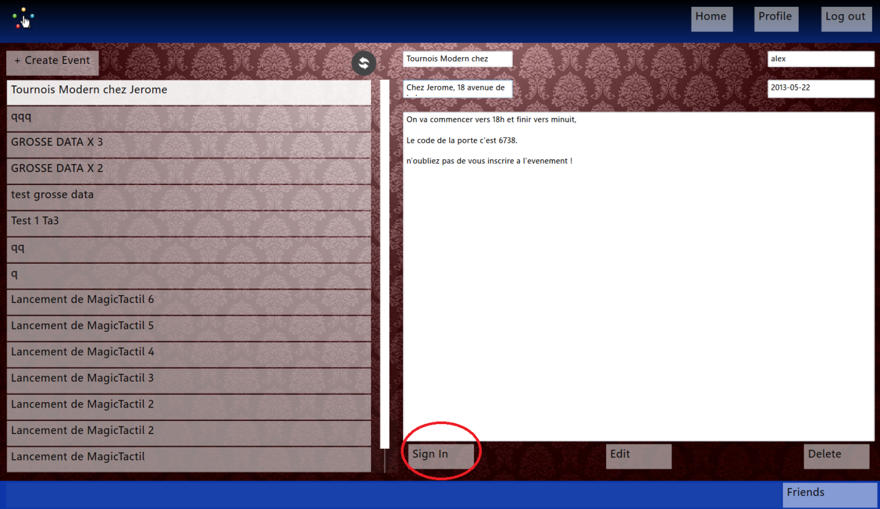
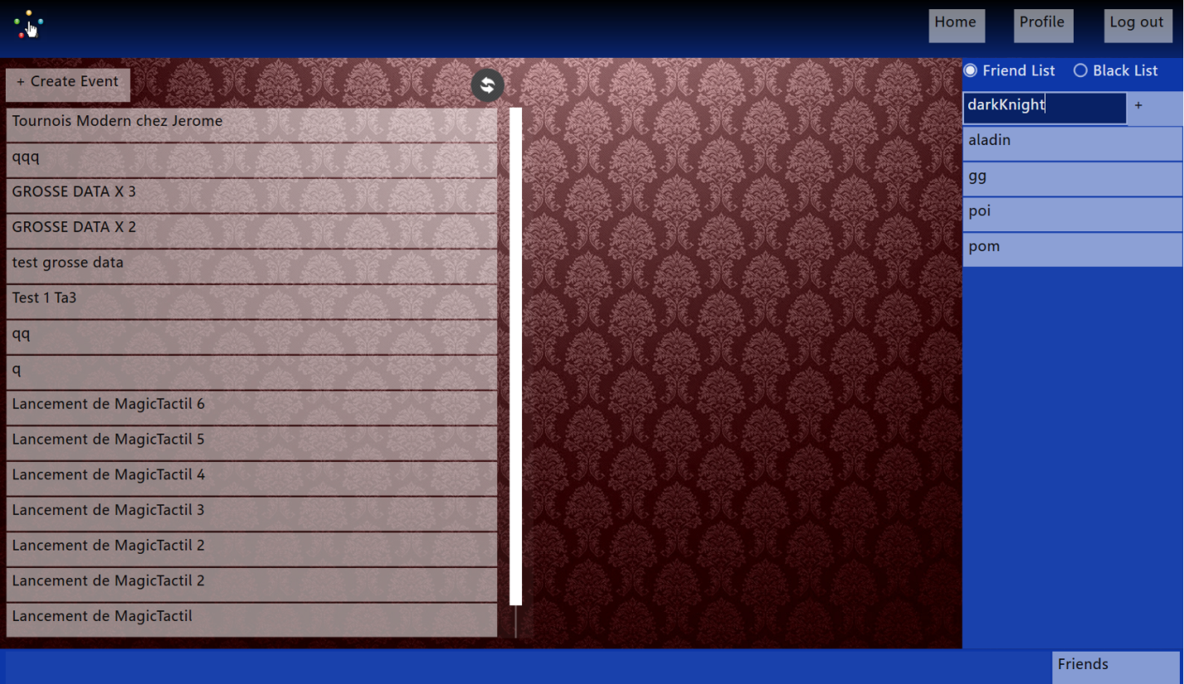
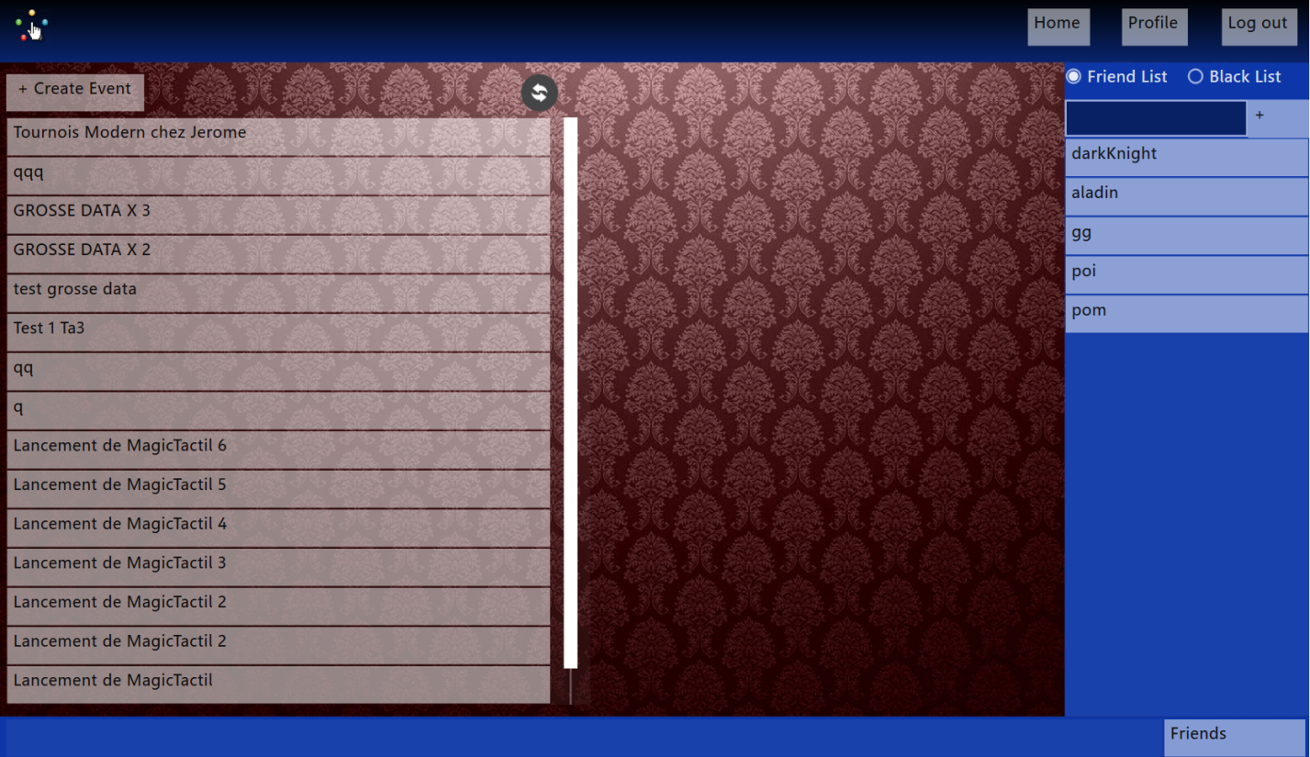
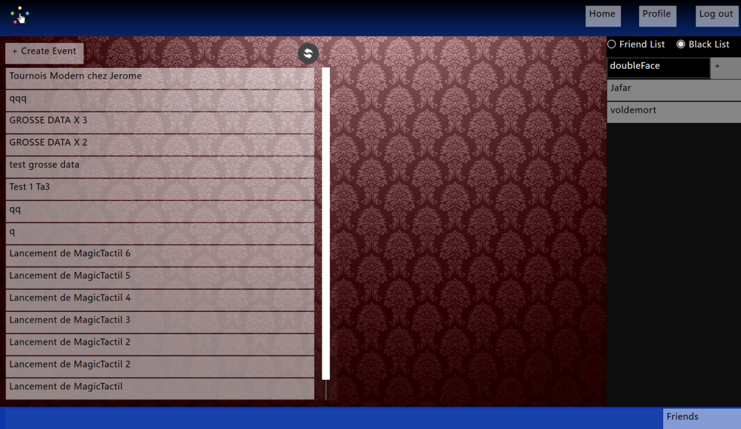
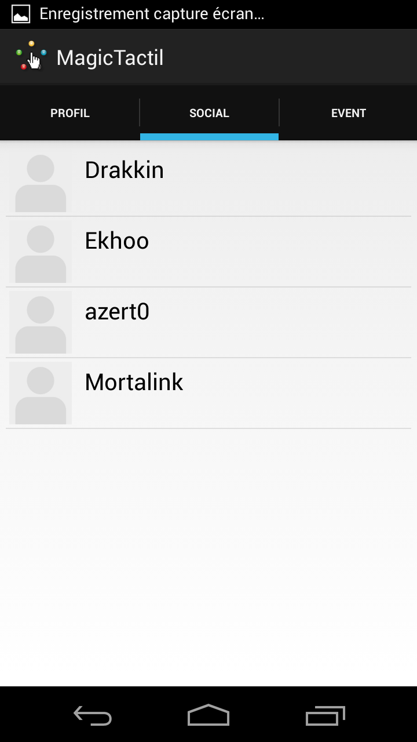
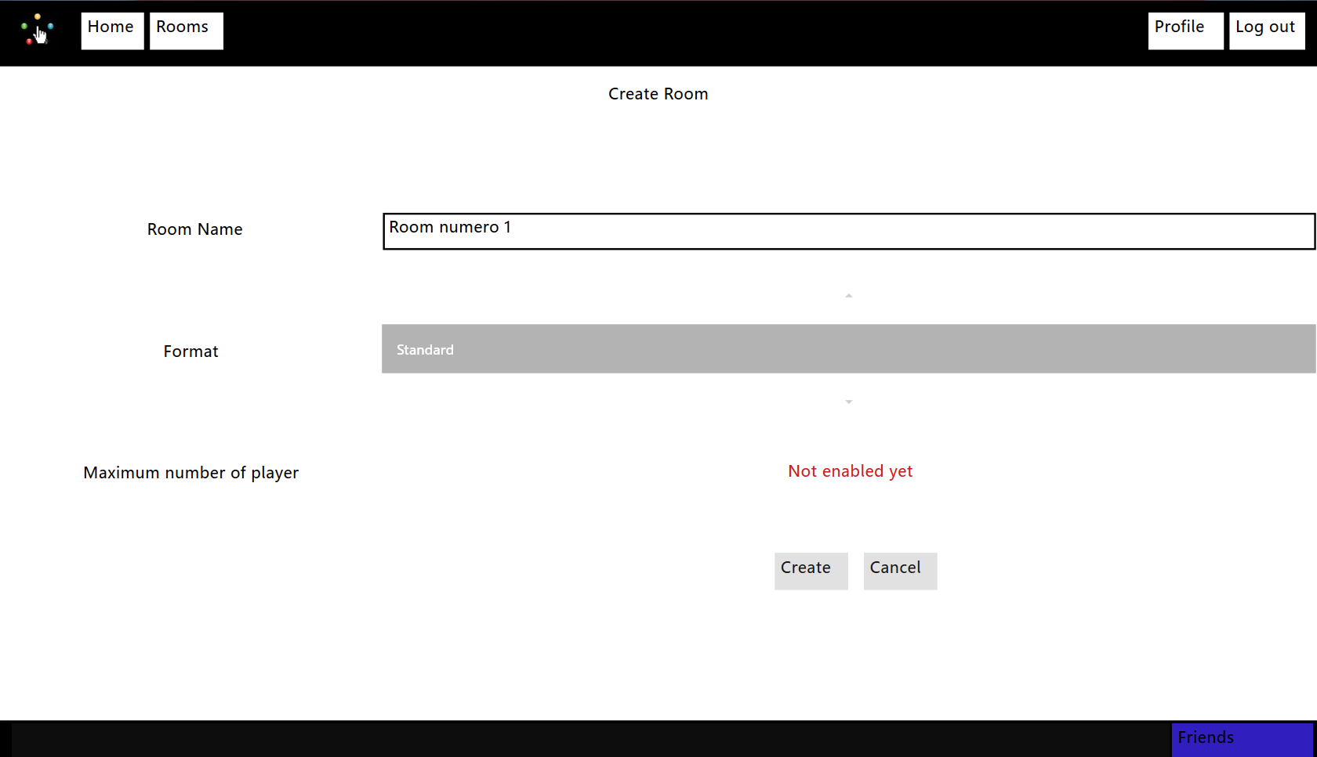
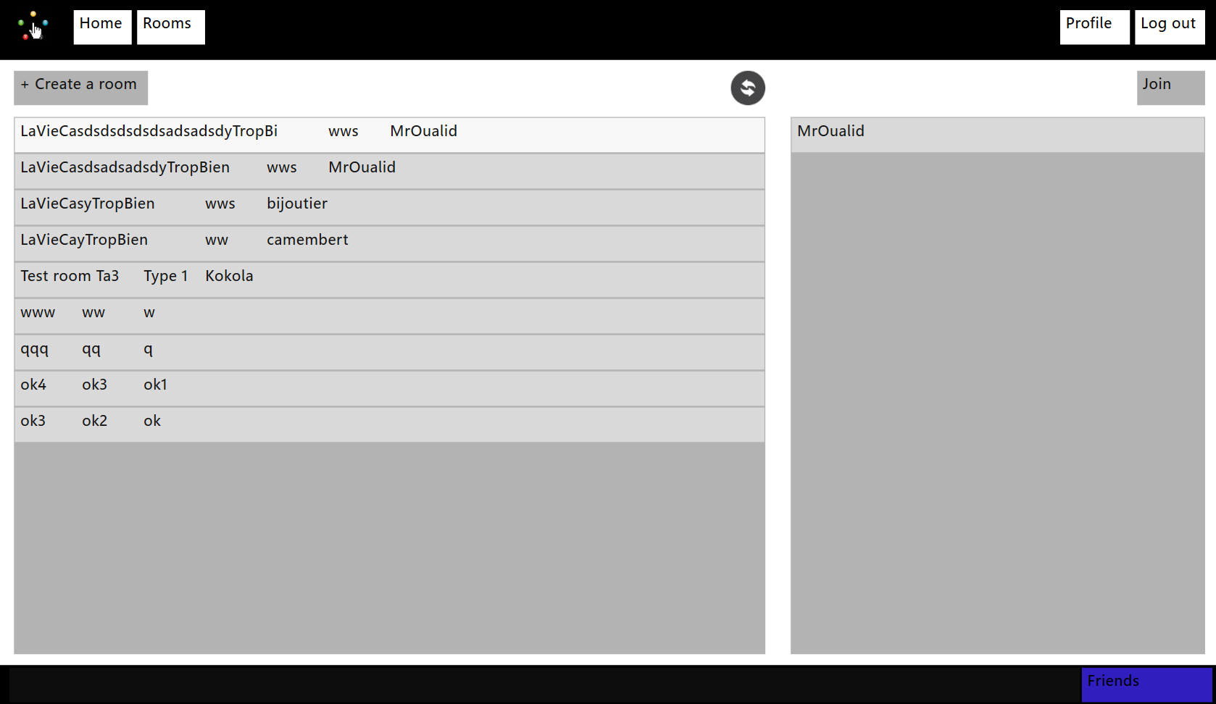
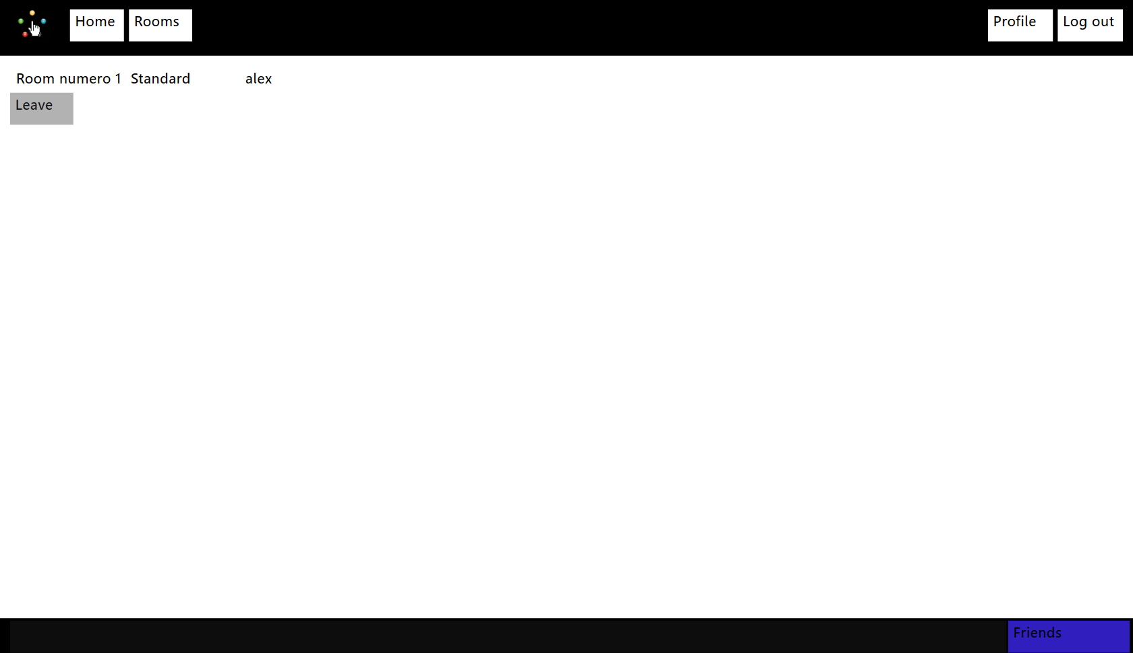
INTRODUCTION

The project consists of a platform based on the card game Magic: The Gathering. This application would allow users to play the game as in real life. The application will be available on IOS, Surface, Pixel Sense, Windows 8 as well as Android. This paper is intended to provide explanations about this platform and so guide the user when to use it.

Document description

Title | [2014][UD5]
Date | 21/03/2013
Auteur | Oualid JOUHRI/Mehdi FARSI
Email | magictactil@epitech.eu
Version | 3.0

Revision table

Date | Author | Section(s) | Comment
21/03/2013 | Jouhri_o/farsi_m | All | First revision
20/05/2013 | Periph_a | All | About Windows Client
27/05/2013 | Periph_a | All | About Android and IOS
18/07/2013 | Periph_a | Utilization | Rooms

Summary

Install & uninstall

Server

Android
If you want to use the Magic Tactil's server on Windows, you have to do the followings steps:
1. Installation of mysql http://dev.mysql.com/downloads/
- Download "MySQL Installer 5.5"
2. Go on http://dev.mysql.com/downloads/connector/c/
- Download : mysql-connector-c-noinstall-6.0.2-win32.zip
- Extract the folder on C:/ (donc vous avez un dossier C:/mysql-connector-c-noinstall-6.0.2-win32)
3. Go on http://rubyinstaller.org/downloads
- Download Ruby 1.9.3-p392 (installer) and DevKit-tdm-32-4.5.2-20111229-1559-sfx.exe
- Install Ruby 1.9.3-p392
- Install DevKit-tdm-32-4.5.2-20111229-1559-sfx.exe
- Choose as destionation folder : C:/DevKit
- Launch Command prompt with ruby and do the following commands :
- cd C:/Devkit
- ruby dk.rb init
- ruby dk.rb review
- ruby dk.rb install
- gem install mysql --platform=ruby -- --with-mysql-dir=C:/mysql-connector-c-noinstall-6.0.2-win32
- Copy this -> C:/mysql-connector-c-noinstall-6.0.2-win32/lib/libmysql.dll in -> C:/Ruby193/bin

5. If you want to the server working you have to do install the following gems :
- gem install activerecord
- gem install activerecord-mysql-adapter
- gem install mysql2
- gem install activerecord-mysql2-adapter

Install the application
1. Open Google play and locate the app Magic Tactil. After, push installation button.

Uninstaller the application
- Click on Option =>Settings
- Go to apps
- Select Manage appplication

- Select Magic tactil in the list
- Click on Uninstall

Windows

Install app
On Start screen, open Windows Store.
Find app Magic tactil. Click on "Install".
After installation, the start screen will display the app.

Uninstall the application
Find app Magic tactil by using the Finder.
Select app and click on Uninstall button.
Click on "Uninstall".

IOS

Install the application

Open App Store on iPhone and locate app Magic tactil. After, push on Install button.

Uninstall the application
1. Push and maintain click on Magic tactil app icon on Home screen until icons start to shake.
2. Press on the "x" in the corner of the application you want to delete.
3. Push on Delete to delete all data of the app.
4. Click on Home button to cancel the deletion.

Utilization

Authentication

Account creation
To create an account it is mandatory to fill in the following fields:
    - User name
    - Email
    - password

Sign In
To log in the user needs to fill in the following fields:
    - Username
    - password

Logout
To log out the user needs to open tab Settings and click on « Log out ».

Profile

Editing personal information
To edit personal information you just replace them through the application.

Event

Create an event
To create an event the user needs to open tab Events and click on Create an event. After, just fill in the following fields:
- Title
- Date
- Description

Participate in an event
To participate in an event the user needs to open tab Events, select Events list and pick an event on the list. After, just click on I participate.

Friends

Add a friend
To add a friend the user needs to open tab Friend and select add friend. After, fill in the field Name.

Remove a friend
To remove a friend the user needs to open tab Friend and select Friend list, pick a friend and maintain a long click on this friend. A menu is displayed. On this menu, the user select Remove.

Room

Create a room
To create a room the user needs to fill in the following fields:
    - Maximum number of players
    - Format
    - Nom de la room

Join a room
To join a room the user just has to select it from the room list.

Leave a room
To leave a room, just push the leave button.

Game

Message an opponent
To message an opponent the user needs to write his message on the chat available on the side. After, click on Enter to send it.

Move cards
To move a card the user has to drag and drop the card until the wished destination spot.

Contact

To stay up to date about Magic Tactil follow these links:
Facebook: https://www.facebook.com/pages/Magictactil/319882788114639
Twitter: https://twitter.com/MagicTactil
Website: http://eip.epitech.eu/2014/magictactil/about_fr.html
For more information about the game Magic you can look into the explanations of the official website thanks to this link:
Game booklet:
http://www.wizards.com/Magic/TCG/NewtoMagic.aspx?x=mtg/tcg/newtomagic/whatismagic

