**Theory Questions**

*These questions are designed to test your understanding of the skeleton code. Many of these are similar to the kinds of question you can expect to see in Section C of the Paper 1 exam. However, sub-questions that are more than 2 marks are rarely seen in this section – these more involved questions are here to challenge your understanding of the code.*

These questions refer to the **Preliminary Material** and the **Skeleton Program**,   
but **do not** require any additional programming

**TOTAL MARKS: 57**

**1.** This question is about the Main() subroutine.

**(a)** Explain why the Choice variable is converted to lower case in the Main() subroutine. [1]

**(b)** Explain the purpose of the TrainingGame variable in the program. [1]

**2.** This question is about the PlayGame() subroutine. It repeatedly calls DisplayState().

Explain the purpose of this repeated call and how it contributes to the gameplay. [2]

**3.** This question is about the RemoveNumbersUsed() function.

**(a)** Identify what UserInputInRPN represents within this function. [1]

**(b)** Explain the logic used to remove numbers from the NumbersAllowed list. [2]

**4.** This question is about the function CheckIfUserInputEvaluationIsATarget() and how it works   
to modify the player's score.

**(a)** What condition needs to be met to increase the player's score? [1]

**(b)** Why is the target set to -1 after it has been evaluated successfully? [2]

**5.** This question is about the function CheckValidNumber(). The function uses a regular expression.

**(a)** Explain the purpose of using the regular expression in this function and how this regular expression works to validate user input. [2]

**(b)** What could happen if the regular expression pattern was changed to ^[0-9]$ by removing   
the + character? [1]

**6.** This question is about the EvaluateRPN() function. It evaluates expressions in Reverse Polish Notation (RPN).

**(a)** Briefly describe how Reverse Polish Notation works and how it can be evaluated using a stack. [2]

**(b)** What would happen if an invalid operation (e.g. division by zero) is attempted in this function? [1]

**7.** Examine the function FillNumbers(). It works differently in training and random game modes.

Explain how the list NumbersAllowed is populated in training mode versus random mode. [2]

**8.** This question is about the function ConvertToRPN(). Operators are stored in a list (which is functioning as a stack) while operands are processed immediately.

**(a)** Explain why the benefit of a stack is used to manage operators in this function. [2]

**(b)** How does the function handle operators of equal precedence? [2]

**9.** This question is about the function CreateTargets().

**(a)** What is the role of the GetTarget() function within CreateTargets()? [1]

**(b)** Explain how the Targets list is initialised differently at the start of the game. [2]

**10.** This question is about the PlayGame() subroutine.

**(a)** Below is a hierarchy chart for PlayGame(). Name the six user-defined subroutines labelled   
A to F. [6]

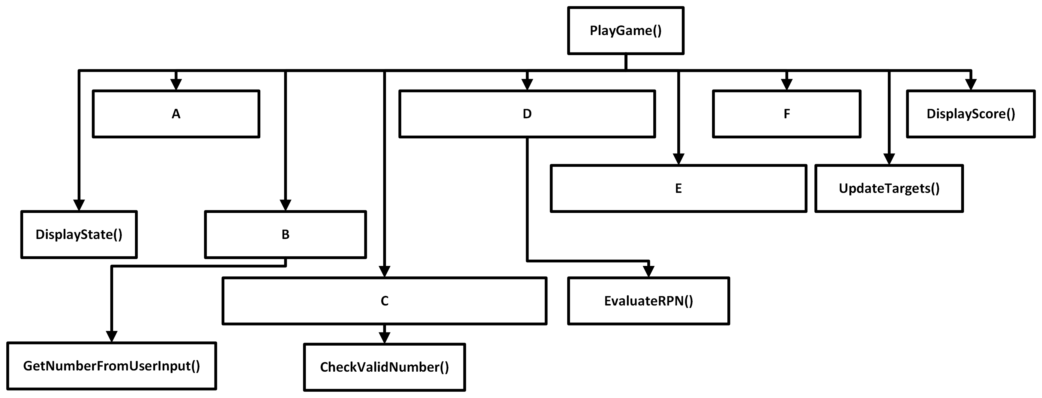

|  |  |  |
| --- | --- | --- |
| A:  B:  C: |  | D:  E:  F: |

**QUESTION 10 CONTINUES OVERLEAF**

**(b)** Describe the purpose/functionality of each of the six labelled subroutines from part (a).   
As part of your description, you can assume that the player enters a **valid expression** that uses **only available numbers** and will **correctly hit** one of the targets. [6]

**11.** This question refers to the use of exception handling in programming.

**(a)** Why might it be useful to use exception handling in a program like this, especially for   
user input? [1]

**(b)** Provide an example of where exception handling could be implemented in this program   
to improve robustness. [1]

**12.** The question is about the PlayGame() subroutine. The subroutine contains a loop that continues until the GameOver variable is true.

**(a)** Explain the criteria for setting the GameOver condition to be True. [1]

**(b)** Why is it important to have a condition like GameOver to end a loop? [1]

**13.** Imagine you want to add a feature to permanently store the highest score achieved in the game.

Explain where you would store this information and how you would retrieve it when needed. [2]

**14.** State an identifier for / name of:

**(a)** A user-defined function that returns a list [1]

**(b)** A Boolean variable within the Main()subroutine [1]

**(c)** A string variable within the function GetNumberFromUserInput()[1]

**(d)** A list method that is used within the function UpdateTargets() [1]

**(e)** An integer variable within the function Main() [1]

**15.** This question is about the CheckIfUserInputValid() function. Inside it there is a regular expression.

"^([0-9]+[\\+\\-\\*\\/])+[0-9]+$"

How does the regular expression make use of the + meta-character? [2]

**16.** Explain why a regular expression could not be adapted to check the validity of a mathematical expression with (indefinitely nested) brackets but BNF syntax could be used. [1]

**17.** This question is about the ConvertToRPN() function. Explain how the function makes use of   
the Precedence dictionary. [3]

**18.** Explain how this program demonstrates the concepts of abstraction and decomposition through   
the use of functions. [2]

**19.** This question is about the UpdateTargets() function. The function implements a *shunting* of the targets down by one position each time it is called. What is the time complexity for this operation? [1]

**END OF QUESTIONS**