**Where to get the source code, technologies used, where to get data, etc**

The program is written in java. It can read file formats in geojson, esri shapefile, or comma separated values. The source code is available at <https://github.com/happyjack27/autoredistrict> or you can just google “autoredistrict”. Included with the source code are screenshots, samples, and this document.

**THE PROGRAM**

1. if you do not have java, install it. (you can find it by googling java jre)
2. run the launch script (e.g. run.bat)
3. load the atoms - from the file menu, select open geojson file if the file is in geojson, or open shapefile if it’s an esri shapefile.
4. Import additional data (merge data button)
5. Select the layers for population and demographics (remember to check the checkboxes)
6. Set the number of desired districts
7. Hit play. “|>”
8. Wait until the map is no longer changing.
9. Hit pause “||”
10. Export results - From the file menu, select export results.

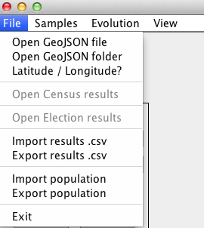

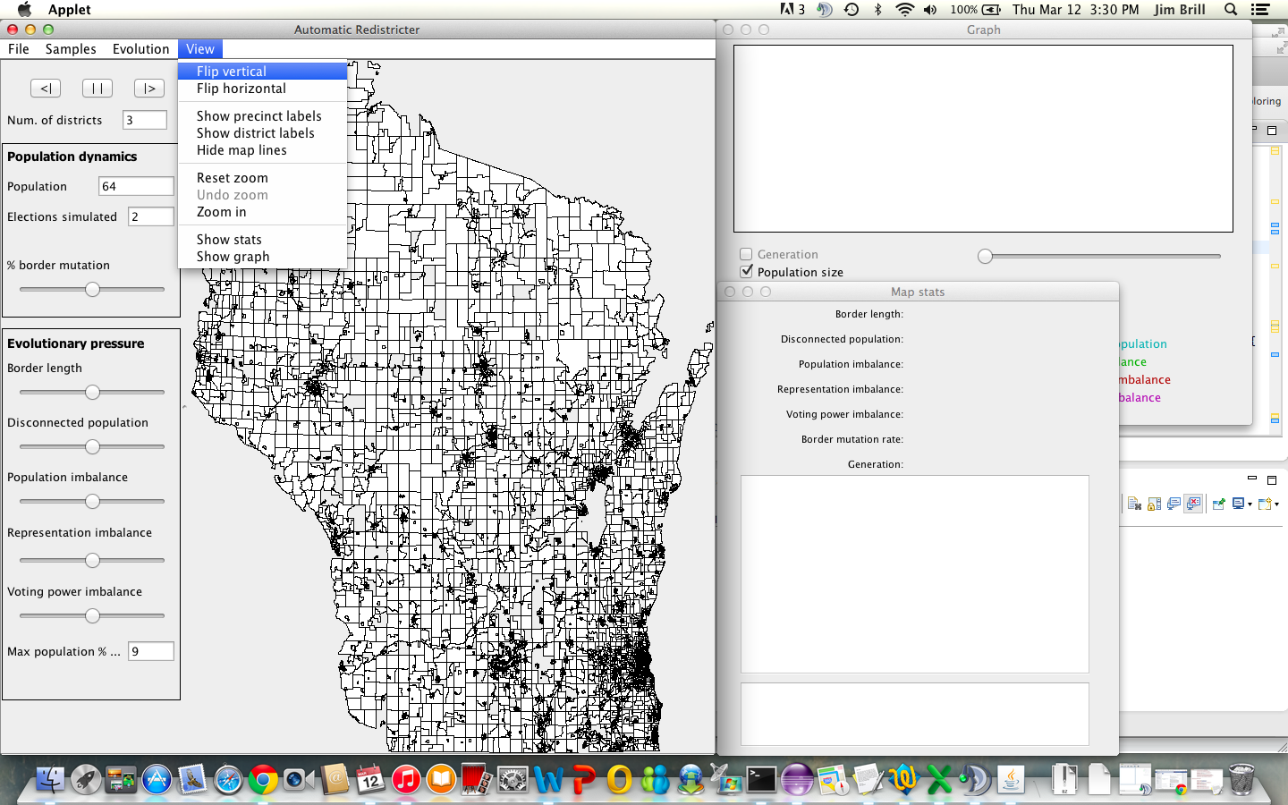

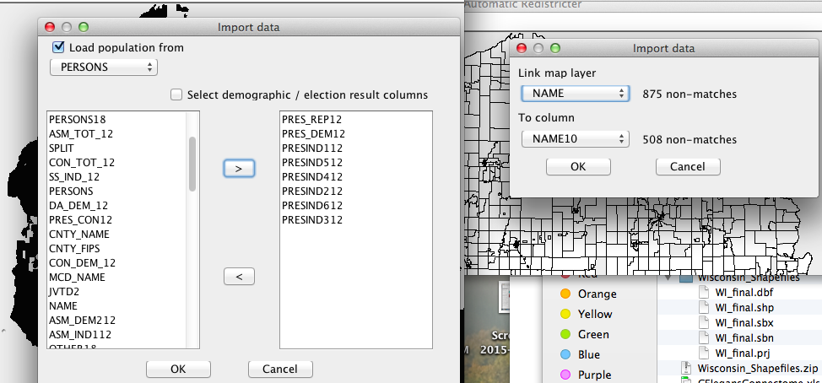

**SAMPLES**

**Older revision - Sample Results – Wisconsin 2010 - Federal Congress**

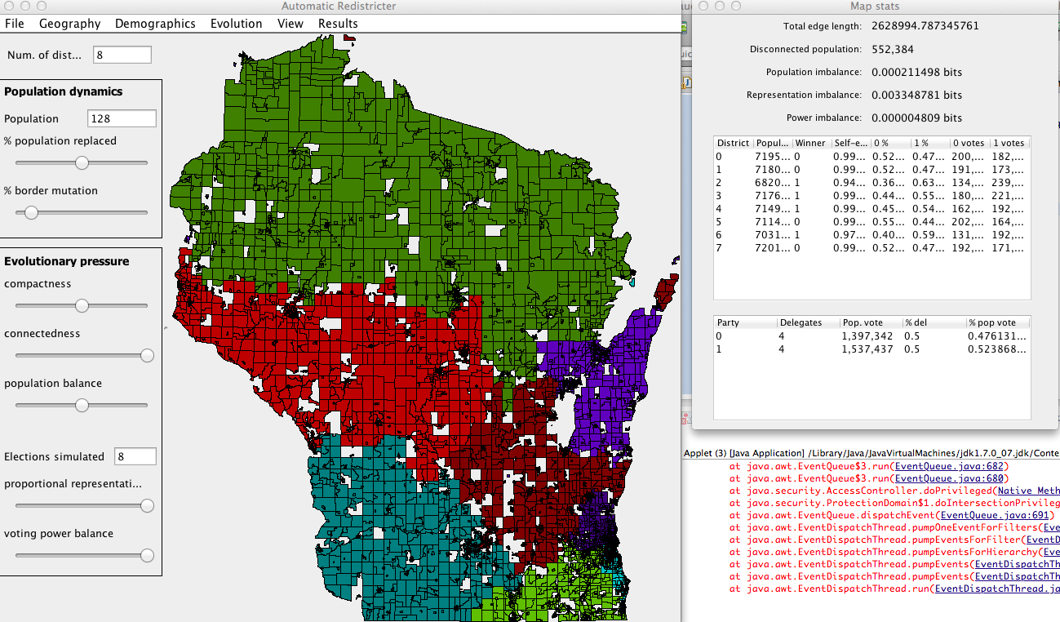

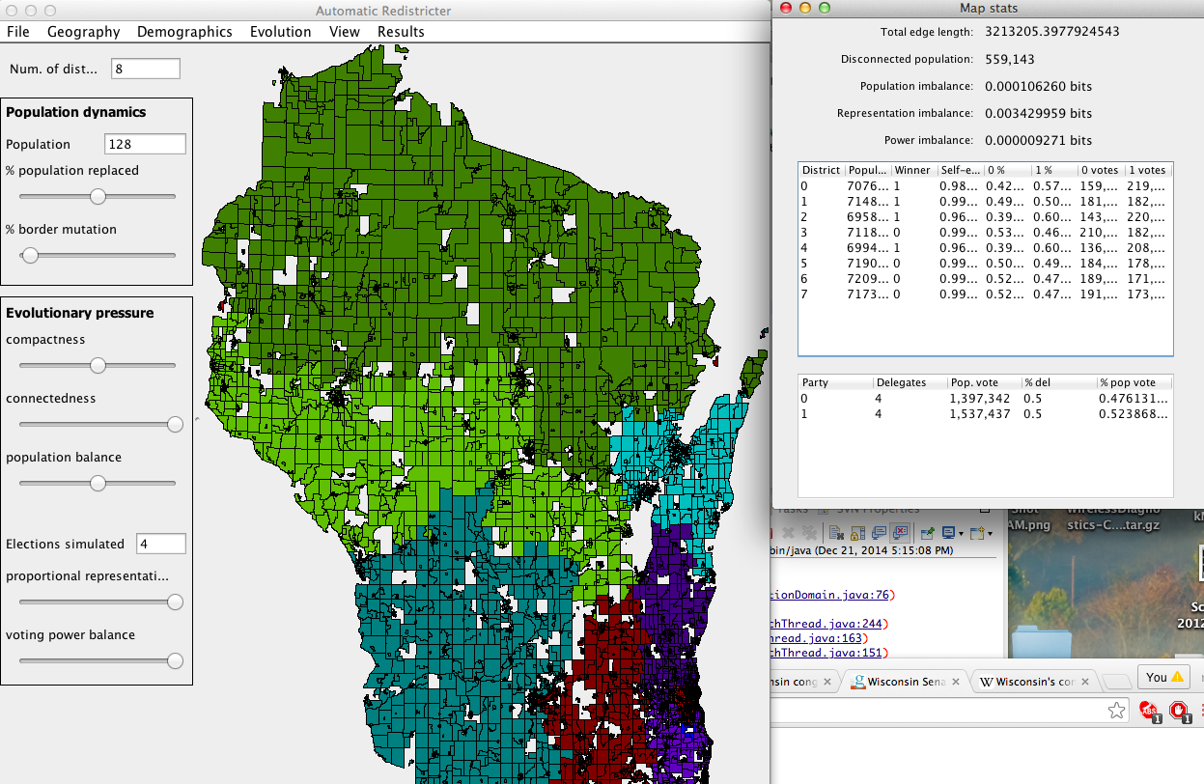

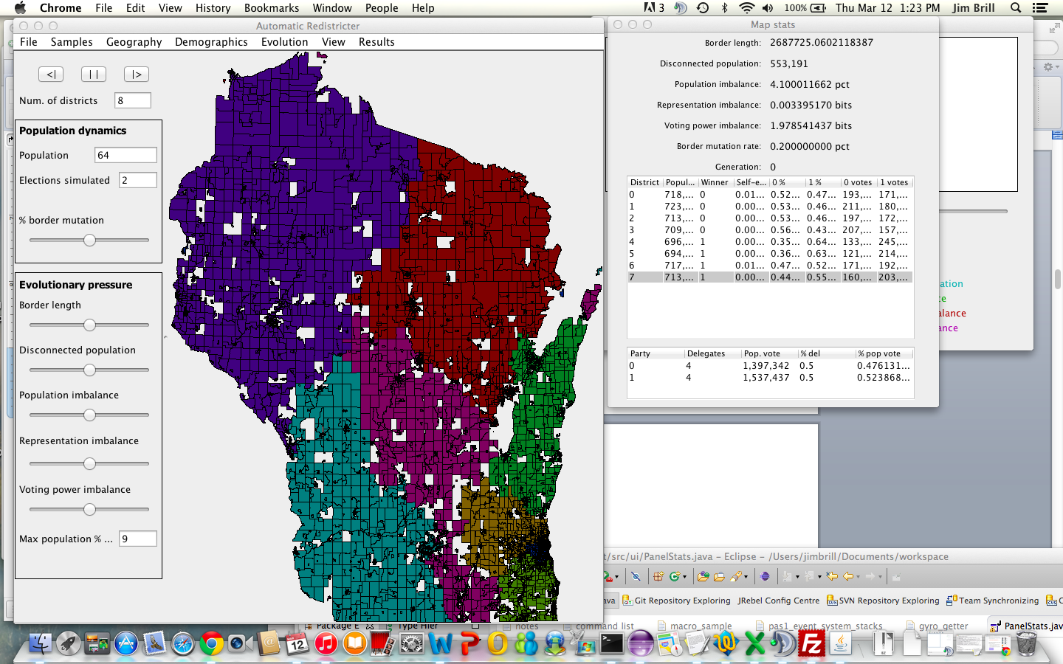

**Older revision - Sample Results – Wisconsin 2010 - State Assembly**

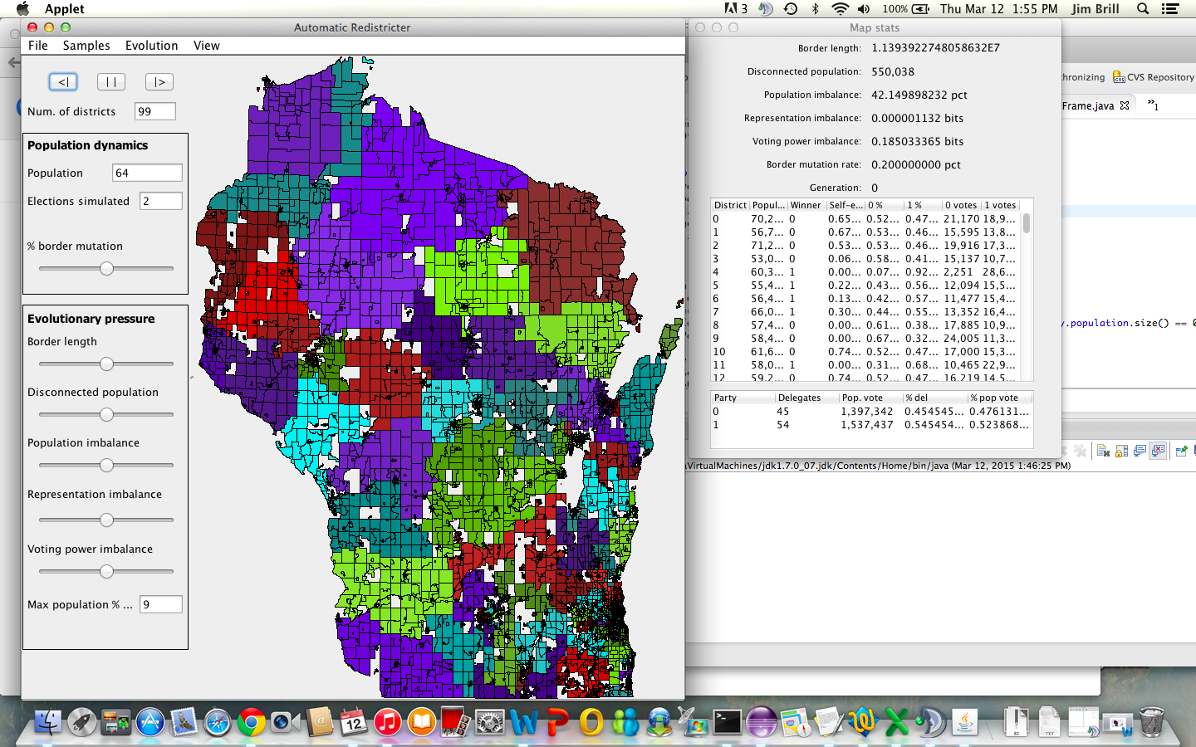

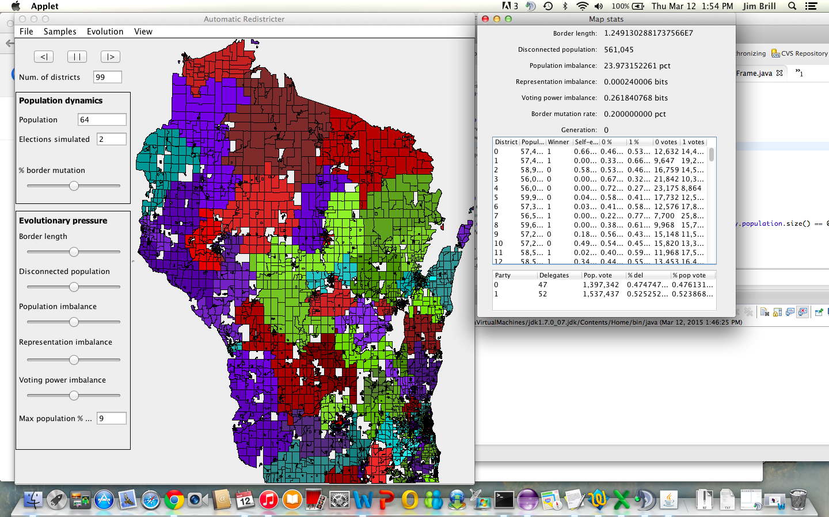

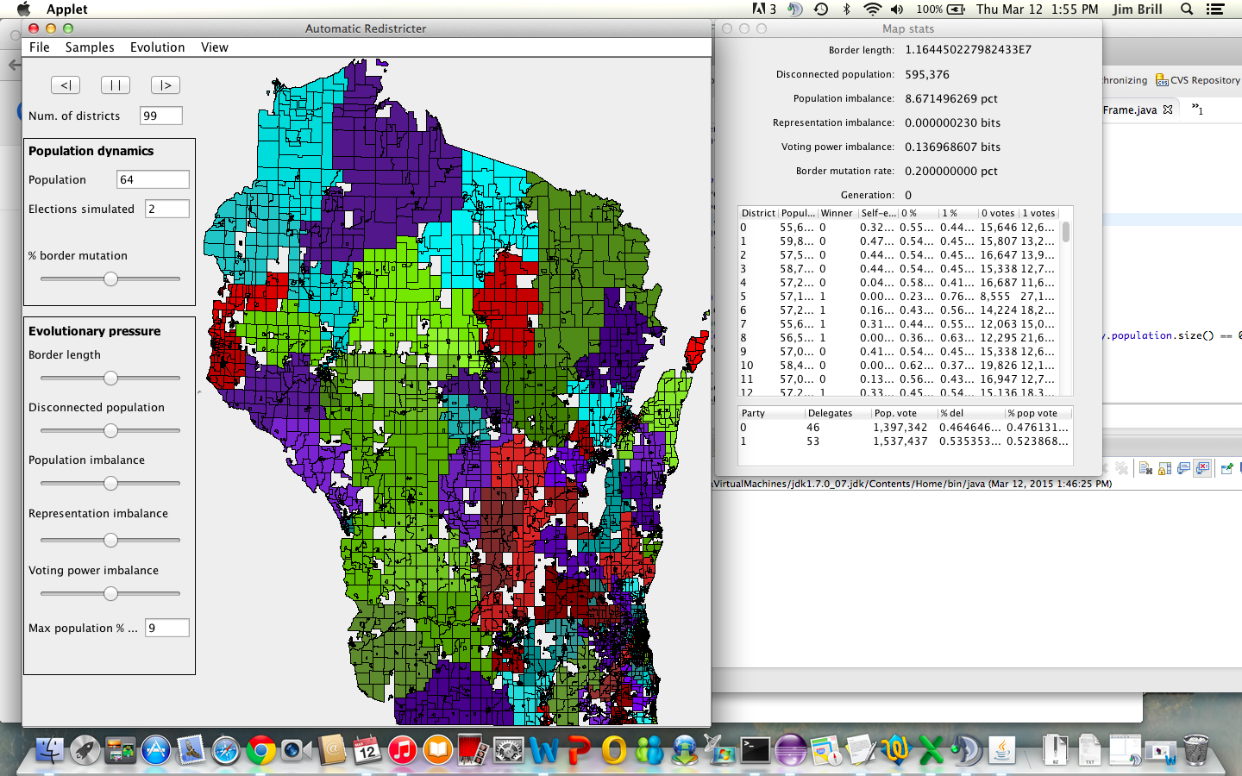

**Sample result – Wisconsin 2010 – State Senate**

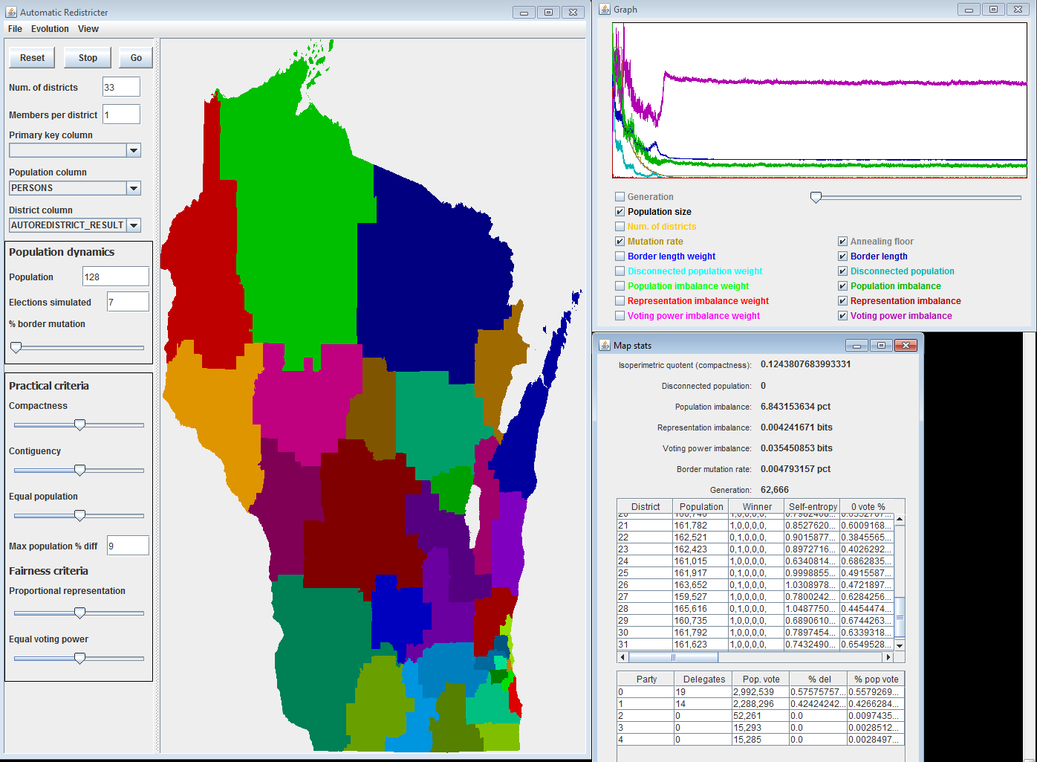

**Sample result – Wisconsin 2010 – FedPeral Congress**

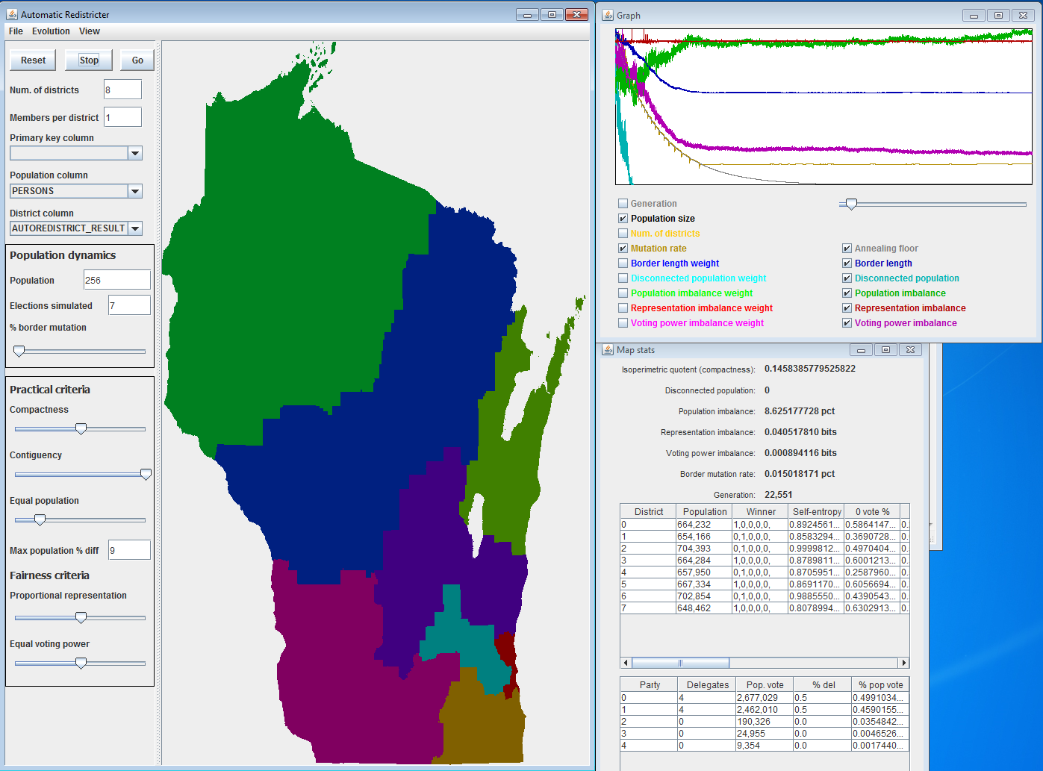

**Advantage 2020**

[**http://www.msnbc.com/msnbc/democrats-launch-new-super-pac-combat-gop-gerrymanders**](http://www.msnbc.com/msnbc/democrats-launch-new-super-pac-combat-gop-gerrymanders)

[**http://www.msnbc.com/msnbc/2016-democrats-already-have-plan-2020**](http://www.msnbc.com/msnbc/2016-democrats-already-have-plan-2020)

[**http://dlcc.org/news/dlcc-launches-advantage-2020-key-success-next-round-redistricting-70-million-plus-effort**](http://dlcc.org/news/dlcc-launches-advantage-2020-key-success-next-round-redistricting-70-million-plus-effort)