**Intent**

Description:

Android allows sending data between apps to make the live easy for the user and the developer. For example, when we want to share image on Facebook from local app we send the image to Facebook app over the bundle then the Facebook app Read it and post it. Another Example, when we want to call someone, we send the phone number that we want to call over the Bundle to calling API to call the person that we want to call.

So sending data between apps is very important for companies that have more than one apps, and they want them to works with gather or sharing or whatever.

The problem is sending data between apps is insecure in Android. That mean, if we send data from App “A” to App “B” any hacker app could have same Application ID of APP “B”. Then it could receive the data that should be received by App “B”. So we cannot send important data between applications without encryption.

We will demonstrate examples to should how to send data between two applications. Then we will show how hacker app could read the data, then we will explain how we could keep sending data in secure way.

**Steps to build the sender app (App “A”) :** This app will send the comment data to App “B”.

1. Open new project with name “sender”, save the package name will will need next

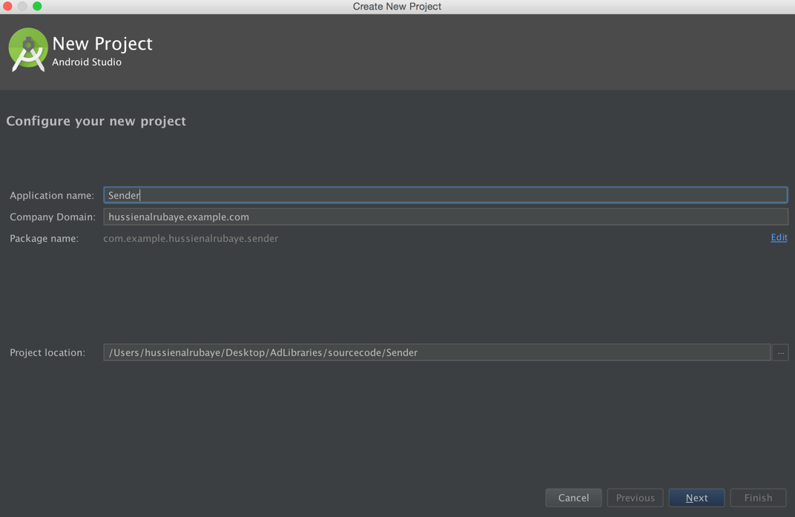

1. add some objects ( TextView, EditText, Button) and make the app like this, see the name of every tool in the right.

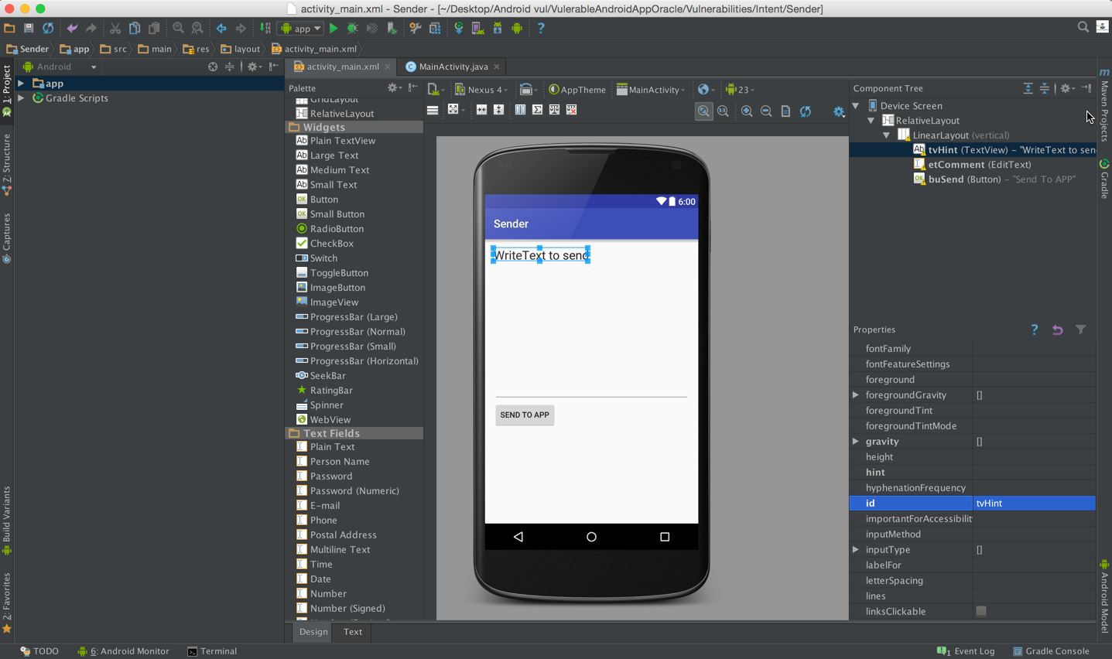

1. The code will be like this code

|  |
| --- |
| Java |
| public class MainActivity extends AppCompatActivity {   // Define Comment edit Text  EditText etComment;  @Override  protected void onCreate(Bundle savedInstanceState) {  super.onCreate(savedInstanceState);  setContentView(R.layout.*activity_main*);   // Define send button  Button buSend=(Button)findViewById(R.id.*buSend*);  //// init Comment edit Text  final EditText etComment=(EditText)findViewById(R.id.*etComment*);  //button listen to click event  buSend.setOnClickListener(new View.OnClickListener() {  @Override  public void onClick(View v) {  // set the package that we want to run  Intent intent=getPackageManager().getLaunchIntentForPackage("com.example.hussienalrubaye.receiver");  // put the data that we want to send over intent  intent.putExtra("Comment",etComment.getText().toString());  // start another app  startActivity(intent);    }  });  } } |

**Steps to build the Receiver app (App “B”) :** This app will receive the comment data and read it

1. Open new project with name “Receiver”, save the package name will will need next

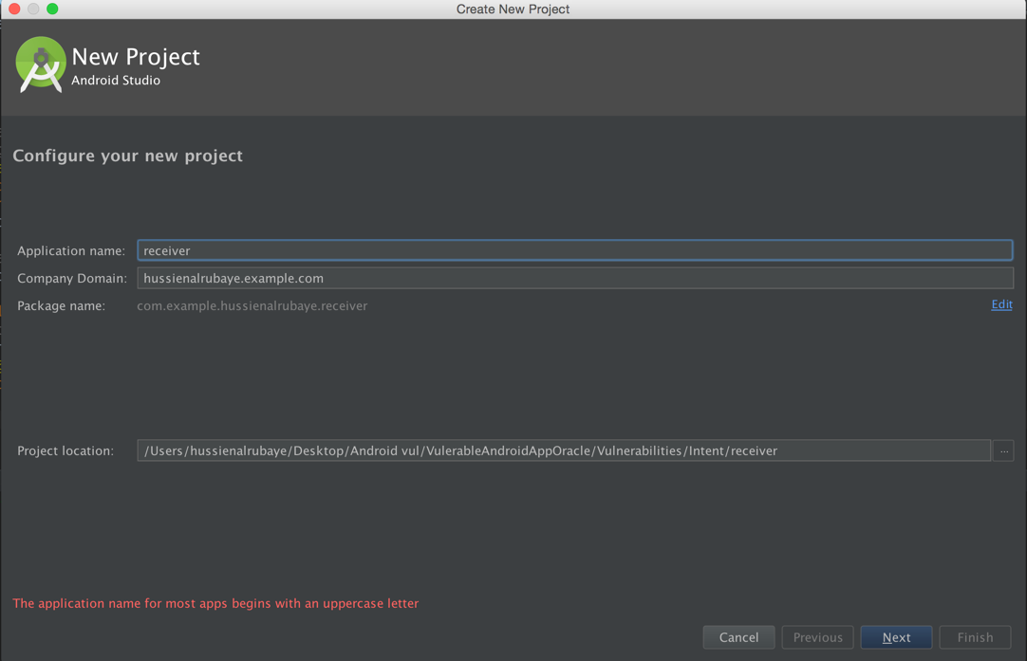

1. add some objects ( TextView) and make the app like this, see the name of every tool in the right.

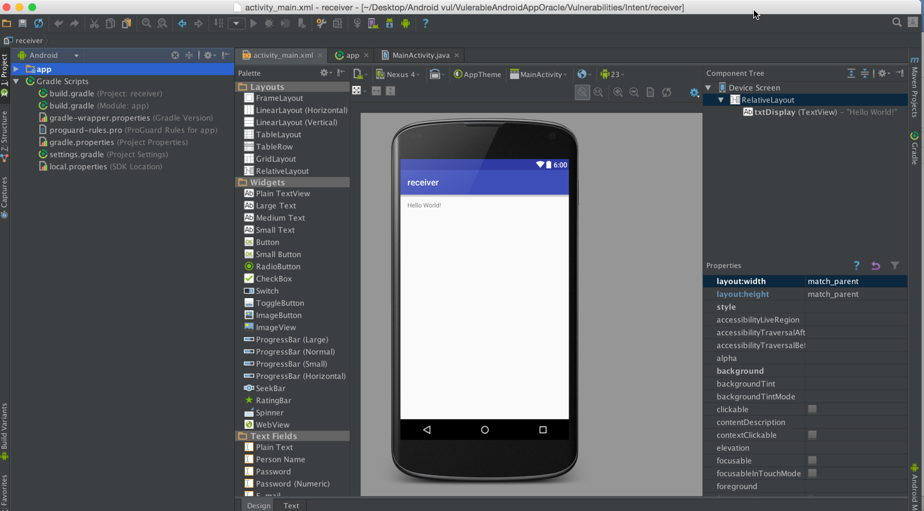

1. The code will be like this code

|  |
| --- |
| Java |
| public class MainActivity extends AppCompatActivity {   @Override  protected void onCreate(Bundle savedInstanceState) {  super.onCreate(savedInstanceState);  setContentView(R.layout.*activity_main*);  // Define the display Text view  TextView txtview=(TextView)findViewById(R.id.*txtDisplay*);  // get app the data sent on bundle  Bundle b=getIntent().getExtras();  // display the key that have the data  txtview.setText(b.getString("Comment"));  } } |

**Example of Run the apps and send comment “hi app 2” from App “A” to App “B”**

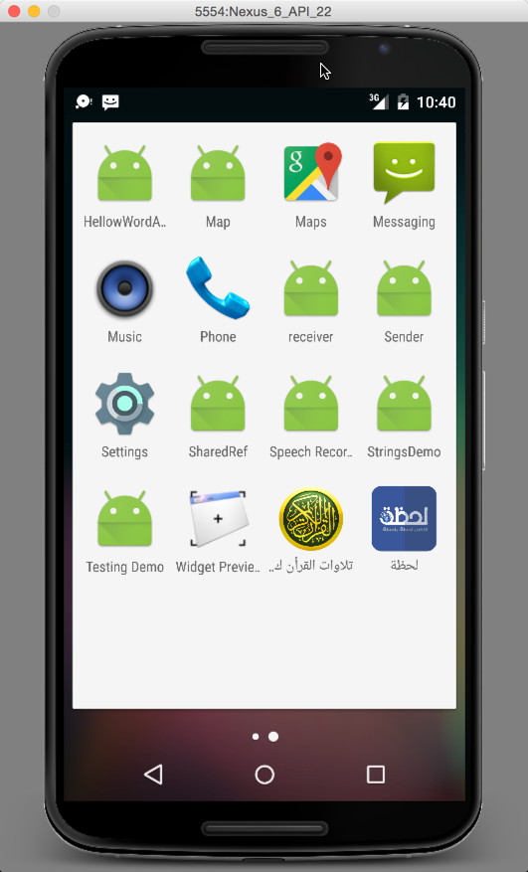 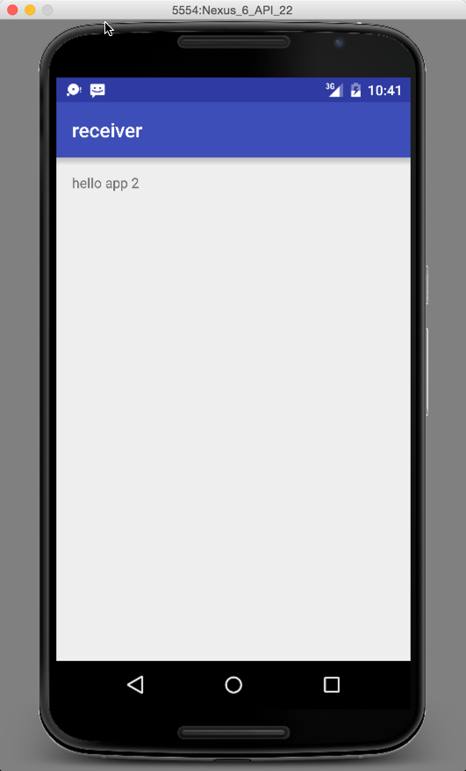 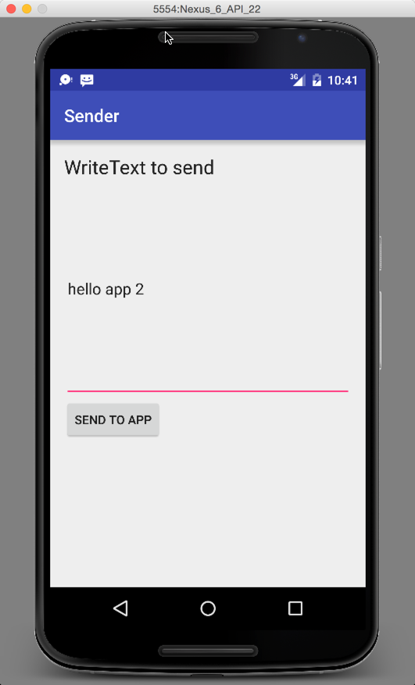

**Steps to build the hacker app:** This app will try to read the data that should be read only by APP “B”.

1. Open new project with name “HackerApp”, save the package name will will need next

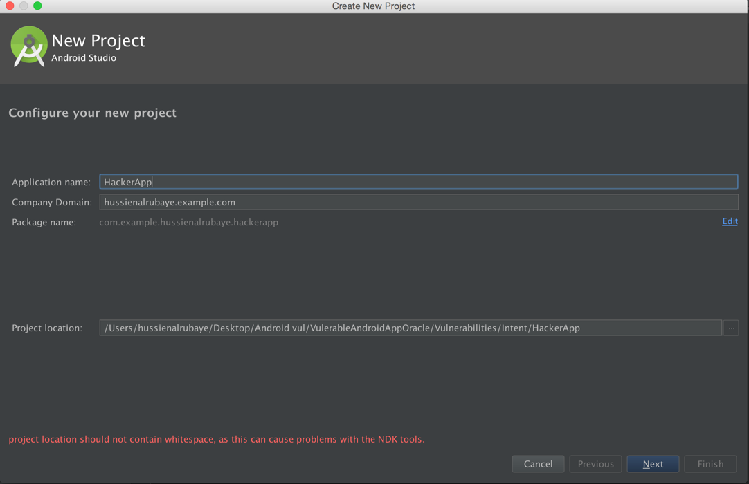

1. add some objects ( TextView) and make the app like this, see the name of every tool in the right.

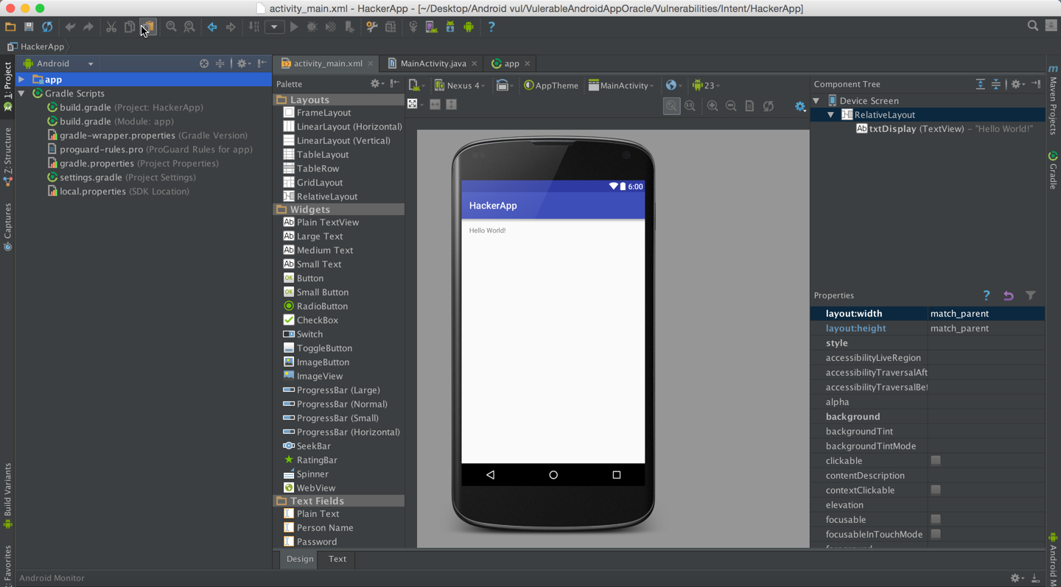

1. Go to the Gradle and change the Hacker application id to same the receiver app ID. So when it has the same receiver app ID, it could receive the data that should be receiver by app App “B”

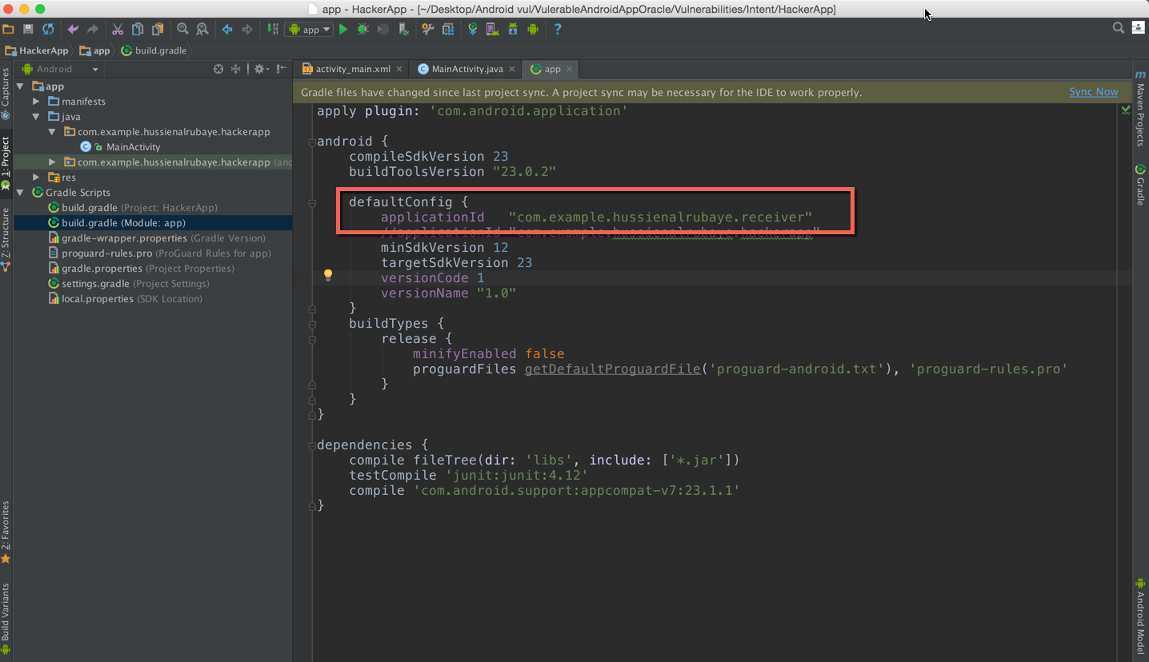

1. The code will be like this code

|  |
| --- |
| Java |
| @Override protected void onCreate(Bundle savedInstanceState) {  super.onCreate(savedInstanceState);  setContentView(R.layout.*activity_main*);  // init the textView to dipslay data  TextView txtDisplay=(TextView)findViewById(R.id.*txtDisplay*);  String DataBundel="";  // get app the data sent on bundle  Bundle bundle=getIntent().getExtras();  //lopp through all keys in the bundle  for (String key : bundle.keySet()) {  // get object by key( we define object became it may be text or image or whatever  Object value = bundle.get(key);  //get all keys  DataBundel+= String.*format*("%s %s (%s)", key, value.toString(), value.getClass().getName());  }  txtDisplay.setText(DataBundel); } |

**Example of Run the apps and send comment “hi app 2” from App “A” then Hacker app read the data**

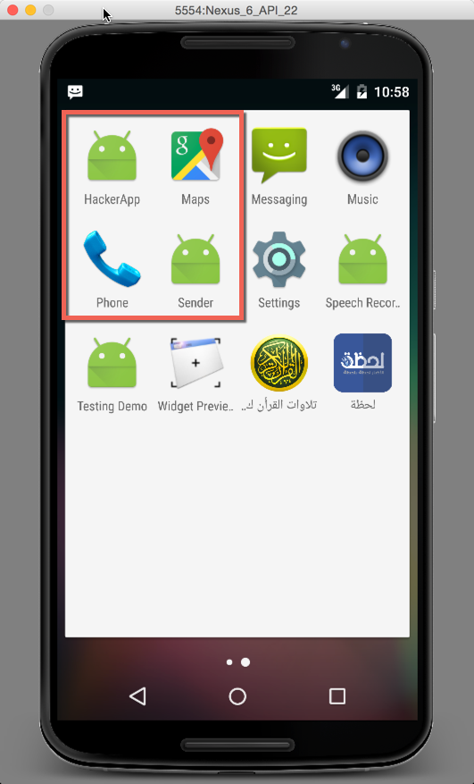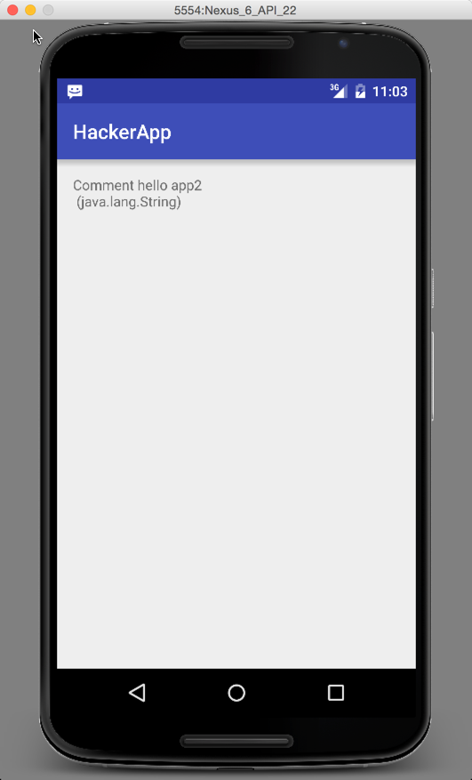

**Fix This Problem**

To fix this problem use encryption and decryption theory. That is mean that in sender app we encrypt the data before send it over bundle. Then in receiver app we decrypt that bundle data so the hacker app even could access to the data, it could not understand it.

**see the example below that shows the secure data send between App “A” and App “B”. It shows that even Hacker app access to the data but it cannot understand it.**

