**XML File**

Description:

Android use XML files string to store static data that mean the data that never change through execution of the app. For example, languages data such as (English, Spanish, Arabic), all theses data are stored in XML files to make the app support multi language. One thing you have to know that the Android execution file that extension “.APK” it just compression files that have many XML files and Java files files that make up the application, the bad thing that any one could un comparison the APK using reverse engineering and read the data that saved in XML tags.

The bad thing many developers store important information in XML such as Ads number or google map API number, and that is so bad, because if some one do reverse engineering to the app, he could read all the keys. We will demonstrate how to build android app that display google map with key saved in the XML, then we extract the key from “APK” using reverse engineering. Then we offer the best place to store the key.

**Steps To work**

1-Create new project , and the make sure to remember package name.

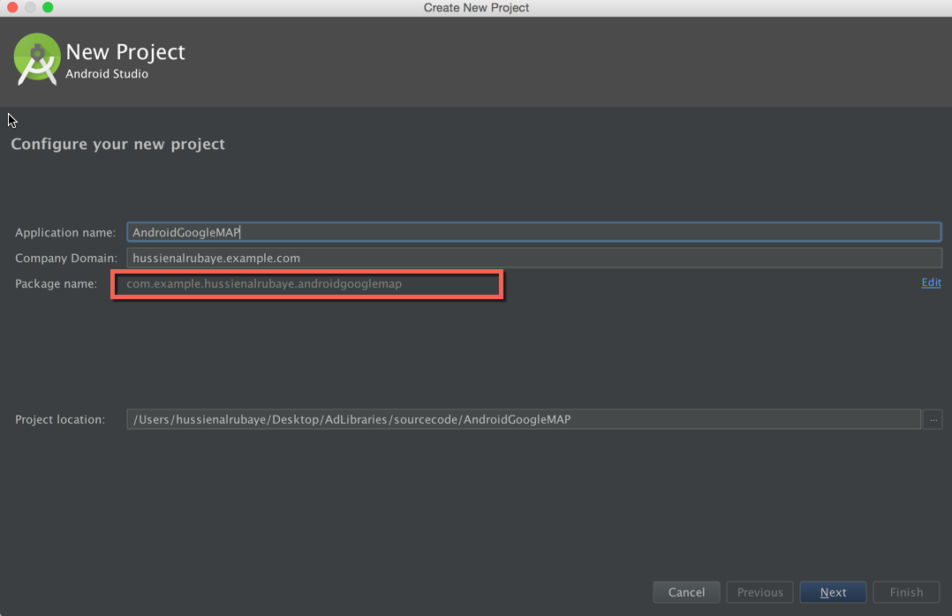

2- select project from type google maps Activity

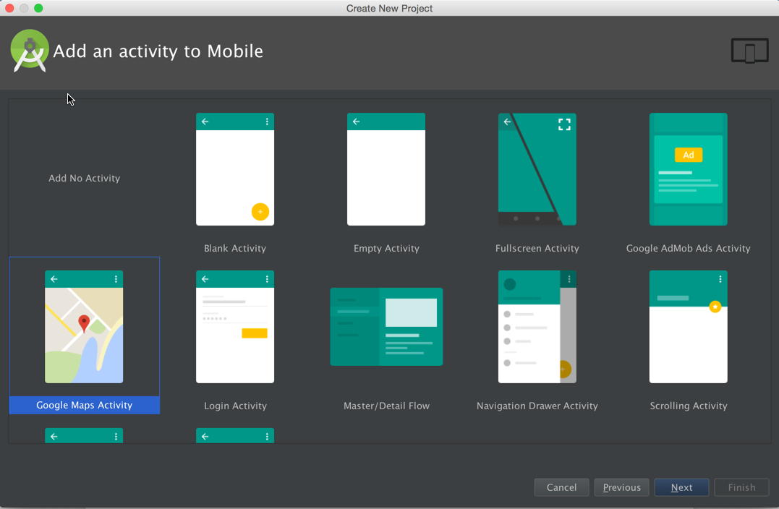

3- See app files one of them is **Strings.xml** file that have key named “google_map_key”, we have to create the key map for this app from google developer console by following the hints in this file, and replace the code it with “Your_KEY_HERE”.

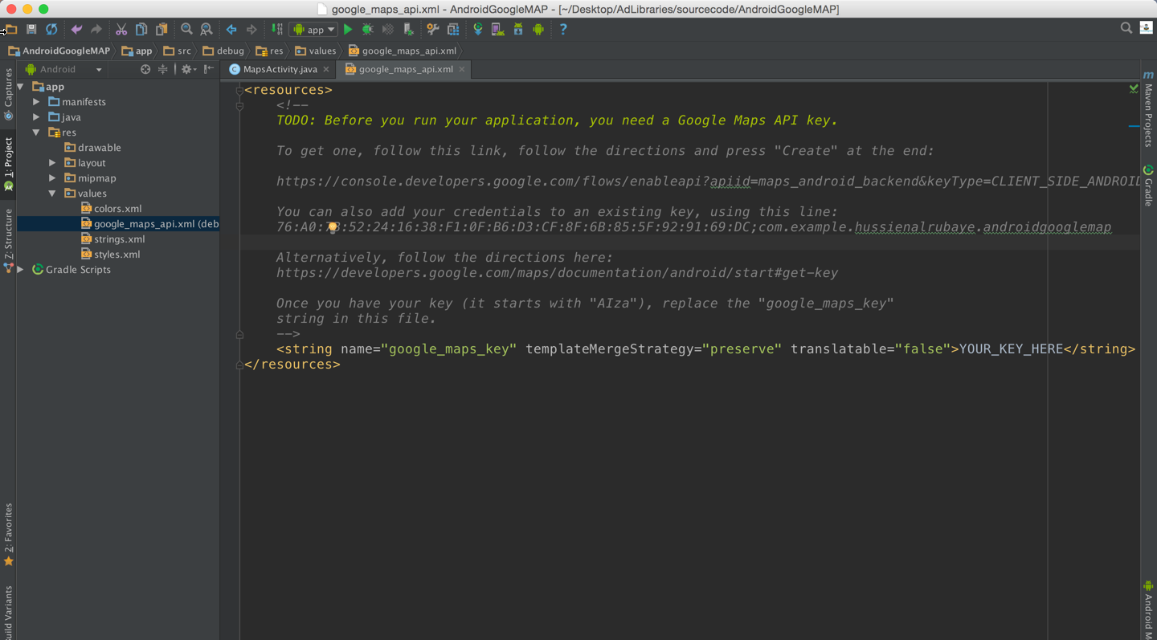

4- after create key in google developer console, you will see like this

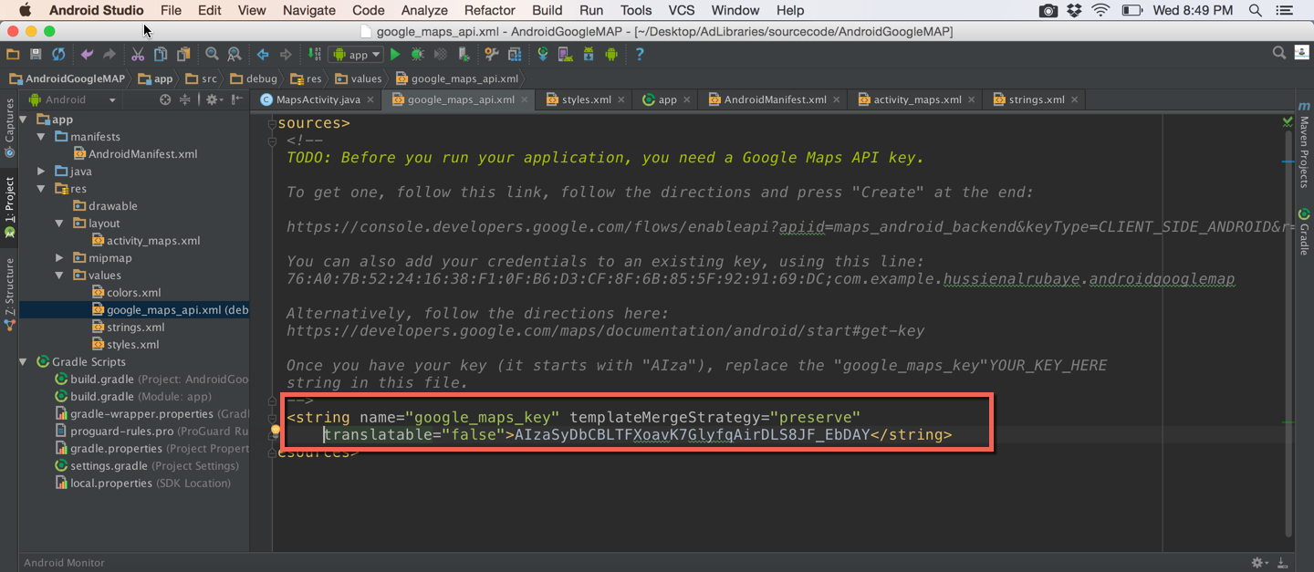

5- Run the app you will see this output

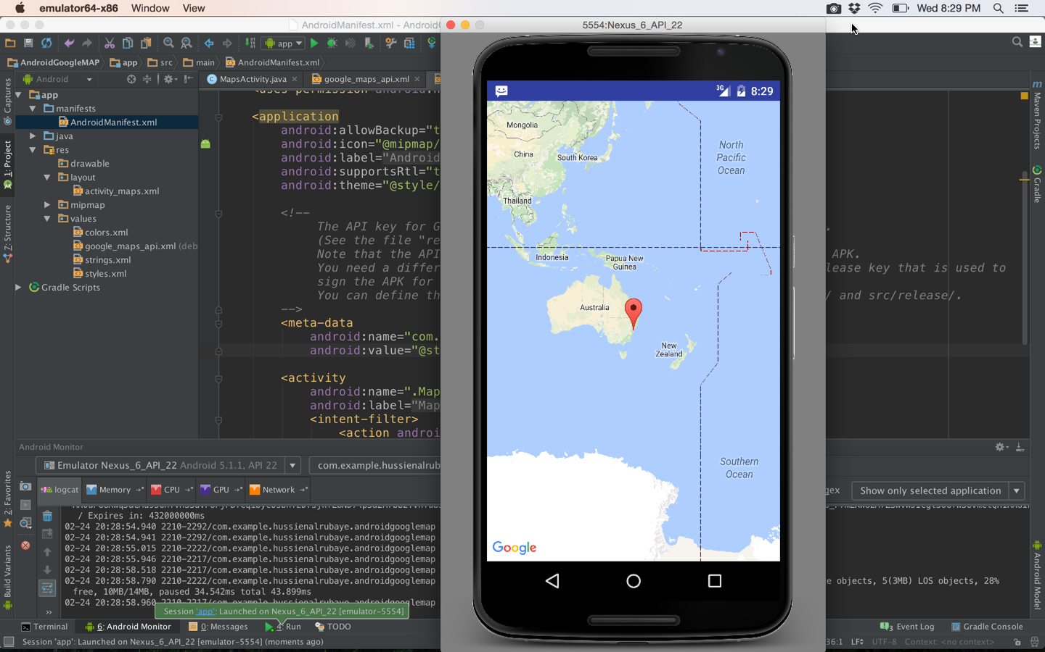

**How to change APK back to source code**

1. Pull back the apk from the device by going to “platform-tools” and run this command

**./adb pm path package_name // get package path**

**./adb pull package_path “computer path” // pull package to the computer**

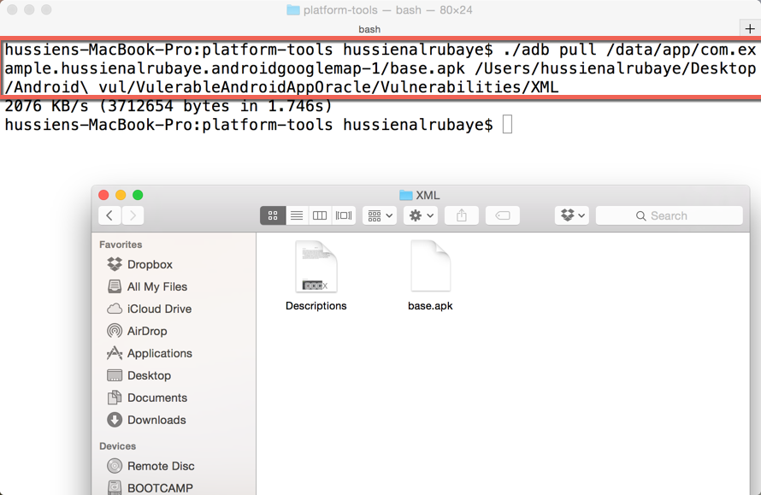

now we have the app as “base.apk”

1. now you could change APK to source code by either

A- change “base.apk” to “base.zip” then double click on it.

1. Using specific tool if you did not success with “A”, download this **apktool** from here.

<http://ibotpeaches.github.io/Apktool/>

and install it in your machine as the description in the website

Run this command, from same path you installed **apktool.jar**

**Java –jar apktool.jar d package_path**

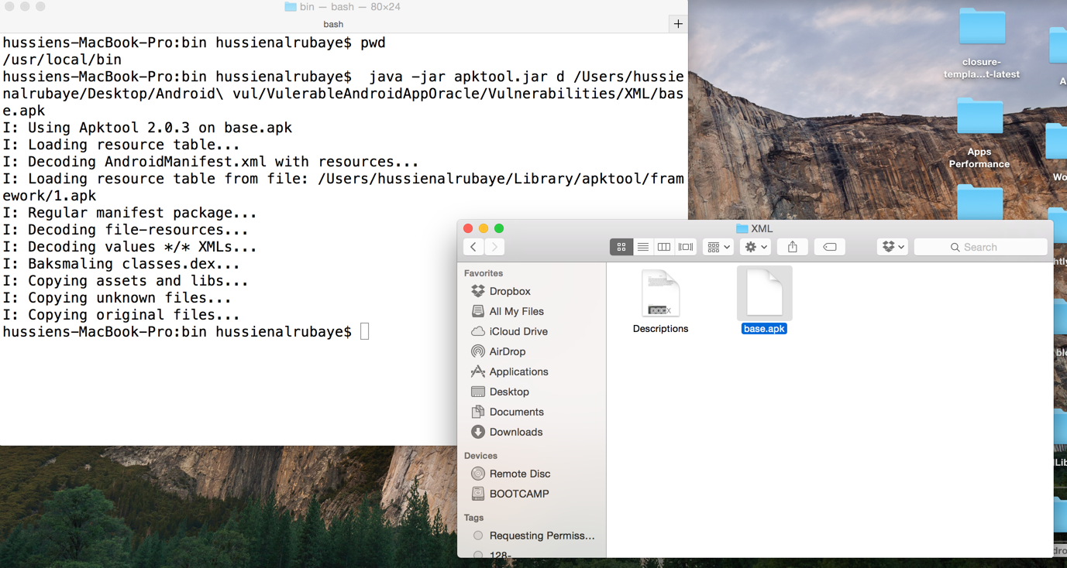

you will see folder “app-debug” that represent all app files. It will be like this.

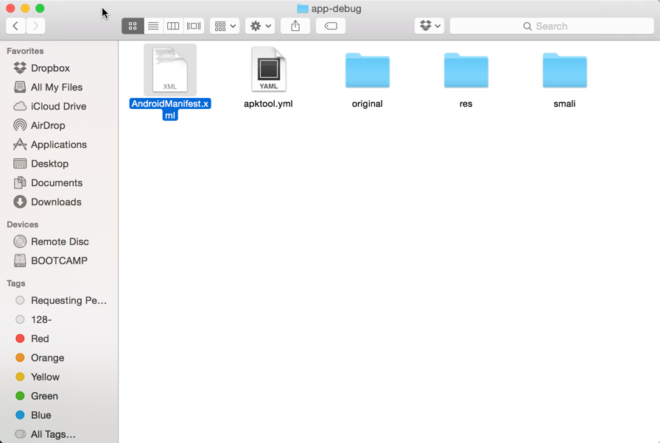

1. Open the file named “google_maps_api.xml” ,you will see the same key that you putted in your project. That is what we want to improve to you

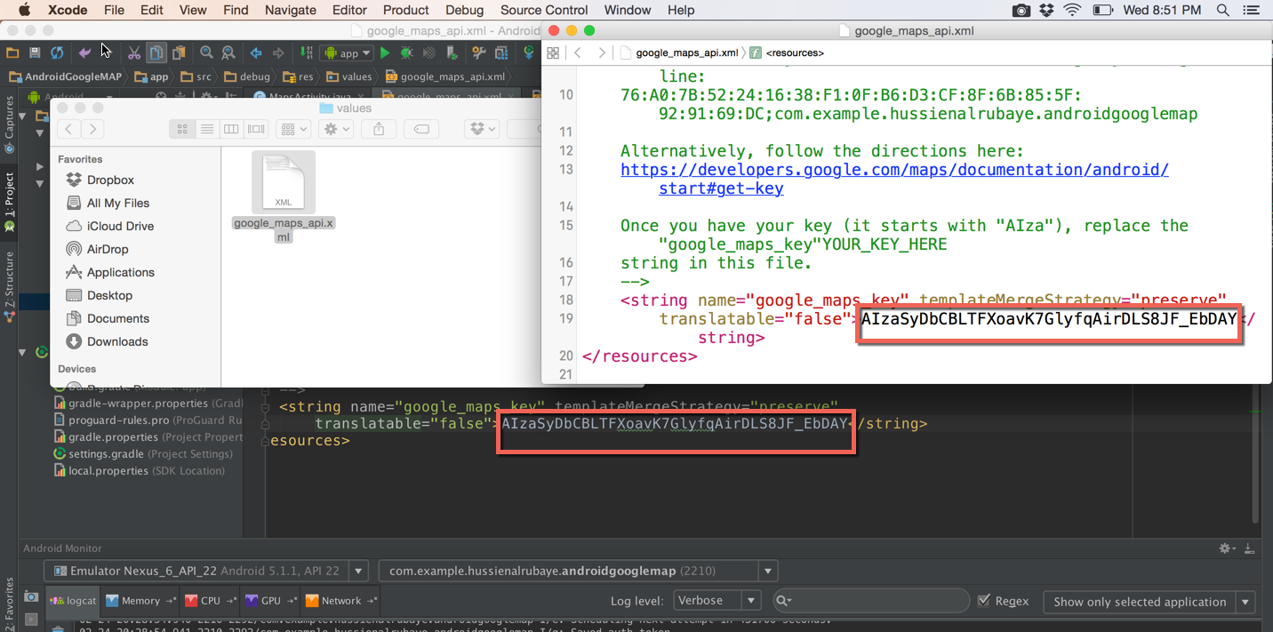

**Fix problem:**

The best way to fix this problem. keep all your read only variables as private in your java code files, and use it when ever you need it because the private variable cannot be reversed.