Appendix

A Tables and Figures
Figure A.1: Predictive power of classical models and ML models

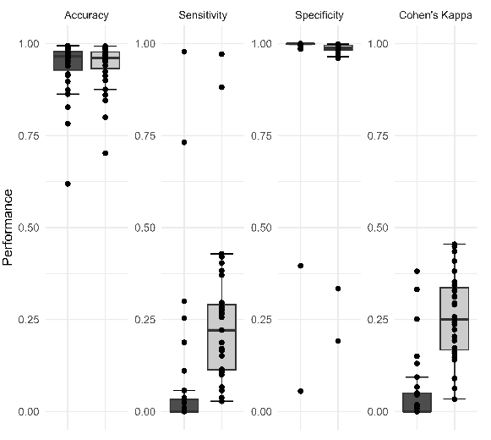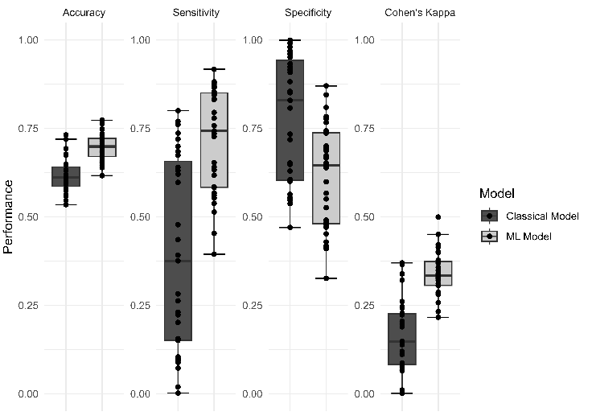

- Health insurance coverage (b) Visited health facility

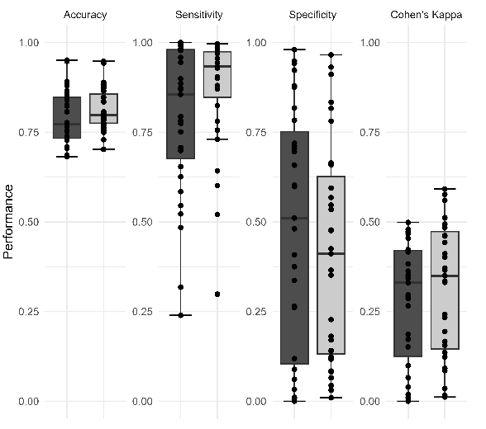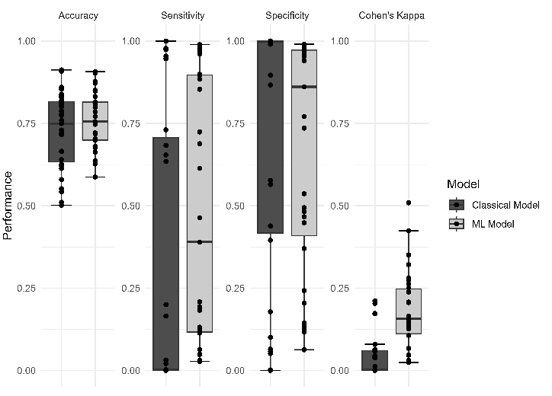
- Health facility-based births (d) Postnatal check

Notes: The figures show the predictive power for the classical model (consisting of 10 variables most often used by the literature, details see Section 2) and the ML model using a XGBoost model with repeated five-fold cross-validation (consisting of 60-79 variables available in the DHS data, details see Section 2). The performance values are Accuracy, a measure of how often the model correctly predicts the outcome, Cohen’s Kappa, a measure of how often the model correctly predicts the outcome adjusted by the underlying probability to make a correct prediction by chance, Sensitivity, a measure to correctly predict true positive cases, and Specificity, a measure to correctly predict true negative cases (more details see Section 3).

Figure A.2: Sensitivity of classical models and ML models

- Health insurance coverage (b) Visited health facility

- Health facility-based births (d) Postnatal check

Notes: The figures show the predictive power by country for the classical model (consisting of 10 variables most often used by the literature, details see Section 2) and the ML model using a XGBoost model with repeated five-fold cross-validation (consisting of 60-79 variables available in the DHS data, details see Section 2). The performance is measured as Sensitivity, a measure of how often the model correctly predicts the outcome adjusted by the underlying probability to make a correct prediction by chance (more details see Section 3).

Figure A.3: Comparison of average health insurance coverage and take-up of health services based on DHS and Census Data, for each available country with census data
- Benin
- Burkina Faso
- Cameroon
- Ethiopia
- Ghana
- Guinea
- Kenya
- Lesotho
- Liberia
- Malawi
- Mali
- Nigeria
- Rwanda
- Senegal
- Sierra Leone
- South Africa
- Tanzania
- Togo
- Uganda
- Zambia
- Zimbabwe
Note: The figures show for all 31 SSA counties (left) the reported regional (admin 1 level) averages in the DHS data, (middle) the predicted district (admin 2 level) average based on the ML model with restricted number of variables from the DHS data, (right) the predicted district (admin 2 level) average based on the ML model with restricted number of variables from the CENSUS data.

Figure A.4: Comparison prediction of health insurance coverage and take-up of health services based on DHS Data if no Census data is available, for each country
- Burundi
- Chad
- Congo Rep.
- Congo Dem. Rep.
- Côte d’Ivoire
- Gambia
- Madagascar
- Namibia
- Niger
Note: The figures show for all 31 SSA counties (left) the reported regional (admin 1 level) averages in the DHS data, (right) the predicted district (admin 2 level) average based on the ML model with restricted number of variables from the DHS data. Districts with less than 30 observations in the DHS data are labelled as NA and displayed in grey.

Figure A.5: Out-of-sample predictions
- Sudan
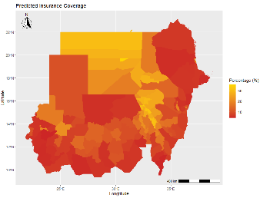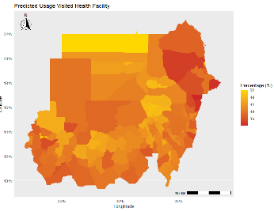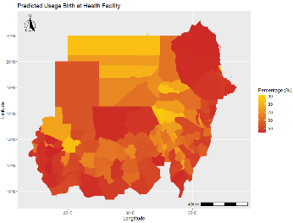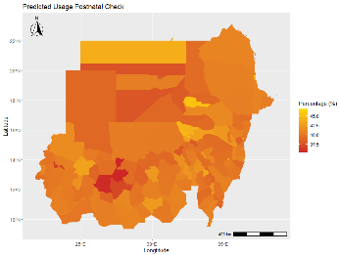
- Mozambique
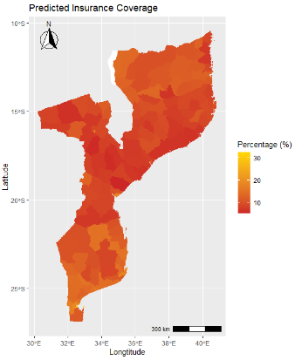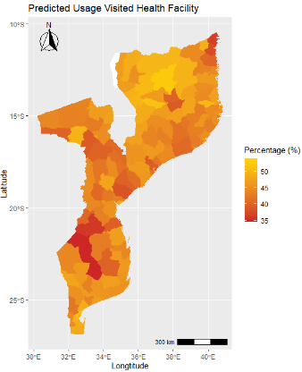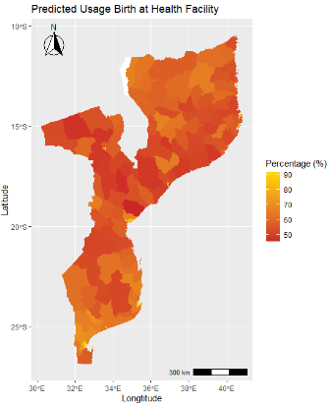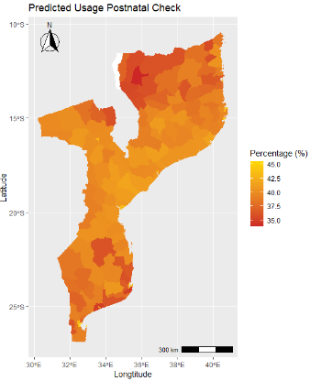
- Mauritius
- South Sudan
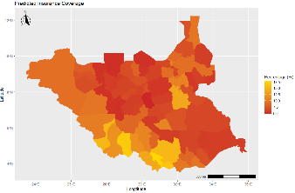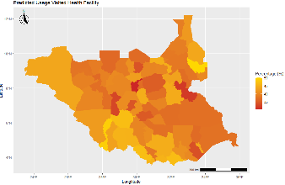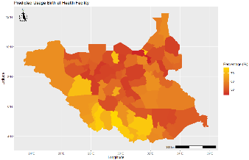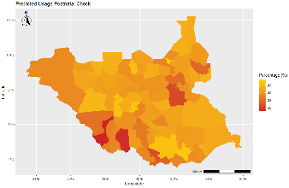
- Botswana
Note: All estimates are done on the individual level and aggregated on the district level. The scale is adjusted for each outcome and country.

Table A.1: Overview of variables
Variables short | Variables description | Number of countries using the variable for the model
age_cat | categoy, age (15-59 , in 5 year groups) | 32
age_HH_head | age of household head (standardized with Z-score normalization) | 32
bankaccount | binary, 1 if household has bankaccount | 31
bicycle | binary, 1 if household has bicycle | 32
birth_last_3y | binary, 1 if women had a birth in the last three years | 32
bmi | numeric, Body Mass Index | 50
boat | binary, 1 if household has boat | 27
canoe | binary, 1 if household has canoe | 9
car | binary, 1 if household has car | 32
cart | binary, 1 if household has cart | 30
cattle | Number of cattle owned | 22
child_born | binary, 1 if women has ever a child born | 32
child_labor_HH | binary, 1 if household has child involved in child labor | 1
computer | binary, 1 if household has computer | 19
contraceptive_health_care | binary, 1 if contraceptive requires access to health facility | 32
credit_union | binary, 1 if household has credit union | 9
currently_working | binary, 1 if women is currently working | 32
decides_health_care | binary, 1 if woman involved in decision about own healthcare | 11
decides_purchases | binary, 1 if woman involved in HH purchases | 11
dvd_player | binary, 1 if household has dvd player | 16
education | category, highest education level attained (in 4 groups) | 32
education_HH | category, highest education level attained in household (in 4 groups) | 32
electricity | binary, 1 if household has electricity | 32
ethnicity | category, Ethnicity of woman | 32
female | binary, 1 if female household member | 32
female_HH_head | binary, 1 if household head is female | 32
female_spend_health_care | binary, 1 if women decides on health care | 12
fertility_HH | binary, 1 if household wants to have another baby | 32
generator | binary, 1 if household has generator | 16
health_card | binary, 1 if woman has health card for child | 13
heard_family_planning | binary, 1 if woman heard of family planning via any media form | 32
heard_sti | binary, 1 if women heard of STI | 30
heard_tuberculosis | binary, 1 if woman has ever heard of tuberculosis | 8
HIV_witchcraft | binary, 1 if woman believes she can get HIV by witchcraft | 23
ideal_nr_children | numeric, ideal number of children | 26
internet_connection | binary, 1 if household has internet connection | 13
iodine | binary, 1 if salt contains iodine | 25
knows_mordern_method | binary, 1 if women knows modern method for contraception | 32
language | category, Native language of woman | 32
listen_radio | binary, 1 if women not at all listens to radio | 32
literate | binary, 1 if someone is literate | 32
malaria_insects | binary, if respondent thinks malaria contracted via other insects | 1
malaria_mosquito | binary, if respondent thinks malaria contracted via mosquito | 1
malaria_mother | binary, if respondent thinks malaria contracted via mother | 1
malaria_sorcery | binary, if respondent thinks malaria contracted via sorcery | 1
malaria_transfusion | binary, if respondent thinks malaria contracted via blood transfusion | 1
malaria_water | binary, if respondent thinks malaria contracted via drinking water | 1
married | binary, 1 if person is married or with a partner | 32
married_HH | binary, 1 if someone in household is married or with a partner | 32
media | binary, 1 if woman has some exposure to mass media | 32
media_HH | binary, 1 if household has some exposure to mass media | 32
member_all_HH | Number of household members (standardized with Z-score normalization) | 32
member_child_under_5 | Number of household members <5 (standardized with Z-score normalization) | 32
member_women_HH | Number of eligible women in household (standardized with Z-score normalization) | 32
migrant | binary, 1 if someone has migrant status | 1
mobile | binary, 1 if household has mobile telephone | 32
mosquitonet | binary, 1 if household uses a mosquitonet for sleeping
mosquitonets_nr | Number of mosquitonets (standardized with Z-score normalization) | 29
motorcycle | binary, 1 if household has motorcycle | 32
music_system | binary, 1 if household has music system | 16
non_numeric_fertility_preference | binary, 1 if woman chose non-numeric response for ideal number of children | 32
oven | binary, 1 if household has oven | 16
owns_land | binary, 1 if household has owns land usable for agriculture | 31
owns_livestock | binary, 1 if household owns livestock,herds or farm animals | 32
pregnant | binary, 1 if women is pregnant | 32
radio | binary, 1 if household has radio | 32
read_newspaper | binary, 1 if women not at all reads newspapers or magazines | 32
refrigerator | binary, 1 if household has refrigerator | 32
region | category, Region | 32
religion | category, religion of woman | 32
rural | binary, 1 if rural place of residence | 32
safe_cooking_fuel | binary, 1 if household uses safe cooking fuel | 32
safe_drinking_water | binary, 1 if safe drinking water source | 32
safe_floor_material | binary, 1 if safe floor material | 32
safe_sewage_disposal | binary, 1 if household has safe sewage disposal | 2
safe_toilet_facility | binary, 1 if safe toilet facility | 32
safe_trash_disposal | binary, 1 if household has safe trash disposal | 3
share_toilet | binary, 1 if household shares toilet with other households | 8
slept | binary, 1 if person slept last night | 32
smoke_inside | binary, 1 if household members smoke inside the house | 29
smokes | binary, 1 if women smokes any cigarette or tobacco | 30
soap | binary, 1 if soap present at place for hand washing | 5
sondaughterdied | binary, 1 if women has either son or daughter who have died | 32
sondaughterhome | binary, 1 if women has either son or daughter at home | 32
tel | binary, 1 if household has landline telephone | 30
television | binary, 1 if household has television | 32
terminated_pregnancy | binary, 1 if women ever had a terminated pregnancy | 32
tested_HIV | binary, 1 if women tested for HIV | 30
toilet | binary, 1 if household has any facility | 32
video_recorder | binary, 1 if household has video recorder | 16
washing_machine | binary, 1 if household has washing machine | 10
watch | binary, 1 if household has watch | 30
watch_TV | binary, 1 if women not at all watches television | 32
water_handwash_present | binary, 1 if water is present at handwashing place | 4
water_interrupted | binary, 1 if water was interrupted for a full day or more | 3
water_time | Time for HH to get to water source (minutes) | 1
water_treated | binary, 1 if Anything done to water to make safe to drink | 32
wealthindex | category, wealth index, combined (in quintiles) | 32
Notes: Tables shows all variables used for the ML models, using all available variables in the DHS data. For each country all available variables were used, excluding variables that have no variation after creating the sub-sample for the outcome or that generate less than 10% missing data in order to avoid a too small sample (see details for variable selection in Section 3).
Table A.2: Top 5 predictors of the ML model for health insurance coverage
 | Top #1 |  | Top #2 |  |  | Top #3 |  |  | Top #4 |  |  | Top #5
 | Predictor | Variable Importance | Predictor | Variable Importance | Predictor |  | Variable Importance | Predictor |  | Variable Importance | Predictor |  | Variable Importance
Benin | Has bankaccount | 100 | Number of HH members | 22 | Literate |  | 21 | Tertiary education level of HH head |  | 21 | *5th wealthquintile |  | 20
Burkina.Faso | HH has electricity | 100 | HH has refrigerator | 64 | Ideal number of children |  | 40 | HH has television |  | 33 | Number of HH members |  | 21
Burundi | Has bankaccount | 100 | *Married or with a partner | 61 | Number of HH members |  | 49 | Ideal number of children |  | 39 | *Age: 15-24 |  | 34
Cameroon | *5th wealthquintile | 100 | Number of HH members | 64 | Ideal number of children |  | 48 | Has bankaccount |  | 46 | *Tertiary education level attained |  | 40
Chad | HH has television | 100 | Literate | 48 | Tertiary education level of HH head |  | 34 | *Rural place of residence |  | 31 | Heard of family planning via any media form |  | 26
Cote dIvoire | Has bankaccount | 100 | Number of HH members | 39 | Literate |  | 23 | Not at all reads newspaper |  | 22 | Ideal number of children |  | 20
DRC | *5th wealthquintile | 100 | Time for HH to get to water source | 49 | Ideal number of children |  | 41 | Number of HH members |  | 39 | Safe floor material |  | 25
Eswatini | *5th wealthquintile | 100 | Body Mass Index | 81 | Number of HH members |  | 27 | HH has electricity |  | 23 | HH has a car |  | 19
Ethiopia | Body Mass Index | 100 | Religion: Orthodox | 33 | Number of HH members |  | 32 | Ideal number of children |  | 29 | Number of cattle owned |  | 27
Ghana | Number of HH members | 100 | Ideal number of children | 47 | Tested for HIV |  | 47 | Number of HH members <5 years |  | 37 | Number of mosquitonets |  | 35
Guinea | Has bankaccount | 100 | *5th wealthquintile | 75 | Number of HH members |  | 33 | Literate |  | 27 | Number of female HH members |  | 23
Kenya | Body Mass Index | 100 | Has bankaccount | 50 | Number of HH members |  | 30 | Ideal number of children |  | 23 | *Tertiary education level attained |  | 22
Lesotho | *Tertiary education level attained | 100 | Number of HH members | 97 | Ideal number of children |  | 58 | Safe cooking fuel |  | 57 | Heard of family planning via any media form |  | 53
Liberia | *Exposure to mass media | 100 | Number of HH members | 79 | *HH has exposure to mass media |  | 73 | Ideal number of children |  | 62 | HH has owns land usable for agriculture |  | 54
Madagascar | *5th wealthquintile | 100 | Has bankaccount | 82 | HH has television |  | 66 | Number of HH members |  | 42 | Ideal number of children |  | 27
Malawi | Has bankaccount | 100 | *Tertiary education level attained | 20 | Number of HH members |  | 16 | Ideal number of children |  | 14 | Not at all reads newspaper |  | 13
Mali | Has bankaccount | 100 | Literate | 51 | Number of HH members |  | 29 | Number of HH members <5 years |  | 14 | Number of mosquitonets |  | 14
Mauritania | Has bankaccount | 100 | Number of HH members | 42 | Number of female HH members |  | 22 | Number of HH members <5 years |  | 16 | Number of mosquitonets |  | 15
Namibia | *5th wealthquintile | 100 | *Tertiary education level attained | 96 | Number of HH members |  | 86 | Ideal number of children |  | 64 | *Currently working |  | 63
Niger | Has bankaccount | 100 | HH has refrigerator | 64 | HH has television |  | 40 | Number of HH members |  | 25 | Ideal number of children |  | 21
Nigeria | *Tertiary education level attained | 100 | Number of HH members | 46 | Ideal number of children |  | 38 | Heard of family planning via any media form |  | 34 | Knows mordern method for contraception |  | 28
Republic of the Congo | Has bankaccount | 100 | Ideal number of children | 87 | Number of HH members |  | 86 | Literate |  | 78 | *5th wealthquintile |  | 66
Rwanda | Number of HH members | 100 | Ideal number of children | 79 | Number of HH members <5 years |  | 55 | Number of mosquitonets |  | 54 | Has bankaccount |  | 49
Senegal | Number of HH members | 100 | Has bankaccount | 95 | Number of mosquitonets |  | 71 | Number of female HH members |  | 65 | Number of HH members <5 years |  | 39
Sierra Leone | Number of HH members | 100 | Ideal number of children | 65 | Salt contains iodine |  | 60 | Language: Themne |  | 56 | Number of mosquitonets |  | 46
Tanzania | Body Mass Index | 100 | Number of HH members | 41 | Ideal number of children |  | 31 | Number of mosquitonets |  | 25 | HH has a music system |  | 22
The Gambia | Not at all reads newspaper | 100 | Has bankaccount | 99 | Literate |  | 74 | Number of HH members |  | 66 | *5th wealthquintile |  | 59
Togo | Has bankaccount | 100 | Tertiary education level of HH head | 36 | Number of HH members |  | 34 | Number of mosquitonets |  | 24 | HH has a motorcycle |  | 22
Uganda | *Tertiary education level attained | 100 | Number of HH members | 38 | Ideal number of children |  | 38 | Number of HH members <5 years |  | 31 | Number of mosquitonets |  | 27
Zambia | Has bankaccount | 100 | *Tertiary education level attained | 54 | Tertiary education level of HH head |  | 38 | *5th wealthquintile |  | 18 | Number of HH members |  | 17
Zimbabwe | Has bankaccount | 100 | Body Mass Index | 65 | *Tertiary education level attained |  | 26 | Number of HH members |  | 22 | HH has refrigerator |  | 20
Notes: Table show the predictors and the variable importance of the top 5 predictors of the ML model. A predictor’s importance score is defined by the decrease in the classification error that is attributed to all of its splits in a given tree, averaged across all trees and normalized to a range from 0-100. Variables with a * highlight variables that are included in the classical model.

Table A.3: Top 5 predictors of the ML model for take-up of visited a health facility
 | Top #1 |  | Top #2 |  |  | Top #3 |  |  | Top #4 |  |  | Top #5
 | Predictor | Variable Importance | Predictor | Variable Importance | Predictor |  | Variable Importance | Predictor |  | Variable Importance | Predictor |  | Variable Importance
Benin | Birth in the last three years | 100 | *Married or with a partner | 49 | Pregnant |  | 39 | Ideal number of children |  | 23 | Number of HH members <5 years |  | 16
Burkina.Faso | Birth in the last three years | 100 | Pregnant | 24 | Tested for HIV |  | 23 | Has child at home |  | 17 | Contraceptive from health facility |  | 16
Burundi | Has child at home | 100 | Ever gave birth | 34 | Birth in the last three years |  | 23 | *Married or with a partner |  | 21 | Number of HH members <5 years |  | 13
Cameroon | Tested for HIV | 100 | Birth in the last three years | 51 | Has child at home |  | 46 | Pregnant |  | 29 | Heard of family planning via any media form |  | 17
Chad | Knows mordern method for contraception | 100 | No education level of HH head | 33 | Number of HH members |  | 21 | Birth in the last three years |  | 20 | Not at all listens to radio |  | 15
Cote dIvoire | Tested for HIV | 100 | Birth in the last three years | 90 | Number of HH members |  | 60 | Pregnant |  | 51 | Ideal number of children |  | 42
DRC | Has child at home | 100 | Time for HH to get to water source | 70 | Birth in the last three years |  | 61 | *Married or with a partner |  | 61 | Ideal number of children |  | 60
Eswatini | Birth in the last three years | 100 | Body Mass Index | 39 | Ever gave birth |  | 34 | Tested for HIV |  | 21 | Pregnant |  | 19
Ethiopia | Tested for HIV | 100 | Body Mass Index | 61 | Has child at home |  | 27 | *Married or with a partner |  | 26 | Birth in the last three years |  | 24
Ghana | Birth in the last three years | 100 | Tested for HIV | 56 | Has a health insurance |  | 40 | Pregnant |  | 30 | Ever gave birth |  | 21
Guinea | Knows mordern method for contraception | 100 | Number of HH members | 86 | Birth in the last three years |  | 70 | Pregnant |  | 53 | Number of HH members <5 years |  | 51
Kenya | Tested for HIV | 100 | Has child at home | 74 | Ideal number of children |  | 55 | Birth in the last three years |  | 55 | Body Mass Index |  | 44
Lesotho | Tested for HIV | 100 | Ever gave birth | 72 | Birth in the last three years |  | 42 | Ideal number of children |  | 31 | Number of HH members |  | 29
Liberia | Tested for HIV | 100 | Birth in the last three years | 76 | Has child at home |  | 60 | Number of HH members |  | 57 | Pregnant |  | 51
Madagascar | Birth in the last three years | 100 | Has child at home | 74 | Number of HH members |  | 61 | Tested for HIV |  | 60 | Pregnant |  | 49
Malawi | Has child at home | 100 | Ever gave birth | 89 | Number of HH members |  | 77 | Ideal number of children |  | 65 | Birth in the last three years |  | 62
Mali | Tested for HIV | 100 | Birth in the last three years | 80 | Hard of STI |  | 71 | Knows mordern method for contraception |  | 51 | Heard of family planning via any media form |  | 51
Mauritania | Number of HH members | 100 | Number of HH members <5 years | 64 | Birth in the last three years |  | 51 | Number of mosquitonets |  | 50 | Number of female HH members |  | 50
Namibia | Tested for HIV | 100 | Number of HH members | 76 | Ideal number of children |  | 71 | Number of cattle owned |  | 62 | Number of HH members <5 years |  | 45
Niger | Birth in the last three years | 100 | Ideal number of children | 47 | Number of HH members |  | 44 | Knows mordern method for contraception |  | 39 | Number of HH members <5 years |  | 30
Nigeria | Birth in the last three years | 100 | Number of HH members | 31 | Ideal number of children |  | 28 | *Married or with a partner |  | 26 | Number of HH members <5 years |  | 25
Republic of the Congo | Birth in the last three years | 100 | Tested for HIV | 70 | Pregnant |  | 66 | Number of HH members |  | 62 | Ideal number of children |  | 56
Rwanda | Has a health insurance | 100 | Ever gave birth | 53 | Tested for HIV |  | 46 | Birth in the last three years |  | 38 | *Married or with a partner |  | 33
Senegal | Ever gave birth | 100 | Has child at home | 36 | Contraceptive from health facility |  | 28 | Pregnant |  | 27 | Birth in the last three years |  | 26
Sierra Leone | Birth in the last three years | 100 | Number of HH members | 54 | Ideal number of children |  | 42 | Pregnant |  | 35 | Ever gave birth |  | 29
Tanzania | Body Mass Index | 100 | Has child at home | 75 | Birth in the last three years |  | 57 | Number of HH members |  | 35 | Ideal number of children |  | 33
The Gambia | Birth in the last three years | 100 | Has child at home | 37 | Ever gave birth |  | 32 | *Married or with a partner |  | 29 | Number of HH members |  | 28
Togo | Birth in the last three years | 100 | Tested for HIV | 77 | Pregnant |  | 39 | *Married or with a partner |  | 29 | Ever gave birth |  | 20
Uganda | Tested for HIV | 100 | Ever gave birth | 79 | Has child at home |  | 53 | *Married or with a partner |  | 45 | Birth in the last three years |  | 42
Zambia | Number of HH members | 100 | Ideal number of children | 87 | Has child at home |  | 84 | Ever gave birth |  | 71 | Number of mosquitonets |  | 64
Zimbabwe | Tested for HIV | 100 | Birth in the last three years | 31 | Body Mass Index |  | 30 | Ever gave birth |  | 22 | Ideal number of children |  | 15
Notes: Table show the predictors and the variable importance of the top 5 predictors of the ML model. A predictor’s importance score is defined by the decrease in the classification error that is attributed to all of its splits in a given tree, averaged across all trees and normalized to a range from 0-100. Variables with a * highlight variables that are included in the classical model
Table A.4: Top 5 predictors of the ML model for take-up of health facility-based birth
 | Top #1 |  | Top #2 |  |  | Top #3 |  |  | Top #4 |  |  | Top #5
 | Predictor | Variable Importance | Predictor | Variable Importance | Predictor |  | Variable Importance | Predictor |  | Variable Importance | Predictor |  | Variable Importance
Benin | Ethnicity: Peulh and related | 100 | Ideal number of children | 84 | Number of HH members |  | 70 | *1st wealthquintile |  | 44 | Language: Fon |  | 44
Burkina.Faso | Number of cattle owned | 100 | Tested for HIV | 92 | Health card for child |  | 75 | Ideal number of children |  | 70 | Time for HH to get to water source |  | 52
Burundi | Number of HH members | 100 | Ideal number of children | 96 | Has a video recorder |  | 50 | Number of male HH members |  | 43 | Number of HH members <5 years |  | 39
Cameroon | HH has electricity | 100 | Tested for HIV | 80 | *No education level attained |  | 45 | Literate |  | 33 | *Rural place of residence |  | 27
Chad | Number of HH members | 100 | *Rural place of residence | 64 | Number of mosquitonets |  | 53 | Number of HH members <5 years |  | 47 | HH has any toilet facility |  | 42
Cote dIvoire | HH has electricity | 100 | Health card for child | 45 | Number of HH members |  | 40 | HH has owns land usable for agriculture |  | 35 | *Rural place of residence |  | 33
DRC | Health card for child | 100 | Time for HH to get to water source | 26 | Ideal number of children |  | 26 | Literate |  | 22 | *Rural place of residence |  | 20
Eswatini | Primary education level of HH head | 100 | Body Mass Index | 41 | Number of HH members <5 years |  | 34 | *1st wealthquintile |  | 30 | Number of cattle owned |  | 29
Ethiopia | HH has electricity | 100 | Tested for HIV | 98 | *Rural place of residence |  | 84 | *5th wealthquintile |  | 26 | *No education level attained |  | 21
Ghana | *Rural place of residence | 100 | Ideal number of children | 70 | Number of HH members |  | 50 | Number of HH members <5 years |  | 45 | Tested for HIV |  | 42
Guinea | *Rural place of residence | 100 | Number of HH members | 43 | HH has television |  | 31 | Safe floor material |  | 27 | Religion: Muslim |  | 24
Kenya | *1st wealthquintile | 100 | Safe floor material | 46 | Number of HH members |  | 44 | *No education level attained |  | 30 | HH has electricity |  | 27
Lesotho | Primary education level of HH head | 100 | Safe floor material | 99 | Safe cooking fuel |  | 94 | Has bankaccount |  | 68 | Literate |  | 67
Liberia | Ideal number of children | 100 | Number of HH members | 94 | Number of HH members <5 years |  | 65 | Tested for HIV |  | 58 | Number of mosquitonets |  | 44
Madagascar | *5th wealthquintile | 100 | Heard of family planning via any media form | 60 | HH has television |  | 52 | Literate |  | 40 | *HH has exposure to mass media |  | 40
Malawi | Number of HH members | 100 | Ideal number of children | 90 | Number of mosquitonets |  | 51 | Number of HH members <5 years |  | 42 | HH shares toilet with other HH |  | 33
Mali | Safe floor material | 100 | HH has any toilet facility | 99 | Tested for HIV |  | 94 | HH has electricity |  | 92 | Number of HH members |  | 74
Mauritania | Safe cooking fuel | 100 | *Rural place of residence | 81 | HH has electricity |  | 75 | *1st wealthquintile |  | 66 | HH has television |  | 38
Namibia | Literate | 100 | Number of HH members | 74 | Ideal number of children |  | 69 | Number of cattle owned |  | 57 | Number of HH members <5 years |  | 39
Niger | *Rural place of residence | 100 | Health card for child | 26 | HH has electricity |  | 22 | *5th wealthquintile |  | 22 | Tested for HIV |  | 21
Nigeria | *No education level attained | 100 | Language: Hausa | 46 | Ideal number of children |  | 34 | HH has television |  | 20 | Language: Other |  | 16
Republic of the Congo | Number of HH members | 100 | Ideal number of children | 98 | *1st wealthquintile |  | 90 | Tested for HIV |  | 55 | Number of mosquitonets |  | 49
Rwanda | Number of HH members | 100 | Ideal number of children | 86 | Had health insurance |  | 69 | Has child at home |  | 67 | HH has a radio |  | 55
Senegal | HH has electricity | 100 | Number of mosquitonets | 92 | Number of HH members |  | 89 | *1st wealthquintile |  | 80 | Number of HH members <5 years |  | 64
Sierra Leone | Number of HH members | 100 | Ideal number of children | 86 | Ethnicity: Mende |  | 60 | Number of mosquitonets |  | 52 | Number of HH members <5 years |  | 51
Tanzania | Body Mass Index | 100 | Ideal number of children | 95 | Safe floor material |  | 90 | *Rural place of residence |  | 81 | Number of HH members <5 years |  | 53
The Gambia | Number of HH members | 100 | Number of HH members <5 years | 54 | Number of female HH members |  | 51 | Number of male HH members |  | 48 | Number of cattle owned |  | 46
Togo | HH has electricity | 100 | Tested for HIV | 64 | Health card for child |  | 39 | *1st wealthquintile |  | 36 | Religion: Traditional animist |  | 32
Uganda | Primary education level of HH head | 100 | *5th wealthquintile | 50 | *Rural place of residence |  | 47 | Safe floor material |  | 38 | Ethnicity: Bagisu |  | 32
Zambia | Ideal number of children | 100 | Number of HH members | 92 | Number of mosquitonets |  | 50 | Number of HH members <5 years |  | 40 | Number of male HH members |  | 33
Zimbabwe | Body Mass Index | 100 | Tested for HIV | 82 | Ideal number of children |  | 38 | Number of HH members |  | 33 | Number of cattle owned |  | 29
Notes: Table show the predictors and the variable importance of the top 5 predictors of the ML model. A predictor’s importance score is defined by the decrease in the classification error that is attributed to all of its splits in a given tree, averaged across all trees and normalized to a range from 0-100. Variables with a * highlight variables that are included in the classical model.

Table A.5: Top 5 predictors of the ML model for take-up of postnatal check
 | Top #1 |  | Top #2 |  |  | Top #3 |  |  | Top #4 |  |  | Top #5
 | Predictor | Variable Importance | Predictor | Variable Importance | Predictor |  | Variable Importance | Predictor |  | Variable Importance | Predictor |  | Variable Importance
Benin | Number of HH members | 100 | Ideal number of children | 91 | Number of mosquitonets |  | 65 | Number of HH members <5 years |  | 54 | Number of male HH members |  | 40
Burkina.Faso | Number of cattle owned | 100 | Time for HH to get to water source | 70 | Number of HH members |  | 66 | Ideal number of children |  | 52 | Health card for child |  | 50
Burundi | Ideal number of children | 100 | Number of HH members | 96 | Health facility-based birth |  | 83 | Number of male HH members |  | 41 | Number of HH members <5 years |  | 40
Cameroon | Heard of family planning via any media form | 100 | Tested for HIV | 73 | Language: Bamoun |  | 69 | Soap present at place for hand washing |  | 67 | Ever had a terminated pregnancy |  | 57
Chad | Number of HH members | 100 | Health facility-based birth | 68 | Health card for child |  | 62 | Number of mosquitonets |  | 55 | Number of HH members <5 years |  | 46
Cote dIvoire | Health card for child | 100 | Ideal number of children | 58 | Number of HH members |  | 56 | Number of mosquitonets |  | 30 | Has access to source of drinking water |  | 27
DRC | Time for HH to get to water source | 100 | Ideal number of children | 75 | Number of HH members |  | 66 | Ethnicity: Bas kasai and kwilu kwngo |  | 45 | Number of mosquitonets |  | 37
Eswatini | Body Mass Index | 100 | Number of HH members | 52 | Ideal number of children |  | 38 | Number of male HH members |  | 26 | Number of HH members <5 years |  | 23
Ethiopia | Body Mass Index | 100 | Ideal number of children | 39 | Number of HH members |  | 33 | Health facility-based birth |  | 25 | Tested for HIV |  | 24
Ghana | Ethnicity: Mole dagbani | 100 | Number of HH members | 75 | Heard of tuberculosis |  | 72 | Ethnicity: Akan |  | 64 | Health card for child |  | 62
Guinea | Number of HH members | 100 | Heard of STI | 57 | Number of mosquitonets |  | 55 | Number of HH members <5 years |  | 49 | Number of male HH members |  | 48
Kenya | Ethnicity: Kalenjin | 100 | Body Mass Index | 86 | Ideal number of children |  | 78 | Ethnicity: Turkana |  | 49 | Ethnicity: Somali |  | 31
Lesotho | Number of HH members | 100 | Number of cattle owned | 77 | Ideal number of children |  | 70 | Number of HH members <5 years |  | 39 | Number of male HH members |  | 36
Liberia | Health facility-based birth | 100 | Number of HH members | 16 | *Currently working |  | 15 | Ideal number of children |  | 13 | Contraceptive requires access to health facility |  | 13
Madagascar | Heard of family planning via any media form | 100 | Tested for HIV | 67 | Health facility-based birth |  | 51 | Not at all listens to radio |  | 48 | Number of mosquitonets |  | 35
Malawi | Language: Chichewa | 100 | *Currently working | 57 | Number of HH members |  | 56 | Ideal number of children |  | 40 | Number of mosquitonets |  | 36
Mali | Number of HH members | 100 | Number of mosquitonets | 79 | Tested for HIV |  | 67 | Heard of family planning via any media form |  | 62 | Health facility-based birth |  | 52
Mauritania | Number of HH members | 100 | Number of mosquitonets | 51 | Number of HH members <5 years |  | 45 | Health facility-based birth |  | 42 | Language: Poular |  | 40
Namibia | Number of HH members | 100 | Ideal number of children | 92 | Number of cattle owned |  | 80 | Number of HH members <5 years |  | 49 | Has bankaccount |  | 49
Niger | Health card for child | 100 | Ideal number of children | 33 | Number of HH members |  | 29 | Health facility-based birth |  | 23 | Tested for HIV |  | 19
Nigeria | Ideal number of children | 100 | Number of HH members | 97 | Number of mosquitonets |  | 57 | Language: Yoruba |  | 57 | *No education level attained |  | 51
Republic of the Congo | Number of HH members | 100 | Ideal number of children | 90 | Health facility-based birth |  | 78 | Number of mosquitonets |  | 54 | Number of HH members <5 years |  | 49
Rwanda | Number of HH members | 100 | Ideal number of children | 85 | Number of mosquitonets |  | 51 | Number of cattle owned |  | 45 | Safe toilet facility |  | 45
Senegal | Health facility-based birth | 100 | Number of HH members | 30 | Number of mosquitonets |  | 25 | Tested for HIV |  | 14 | Number of HH members <5 years |  | 14
Sierra Leone | Number of HH members | 100 | Ideal number of children | 93 | Health facility-based birth |  | 80 | Language: Krio |  | 69 | Number of mosquitonets |  | 62
Tanzania | Body Mass Index | 100 | Health facility-based birth | 83 | Ideal number of children |  | 68 | Contraceptive requires access to health facility |  | 59 | Number of HH members |  | 48
The Gambia | Number of HH members | 100 | Number of mosquitonets | 63 | Number of HH members <5 years |  | 60 | Number of male HH members |  | 50 | *Rural place of residence |  | 48
Togo | Health card for child | 100 | Health facility-based birth | 78 | Tested for HIV |  | 78 | Number of HH members |  | 52 | Involved in decision about own healthcare |  | 50
Uganda | Health facility-based birth | 100 | Language: Runyankole rukiga | 94 | Ideal number of children |  | 77 | Number of HH members |  | 60 | Number of HH members <5 years |  | 54
Zambia | Ideal number of children | 100 | Number of HH members | 85 | Not at all listens to radio |  | 64 | Number of mosquitonets |  | 63 | Contraceptive requires access to health facility |  | 51
Zimbabwe | Body Mass Index | 100 | Number of HH members | 38 | Ideal number of children |  | 34 | Number of cattle owned |  | 27 | Tested for HIV |  | 23
Notes: Table show the predictors and the variable importance of the top 5 predictors of the ML model. A predictor’s importance score is defined by the decrease in the classification error that is attributed to all of its splits in a given tree, averaged across all trees and normalized to a range from 0-100. Variables with a * highlight variables that are included in the classical model.

B Empirical Models
Logit model
Logit models are widely used to estimate regressions with a binary dependent variable. In order to restrict the estimates to the 0, 1 boundary, a function is applied to transform the predictions. In case of the logit model a logistic function is used to always obtain sensible predictions within the range of 0 and 1.
Advantages of the logit model are that the model is very simple the coefficients can be easily interpreted. The training and prediction speed is fast and does not require a lot of memory and it performs well with a relatively small number of observations. Potential drawbacks of the model are that predictions might quickly become overdetermined especially for rare events and therefore perform poorly (Muchlinski et al., 2017). Moreover, as Blair et al. (2017) state, other supervised machine learning approaches can accommodate many highly collinear predictors simultaneously, which the logistic model in general cannot.

Least Absolute Shrinkage and Selection Operator
Probably one of the most familiar machine learning techniques economists know is the Least Absolute Shrinkage and Selection Operator (LASSO) due to its similarities with the Ordinary Least Squares (OLS) model. Additionally to the OLS estimate, the LASSO estimate includes a penalty term lambda that implies a regularization and a shrinkage of the regression coefficients. The LASSO estimate then minimizes the penalized residual sum of squares. Since the solution is nonlinear in y and therefore can not be solved with a closed form solution such as OLS or logit, an algorithm is needed to solve the minimization problem. If lambda is low, penalty is low and therefore coefficients are close to the OLS model. If lambda is high, coefficients are shrinked towards zero and therefore less relevant in the model. As a result, LASSO model often only takes a subset of variables into account. Hence, not all variables included in the dataset will be used for the model (James et al., 2013). In our LASSO model, the shrinkage factor lambda is chosen to be one standard error right of the mean-squared-error (MSE) as Hastie et al. (2008) suggest.
Advantages of this model are similar to the one from the logit model: it is quite simple and the coefficients can be easily interpreted. Due to the non-closed solution. The training and prediction speed is a bit slower but is still fast compared to more complex algorithms. Further, it also performs well with a relatively small number of observations. On contrary to the logit model, LASSO can handle lots of irrelevant features since it can regularize them towards zero.

Random Forest
Based on the basic decision tree model, random forests aggregate many decision trees to improve the predictive performance of the tree. A decision tree divides the observations into binary subgroups (nodes) ranked by their importance. Namely, what most accurately distinguishes the binary dependent variable. After identifying factors that reduce the mean-squared error within each node, this process continues until it reaches a terminal node (Blair et al., 2017; Morgan, 2014). Additionally to the mentioned tree process, the random forest algorithm is selecting a subset of m variables at random from total variables at each split. This feature is one of the most important advantages of the model. It prevents that the trees will be highly correlated, especially when there is a strong predictor in the dataset. Hence, the results of random forest are more reliable than from other tree models due to the decreased variance (James et al., 2013). Furthermore. The results can somewhat be interpreted and illustrated as a tree. Potential drawbacks are that it needs much more memory, training and prediction time.

Neural Networks
Based on the concept of a human brain, neural networks simulate human neurons that get an input, process it by an activation function and generate an output. More precisely the neural network recognizes patterns, classifies data and forecasts events. Moreover, by a specified learning rule that uses weights to distinguish between the importance of the variables, the algorithm trains the model until it performs the desired task as good as possible (Venables & Ripley, 2002; Alpaydin, 2010).
The main advantages of the model are that very complex models can be trained and that the model can be iteratively improved. A drawback of learning with such a flexible algorithm is the overfitting of the model (James et al., 2013). Therefore, weight decays are used to improve the predictive power. Our model was calibrated with parameters for weight decays as well as nodes, which optimize the result. Further drawbacks are that it is somehow a black-box where coefficients cannot be interpreted and parametrization is very complex. Moreover, neural networks require more learning data than usual and is similar to random forest due to it’s complexity much slower in training and prediction time.

XGBoost
XGBoost stands for eXtreme Gradient Boosting and is a type of a tree model. Thus, the model characteristics are very similar to the random forest; however, XGBoost is using the gradient boosting decision tree algorithm. Especially for structured and tabular datasets, as we have in our case, XGBoost dominates many prediction competitions. Major advantages are the execution speed and the model performance (Brownlee, 2021).

Table B1: Performance metrics for
 | Lasso | Random Forest | Neural Networks | XGBoost
 | (1) | (2) | (3) | (4)
Health insurance Coverage
Accuracy
Cohen’s Kappa
Sensitivity
Specificity
Visited health facility last year
Accuracy
Cohen’s Kappa
Sensitivity
Specificity
Child born in health facility
Accuracy
Cohen’s Kappa
Sensitivity
Specificity
Child had postnatal check
Accuracy
Cohen’s Kappa
Sensitivity
Specificity
Note:

Table B2: Performance metrics for each model specification
 | Long XGBoost | Long Classical Model | Short XGBoost (sd) | Short Classical Model (sd)
 | (1) | (2) | (3) | (4)
Health insurance Coverage
Accuracy | 0.939 | 0.936 | 0.906 (0.06) | 0.936 (0.08)
Cohen’s Kappa | 0.250 | 0.051 | 0.186 (0.11) | 0.040 (0.09)
Sensitivity | 0.252 | 0.089 | 0.383 (0.21) | 0.083 (0.22)
Specificity | 0.941 | 0.948 | 0.890 (0.24) | 0.945 (0.21)
Visited health facility last year
Accuracy | 0.696 | 0.616 | 0.661 (0.04) | 0.633 (0.05)
Cohen’s Kappa | 0.340 | 0.169 | 0.259 (0.07) | 0.202 (0.12)
Sensitivity | 0.716 | 0.392 | 0.673 (0.20) | 0.426 (0.28)
Specificity | 0.613 | 0.777 | 0.576 (0.17) | 0.776 (0.17)
Child born in health facility
Accuracy | 0.814 | 0.790 | 0.787 (0.07) | 0.783 (0.08)
Cohen’s Kappa | 0.318 | 0.275 | 0.201 (0.18) | 0.235 (0.17)
Sensitivity | 0.872 | 0.790 | 0.867 (0.18) | 0.787 (0.22)
Specificity | 0.414 | 0.477 | 0.318 (0.33) | 0.443 (0.37)
Child had postnatal check
Accuracy | 0.754 | 0.727 | 0.733 (0.10) | 0.727 (0.12)
Cohen’s Kappa | 0.153 | 0.040 | 0.030 (0.04) | 0.032 (0.05)
Sensitivity | 0.469 | 0.321 | 0.417 (0.45) | 0.321 (0.43)
Specificity | 0.659 | 0.715 | 0.608 (0.45) | 0.709 (0.41)
No. of predictors
No. of observations
Note:

C Model validation
To build a reliable model, model validation is an important but often underestimated part of an analysis (Borovicka et al, 2012). The goal of model validation is to have a model that explains our dataset but also has the ability to accurately predict further datasets. In our case out-of-sample prediction of census data. Especially for supervised learning algorithms this can be a drawback. Due to their often very flexible learning process it might happen that a model perfectly fits the current dataset but has poor generalization capability. This so-called overfitting of the data leads to a perfect fit of the noisy data points where on the other hand the underlying relationship is distorted (Du and Swamy, 2014). In order to increase the predictive power and avoid overfitting of the models our data is split into three pieces, namely a train. validation and test dataset. The most common approach is to split the dataset randomly into 2/3 train as well as validation and 1/3 test dataset (Dobbin and Simon, 2011).

The process of model validation can be divided into three steps: The first step is the model selection, where a preferred model is chosen. Second, in the model assessment the performance from the chosen model will be evaluated on an ”untrained” dataset. Third, various robustness checks are made to evaluate how robust the results are. The process of model validation can then be divided into three steps:

1. Model Selection
In the first step, the model selection, the aim is on one hand to learn and estimate parameters of different models with the training dataset and on the other hand to evaluate the model in order to select a preferred model based on the validation dataset. The validation tries not necessarily to choose a model that perfectly fits the data but that captures best the underlying relationship (Borovicka et al, 2012). As Du and Swamy (2011) show, this can be done i.a. by cross validation.
Cross validation (CV) is besides bootstrapping the most common method used to estimate the prediction error among the train and validation dataset. In k-fold CV the training/validation dataset is randomly split up into k folds of the same size. Out of these k folds, k-1 folds are used as training sets and one is used as validation set. In k turns, each of the folds is used once as validation set and k-1 times as training set. After k turns, k estimates of the mean squared error (MSE) were computed. The average of this k MSE reveals then the CV estimate that is used to chose the preferred model. Since k-fold CV uses a smaller training set as without (k-1 vs. k) some authors claim that there is an additional pessimistic bias for strong learning algorithms. This occurs due to an assumed decreasing marginal learning curve where changes in sample size for small datasets are much higher than for large ones (James et al., 2013). Therefore, as Blair et al. (2017) suggest, we run a repeated k-fold CV to get robust results. In particular, we used a 5-fold CV that ran 200 times.

2. Model Assessment
In a second step, the model assessment, the aim is to evaluate the selected model. Precisely, the performance of the model based on new and untrained data is evaluated. Therefore, the test dataset which was not used before is applied. Measures to describe how well the model performed can be deduced by the confusion matrix, which compares the predicted outcome with the actual value in the data.
As we can see from Table 2 four possible cases of outcomes are possible:
- True Positive (TP). where the positive condition is correctly predicted as positive (in our case insured women is predicted as insured).
- False Negative (FN). where the positive condition is wrongly predicted as negative (in our case insured women is predicted as non-insured). This case is in the literature often called Type II error.
- False Positive (FP). where the negative condition is wrongly predicted as positive (in our case non-insured women is predicted as insured). This case is in the literature often called Type I error.
- True Negative (TN). where the negative condition is correctly predicted as negative (in our case non-insured women is predicted as non-insured).

Deduced from the four cases various performance measurements can be created to better evaluate and
compare the performance of the models:
- Accuracy: (TP + TN) / Total. An optimal prediction would perfectly predict the True Positives and the True Negatives and would have zero False Positives and Negatives. Accuracy measures thus the rate of correctly identified observations among the total number.
- Sensitivity: TP / Positive condition (P0). Sometimes also called the probability of detection. Which measures the proportion of actual positive values that are correctly identified.
- Specificity: TN / Negative condition (N0). Sometimes also called the true negative rate. which measures the proportion of actual negative values that are correctly identified.
- Precision: TP / Predicted positive condition (P)
- F1 score: 2 / [(1/Sensitivity)+(1/Precision)]. The harmonic average of Sensitivity and Precision is a measure of the test’s accuracy.
- ROC Curve: To graphically illustrate the performance of the models the Receiver operating characteristic (ROC) curve can be drawn. On the Y-axis the True Positive Rate (TPR) and on the X-axis False Positive Rate (FPR) is plotted for each threshold point between 0 and 1. Because the TPR is equal to the Sensitivity and the FPR equal to the fall-out, the ROC curve can also been described as a function of sensitivity in terms of the fall-out. Thus the more the curve is in the upper left corner, which means that the sensitivity is high and fall-out is low (respectively specificity high), the better is the predicting performance of our model. On the contrary, the closer the ROC curve gets to the 45- degree line, which stand for an absolute random model without learning from the data, the worse the performance is.
- AUC: To better compare the performance of the ROC curves between models. The Area under the curve (AUC) measurement is used. As the term already explains. AUC calculated the area under the ROC curve. Thus, AUC is equal to 1 if the model perfectly predicts the data such that the ROC curve is in the upper left corner and equal to 0.5 if the ROC curve is on the 45-degree line.
- Cohen’s Kappa: To avoid the bias of accuracy in an imbalanced sample, Cohen’s Kappa can be used. It is calculated with the following formula (2 ∗(𝑇𝑃∗ 𝑇𝑁 −𝐹𝑁 ∗𝐹𝑃))/((𝑇𝑃+𝐹𝑃)∗(𝐹𝑃+𝑇𝑁)+(𝑇𝑃+𝐹𝑁)∗(𝐹𝑁+𝑇𝑁)) and has values between -1 and 1. The comparison of the Cohen’s Kappa value between different samples should be done with care, due to the underlying distribution. However, within a sample, a higher Cohen’s Kappa means a better identification.

A model will not necessarily outperform in all these performance measurements. Depending on the data and the prediction problem some performance measurement can be prioritized.

3. Robustness Checks
In a third step. various robustness checks based either on the data or on the parameters used in the model
are made to see how consistent the results of the models are and if predictive power can be improved.

