Which women in Africa are excluded from health insurance and health care? Insights from machine learning
Kathrin Durizzo*¹ (0000-0002-9036-0741), Kenneth Harttgen¹ ⁽0000-0002-8499-5281), Isabel Günther¹ ⁽0000-0002-1601-0495)

¹ Development Economics Group & Center for Development and Cooperation (NADEL), ETH Zurich, Clausiusstrasse 37, 8092 Zurich, Switzerland
* Corresponding author: kathrin.durizzo@nadel.ethz.ch

Abstract
Across many African countries, health insurance coverage rates rarely exceed 10%, and only 50% of the population does have access to the most basic health services. However, little is known about which indicators could be applied to better target the excluded populations. We apply advanced machine learning (ML) methods to Demographic and Health Survey (DHS) data from 33 African countries to identify the included and excluded populations. Based on the predictions, we use census data to make out-of-sample predictions to lower administrative levels and for the whole population. We show how this method can also be applied to countries where DHS data is not available. We find that ML models lead to more accurate and sensitive predictions and better identification of the excluded population than a classical logistic regression approach. Cohens’s Kappa–the accuracy metric that accounts for the imbalanced–increases on average by 25 percentage points (p.p) for health insurance prediction and around 17 p.p. for the take-up of health services. The analysis further shows that the main barrier for access to healthcare and financial protection is still for the poor, with lower education, and in rural areas. Only in countries with an advanced health insurance scheme, such as Rwanda and Ghana, we could find that insurance enrollment predicts the take-up of health services. By creating a detailed map of all 38 countries, we observe large within-country differences both in coverage of health insurance as well as in access to health services, such as in Kenya and Nigeria. Overall, our findings emphasize that most African countries are far from achieving Universal Health Coverage (UHC), especially for vulnerable population groups. ML methods can be used for improved predictions, improving the current targeting to advance the identification of excluded populations.

Keywords: Universal Health Protection; health insurance; health services; machine learning; spatial analysis

JEL codes: C4; I1; I32; O10

Funding: We thank ETH Zurich and the Swiss National Research Fund (SNF) for funding this project (SNF grant number: 400640_183760).

Conflict of Interest: The authors declare that they have no conflict of interest and nothing to disclose.

Data availability: Data and materials are available for review if needed.

Code availability: Code is available for review if needed.

Introduction
Although many health outcomes have improved over the last decades, maternal and neonatal health outcomes remain relatively low (e.g., World Bank, 2021; Coates et al., 2021). African countries have the highest maternal mortality rates with 534 per 100,000 live births compared to the average of low and middle-income countries (LMICs) of 231 and high-income countries (HICs) average of 11 (World Bank, 2021). A similar pattern can be found for neonatal mortality rates. In African countries, 27 children per 1,000 live births die within the first months of life compared to 3 in high-income countries (World Bank, 2021). Important factors to improve maternal and neonatal outcomes are access to health care during pregnancy and birth, and after delivery. Many African countries have the lowest share of births attended by skilled health practitioners, leading to many avoidable maternal deaths (WHO, 2022). Postnatal checkups of children are also rare (DHS, 2022).
In addition to a limited number of health facilities in certain areas, many governments in LMICs face challenges to sustainably finance health services, resulting in mothers paying out-of-pocket for their health services or not even using them (e.g., Mills et al., 2012; McIntyre, 2007). Out-of-pocket health expenditures affect the poorest households disproportionally, often causing households to face financial impoverishment (Wagstaff et al., 2018). Therefore, Universal Health Coverage (UHC) is receiving increased attention from policymakers both globally and nationally (SDGs; Boerma et al., 2014; Evans et al., 2012; UN, 2013). UHC means that everyone has access to essential health care services without the fear of financial hardship. Over the last decades, many LMICs have therefore implemented a mix of social, national, and community-based health insurance schemes to achieve UHC (Osei Afriye et al., 2022). Although the impact of the various types of health insurance schemes varies across country and schemes, the overall evidence suggests positive effects on the two goals of UHC, namely improved access to health care and financial protection (e.g., Erlangga et al., 2019; Spaan et al., 2012). Yet, in many African countries, health insurance coverage is still very low and rarely exceeds 10% (World Bank, 2021).
Many studies have studied the determinants of health insurance coverage in LMICs. The main findings show that higher wealth, high education, older age, formal occupation, and urban residence are key drivers for health insurance coverage (e.g., Osei Afriyie et al, 2022; Salari et al., 2019; Amu et al. 2018). Wealth, and formal employment are crucial economic determinants and, at the same time, portray two of the main barriers to enrolment into health insurance schemes: lack of access for the very poor and work in the informal sector (e.g., Duku; 2018; Kumi-Kyereme and Amo-Adjei, 2013; Amu et al., 2018; Msuya at al., 2007; Salari et al., 2019; Dixon et al., 2014; Akazili et al., 2014; Jehu-Appiah et al., 2011). Since LMICs have a large share of informal sector workers – resulting in a lack of information about working status and income– it is challenging to target and cover workers with health insurance (Lagomarsino et al., 2012). Other studies have shown that also supply-side factors, such as distance to the next health facility, play an important role in explaining health insurance coverage (e.g., Boateng and Awunyor-Vitor, 2013; Jehu-Appiah et al., 2011; Kusi et al., 2018; Duku, 2018; Dixon et al., 2014; Mensah et al., 2010). Last, other studies have identified country-specific factors, such as media exposure, associated with health insurance coverage (e.g., Akazili et al., 2014; Macha et al., 2014; Jehu-Appiah et al., 2011; Kusi et al., 2017; Boateng and Awunyor-Vitor, 2013; Mosonsieyiri Kansanga et al., 2018, Kimani et al., 2014; Kirigia et al., 2005). Overall, the results highlight that LMICs still predominantly protect better-off population groups, leaving out the most vulnerable population groups (e.g., Osei Afriyie et al., 2022).
Whereas the study from Brugiavini and Pace (2016) highlights that health insurance coverage generally improves health care utilization, there is in general mixed evidence if health service usage improves with being enrolled in a health insurance scheme since people still face barriers to accessing health care or being financially protected despite being enrolled (e.g., Mesah et al., 2010; Wang et al., 2017). However, studies for maternal and child health services in LMICs indicate that being insured increases the probability to take up prenatal treatments (Mensah et al., 2010; Hanson at al., 2017; Owoo and Lambon-Quayefio, 2013; Browne et al., 2016; Brugiavini and Pace, 2016; Wang et al., 2017), to deliver at a health facility with professional assistance (Mensah et al., 2010; Hanson et al., 2017; Wang et al., 2017; Brugiavini and Pace, 2016; Dalinjong et al., 2017), and to take up postnatal treatments (Mensah et al., 2010; Browne et al., 2016). Other correlating factors mentioned in the literature for the usage of maternal and child health services are location (Mesah et al., 2010), social factors, such as perception of the quality of health services within the community (Owoo and Lambon-Quayefio, 2013), or individual preferences (Brugiavini and Pace, 2016).
This study addresses a challenge crucial for strengthening UHC and supporting the development of an inclusive social health protection system: how can the included and excluded population of health insurance systems and essential health services be better identified and what are predictors for targeting? We focus on three basic health services: (i) if a woman visited a health facility at least once a year, (ii) if the last-born child was born in a health facility, and (iii) if they had a postnatal check within the first two weeks. Improving accurate policy targeting to improve maternal and child health is highly important across the African continent given high maternal and neo-natal mortality, severe resources constraints, and very limited administrative data on health at all administrative levels for most countries. To answer this research question, we apply advanced ML methods that are increasingly used to improve predictions and targeting. This enhances the understanding of who and where the most vulnerable population groups are.
A growing body of literature uses Machine Learning (ML) techniques with the aim of better-targeting policies. For example, Blair et al. (2017) and Bazzi et al. (2019) use ML to predict where local violence most likely occurs to allocate peacekeeping and policing resources. Savage et al. (2017) predict instances of money laundering in the US; Sansone and Zhu (2021) use ML to better target welfare recipients in Australia; Kang et al. (2013) aim to improve the allocation of health inspectors; Chandler et al. (2011) aim at shooting preventions for high-risk youth in the US; and Cuccaro-Alamin et al. (2017) and Vaithianathan et al. (2013) predict child abuse and maltreatment in the US and New Zealand to improve the targeting of prevention policies. Others have used ML for detecting early warning signs of high infant and child mortality risk (Brahma, 2021), patient screening (e.g., Mullainathan and Spiess, 2017), or healthcare cost predictions (e.g., Vimont et al., 2021). As Sansone and Zhu (2021) show in their study about welfare recipients in Australia, caseworkers can achieve a better detection rate with an ML approach than the early warning systems currently in use. can increase the predictive power to make accurate forecasts and is more accurately in out-of-sample predictions than “classic” econometrics.
A parallel line of work applies ML to predict poverty and economic well-being directly. For example, Corral et al. (2025) use ML models and demographic survey data to predict poverty rates and contrast it with modern approaches that rely on remotely sensed data. Another recent article proposes an ML approach that allows to leverage the unlabeled data from the census to get more granular estimates for poverty prediction, outperforming traditional survey-only models (Echevin et al., 2025).
To our knowledge, there has not been a study applying ML models on demographic survey and census data that focuses on health insurance and health services usage in Africa.
We apply ML techniques to the most recent Demographic Health Surveys (DHS) across the African continent to predict health insurance coverage and the usage of basic health services of mothers. With a data-driven approach, we run XGBoost ML models for each of the 33 SSA countries, including over 123 covariates from the DHS survey, to better understand the predictive performance and discuss key predictors compared to a classical logistic model with only 10 covariates. Furthermore, we apply out-of-sample predictions with census data for insights on a lower administrative level for the whole population. This allows us to more reliably map and identify the most vulnerable women in Sub-Saharan Africa (SSA).
We find that ML techniques improve the identification (compared to classical logistic models) of women covered by and excluded from health insurance and essential health services, which is a highly imbalanced sample. Cohen’s Kappa–the accuracy metric that accounts for the imbalances–increases by 25 percentage points (p.p.) for health insurance coverage (from 0.01 to 0.25), by 17 p.p. for health facilities visits (from 0.15 to 0.32), by 5 p.p. for facility-based births (from 0.3 to 0.35), and by 16 p.p. for postnatal checkups. In addition, our findings on the key predictors show that SSA countries still leave out the vulnerable women with low income, low education, and in rural areas. The ML approach also highlights previously underexplored factors, such as household size, previous exposure to health care, health condition indicators, and health information indicators. Only in countries with an advanced health insurance scheme, such as Rwanda and Ghana, did we find that insurance coverage predicts the take-up of health services. Additionally, the models reveal context-specific nuances, including cultural and regional differences, such as language and ethnicity, that are often overlooked by classical models. These insights provide a more comprehensive understanding of the determinants of health insurance coverage and take-up of health services, providing valuable guidance for designing policies and programs tailored to the unique needs of different populations in the 33 countries.
The substantial improvement of the ML techniques remains even when the set of variables is restricted to make out-of-sample predictions using census data, highlighting that the models are also outperforming the classical logistic regression model even for out-of-sample predictions with a restricted set of variables. The small-scale predictions with the census data are important because they play a crucial role in the organization and management of health care provision and are representative at a lower administrative level than the DHS data. We find that the three countries with a particularly high within-country variance for the outcomes are Kenya, South Africa, and Nigeria, while we find the lowest within-country variation in Congo, Sierra Leone, and Madagascar. Out-of-sample prediction using census data from countries without underlying DHS data reveals that the models are also generally insightful, except in countries where strong country-specific implementation, attitudinal, or cultural factors that also play a critical role in the level of coverage and/or where the level of the outcome variable is an outlier relative to the level of the training data.
Finally, we created small-scale maps of the all the results aggregated to the district level to highlight the spatial distributions of the results across all 39 African countries. This information is also available in an interactive online dashboard (LINK) to help policymakers and researchers to access the results.
Our contribution to the current literature is twofold. First, we show that within-country variations of health insurance coverage and usage of health services can be more accurately predicted with ML techniques than with a classical regression approach. This contributes to the literature on using ML to improve targeting (e.g., Sansone and Zhu, 2021; Brahma, 2021). Second, we demonstrate how broader data sources, e.g., census data, can be used to gain insights on health for lower administrative levels. This enables us to make not only predictions based on the sample we have, which often covers only some districts of a country, but to make country-wide spatial predictions. These results provide policymakers with more accurate information to identify and address marginalized populations, for universal health care. This is particularly important because, in many countries, the lower administrative levels play a crucial role in the organization and management of the health system.

Data
We use two data sources for our analysis: the Demographic Health Surveys (DHS) and the census data.
DHS data
The DHS are representative household surveys that collect individual-specific indicators in the areas of population, health, and nutrition (DHS, 2021). We use the most recent wave collected for each country on the African continent, with the exception of small islands such as São Tomé and Príncipe and Comoros (Table 1). In each country sample we excluded: (1) all males, (2) all observations younger than 15 years and older than 49 years, (3) the observations that did not have information on the four outcome variables, (4) the observations that did not have information on key covariates. In total, the datasets consist of over 380,000 observations from 32 SSA countries.
We consider four outcome variables: (i) whether a woman is covered by a health insurance scheme, (ii) whether a woman has visited a health facility because she was sick in the last year, (iii) whether the woman’s last-born child was born in a health facility, and (iv) whether woman’s last-born child had a postnatal check-up within two weeks. The last two are critical to improving maternal and newborn mortality. Prenatal or other maternal and child health services are not analyzed due to lack of relevant data.
On average, women in the 32 countries with DHS data have health insurance coverage of 9.5%, 52.8% visited a health facility at least once in the last year, 68.4% gave birth in a health facility and only 40.4% took their baby to a postnatal check within two weeks after the last birth. Table 1 shows the country averages for each of the 32 countries. We find a wide range of health insurance coverage, with many countries below 5%, such as Burkina Faso or Benin, but three countries with much higher rates: Rwanda with 83.7%, Ghana with 66.4%, and Burundi with 24.0%. At the country level, visiting a health facility ranges from around 35% (Chad and Guinea) up to 74% (Burundi), giving birth from around 20% (Chad) up to 95% (Malawi and Rwanda), and postnatal checks within two weeks after birth range from around 9% (Burundi and Ethiopia) up to 86% (Zimbabwe).
We had three approaches to deciding on the covariates from the DHS data, depending on the models we were using (more details on the analysis are in Section 3):
- Approach 1: All available information in the DHS surveys was used to create the covariates. In this data-driven approach we went through the DHS survey data of each of the countries and created covariates of all available information, except i) those with more than 10% missing values, ii) those with too little variation, iii) all types of treatment covariates (e.g., receiving a tuberculosis injection), and iv) all acute health issues (e.g., anemia). A total of 123 variables were identified, with categorical variables included in the models as dummies (see Table A.1).
- Approach 2: Only covariates of the classical model derived from the literature were used. We also include variables with mixed evidence, such as the sex of the household head (Kimani et al., 2014; Macha et al., 2014); household size (Macha et al., 2014; Kirigia et al., 2005; Jehu-Appiah et al., 2011), children at home (Akazili et al., 2014; Kusi et al., 2017), and media and TV exposure (Mosonsieyiri Kansanga et al., 2018, Kimani et al., 2014). In particular, woman is married (binary), age (categories, 15-49), age of household head (categories, 15-59), education (categories: none, primary, secondary, tertiary), wealth index (categories, 1-5), woman is working (binary), location is rural (binary), women is smoking (binary), woman is the household head (binary), household has some exposure to media (binary), region (categories). In total, we included 11 variables, where categorical variables were included as dummies into the models (see Table A.1)
- Approach 3: Only covariates that are also available in the census data were used. In particular, we used the following 9 covariates, where categorical variables were included as dummies: woman is married (binary), age (categories, 15-49), education (categories: no, primary, secondary, tertiary), woman is working (binary), location is rural (binary), household has children (binary), electricity (binary), toilet (binary), region (categories).

Census Data
The most recent census data for all available countries on the African continent from the IPUMS international platform (Ipums, 2021) were used. Similar to the DHS data, we excluded in each country sample: (1) all males, (2) all observations younger than 15 years and older than 49 years. In total, the datasets consist of over 10 million observations from 25 countries (see Table 1). Survey years range from 2005 for Cameroon up to 2013 for Benin. If a country also had DHS data available, we made sure that the most recent year was also the closest available year to the DHS data. Five countries did not have DHS data available but census data: Botswana, Mauritius, Mozambique, South Sudan, and Sudan.
The IPUMS census data contains various socio-demographic variables but none on health, such as health insurance or health services usage. It also has far fewer covariates than the DHS. In order to use the insights from the DHS health outcomes for the census data, we only included variables in the census data that were also available in the DHS data. In particular, we only used the following nine covariates (see also approach 3. in the DHS data subsection): woman is married (binary), age (categories, 15-49), education (categories: no, primary, secondary, tertiary), woman is working (binary), location is rural (binary), household has children (binary), electricity (binary), toilet (binary), region (categories).

Table 1: Used dataset by country
Country | DHS | Census | DHS sample country average
 |  |  | Health insurance  Coverage (%) | Visited health facility last year  (%) | Last-born children born in health facility (%) | Last-born children had postnatal check within two weeks (%)
Benin | 2017-18 | 2013 | 1.2 | 40.5 | 86.0 | 19.4
Burkina Faso | 2010 | 2006 | 0.5 | 59.2 | 71.8 | 83.8
Burundi | 2015-17 |  | 24.0 | 74.0 | 89.2 | 8.8
Cameroon | 2018 | 2005 | 2.6 | 51.0 | 76.0 | 28.0
Chad | 2014-15 |  | 0.8 | 33.5 | 19.0 | 14.7
Côte d’Ivoire | 2011-12 |  | 3.2 | 47.3 | 59.0 | 73.3
DRC | 2013-14 |  | 3.1 | 38.6 | 77.5 | 16.7
Eswatini | 2007 |  | 5.3 | 49.7 | 76.2 | 22.6
Ethiopia | 2006 | 2007 | 4.6 | 45.8 | 37.8 | 9.2
Ghana | 2014 | 2010 | 66.4 | 51.2 | 73.3 | 74.4
Guinea | 2018 | 2014 | 1.5 | 36.5 | 50.6 | 33.5
Kenya | 2014 | 2009 | 15.6 | 64.9 | 60.0 | 64.1
Lesotho | 2014 | 2006 | 1.6 | 63.4 | 77.8 | 82.7
Liberia | 2019 | 2008 | 4.0 | 62.1 | 82.6 | 28.4
Madagascar | 2021 |  | 3.4 | 44.1 | 39.8 | 33.5
Malawi | 2015-16 | 2008 | 1.4 | 62.9 | 94.8 | 45.2
Mali | 2018 | 2009 | 4.7 | 41.6 | 66.9 | 25.0
Mauritania | 2021 |  | 8.9 | 47.0 | 73.9 | 19.9
Namibia | 2013 |  | 16.2 | 50.5 | 88.5 | 53.4
Niger | 2012 |  | 3.5 | 49.0 | 39.4 | 63.6
Nigeria | 2018 | 2010 | 2.8 | 41.0 | 43.1 | 21.2
Rep. of the Congo | 2011-12 |  | 2.2 | 51.7 | 88.0 | 54.0
Rwanda | 2020 | 2012 | 83.7 | 61.3 | 95.2 | 18.8
Senegal | 2016 |  | 6.1 | 62.4 | 72.7 | 83.9
Sierra Leone | 2019 | 2014 | 3.7 | 55.1 | 85.0 | 45.8
South Africa | 2016 |  | 13.1 | 65.7 | 96.4 | 83.2
Tanzania | 2015-16 | 2012 | 8.3 | 61.4 | 68.1 | 36.0
The Gambia | 2019 |  | 2.3 | 69.2 | 82.7 | 62.9
Togo | 2013-14 | 2010 | 4.8 | 43.3 | 70.9 | 76.6
Uganda | 2016 | 2014 | 1.4 | 68.3 | 76.2 | 22.6
Zambia | 2018 |  | 2.2 | 63.2 | 85.8 | 64.0
Zimbabwe | 2015 | 2012 | 12.1 | 54.9 | 85.0 | 86.0
Botswana |  | 2011
Mauritius |  | 2011
Mozambique |  | 2007
South Africa |  | 2011
South Sudan |  | 2011
Sudan |  | 2008
Note: DHS country average was calculated with our women sample for each country.

Methodological approach
The main objective of this paper is to improve the prediction of health insurance coverage and the use of basic health services, and, thus the potential targeting of people, by exploring the potential of supervised ML models. As a first step, we will explore how ML models enhance the prediction of health insurance coverage and take-up of the three health services compared to the classical economic approach. Accurately predicting health insurance coverage and take-up of healthcare is critical for informing policy decisions in SSA, where disparities in access remain significant. In a second step, we explore the potential of out-of-sample predictions with the ML models to gain insight into small-scale predictions that are representative of the entire population at the lowest administrative level. The following subsections will discuss the methods we used to address both steps.

Machine learning models for improved predictions
Many studies have studied the correlates of health insurance coverage (e.g., Osei Afriyie et al, 2022; Salari et al., 2019; Amu et al. 2018) and take-up of health services (e.g., Mensah et al., 2010; Hanson at al., 2017; Owoo and Lambon-Quayefio, 2013; Browne et al., 2016; Brugiavini and Pace, 2016; Wang et al., 2017) in LMICs. The classical approach typically applies a logistic regression model on DHS data using a fewsocio-economic variables as predictors. In this paper we will use this classical logistic regression approach as a benchmark model to compare how ML models enhance the prediction of health insurance coverage and take-up of health services. For each country, the logit model estimates each binary outcome ($Y_{i}$) for individual i with a vector of 11 covariates (see Section 2).
We use extreme gradient boosting (XGBoost) for our prediction tasks. We selected it after benchmarking four algorithms - LASSO, random forest, a neural network, and XGBoost - on our dataset with 123 predictors and four outcomes; XGBoost achieved the strongest overall out-of-sample performance (Table B1). Moreover, a large body of literature has shown, that XGBoost often outperforms other ML models while still being highly interpretable (Lundberg et al., 2020; Chen and Guestrin, 2016).Appendix B describes the four ML models and the benchmark model and provides an intuition on their main strengths and limitations. To limit overfitting, we split the data into training/validation/test sets and tune hyperparameters using repeated five-fold cross-validation. In addition, we apply oversampling for outcomes with class imbalance, i.e., when one outcome class makes up less than 20% of the whole data set. Additional details on the implementation are provided in Appendix C.
As a first step in Section 4.1, to evaluate the predictive power of the classical and the ML models for each country, the model performance of four different performance metrics is compared and analyzed. To do this, the actual and predicted results of each individual observation in a dataset are compared in a confusion matrix (see Table 2). Table 2 highlights the performance metrics of the confusion matrix (a detailed explanation can be found in Appendix C). Since our aim is to better identify the included and excluded population, we focus not only on the overall accuracy (proportion of correctly classified observations out of all observations), but also on Cohen’s Kappa (a measure to classify the accuracy normalized by the imbalance of the sample). Especially in an imbalanced sample, where most of the observations are negative (e.g., not insured), we make sure that not only the negative cases are correctly identified but also the positive ones. For example, if we have 2% positive cases in a dataset, a model could easily achieve 98% accuracy by simply classifying all observations as negative. Thus, the model would not provide useful insights, as indicated by a Cohen’s Kappa of 0. Other commonly used performance metrics discussed in the results section are sensitivity (a measure of how many true positives are identified) and specificity (a measure of how many true negatives are identified). Again, these metrics are particularly important given the imbalanced nature of insurance coverage. For example, on average, only 9.5% of the sample has health insurance coverage. A model that classifies all cases as negative (i.e. not insured)will achieve 90.5%% specificity but only 9.5% sensitivity, failing to identify the insured population.
In a second first step in Section 4.2, to get a better understanding of what are the key predictors in our data that could be used for targeting, the variable importance is calculated for each country model. The importance score of a predictor is defined by the reduction in classification error attributed to all its splits in a given tree, averaged over all trees and normalized to a range of 0-100 (Blair et al., 2017).
Table 2: Confusion matrix
 | Predicted Positive Cases (PP) | Predicted Negative Cases (NP)
Actual Positive Cases (P) | True positive (TP) | False negative (FN) | Sensitivity: TP/P
Actual Negative Cases (N) | False positive (FP) | True negative (TN) | Specificity: TN/ N
 |  |  | Accuracy: (TP + TN)/ (P+N)
Note: The performance metrics Cohen’s Kappa is calculated as: (2 ∗ (𝑇𝑃∗ 𝑇𝑁 −𝐹𝑁 ∗𝐹𝑃))/((𝑇𝑃+𝐹𝑃)∗(𝐹𝑃+𝑇𝑁)+(𝑇𝑃+𝐹𝑁)∗(𝐹𝑁+𝑇𝑁)

Machine learning models for out-of-sample predictions
In Sections 4.2 and 4.3, we explore the potential out-of-sample predictions with the ML models to gain insight into small-scale predictions. Therefore, we first apply out-of-sample predictions with census data to countries where we have underlying DHS data to be able to still validate the predictions (see Section 4.2), before applying out-of-sample predictions to other countries, where we have access to the same covariates but not the outcome variables because no DHS data are available (see Section 4.3).
In Section 4.2, we use the XGBoost ML model and train it with the DHS data for each country. However, for these models we only include nine covariates in the model, because we need to ensure that the variables used to train the model are also available in the census data (see Section 2). As discussed in Section 2, the census data contains only a limited number of covariates compared to the DHS survey data. We then apply each country model to the corresponding country’s census data to obtain the out-of-sample predictions. Since the census data is population data, we obtain representative predictions on a small scale.

In a final step (see Section 4.3), we map all of our results to better understand the spatial distributions in SSA and to inform policymakers about which districts still exclude people from health insurance and suffer the most from low health service usage. To do this, we aggregate our estimates from the individual level to district averages. For the 32 countries with DHS data, we use ML model predictions from Section 4.2, while for the six countries with only census data, we use the ML model from Section 4.3.

Results

Predictive power of ML models
Accurate prediction of health insurance coverage and healthcare utilization is vital for informing policy decisions in Sub-Saharan Africa, where disparities in access remain significant. In this section, we compare the predictive power of classical models against the preferred ML model (see Section 3) across 33 SSA countries with available DHS data. The focus is on enhancing the prediction of health insurance coverage and take-up of the three health services, women visited a health facility at least once a year, last-born child was born in a health facility, and had a postnatal check within the first two weeks.
Figure 1 illustrates that ML models consistently outperform classical models in predictive accuracy. A comparison using Cohen’s Kapp ML models reveals substantial improvements across all 33 countries. Notably, outcomes such as health insurance coverage and postnatal checks often result in a Cohen’s Kappa of 0 for classical models, meaning they fail to correctly identify any cases (Cohen’s Kappa of 1 would be a perfect prediction). In contrast, ML models improve prediction performance significantly. On average, Cohen’s Kappa increases by 25 percentage points (p.p.) for health insurance coverage (from 0.01 to 0.25), by 17 p.p. for visits to health facilities (from 0.15 to 0.32), by 5 p.p. for facility-based births (from 0.3 to 0.35), and by 16 p.p. for postnatal checks (from 0.01 to 0.17; see Figure A.1 in the Appendix). These results underscore the robustness of ML models in identifying patterns of health insurance and take-up of services.
While ML models generally outperform the classical model in the 33 countries, there are seven exceptions regarding the outcome of facility-based births of the last-born child (e.g., in Uganda, Lesotho, Namibia, Eswatini, Ghana, Senegal, and Mauritania), where Cohen’s Kappa slightly declines (see Figure 1). However, even in these cases, Sensitivity and Accuracy still improve or stay at least the same (see Appendix Figure A.2). For instance, in Namibia, Cohen’s Kappa decreases from 0.35 to 0.2 with the ML model; however, Accuracy remains constant at 0.89, and Sensitivity increases from 0.96 to 0.97. These results suggest that while ML models may have occasional limitations, they generally offer substantial benefits for predicting health insurance coverage and service uptake across SSA.
Figure 1: Cohen’s Kappa of classical models and ML models

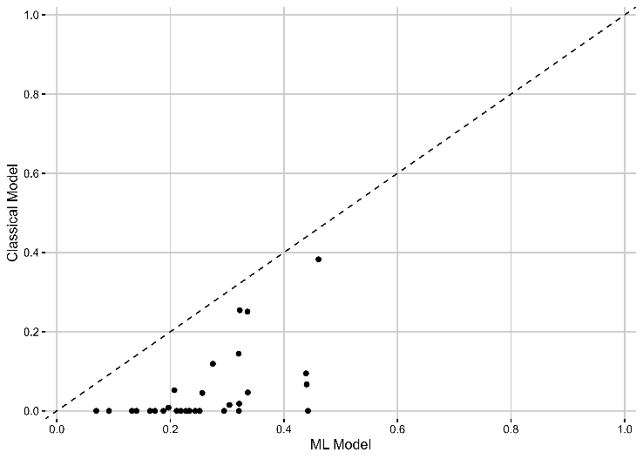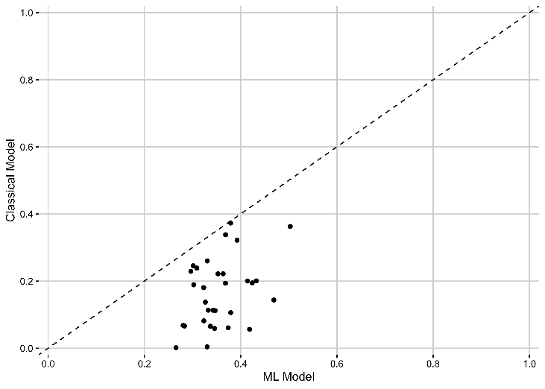

- Health insurance coverage (b) Visited health facility

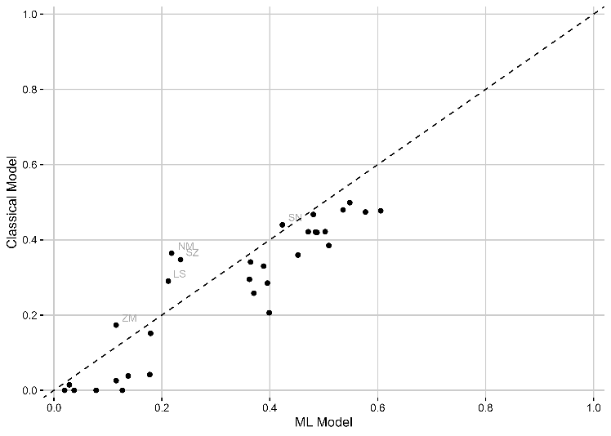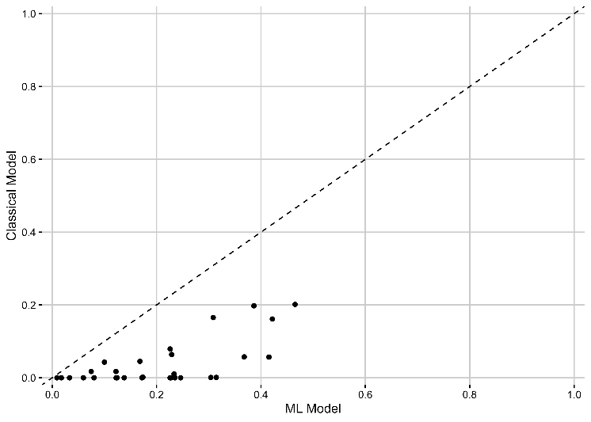
- Health facility-based births (d) Postnatal check

Notes: The figures show the predictive power by country for the classical model (consisting of 10 variables most often used by the literature, details see Section 2) and the ML model using a XGBoost model with repeated five-fold cross-validation (consisting of 123 variables available in the DHS data, details see Section 2). The performance is measured as Cohen’s Kappa, a measure of how often the model correctly predicts the outcome adjusted by the underlying probability to make a correct prediction by chance (more details, see Section 3).

Predictors of health insurance coverage and take-up of health services
In the classical models most often about ten socio-economic or household indicators are used to predict health insurance take-up or take-up of health services, i.e., if a person is married, smokes, age, education, work status, as well as the location and wealth status of household and if a female is the head of the household (e.g., Weldesenbet et al., 2021). With our data-driven approach to understanding the differences from classical models, all available variables in the DHS data were included in the ML models (details see Section 3), consisting of many more socio-economic or household indicators as well as additionally health, culture, language, ethnicity, and religion.
Figure 2 shows the top five predictors of the ML model for health insurance coverage and take-up of health services for each country. In panel (a), the top five predictors for health insurance coverage, we find similar to the classical model that socio-economic variables such as wealth or education, or predictors that are highly correlated, such as having a bank account or literate, are strong predictors for the majority of the countries. In contrast, predictors like smoking status or female household headship, often used in classical models, do not rank among the top five in ML models. Only a few countries used other classical predictors in the top five, namely rural only for Chad, married and age for Burundi, and exposure to mass media for Liberia (see Table A.2 for detailed predictors per country). Numerical variables, such as the number of household members or the ideal number of children, frequently appear as top predictors, as tree-based ML models can flexibly split these variables. Interestingly, novel predictors, revealed through the data-driven approach of ML models, include household size (e.g., number of household members used by almost all country models), protective measures (e.g., number of mosquito nets used by almost a third of the countries), Body Mass Index (BMI; used by around 16% of the country models). Nevertheless, many other new potential predictors defined based on the DHS data availability, such as predictors about health, household power structures, culture, language, ethnicity, and religion seem not to significantly contribute as predictors to the models or if only for individual countries (see Table A.1 for the overview of all available variables).
In Panel (b), we examine the top predictors for whether a woman visited a health facility in the last 12 months. Besides traditional socio-economic factors, predictors related to childbirth, pregnancy, and health condition frequently emerge as important. For instance, variables such as giving birth in the last three years, ever giving birth, being pregnant, or being tested for HIV, and BMI are key predictors in many countries. Additionally, for some individual countries health information indicators, such as knows of modern method for contraception, heard of family planning, or heard of STI play an important role. In general, the top predictors of each of the 33 countries are very similar and fewer compared to the health insurance status prediction. Two exceptions are Ghana and Rwanda, the two SSA countries with the highest insurance coverage rates. We see that health insurance coverage is also a top five predictor (see Table A.3 for detailed predictors per country).
Panels (c) and (d) focus on maternal health services, specifically health facility-based births and postnatal checks. Similar to the results for general health facility visits, socio-economic factors, and recent childbirth are significant predictors. Additionally, having had a health facility-based birth is a key predictor for postnatal checks in almost half of the countries. However, health insurance coverage is not a top predictor for these outcomes, likely because many countries provide free maternal and child healthcare services. Unique predictors related to health conditions—tested for HIV and BMI—are prominent in several countries. A greater variety of predictors, including cultural and regional variables, emerge for maternal health outcomes compared to general health service use (see Tables A.4 and A.5 for detailed predictors per country). For instance, in Benin, the model identifies speaking Fon—a language associated with rural areas—as a key predictor for health facility-based birth, while in Kenya, being part of the Turkana ethnic group—a marginalized community—is essential for postnatal check take-up, highlighting also important regional differences.
Overall, the ML models uncover a mix of expected and novel predictors for health insurance coverage and health service uptake. While aligning with classical predictors like wealth and education, the ML approach also highlights previously underexplored factors, such as household size, previous exposure to health care, health condition indicators, and health information indicators. Additionally, the models reveal context-specific nuances, including cultural and regional differences, such as language and ethnicity, that classical models often overlook. These insights offer a more comprehensive understanding of the determinants of health insurance coverage and take-up of health services, providing valuable guidance for designing policies and programs tailored to the unique needs of different populations across the 33 countries.

Figure 2: Number of times variable was ranked top 5 for ML prediction for health insurance coverage and take-up of health services
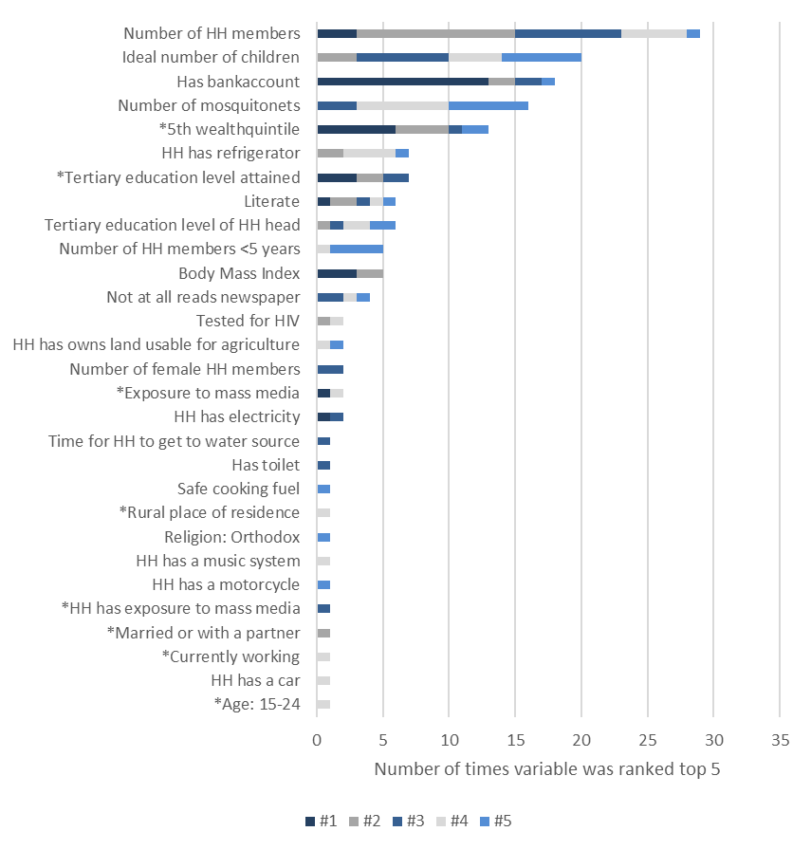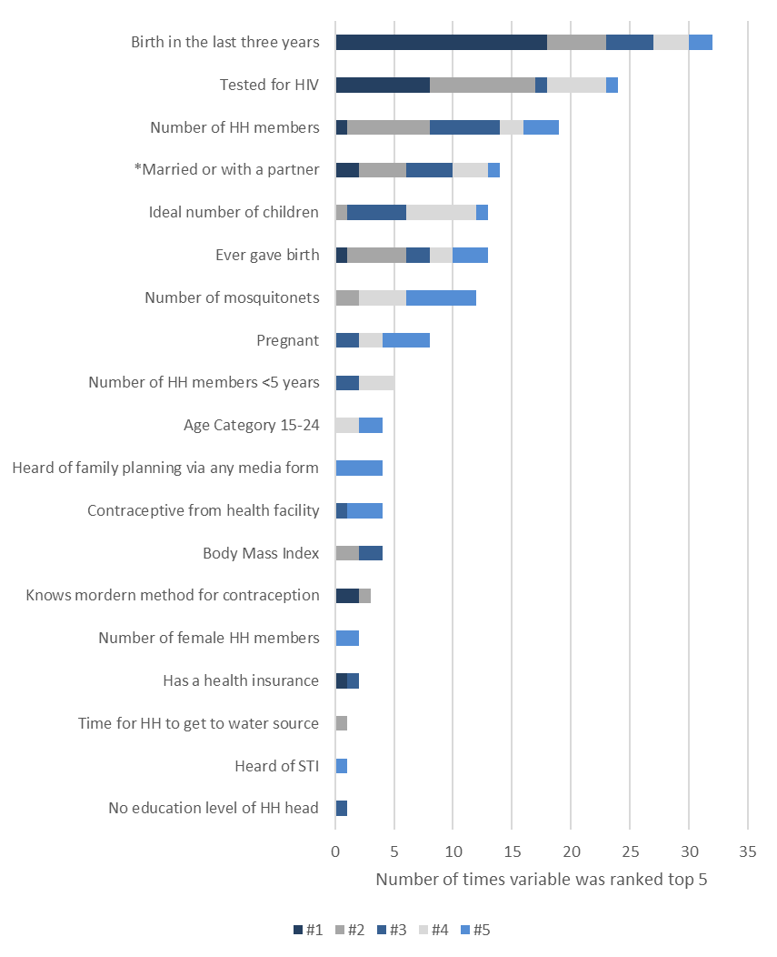
- Health insurance coverage (b) Visited health facility

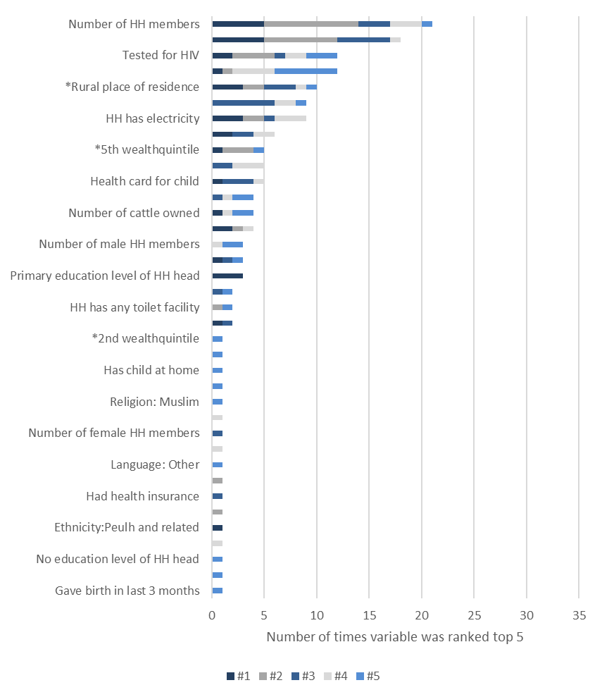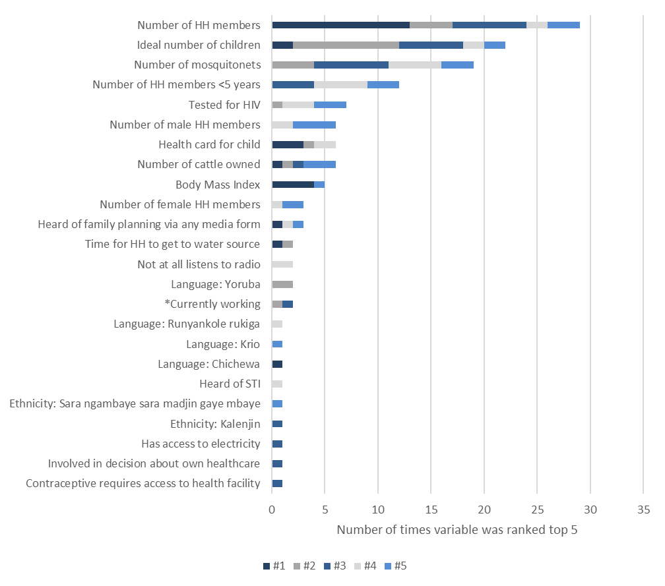
- Health facility-based births (d) Postnatal check

Notes: Figures show the number of times the ML model used the variables as a top five predictor. Variables with a * highlight variables that are included in the classical model. The total number of times a variable can be ranked as top five is 33 since we include 33 countries in the analysis. For some variables, which were not available for all countries based on the selection criteria (see Section 3), the maximum of top five predictor is lower than 33. A detailed description of the variables and the availability per country can be found in Appendix Table A.1. The table on country level and with the variable importance score can be found in Appendix Table A.2 – A.4.

4.3 Small-Scale predictions of health insurance coverage and take-up of health services
Many nationally representative surveys that contain important information on health insurance coverage and take-up of health services, such as the DHS survey, are only representative at the regional level and not at the lower administrative levels. On the contrary, large-scale surveys that are representative at the district level, such as the census, do not include detailed health-related information. Based on the improved prediction with ML models, as shown in Section 4.1, in this section we perform out-of-sample prediction with census data to gain insights at a lower administrative level for the whole population.
Figure 3 shows …. See our gitlab repository for the CENSUS and DHS maps of all remaining countries.
We detect that the three countries with a particularly high within-country variance for the outcomes are Kenya, South Africa, and Nigeria, whereas in Congo, Sierra Leone, and Madagascar we find the lowest within-country variation. Figure A.3 shows the zoomed-in country map of two countries with large within-country variance, Kenya and Nigeria. In both cases, we find that especially the highly populated regions, often the regions of the capital city, have the higher health insurance coverage rates. This result emphasizes that rural regions still face barriers to being financially protected by a health insurance scheme. On the contrary, the district distribution of the three health service outcomes reveal that even though financial protection by a health insurance scheme is different in more rural areas; in some districts, usage of a health services is still high. The examples of Kenya and Nigeria show that the rate was even higher in some rural areas than in more urbanized ones.
Figure 3: Comparison of average health insurance coverage and take-up of health services based on DHS and Census Data, Ghana
- Health insurance coverage
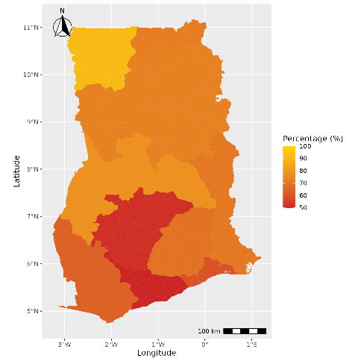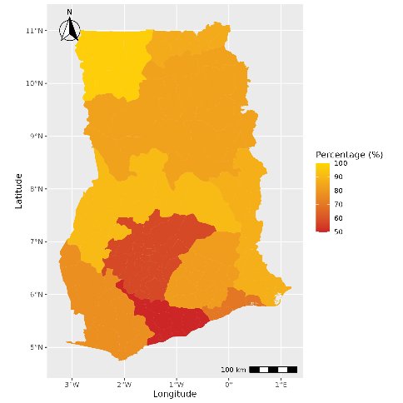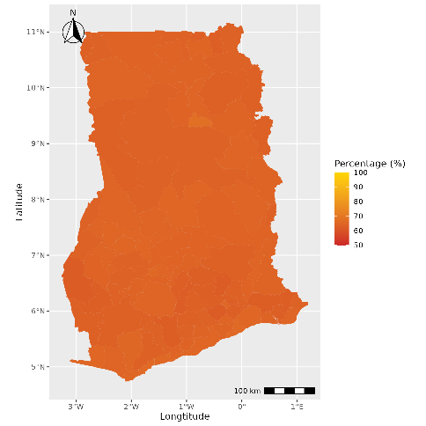
(a) Measured in DHS, regional level (b) ML prediction with DHS data (c) ML prediction with CENSUS data

- Visited health facility

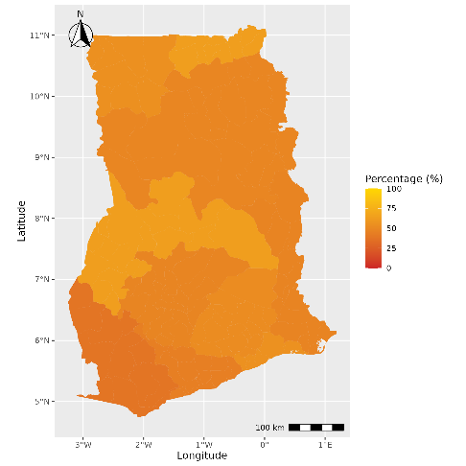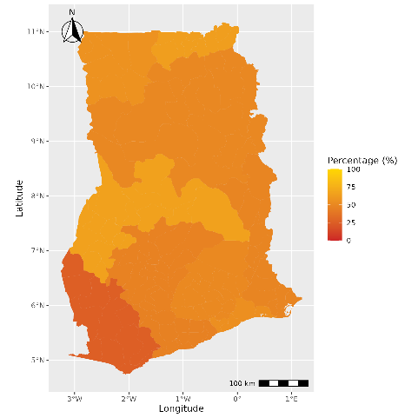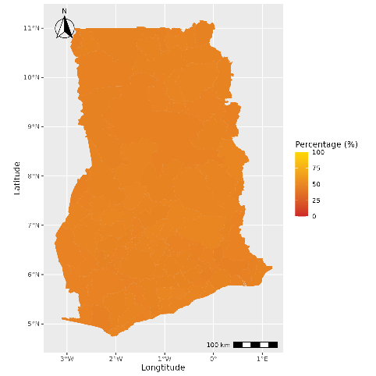
(a) Measured in DHS, regional level (b) ML prediction with DHS data (c) ML prediction with CENSUS data

- Health facility-based births

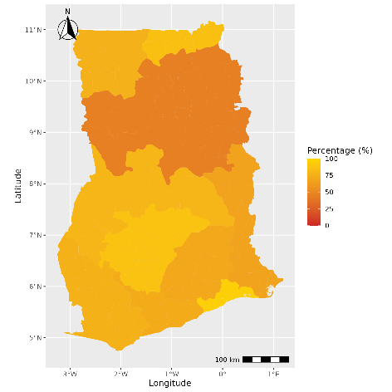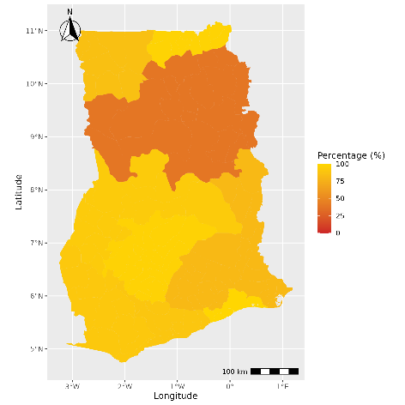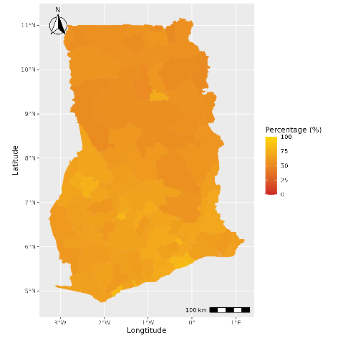
(a) Measured in DHS, regional level (b) ML prediction with DHS data (c) ML prediction with CENSUS data

- Postnatal check

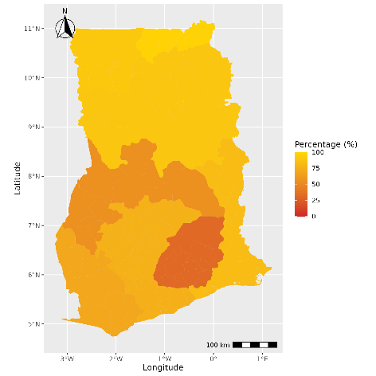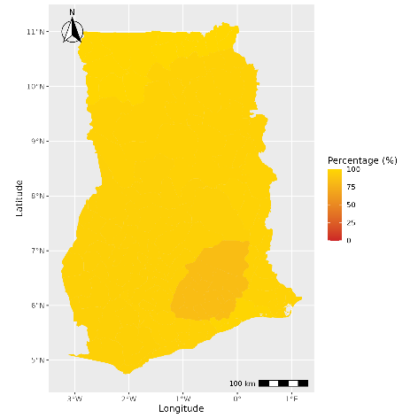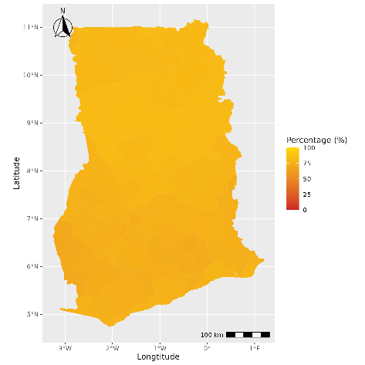
(a) Measured in DHS, regional level (b) ML prediction with DHS data (c) ML prediction with CENSUS data
Note: The figures show exemplary for the case of Ghana (a) the reported regional (admin 1 level) averages in the DHS data, (b) the predicted district (admin 2 level) average based on the ML model with a restricted number of variables from the DHS data, (c) the predicted district (admin 2 level) average based on the ML model with a restricted number of variables from the CENSUS data. Districts with less than 30 observations in the DHS data are labelled as NA and displayed in grey.

Conclusion
This study addresses a crucial challenge in achieving UHC: how can the included and excluded population of (i) health insurance coverage and (ii) basic health service usage be better identified? Based on data from 39 SSA countries, where access to financial protection and basic health care is still the most limited, in this study, we are the first to provide insights on improving predictions using machine learning techniques. In addition, we enable better targeting of the outcomes by providing a better understanding of important factors for the predictions and maps on lower administrative levels (districts), highlighting within-country variations.
Overall, the comparison among the 39 SSA countries shows a great variation in health insurance coverage rates among countries, rarely exceeding the SSA average of 7%, with some exceptions, such as Rwanda with 83%, Ghana with 66%, and Burundi with 23%. The percentage of people using health services, such as visiting a health facility, giving birth in a health facility, and having a postnatal check-up, also shows a relatively low rate (51%, 70%, and 44%, respectively). Our results emphasize that SSA is still very far from UHC, and there is a great need to improve coverage and usage.
Our empirical analysis shows that machine learning techniques instead of the classical logistical regression approach can improve the accuracy of predicting our outcomes. Our models, with over 490,000 observations from 33 SSA countries and 28 covariates, highlight that overall accuracy and sensitivity (correctly predicted positive cases) can be substantially increased, improving our understanding of who and where the most vulnerable population groups are. For example, increases sensitivity for the prediction of health insurance coverage from 0% to 22%, for visiting a health insurance from 32% to 69%, for giving birth in a health facility from 78% to 92%, and for having a postnatal check from 1% to 27%. These results contribute to the growing literature using ML techniques with the aim of better targeting policies (e.g., Blair et al, 2017; Sansone and Zhu, 2021; Brahma et al., 2021; Müller et al., 2019).
Compared to other models currently used, the model performance of all our ML models has a higher level of accuracy (Blair et al., 2017; Beger et al., 2016; Chiba & Gleditsch, 2017). For example, the model to predict local violence in Liberia never exceeded an accuracy of around 79%, whereas in this study we have up to around 89% (Blair et al., 2017). The authors argue that some outcomes might be more difficult to predict than others due to the complexity of behavior or due to the data structure (e.g., variation in the variables, panel structure, number of observations, etc.). Indeed, we also see for our model for health insurance coverage, which consists of an imbalanced dataset of 7% covered and 93% non-covered population, that a high accuracy of 93% can also be achieved just by predicting all observations as non-covered. Thus, in an imbalanced dataset, only optimizing accuracy would not lead to a model where we gain insights about who is the excluded population and understand if vulnerable groups are covered. Our results contribute to this challenge and show that our ML models do not fail to make predictions even in a highly imbalanced sample, such as in the health insurance coverage case.
The substantial improvement from the ML models compared to the classical model remains even if the set of covariates is restricted, as is the case if we make out-of-sample predictions with census data, which contains several million observations covering all districts in the country but fewer covariates. Nevertheless, the overall model performance is lower than with more covariates, which is expected since the models have less information to learn from.
We can show when applying the ML techniques that the performances of the algorithms are very similar among the five algorithms used for the ML models (logit, LASSO, random forest, neural networks, xgboost). Our results suggest that due to the limited scope of covariates in the model, very complex algorithms might not show their full potential but still outperform the classical approach. In other studies, such as Sansone and Zhu (2021) who used approximately 1,800 possible predictors in their model, the predictive power could be even more improved. The results emphasize that the models need to be optimally calibrated for each sample and outcome and cannot be generally applied.
The out-of-sample predictions with census data of the 33 countries with underlying DHS data and the six countries, where DHS survey data were not available, enable us to gain insights into new countries and on a lower administrative level for the whole population. Overall, based on our models, the out-of-sample predictions seem to work reliably even for countries where we had no initial information about the outcome if the sample for the model training contains enough data of similar cases. For example, the predictions for health insurance coverage for Botswana and South Africa, two countries with rather high rates in the sample, were inaccurate. Therefore, predictions for extraordinary cases should be interpreted with caution and might be limited. Another limitation is that if the year of census data is several years from the underlying DHS survey year, the predictions are also assumed to be inaccurate due to potential unobserved factors and trends that influence the outcomes. Nevertheless, the algorithms still manage to outperform the classical model. As recommended by the study of Sansone and Zhu (2021) about welfare programs in Australia, it could be beneficial for researchers and policymakers to “obtain more precise predictions – at no extra costs – by exploiting the available datasets”. This conclusion emphasizes that ML techniques can complement current targeting processes to improve the overall targeting of excluded populations.
Our findings from the most and least important variable to predict our outcomes shows that SSA countries still predominantly protect better-off population groups, leaving out the vulnerable. In line with the existing literature, country-specific factors, education, wealth indicators, and location of residence play the most important role in predicting health insurance coverage (e.g., Osei Afriyie et al, 2022; Salari et al., 2019; Amu et al. 2018). In line with the literature, health insurance coverage is not an important variable for predicting health service usage outcomes. We find that the outcome of visiting a health facility at least once within the last year is mainly predicted by factors of family planning. If the last-born child was born in a health facility is mainly predicted by educational and economic factors as well as the location. And if the last-born child had postnatal checks within two weeks after birth is mainly predicted by health insurance enrollment status.
However, since the accuracy of the predictions is not 100% and accuracy levels vary substantially among the countries, this indicates that underlying variables for health insurance enrollment and usage of health services (e.g., Mensah et al., 2010; Hanson et al., 2017; Wang et al., 2017; Brugiavini and Pace, 2016; Dalinjong et al., 2017; Browne et al., 2016) or county-specific factors still play a crucial role. Due to data limitations, we cannot disentangle these effects. Nevertheless, the results highlight that financial and non-financial barriers still exist, excluding the most vulnerable population groups (e.g., Tessema et al., 2020). In addition, the large country differences emphasize that further studies from in-depth country analyses are needed.
Lastly, the detailed maps of the 39 SSA countries reveal large within-country variations in several countries, such as Kenya and Nigeria. In almost all country maps, we see that health insurance coverage are particularly higher in highly populated areas and the region of the capital city, whereas health service usage seems to be less correlated with populated areas.
This study has three main limitations. First, due to data availability, our study can only give insights of three essential health services. Therefore, the results cannot be generalized to all essential health services. Nevertheless, since outcomes such as overall access and maternal and child health services are crucial in SSA countries, our results bring important insights into the functioning of needed health services. Second, as the literature about determinants of health insurance enrolment and health services concludes, play besides socio-economic, economic, and household characteristics also other demand- and supply-side factors an important role (e.g., Owoo and Lambon-Quayefio, 2013; Brugiavini and Pace, 2016). Therefore, we cannot exclude the possibility that adding additional variables into our model would lead to another ranking of the most and least important variables. However, due to data limitations this is not possible to test. Still, based on meta-studies, the included covariates seem to account for the most important variables (e.g., Osei Afriyie et al., 2022). Additionally, as we highlighted in the analysis, more in-depth country analyses might be needed to fully understand the driving factors. Third, our best-performing models outperform the classical model but still do not 100% accurately predict our four outcomes. Thus, our results should be applied with caution to out-of-sample data, especially for extraordinary cases. We recommend, as for all targeting approaches, to reevaluate for each outcome and country to assess first the feasibility of a potential application before applying.

References
Adebayo, E.F., Uthman, O.A., Wiysonge, C.S., Stern, E.A., Lamont, K.T., Ataguba, J.E. (2015). A systematic review of factors that affect uptake of community based health insurance in low-income and middle-income countries. BMC health services research, 15(1):543-543. https://doi.org/10.1186/s12913-015-1179-3
Akazili, J.,Welaga, P., Bawah, A., Achana, F., Oduro, A., Awoonor-Williams, J., Williams, J., Aikins, M., Phillips, J. (2014). Is Ghana’s pro-poor health insurance scheme really for the poor? Evidence from Northern Ghana. BMC Health Services Research, 14(63): 637. https://doi.org/10.1186/1472-6963-14-63
Alpaydin, E. (2010). Introduction to machine learning, Cambridge: The MIT Press.
Amu, H., Dickson, K.S., Kumi-Kyereme, A., Darteh, E.K.M. (2018). Understanding variations in health insurance coverage in Ghana, Kenya, Nigeria, and Tanzania: Evidence from demographic and health surveys. PLoS ONE, 13(8): e0201833. https://doi.org/10.1371/journal.pone.0201833
Ansu-Mensah, M., Danquah, F.I., Bawontuo, V. et al. (2021). Quality of care in the free maternal healthcare era in sub-Saharan Africa: a scoping review of providers’ and managers’ perceptions. BMC Pregnancy Childbirth, 21(220). https://doi.org/10.1186/s12884-021-03701-z
Baloul, I., Dahlui, M. (2014). Determinants of health insurance enrolment in Sudan: evidence from Health Utilisation and Expenditure Household Survey 2009. BMC Health Serv Res, 14(O17). https://doi.org/10.1186/1472-6963-14-S2-O17
Basaza, R., Alier, P.K., Kirabira, P., Ogubi, D., Lako, R.L.L. (2017). Willingness to pay for National Health Insurance Fund among public servants in Juba City, South Sudan: a contingent evaluation. International Journal for Equity in Health, 16:158. https://doi.org/10.1186/s12939-017-0650-7
Bazzi, S., Blair, R.A., Blattmann, C., Dube, D., Gudgeon, M., Pack, R., (2022). The Promise and Pitfalls of Conflict Prediction: Evidence from Colombia and Indonesia. The Review of Economics and Statistics, 104(4): 764-779. https://doi.org/10.1162/rest_a_01016
Beger, A., Dorff, C.L., Ward, M.D. (2016). Irregular Leadership Changes in 2014: Forecasts using ensemble, split-population duration models. International Journal of Forecasting, 31(1): 98-111. https://doi.org/10.1016/j.ijforecast.2015.01.009
Blair, R.A., Blattmann, C., Hartmann, A. (2017). Predicting local violence: evidence from a panel survey in Liberia. Journal of Peace Research, 54(2): 298-312. https://doi.org/10.1177/002234331668400
Blondel, P. (2017). Which machine learning algorithm to choose for my problem. Retrieved from: https://recast.ai/blog/machine-learning-algorithms/2/. Accessed on March 31. 2021.
Boateng, D., Awunyor-Vitor, D. (2013). Health insurance in Ghana: evaluation of policy holders perceptions and factors influencing policy renewal in the Volta region. Journal for Equity in Health, 12:50. https://doi.org/10.1186/1475-9276-12-50
Boerma, T., Eozenou, P., Evans, D., Evans, T., Kieny, M.P., Wagstaff, A. (2014). Monitoring Progress towards Universal Health Coverage at Country and Global Levels. PLoS Med, 11 (9): e1001731. https://doi.org/10.1371/journal.pmed.1001731
Borovicka, T., Jirina, M.J., Kordik, P., Jirina, M. (2012). Selecting Representative Data Sets, Intech. In: Advances in Data Mining Knowledge Discovery and Applications. https://doi.org/10.5772/50787
Brahma, D., Mukherjee, D. (2021). Early warning signs: targeting neonatal and infant mortality using machine learning. Applied Economics, 54(1): 57-74. https://doi.org/10.1080/00036846.2021.1958141
Browne, J.L., Kayode, G.A., Arhinful, D., Fidder, S.A.J, Grobbee, D.E., Klipstein-Grobusch, K. (2016). Health insurance determines antenatal, delivery and postnatal care utilization: evidence from the Ghana Demographic and Health Surveillance data. BMJ Open, 6:e008175. https://doi.org/10.1136/bmjopen-2015-008175

Brugiavini, A., Pace, N. (2016). Extending health insurance in Ghana: effects of the National Health Insurance Scheme on maternity care. Health Economics Review, 6(1): 7.. https://doi.org/10.1186/s13561-016-0083-9
Coates, M.M., Ezzati, M., Robles Aguilar, G., Kwan, G.F., Vigo, D., Mocumbi, A.O., et al. (2021). Burden of disease among the world’s poorest billion people: An expert-informed secondary analysis of Global Burden of Disease estimates. PLoS ONE, 16(8): e0253073. https://doi.org/10.1371/journal.pone.0253073
Chandler, B.D., Levitt, S.D., List, J.A. (2011). Predicting and Preventing Shootings among At-Risk Youth. American Economic Review, 101(3): 288–29. https://doi.org/10.1257/aer.101.3.288
Chemouni, B. (2018). The political path to universal health coverage: Power, ideas and community based health insurance in Rwanda. World Development, 106: 87-98. https://doi.org/10.1016/j.worlddev.2018.01.023
Chiba, D., Gleditsch, K.S. (2017). The shape of things to come? Expanding the inequality and grievance model for civil war forecasts with event data. Journal of Peace Research, 54(2) 275–297. https://doi.org/10.1177/0022343316684192
Corral, P., Henderson, H., Segovia, S. (2025). Poverty mapping in the age of machine learning. Journal of Development Economics, 172: 103377. https://doi.org/10.1016/j.jdeveco.2024.103377
Cuccaro-Alamin, S., Foust, R., Vaithianathan, R., Putnam-Hornstein, E. (2017). Risk assessment and decision making in child protective services: Predictive risk modeling in context. Child. Youth Serv. Rev., 79: 291–298. http://dx.doi.org/10.1016/j.childyouth.2017.06.027
Evans, D.B., Marten, R., Etienne, C. (2012). Universal health coverage is a development issue. The Lancet, 380(9845): 864-865. https://doi.org/10.1016/S0140-6736(12)61483-4
Dalinjong, P.A., Welaga, P., Akazili, J., Kwarteng, A., Bangha, M., Oduro, A., Sankoh, O. & Goudge J. (2017). The association between health insurance status and utilization of health services in rural Northern Ghana: evidence from the introduction of the National Health Insurance Scheme. Journal of Health, Population and Nutrition, 36:42. https://doi.org/10.1186/s41043-017-0128-7
DHS (2022). Statcompiler the DHS program. Retrieved from: https://www.statcompiler.com/en/. Accessed on March 31. 2021.
DHS (2021). The Demographic and Health Surveys (DHS) Program. Retrieved from: https://dhsprogram.com. Accessed on March 31. 2021.
Dixon, J., Luginaah, I., Mkandawire, P. (2014). The National Health Insurance Scheme in Ghana’s Upper West Region: A gendered perspective of insurance acquisition in a resource-poor setting. Social Science & Medicine, 122: 103-112. https://doi.org/10.1016/j.socscimed.2014.10.028
Dobbin, K.K., Simon, R.M. (2011). Optimally splitting cases for training and testing high dimensional classifiers. BMC Medical Genomics, 4(3): 31. https://doi.org/10.1186/1755-8794-4-3
Du, K.L., Swamy, M.N.S. (2014). Neural Networks and Statistical Learning. Berlin: Springer.
Duku, A.K.O. (2018). Differences in the determinants of health insurance enrolment among working-age adults in two regions in Ghana. BMC Health Services Research, 18:384. https://doi.org/10.1186/s12913-018-3192-9
Echevin, D., Fotso, G., Bouroubi, Y., Coulombe, H., Li, Q. (2025). Combining survey and census data for improved poverty prediction using semi-supervised deep learning. Journal of Development Economics, 172: 103385. https://doi.org/10.1016/j.jdeveco.2024.103385
Engstrom, R., Hersh, J., Newhouse, D.L. (2017). Poverty from Space: Using High-Resolution Satellite Imagery for Estimating Economic Well-Being. World Bank Policy Research Working Paper, No. 8284.
Erlangga D, Suhrcke M, Ali S, Bloor K. (2019). The impact of public health insurance on health care utilisation, financial protection and health status in low- and middle-income countries: A systematic review. PLoS One, 14(8): e0219731. https://doi.org/10.1371/journal.pone.0219731.
Garrett, L., Chowdhury, A.M., Pablos-Mendez, A. (2009). All for universal health coverage. The Lancet, 374: 1294-1299. https://doi.org/10.1016/S0140-6736(09)61503-8
Gitobu, C.M., Gichangi, P.B., Mwanda, W.O. (2018). The effect of Kenya’s free maternal health care policy on the utilization of health facility delivery services and maternal and neonatal mortality in public health facilities. BMC Pregnancy Childbirth 18(77). https://doi.org/10.1186/s12884-018-1708-2
Glaeser, E.L., Kominers, S.D., Luca, M., Naik, N. (2018). Big data and big cities: The promises and limitations of improved measures of urban life. Econ. Inq., 56(1): 114–137. https://doi.org/10.3386/w21778
Gottret, P.E., Schieber, G.. (2006). Health financing revisited: a practitioner’s guide. Washington: World Bank Publications.
Goudge, J, Alaba, O.A, Govender, V., Harrias, B., Nxumalo, N., Cherich, M.F. (2018). Social health insurance contributes to universal coverage in South Africa, but generates inequities: survey among members of a government employee insurance scheme. International Journal for Equity in Health, 17(1). https://doi.org/10.1186/s12939-017-0710-z
Hanson, C., Gabrysch, S., Mbaruku, G., Cox, J., Mkumbo, E., Manzi, F.,Schellenberg, J., Ronsmans C. (2017). Access to maternal health services: geographical inequalities, United Republic of Tanzania. Bull World Health Organ, 95(12): 810–820. http://dx.doi.org/10.2471/BLT.17.194126
Hastie, T., Tibshirani, R., Friedman, J. (2008). The Elements of Statistical Learning: Data Mining, Inference, and Prediction. Berlin: Springer, Series in Statistics, 2008.
Ipums (2021). IPUMS. Retrieved from: https://ipums.org/. Accessed on March 31. 2021.
James, G., Hastie, T., Witten, D., Tibshirani, R. (2013). An introduction to Statistical Learning with Application in R. Berlin: Springer, 2013 https://doi.org/10.1007/978-1-4614-7138-7
Jehu-Appiah, C., Aryeetey, G., Spaan, E., de Hoop, T., Agyepong, I., Baltussen, R. (2011). Equity aspects of the National Health Insurance Scheme in Ghana: Who is enrolling, who is not and why? Social Science & Medicine, 72(2): 157-165. https://doi.org/10.1016/j.socscimed.2010.10.025
Josephson, E., Rajkotia, Y., Banzon, E., Andoh, A., Francis, X. (2014). National Health Insurance Design in Liberia: Key Considerations for Equitable, Efficient, and Sustainable Health Care Access. Retrieved from https://thinkwell.global/wp-content/uploads/2014/12/National-Health-Insurance-Design-in-Liberia-ThinkWell.pdf. Accessed on March 31. 2021.
Kang, J.S., Kuznetsova, P., Luca, M., Choi, Y. (2013). Where Not to Eat? Improving Public Policy by Predicting Hygiene Inspections Using Online Reviews. Proc. 2013 Conf. Empir. Methods Nat. Lang. Process. (Association for Computational Linguistics, Seattle, Washington, USA), 1443--1448.
Kimani, J.K., Ettarh, R., Warren, C., Bellows, B. (2014). Determinants of health insurance ownership among women in Kenya: evidence from the 2008-09 Kenya demographic and health survey. International Journal for Equity in Health, 13:27. http://www.equityhealthj.com/content/13/1/27
Kirigia, J.M., Sambo, L.G., Nganda, B. et al. (2005). Determinants of health insurance ownership among South African women. BMC Health Serv Res 5, 17. https://doi.org/10.1186/1472-6963-5-17
Kumi-Kyereme, A., Amo-Adjei, J. (2013). Effects of spatial location and household wealth on health insurance subscription among women in Ghana. BMC Health Services Research, 13:221. https://doi.org/10.1186/1472-6963-13-221
Kusi, A., Fenny, A.P., Arhinful, D.K., Asante, F.A., Parmar, D. (2018). Determinants of enrolment in the NHIS for women in Ghana. International Journal of Social Economics, 45(9): 1318-1334. https://doi.org/10.1108/IJSE-10-2016-0291
Lagomarsino, G., Garabrant, A., Adyas, A., Muga, R., Otoo, N. (2012). Moving towards universal health coverage: health insurance reforms in nine developing countries in Africa and Asia. The Lancet, 380(9845): 933-943. https://doi.org/10.1016/S0140-6736(12)61147-7
Lundberg, S. M., Erion, G., Chen, H., DeGrave, A., Prutkin, J. M., Nair, B., Katz, R., Himmelfarb, J., Bansal, N., Lee, S. I. (2020). From local explanations to global understanding with explainable AI for trees. Nature machine intelligence, 2(1): 56-67. https://doi.org/10.1038/s42256-019-0138-9
Macha, J., Kuwawenaruwa, A., Makawia, S., Mtei, G., Borghi, J. (2014). Determinants of community health fund membership in Tanzania: A mixed methods analysis. BMC health Service Research, 14:538. https://doi.org/10.1186/s12913-014-0538-9
Markham, K. (2015). Comparing supervised learning algorithms. Retrieved from: https://www.dataschool.io/comparing-supervised-learning-algorithms/. Accessed on March 31. 2021.
Mbogo, B.A & McGill, D. (2016). Perspectives on financing population-based health care towards Universal Health Coverage among employed individuals in Ghanzi district, Botswana: A qualitative study. BMC Health Service Research: 413. https://doi.org/10.1186/s12913-016-1657-2
McIntyre D. (2007). Learning from experience: Health care financing in low-and middle-income countries. Geneva: Global forum for health research.
Mensah, J., Oppong, J.R., Schmidt, C.M. (2010). Ghana's National Health Insurance Scheme in the context of the health MDGs: an empirical evaluation using propensity score matching. Health Econ, 19: 95–106. https://doi.org/10.1002/hec.1633
Mills A, Ataguba JE, Akazili J, Borghi J, Garshong B, Makawia S, et al. (2012). Equity in financing and use of health care in Ghana, South Africa, and Tanzania: implications for paths to universal coverage. Lancet, 380(9837): 126–33. https://doi.org /10.1016/S0140-6736(12)60357-2
Msuya, J.M, Jütting, J.P., Asfaw, A. (2007). Impact of Community Health Funds on the Access to Health Care: Empirical Evidence from Rural Tanzania. International Journal of Public Administration, 30(8-9): 813-833. https://doi.org/10.1080/01900690701227263
Morgan, J. (2014). Classification and Regression Tree Analysis. Boston University School of Public Health, Technical Report No. 1, 2014. Retrieved from: https://www.bu.edu/sph/files/2014/05/MorganCART.pdf. Accessed on March 31. 2021.
Mosonsieyiri Kansanga, M., Braimah, J.J., Antabe, R., Sano, Y., Kyeremeh, E., Luginaah, I. (2018). Examining the association between exposure to mass media and health insurance enrolment in Ghana. The International Journal of Health Planning and Management, 33(2): e531-e540. https://doi.org/10.1002/hpm.2505
Muchlinski, D., Siroky, D., He, J., Kocher, M. (2017). Comparing Random Forest with Logistic Regression for Predicting Class-Imbalanced Civil War Onset Data, Political Analysis. Cambridge: Cambridge University Press, 2017. https://doi.org/10.1093/pan/mpv024
Mueller, E., Sandoval, J.S.o., Mudigonda, S., Elliott, M. (2019). A Cluster-Based Machine Learning Ensemble Approach for Geospatial Data: Estimation of Health Insurance Status in Missouri. ISPRS Int. J. Geo-Inf., 8(1): 13. https://doi.org/10.3390/ijgi8010013
Mullainathan, S., Spiess, J. (2017). Machine Learning: An Applied Econometric Approach. J. Econ. Perspect., 31(2):87–106. http://dx.doi.org/10.1257/jep.31.2.87
Murphy, Kevin P. (2012). Machine Learning: A Probabilistic Perspective. Cambridge, MA: MIT Press, 2012.
Njuguna, J., Kamau, N., Muruka, C. (2017). Impact of free delivery policy on utilization of maternal health services in county referral hospitals in Kenya. BMC Health Serv Res, 17(429). https://doi.org/10.1186/s12913-017-2376-z
Nundoochan, A., Thorabally, Y., Monohur, S., Hsu, J. (2019). Impact of out of pocket payments on financial risk protection indicators in a setting with no user fees: the case of Mauritius. International Journal for Equity in Health, 18:63. https://doi.org/10.1186/s12939-019-0959-5
Osei Afriyie, D., Krasniq, B., Hooley, B. et al. (2022). Equity in health insurance schemes enrollment in low and middle-income countries: A systematic review and meta-analysis. Int J Equity Health, 21(21). https://doi.org/10.1186/s12939-021-01608-x
Owoo, N.S., Lambon-Quayefio, M.P. (2013). National health insurance, social influence and antenatal care use in Ghana. Health Economics Review, 3:19. https://doi.org/10.1186/2191-1991-3-19
Salari, P., Akweongo, P., Aikins, M., Tediosi, F. (2019). Determinants of health insurance enrollment in Ghana: Evidence from three national household surveys. Health Policy and Planning, 34(8): 582–594. https://doi.org/10.1093/heapol/czz079
Samauma Consulting (2021). Data Collection Survey on the Health System in Mozambique. Japan International Cooperation Agency. Retrieved from: https://openjicareport.jica.go.jp/pdf/1000045945.pdf. Accessed on January 14. 2023.
Sansone, D., & Zhu, A, (2021). Using Machine Learning to Create an Early Warning System for Welfare Recipients. IZA Discussion Papers 14377, Institute of Labor Economics (IZA).
Savage, D., Zhang, X., Wang, Q., Yu, X., Chou, P. (2017). Detection of Money Laundering Groups: Supervised Learning on Small Networks. The AAAI Workshop 2017. Retrieved from: http://aaai.org/ocs/index.php/WS/AAAIW17/paper/view/15101. Accessed on March 31. 2021.
Spaan, E., Mathijssen, J., Tromp, N., McBain, F., ten Have, A., Baltussen, R. (2012). The impact of health insurance in Africa and Asia: a systematic review. Bulletin of the World Health Organization, 90(9):685–92. https://doi.org/10.2471/BLT.12.102301
Tessema, Z.T., Yazachew, L., Tesema, G.A. et al. (2020). Determinants of postnatal care utilization in sub-Saharan Africa: a meta and multilevel analysis of data from 36 sub-Saharan countries. Ital J Pediatr, 46(175). https://doi.org/10.1186/s13052-020-00944-y
Tenkorang, E.Y. (2016), Health Provider Characteristics and Choice of Health Care Facility among Ghanaian Health Seekers. Health Systems & Reform, 2(2): 160-170. https://doi.org/10.1080/23288604.2016.1171282
United Nations (2013). A new global partnership: eradicate poverty and transform economies through sustainable development. Report of the High-level Panel of Eminent Persons on the Post-2015. Development Agenda. New York: United Nations, 2013.
Vaithianathan, R., Maloney, T., Putnam-Hornstein, E., Jiang, N. (2013). Children in the public benefit system at risk of maltreatment: Identification via predictive modeling. Am. J. Prev. Med., 45(3): 354–359. http://dx.doi.org/10.1016/j.amepre.2013.04.022
Venables, W.N., Ripley, B.D. (2002). Modern Applied Statistics with S: fourth edition. Berlin: Springer.
Vimont, A., Leleu, H., Durand-Zaleski, I. (2021). Machine learning versus regression modelling in predicting individual healthcare costs from a representative sample of the nationwide claims database in France. European Journal of Health Economics. https://doi.org/10.1007/s10198-021-01363-4
Wagstaff, A., Flores, G., Smitz, M., Hsu, J., Chepynoga, K., Eozenou, P. (2018). Progress on impoverishing health spending in 122 countries: a retrospective observational study. Lancet Glob Health, 6: e180–92. https://doi.org/10.1016/S2214-109X(17)30486-2
Wang, W., Temsah, G., Mallick, L. (2017). The impact of health insurance on maternal health care utilization: evidence from Ghana, Indonesia and Rwanda. Health Policy and Planning, 32(2): 366-75. https://doi.org/10.1093/heapol/czw135
World Bank (2021). World Bank Open Data. Retrieved from: https://data.worldbank.org/. Accessed on March 31. 2021.
WHO (2022). Skilled health professionals density (per 10 000 population). Retrieved from: https://www.who.int/data/gho/indicator-metadata-registry/imr-details/4667. Accessed on January 14. 2023.

Appendix
see separate document

A deeper discussion of the models and their field of application can be found in Hastie et al. (2008) as well as Murphy (2012) who provide both a very good overview of statistical techniques with a focus on machine learning. Advantages and disadvantages are additionally deduced from Markham (2015) and Blondel (2017).

