Which women in Africa are excluded from health insurance and health care? Insights from machine learning
Kathrin Durizzo*¹, Beat Scherrer², Kenneth Harttgen³, Isabel Günther³

¹ Goettingen University, Platz der Göttinger Sieben 3, 37073 Göttingen, Germany
² PEPE, PLESE ADD YOUR CURRENT AFFILIATION
³ ETH Zurich, Clausiusstrasse 37, 8092 Zurich, Switzerland
* Corresponding author: kdurizzo@uni-goettingen.de

Abstract
Across many African countries, health insurance coverage remains low and access to essential health services is limited. Yet, policymakers often lack information on which populations are most likely to be excluded. We apply supervised machine-learning methods to Demographic and Health Survey (DHS) data from 32 Sub-Saharan African countries to predict four outcomes related to financial protection and healthcare utilization: health insurance coverage, health facility visits, facility-based births, and postnatal care. We compare machine-learning models with a classical logistic regression approach and combine survey and census data to generate small-area diagnostics on exclusion from health insurance and health services. Machine-learning models consistently outperform logistic regression, particularly for rare and highly imbalanced outcomes. The most important predictors of exclusion include wealth, education, household composition, health awareness, and previous interaction with the healthcare system. Combining survey and census data further provides geographically disaggregated diagnostics on exclusion beyond conventional survey analyses. While not a substitute for direct measurement, these diagnostics can help identify underserved populations and support the targeting of universal health coverage efforts.

Keywords: Universal Health Protection; health insurance; health services; machine learning; spatial analysis

JEL codes: C4; I1; I32; O10

Funding: We thank ETH Zurich and the Swiss National Research Fund (SNF) for funding this project (SNF grant number: 400640_183760).

Conflict of Interest: The authors declare that they have no conflict of interest and nothing to disclose.

Data availability: Data and materials are available for review if needed.

Code availability: Code is available for review if needed.

Introduction
Although many health outcomes have improved over the last few decades, maternal and neonatal health outcomes remain relatively low in Sub-Saharan Africa (e.g., World Bank, 2021; Coates et al., 2021). Countries in the region have the highest maternal mortality rates, with 534 deaths per 100,000 live births compared to an average of 231 in low- and middle-income countries (LMICs) and 11 in high-income countries (World Bank, 2021). A similar pattern exists for neonatal mortality. Many of these deaths are preventable through timely access to skilled care during pregnancy, delivery, and the postnatal period, yet essential maternal and newborn health services remain underutilized throughout the region (WHO, 2022; DHS, 2022).
At the same time, limited financial protection continues to constrain healthcare use: out-of-pocket payments remain common and disproportionately burden poorer households (e.g., Mills et al., 2012; McIntyre, 2007; Wagstaff et al., 2018). Over the last decades, many LMICs have therefore implemented a mix of social, national, and community-based health insurance schemes to achieve Universal Health Coverage (UHC), defined as access to essential services without financial hardship (Osei Afriyie et al., 2022; Boerma et al., 2014; Evans et al., 2012; UN, 2013). Although the impact of the various types of health insurance schemes varies across countries and schemes, the evidence suggests positive effects on the two goals of UHC, namely improved access to health care and financial protection (e.g., Erlangga et al., 2019; Spaan et al., 2012). Yet, in many African countries, health insurance coverage is still very low and rarely exceeds 10% (World Bank, 2021), and coverage remains uneven across socioeconomic groups, leaving out the most vulnerable (e.g., Osei Afriyie et al., 2022).
A central challenge for policymakers is that expansion efforts for UHC, such as insurance enrollment campaigns, information provision, and service delivery strengthening, must be implemented under tight administrative budgets. This creates a practical decision problem: which populations are most likely to remain excluded from health insurance coverage and essential maternal and neonatal health services, and where should limited outreach and implementation capacity be concentrated? While household surveys have been instrumental in documenting gaps and correlates of insurance enrollment and maternal health service use, standard regression-based approaches may struggle to support targeting when outcomes are rare, highly imbalanced, and shaped by complex interactions across socioeconomic status and many other unexplained factors.
This study addresses this challenge by asking how the included and excluded populations of health insurance systems and essential health services can be better identified. We test whether supervised machine learning can improve the identification of women at high risk of being uninsured or not receiving essential maternal and neonatal health services in Sub-Saharan Africa, compared to classical regression-based prediction models. We use Demographic and Health Survey data from 32 countries and predict four outcomes spanning financial protection and care use:(i) health insurance coverage, (ii) if a woman visited a health facility at least once a year, (iii) if the last-born child was born in a health facility, and (iv) if they had a postnatal check within the first two weeks. We compare a range of supervised machine-learning models with a classical logistic regression benchmark and evaluate predictive performance using metrics that are robust to class imbalance. We further examine which observable characteristics are most predictive of exclusion and apply the trained models to census data to generate small-area diagnostics beyond the spatial resolution of household surveys. We find that machine-learning methods substantially improve predictive performance relative to logistic regression, particularly for rare outcomes. Moreover, combining survey and census data generates geographically disaggregated diagnostics on exclusion from health insurance and health services, providing additional information on within-country heterogeneity beyond that available from conventional survey analyses.
This paper contributes to a growing literature that uses machine learning (ML) to support policy decisions under informational constraints. A first strand of this literature applies ML techniques to improve the targeting of public policies and social programs (Aiken et al., 2025; Blair et al., 2017; Bazzi et al., 2022; Savage et al., 2017). For example, Aiken et al. (2025) illustrate the potential of machine learning for improving the allocation of scarce public resources by using mobile phone data to identify populations most in need of social protection in Bangladesh and Togo. Similarly, Sansone and Zhu (2021) use ML to improve the targeting of welfare recipients in Australia, Kang et al. (2013) predict hygiene inspection outcomes to improve the allocation of health inspectors, and Cuccaro-Alamin et al. (2017) and Vaithianathan et al. (2013) develop predictive models to identify children at risk of abuse and maltreatment. Other applications include the prediction of infant and child mortality risk (Brahma and Mukherjee, 2021), patient screening (Mullainathan and Spiess, 2017), and healthcare expenditures (Vimont et al., 2021). Overall, these studies show that ML methods can improve predictive performance and support more effective targeting of scarce public resources. Relative to this literature, evidence on ML-based prediction for social health protection, specifically health insurance coverage and essential maternal and neonatal health services in Sub-Saharan Africa, remains limited, particularly in settings where administrative data are scarce and policymakers must rely on household survey data.
A related literature combines survey and census data to generate geographically disaggregated estimates of socioeconomic outcomes. Recent studies use machine-learning techniques to improve poverty measurement and small-area estimation by leveraging both labeled survey data and unlabeled census data (Corral et al., 2025; Echevin et al., 2025, Hazlett et al., 2023). These approaches demonstrate that combining the strengths of representative household surveys and census datasets can substantially improve the spatial granularity of policy-relevant indicators. To our knowledge, this approach has not yet been applied to health insurance coverage and essential maternal and neonatal health services in Sub-Saharan Africa.
This paper also relates to the large literature on determinants of health insurance coverage and health care utilization in LMICs. Studies about health insurance coverage show that higher wealth, higher education, older age, formal occupation, and urban residence are key drivers for health insurance coverage (e.g., Osei Afriyie et al, 2022; Salari et al., 2019; Amu et al., 2018). Wealth and formal employment are crucial economic determinants and, at the same time, portray two of the main barriers to enrolment into health insurance schemes: lack of access for the very poor and work in the informal sector (e.g., Duku, 2018; Kumi-Kyereme and Amo-Adjei, 2013; Amu et al., 2018; Msuya et al., 2007; Salari et al., 2019; Dixon et al., 2014; Akazili et al., 2014; Jehu-Appiah et al., 2011). Since LMICs have a large share of informal sector workers – resulting in a lack of information about working status and income – it is challenging to target and cover workers with health insurance (Lagomarsino et al., 2012). Other studies have shown that also supply-side factors, such as distance to the next health facility, play an important role in explaining health insurance coverage (e.g., Boateng and Awunyor-Vitor, 2013; Jehu-Appiah et al., 2011; Kusi et al., 2018; Duku, 2018; Dixon et al., 2014; Mensah et al., 2010). Last, other studies have identified country-specific factors, such as media exposure, associated with health insurance coverage (e.g., Akazili et al., 2014; Macha et al., 2014; Jehu-Appiah et al., 2011; Kusi et al., 2017; Boateng and Awunyor-Vitor, 2013; Mosonsieyiri Kansanga et al., 2018, Kimani et al., 2014; Kirigia et al., 2005). Overall, the results highlight that LMICs still predominantly protect better-off population groups, leaving out the most vulnerable population groups (e.g., Osei Afriyie et al., 2022). We do not aim to estimate causal determinants; instead, we complement this literature by identifying which observable characteristics are most predictive, which is directly relevant for policy targeting. Whereas the study from Brugiavini and Pace (2016) highlights that health insurance coverage generally improves health care utilization, there is in general mixed evidence if health service usage improves with being enrolled in a health insurance scheme since people still face barriers to accessing health care or being financially protected despite being enrolled (e.g., Mesah et al., 2010; Wang et al., 2017). However, studies for maternal and child health services in LMICs indicate that being insured increases the probability to take up prenatal treatments (Mensah et al., 2010; Hanson at al., 2017; Owoo and Lambon-Quayefio, 2013; Browne et al., 2016; Brugiavini and Pace, 2016; Wang et al., 2017), to deliver at a health facility with professional assistance (Mensah et al., 2010; Hanson et al., 2017; Wang et al., 2017; Brugiavini and Pace, 2016; Dalinjong et al., 2017), and to take up postnatal treatments (Mensah et al., 2010; Browne et al., 2016). Other correlating factors mentioned in the literature for the use of maternal and child health services include location (Mensah et al., 2010), social factors such as perceptions of service quality within the community (Owoo and Lambon-Quayefio, 2013), individual preferences (Brugiavini and Pace, 2016), and a range of household- and community-level characteristics associated with postnatal care utilization (Tessema et al., 2020). These findings motivate our focus on jointly predicting financial protection and service use outcomes.
Our contribution is twofold. First, we demonstrate how machine learning can combine household survey and census data to generate small-area diagnostics on exclusion from health insurance and essential maternal and neonatal health services. Second, we show that machine-learning models outperform classical logistic regression in identifying excluded populations, particularly when outcomes are rare and highly imbalanced. Together, these results provide a practical framework for improving the targeting of universal health coverage efforts in data-constrained settings.

Data
We combine two complementary data sources: the Demographic and Health Surveys (DHS) and population census microdata from IPUMS International. The DHS provide detailed information on health insurance coverage and healthcare utilization but are typically representative only at national and regional levels. In contrast, census data provide full population coverage and representativeness at lower administrative levels but do not contain information on health insurance or health service utilization. Combining the two data sources therefore allows us to leverage the rich health information in the DHS while extending predictions to lower administrative levels using census data.

DHS data
The DHS are nationally representative household surveys that collect detailed information on demographic characteristics, health, and nutrition. We use the most recent DHS wave available for 32 Sub-Saharan African countries (Table 1). The analysis is restricted to women aged 15-49 years with complete information on outcomes and covariates, resulting in a sample of more than 380,000 observations.
We examine four outcome variables: (i) whether a woman is covered by a health insurance scheme, (ii) whether a woman has visited a health facility because she was sick in the last year, (iii) whether the woman’s last-born child was born in a health facility, and (iv) whether woman’s last-born child had a postnatal check-up within two weeks. The last two are critical to improving maternal and newborn mortality. Prenatal or other maternal and child health services are not analyzed due to lack of relevant data.
Across countries, health insurance coverage averages 9.5%, while 52.8% of women report at least one health facility visit in the previous year, 68.4% report facility-based delivery, and 40.4% report a postnatal check-up within two weeks. Considerable variation exists across countries for all four outcomes (Table 1).

Census data
We use the most recent census microdata available from IPUMS International for all countries that also have DHS data. To maximize comparability, we select the census year closest to the corresponding DHS wave. The sample is restricted to women aged 15-49 years, resulting in more than 10 million observations across 18 countries. Unlike the DHS, the census does not contain information on health insurance or health service utilization. However, it includes a range of socioeconomic and demographic characteristics that overlap with the DHS and can therefore be used to generate out-of-sample predictions. Because census data are representative at lower administrative levels, they enable small-area diagnostics that are not possible using DHS data alone.

Covariates
We had three approaches to deciding on the covariates from the DHS data, depending on the models we were using (more details on the analysis are in Section 3):
- Approach 1: Data-driven specification: This specification includes all eligible DHS variables available in each country, excluding variables with more than 10% missing values, variables with little variation, treatment variables, and indicators of acute health conditions. Depending on the country, this yields up to 85 predictors (see Table A.1).
- Approach 2: Literature-based specification: Only covariates of the classical model are derived from literature. We also include variables with mixed evidence, such as the sex of the household head (Kimani et al., 2014; Macha et al., 2014); household size (Macha et al., 2014; Kirigia et al., 2005; Jehu-Appiah et al., 2011), children at home (Akazili et al., 2014; Kusi et al., 2017), and media exposure (Mosonsieyiri Kansanga et al., 2018, Kimani et al., 2014). In particular, woman is married (binary), age (categories, 15-49), age of household head (categories, 15-59), education (categories: none, primary, secondary, tertiary), wealth index (1-5), woman is working (binary), location is rural (binary), women is smoking (binary), woman is the household head (binary), household has some exposure to media (binary). In total, we included 11 variables, where categorical variables were included as dummies in the models (see Table A.1)
- Approach 3: Census-compatible specification: Only covariates that are also available in the census data were used. In particular, we used the following nine covariates, where categorical variables were included as dummies: woman is married (binary), age (15-49), education (categories: no, primary, secondary, tertiary), woman is working (binary), location is rural (binary), household has children (binary), electricity (binary), toilet (binary), region (categories).

Methodological approach
The objective of this study is to assess whether machine-learning methods can improve the identification of women who are excluded from health insurance coverage and essential maternal and neonatal health services. We proceed in two steps. First, we evaluate whether supervised machine-learning models improve the prediction of health insurance coverage and health service utilization relative to a classical logistic regression approach. Accurate identification of excluded populations is particularly important in Sub-Saharan Africa, where resources for outreach and service delivery are limited. Second, we examine whether the estimated models can be combined with census data to generate small-area diagnostics on exclusion from health insurance and health services at lower administrative levels than those covered by household surveys. The following subsections describe the prediction models, evaluation metrics, and out-of-sample prediction approach.

Machine learning models for improved predictions
We evaluate whether machine-learning methods improve the prediction of health insurance coverage and health service utilization relative to a classical logistic regression benchmark. Logistic regression remains the standard approach in much of the literature on health insurance enrollment and health service utilization in LMICs and therefore serves as a natural benchmark for comparison (e.g., Osei Afriyie et al., 2022; Salari et al., 2019; Amu et al., 2018; Mensah et al., 2010; Hanson et al., 2017; Owoo and Lambon-Quayefio, 2013; Browne et al., 2016; Brugiavini and Pace, 2016; Wang et al., 2017).
We compare four commonly used supervised machine-learning algorithms: LASSO, random forest, neural network, and extreme gradient boosting (XGBoost). Model performance is evaluated using out-of-sample predictions. Among the candidate algorithms, XGBoost consistently achieves the strongest predictive performance across outcomes and countries. Moreover, a large body of literature has shown that XGBoost often outperforms other ML models while still being highly interpretable (Lundberg et al., 2020; Chen and Guestrin, 2016). We therefore present XGBoost as our preferred specification throughout the remainder of the paper. Appendix B describes the four ML models and the benchmark model and provides an intuition on their main strengths and limitations.
To reduce the risk of overfitting, observations are randomly divided into training, validation, and test samples. Hyperparameters are tuned using repeated five-fold cross-validation on the training data, and model performance is evaluated on a hold-out test sample. For outcomes with substantial class imbalance, defined as less than 20% or more than 80% observations in one outcome category, we apply oversampling during model training. Additional implementation details are provided in Appendix C.
As a first step in Section 4.1, to evaluate the predictive power of the classical and the ML models for each country, the model performance of four different performance metrics is compared and analyzed. To do this, the actual and predicted results of each individual observation in a dataset are compared in a confusion matrix (see Table 2). Table 2 highlights the performance metrics of the confusion matrix (a detailed explanation can be found in Appendix C). Since our aim is to better identify the included and excluded population, we focus not only on the overall accuracy (proportion of correctly classified observations out of all observations), but also on Cohen’s Kappa (a measure to classify the accuracy normalized by the imbalance of the sample). Especially in an imbalanced sample, where most of the observations are negative (e.g., not insured), we make sure that not only the negative cases are correctly identified but also the positive ones. For example, if we have 2% positive cases in a dataset, a model could easily achieve 98% accuracy by simply classifying all observations as negative. Thus, the model would not provide useful insights, as indicated by a Cohen’s Kappa of 0. Other commonly used performance metrics discussed in the results section are sensitivity (a measure of how many true positives are identified) and specificity (a measure of how many true negatives are identified). Again, these metrics are particularly important given the imbalanced nature of insurance coverage. For example, only 9.5% of the sample has health insurance coverage on average. A model that classifies all cases as negative (i.e. not insured) will achieve 90.5% specificity but only 9.5% sensitivity, failing to identify the insured population.
In a second step, in Section 4.2, to get a better understanding of what the key predictors in our data are that could be used for targeting, we present the variable importance for each country model. The importance metric of the predictors in our model is based on SHAP (SHapley Additive exPlanations) values (Lundberg and Lee, 2017). Shapley values have their roots in cooperative game theory, and they represent the average marginal contribution of each predictor to the final prediction. Unlike Gini importance, SHAP values are not biased in favour of variables with many possible split points (e.g., continuous variables) or against highly correlated variables, which is the case in our sample.

Machine learning models for out-of-sample predictions
In Section 4.3, we combine the DHS and census data to generate small-area diagnostics on exclusion from health insurance and health services. For each country with both DHS and census data, we estimate the preferred XGBoost model using the DHS sample and then apply the estimated model to the corresponding census data. To ensure comparability across datasets, these models are estimated using only the nine predictors available in both the DHS and census data (see Section 2). Applying the DHS-based models to the census population allows us to generate predictions for women aged 15-49 years at administrative levels below those covered by the DHS. Because the census data provide complete population coverage, the resulting estimates can be aggregated to small geographic units and used to examine spatial heterogeneity in exclusion from health insurance and health services.
In a final step, we aggregate the individual-level predictions to the district level and visualize their spatial distribution. These maps are intended as decision-support diagnostics that help identify areas with a high predicted risk of exclusion and may therefore assist policymakers in prioritizing outreach and service delivery efforts.

Results

Predictive power of ML models
Accurately identifying populations excluded from health insurance coverage and essential health services is critical for effective policy targeting. We therefore compare the predictive performance of the preferred machine-learning model (XGBoost) with a classical logistic regression benchmark across the 32 Sub-Saharan African countries in our sample. The performance is evaluated using Cohen's Kappa, Accuracy, Sensitivity, and Specificity, with particular emphasis on Cohen's Kappa because several of our outcomes are highly imbalanced.
Figure 1 shows that the machine-learning model outperforms the classical benchmark for almost all countries and outcomes (see also Figure A.1). The improvements are particularly large for health insurance coverage and postnatal care, where classical models frequently fail to identify positive cases and therefore achieve Cohen's Kappa values close to zero. On average, Cohen's Kappa increases from 0.06 to 0.27 for health insurance coverage, from 0.17 to 0.35 for health facility visits, from 0.27 to 0.33 for facility-based births, and from 0.04 to 0.21 for postnatal care. These results indicate that machine-learning methods are substantially more effective at distinguishing included from excluded populations than conventional regression models.
While ML models generally outperform the classical model in the 32 countries, there are five exceptions regarding the outcome of facility-based births of the last-born child (e.g., in Eswatini, Lesotho, Namibia, Senegal, and Zimbabwe), where Cohen’s Kappa slightly declines (see Figure 1c). However, even in these cases, Accuracy still improves or stays at least the same (see Appendix Figure A.2). For instance, in Senegal where 72.7% of the last-born children were born in a health facility, Cohen’s Kappa decreases from 0.44 to 0.43 with the ML model; however, Accuracy improves from 0.76 to 0.78, meaning that with the ML model 78% of the women are correctly classified. Overall, the results consistently favour machine-learning methods across countries and outcomes.
An important policy question is whether these gains are concentrated among better-off households. Figure 2 shows that predictive performance improves across all wealth quintiles, with particularly large gains among poorer households. This suggests that machine-learning methods not only improve overall prediction accuracy but may also be particularly useful for identifying underserved populations that are most relevant for universal health coverage efforts.

Predictors of health insurance coverage and take-up of health services
Conventional studies of health insurance enrollment and health service utilization typically rely on a relatively small set of socioeconomic and household characteristics, such as age, education, marital status, employment status, wealth, place of residence, and household composition (e.g., Weldesenbet et al., 2021). In contrast, our machine-learning approach exploits a much broader set of information available in the DHS data, including additional household, demographic, health, cultural, language, ethnicity, and religion variables (see Section 3). Comparing the most important predictors identified by the machine-learning models with those commonly emphasized in the literature provides insights into whether broader data sources can improve the identification of populations at risk of exclusion from health insurance and essential health services.
Figure 3 reports on the five most important predictors for health insurance coverage in each country based on the SHAP variable importance measure. Consistent with the existing literature, socioeconomic indicators remain the most important predictors of insurance coverage. Wealth, education, and marital status frequently appear among the top predictors, as do closely related indicators such as literacy, access to electricity, and ownership of a bank account. Other characteristics commonly emphasized in the literature, including rural residence, age, female household headship, and media exposure, are among the top five predictors only in a small number of countries (see Table A.2 for country-specific results). The broader set of DHS variables used in the machine-learning models also reveals several additional predictive correlates that are rarely considered in conventional analyses. Household composition measures, such as the number of household members or the ideal number of children, frequently rank among the most important predictors. Other recurring predictors include ownership of mosquito nets, HIV testing status, and body mass index (BMI). While these variables are not typically emphasized in the health insurance literature, they may capture dimensions of socioeconomic status, health awareness, and engagement with the healthcare system. In particular, HIV testing status may proxy previous interaction with formal healthcare services and exposure to health information, both of which are likely associated with insurance enrollment. At the same time, the results suggest that many of the additional variables available in the DHS contribute little to predictive performance. Variables related to culture, language, ethnicity, religion, and household power structures appear among the top predictors only in a small number of countries. Likewise, region is among the five most important predictors in only five countries (Ethiopia, Ghana, Guinea, Lesotho, and Sierra Leone), suggesting that much of the variation in insurance coverage can be captured by individual and household characteristics rather than broad geographic differences.
Panel (b) reports the most important predictors of whether a woman visited a health facility within the previous 12 months. In contrast to health insurance coverage, traditional socioeconomic characteristics such as wealth and education play a less prominent role. Instead, predictors related to childbirth, children, pregnancy, and health knowledge emerge as particularly important. In several countries, indicators such as knowledge of modern contraceptive methods, family planning, and sexually transmitted infections rank among the strongest predictors, suggesting that awareness of health issues and engagement with the healthcare system are closely associated with healthcare utilization. Insurance status appears among the five most important predictors in only three countries, namely Rwanda, Ghana, and Burundi. These countries also have the most advanced and widespread health insurance systems in our sample, suggesting that insurance enrollment is predictive of healthcare utilization only where coverage has reached substantial levels. A further notable finding is the increased importance of geography. Region is among the five most important predictors in ten countries, including Eswatini, DRC, Guinea, Liberia, Namibia, Niger, Republic of Congo, South Africa, The Gambia, and Zambia (Table A.3). This suggests that healthcare utilization is influenced more strongly by location-specific factors, such as service availability, access conditions, or differences in health systems, than is health insurance coverage itself.
Panels (c) and (d) examine maternal health services, namely facility-based births and postnatal care utilization. Similar to the results for general health facility visits, geographic factors play an important role in predicting both outcomes. Region is frequently among the most important predictors, and in several countries, including Côte d’Ivoire, Ghana, Namibia, Republic of Congo, and The Gambia, multiple regional indicators rank among the top five predictors of postnatal care utilization. Likewise, related contextual characteristics such as language and ethnicity emerge as important predictors in several countries, suggesting that maternal health service use is strongly shaped by local conditions beyond individual and household characteristics (Tables A.4 and A.5). In contrast to health facility visits, facility-based births and postnatal care are predicted by a broader set of characteristics. Socioeconomic indicators remain important, while household composition, health-related characteristics, and health information indicators also feature prominently. Examples include household size, HIV testing status, body mass index (BMI), and knowledge of family planning. By contrast, health insurance coverage is rarely among the most important predictors and appears in the top five only for Rwanda (Tables A.4 and A.5). Taken together, these results suggest that barriers to maternal health service utilization extend beyond insurance enrollment and are shaped by a combination of socioeconomic, informational, and contextual factors.
Overall, the machine-learning models confirm the importance of socioeconomic disadvantage and geographic location in predicting exclusion from health insurance and health services, while also highlighting the additional role of household composition, health awareness, and contextual factors. These results suggest that broader data sources can improve the identification of vulnerable populations and support more effective targeting of universal health coverage efforts.

4.3 Small-Scale predictions of health insurance coverage and take-up of health services
Detailed health surveys such as the DHS provide rich information on health insurance coverage and healthcare utilization but are typically representative only at relatively aggregated administrative levels. Census data, by contrast, provide population-wide coverage at much finer geographic scales but do not collect information on health outcomes. Policymakers therefore often face a trade-off between rich health information and geographic precision. Building on the improved predictive performance of the machine-learning models documented in Section 4.1, we combine DHS and census data to generate small-area diagnostics on exclusion from health insurance and health services.
Figure 3a illustrates the approach for Nigeria. The rows correspond to the four outcomes, while the columns show four data sources and model specifications: (a) observed regional averages from the DHS, (b) predicted regional averages from the full DHS model, (c) predicted regional averages from the census-compatible DHS model, and (d) district-level predictions obtained by applying the census-compatible model to the census population. Comparing columns (a) to (c) indicates that the machine-learning models reproduce the broad spatial patterns observed in the DHS data. Applying the model to census data further enables out-of-sample predictions at the district level, revealing variation that is masked by regional averages. Districts within the same state often display substantially different predicted levels of health insurance coverage and health service utilization, highlighting local disparities that cannot be identified from DHS data alone. The additional geographic detail, however, comes at the cost of predictive performance. To generate census-based predictions, the models must be restricted to the nine predictors available in both the DHS and census data. As shown in Table B.2, this reduction in information lowers performance relative to the full DHS specification. Average Cohen’s Kappa declines from 0.267 to 0.186 for health insurance coverage, from 0.358 to 0.259 for health facility visits, and from 0.324 to 0.201 for facility-based births when moving from the full to the census-compatible XGBoost model. These predictions should therefore not be interpreted as precise local measurements. Rather, they provide decision-support diagnostics that highlight broad spatial patterns of exclusion and help identify areas where additional outreach, data collection, or service provision may be warranted. Because important local determinants may not be captured by the variables shared between the DHS and census data, census-based predictions are best viewed as complements to, rather than substitutes for, direct measurement.
Figure 3b presents the corresponding results for Zimbabwe. Similar to Nigeria, both the full and census-compatible DHS models reproduce the broad regional patterns observed in the survey data. However, once applied to the census population, the resulting district-level predictions are considerably more homogeneous. The contrast between the two country examples illustrates both the potential and the limitations of the approach. While combining DHS and census data can reveal important within-country variation in exclusion from health insurance and health services, the precision of the resulting predictions depends on the extent to which the key predictors of the outcomes are captured by the variables available in the census data.
More generally, the performance of census-based predictions varies across countries and outcomes. While a formal analysis of cross-country prediction performance is beyond the scope of this study, the results suggest that predictions are most informative when exclusion is primarily explained by socioeconomic characteristics observed in both the DHS and census data, such as education, marital status, employment, and household composition. Predictive performance appears weaker when outcomes depend more strongly on contextual factors, including region, language, or ethnicity, that are only imperfectly captured in census data. Consistent with this interpretation, countries in which contextual factors play a larger role tend to exhibit more homogeneous census-based predictions. Overall, the results suggest that census-based predictions are most useful as diagnostic tools for identifying broad geographic disparities in exclusion from health insurance and healthcare rather than as precise local estimates.

Conclusion
Achieving universal health coverage requires not only expanding health insurance and essential health services but also identifying the populations that remain excluded from them. Using DHS data from 32 Sub-Saharan African countries, this study examined whether machine-learning methods can improve the prediction of exclusion from health insurance coverage and essential maternal and neonatal health services. We further combined survey and census data to generate small-area diagnostics on exclusion at lower administrative levels.
A central contribution of the study is the integration of DHS and census data to generate geographically disaggregated diagnostics on exclusion from health insurance and health services. The resulting out-of-sample predictions reveal within-country variation that is not visible in regional survey estimates alone and provide information at administrative levels where many outreach and service-delivery decisions are implemented. In this respect, the study extends recent efforts to combine survey and census data for geographically disaggregated policy analysis to the domains of health insurance coverage and healthcare utilization.
Our results further show that machine-learning models consistently outperform a classical logistic regression approach in predicting exclusion from health insurance and health services, particularly for outcomes characterized by strong class imbalance. The analysis of predictor importance confirms the importance of socioeconomic factors such as wealth, education, and geographic location while also highlighting additional predictive correlates related to household composition, health awareness, and previous interaction with the healthcare system. Moreover, health insurance enrollment emerges as an important predictor of healthcare utilization only in countries with more mature insurance systems, such as Rwanda and Ghana. Together, these findings suggest that broader sets of observable characteristics can improve the identification of populations at risk of exclusion.
Several limitations should be acknowledged. First, the analysis focuses on a limited set of indicators related to health insurance coverage and maternal and neonatal healthcare utilization and therefore does not capture all dimensions of universal health coverage. Second, although the DHS contains a rich set of socioeconomic and demographic variables, important demand- and supply-side determinants of healthcare utilization, such as service quality, distance to facilities, local health-system capacity, or social norms, remain unobserved, despite being highlighted in previous studies (Owoo and Lambon-Quayefio, 2013; Brugiavini and Pace, 2016). Third, the census-based prediction exercise relies on a restricted set of variables available in both the DHS and census data. As a result, important local determinants of exclusion may not be fully captured, leading to lower predictive performance and more homogeneous spatial patterns in some countries. Consequently, the resulting small-area estimates should be interpreted as decision-support diagnostics rather than precise local measurements. More broadly, the findings illustrate both the potential and the limitations of using machine-learning methods to extend survey-based information to finer geographic scales.
Overall, the results suggest that machine-learning approaches can complement existing tools for monitoring and targeting universal health coverage. In settings where detailed health information is available only through sample surveys, combining survey and census data offers a practical way of generating geographically disaggregated decision-support diagnostics on exclusion from health insurance and healthcare. Such information may help policymakers better identify underserved populations and target interventions aimed at expanding universal health coverage in data-constrained settings

References
Aiken, E., Ashraf, A., Blumenstock, J. E., Guiteras, R. P. Mobarak, A. M. (2025). Scalable Targeting of Social Protection: When Do Algorithms Out-Perform Surveys and Community Knowledge? CEnREP Working Paper No. 25-001, November 2025, https://go.ncsu.edu/cenrep.wp.25.001.
Akazili, J.,Welaga, P., Bawah, A., Achana, F., Oduro, A., Awoonor-Williams, J., Williams, J., Aikins, M., Phillips, J. (2014). Is Ghana’s pro-poor health insurance scheme really for the poor? Evidence from Northern Ghana. BMC Health Services Research, 14(63): 637. https://doi.org/10.1186/1472-6963-14-63.
Alpaydin, E. (2010). Introduction to machine learning, Cambridge: The MIT Press.
Amu, H., Dickson, K.S., Kumi-Kyereme, A., Darteh, E.K.M. (2018). Understanding variations in health insurance coverage in Ghana, Kenya, Nigeria, and Tanzania: Evidence from demographic and health surveys. PLoS ONE, 13(8): e0201833. https://doi.org/10.1371/journal.pone.0201833.
Ansu-Mensah, M., Danquah, F.I., Bawontuo, V. et al. (2021). Quality of care in the free maternal healthcare era in sub-Saharan Africa: a scoping review of providers’ and managers’ perceptions. BMC Pregnancy Childbirth, 21(220). https://doi.org/10.1186/s12884-021-03701-z.
Bazzi, S., Blair, R.A., Blattmann, C., Dube, D., Gudgeon, M., Pack, R., (2022). The Promise and Pitfalls of Conflict Prediction: Evidence from Colombia and Indonesia. The Review of Economics and Statistics, 104(4): 764-779. https://doi.org/10.1162/rest_a_01016.
Blair, R.A., Blattmann, C., Hartmann, A. (2017). Predicting local violence: evidence from a panel survey in Liberia. Journal of Peace Research, 54(2): 298-312. https://doi.org/10.1177/002234331668400.
Blondel, P. (2017). Which machine learning algorithm to choose for my problem. Retrieved from: https://recast.ai/blog/machine-learning-algorithms/2/. Accessed on March 31. 2021.
Boateng, D., Awunyor-Vitor, D. (2013). Health insurance in Ghana: evaluation of policy holders perceptions and factors influencing policy renewal in the Volta region. Journal for Equity in Health, 12:50. https://doi.org/10.1186/1475-9276-12-50.
Boerma, T., Eozenou, P., Evans, D., Evans, T., Kieny, M.P., Wagstaff, A. (2014). Monitoring Progress towards Universal Health Coverage at Country and Global Levels. PLoS Med, 11 (9): e1001731. https://doi.org/10.1371/journal.pmed.1001731.
Borovicka, T., Jirina, M.J., Kordik, P., Jirina, M. (2012). Selecting Representative Data Sets, Intech. In: Advances in Data Mining Knowledge Discovery and Applications. https://doi.org/10.5772/50787.
Brahma, D., Mukherjee, D. (2021). Early warning signs: targeting neonatal and infant mortality using machine learning. Applied Economics, 54(1): 57-74. https://doi.org/10.1080/00036846.2021.1958141.
Browne, J.L., Kayode, G.A., Arhinful, D., Fidder, S.A.J, Grobbee, D.E., Klipstein-Grobusch, K. (2016). Health insurance determines antenatal, delivery and postnatal care utilization: evidence from the Ghana Demographic and Health Surveillance data. BMJ Open, 6:e008175. https://doi.org/10.1136/bmjopen-2015-008175.
Brugiavini, A., Pace, N. (2016). Extending health insurance in Ghana: effects of the National Health Insurance Scheme on maternity care. Health Economics Review, 6(1): 7.. https://doi.org/10.1186/s13561-016-0083-9.
Coates, M.M., Ezzati, M., Robles Aguilar, G., Kwan, G.F., Vigo, D., Mocumbi, A.O., et al. (2021). Burden of disease among the world’s poorest billion people: An expert-informed secondary analysis of Global Burden of Disease estimates. PLoS ONE, 16(8): e0253073. https://doi.org/10.1371/journal.pone.0253073.
Chandler, B.D., Levitt, S.D., List, J.A. (2011). Predicting and Preventing Shootings among At-Risk Youth. American Economic Review, 101(3): 288–29. https://doi.org/10.1257/aer.101.3.288.
Corral, P., Henderson, H., Segovia, S. (2025). Poverty mapping in the age of machine learning. Journal of Development Economics, 172: 103377. https://doi.org/10.1016/j.jdeveco.2024.103377.
Cuccaro-Alamin, S., Foust, R., Vaithianathan, R., Putnam-Hornstein, E. (2017). Risk assessment and decision making in child protective services: Predictive risk modeling in context. Child. Youth Serv. Rev., 79: 291–298. http://dx.doi.org/10.1016/j.childyouth.2017.06.027.
Dalinjong, P.A., Welaga, P., Akazili, J., Kwarteng, A., Bangha, M., Oduro, A., Sankoh, O. & Goudge J. (2017). The association between health insurance status and utilization of health services in rural Northern Ghana: evidence from the introduction of the National Health Insurance Scheme. Journal of Health, Population and Nutrition, 36:42. https://doi.org/10.1186/s41043-017-0128-7.
DHS (2022). Statcompiler the DHS program. Retrieved from: https://www.statcompiler.com/en/. Accessed on March 31. 2021.
DHS (2021). The Demographic and Health Surveys (DHS) Program. Retrieved from: https://dhsprogram.com. Accessed on March 31. 2021.
Dixon, J., Luginaah, I., Mkandawire, P. (2014). The National Health Insurance Scheme in Ghana’s Upper West Region: A gendered perspective of insurance acquisition in a resource-poor setting. Social Science & Medicine, 122: 103-112. https://doi.org/10.1016/j.socscimed.2014.10.028
Dobbin, K.K., Simon, R.M. (2011). Optimally splitting cases for training and testing high dimensional classifiers. BMC Medical Genomics, 4(3): 31. https://doi.org/10.1186/1755-8794-4-3.
Du, K.L., Swamy, M.N.S. (2014). Neural Networks and Statistical Learning. Berlin: Springer.
Duku, A.K.O. (2018). Differences in the determinants of health insurance enrolment among working-age adults in two regions in Ghana. BMC Health Services Research, 18:384. https://doi.org/10.1186/s12913-018-3192-9.
Echevin, D., Fotso, G., Bouroubi, Y., Coulombe, H., Li, Q. (2025). Combining survey and census data for improved poverty prediction using semi-supervised deep learning. Journal of Development Economics, 172: 103385. https://doi.org/10.1016/j.jdeveco.2024.103385.
Erlangga D, Suhrcke M, Ali S, Bloor K. (2019). The impact of public health insurance on health care utilisation, financial protection and health status in low- and middle-income countries: A systematic review. PLoS One, 14(8): e0219731. https://doi.org/10.1371/journal.pone.0219731.
Evans, D.B., Marten, R., Etienne, C. (2012). Universal health coverage is a development issue. The Lancet, 380(9845): 864-865. https://doi.org/10.1016/S0140-6736(12)61483-4.
Hanson, C., Gabrysch, S., Mbaruku, G., Cox, J., Mkumbo, E., Manzi, F.,Schellenberg, J., Ronsmans C. (2017). Access to maternal health services: geographical inequalities, United Republic of Tanzania. Bull World Health Organ, 95(12): 810–820. http://dx.doi.org/10.2471/BLT.17.194126.
Hastie, T., Tibshirani, R., Friedman, J. (2008). The Elements of Statistical Learning: Data Mining, Inference, and Prediction. Berlin: Springer, Series in Statistics, 2008.
Hazlett, C., Ramons, A. P., Smith, S. (2023). Better individual-level risk models can improve the targeting and life-saving potential of early-mortality interventions: Scientific Reports, 13(21706) https://doi.org/10.1038/s41598-023-48888-7.
Ipums (2021). IPUMS. Retrieved from: https://ipums.org/. Accessed on March 31. 2021.
James, G., Hastie, T., Witten, D., Tibshirani, R. (2013). An introduction to Statistical Learning with Application in R. Berlin: Springer, 2013 https://doi.org/10.1007/978-1-4614-7138-7.
Jehu-Appiah, C., Aryeetey, G., Spaan, E., de Hoop, T., Agyepong, I., Baltussen, R. (2011). Equity aspects of the National Health Insurance Scheme in Ghana: Who is enrolling, who is not and why? Social Science & Medicine, 72(2): 157-165. https://doi.org/10.1016/j.socscimed.2010.10.025.
Kang, J.S., Kuznetsova, P., Luca, M., Choi, Y. (2013). Where Not to Eat? Improving Public Policy by Predicting Hygiene Inspections Using Online Reviews. Proc. 2013 Conf. Empir. Methods Nat. Lang. Process. (Association for Computational Linguistics, Seattle, Washington, USA), 1443--1448.
Kimani, J.K., Ettarh, R., Warren, C., Bellows, B. (2014). Determinants of health insurance ownership among women in Kenya: evidence from the 2008-09 Kenya demographic and health survey. International Journal for Equity in Health, 13:27. http://www.equityhealthj.com/content/13/1/27.
Kirigia, J.M., Sambo, L.G., Nganda, B. et al. (2005). Determinants of health insurance ownership among South African women. BMC Health Serv Res 5, 17. https://doi.org/10.1186/1472-6963-5-17.
Kumi-Kyereme, A., Amo-Adjei, J. (2013). Effects of spatial location and household wealth on health insurance subscription among women in Ghana. BMC Health Services Research, 13:221. https://doi.org/10.1186/1472-6963-13-221.
Kusi, A., Fenny, A.P., Arhinful, D.K., Asante, F.A., Parmar, D. (2018). Determinants of enrolment in the NHIS for women in Ghana. International Journal of Social Economics, 45(9): 1318-1334. https://doi.org/10.1108/IJSE-10-2016-0291.
Lagomarsino, G., Garabrant, A., Adyas, A., Muga, R., Otoo, N. (2012). Moving towards universal health coverage: health insurance reforms in nine developing countries in Africa and Asia. The Lancet, 380(9845): 933-943. https://doi.org/10.1016/S0140-6736(12)61147-7.
Lundberg, S. M., Erion, G., Chen, H., DeGrave, A., Prutkin, J. M., Nair, B., Katz, R., Himmelfarb, J., Bansal, N., Lee, S. I. (2020). From local explanations to global understanding with explainable AI for trees. Nature machine intelligence, 2(1): 56-67. https://doi.org/10.1038/s42256-019-0138-9.
Lundberg, S.M. and Lee, S.I. (2017). A unified approach to interpreting model predictions. Advances in neural information processing systems, 30.
Macha, J., Kuwawenaruwa, A., Makawia, S., Mtei, G., Borghi, J. (2014). Determinants of community health fund membership in Tanzania: A mixed methods analysis. BMC health Service Research, 14:538. https://doi.org/10.1186/s12913-014-0538-9.
Markham, K. (2015). Comparing supervised learning algorithms. Retrieved from: https://www.dataschool.io/comparing-supervised-learning-algorithms/. Accessed on March 31. 2021.
McIntyre D. (2007). Learning from experience: Health care financing in low-and middle-income countries. Geneva: Global forum for health research.
Mensah, J., Oppong, J.R., Schmidt, C.M. (2010). Ghana's National Health Insurance Scheme in the context of the health MDGs: an empirical evaluation using propensity score matching. Health Econ, 19: 95–106. https://doi.org/10.1002/hec.1633.
Mills A, Ataguba JE, Akazili J, Borghi J, Garshong B, Makawia S, et al. (2012). Equity in financing and use of health care in Ghana, South Africa, and Tanzania: implications for paths to universal coverage. Lancet, 380(9837): 126–33. https://doi.org /10.1016/S0140-6736(12)60357-2.
Msuya, J.M, Jütting, J.P., Asfaw, A. (2007). Impact of Community Health Funds on the Access to Health Care: Empirical Evidence from Rural Tanzania. International Journal of Public Administration, 30(8-9): 813-833. https://doi.org/10.1080/01900690701227263.
Morgan, J. (2014). Classification and Regression Tree Analysis. Boston University School of Public Health, Technical Report No. 1, 2014. Retrieved from: https://www.bu.edu/sph/files/2014/05/MorganCART.pdf. Accessed on March 31. 2021.
Mosonsieyiri Kansanga, M., Braimah, J.J., Antabe, R., Sano, Y., Kyeremeh, E., Luginaah, I. (2018). Examining the association between exposure to mass media and health insurance enrolment in Ghana. The International Journal of Health Planning and Management, 33(2): e531-e540. https://doi.org/10.1002/hpm.2505.
Muchlinski, D., Siroky, D., He, J., Kocher, M. (2017). Comparing Random Forest with Logistic Regression for Predicting Class-Imbalanced Civil War Onset Data, Political Analysis. Cambridge: Cambridge University Press, 2017. https://doi.org/10.1093/pan/mpv024.
Mueller, E., Sandoval, J.S.o., Mudigonda, S., Elliott, M. (2019). A Cluster-Based Machine Learning Ensemble Approach for Geospatial Data: Estimation of Health Insurance Status in Missouri. ISPRS Int. J. Geo-Inf., 8(1): 13. https://doi.org/10.3390/ijgi8010013.
Mullainathan, S., Spiess, J. (2017). Machine Learning: An Applied Econometric Approach. J. Econ. Perspect., 31(2):87–106. http://dx.doi.org/10.1257/jep.31.2.87.
Murphy, Kevin P. (2012). Machine Learning: A Probabilistic Perspective. Cambridge, MA: MIT Press, 2012.
Osei Afriyie, D., Krasniq, B., Hooley, B. et al. (2022). Equity in health insurance schemes enrollment in low and middle-income countries: A systematic review and meta-analysis. Int J Equity Health, 21(21). https://doi.org/10.1186/s12939-021-01608-x.
Owoo, N.S., Lambon-Quayefio, M.P. (2013). National health insurance, social influence and antenatal care use in Ghana. Health Economics Review, 3:19. https://doi.org/10.1186/2191-1991-3-19.
Salari, P., Akweongo, P., Aikins, M., Tediosi, F. (2019). Determinants of health insurance enrollment in Ghana: Evidence from three national household surveys. Health Policy and Planning, 34(8): 582–594. https://doi.org/10.1093/heapol/czz079.
Sansone, D., & Zhu, A, (2021). Using Machine Learning to Create an Early Warning System for Welfare Recipients. IZA Discussion Papers 14377, Institute of Labor Economics (IZA).
Savage, D., Zhang, X., Wang, Q., Yu, X., Chou, P. (2017). Detection of Money Laundering Groups: Supervised Learning on Small Networks. The AAAI Workshop 2017. Retrieved from: http://aaai.org/ocs/index.php/WS/AAAIW17/paper/view/15101. Accessed on March 31. 2021.
Spaan, E., Mathijssen, J., Tromp, N., McBain, F., ten Have, A., Baltussen, R. (2012). The impact of health insurance in Africa and Asia: a systematic review. Bulletin of the World Health Organization, 90(9):685–92. https://doi.org/10.2471/BLT.12.102301.
Tessema, Z.T., Yazachew, L., Tesema, G.A. et al. (2020). Determinants of postnatal care utilization in sub-Saharan Africa: a meta and multilevel analysis of data from 36 sub-Saharan countries. Ital J Pediatr, 46(175). https://doi.org/10.1186/s13052-020-00944-y.
United Nations (2013). A new global partnership: eradicate poverty and transform economies through sustainable development. Report of the High-level Panel of Eminent Persons on the Post-2015. Development Agenda. New York: United Nations, 2013.
Vaithianathan, R., Maloney, T., Putnam-Hornstein, E., Jiang, N. (2013). Children in the public benefit system at risk of maltreatment: Identification via predictive modeling. Am. J. Prev. Med., 45(3): 354–359. http://dx.doi.org/10.1016/j.amepre.2013.04.022.
Venables, W.N., Ripley, B.D. (2002). Modern Applied Statistics with S: fourth edition. Berlin: Springer.
Vimont, A., Leleu, H., Durand-Zaleski, I. (2021). Machine learning versus regression modelling in predicting individual healthcare costs from a representative sample of the nationwide claims database in France. European Journal of Health Economics. https://doi.org/10.1007/s10198-021-01363-4.
Wagstaff, A., Flores, G., Smitz, M., Hsu, J., Chepynoga, K., Eozenou, P. (2018). Progress on impoverishing health spending in 122 countries: a retrospective observational study. Lancet Glob Health, 6: e180–92. https://doi.org/10.1016/S2214-109X(17)30486-2.
Wang, W., Temsah, G., Mallick, L. (2017). The impact of health insurance on maternal health care utilization: evidence from Ghana, Indonesia and Rwanda. Health Policy and Planning, 32(2): 366-75. https://doi.org/10.1093/heapol/czw135.
Weldesenbet, A.B., Kebede, S.A., Ayele, B.H., & Tusa, B.S. (2021). Health Insurance Coverage and Its Associated Factors Among Reproductive-Age Women in East Africa: A Multilevel Mixed-Effects Generalized Linear Model. ClinicoEconomics and Outcomes Research, 13, 693-701. https://doi.org/10.2147/CEOR.S322087.
World Bank (2021). World Bank Open Data. Retrieved from: https://data.worldbank.org/. Accessed on March 31. 2021.
WHO (2022). Skilled health professionals density (per 10 000 population). Retrieved from: https://www.who.int/data/gho/indicator-metadata-registry/imr-details/4667. Accessed on January 14. 2023.

Tables and Figures
Table 1: Used dataset by country
Country | DHS | Census | DHS sample country average
 |  |  | Health insurance  Coverage (%) | Visited health facility last year  (%) | Last-born children born in health facility (%) | Last-born children had postnatal check within two weeks (%)
Benin | 2017-18 | 2013 | 1.2 | 40.5 | 86.0 | 19.4
Burkina Faso | 2010 | 2006 | 0.5 | 59.2 | 71.8 | 83.8
Burundi | 2015-17 |  | 24.0 | 74.0 | 89.2 | 8.8
Cameroon | 2018 | 2005 | 2.6 | 51.0 | 76.0 | 28.0
Chad | 2014-15 |  | 0.8 | 33.5 | 19.0 | 14.7
Côte d’Ivoire | 2011-12 |  | 3.2 | 47.3 | 59.0 | 73.3
DRC | 2013-14 |  | 3.1 | 38.6 | 77.5 | 16.7
Eswatini | 2007 |  | 5.3 | 49.7 | 76.2 | 22.6
Ethiopia | 2006 | 2007 | 4.6 | 45.8 | 37.8 | 9.2
Ghana | 2014 | 2010 | 66.4 | 51.2 | 73.3 | 74.4
Guinea | 2018 | 2014 | 1.5 | 36.5 | 50.6 | 33.5
Kenya | 2014 | 2009 | 15.6 | 64.9 | 60.0 | 64.1
Lesotho | 2014 | 2006 | 1.6 | 63.4 | 77.8 | 82.7
Liberia | 2019 | 2008 | 4.0 | 62.1 | 82.6 | 28.4
Madagascar | 2021 |  | 3.4 | 44.1 | 39.8 | 33.5
Malawi | 2015-16 | 2008 | 1.4 | 62.9 | 94.8 | 45.2
Mali | 2018 | 2009 | 4.7 | 41.6 | 66.9 | 25.0
Mauritania | 2021 |  | 8.9 | 47.0 | 73.9 | 19.9
Namibia | 2013 |  | 16.2 | 50.5 | 88.5 | 53.4
Niger | 2012 |  | 3.5 | 49.0 | 39.4 | 63.6
Nigeria | 2018 | 2010 | 2.8 | 41.0 | 43.1 | 21.2
Rep. of the Congo | 2011-12 |  | 2.2 | 51.7 | 88.0 | 54.0
Rwanda | 2020 | 2012 | 83.7 | 61.3 | 95.2 | 18.8
Senegal | 2016 |  | 6.1 | 62.4 | 72.7 | 83.9
Sierra Leone | 2019 | 2014 | 3.7 | 55.1 | 85.0 | 45.8
South Africa | 2016 |  | 13.1 | 65.7 | 96.4 | 83.2
Tanzania | 2015-16 | 2012 | 8.3 | 61.4 | 68.1 | 36.0
The Gambia | 2019 |  | 2.3 | 69.2 | 82.7 | 62.9
Togo | 2013-14 | 2010 | 4.8 | 43.3 | 70.9 | 76.6
Uganda | 2016 | 2014 | 1.4 | 68.3 | 76.2 | 22.6
Zambia | 2018 |  | 2.2 | 63.2 | 85.8 | 64.0
Zimbabwe | 2015 | 2012 | 12.1 | 54.9 | 85.0 | 86.0
Note: DHS country average was calculated based on the women’s sample for each country.

Table 2: Confusion matrix
 | Predicted Positive Cases (PP) | Predicted Negative Cases (NP)
Actual Positive Cases (P) | True positive (TP) | False negative (FN) | Sensitivity: TP/P
Actual Negative Cases (N) | False positive (FP) | True negative (TN) | Specificity: TN/ N
 |  |  | Accuracy: (TP + TN)/ (P+N)
Note: The performance metric Cohen’s Kappa is calculated as: (2 ∗ (𝑇𝑃∗ 𝑇𝑁 −𝐹𝑁 ∗𝐹𝑃))/((𝑇𝑃+𝐹𝑃)∗(𝐹𝑃+𝑇𝑁)+(𝑇𝑃+𝐹𝑁)∗(𝐹𝑁+𝑇𝑁).

Figure 1: Cohen’s Kappa of classical models and ML models
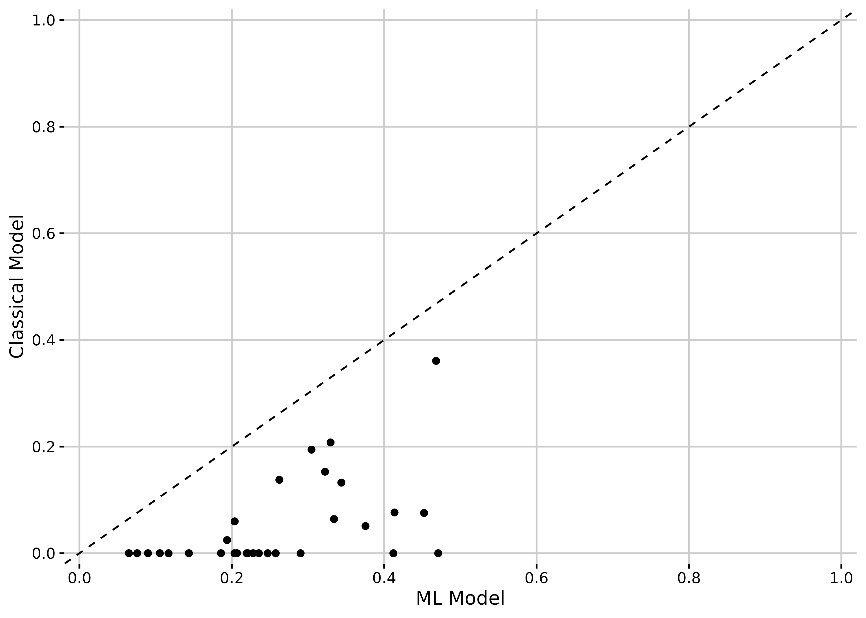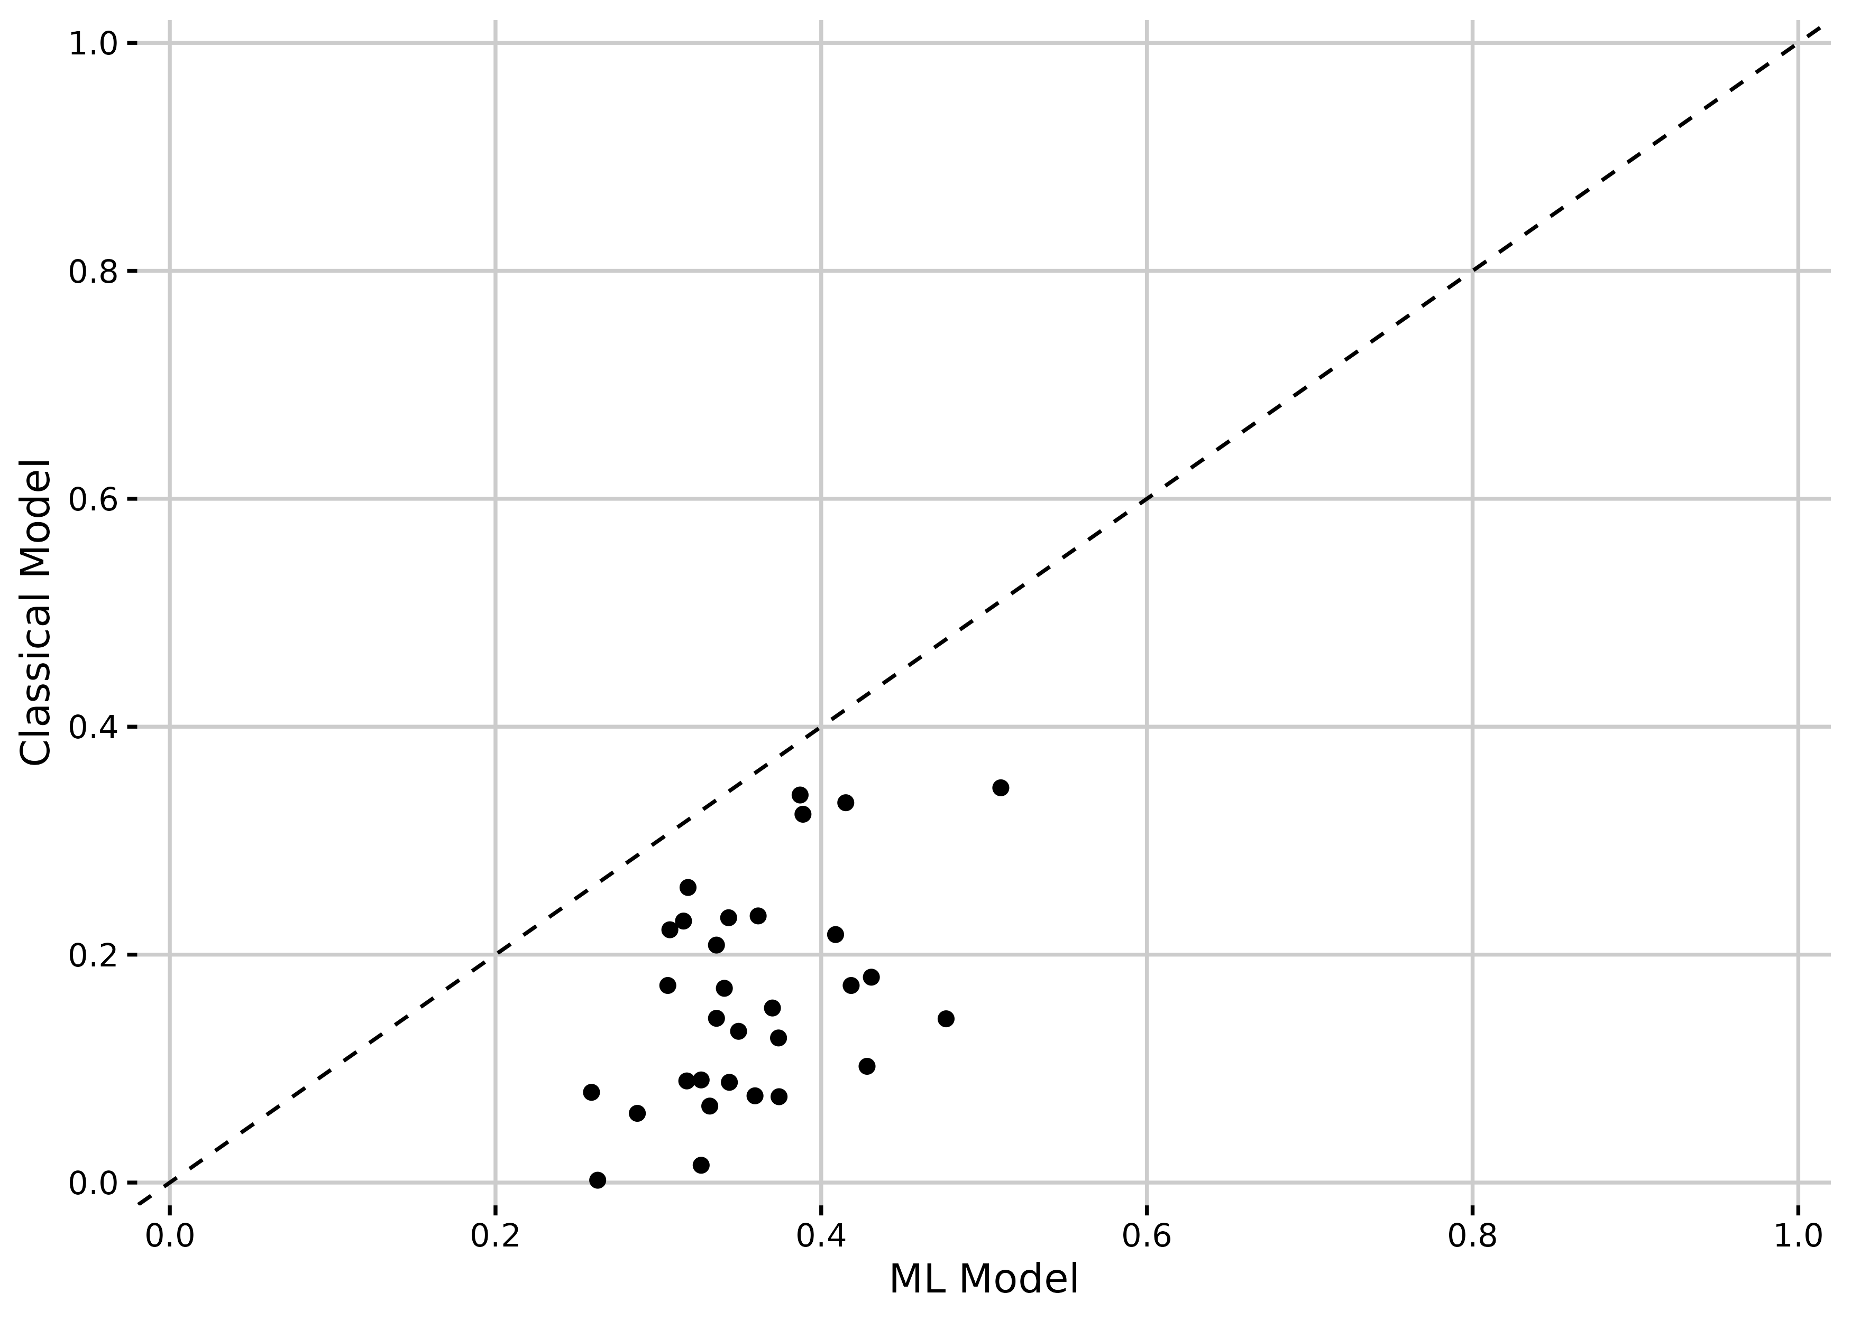
- Health insurance coverage (b) Visited health facility

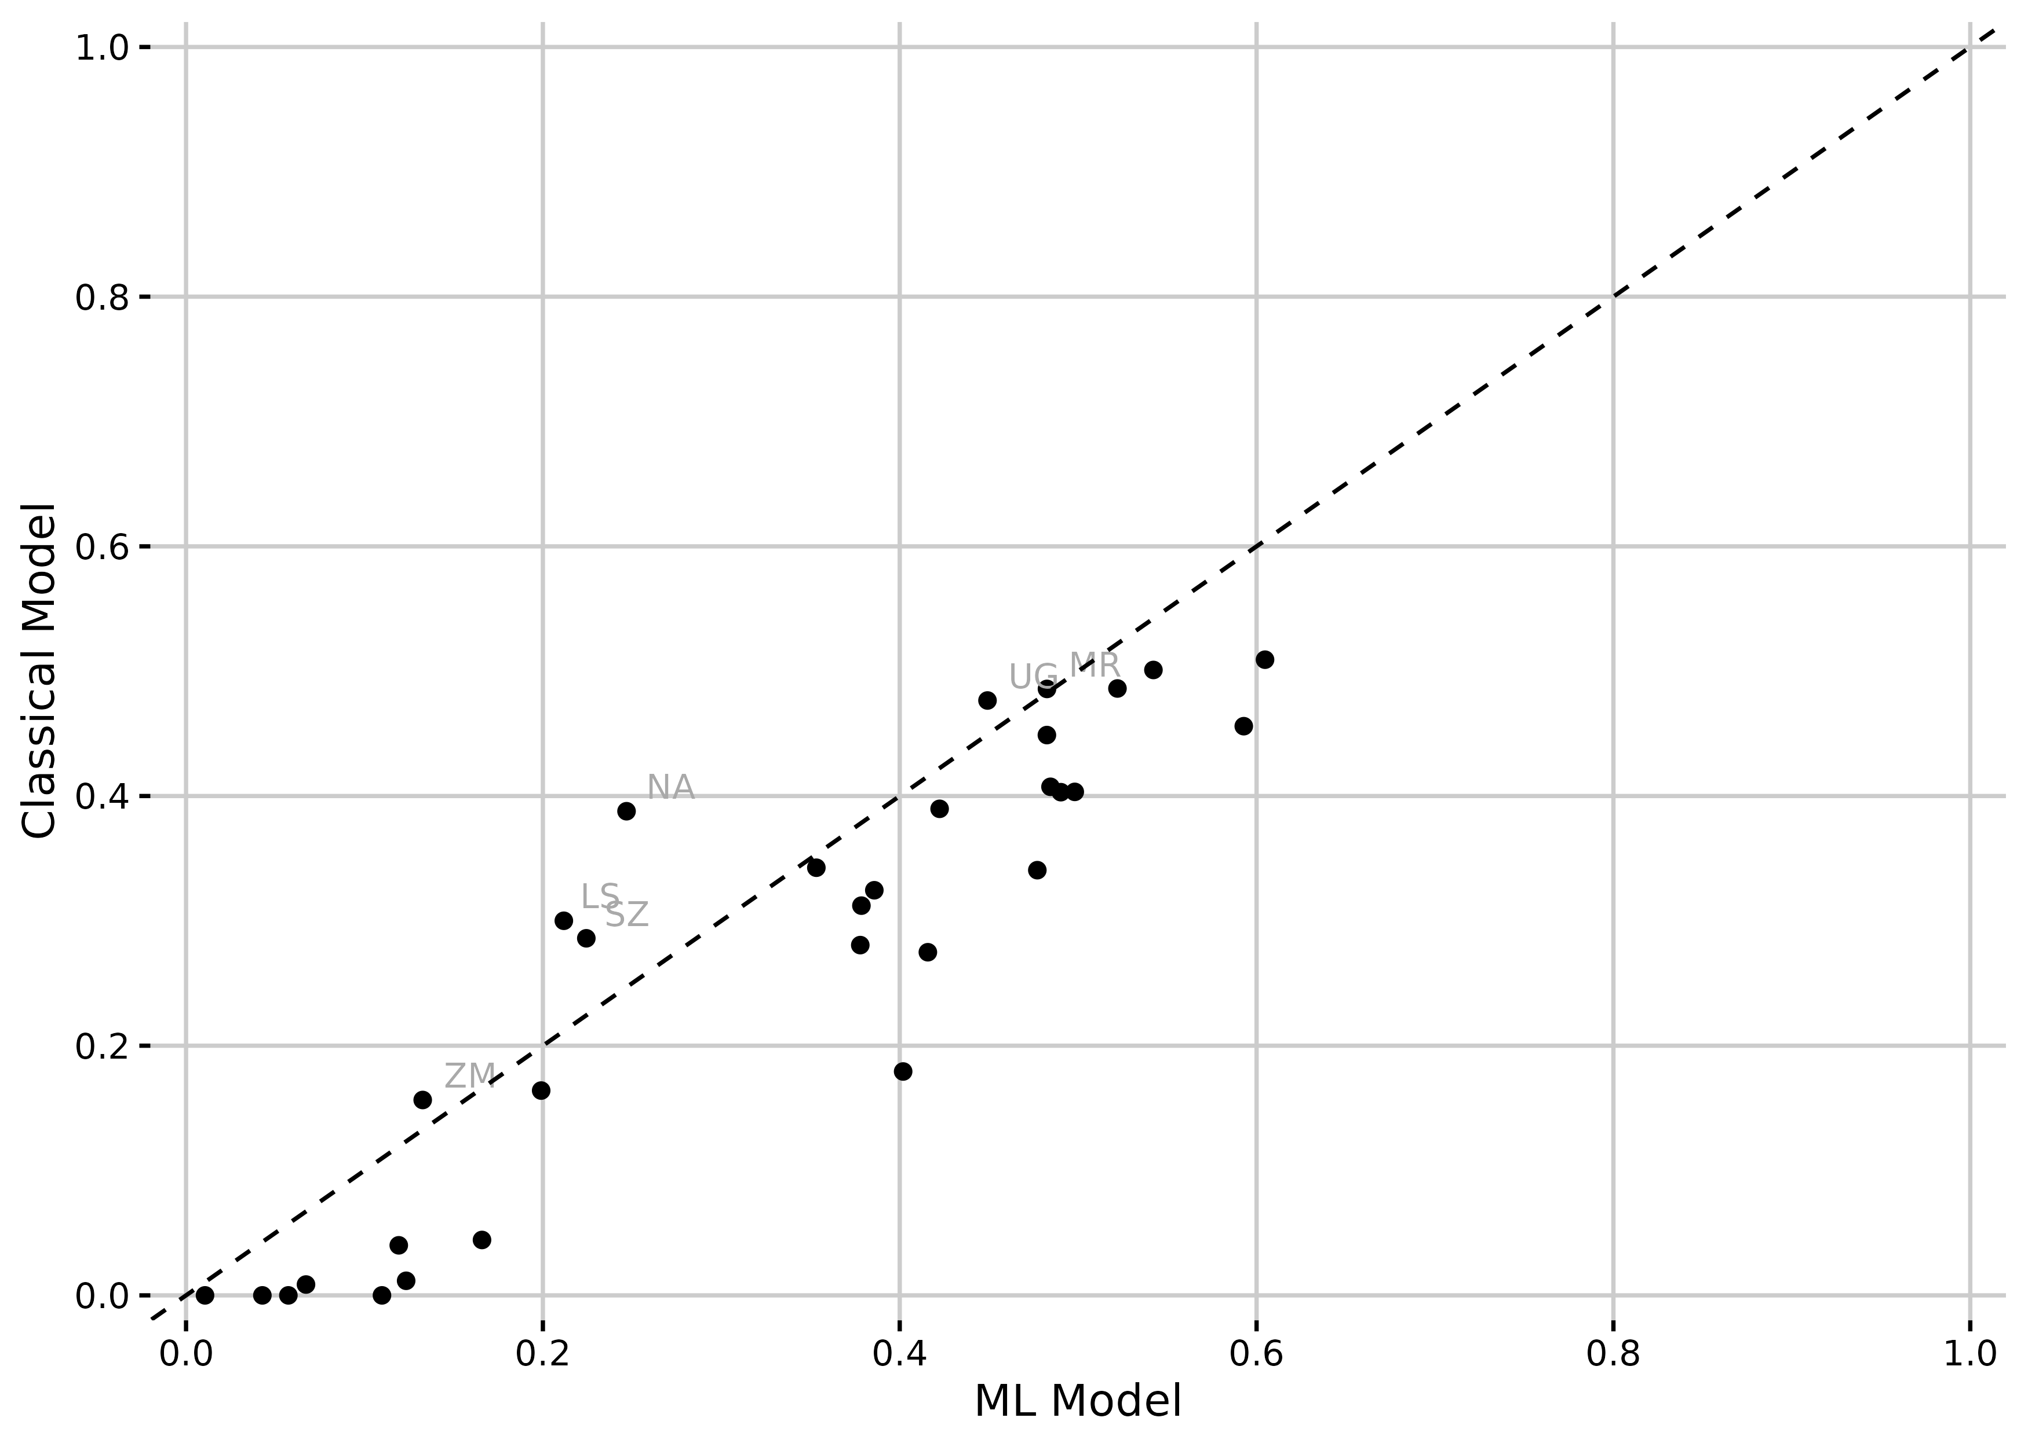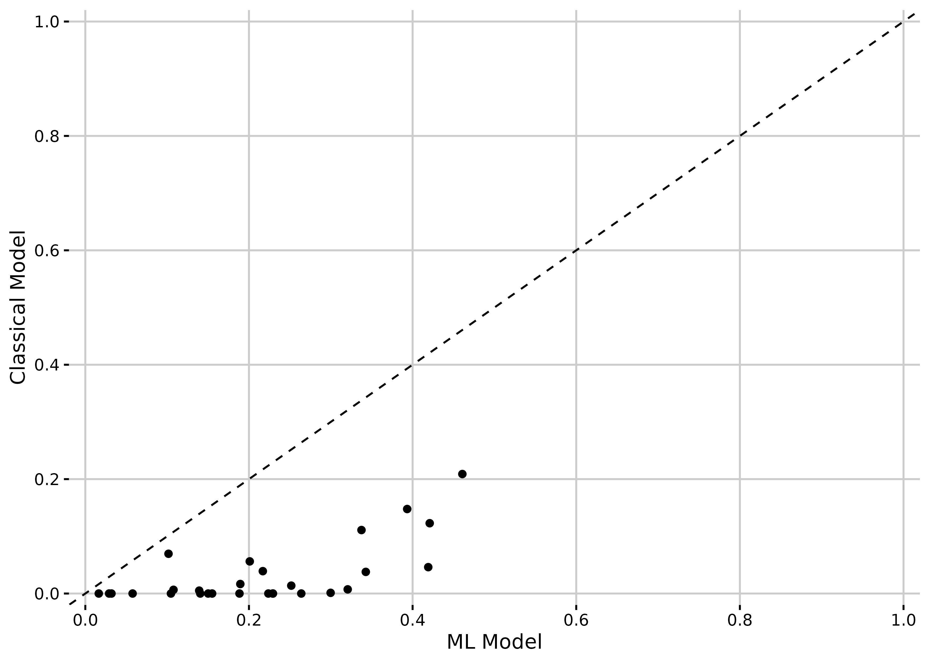
- Health facility-based births (d) Postnatal check

Notes: The figures show the predictive power by country for the classical model (consisting of 11 variables most often used by the literature, details see Section 2) and the ML model using an XGBoost model with repeated five-fold cross-validation (consisting of a maximum of 85 variables available in the DHS data, details see Section 2). The performance is measured as Cohen’s Kappa, a measure of how often the model correctly classifies the outcome, adjusted for the underlying probability of making a correct classification by chance (see Section 3 for more details).

Figure 2: Distribution of Cohen’s Kappa of ML models by wealth quintiles

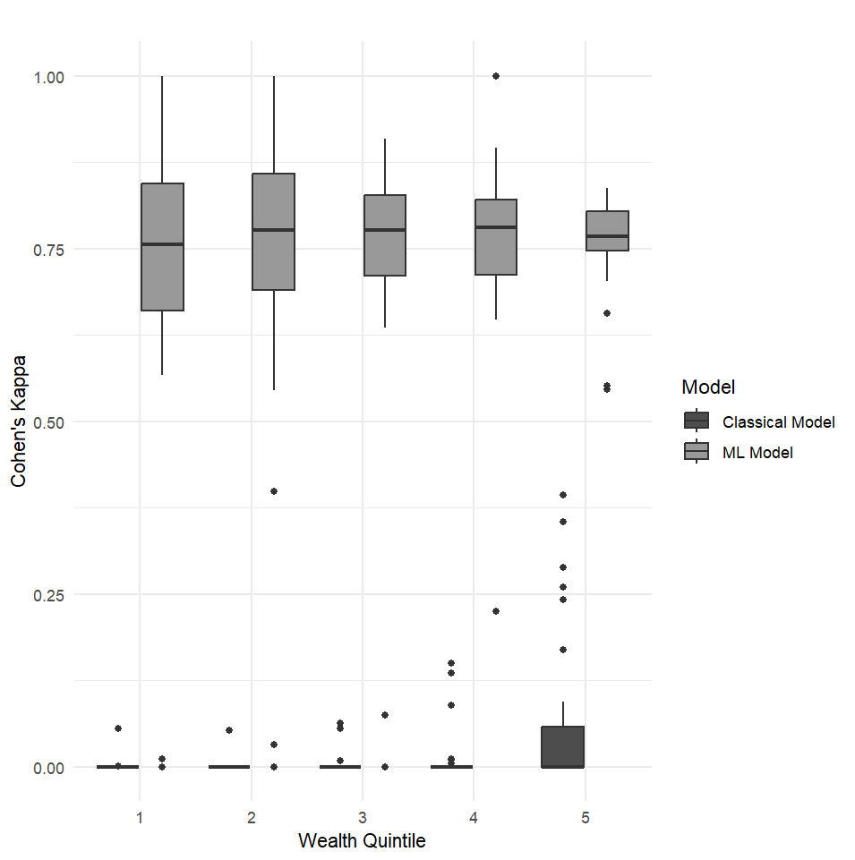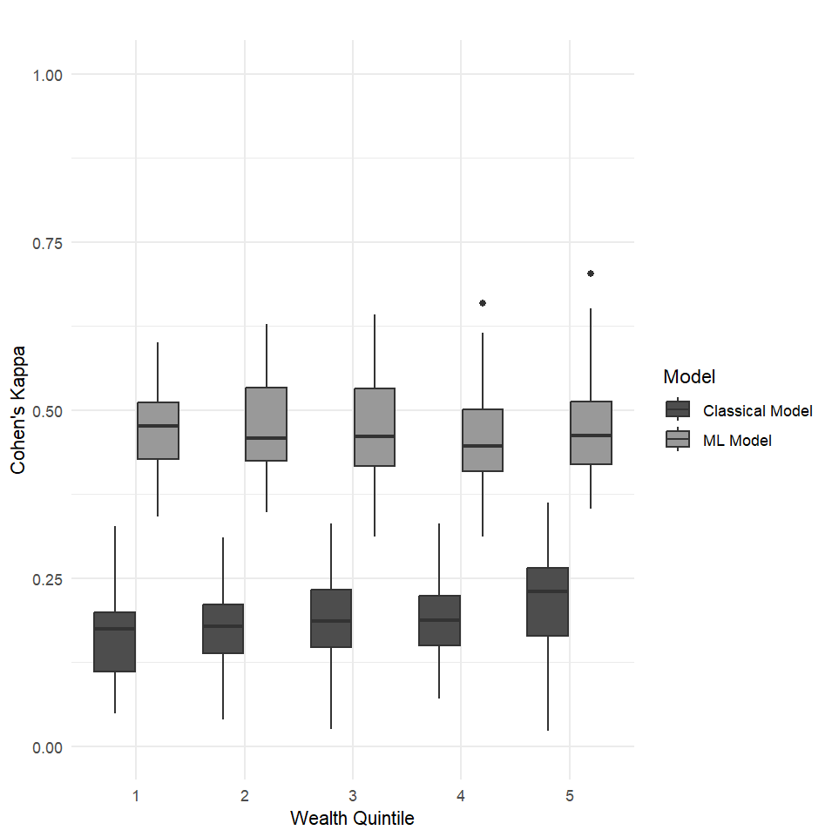
- Health insurance coverage (b) Visited health facility
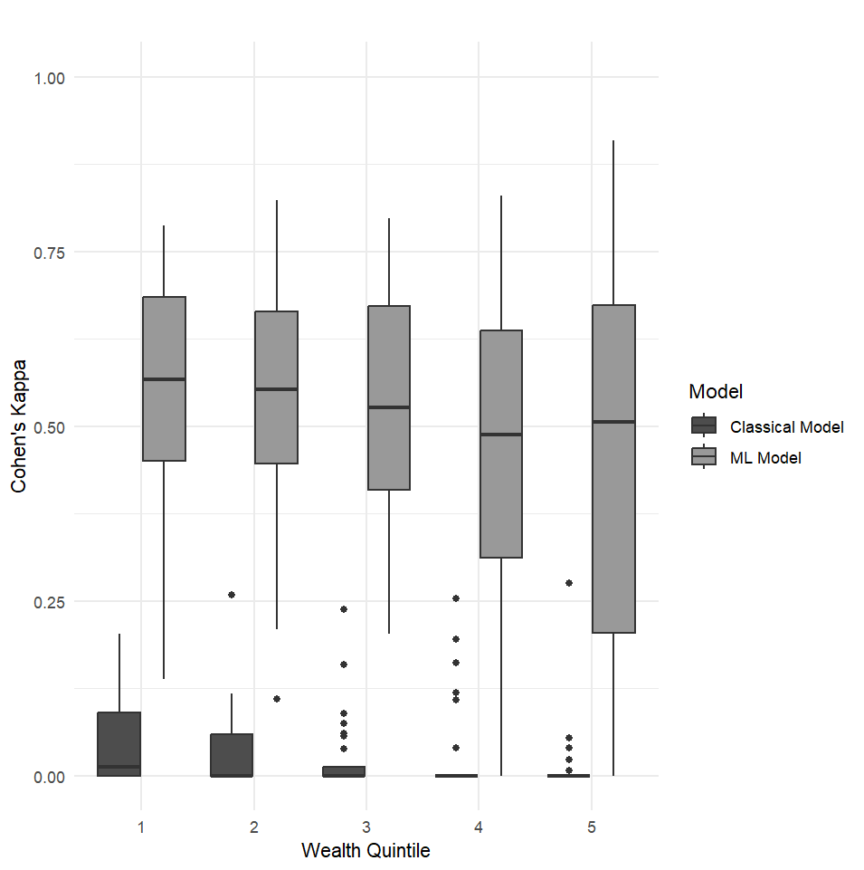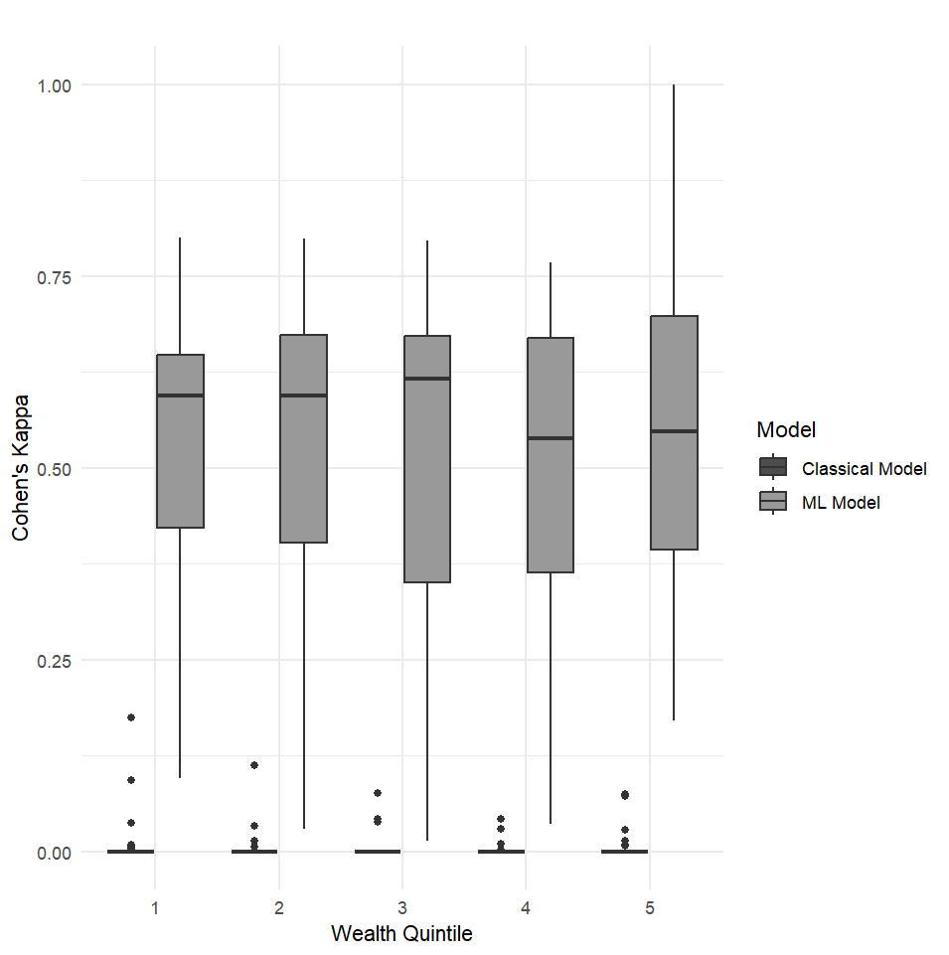
- Health facility-based births (d) Postnatal check

Notes: The figures show the distribution of Cohen’s Kappa for the classical model (consisting of 11 variables most often used by the literature, details see Section 2) and the ML model using an XGBoost model with repeated five-fold cross-validation (consisting of maximal 83 variables available in the DHS data, details see Section 2) across the five wealth quintiles.

Figure 3: Number of times the variable was ranked in the top 5 for ML prediction of health insurance coverage and uptake of health services
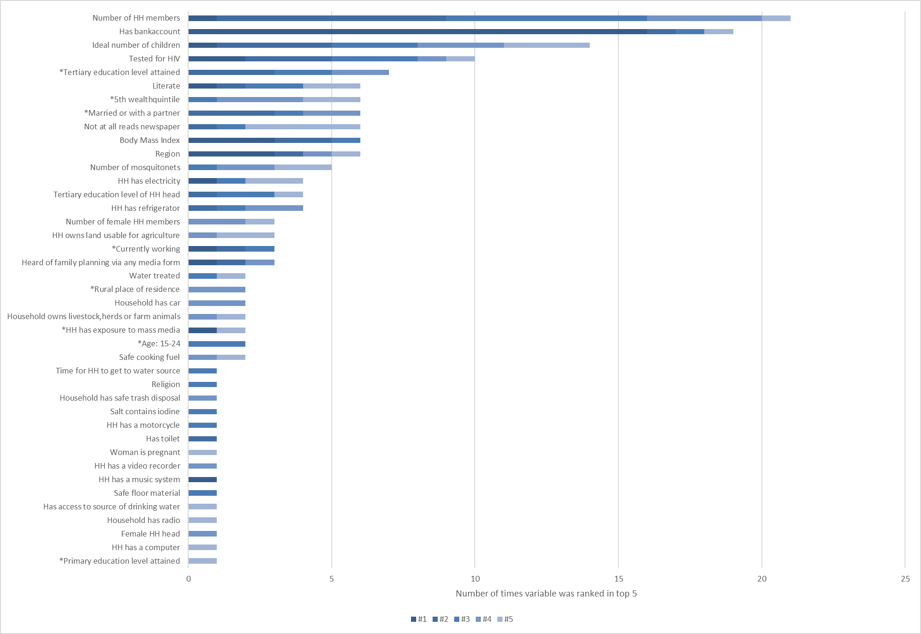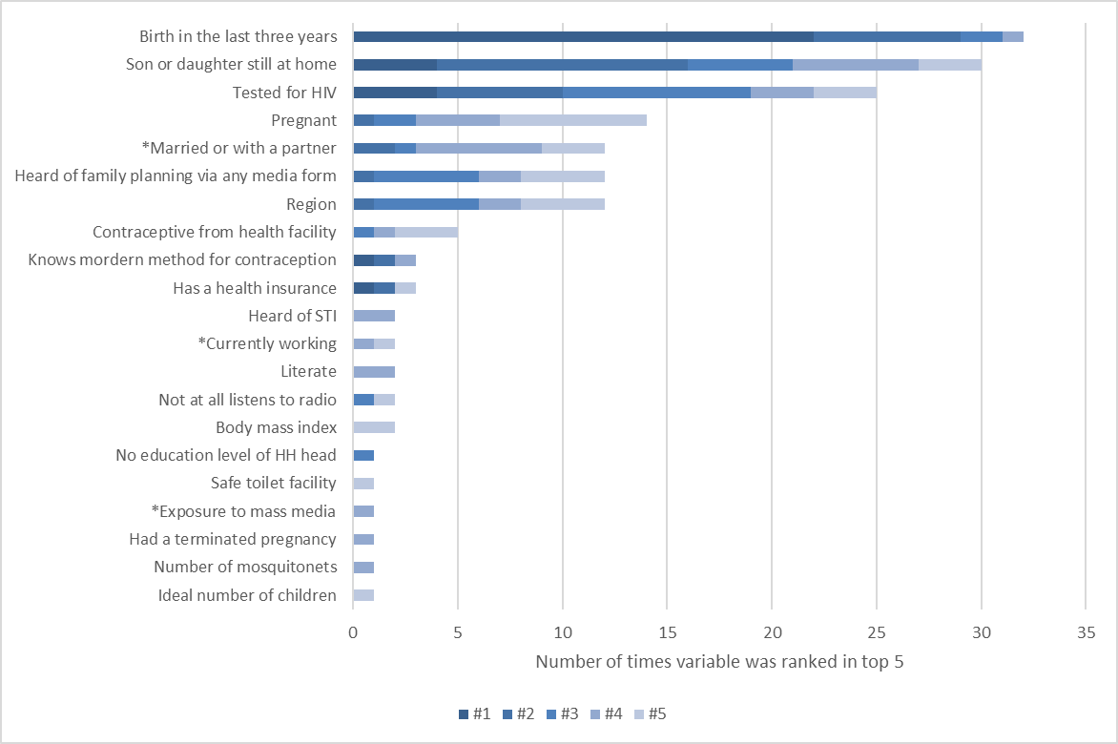
- Health insurance coverage (b) Visited health facility

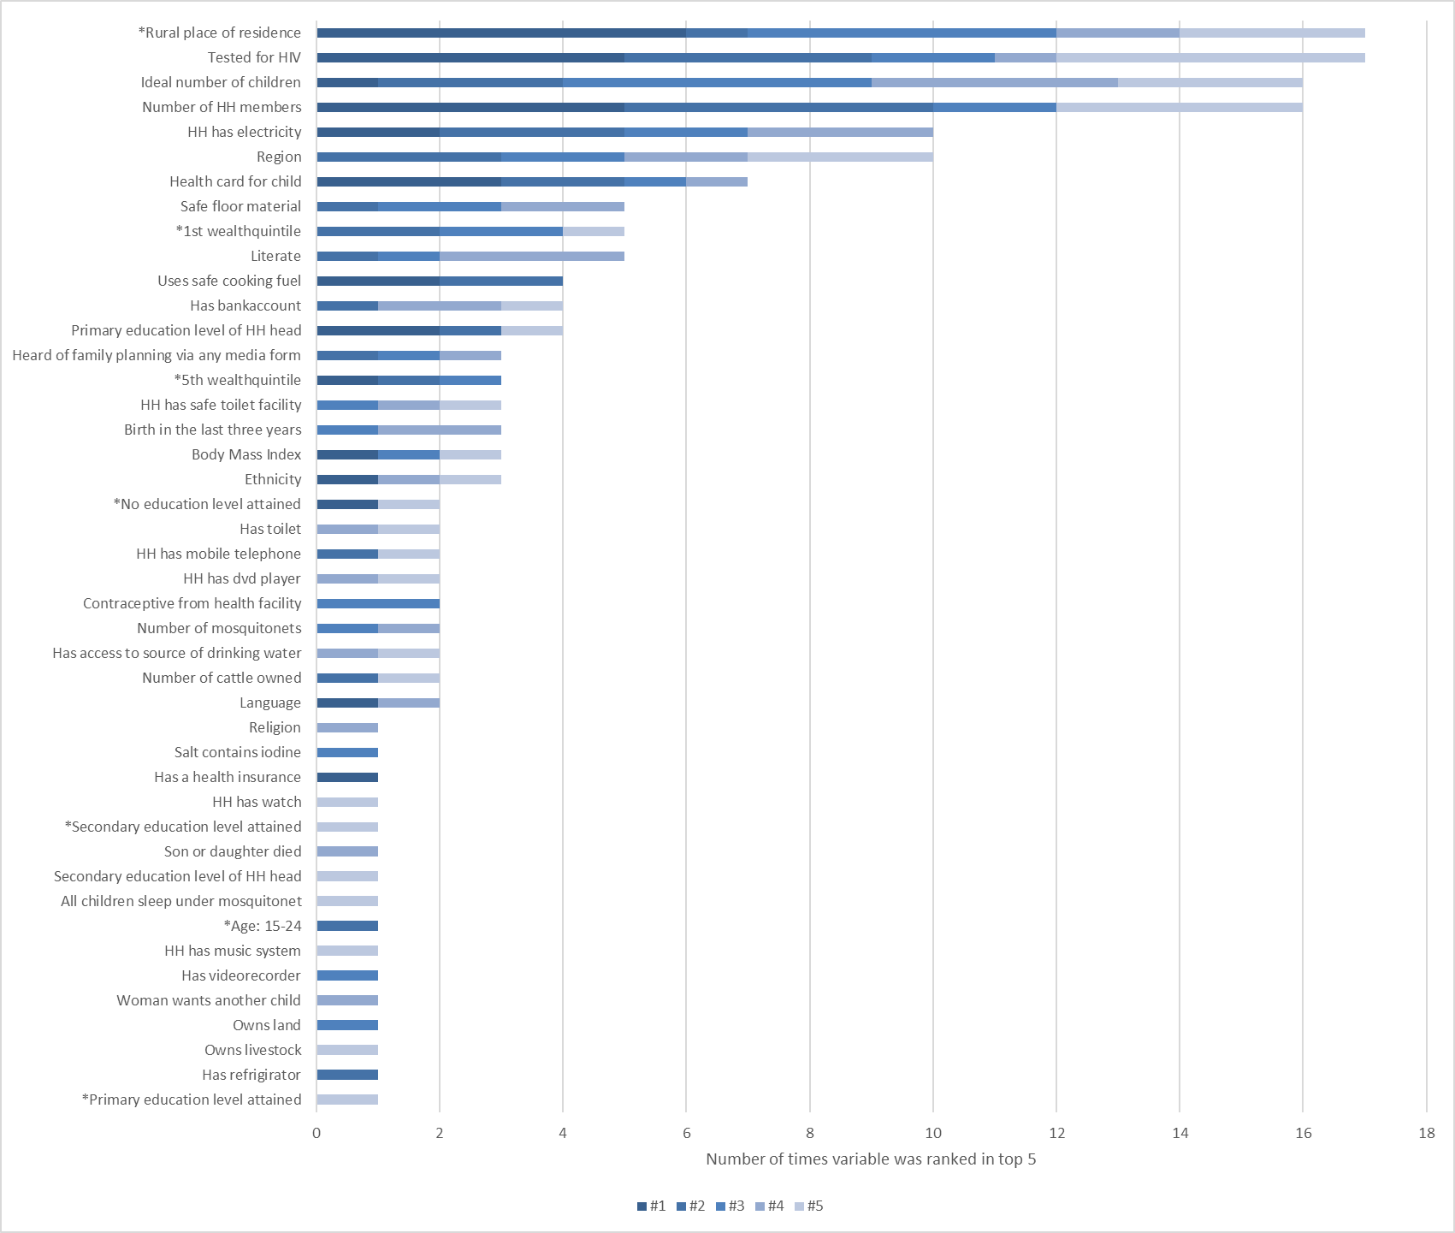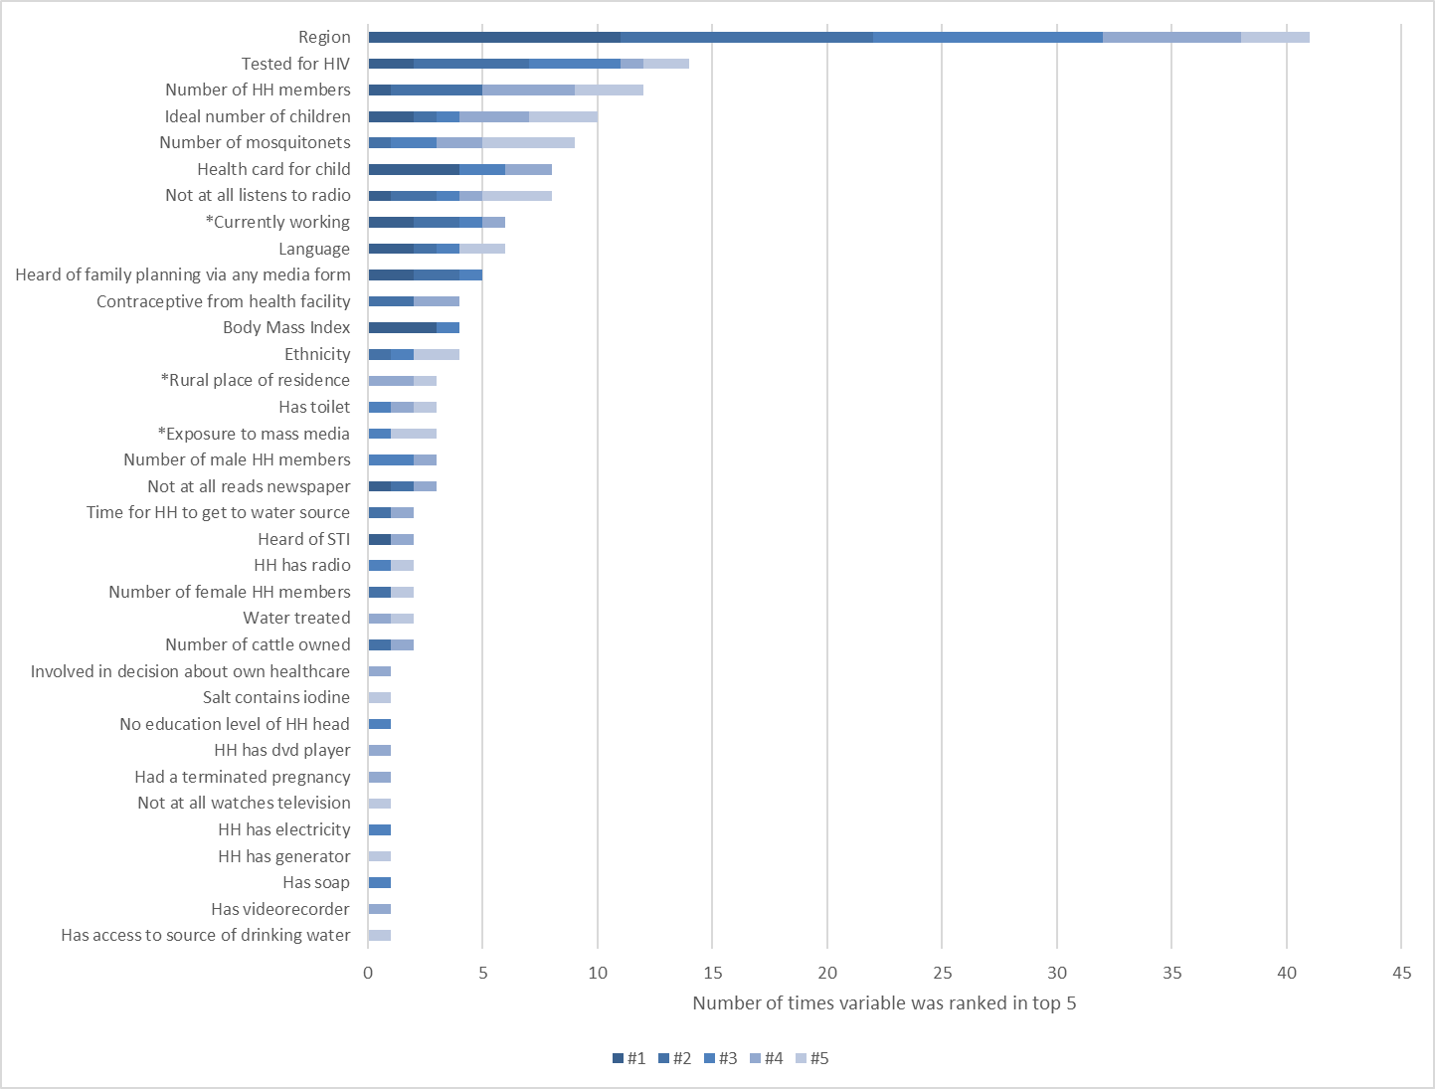
- Health facility-based births (d) Postnatal check

Notes: Figures show the number of times the ML model used the variables as a top five predictor. Variables with a * highlight variables that are included in the classical model. The total number of times a variable can be ranked as top five is 32 because we include 32 countries in the analysis. For some variables, which were not available for all countries based on the selection criteria (see Section 3), the maximum of the top five predictors is lower than 32. A detailed description of the variables and the availability per country can be found in Appendix Table A.1. The table on the country level and with the variable importance score can be found in Appendix Table A.2 – A.5.

Figure 3: Comparison of average health insurance coverage and take-up of health services based on DHS and census data, Nigeria and Zimbabwe
(a)
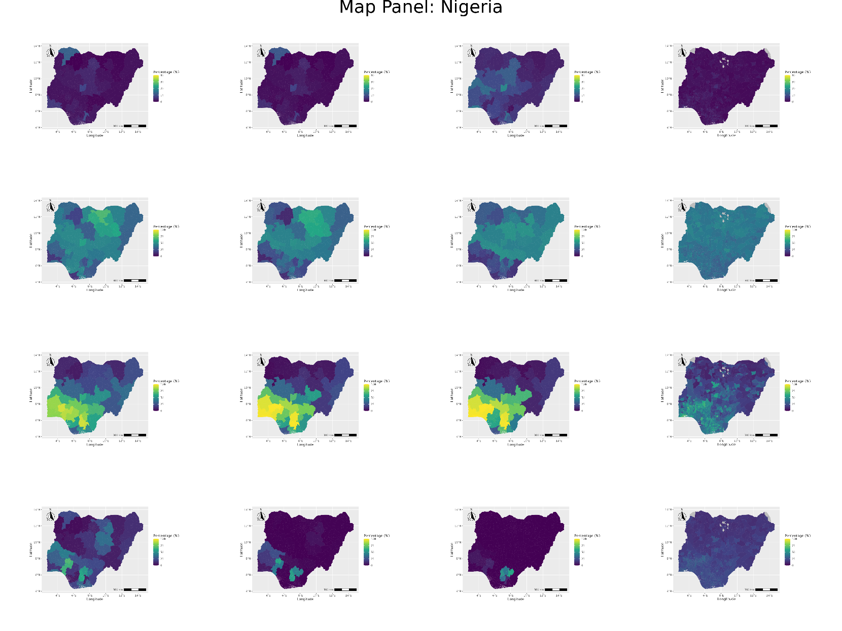

(b)
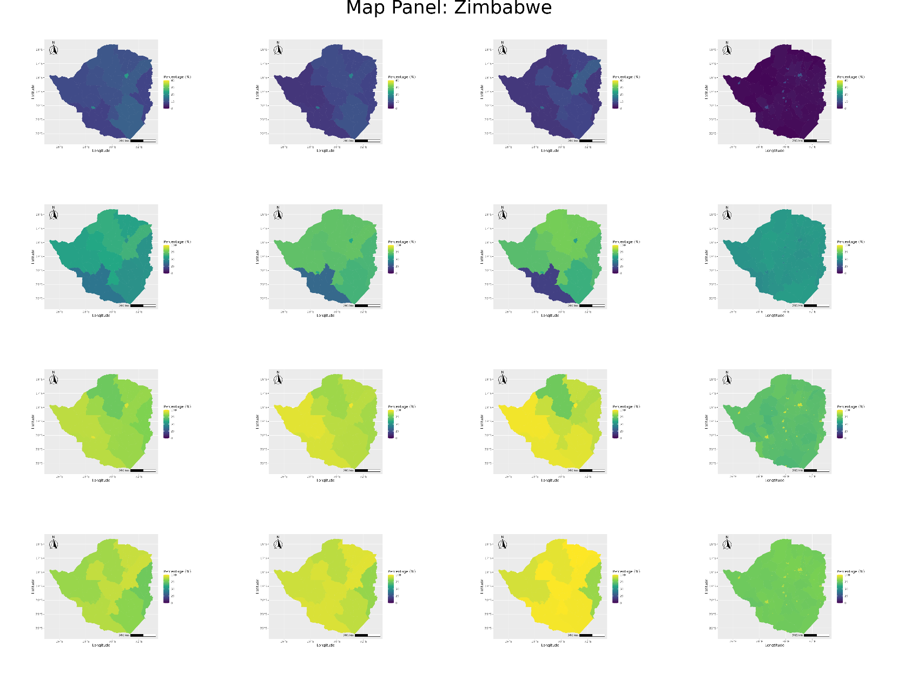
Note: The figures show exemplary for the case of Nigeria: the rows correspond to the four different outcomes (1) health insurance coverage, (2) visited health facility, (3) health facility-based births, (4) postnatal check, and the columns corresponds to the four different models and data sources (a) the reported regional (admin 1 level) averages in the DHS data, (b) the predicted regional (admin 1 level) averages based on the ML model with all available variables from the DHS data, (c) the predicted regional (admin 1 level) averages based on the ML model with a restricted number of variables from the DHS data that are also available in the census data, (d) the predicted district (admin 2 level) average based on the ML model with a restricted number of variables from the census data. The scale for the outcome health insurance coverage only ranges from 0-40% for better visualization of differences in an imbalanced sample. Maps of all available countries can be found in Appendix FigureA.5.

Appendix
see separate document

A deeper discussion of the models and their field of application can be found in Hastie et al. (2008) as well as Murphy (2012) who provide both a very good overview of statistical techniques with a focus on machine learning. Advantages and disadvantages are additionally deduced from Markham (2015) and Blondel (2017).

