Insurance
Figure 1: Boxplots by Model for prediction of Health insurance Coverage

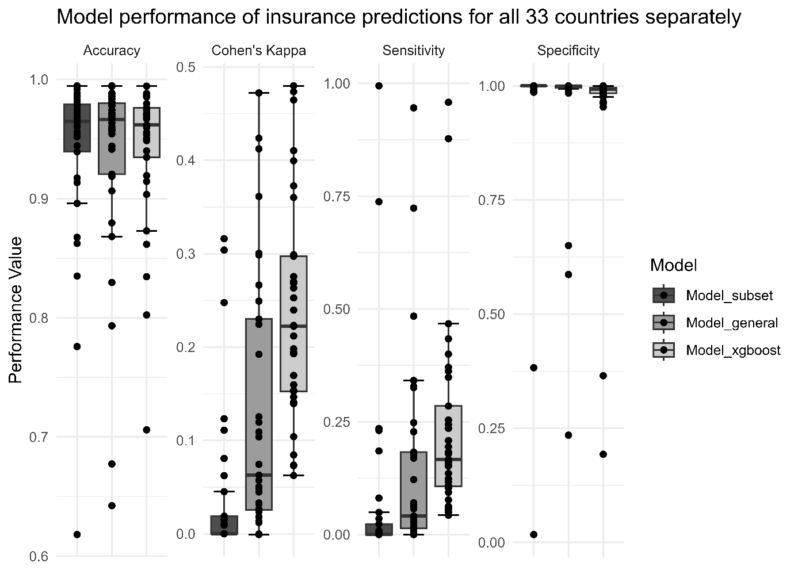

Figure 2: Top 15 variables used by the ML model to predict health insurance coverage (average variable rank)

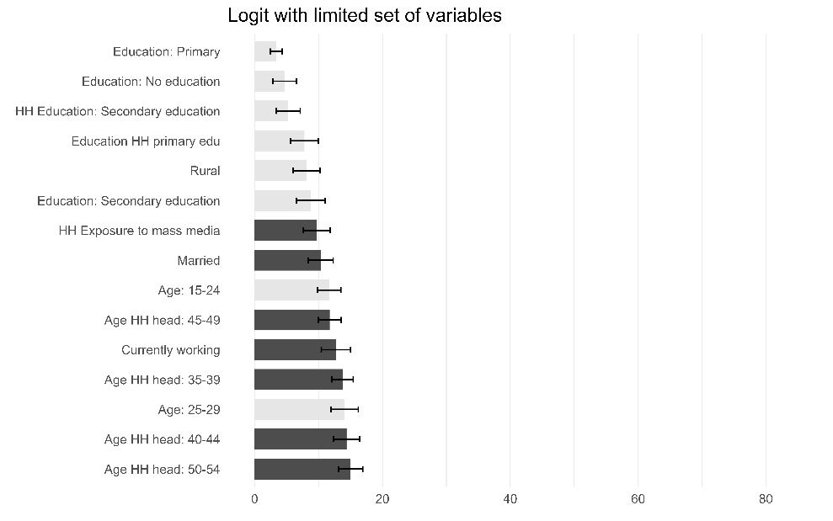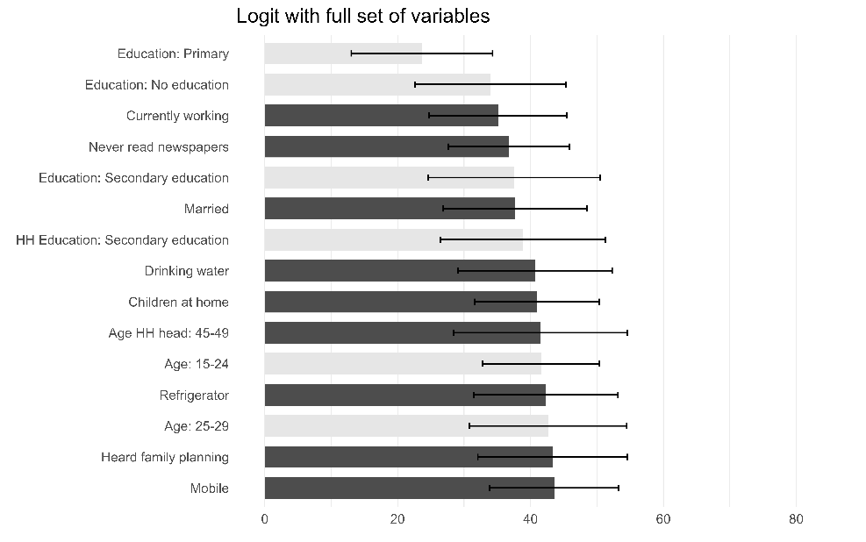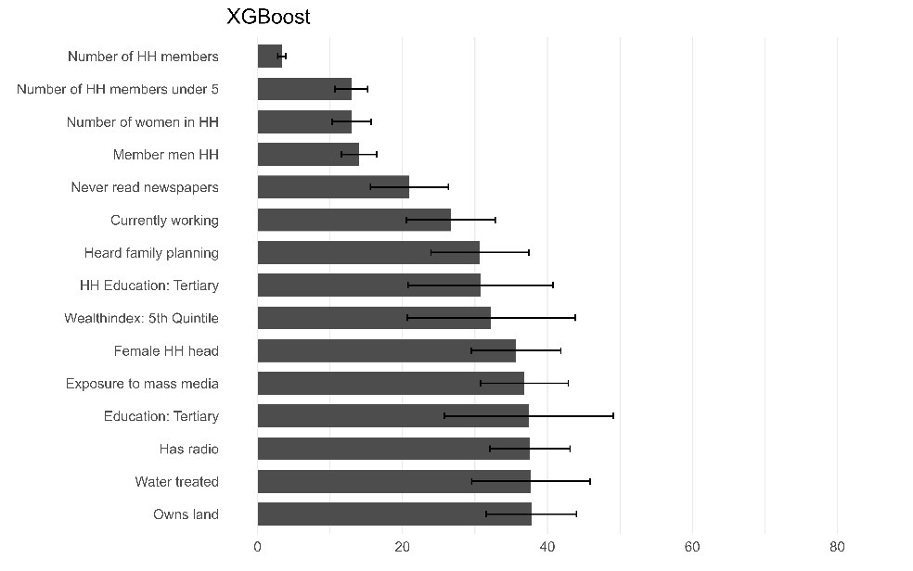
Notes: For the two logit models, bars in dark (light) gray correspond to positive (negative) coefficients
Figure 3: Top 15 variables used by the ML model to predict health insurance coverage (normalized importance score, max = 100)

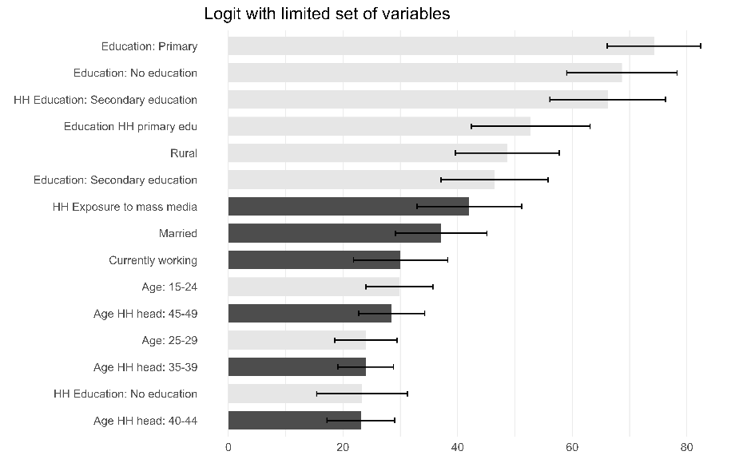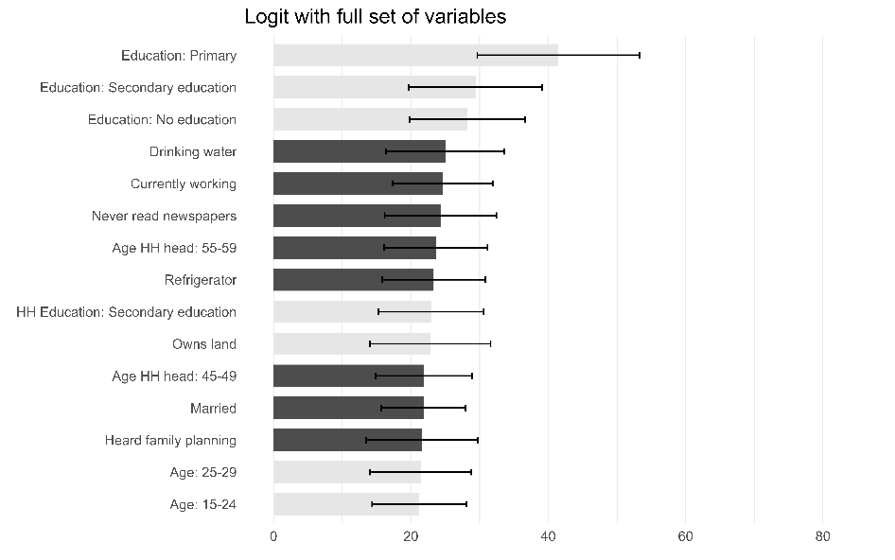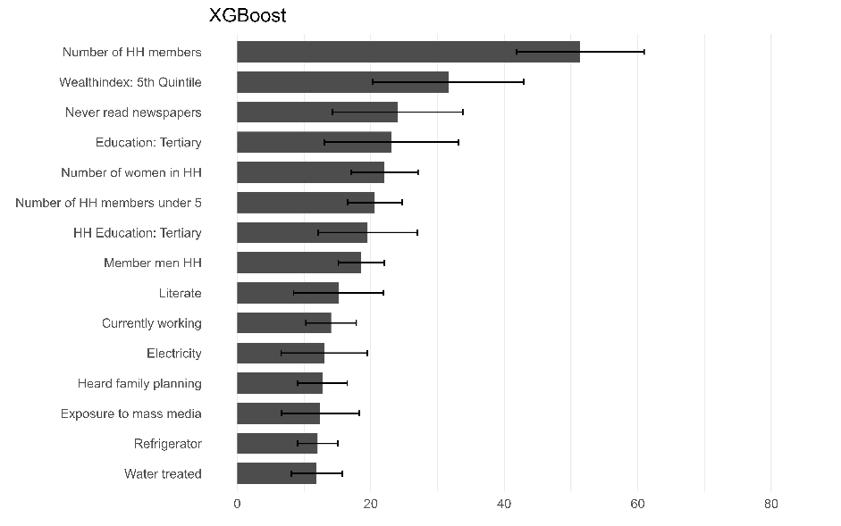
Notes: For the two logit models, bars in dark (light) gray correspond to positive (negative) coefficients

Postnatal Check
Figure 4: Boxplots by Model for prediction of whether child had postnatal check

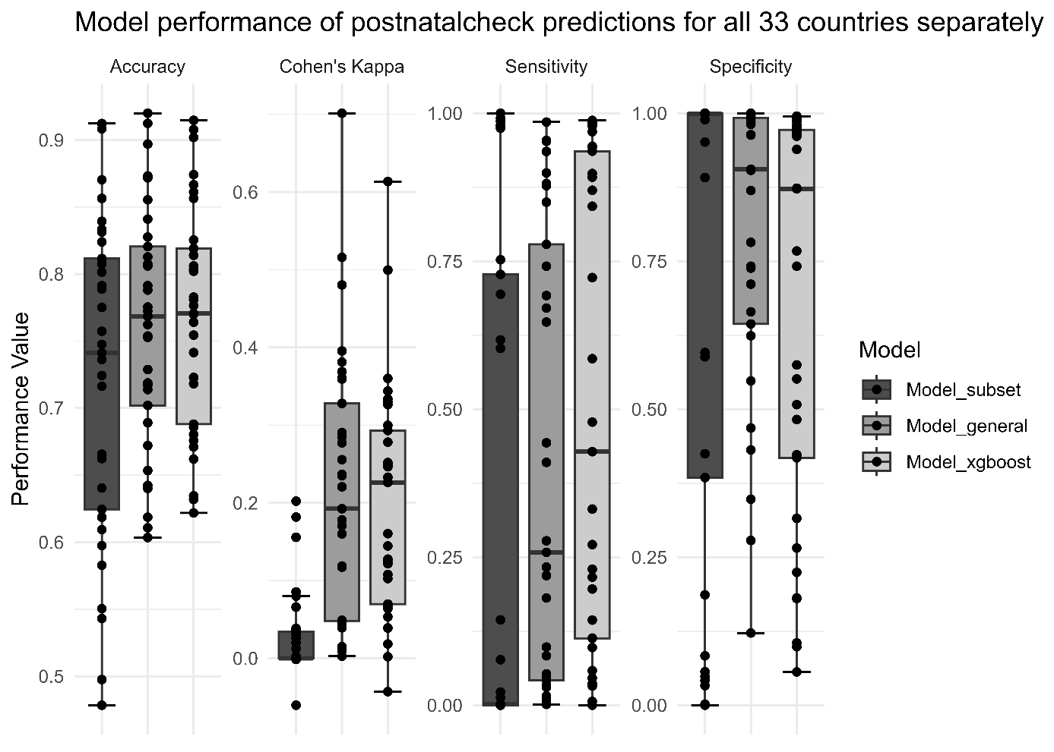

Figure 5: Top 15 variables used by the ML model to predict whether child had postnatal check (average variable rank)
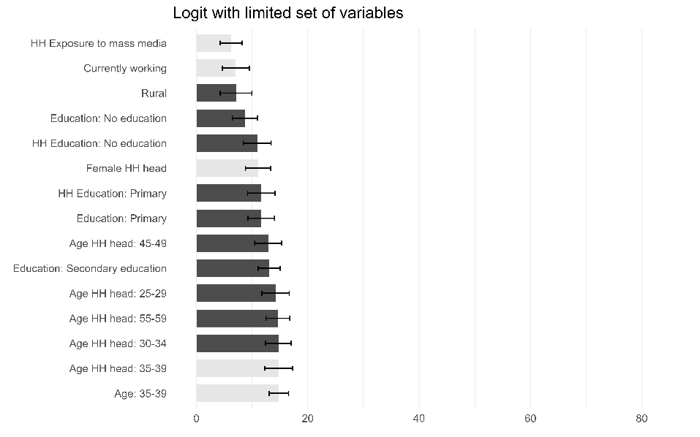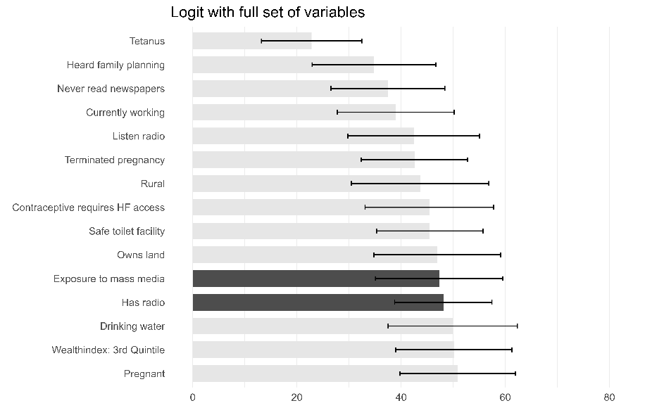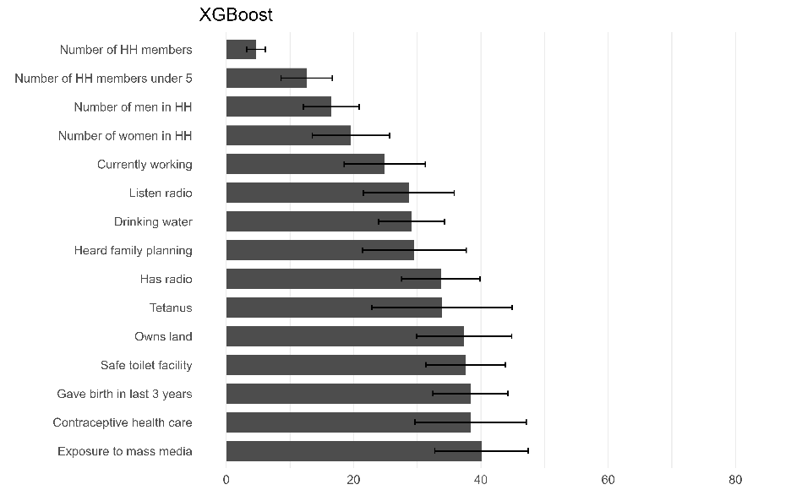
Notes: For the two logit models, bars in dark (light) gray correspond to positive (negative) coefficients

Figure 6: Top 15 variables used by the ML model to predict health insurance coverage (normalized importance score, max = 100)

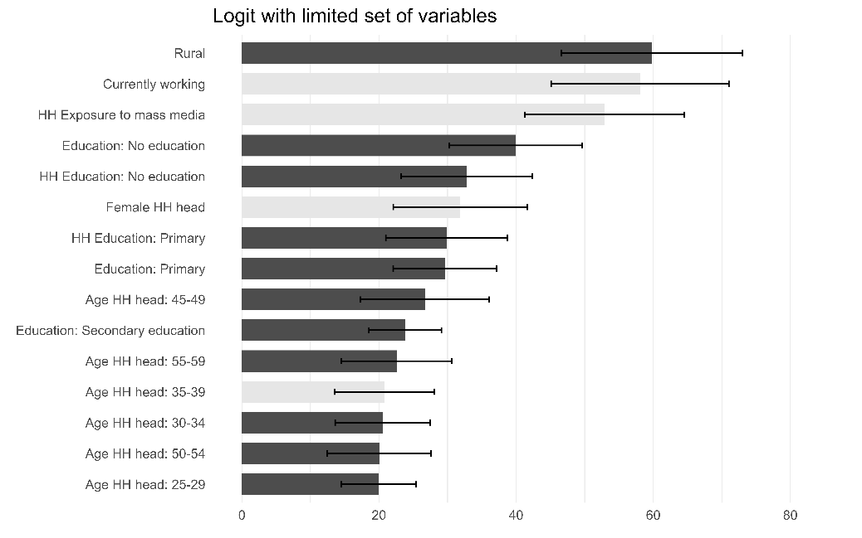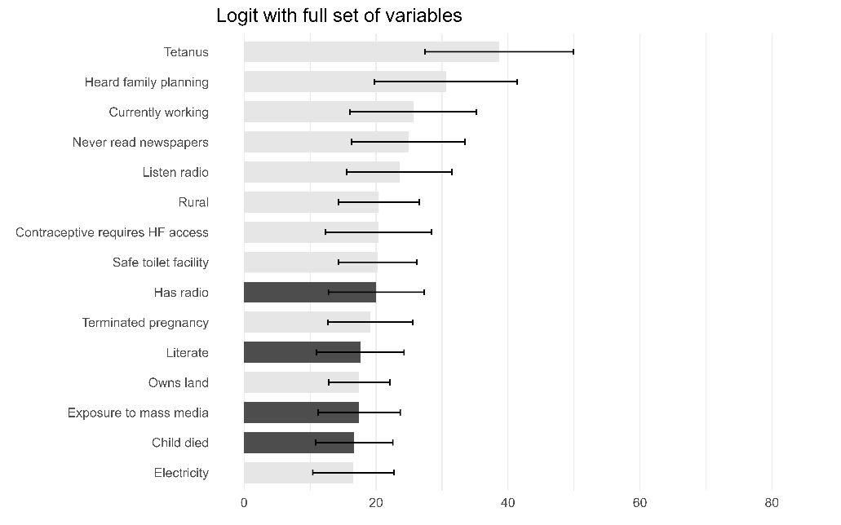
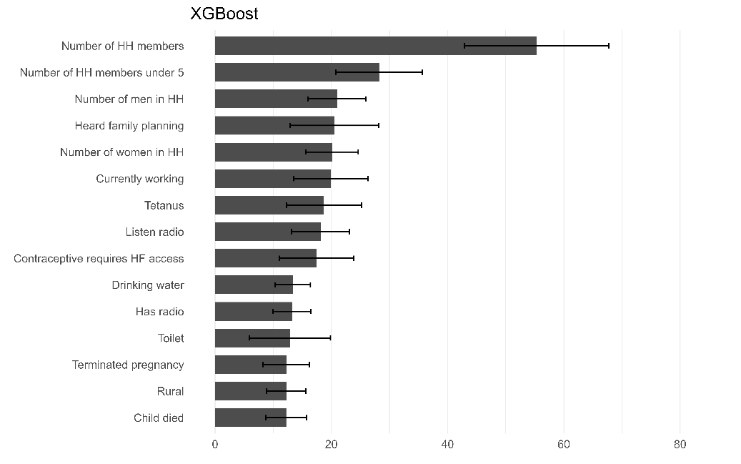
Notes: For the two logit models, bars in dark (light) gray correspond to positive (negative) coefficients

Location Birth
Figure 7: Boxplots by Model for prediction of whether child was born in health facility

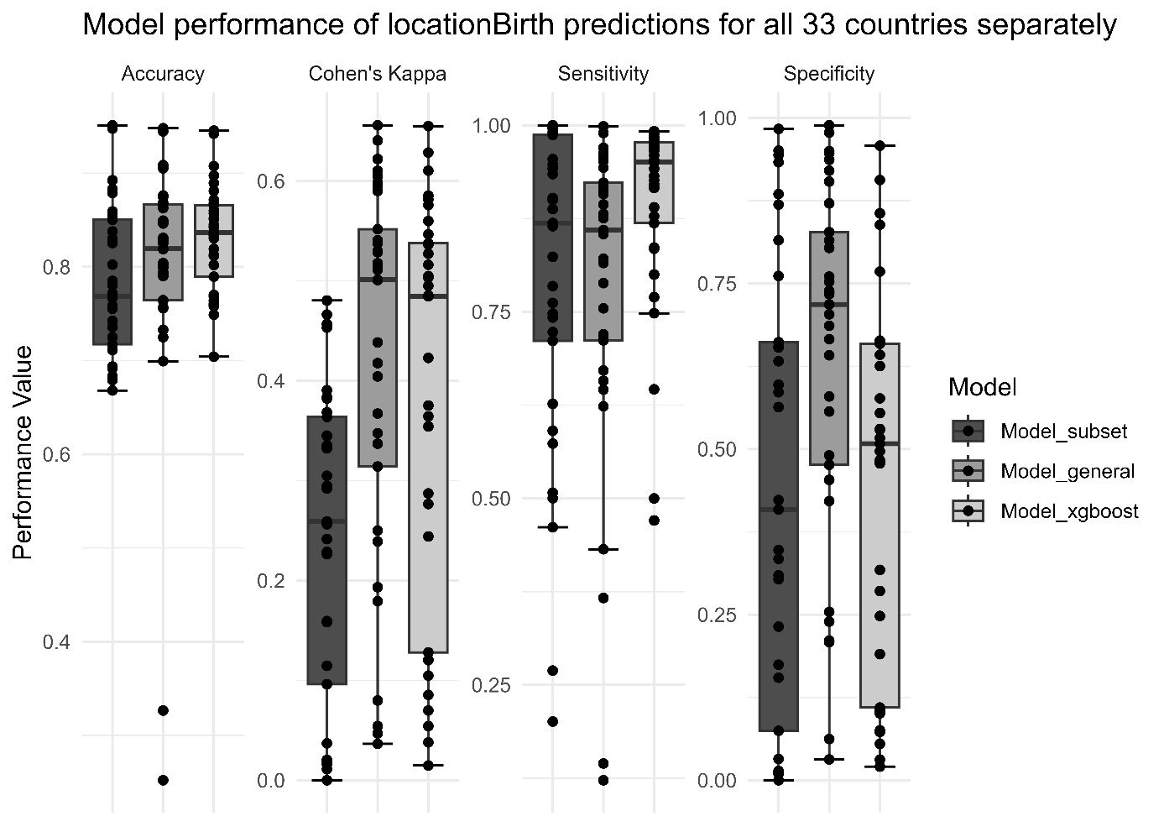

Figure 8: Top 15 variables used by the ML model to predict whether child was born in health facility (average variable rank)

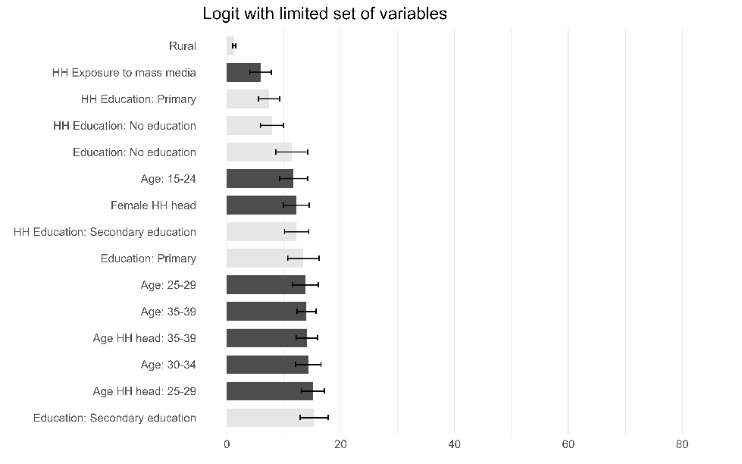
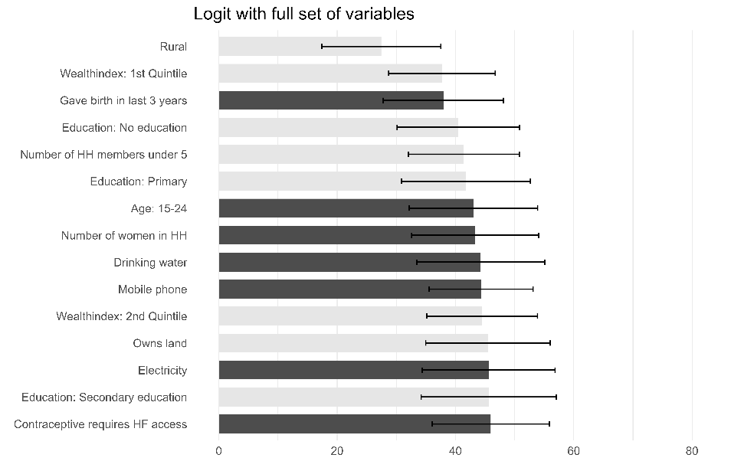
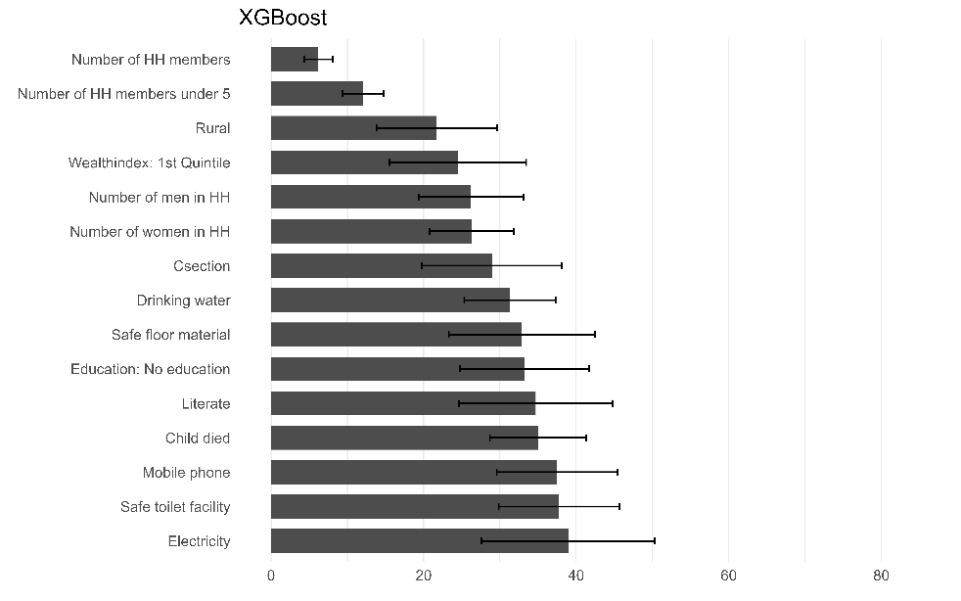
Notes: For the two logit models, bars in dark (light) gray correspond to positive (negative) coefficients

Figure 9: Top 15 variables used by the ML model to predict whether child was born in health facility (normalized importance score, max = 100)

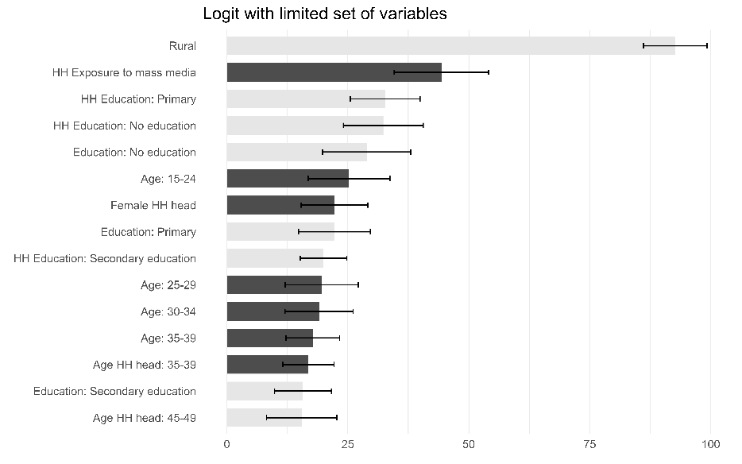
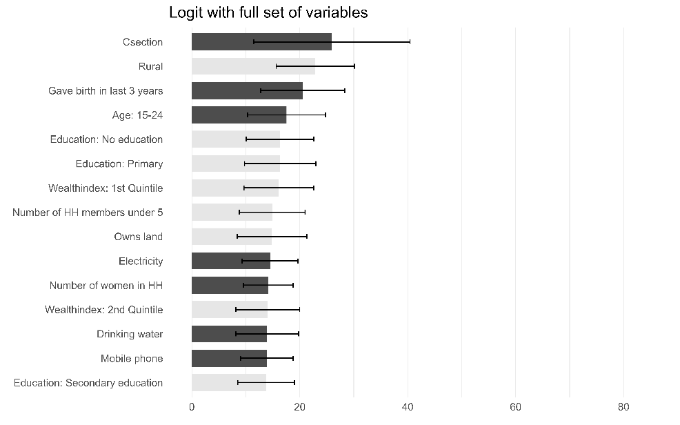
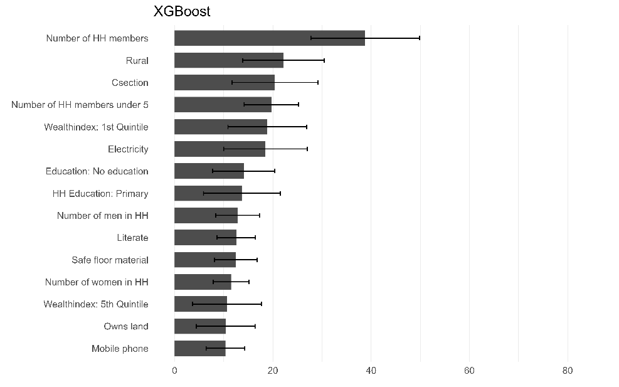
Notes: For the two logit models, bars in dark (light) gray correspond to positive (negative) coefficients

Visited Health Facility in Last 12 Months
Figure 10: Boxplots by Model for prediction of whether woman visited health facility in last 12 months

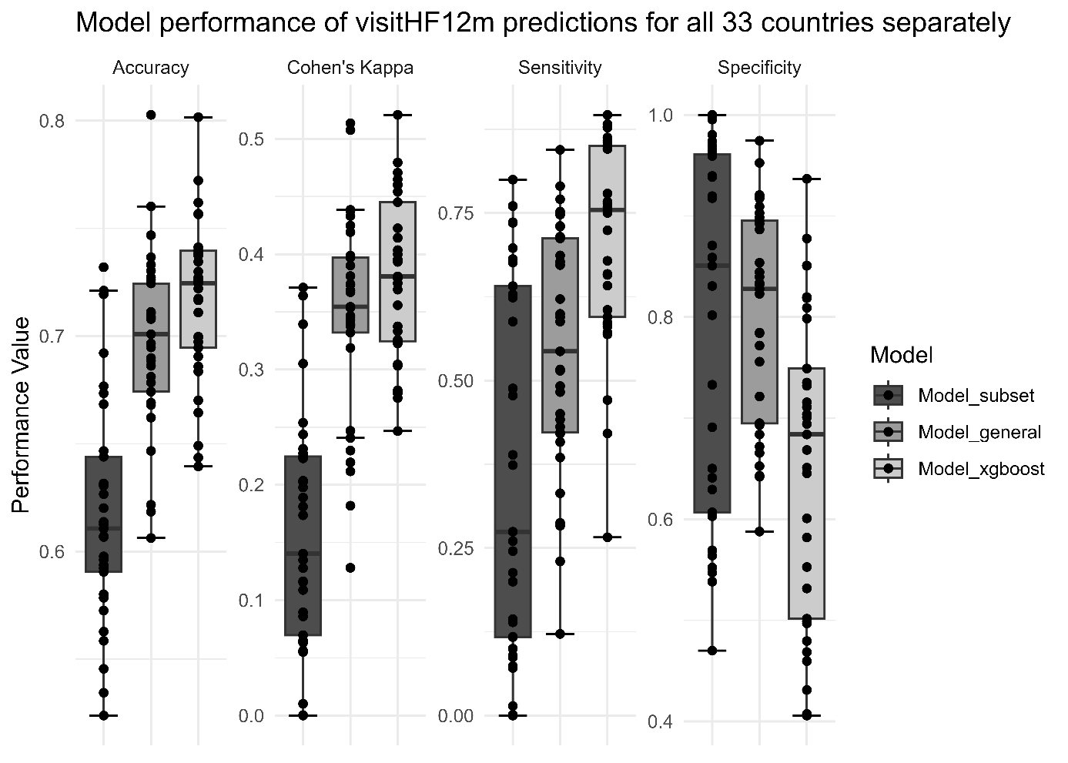

Figure 11: Top 15 variables used by the ML model to predict whether woman visited health facility in last 12 months (average variable rank)

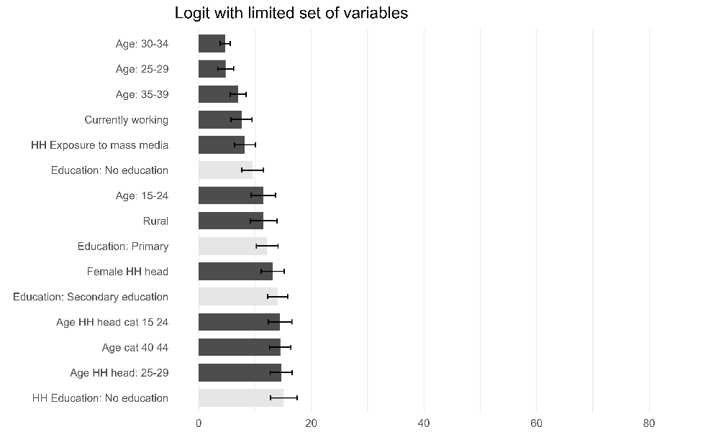
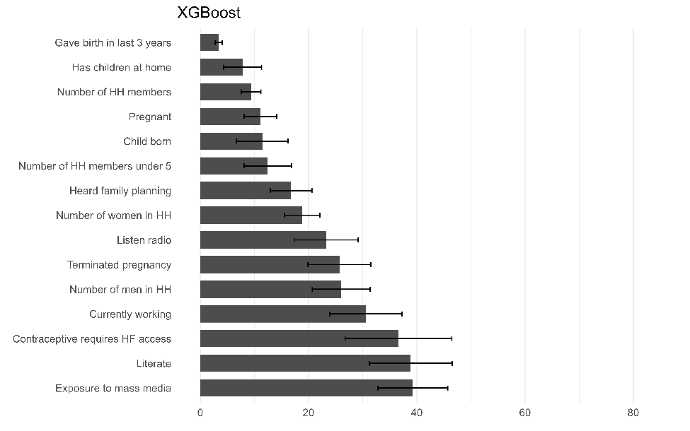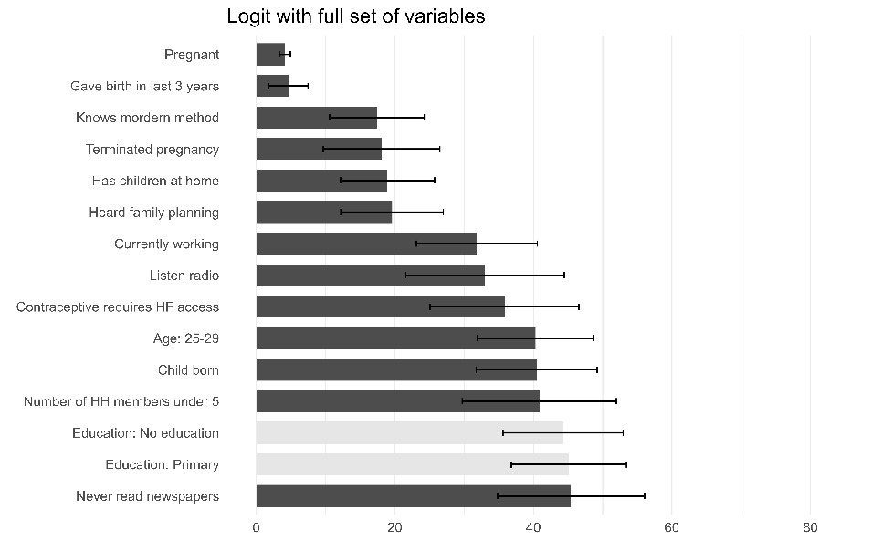
Notes: For the two logit models, bars in dark (light) gray correspond to positive (negative) coefficients

Figure 12: Top 15 variables used by the ML model to predict whether woman visited health facility in last 12 months (normalized importance score, max = 100)

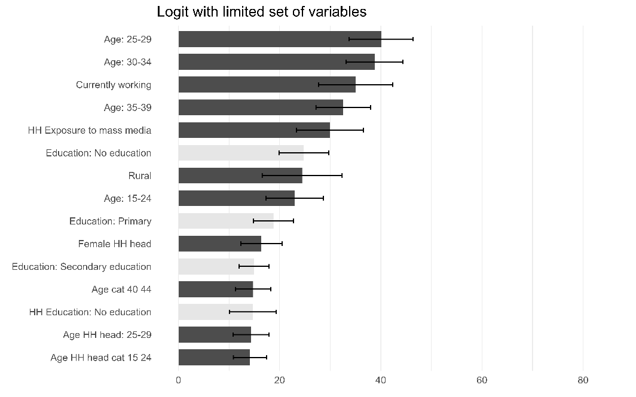
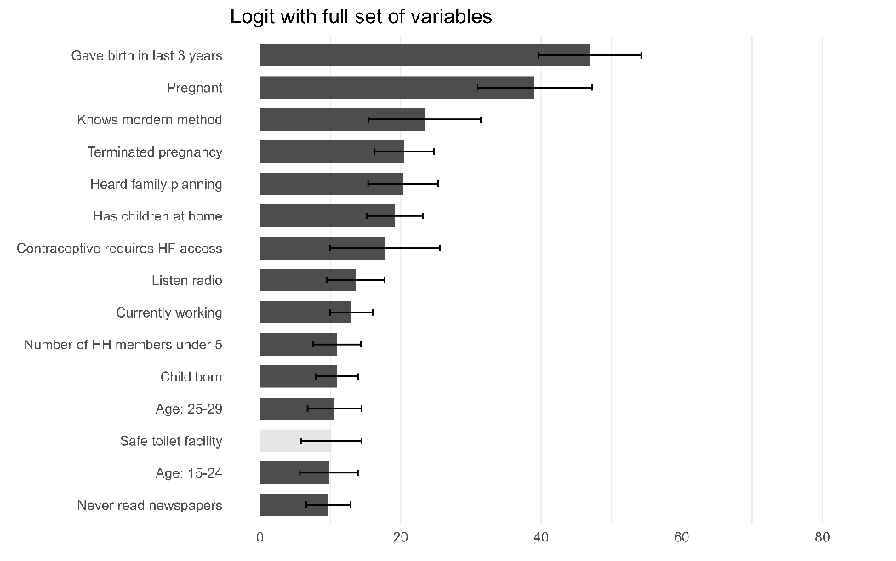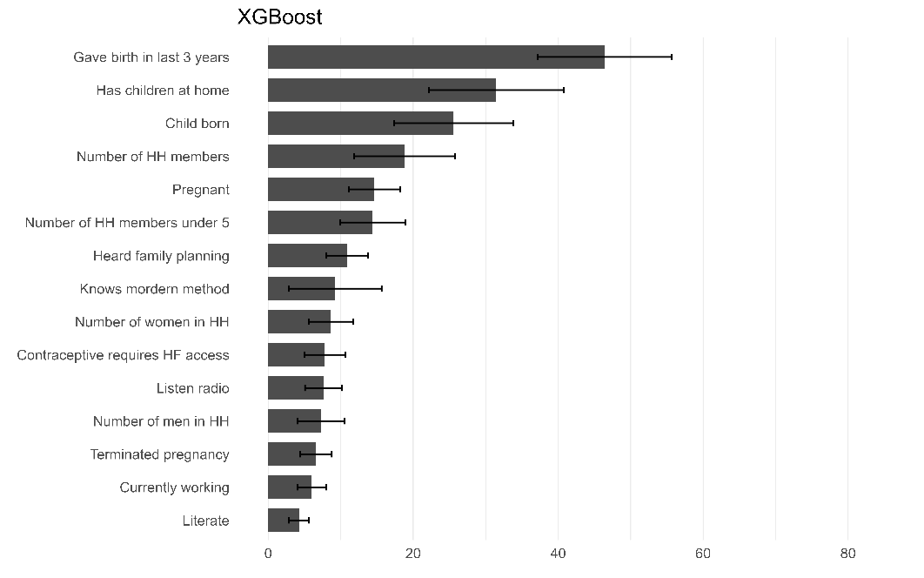
Notes: For the two logit models, bars in dark (light) gray correspond to positive (negative) coefficients

