Which women in Africa are excluded from health insurance and health care? Insights from machine learning
Kathrin Durizzo*¹ (0000-0002-9036-0741), Kenneth Harttgen¹ ⁽0000-0002-8499-5281), Isabel Günther¹ ⁽0000-0002-1601-0495)

¹ Development Economics Group & Center for Development and Cooperation (NADEL), ETH Zurich, Clausiusstrasse 37, 8092 Zurich, Switzerland
* Corresponding author: kathrin.durizzo@nadel.ethz.ch

Abstract
Across many African countries, health insurance coverage rates rarely exceed 10%, and only 50% of the population does have access to the most basic health services. However, little is known about which indicators could be applied to better target the excluded populations. We apply advanced machine learning (ML) methods to Demographic Health Surveys from 33 African countries to identify the included and excluded populations. Based on the predictions, we use census data to make out-of-sample predictions to lower administrative levels and for the whole population. This method can also be applied to countries where DHS data is not available. We find that applying different ML approaches leads to more accurate and sensitive predictions and better identification of the excluded population than a classical logistic regression approach. The true positive rate increases from 15% to 57% for health insurance and the sensitivity to predict the use of health services increases from 41% to 66%. The analysis further shows that insurances still exclude the poor, with lower education, and in rural areas. By creating a detailed map of all 38 countries, we observe large within-country differences both in coverage of health insurance as well as in access to health services, such as in Kenya and Nigeria. Overall, our findings emphasize that most African countries are far from achieving Universal Health Coverage (UHC), especially for vulnerable population groups. ML methods can be used for improved predictions, improving the current targeting to advance the identification of excluded populations.

Keywords: Universal Health Protection; health insurance; health services; machine learning; spatial analysis

JEL codes: C4; I1; I32; O10

Funding: We thank ETH Zurich and the Swiss National Research Fund (SNF) for funding this project (SNF grant number: 400640_183760).

Conflict of Interest: The authors declare that they have no conflict of interest and nothing to disclose.

Data availability: Data and materials are available for review if needed.

Code availability: Code is available for review if needed.

Introduction
Although many health outcomes have improved over the last decades, maternal and neonatal health outcomes remain relatively low (e.g., World Bank, 2021; Coates et al., 2021). African countries have the highest maternal mortality rates with 534 per 100,000 live births compared to the LMICs average of 231 and high-income countries (HICs) average of 11 (World Bank, 2021). A similar pattern can be found for neonatal mortality rates. In African countries, 27 children per 1,000 live birth die within the first months of life compared to 3 in high-income countries (World Bank, 2021). Important factors to improve maternal and neonatal outcomes are access to health care during pregnancy and birth, and after delivery. Many African countries have the lowest share of births attended by skilled health practitioners, leading to many avoidable maternal deaths (WHO, 2022). Postnatal checkups of children are also rare (DHS, 2022).
In addition to a limited number of health facilities in certain areas, many governments in LMICs face challenges to sustainably finance health services, resulting in mothers paying out-of-pocket for their health services or not even using them (e.g., Mills et al., 2012; McIntyre, 2007). Out-of-pocket health expenditures affect the poorest households disproportionally, often causing households to face financial impoverishment (Wagstaff et al., 2018). Therefore, Universal Health Coverage (UHC) is receiving increased attention from policymakers both globally and nationally (SDGs; Boerma et al., 2014; Evans et al., 2012; UN, 2013). UHC means that everyone has access to essential health care services without the fear of financial hardship. Over the last decades, many LMICs have therefore implemented a mix of social, national, and community-based health insurance schemes to achieve UHC (Osei Afriye et al., 2022). Although the impact of the various types of health insurance schemes varies across country and schemes, the overall evidence suggests positive effects on the two goals of UHC, namely improved access to health care and financial protection (e.g., Erlangga et al., 2019; Spaan et al., 2012). Yet, in many African countries, health insurance coverage is still very low and rarely exceeds 10% (World Bank, 2021).
Many studies have studied the determinants of health insurance coverage in LMICs. The main findings show that higher wealth, high education, older age, formal occupation, and urban residence are key drivers for health insurance coverage (e.g., Osei Afriyie et al, 2022; Salari et al., 2019; Amu et al. 2018). Wealth, and formal employment are crucial economic determinants and, at the same time, portray two of the main barriers to enrolment into health insurance schemes: lack of access for the very poor and work in the informal sector (e.g., Duku; 2018; Kumi-Kyereme and Amo-Adjei, 2013; Amu et al., 2018; Msuya at al., 2007; Salari et al., 2019; Dixon et al., 2014; Akazili et al., 2014; Jehu-Appiah et al., 2011). Since LMICs have a large share of informal sector workers – resulting in a lack of information about working status and income– it is challenging to target and cover workers with health insurance (Lagomarsino et al., 2012). Other studies have shown that also supply-side factors, such as distance to the next health facility, play an important role in explaining health insurance coverage (e.g., Boateng and Awunyor-Vitor, 2013; Jehu-Appiah et al., 2011; Kusi et al., 2018; Duku, 2018; Dixon et al., 2014; Mensah et al., 2010). Last, other studies have identified country-specific factors, such as media exposure, associated with health insurance coverage (e.g., Akazili et al., 2014; Macha et al., 2014; Jehu-Appiah et al., 2011; Kusi et al., 2017; Boateng and Awunyor-Vitor, 2013; Mosonsieyiri Kansanga et al., 2018, Kimani et al., 2014; Kirigia et al., 2005). Overall, the results highlight that LMICs still predominantly protect better-off population groups, leaving out the most vulnerable population groups (e.g., Osei Afriyie et al., 2022).
Whereas the study from Brugiavini and Pace (2016) highlights that health insurance coverage generally improves health care utilization, there is in general mixed evidence if health service usage improves with being enrolled in a health insurance scheme since people still face barriers to accessing health care or being financially protected despite being enrolled (e.g., Mesah et al., 2010; Wang et al., 2017). However, studies for maternal and child health services in LMICs indicate that being insured increases the probability to take up prenatal treatments (Mensah et al., 2010; Hanson at al., 2017; Owoo and Lambon-Quayefio, 2013; Browne et al., 2016; Brugiavini and Pace, 2016; Wang et al., 2017), to deliver at a health facility with professional assistance (Mensah et al., 2010; Hanson et al., 2017; Wang et al., 2017; Brugiavini and Pace, 2016; Dalinjong et al., 2017), and to take up postnatal treatments (Mensah et al., 2010; Browne et al., 2016). Other correlating factors mentioned in the literature for the usage of maternal and child health services are location (Mesah et al., 2010), social factors, such as perception of the quality of health services within the community (Owoo and Lambon-Quayefio, 2013), or individual preferences (Brugiavini and Pace, 2016).
This study addresses a challenge crucial for strengthening UHC and supporting the development of an inclusive social health protection system: how can the included and excluded population of health insurance systems and essential health services be better identified and targeted? We focus on three basic health services: (i) if a woman visited a health facility at least once a year, (ii) if the last-born child was born in a health facility, and (iii) if they had a postnatal check within the first two weeks. Improving accurate policy targeting to improve maternal and child health is highly important across the African continent given high maternal and neo-natal mortality, severe resources constraints, and very limited administrative data on health at all administrative levels for most countries. To answer this research question, we apply advanced ML methods that are increasingly used to improve predictions and targeting. This enhances the understanding of who and where the most vulnerable population groups are.
A growing body of literature uses Machine Learning (ML) techniques with the aim of better-targeting policies. For example, Blair et al. (2017) and Bazzi et al. (2019) use ML to predict where local violence most likely occurs to allocate peacekeeping and policing resources. Savage et al. (2017) predict instances of money laundering in the US; Sansone and Zhu (2021) use ML to better target welfare recipients in Australia; Kang et al. (2013) aim to improve the allocation of health inspectors; Chandler et al. (2011) aim at shooting preventions for high-risk youth in the US; and Cuccaro-Alamin et al. (2017) and Vaithianathan et al. (2013) predict child abuse and maltreatment in the US and New Zealand to improve the targeting of prevention policies. Others have used ML for detecting early warning signs of high infant and child mortality risk (Brahma, 2021), patient screening (e.g., Mullainathan and Spiess, 2017), or healthcare cost predictions (e.g., Vimont et al., 2021). As Sansone and Zhu (2021) show in their study about welfare recipients in Australia, caseworkers can achieve a better detection rate with an ML approach than the early warning systems currently in use. can increase the predictive power to make accurate forecasts and is more accurately in out-of-sample predictions than “classic” econometrics. To our knowledge, there has not been a study applying ML models to health insurance and health services usage across Africa.
We apply ML techniques to the most recent Demographic Health Surveys (DHS) across the African continent to predict health insurance coverage and the usage of basic health services of mothers. Based on the improved predictions, we make out-of-sample predictions with census data for insights on a lower administrative level for the whole population. This allows us to more reliably map and identify the most vulnerable women in Sub-Saharan Africa (SSA). We find ML techniques improve the identification (in comparison to classical logistical models) of women covered by and excluded from health insurance and essential health services, which is a highly imbalanced sample. Sensitivity – the rate of true positive predicted observations –increases from 15% to 57% for health insurance coverage, from 41% to 66% for visiting a health facility at least once a year, from 84% to 92% for last-born children born in a health facility, and from 59% to 70% for postnatal checks within the two weeks after birth for last-born children. The substantial improvement from the ML techniques remains even if the set of variables is restricted, highlighting that the models are also outperforming the classical logistical regression model for out-of-sample predictions with a restricted set of variables. Furthermore, our findings from the most and least important variable for prediction show that SSA countries still leave out the vulnerable women with low income, low education, and in rural areas. Lastly, the detailed maps of the 38 SSA countries reveal large within-country variations in several countries, such as Kenya and Nigeria – which could also be used for spatial targeting.
Our contribution to the current literature is twofold. First, we show that within-country variations of health insurance coverage and usage of health services can be more accurately predicted with ML techniques than with a classical regression approach. This contributes to the literature on using ML to improve targeting (e.g., Sansone and Zhu, 2021; Brahma, 2021). Second, we demonstrate how broader data sources, e.g., census data, can be used to gain insights on health for lower administrative levels. This enables us to make not only predictions based on the sample we have, which often covers only some districts of a country, but to make country-wide spatial predictions. These results provide policymakers with more accurate information to identify and address marginalized populations, for universal health care. This is particularly important because, in many countries, the lower administrative levels play a crucial role in the organization and management of the health system.

Data
We use two data sources for our analysis: the Demographic Health Surveys (DHS) and the census data. The DHS are representative household surveys that collect individual-specific indicators in the areas of population, health, and nutrition (DHS, 2021). We use the most recent wave collected for each country on the African continent (Table 1) and exclude from the sample: (1) all men, (2) all observations younger than 15 years and older than 59 years, (3) the observations who had no information about the four outcome variables, (4) the observations who had no information about our key covariates. In total, the datasets consist of over 490,000 observations from 33 SSA countries.
We consider four outcome variables: (i) if a woman is covered by a health insurance scheme, (ii) if a woman has visited a health facility in the last year (iii) if the woman’s last-born child was born in a health facility, and (iv) if woman’s last-born child had a postnatal check-up within two weeks. The last two are crucial to improving maternal and neonatal mortality rates. Prenatal or other maternal and child health services are not analyzed because of a lack of relevant data.
On average, women in the 33 countries with DHS data have health insurance coverage of 7%, 51% visited a health facility at least once in the last year, 70% gave birth at a health facility and 44% went with their baby to a postnatal check within two weeks after the last birth. Table 1 shows the country averages for each of the 33 countries. We find a large spectrum for health insurance coverage, with many countries below 5%, such as Burkina Faso or Benin, but three countries with much higher rates: Rwanda with 83%, Ghana with 66%, and Burundi with 23%. At the country level, visiting a health facility ranges from around 30% (Comoros and Chad) up to 73% (Burundi), giving birth from around 20% (Chad) up to 95% (Malawi and Rwanda), and postnatal checks within two weeks after birth range from around 10% (Burundi and Ethiopia) up to 85% (Zimbabwe).
The covariates for our analysis were deduced from the literature. We also include variables with mixed evidence, such as the sex of the household head (Kimani et al., 2014; Macha et al., 2014); household size (Macha et al., 2014; Kirigia et al., 2005; Jehu-Appiah et al., 2011), children at home (Akazili et al., 2014; Kusi et al., 2017), and media and TV exposure (Mosonsieyiri Kansanga et al., 2018, Kimani et al., 2014). In particular, we use the following covariates: person is married (binary), age (categories, 15-59), education (categories: no, primary, secondary, tertiary), person is working (binary), location is rural (binary), household has children (binary), male household head (binary), exposure to mass media at least once a week (binary), wealth quintile (categories: 1-5), and household has the following assets: electricity (binary), toilet (binary), bicycle (binary), car (binary), motorcycle (binary), mobile phone (binary), TV (binary). Due to limited data availability and to maximize the sample size, we did not include covariates such as religion (Akazili et al., 2014; Macha et al., 2014; Jehu-Appiah et al., 2011), distance to the next health facility (Mesah et al., 2010), patients perception on quality of health care (Boateng and Awunyor-Vitor, 2013; Jehu-Appiah et al., 2011; Duku, 2018; Dixon et al., 2014; Mensah et al., 2010), or general health condition (Kusi et al., 2017; Boateng and Awunyor-Vitor, 2013; Jehu-Appiah et al., 2011, Duku, 2018; Salari et al., 2019; Dixon et al., 2014; Kirigia et al., 2005). In particular, we use the following covariates: person is married (binary), age (six categories, 15-59), education (four categories: no, primary, secondary, tertiary), person is working (binary), location is rural (binary), household has children (binary), exposure to media at least once a week (binary), household head female (binary), and several wealth related variables: wealth index (five categories, 1st quintile to 5th quintile), electricity (binary), toilet (binary), bicycle (binary), car (binary), motorcycle (binary), mobile (binary), TV (binary).
Table 1: Used dataset by country
Country | DHS | Census  (for out-of-sample prediction) | DHS country average
 |  |  | Health insurance  Coverage (%) | Visited health facility last year  (%) | Last-born children born in health facility (%) | Last-born children had postnatal check within two weeks (%)
Benin | 2017-18 | 2013 | 1 | 40 | 86 | 20
Burkina Faso | 2010 | 2006 | 1 | 59 | 74 | 82
Burundi | 2015-17 |  | 23 | 73 | 89 | 9
Cameroon | 2018 | 2005 | 2 | 48 | 72 | 27
Chad | 2014-15 |  | 1 | 33 | 21 | 15
Comoros | 2012 |  | 5 | 28 | 79 | 32
Congo. Rep. | 2011-12 |  | 2 | 51 | 87 | 53
Congo. Dem. Rep. | 2013-14 |  | 4 | 38 | 76 | 17
Côte d’Ivoire | 2011-12 |  | 3 | 46 | 58 | 72
Ethiopia | 2006 | 2007 | 4 | 43 | 39 | 9
Gambia | 2019 |  | 2 | 69 | 83 | 62
Ghana | 2014 | 2010 | 66 | 51 | 72 | 73
Guinea | 2018 | 2014 | 1 | 37 | 52 | 33
Kenya | 2014 | 2009 | 15 | 64 | 60 | 63
Lesotho | 2014 | 2006 | 2 | 63 | 77 | 80
Madagascar | 2021 |  | 3 | 44 | 40 | 33
Malawi | 2015-16 | 2008 | 1 | 62 | 94 | 45
Mali | 2018 | 2009 | 5 | 42 | 67 | 25
Namibia | 2013 |  | 16 | 50 | 88 | 53
Niger | 2012 |  | 4 | 49 | 40 | 63
Nigeria | 2018 | 2010 | 3 | 40 | 43 | 21
Senegal | 2016 |  | 6 | 61 | 73 | 82
Sierra Leone | 2019 | 2014 | 3 | 54 | 84 | 47
Tanzania | 2015-16 | 2012 | 8 | 61 | 68 | 36
Togo | 2013-14 | 2010 | 5 | 42 | 71 | 73
Uganda | 2016 | 2014 | 1 | 69 | 76 | 23
Zambia | 2018 |  | 2 | 63 | 86 | 62
Zimbabwe | 2015 | 2012 | 12 | 54 | 85 | 85
Eswatini | 2007 |  | 5 | 49 | 76 | 20
Liberia | 2019 | 2008 | 4 | 61 | 82 | 29
Sao Tome & Príncipe | 2009 |  | 2 | 41 | 79 | 79
Rwanda | 2020 | 2012 | 83 | 61 | 95 | 19
Mauritania | 2021 |  | 9 | 47 | 75 | 20
Botswana |  | 2011
Mauritius |  | 2011
Mozambique |  | 2007
South Africa |  | 2011
South Sudan |  | 2011
Sudan |  | 2008
Note: DHS country average was calculated with our women sample for each country.

To make out-of-sample predictions (see Section 3), the most recent census for all countries in SSA where no DHS data about of the four outcome variables but census data is available (Table 1; Ipums, 2021). The census data contains various socio-demographic variables but none about health, such as health insurance or health services usage. It also has fewer covariates than the DHS. Therefore, the number of covariates needs to be restricted to 16 covariates compared to the DHS covariates. In total, the dataset consists of over 15 million observations for the six countries, covering all regions and districts of the countries. We can use this data to make predictions for the six countries for which we have census data only (Botswana, Mauritius, Mozambique, South Africa, South Sudan, and Sudan).
Finally, to map detailed information about our four outcomes on the sub-national level for all available SSA countries and to provide more insights into where excluded population groups are, we use the data from the 33 SSA countries with available DHS data and enhance the map with the data from the six SSA countries (Botswana, Liberia, Mauritius, Mozambique, Rwanda, South Africa, South Sudan, and Sudan) where we have no DHS data but census data.

Methodological approach
As a benchmark model, we use a classical logistic regression model based on the pooled DHS dataset for each of the four outcomes to predict health insurance and health service usage. The model estimates each binary outcome ($Y_{i}$) for individual i with the vector of covariates (see Section 2). In our main analysis, we apply advanced ML methods on the pooled DHS dataset for each of the four outcomes to analyze if the prediction of our four outcomes can be improved compared to a classical regression approach. Since there are multiple ML algorithms, with performance depending on the underlying data structure, we use a set of five ML models: (i) logit model, (ii) LASSO model, (iii) random forest model, (iv) neural networks, and (v) xgboost. The selection of the five different models enables some flexibility in choosing the best possible model, as it is commonly done in other studies (e.g., Blair et al., 2017; Brahma et al., 2021). In Appendix B, the five models are described as well as an intuition of the potential advantages and disadvantages of the algorithms is given. All models contain the covariates deduced from the existing literature. The ML methods use a training, test, and validation set with a repeated five-fold cross-validation method to avoid overfitting, which is often the problem with the classical regression model (more details can be found in Appendix C). The classical logistical regression model and the ML logit model only differ in terms of the sample split and cross-validation.
As a first step (see Section 4.1), to evaluate the predictive power of the classical and the five ML models, the model performance of five different performance metrics is compared and analyzed. Since our aim is to better identify the excluded population, we focus not only on the overall accuracy (correctly positive and negative predicted observations out of all observations) but also on Cohen’s Kappa (a measure to classify the accuracy normalized by the imbalance of the sample). Especially in an imbalanced sample, where most of the observations are negative (e.g., not insured), we are making sure that not only the negative cases are correctly identified but also the positive ones. For example, if we have 2% positive cases in a dataset, a model could easily achieve an accuracy of 98% by simply defining all observations as negative. Thus, the model would not bring any useful insights. Other commonly used performance metrics discussed in the result section are sensitivity (measure of how many true positive cases are predicted) and specificity (measure of how many true negative cases are predicted). Table 2 highlights the performance metrics (a detailed explanation can be found in Appendix C).
Table 2: Confusion matrix
 | Predicted Positive Cases (PP) | Predicted Negative Cases (NP)
Actual Positive Cases (P) | True positive (TP) | False negative (FN) | Sensitivity: TP/P
Actual Negative Cases (N) | False positive (FP) | True negative (TN) | Specificity: TN/ N
 |  |  | Accuracy: (TP + TN)/ (P+N)
Note: The performance metrics Cohen’s Kappa is calculated as: (2 ∗(𝑇𝑃∗ 𝑇𝑁 −𝐹𝑁 ∗𝐹𝑃))/((𝑇𝑃+𝐹𝑃)∗(𝐹𝑃+𝑇𝑁)+(𝑇𝑃+𝐹𝑁)∗(𝐹𝑁+𝑇𝑁)
Second, to get a better intuition about which key covariates drive our results and could hence be used for targeting and to understand differences in the among country outcomes, the variable importance for each country is calculated based on the best-performing ML model. The variable importance is defined based on the average decrease in Mean Squared Error (MSE) achieved by the addition of each variable to the model (Blair et al., 2017). Results are shown in sections 4.2 and 4.3.
In a third step (see section 4.4), we first apply out-of-sample predictions to countries where we have underlining DHS data to validate the predictions. Then we apply out-of-sample predictions to other countries, where we have access to the same covariates but not the outcome variables. We use the best performing ML model with a restricted set of 19 covariates. This is needed if we want to use the model for an out-of-sample prediction with census data for other countries because the census data has limited variables available compared to the DHS surveys as discussed in Section 2. We make out-of-sample predictions with census data for the additional six SSA countries (Botswana, Mauritius, Mozambique, South Africa, South Sudan, and Sudan), where we do not have DHS data. As a result, we are able to make country-wide spatial predictions for countries where we have no underlying DHS data.
In a final step (see section 4.5), we map all our results to better understand spatial distributions in SSA and to inform policymakers about which districts people are still excluded from health insurance and suffer most from low health service usage. To do so, we aggregate our estimations from an individual level to district averages. For the 33 countries with DHS data, we use the best-performing model from the second step (full set of covariates), whereas for the six countries with only census data, we use the best-performing model from the third step (restricted set of covariates). Districts with less than 10 observations per district were left grey in the map and marked as missing data.

Results

Performance of machine learning models
We compare the classical model and five different ML models to understand the potential benefit of using ML for our predictions of our four outcomes.
Our dataset for health insurance status, using the DHS data of 33 SSA countries, is highly imbalanced with an average of only 7% of the population covered by a health insurance scheme. Therefore, it is not surprising that even with a very basic model – a classical regression model without a training and testing sample – 91% of all insured and non-insured people can be correctly predicted to be insured and non-insured (accuracy in Table 3, column 1). However, the specificity of 100% and sensitivity of 0% indicates that a basic model will tend to classify all people as non-insured and will not be able to classify any insured. Optimizing accuracy in such an imbalanced sample would not lead to a model that correctly classifies who are the ones already included. The performance metrics of Cohen’s Kappa, a measure to classify the accuracy normalized by the imbalance of the sample, show that the classical model performs poorly.
Table 3: Performance metrics for predicting health insurance coverage for SSA countries
 | Classical model | Logit | Lasso | Random Forest | Neural Networks | Xgboost
 | (1) | (2) | (3) | (4) | (5) | (6)
Health insurance Coverage
Accuracy | 0.91 | 0.89 | 0.89 | 0.86 | 0.89 | 0.86
Cohen’s Kappa | 0.00 | 0.17 | 0.16 | 0.17 | 0.21 | 0.17
Sensitivity | 0.00 | 0.18 | 0.17 | 0.26 | 0.22 | 0.27
Specificity | 1.00 | 0.96 | 0.96 | 0.92 | 0.95 | 0.91
Visited health facility last year
Accuracy | 0.57 | 0.61 | 0.61 | 0.59 | 0.62 | 0.62
Cohen’s Kappa | 0.16 | 0.22 | 0.22 | 0.18 | 0.24 | 0.24
Sensitivity | 0.32 | 0.66 | 0.67 | 0.66 | 0.69 | 0.69
Specificity | 0.84 | 0.56 | 0.55 | 0.52 | 0.55 | 0.55
Child born in health facility
Accuracy | 0.72 | 0.74 | 0.74 | 0.72 | 0.75 | 0.75
Cohen’s Kappa | 0.34 | 0.28 | 0.27 | 0.28 | 0.29 | 0.29
Sensitivity | 0.78 | 0.90 | 0.91 | 0.85 | 0.92 | 0.91
Specificity | 0.58 | 0.34 | 0.33 | 0.41 | 0.34 | 0.34
Child had postnatal check
Accuracy | 0.60 | 0.62 | 0.62 | 0.60 | 0.63 | 0.63
Cohen’s Kappa | 0.01 | 0.11 | 0.11 | 0.12 | 0.16 | 0.17
Sensitivity | 0.01 | 0.20 | 0.19 | 0.33 | 0.26 | 0.27
Specificity | 0.99 | 0.90 | 0.91 | 0.79 | 0.89 | 0.88
Note: Model with full set of variables (27 covariates for insurance; 28 for the three other outcomes) for all 33 SSA countries in a pooled sample.

In contrast, the five different ML models all improve the performance to predict health insurance (see Table 3, columns 2-6). They increase the share of the correctly classified insured population from 0% up to 27%, i.e. reducing false negatives. Due to our aim to better understand who the excluded population is and who is already covered, avoiding misclassifying the positive cases is primarily important. Besides the fact that the ML models perform better than the classical approach, we can further observe that performance among the ML models only differs a bit (e.g., Cohen’s Kappa of around 20). The neural networks model improves all parameters the most. As a result, with this algorithm, 95% of the non-insured, as well as 22% of the insured, can be correctly identified, leading to an overall accuracy of 89% (Table 3, column 5). This is compared to the classical approach, where 0% of the insured were correctly identified, a considerable improvement.
The dataset of the three health services is less imbalanced than the health insurance rate outcome. On average, in the 33 SSA countries, 51% visited a health facility at least once per year, 70% gave birth at a health facility, and 44% had a postnatal check within two weeks after birth. As a result, the accuracy of the performance measure is more meaningful because the model cannot achieve high accuracy by predicting all the same classes – as we saw in the case of the health insurance rate.
In line with the results from the health insurance coverage rate, we find that all ML models improve performance compared to the classical approach (Table 3). Again, we can only see small differences among the five ML models. The models that outperform the classical model the most is again the neural networks model for the two outcomes visited health facility last year and child born in health facility, and xgboost for child had postnatal check. Overall, the best-performing ML models improve the accuracy by 5 percentage points (p.p.) for visiting a health facility at least once within the last year, 3 p.p. for giving birth at a health facility, and 3 p.p. for postnatal check within two weeks after birth. This means that for example, instead of 58% of the population correctly predicting if they visited a health facility, with the ML models up to 67% can be correctly identified. Cohen’s Kappa, the measure of the adjusted accuracy, also improves substantially. The only metric that slightly decreases is the specificity, a measure of correctly classified negative cases. Nevertheless, because we aim to study who is the excluded population and if vulnerable groups are covered, this is a reasonable trade-off in the overall model performance.
Since we apply our model to census data, which has much more data representative on a lower level but covers fewer variables, we can check as a robustness test, if our model will still perform better if we only include a restricted variable sample of 16 instead of 27 variables. Table A.1 in the Appendix reveals that the ML models with the restricted sample perform worse than the model with the full set of covariates due to less information in the data. However, ML models still outperform the classical model. Again, the result for the classical model shows that the model often does not have any explanatory power (Cohen’s Kappa of 0), defining all observations as negatives (specificity is 100%) and none as positive (sensitivity is 0%). Therefore, applying such a model to out-of-sample prediction would not lead to any insights about who the excluded population is. That the restricted models perform worse than the full model is expected since there is less information to learn from. Nevertheless, the models still manage to improve the prediction substantially compared to the classical model.
In the following result sections, we will only focus on the best-performing ML model. For sensitivity analysis, the results were also run with the other ML models.

Prediction of health insurance coverage
We are now applying the best-performing ML model to each country separately to better understand country differences in the prediction of health insurance coverage.
As Figure A.1 in the Appendix shows, the predictive power of the models is similar to the pooled sample (e.g., Cohen’s Kappa 0.14). However, based on the underlying distribution of health insurance coverage, the prediction for some countries is much better, e.g., Cohen’s Kappa 0.38 for Zimbabwe, or worse, e.g., Cohen’s Kappa 0.00 for Rwanda. The example of Rwanda highlights that – like the classical model – the algorithm is not able to differentiate the insured and non-insured, classifying all as the same (this time all as insured because Rwanda has such a high health insurance coverage rate). Figure A.2 in the Appendix compares the DHS data country averages and the predicted country averages (a 100% accurate prediction would lie on a 45° line). We find that all country averages are a bit overestimated (left side of 45° line) but close to the underlying average. However, for countries with an exceptionally high health insurance rate, such as Rwanda with 84% and Ghana with 66%, the model prediction is less exact (further away from the 45° line), indicating that the model performs worse for exceptional cases. For example, Ghana with an exceptionally high health insurance rate of around 66% is predicted to have a rate of 92%.

Figure 1: Top 15 variables used by the ML model to predict health insurance coverage

Note: Average variable rank is shown with 95%-Confidence Interval. All models are estimated with the full set of 27 variables. Therefore, the most important variable has rank 1 and least 27.

Figure 1 highlights the 15 most important factors of the models, defined based on the decrease in Mean Squared Error (MSE) by each variable. In line with the literature, primarily educational and economic factors and rural residence represent the most important factors (Osei Afriyie et al, 2022; Salari et al., 2019; Amu et al. 2018). Additionally, and also in line with the literature, age in the reproductive age range is an important factor, whereas age categories in the older working age are less important, emphasizing that people are not randomly enrolled in an insurance scheme but often when they expect to use the services (Dixon et al. 2014). The results show that SSA countries still predominantly protect better-off population groups, leaving out the vulnerable groups of lower income, lower education, and living in rural areas (Amu et al. 2018).

Prediction of health service usage
Similar to section 4.2, we apply the best-performing ML model to each country separately to better understand country differences in the prediction, but this time for the three health service usage outcomes.
Figure A.2. in the Appendix compares the DHS data country averages and the predicted country averages based on the best model for each health service (Table 3). In line with the findings from the health insurance coverage (Section 4.2), we find the pattern that countries with exceptional baseline averages perform worse. Especially for the outcome if a child had a postnatal check, we find that the predicted values are less precise – mostly either predicting values close to 0% or 100%, which is expected due to the lower model performance (e.g., Cohens Kappa close to 0.03, see Figure A.1. in the Appendix).
Figure 2 reveals the 15 most important factors for the model prediction. The outcome visited a health facility at least once within the last year is mainly predicted with maternal and family-related factors such as marriage, reproductive age, children at home or household members, and less with solely wealth variables. On the contrary, the outcome of the last-born child being born in a health facility is similar to health insurance coverage mainly predicted by educational and economic factors as well as the location. In line with what we expect from the reproductive age, the age category 15-24 is important for the prediction. Also, the outcome of the last-born child having postnatal check-ups within two weeks after birth is mainly predicted by educational and economic factors. However, health insurance enrollment is the most important one. In line with the literature, we find for all three outcomes that health insurance status is an important variable for the prediction (e.g., Mesah et al., 2010; Wang et al., 2017).
Figure 2: Top 15 important variables used by the ML model for each health service usage prediction

Note: Average variable rank is shown with 95%-Confidence Interval. All models are estimated with the full set of 28 variables. Therefore, most important variable has rank 1 and least 28. The upper figure shows results for the outcome visited a health facility at least once within year, the middle last-born child was born in a health facility, and the bottom last-born child had postnatal checks within two weeks after birth.

Out-of-sample prediction with census data
Based on the improved predictions, we make out-of-sample predictions with census data to gain insights on a lower administrative level for the whole population and to get insights into countries where no DHS is available.
Figure 3 shows three exemplary countries, Zimbabwe, Togo and Ghana, where we have DHS and census data from almost the same year (see Table 1). The left side of the panel shows the predicted health insurance coverage based on DHS data applying our preferred model from Section 4.2. As discussed in Section 2, in the DHS data not all administrative districts are sampled or in others only a few observations are sampled (less than 10 observations). Thus, the insights on a lower administrative level with DHS are limited. However, the lower administrative levels play in many countries a crucial role in the organization and management of the health system. Therefore, we applied our model to the census data, which is representative on the district level, to make out-of-sample predictions. The right side of the panel shows the predicted health insurance coverage based on census data. For all three exemplary countries we see that we gain more insights because we have out-of-sample predictions for all districts. Comparing the predictions of the two data sources, we can visually validate that the out-of-sample predictions are accurate. An exception is Ghana, where the out-of-sample prediction with census data leads to much lower health insurance rates than sampled in DHS. However, this is not surprising, as we discussed in Section 4.2 and showed in Figure A.2 that the predictions for exceptional high rates such as in Rwanda and Ghana are not accurately predicted due to too little information in the training data. Another limitation of the out-of-sample prediction is that DHS and census data are often several years apart (see Table 1, e.g., Ghana DHS for 2014 and census for 2020) and consequently unobserved factors and trends can influence the outcomes. These findings are also in line for the three health service outcomes (see Appendix Figure A.3 – A.5).
We cannot only apply out-of-sample predictions to countries where we have underlying DHS data to enlarge our insights on district level, but we can also apply it to the six SSA countries where we only have census data to get insights for the whole population. Table 4 presents the country averages for the out-of-sample predictions, where we applied the best ML model from the restricted set of covariates (Table A.1. in the Appendix) using census data of the additional six SSA countries that do not have DHS data.
Figure 3: Comparison prediction of health insurance coverage based on DHS and Census Data
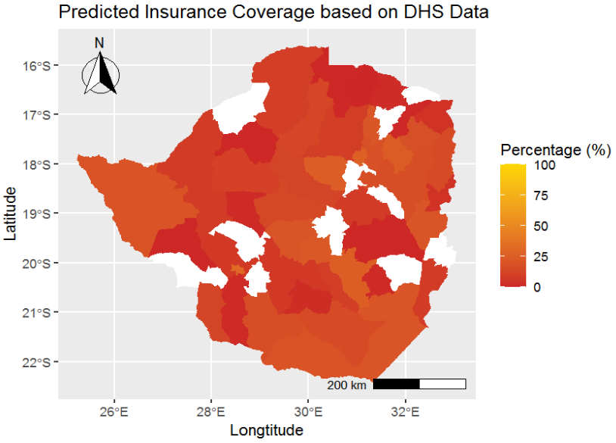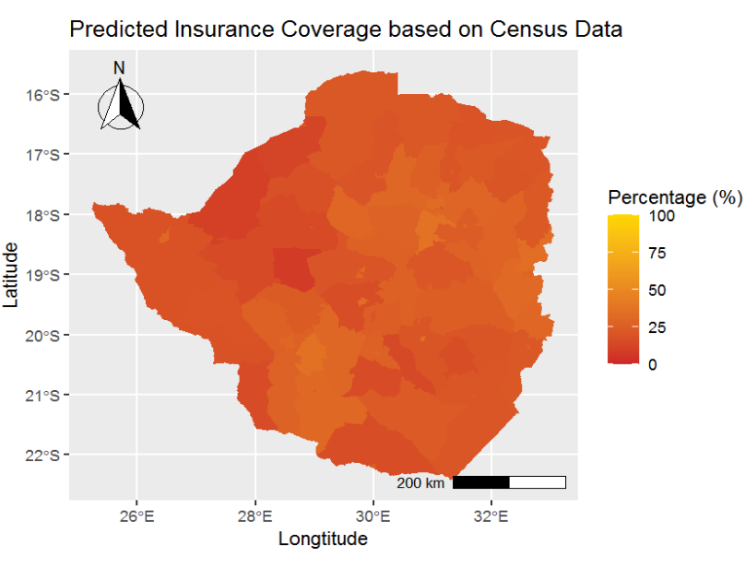
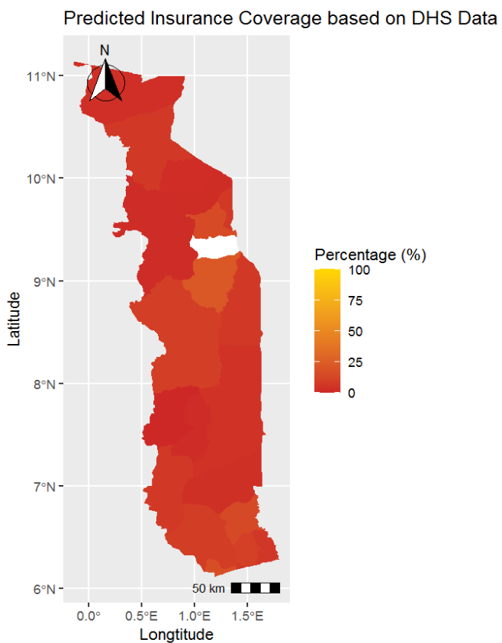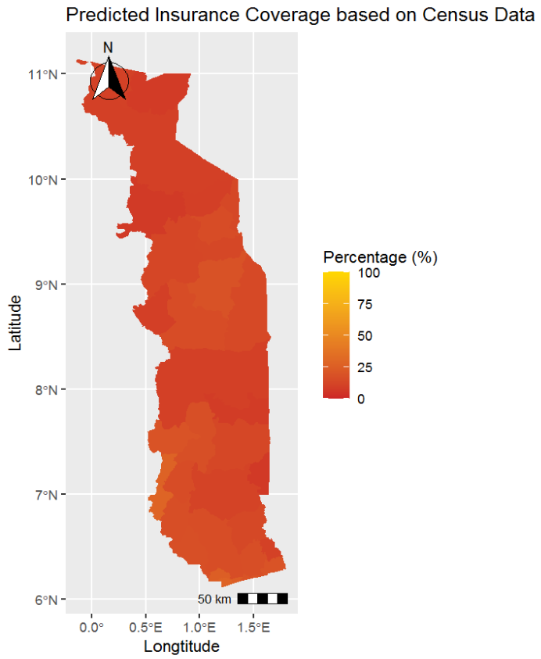
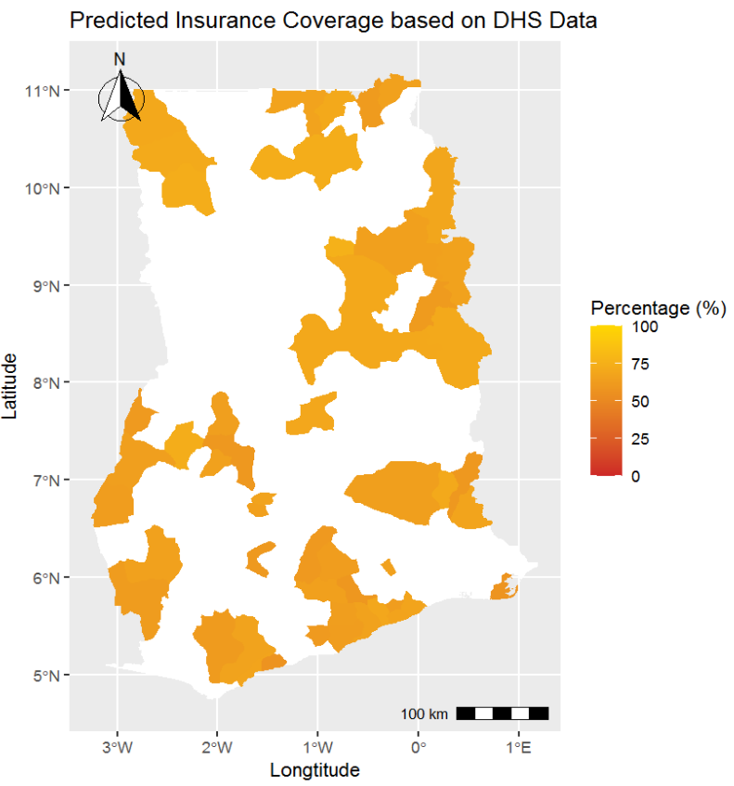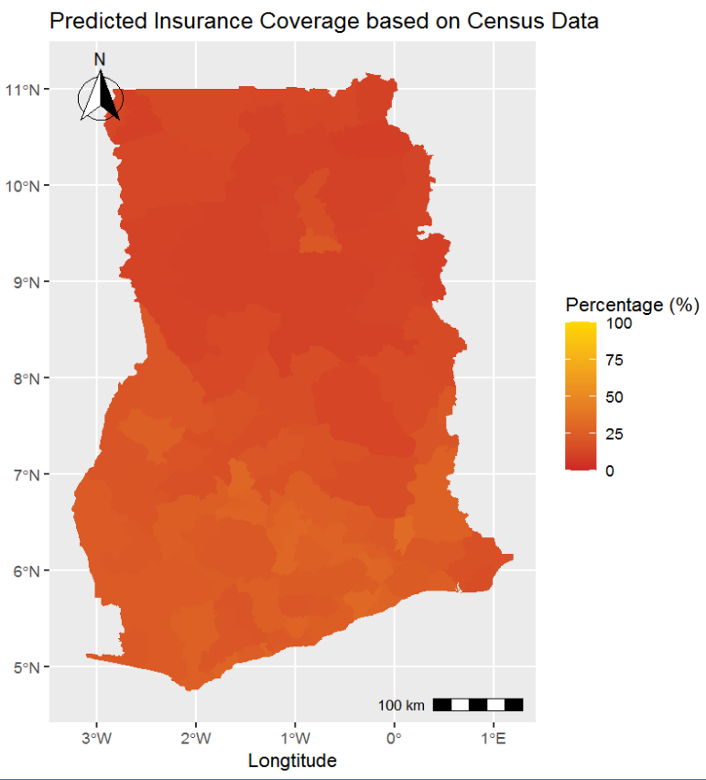
Note: The predictions are based on the preferred models for DHS and census data discussed in Section 4.1 for three exemplary countries. The left figures maps health insurance coverage at district level based on DHS data for Zimbabwe, Togo, and Ghana. Missing data for districts or districts with less than ten observations were left empty. The right figures predict out-of-sample based on census data.

We found data for country averages for health insurance coverage in administrative reports. Figure A.6. in the Appendix shows that the out-of-sample prediction for health insurance coverage for the six countries that were not covered in DHS shows a similar predicted level of coverage to the rates found in the reports (Baloul & Dahlui, 2014; Basaza, 2017; Goudge et al., 2018; Nundoochan et al., 2019; Mbogo & McGill, 2016; Samauma Consulting, 2021). This indicates that the model works well even for countries where we had no initial information about the outcome. However, there are also two predictions that differ more than 10 p.p. – Botswana and South Africa. For Botswana, we expect from the literature a coverage rate of 17%; however, our model predicts a rate of 38% (Mbogo & McGill, 2016). For South Africa, we expect from the literature a coverage rate of 16%; however, our model only predicts a rate of 36% (Goudge et al., 2018). Thus, the out-of-sample prediction for relatively high values is not reliable because the model has too little information to learn from; – Rwanda with around 85%, Ghana with around 60%, Burundi with around 23%, and Namibia with around 17%, were the only high coverage countries for the learning model (see Figure A.2. in the Appendix). This result also highlights that country-specific implementation, attitudes, and culture also play a crucial role in the level of coverage. As Chemouni (2018) concludes, the high coverage rate in Rwanda was only possible thanks to the political power of the ruling coalition. Unfortunately, our model cannot account for this factor without testing and training data. As a result, the out-of-sample predictions for Botswana and South Africa are less reliable than the prediction for the other countries.

Table 4: Country averages of out-of-sample predictions
 | Predicted health insurance coverage rate (%) | Predicted usage: visited health facility (%) | Predicted usage: birth at health facility (%) | Predicted usage: postnatal check (%)
Sudan | 12 | 16 | 52 | 40
South Africa | 36 | 40 | 56 | 43
Mozambique | 12 | 60 | 60 | 35
Mauritius | 10 | 60 | 61 | 38
South Sudan | 8 | 50 | 66 | 45
Botswana | 38 | 55 | 98 | 44
Note: The best machine learning (ML) model with a restricted set of covariates (Table A.1. in the Appendix) was used for the out-of-sample prediction with the census data.
For the three basic health service outcomes, we found no survey data or administrative reports for the six countries that were not covered in DHS. Thus, the out-of-sample prediction cannot be compared. However, based on the findings presented in Figure A.1. in the Appendix, we assume that the overall reliability will be higher for the two outcomes the last-born child was born in a health facility and visited a health facility at least once within the last year. The predictions for the outcome last-born child had postnatal checks within two weeks after birth is assumed to be lower in reliability (Cohen’s Kappa low) and, therefore, should be interpreted with caution.
Nevertheless, the out-of-sample predictions give a first indication where no other information is available. Figure A.7 in the Appendix maps the district averages for four exemplary countries in detail (Sudan, Congo, South Africa, and South Sudan).

Mapping of predictions
In a last step, in Figure 4, we map all the results based on the best model constructed by DHS data for the 33 SSA countries where we have DHS data (see Sections 4.2. and 4.3) and based on the best model constructed by the census data for the six countries where we do not have DHS data (see Section 4.4). The estimates are on an individual level and aggregated to the district level to highlight spatial distributions of health insurance coverage and the usage of the three health services in the 39 SSA countries. Results on the sub-national level are important because they play a crucial role in the organization and management of health care provision.
Figure 4: Map of prediction of health insurance coverage and health service usage
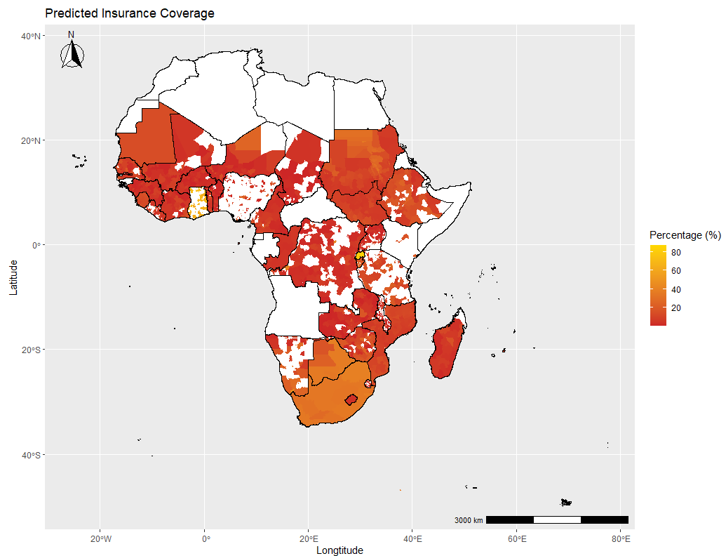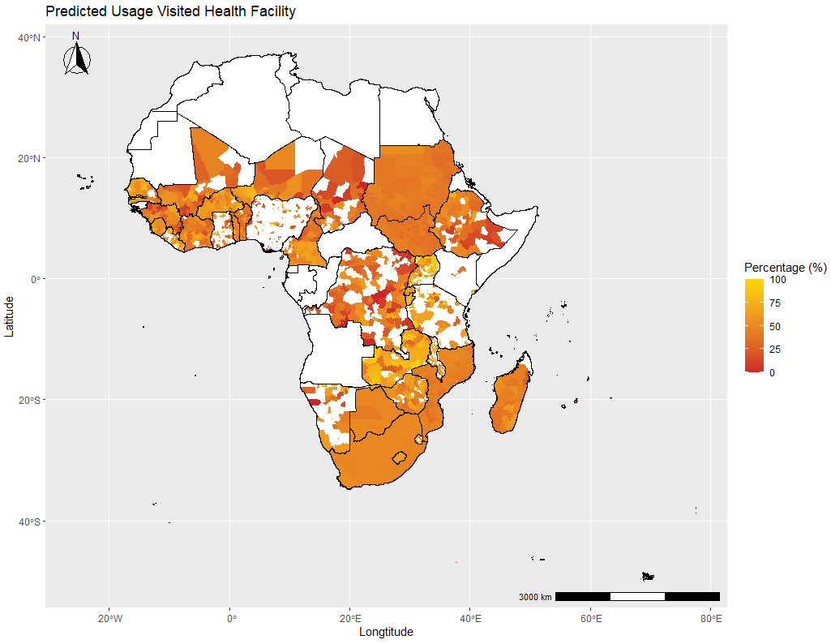
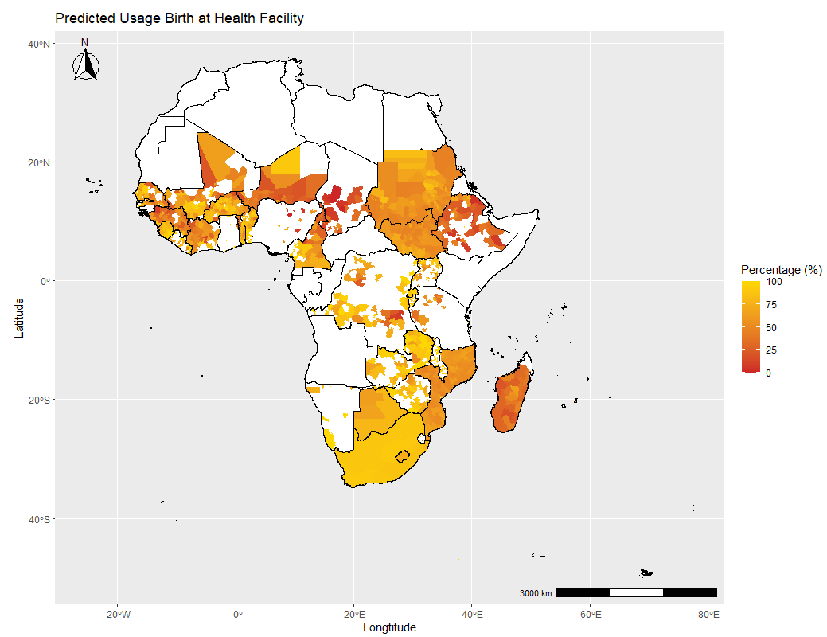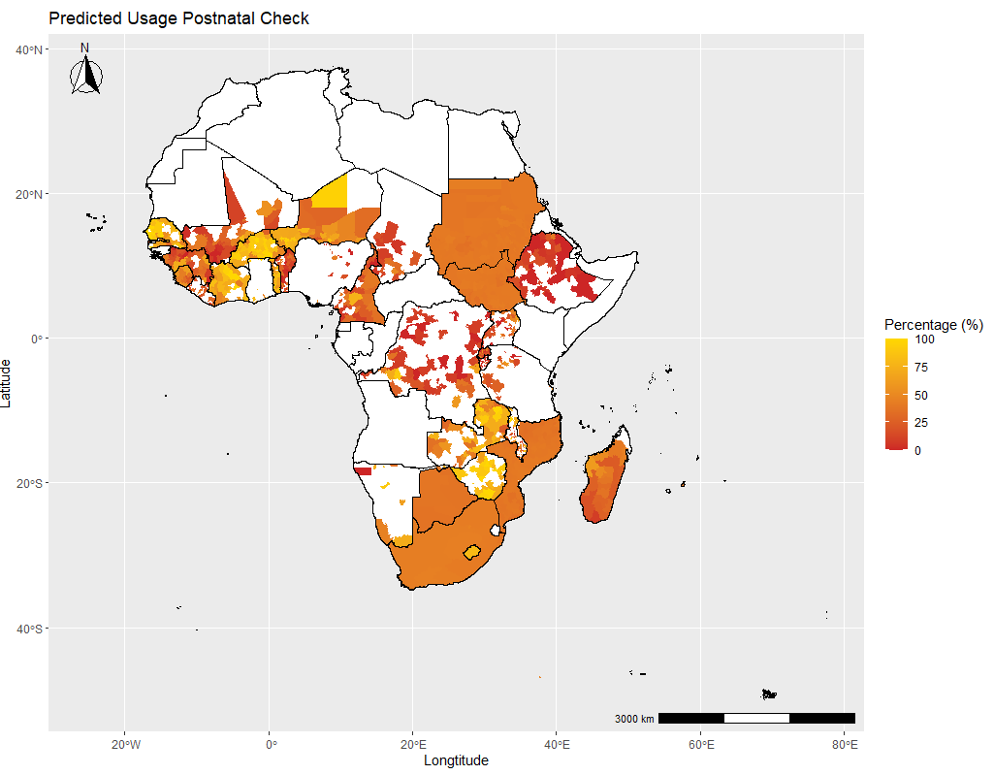
Note: Predictions are based on preferred models discussed in Section 4.1. The upper left figure estimates health insurance coverage based on a neural network model; the upper right figure if a person visited a health facility within the last year based on a neural network model; the lower left figure if the birth was given at health facilities based on a neural network model; and the lower right figure if went for a postnatal check based on a xgboost model. All estimates are done on the individual level and aggregated at the district level. Exceptions are the countries Congo, Mauritania, Sao Tome and Principe, Botswana, Lesotho, and Comoros which were aggregated on a regional level due to missing district information. Districts with less than ten observations for the predictions are left empty (the full map can be found in Appendix Figure A.8. The scale is adjusted for each outcome.

We detect that the three countries with a particularly high within-country variance for the outcomes are Kenya, South Africa, and Nigeria, whereas in Congo, Sierra Leone, and Madagascar we find the lowest within-country variation. Figure A.9 shows the zoomed-in country map of two countries with large within-country variance, Kenya and Nigeria. In both cases, we find that especially the highly populated regions, often the regions of the capital city, have the higher health insurance coverage rates. This result emphasizes that rural regions still face barriers to being financially protected by a health insurance scheme. On the contrary, the district distribution of the three health service outcomes reveal that even though financial protection by a health insurance scheme is different in more rural areas; in some districts, usage of a health services is still high. The examples of Kenya and Nigeria show that the rate was even higher in some rural areas than in more urbanized ones.

Conclusion
This study addresses a crucial challenge in achieving UHC: how can the included and excluded population of (i) health insurance coverage and (ii) basic health service usage be better identified? Based on data from 39 SSA countries, where access to financial protection and basic health care is still the most limited, in this study, we are the first to provide insights on improving predictions using machine learning techniques. In addition, we enable better targeting of the outcomes by providing a better understanding of important factors for the predictions and maps on lower administrative levels (districts), highlighting within-country variations.
Overall, the comparison among the 39 SSA countries shows a great variation in health insurance coverage rates among countries, rarely exceeding the SSA average of 7%, with some exceptions, such as Rwanda with 83%, Ghana with 66%, and Burundi with 23%. The percentage of people using health services, such as visiting a health facility, giving birth in a health facility, and having a postnatal check-up, also shows a relatively low rate (51%, 70%, and 44%, respectively). Our results emphasize that SSA is still very far from UHC, and there is a great need to improve coverage and usage.
Our empirical analysis shows that machine learning techniques instead of the classical logistical regression approach can improve the accuracy of predicting our outcomes. Our models, with over 490,000 observations from 33 SSA countries and 28 covariates, highlight that overall accuracy and sensitivity (correctly predicted positive cases) can be substantially increased, improving our understanding of who and where the most vulnerable population groups are. For example, increases sensitivity for the prediction of health insurance coverage from 0% to 22%, for visiting a health insurance from 32% to 69%, for giving birth in a health facility from 78% to 92%, and for having a postnatal check from 1% to 27%. These results contribute to the growing literature using ML techniques with the aim of better targeting policies (e.g., Blair et al, 2017; Sansone and Zhu, 2021; Brahma et al., 2021; Müller et al., 2019).
Compared to other models currently used, the model performance of all our ML models has a higher level of accuracy (Blair et al., 2017; Beger et al., 2016; Chiba & Gleditsch, 2017). For example, the model to predict local violence in Liberia never exceeded an accuracy of around 79%, whereas in this study we have up to around 89% (Blair et al., 2017). The authors argue that some outcomes might be more difficult to predict than others due to the complexity of behavior or due to the data structure (e.g., variation in the variables, panel structure, number of observations, etc.). Indeed, we also see for our model for health insurance coverage, which consists of an imbalanced dataset of 7% covered and 93% non-covered population, that a high accuracy of 93% can also be achieved just by predicting all observations as non-covered. Thus, in an imbalanced dataset, only optimizing accuracy would not lead to a model where we gain insights about who is the excluded population and understand if vulnerable groups are covered. Our results contribute to this challenge and show that our ML models do not fail to make predictions even in a highly imbalanced sample, such as in the health insurance coverage case.
The substantial improvement from the ML models compared to the classical model remains even if the set of covariates is restricted, as is the case if we make out-of-sample predictions with census data, which contains several million observations covering all districts in the country but fewer covariates. Nevertheless, the overall model performance is lower than with more covariates, which is expected since the models have less information to learn from.
We can show when applying the ML techniques that the performances of the algorithms are very similar among the five algorithms used for the ML models (logit, LASSO, random forest, neural networks, xgboost). Our results suggest that due to the limited scope of covariates in the model, very complex algorithms might not show their full potential but still outperform the classical approach. In other studies, such as Sansone and Zhu (2021) who used approximately 1,800 possible predictors in their model, the predictive power could be even more improved. The results emphasize that the models need to be optimally calibrated for each sample and outcome and cannot be generally applied.
The out-of-sample predictions with census data of the 33 countries with underlining DHS data and the six countries, where DHS survey data were not available, enable us to gain insights into new countries and on a lower administrative level for the whole population. Overall, based on our models, the out-of-sample predictions seem to work reliably even for countries where we had no initial information about the outcome if the sample for the model training contains enough data of similar cases. For example, the predictions for health insurance coverage for Botswana and South Africa, two countries with rather high rates in the sample, were inaccurate. Therefore, predictions for extraordinary cases should be interpreted with caution and might be limited. Another limitation is that if the year of census data is several years from the underlying DHS survey year, the predictions are also assumed to be inaccurate due to potential unobserved factors and trends that influence the outcomes. Nevertheless, the algorithms still manage to outperform the classical model. As recommended by the study of Sansone and Zhu (2021) about welfare programs in Australia, it could be beneficial for researchers and policymakers to “obtain more precise predictions – at no extra costs – by exploiting the available datasets”. This conclusion emphasizes that ML techniques can complement current targeting processes to improve the overall targeting of excluded populations.
Our findings from the most and least important variable to predict our outcomes shows that SSA countries still predominantly protect better-off population groups, leaving out the vulnerable. In line with the existing literature, country-specific factors, education, wealth indicators, and location of residence play the most important role in predicting health insurance coverage (e.g., Osei Afriyie et al, 2022; Salari et al., 2019; Amu et al. 2018). In line with the literature, health insurance coverage is not an important variable for predicting health service usage outcomes. We find that the outcome of visiting a health facility at least once within the last year is mainly predicted by factors of family planning. If the last-born child was born in a health facility is mainly predicted by educational and economic factors as well as the location. And if the last-born child had postnatal checks within two weeks after birth is mainly predicted by health insurance enrollment status.
However, since the accuracy of the predictions is not 100% and accuracy levels vary substantially among the countries, this indicates that underlying variables for health insurance enrollment and usage of health services (e.g., Mensah et al., 2010; Hanson et al., 2017; Wang et al., 2017; Brugiavini and Pace, 2016; Dalinjong et al., 2017; Browne et al., 2016) or county-specific factors still play a crucial role. Due to data limitations, we cannot disentangle these effects. Nevertheless, the results highlight that financial and non-financial barriers still exist, excluding the most vulnerable population groups (e.g., Tessema et al., 2020). In addition, the large country differences emphasize that further studies from in-depth country analyses are needed.
Lastly, the detailed maps of the 39 SSA countries reveal large within-country variations in several countries, such as Kenya and Nigeria. In almost all country maps, we see that health insurance coverage are particularly higher in highly populated areas and the region of the capital city, whereas health service usage seems to be less correlated with populated areas.
This study has three main limitations. First, due to data availability, our study can only give insights of three essential health services. Therefore, the results cannot be generalized to all essential health services. Nevertheless, since outcomes such as overall access and maternal and child health services are crucial in SSA countries, our results bring important insights into the functioning of needed health services. Second, as the literature about determinants of health insurance enrolment and health services concludes, play besides socio-economic, economic, and household characteristics also other demand- and supply-side factors an important role (e.g., Owoo and Lambon-Quayefio, 2013; Brugiavini and Pace, 2016). Therefore, we cannot exclude the possibility that adding additional variables into our model would lead to another ranking of the most and least important variables. However, due to data limitations this is not possible to test. Still, based on meta-studies, the included covariates seem to account for the most important variables (e.g., Osei Afriyie et al., 2022). Additionally, as we highlighted in the analysis, more in-depth country analyses might be needed to fully understand the driving factors. Third, our best-performing models outperform the classical model but still do not 100% accurately predict our four outcomes. Thus, our results should be applied with caution to out-of-sample data, especially for extraordinary cases. We recommend, as for all targeting approaches, to reevaluate for each outcome and country to assess first the feasibility of a potential application before applying.

References
Adebayo, E.F., Uthman, O.A., Wiysonge, C.S., Stern, E.A., Lamont, K.T., Ataguba, J.E. (2015). A systematic review of factors that affect uptake of community based health insurance in low-income and middle-income countries. BMC health services research, 15(1):543-543. https://doi.org/10.1186/s12913-015-1179-3
Akazili, J.,Welaga, P., Bawah, A., Achana, F., Oduro, A., Awoonor-Williams, J., Williams, J., Aikins, M., Phillips, J. (2014). Is Ghana’s pro-poor health insurance scheme really for the poor? Evidence from Northern Ghana. BMC Health Services Research, 14(63): 637. https://doi.org/10.1186/1472-6963-14-63
Alpaydin, E. (2010). Introduction to machine learning, Cambridge: The MIT Press.
Amu, H., Dickson, K.S., Kumi-Kyereme, A., Darteh, E.K.M. (2018). Understanding variations in health insurance coverage in Ghana, Kenya, Nigeria, and Tanzania: Evidence from demographic and health surveys. PLoS ONE, 13(8): e0201833. https://doi.org/10.1371/journal.pone.0201833
Ansu-Mensah, M., Danquah, F.I., Bawontuo, V. et al. (2021). Quality of care in the free maternal healthcare era in sub-Saharan Africa: a scoping review of providers’ and managers’ perceptions. BMC Pregnancy Childbirth, 21(220). https://doi.org/10.1186/s12884-021-03701-z
Baloul, I., Dahlui, M. (2014). Determinants of health insurance enrolment in Sudan: evidence from Health Utilisation and Expenditure Household Survey 2009. BMC Health Serv Res, 14(O17). https://doi.org/10.1186/1472-6963-14-S2-O17
Basaza, R., Alier, P.K., Kirabira, P., Ogubi, D., Lako, R.L.L. (2017). Willingness to pay for National Health Insurance Fund among public servants in Juba City, South Sudan: a contingent evaluation. International Journal for Equity in Health, 16:158. https://doi.org/10.1186/s12939-017-0650-7
Bazzi, S., Blair, R.A., Blattmann, C., Dube, D., Gudgeon, M., Pack, R., (2022). The Promise and Pitfalls of Conflict Prediction: Evidence from Colombia and Indonesia. The Review of Economics and Statistics, 104(4): 764-779. https://doi.org/10.1162/rest_a_01016
Beger, A., Dorff, C.L., Ward, M.D. (2016). Irregular Leadership Changes in 2014: Forecasts using ensemble, split-population duration models. International Journal of Forecasting, 31(1): 98-111. https://doi.org/10.1016/j.ijforecast.2015.01.009
Blair, R.A., Blattmann, C., Hartmann, A. (2017). Predicting local violence: evidence from a panel survey in Liberia. Journal of Peace Research, 54(2): 298-312. https://doi.org/10.1177/002234331668400
Blondel, P. (2017). Which machine learning algorithm to choose for my problem. Retrieved from: https://recast.ai/blog/machine-learning-algorithms/2/. Accessed on March 31. 2021.
Boateng, D., Awunyor-Vitor, D. (2013). Health insurance in Ghana: evaluation of policy holders perceptions and factors influencing policy renewal in the Volta region. Journal for Equity in Health, 12:50. https://doi.org/10.1186/1475-9276-12-50
Boerma, T., Eozenou, P., Evans, D., Evans, T., Kieny, M.P., Wagstaff, A. (2014). Monitoring Progress towards Universal Health Coverage at Country and Global Levels. PLoS Med, 11 (9): e1001731. https://doi.org/10.1371/journal.pmed.1001731
Borovicka, T., Jirina, M.J., Kordik, P., Jirina, M. (2012). Selecting Representative Data Sets, Intech. In: Advances in Data Mining Knowledge Discovery and Applications. https://doi.org/10.5772/50787
Brahma, D., Mukherjee, D. (2021). Early warning signs: targeting neonatal and infant mortality using machine learning. Applied Economics, 54(1): 57-74. https://doi.org/10.1080/00036846.2021.1958141
Browne, J.L., Kayode, G.A., Arhinful, D., Fidder, S.A.J, Grobbee, D.E., Klipstein-Grobusch, K. (2016). Health insurance determines antenatal, delivery and postnatal care utilization: evidence from the Ghana Demographic and Health Surveillance data. BMJ Open, 6:e008175. https://doi.org/10.1136/bmjopen-2015-008175
Brownlee, J. (2021). A gentle introduction to XGBoost for applied machine learning. Retrieved from: https://machinelearningmastery.com/gentle-introduction-xgboost-applied-machine-learning/. Accessed on March 31. 2021.
Brugiavini, A., Pace, N. (2016). Extending health insurance in Ghana: effects of the National Health Insurance Scheme on maternity care. Health Economics Review, 6(1): 7.. https://doi.org/10.1186/s13561-016-0083-9
Coates, M.M., Ezzati, M., Robles Aguilar, G., Kwan, G.F., Vigo, D., Mocumbi, A.O., et al. (2021). Burden of disease among the world’s poorest billion people: An expert-informed secondary analysis of Global Burden of Disease estimates. PLoS ONE, 16(8): e0253073. https://doi.org/10.1371/journal.pone.0253073
Chandler, B.D., Levitt, S.D., List, J.A. (2011). Predicting and Preventing Shootings among At-Risk Youth. American Economic Review, 101(3): 288–29. https://doi.org/10.1257/aer.101.3.288
Chemouni, B. (2018). The political path to universal health coverage: Power, ideas and community based health insurance in Rwanda. World Development, 106: 87-98. https://doi.org/10.1016/j.worlddev.2018.01.023
Chiba, D., Gleditsch, K.S. (2017). The shape of things to come? Expanding the inequality and grievance model for civil war forecasts with event data. Journal of Peace Research, 54(2) 275–297. https://doi.org/10.1177/0022343316684192
Cuccaro-Alamin, S., Foust, R., Vaithianathan, R., Putnam-Hornstein, E. (2017). Risk assessment and decision making in child protective services: Predictive risk modeling in context. Child. Youth Serv. Rev., 79: 291–298. http://dx.doi.org/10.1016/j.childyouth.2017.06.027
Evans, D.B., Marten, R., Etienne, C. (2012). Universal health coverage is a development issue. The Lancet, 380(9845): 864-865. https://doi.org/10.1016/S0140-6736(12)61483-4
Dalinjong, P.A., Welaga, P., Akazili, J., Kwarteng, A., Bangha, M., Oduro, A., Sankoh, O. & Goudge J. (2017). The association between health insurance status and utilization of health services in rural Northern Ghana: evidence from the introduction of the National Health Insurance Scheme. Journal of Health, Population and Nutrition, 36:42. https://doi.org/10.1186/s41043-017-0128-7
DHS (2022). Statcompiler the DHS program. Retrieved from: https://www.statcompiler.com/en/. Accessed on March 31. 2021.
DHS (2021). The Demographic and Health Surveys (DHS) Program. Retrieved from: https://dhsprogram.com. Accessed on March 31. 2021.
Dixon, J., Luginaah, I., Mkandawire, P. (2014). The National Health Insurance Scheme in Ghana’s Upper West Region: A gendered perspective of insurance acquisition in a resource-poor setting. Social Science & Medicine, 122: 103-112. https://doi.org/10.1016/j.socscimed.2014.10.028
Dobbin, K.K., Simon, R.M. (2011). Optimally splitting cases for training and testing high dimensional classifiers. BMC Medical Genomics, 4(3): 31. https://doi.org/10.1186/1755-8794-4-3
Du, K.L., Swamy, M.N.S. (2014). Neural Networks and Statistical Learning. Berlin: Springer.
Duku, A.K.O. (2018). Differences in the determinants of health insurance enrolment among working-age adults in two regions in Ghana. BMC Health Services Research, 18:384. https://doi.org/10.1186/s12913-018-3192-9
Engstrom, R., Hersh, J., Newhouse, D.L. (2017). Poverty from Space: Using High-Resolution Satellite Imagery for Estimating Economic Well-Being. World Bank Policy Research Working Paper, No. 8284.
Erlangga D, Suhrcke M, Ali S, Bloor K. (2019). The impact of public health insurance on health care utilisation, financial protection and health status in low- and middle-income countries: A systematic review. PLoS One, 14(8): e0219731. https://doi.org/10.1371/journal.pone.0219731.
Garrett, L., Chowdhury, A.M., Pablos-Mendez, A. (2009). All for universal health coverage. The Lancet, 374: 1294-1299. https://doi.org/10.1016/S0140-6736(09)61503-8
Gitobu, C.M., Gichangi, P.B., Mwanda, W.O. (2018). The effect of Kenya’s free maternal health care policy on the utilization of health facility delivery services and maternal and neonatal mortality in public health facilities. BMC Pregnancy Childbirth 18(77). https://doi.org/10.1186/s12884-018-1708-2
Glaeser, E.L., Kominers, S.D., Luca, M., Naik, N. (2018) Big data and big cities: The promises and limitations of improved measures of urban life. Econ. Inq., 56(1): 114–137. https://doi.org/10.3386/w21778
Gottret, P.E., Schieber, G.. (2006). Health financing revisited: a practitioner’s guide. Washington: World Bank Publications.
Goudge, J, Alaba, O.A, Govender, V., Harrias, B., Nxumalo, N., Cherich, M.F. (2018). Social health insurance contributes to universal coverage in South Africa, but generates inequities: survey among members of a government employee insurance scheme. International Journal for Equity in Health, 17(1). https://doi.org/10.1186/s12939-017-0710-z
Hanson, C., Gabrysch, S., Mbaruku, G., Cox, J., Mkumbo, E., Manzi, F.,Schellenberg, J., Ronsmans C. (2017). Access to maternal health services: geographical inequalities, United Republic of Tanzania. Bull World Health Organ, 95(12): 810–820. http://dx.doi.org/10.2471/BLT.17.194126
Hastie, T., Tibshirani, R., Friedman, J. (2008). The Elements of Statistical Learning: Data Mining, Inference, and Prediction. Berlin: Springer, Series in Statistics, 2008.
Ipums (2021). IPUMS. Retrieved from: https://ipums.org/. Accessed on March 31. 2021.
James, G., Hastie, T., Witten, D., Tibshirani, R. (2013). An introduction to Statistical Learning with Application in R. Berlin: Springer, 2013 https://doi.org/10.1007/978-1-4614-7138-7
Jehu-Appiah, C., Aryeetey, G., Spaan, E., de Hoop, T., Agyepong, I., Baltussen, R. (2011). Equity aspects of the National Health Insurance Scheme in Ghana: Who is enrolling, who is not and why? Social Science & Medicine, 72(2): 157-165. https://doi.org/10.1016/j.socscimed.2010.10.025
Josephson, E., Rajkotia, Y., Banzon, E., Andoh, A., Francis, X. (2014). National Health Insurance Design in Liberia: Key Considerations for Equitable, Efficient, and Sustainable Health Care Access. Retrieved from https://thinkwell.global/wp-content/uploads/2014/12/National-Health-Insurance-Design-in-Liberia-ThinkWell.pdf. Accessed on March 31. 2021.
Kang, J.S., Kuznetsova, P., Luca, M., Choi, Y. (2013). Where Not to Eat? Improving Public Policy by Predicting Hygiene Inspections Using Online Reviews. Proc. 2013 Conf. Empir. Methods Nat. Lang. Process. (Association for Computational Linguistics, Seattle, Washington, USA), 1443--1448.
Kimani, J.K., Ettarh, R., Warren, C., Bellows, B. (2014). Determinants of health insurance ownership among women in Kenya: evidence from the 2008-09 Kenya demographic and health survey. International Journal for Equity in Health, 13:27. http://www.equityhealthj.com/content/13/1/27
Kirigia, J.M., Sambo, L.G., Nganda, B. et al. (2005). Determinants of health insurance ownership among South African women. BMC Health Serv Res 5, 17. https://doi.org/10.1186/1472-6963-5-17
Kumi-Kyereme, A., Amo-Adjei, J. (2013). Effects of spatial location and household wealth on health insurance subscription among women in Ghana. BMC Health Services Research, 13:221. https://doi.org/10.1186/1472-6963-13-221
Kusi, A., Fenny, A.P., Arhinful, D.K., Asante, F.A., Parmar, D. (2018). Determinants of enrolment in the NHIS for women in Ghana. International Journal of Social Economics, 45(9): 1318-1334. https://doi.org/10.1108/IJSE-10-2016-0291
Lagomarsino, G., Garabrant, A., Adyas, A., Muga, R., Otoo, N. (2012). Moving towards universal health coverage: health insurance reforms in nine developing countries in Africa and Asia. The Lancet, 380(9845): 933-943. https://doi.org/10.1016/S0140-6736(12)61147-7
Macha, J., Kuwawenaruwa, A., Makawia, S., Mtei, G., Borghi, J. (2014). Determinants of community health fund membership in Tanzania: A mixed methods analysis. BMC health Service Research, 14:538. https://doi.org/10.1186/s12913-014-0538-9
Markham, K. (2015). Comparing supervised learning algorithms. Retrieved from: https://www.dataschool.io/comparing-supervised-learning-algorithms/. Accessed on March 31. 2021.
Mbogo, B.A & McGill, D. (2016). Perspectives on financing population-based health care towards Universal Health Coverage among employed individuals in Ghanzi district, Botswana: A qualitative study. BMC Health Service Research: 413. https://doi.org/10.1186/s12913-016-1657-2
McIntyre D. (2007). Learning from experience: Health care financing in low-and middle-income countries. Geneva: Global forum for health research.
Mensah, J., Oppong, J.R., Schmidt, C.M. (2010). Ghana's National Health Insurance Scheme in the context of the health MDGs: an empirical evaluation using propensity score matching. Health Econ, 19: 95–106. https://doi.org/10.1002/hec.1633
Mills A, Ataguba JE, Akazili J, Borghi J, Garshong B, Makawia S, et al. (2012). Equity in financing and use of health care in Ghana, South Africa, and Tanzania: implications for paths to universal coverage. Lancet, 380(9837): 126–33. https://doi.org /10.1016/S0140-6736(12)60357-2
Msuya, J.M, Jütting, J.P., Asfaw, A. (2007). Impact of Community Health Funds on the Access to Health Care: Empirical Evidence from Rural Tanzania. International Journal of Public Administration, 30(8-9): 813-833. https://doi.org/10.1080/01900690701227263
Morgan, J. (2014). Classification and Regression Tree Analysis. Boston University School of Public Health, Technical Report No. 1, 2014. Retrieved from: https://www.bu.edu/sph/files/2014/05/MorganCART.pdf. Accessed on March 31. 2021.
Mosonsieyiri Kansanga, M., Braimah, J.J., Antabe, R., Sano, Y., Kyeremeh, E., Luginaah, I. (2018). Examining the association between exposure to mass media and health insurance enrolment in Ghana. The International Journal of Health Planning and Management, 33(2): e531-e540. https://doi.org/10.1002/hpm.2505
Muchlinski, D., Siroky, D., He, J., Kocher, M. (2017). Comparing Random Forest with Logistic Regression for Predicting Class-Imbalanced Civil War Onset Data, Political Analysis. Cambridge: Cambridge University Press, 2017. https://doi.org/10.1093/pan/mpv024
Mueller, E., Sandoval, J.S.o., Mudigonda, S., Elliott, M. (2019). A Cluster-Based Machine Learning Ensemble Approach for Geospatial Data: Estimation of Health Insurance Status in Missouri. ISPRS Int. J. Geo-Inf., 8(1): 13. https://doi.org/10.3390/ijgi8010013
Mullainathan, S., Spiess, J. (2017). Machine Learning: An Applied Econometric Approach. J. Econ. Perspect., 31(2):87–106. http://dx.doi.org/10.1257/jep.31.2.87
Murphy, Kevin P. (2012). Machine Learning: A Probabilistic Perspective. Cambridge, MA: MIT Press, 2012.
Njuguna, J., Kamau, N., Muruka, C. (2017). Impact of free delivery policy on utilization of maternal health services in county referral hospitals in Kenya. BMC Health Serv Res, 17(429). https://doi.org/10.1186/s12913-017-2376-z
Nundoochan, A., Thorabally, Y., Monohur, S., Hsu, J. (2019). Impact of out of pocket payments on financial risk protection indicators in a setting with no user fees: the case of Mauritius. International Journal for Equity in Health, 18:63. https://doi.org/10.1186/s12939-019-0959-5
Osei Afriyie, D., Krasniq, B., Hooley, B. et al. (2022). Equity in health insurance schemes enrollment in low and middle-income countries: A systematic review and meta-analysis. Int J Equity Health, 21(21). https://doi.org/10.1186/s12939-021-01608-x
Owoo, N.S., Lambon-Quayefio, M.P. (2013). National health insurance, social influence and antenatal care use in Ghana. Health Economics Review, 3:19. https://doi.org/10.1186/2191-1991-3-19
Salari, P., Akweongo, P., Aikins, M., Tediosi, F. (2019). Determinants of health insurance enrollment in Ghana: Evidence from three national household surveys. Health Policy and Planning, 34(8): 582–594. https://doi.org/10.1093/heapol/czz079
Samauma Consulting (2021). Data Collection Survey on the Health System in Mozambique. Japan International Cooperation Agency. Retrieved from: https://openjicareport.jica.go.jp/pdf/1000045945.pdf. Accessed on January 14. 2023.
Sansone, D., & Zhu, A, (2021). Using Machine Learning to Create an Early Warning System for Welfare Recipients. IZA Discussion Papers 14377, Institute of Labor Economics (IZA).
Savage, D., Zhang, X., Wang, Q., Yu, X., Chou, P. (2017). Detection of Money Laundering Groups: Supervised Learning on Small Networks. The AAAI Workshop 2017. Retrieved from: http://aaai.org/ocs/index.php/WS/AAAIW17/paper/view/15101. Accessed on March 31. 2021.
Spaan, E., Mathijssen, J., Tromp, N., McBain, F., ten Have, A., Baltussen, R. (2012). The impact of health insurance in Africa and Asia: a systematic review. Bulletin of the World Health Organization, 90(9):685–92. https://doi.org/10.2471/BLT.12.102301
Tessema, Z.T., Yazachew, L., Tesema, G.A. et al. (2020). Determinants of postnatal care utilization in sub-Saharan Africa: a meta and multilevel analysis of data from 36 sub-Saharan countries. Ital J Pediatr, 46(175). https://doi.org/10.1186/s13052-020-00944-y
Tenkorang, E.Y. (2016), Health Provider Characteristics and Choice of Health Care Facility among Ghanaian Health Seekers. Health Systems & Reform, 2(2): 160-170. https://doi.org/10.1080/23288604.2016.1171282
United Nations (2013). A new global partnership: eradicate poverty and transform economies through sustainable development. Report of the High-level Panel of Eminent Persons on the Post-2015. Development Agenda. New York: United Nations, 2013.
Vaithianathan, R., Maloney, T., Putnam-Hornstein, E., Jiang, N. (2013). Children in the public benefit system at risk of maltreatment: Identification via predictive modeling. Am. J. Prev. Med., 45(3): 354–359. http://dx.doi.org/10.1016/j.amepre.2013.04.022
Venables, W.N., Ripley, B.D. (2002). Modern Applied Statistics with S: fourth edition. Berlin: Springer.
Vimont, A., Leleu, H., Durand-Zaleski, I. (2021). Machine learning versus regression modelling in predicting individual healthcare costs from a representative sample of the nationwide claims database in France. European Journal of Health Economics. https://doi.org/10.1007/s10198-021-01363-4
Wagstaff, A., Flores, G., Smitz, M., Hsu, J., Chepynoga, K., Eozenou, P. (2018). Progress on impoverishing health spending in 122 countries: a retrospective observational study. Lancet Glob Health, 6: e180–92. https://doi.org/10.1016/S2214-109X(17)30486-2
Wang, W., Temsah, G., Mallick, L. (2017). The impact of health insurance on maternal health care utilization: evidence from Ghana, Indonesia and Rwanda. Health Policy and Planning, 32(2): 366-75. https://doi.org/10.1093/heapol/czw135
World Bank (2021). World Bank Open Data. Retrieved from: https://data.worldbank.org/. Accessed on March 31. 2021.
WHO (2022). Skilled health professionals density (per 10 000 population). Retrieved from: https://www.who.int/data/gho/indicator-metadata-registry/imr-details/4667. Accessed on January 14. 2023.

Appendix

A Tables and Figures

Table A.1: Performance metrics for predicting health insurance coverage for SSA countries
 | Classical model | Logit | Lasso | Random Forest | Neural Networks | Xgboost
Health insurance coverage
Accuracy | 0.91 | 0.89 | 0.89 | 0.89 | 0.89 | 0.89
Cohen’s Kappa | 0.00 | 0.14 | 0.14 | 0.16 | 0.17 | 0.17
Sensitivity | 0.00 | 0.14 | 0.13 | 0.18 | 0.17 | 0.18
Specificity | 1.00 | 0.97 | 0.97 | 0.96 | 0.96 | 0.96
Visited health facility last year
Accuracy | 0.56 | 0.61 | 0.61 | 0.61 | 0.62 | 0.62
Cohen’s Kappa | 0.14 | 0.21 | 0.21 | 0.22 | 0.23 | 0.23
Sensitivity | 0.29 | 0.68 | 0.68 | 0.69 | 0.70 | 0.70
Specificity | 0.85 | 0.53 | 0.53 | 0.53 | 0.54 | 0.53
Child born in health facility
Accuracy | 0.71 | 0.74 | 0.74 | 0.73 | 0.74 | 0.74
Cohen’s Kappa | 0.33 | 0.25 | 0.25 | 0.24 | 0.25 | 0.25
Sensitivity | 0.77 | 0.92 | 0.92 | 0.91 | 0.92 | 0.92
Specificity | 0.58 | 0.30 | 0.30 | 0.30 | 0.29 | 0.29
Child had postnatal check
Accuracy | 0.60 | 0.59 | 0.60 | 0.59 | 0.60 | 0.60
Cohen’s Kappa | 0.00 | 0.01 | 0.00 | 0.03 | 0.03 | 0.02
Sensitivity | 0.00 | 0.03 | 0.01 | 0.11 | 0.05 | 0.04
Specificity | 1.00 | 0.98 | 0.99 | 0.92 | 0.97 | 0.98
Note: Model with restricted set of variables (16 covariates for insurance; 17 for the three other outcomes) for all 33 SSA countries in a pooled sample.

Figure A.1: Model performance of outcome predictions for all 33 countries separately

Figure A.2: Country averages of outcome predictions

Note: Country averages of predicted health insurance coverage rate are based on the best performing ML model (Table 3). The country's average insurance coverage rate is based on the underlying DHS data. In case of a 100% accurate prediction, the country averages would lie on the 45° line.

Figure A.3: Comparison prediction of visited health facility based on DHS and Census Data
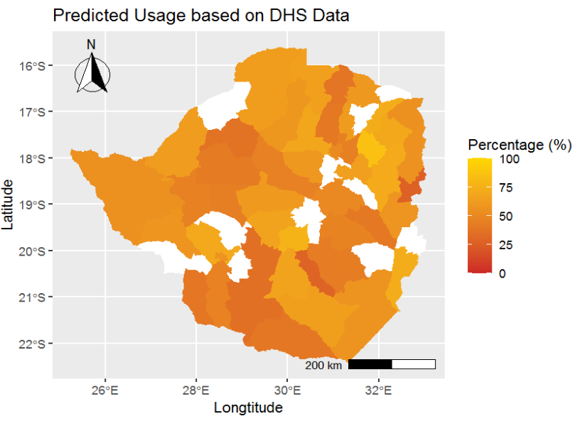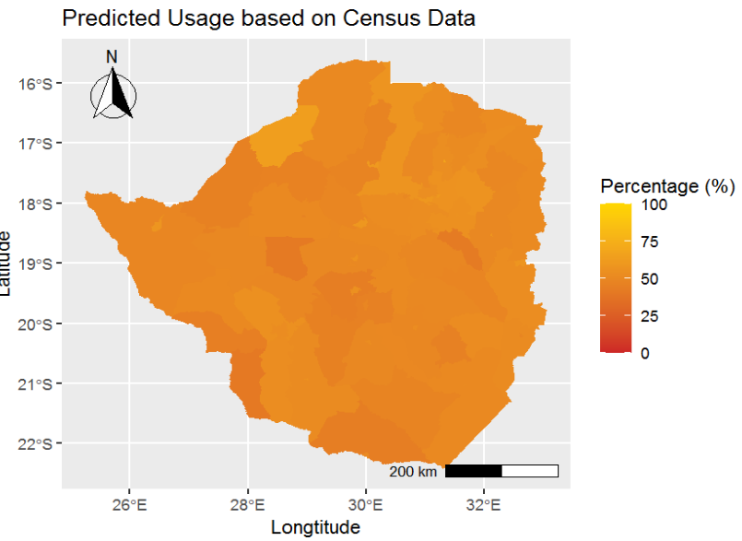
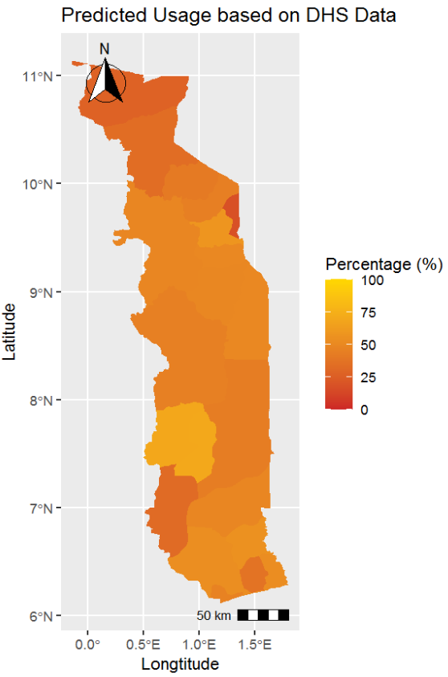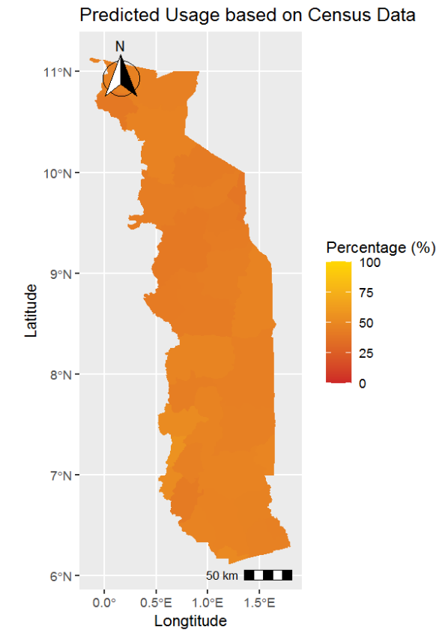
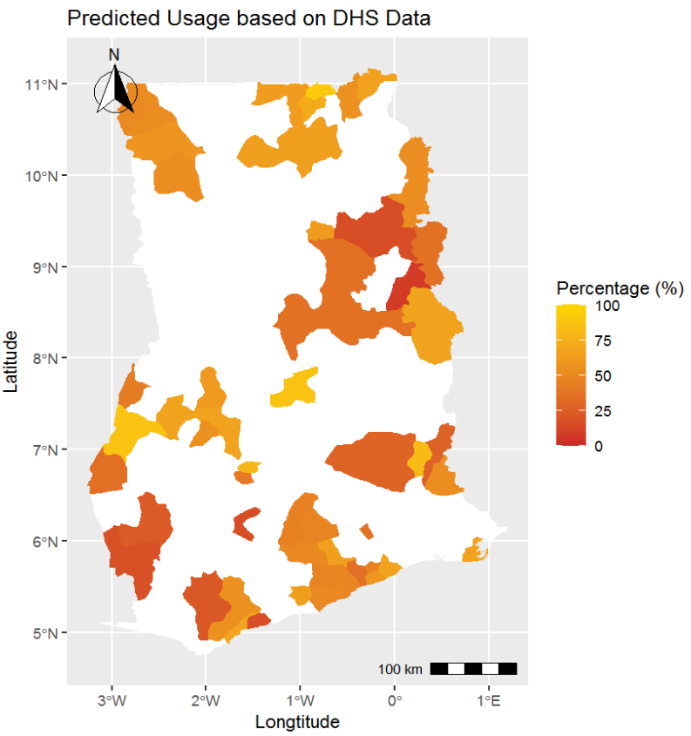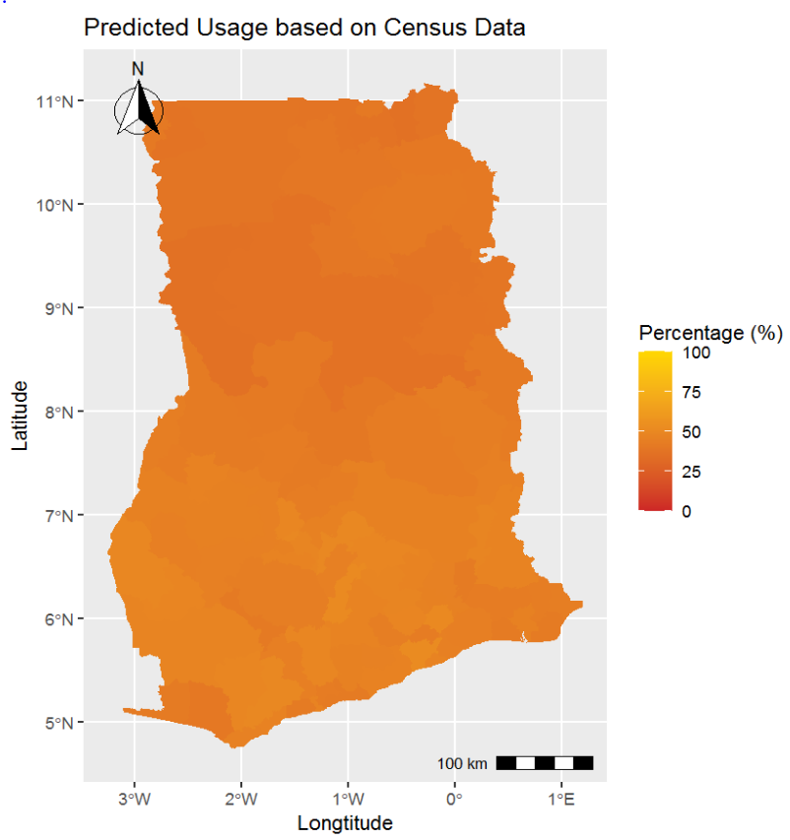

Note: The predictions are based on the preferred models for DHS and census data discussed in Section 4.1 for three exemplary countries. The left figures maps usage of visited health facilities at least once a year at district level based on DHS data for Zimbabwe, Togo, and Ghana. Missing data for districts or districts with less than ten observations were left empty. The right figures predict out-of-sample based on census data.

Figure A.4: Comparison prediction of child born in health facility based on DHS and Census Data
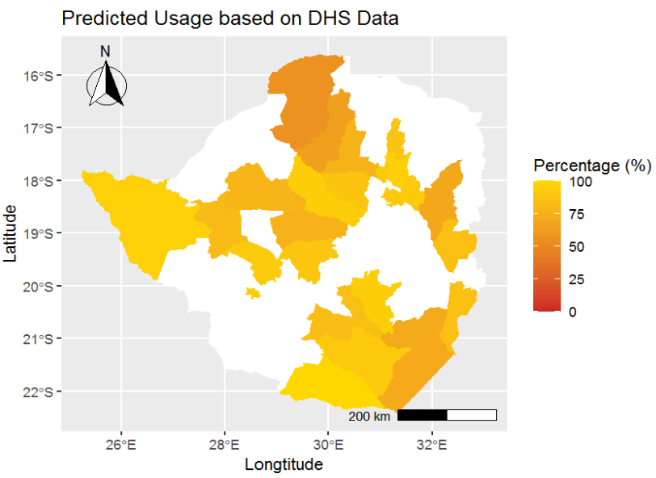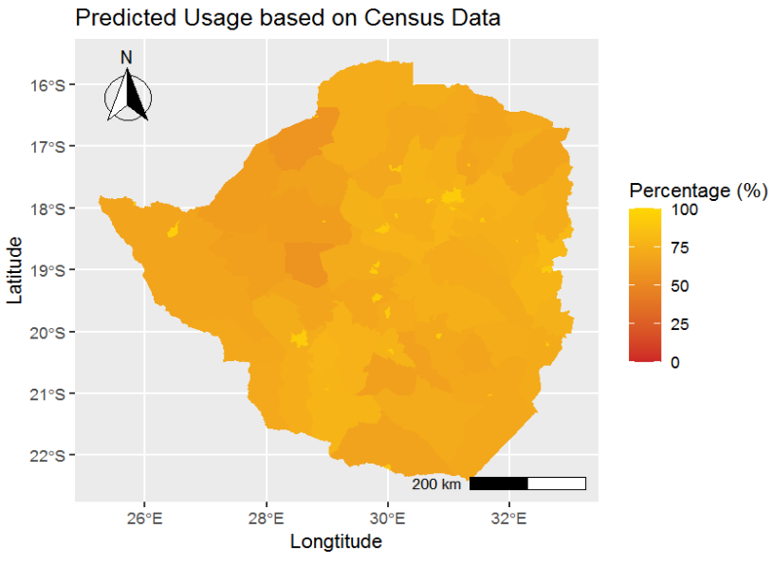
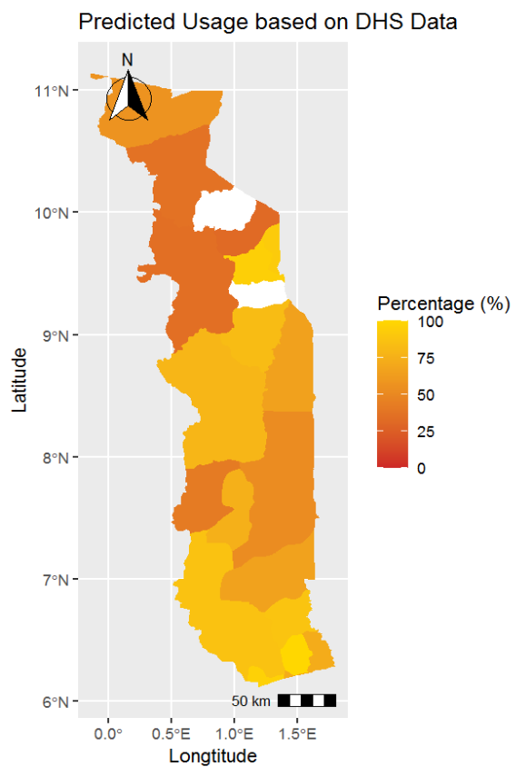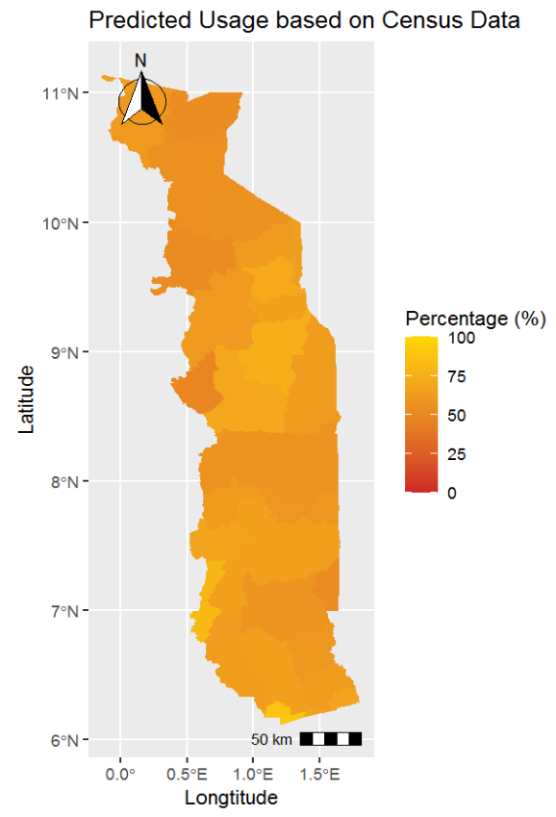
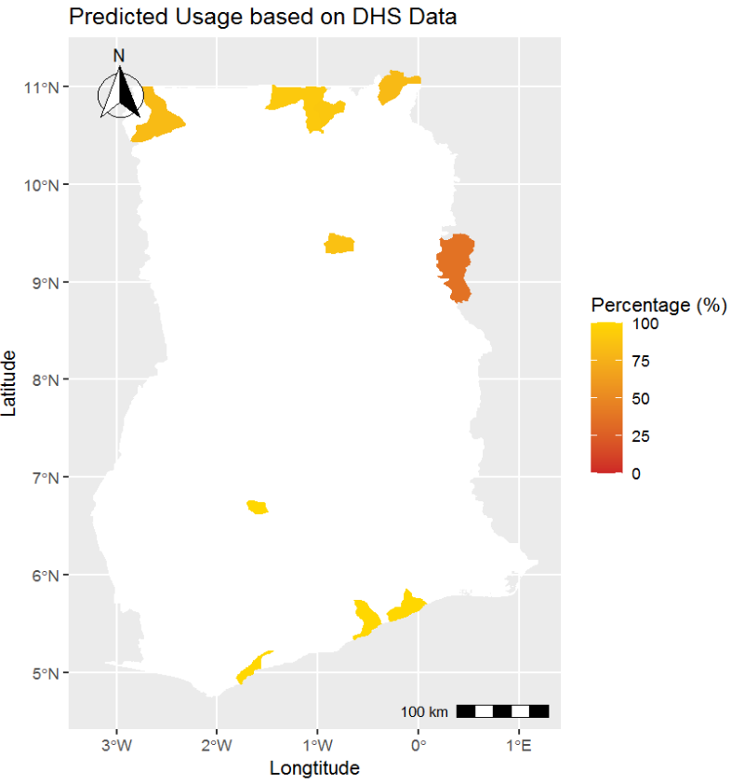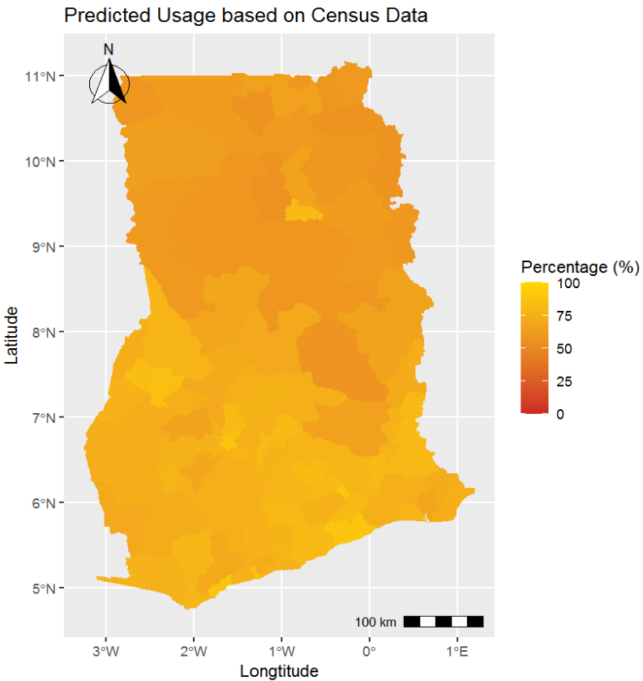
Note: The predictions are based on the preferred models for DHS and census data discussed in Section 4.1 for three exemplary countries. The left figures maps usage of child born in health facility at district level based on DHS data for Zimbabwe, Togo, and Ghana. Missing data for districts or districts with less than ten observations were left empty. The right figures predict out-of-sample based on census data.

Figure A.5: Comparison prediction of child had postnatal check based on DHS and Census Data

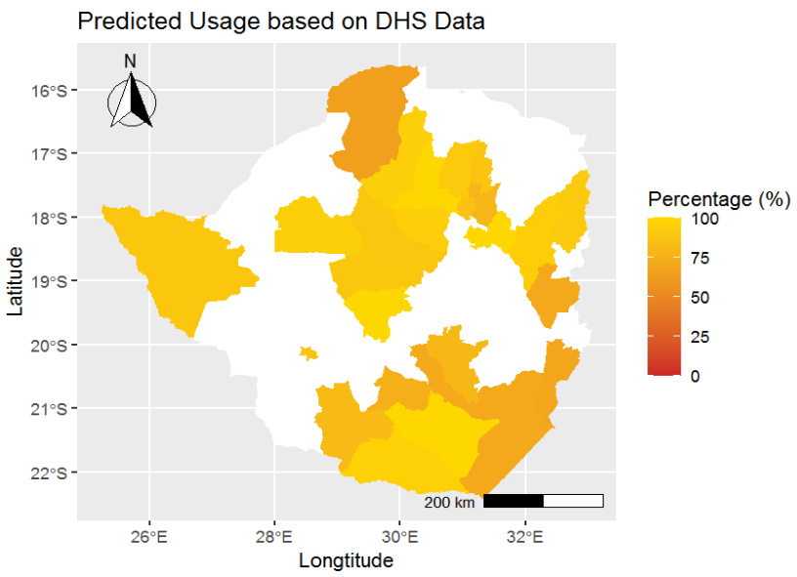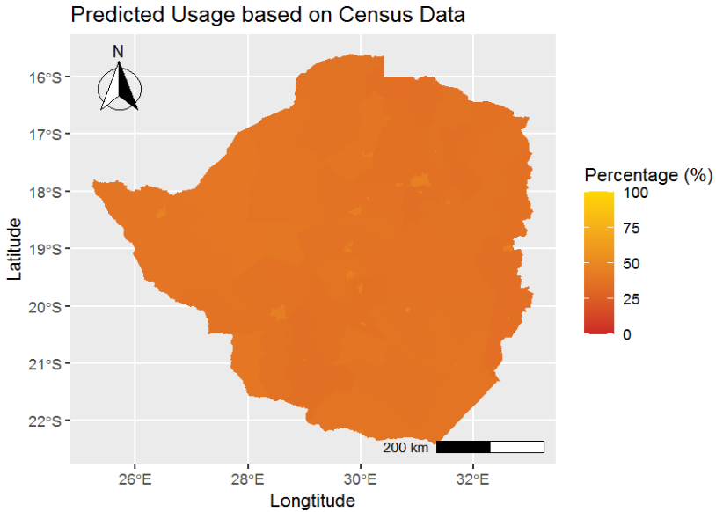
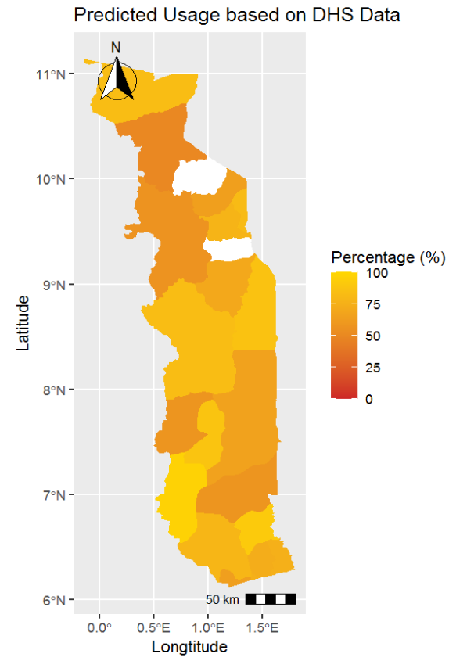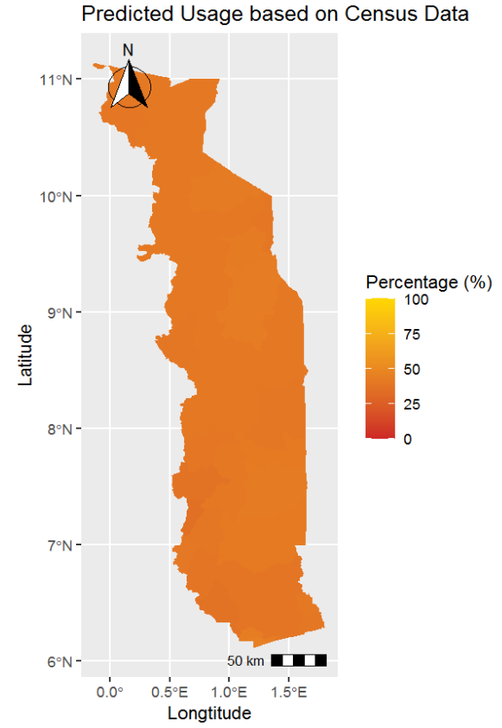
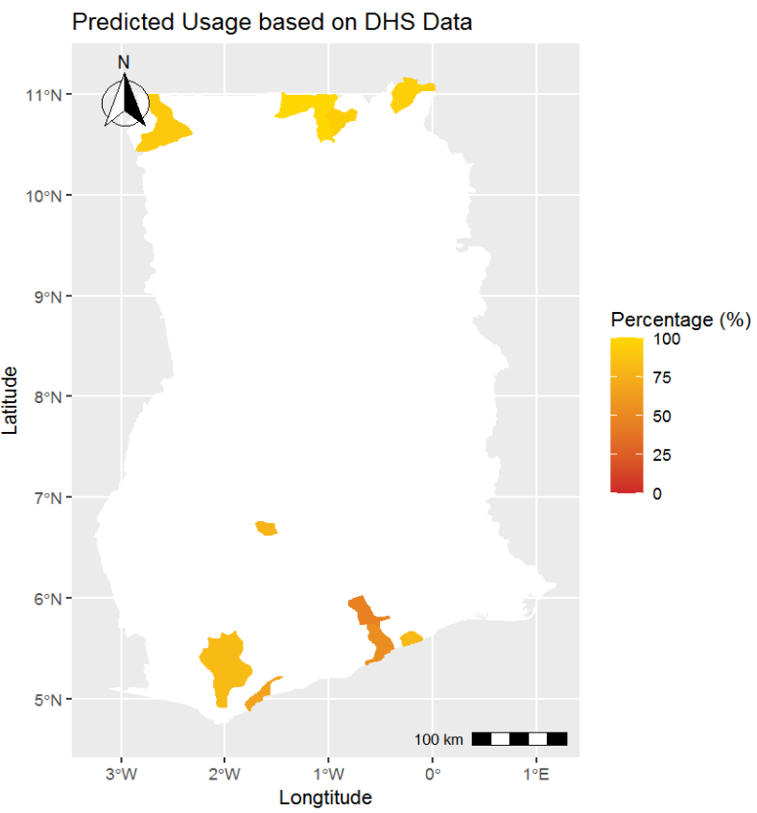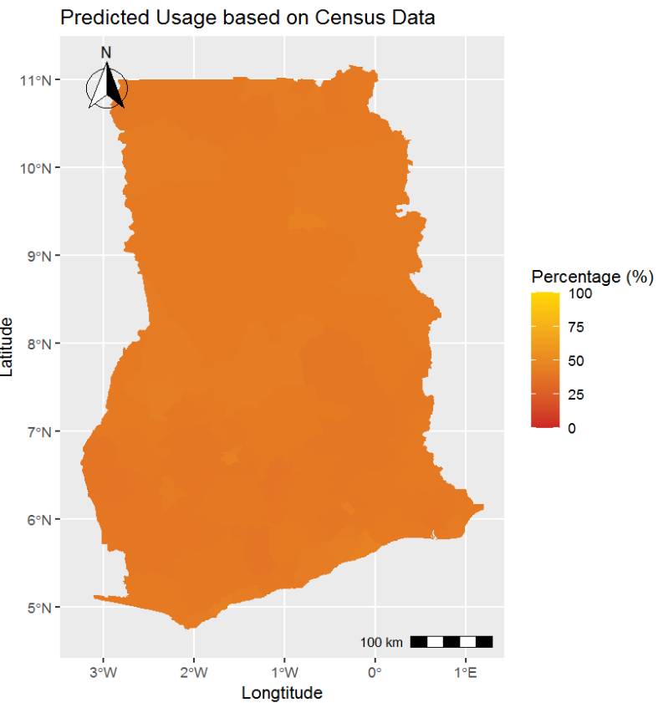
Note: The predictions are based on the preferred models for DHS and census data discussed in Section 4.1 for three exemplary countries. The left figures maps usage of child had postnatal checks at health facility at district level based on DHS data for Zimbabwe, Togo, and Ghana. Missing data for districts or districts with less than ten observations were left empty. The right figures predict out-of-sample based on census data.

Figure A.6: Country averages of out-of-sample health insurance coverage prediction

Note: Country averages of predicted health insurance coverage based on the neural network model with a restricted set of covariates are shown. Country average insurance coverage rate is based on the following studies: Baloul & Dahlui, 2014; Basaza, 2017; Goudge et al., 2018; Nundoochan et al., 2019; Mbogo & McGill, 2016; Samauma Consulting, 2021. In case of a 100% accurate prediction, the country averages would lie on the 45° line.

Figure A.7: Out-of-sample predictions for Sudan, Congo, South Africa, and South Sudan
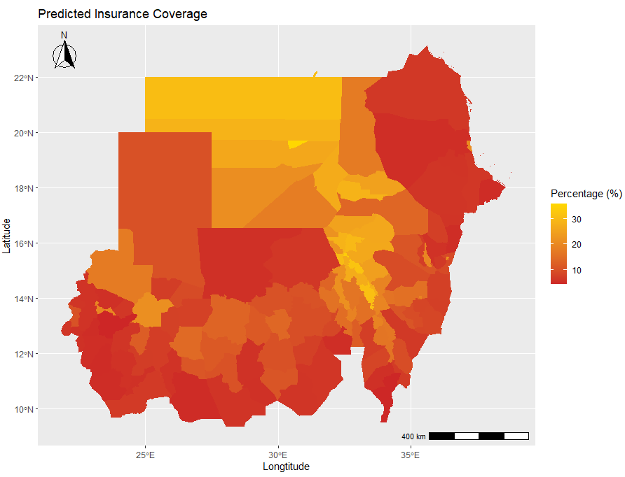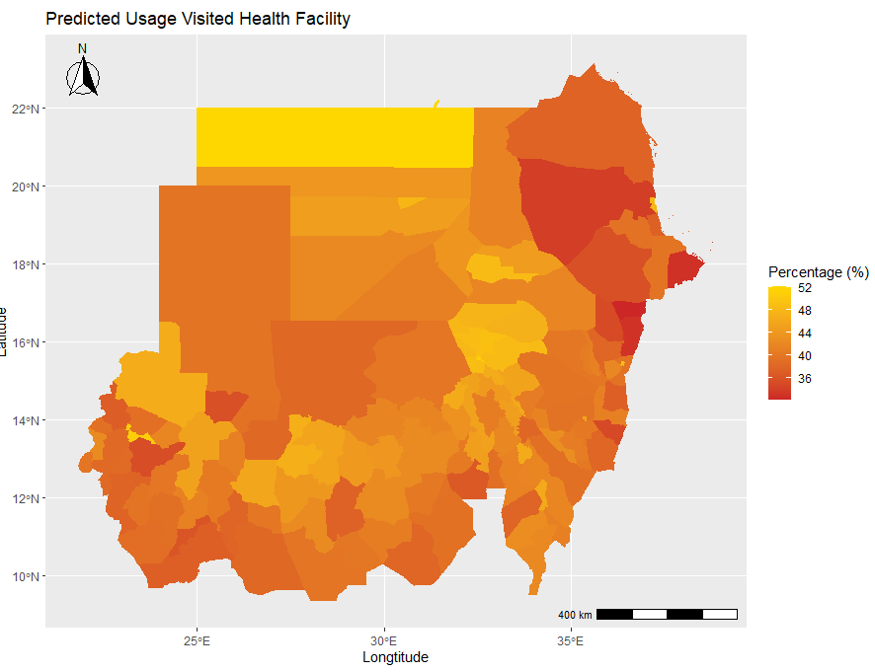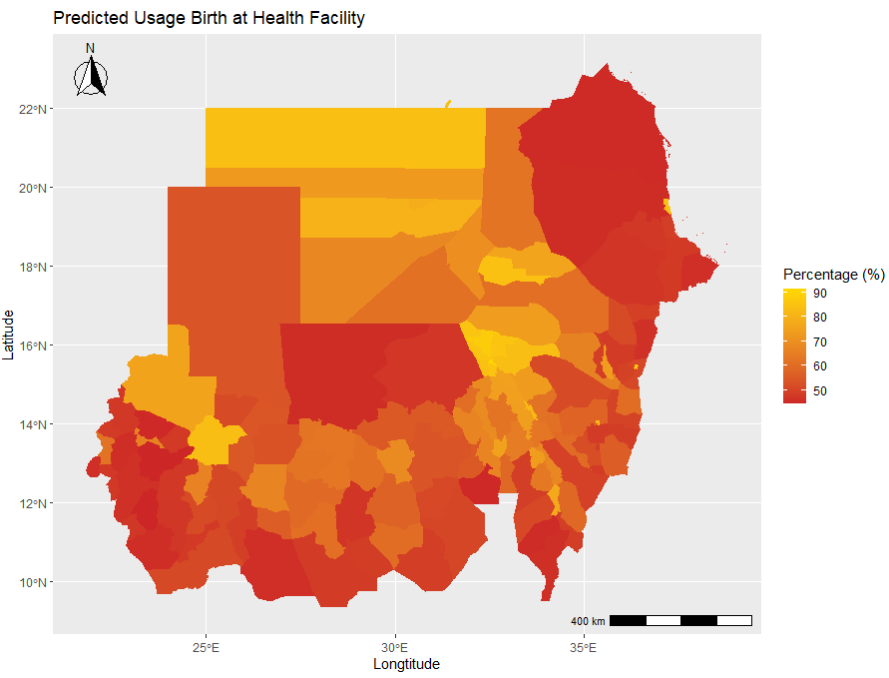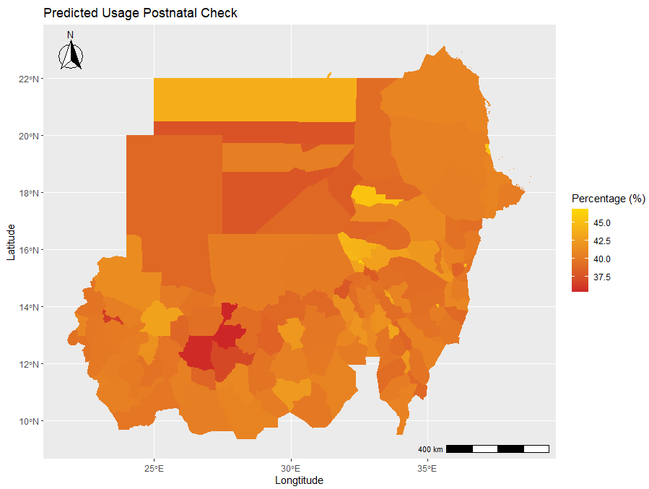
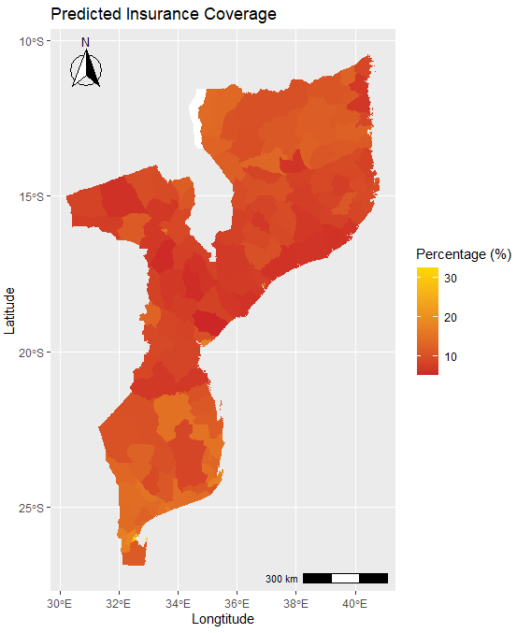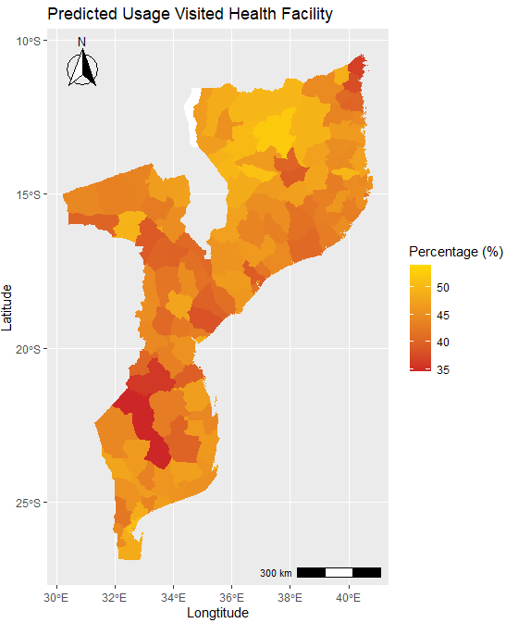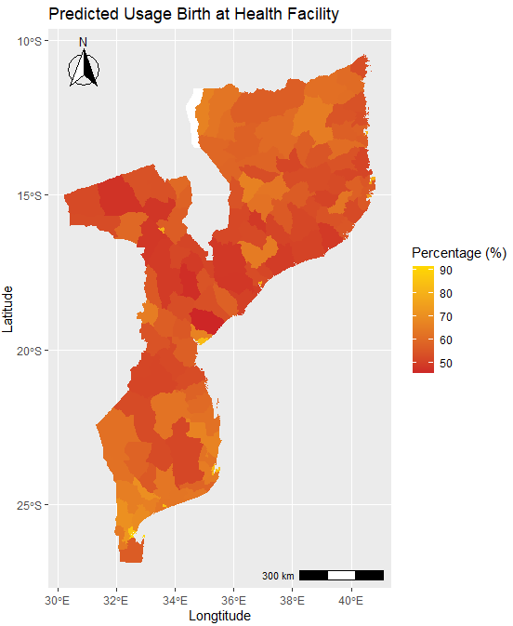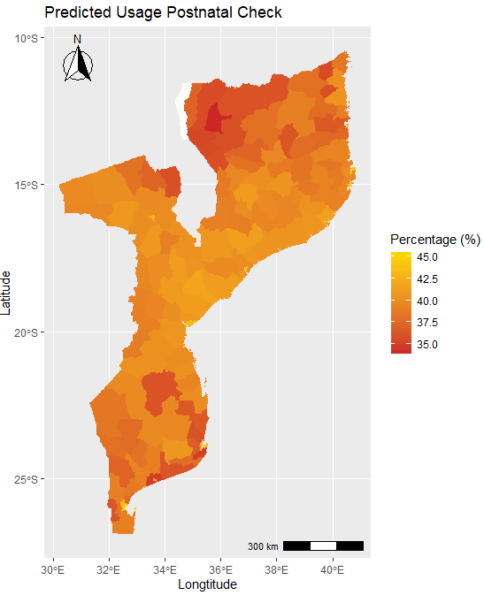
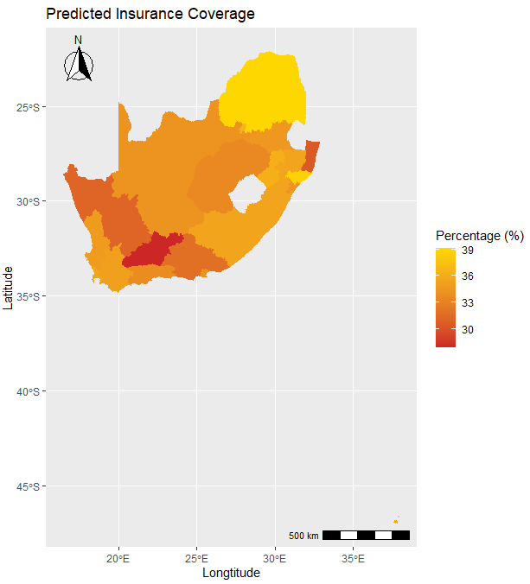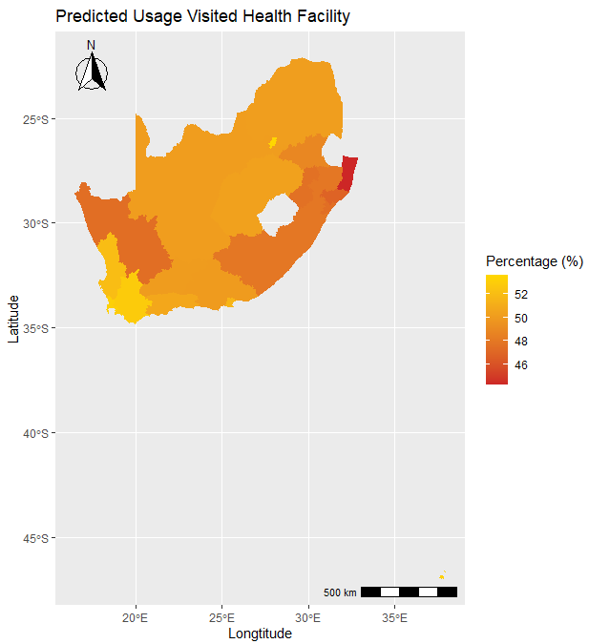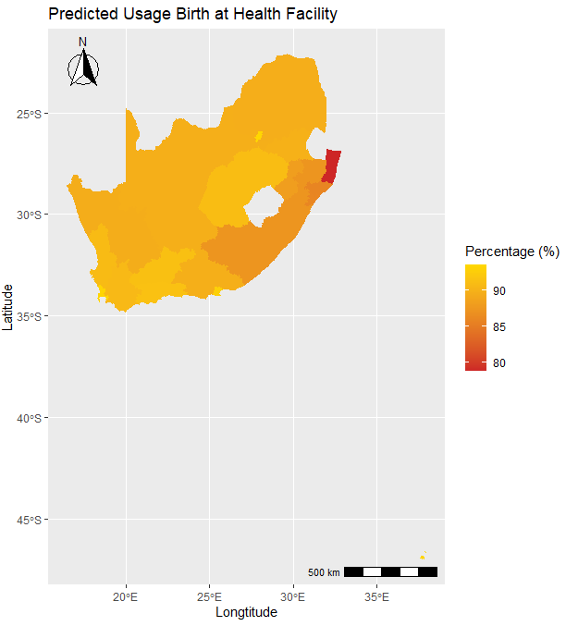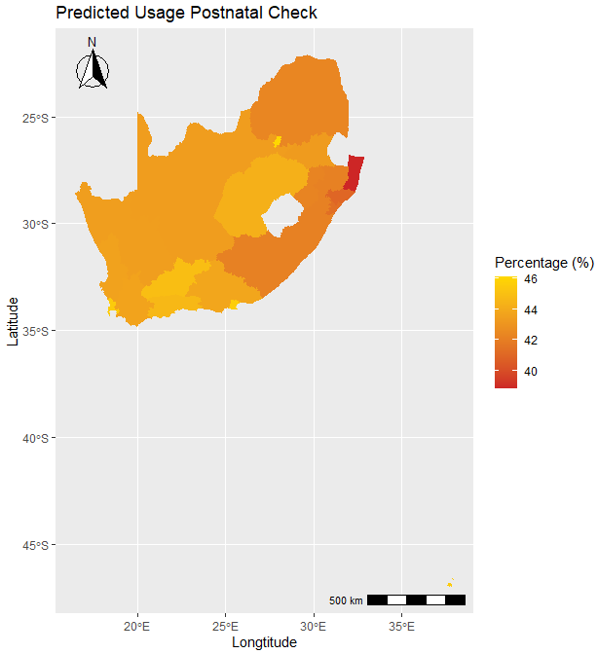
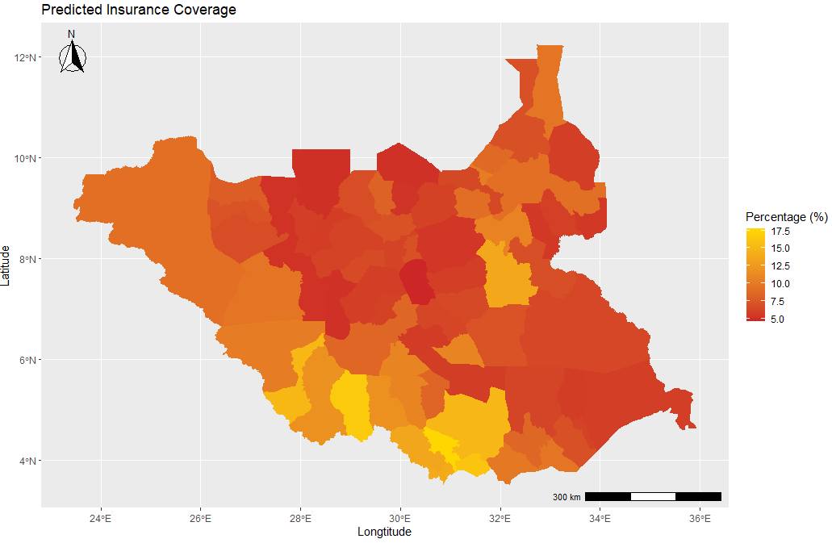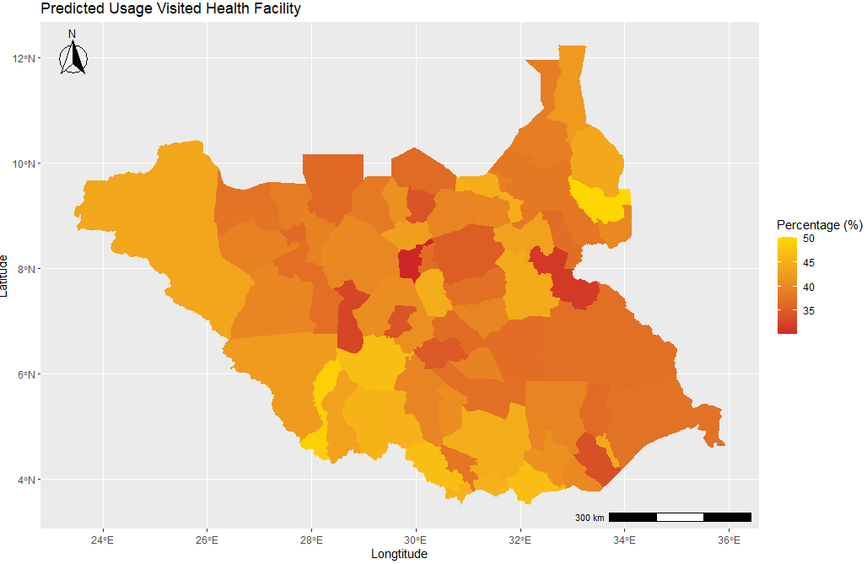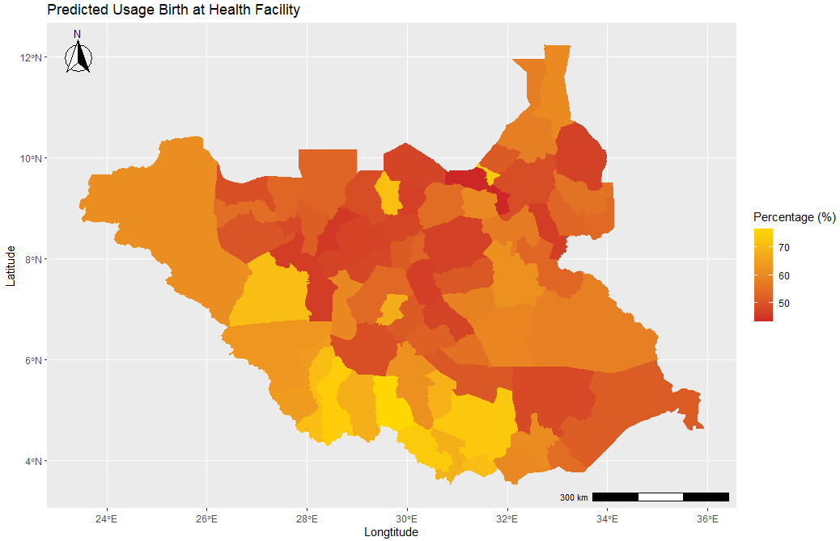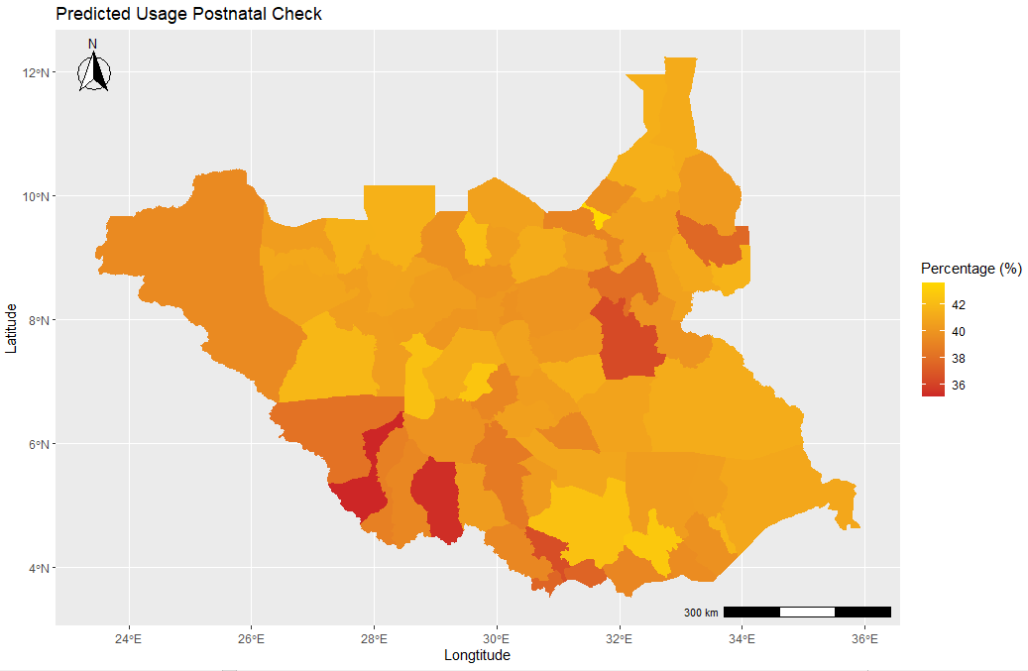
Note: All estimates are done on the individual level and aggregated on the district level. The scale is adjusted for each outcome and country.
Figure A.8: Map of all prediction of health insurance coverage and health service usage
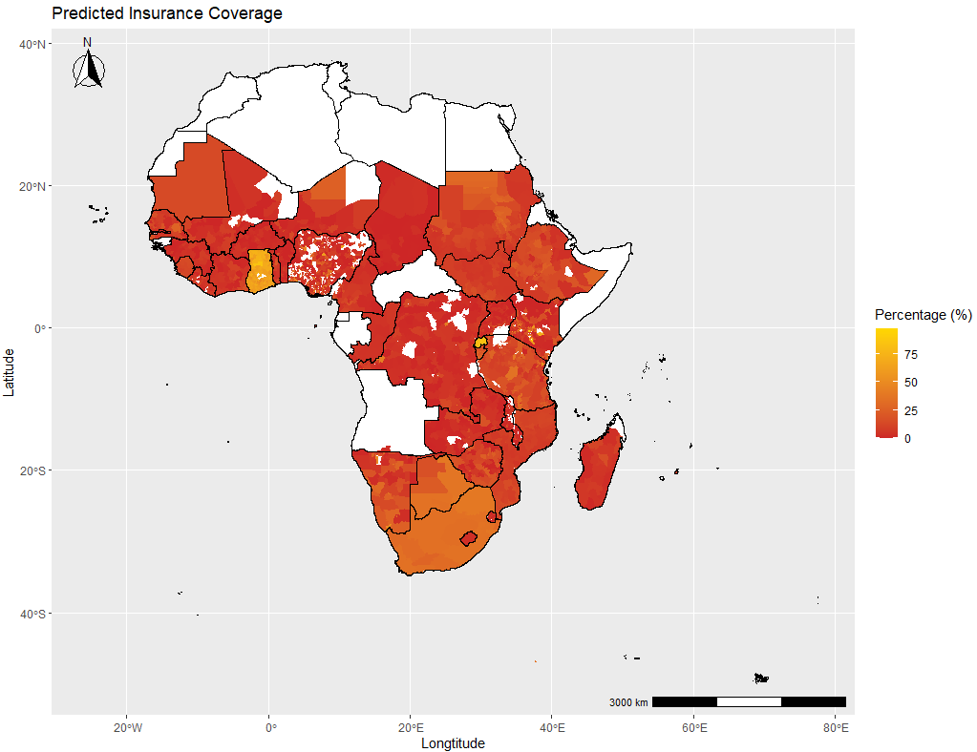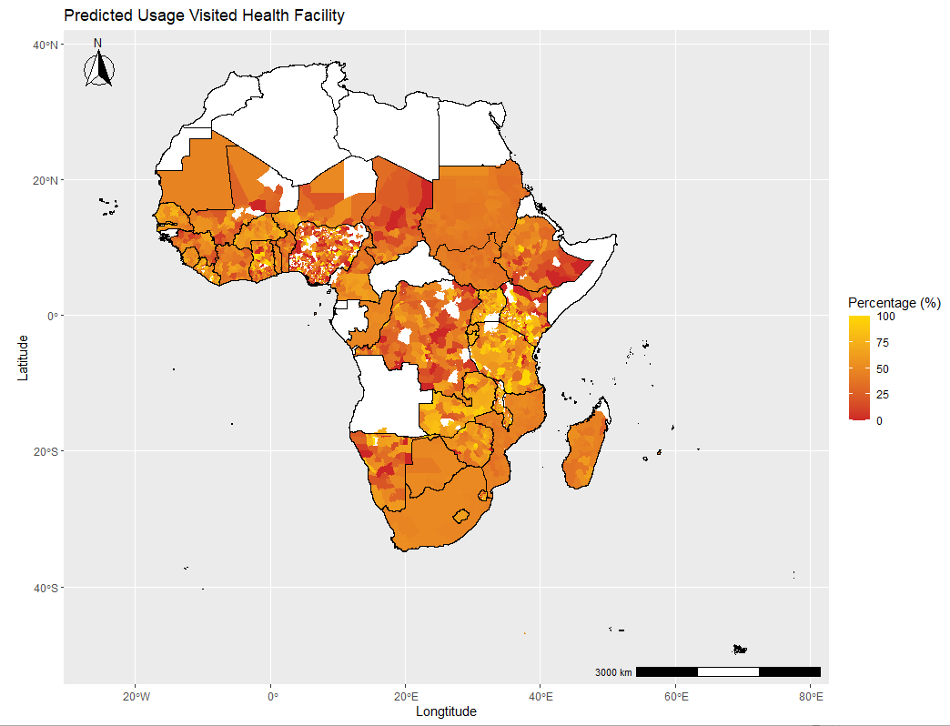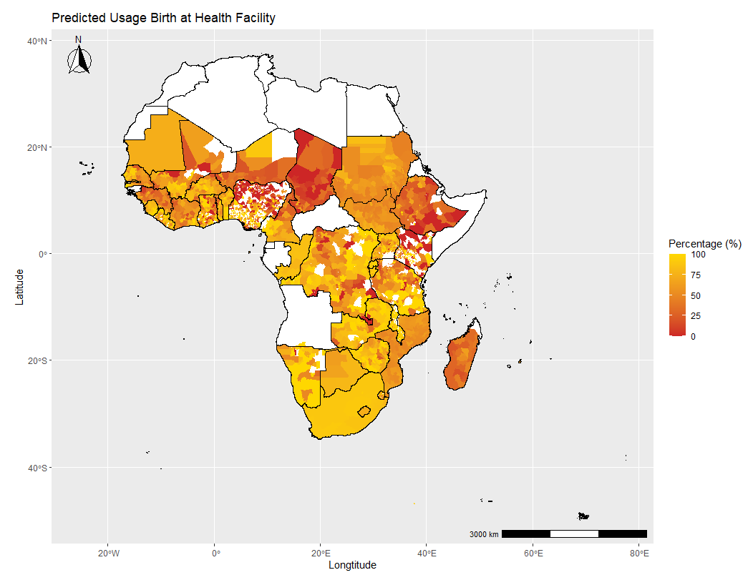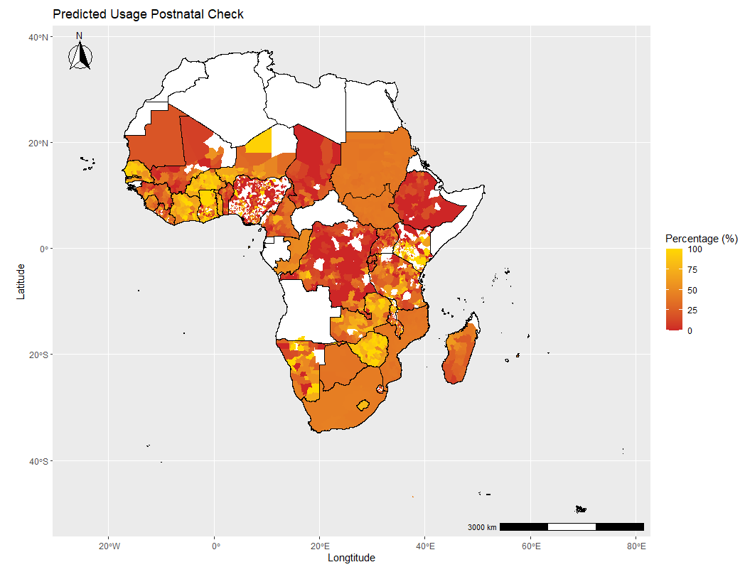
Note: Predictions are based on preferred models discussed in Section 4.1. The upper left figure estimates health insurance coverage based on a neural network model; the upper right figure if a person visited a health facility within the last year based on a neural network model; the lower left figure if the birth was given at health facilities based on a neural network model; and the lower right figure if went for a postnatal check based on a xgboost model. All estimates are done on the individual level and aggregated at the district level. Exceptions are the countries Congo, Mauritania, Sao Tome and Principe, Botswana, Lesotho, and Comoros which were aggregated on a regional level due to missing district information. Districts with less than ten observations for the predictions are not left empty (restricted map can be found in Figure 4). The scale is adjusted for each outcome.

Figure A.9: Predictions for Kenya and Nigeria
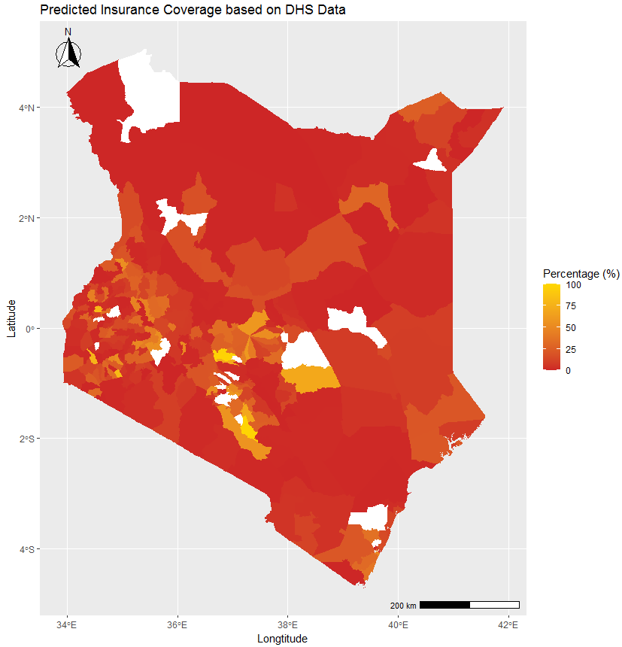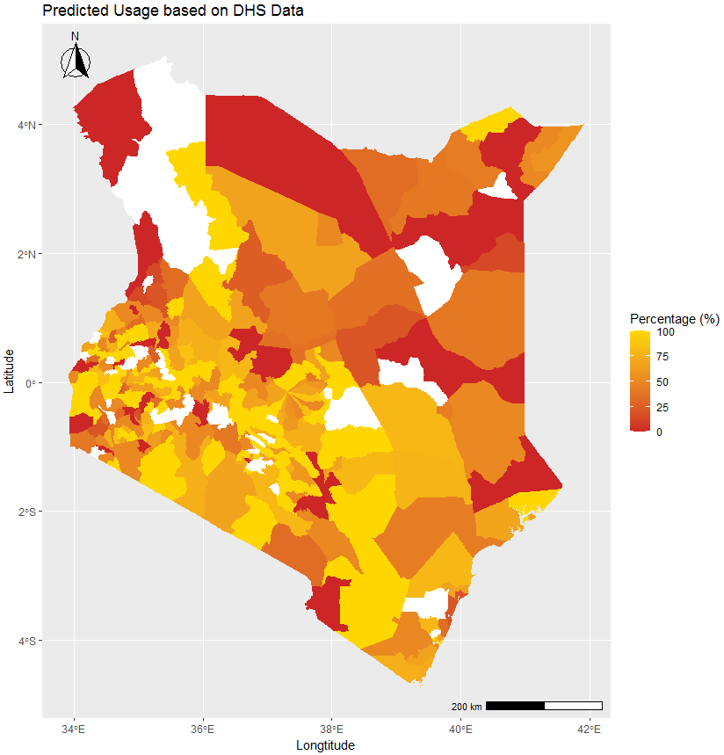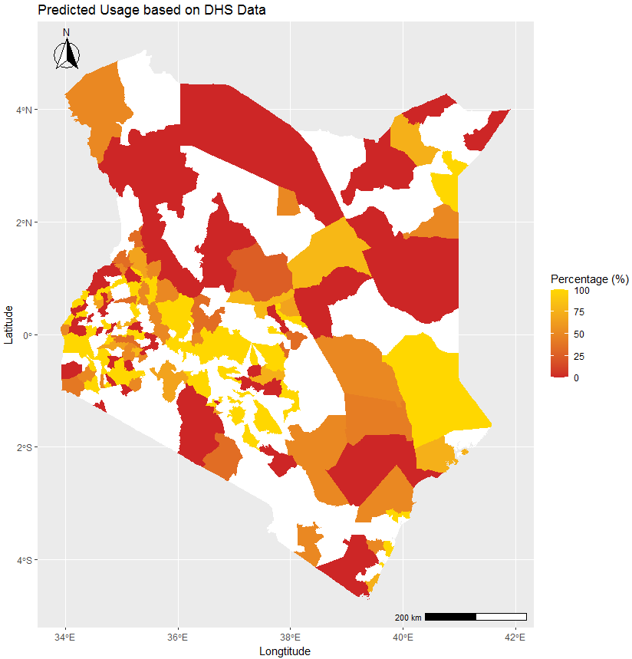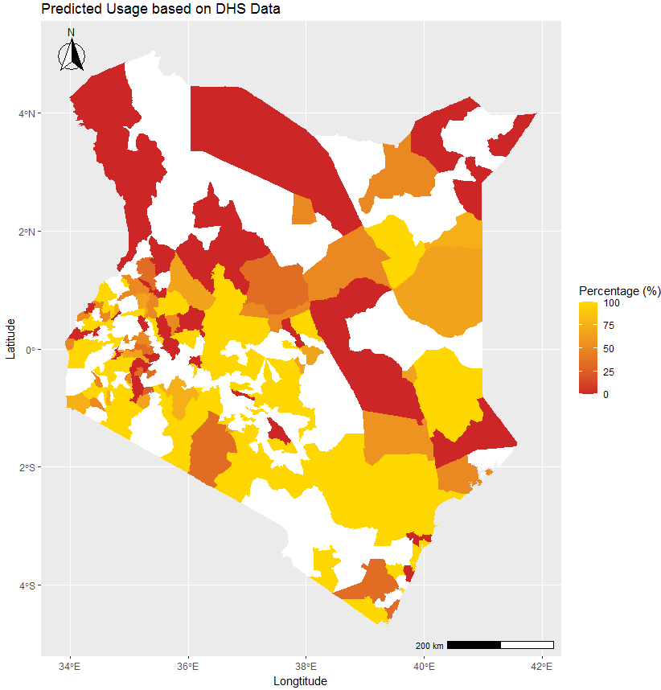
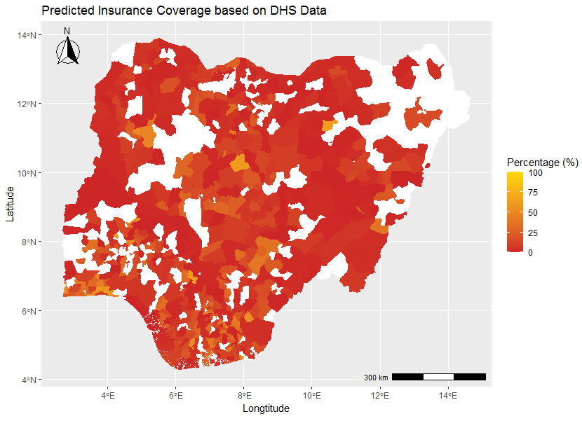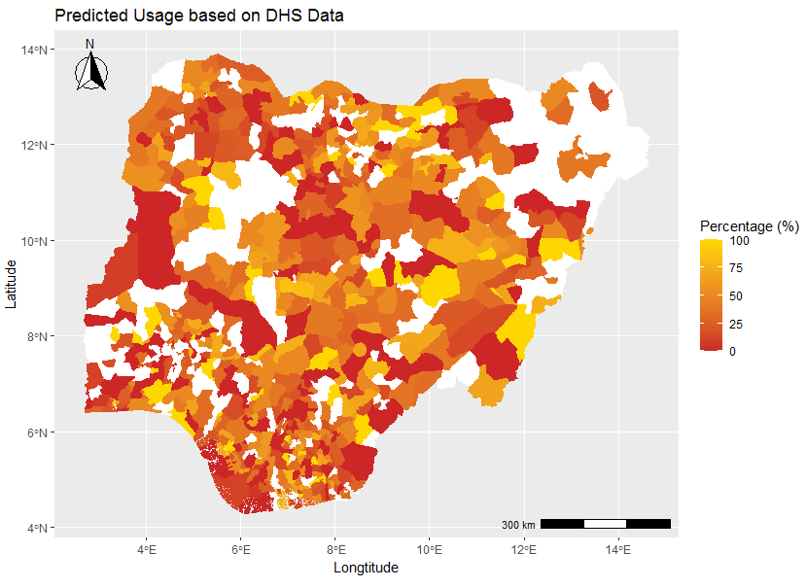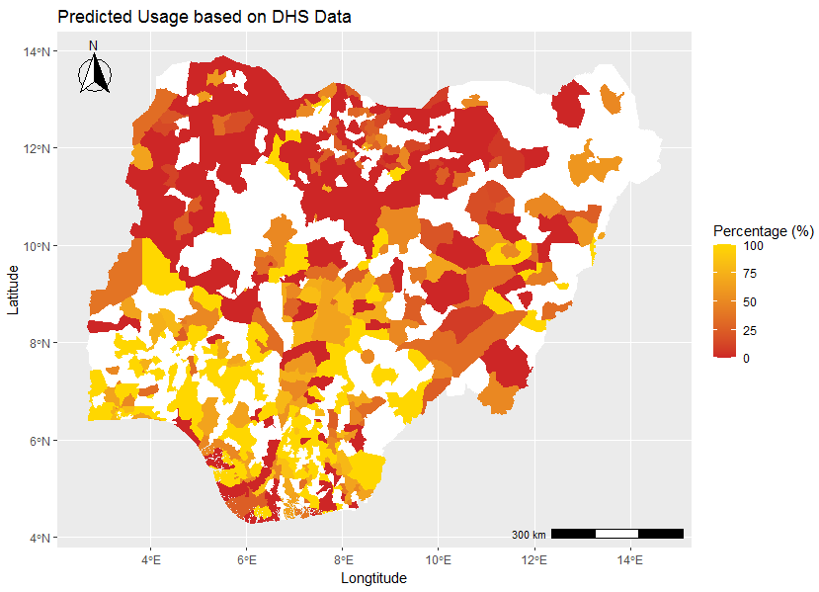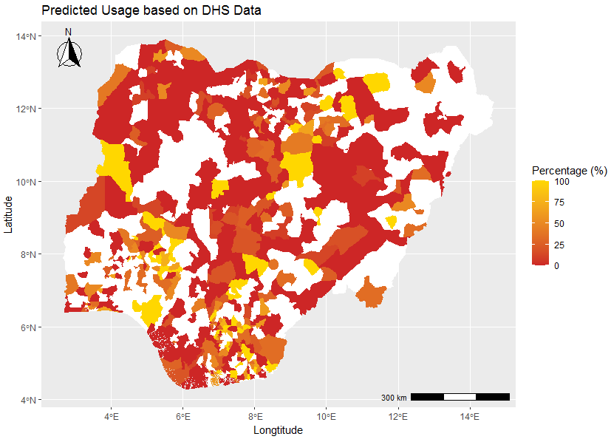
Note: All estimates are done on the individual level and aggregated on the district level.

B Empirical Models
Logit model
Logit models are widely used to estimate regressions with a binary dependent variable. In order to restrict the estimates to the 0, 1 boundary, a function is applied to transform the predictions. In case of the logit model a logistic function is used to always obtain sensible predictions within the range of 0 and 1.
Advantages of the logit model are that the model is very simple the coefficients can be easily interpreted. The training and prediction speed is fast and does not require a lot of memory and it performs well with a relatively small number of observations. Potential drawbacks of the model are that predictions might quickly become overdetermined especially for rare events and therefore perform poorly (Muchlinski et al., 2017). Moreover, as Blair et al. (2017) state, other supervised machine learning approaches can accommodate many highly collinear predictors simultaneously, which the logistic model in general cannot.

Least Absolute Shrinkage and Selection Operator
Probably one of the most familiar machine learning techniques economists know is the Least Absolute Shrinkage and Selection Operator (LASSO) due to its similarities with the Ordinary Least Squares (OLS) model. Additionally to the OLS estimate, the LASSO estimate includes a penalty term lambda that implies a regularization and a shrinkage of the regression coefficients. The LASSO estimate then minimizes the penalized residual sum of squares. Since the solution is nonlinear in y and therefore can not be solved with a closed form solution such as OLS or logit, an algorithm is needed to solve the minimization problem. If lambda is low, penalty is low and therefore coefficients are close to the OLS model. If lambda is high, coefficients are shrinked towards zero and therefore less relevant in the model. As a result, LASSO model often only takes a subset of variables into account. Hence, not all variables included in the dataset will be used for the model (James et al., 2013). In our LASSO model, the shrinkage factor lambda is chosen to be one standard error right of the mean-squared-error (MSE) as Hastie et al. (2008) suggest.
Advantages of this model are similar to the one from the logit model: it is quite simple and the coefficients can be easily interpreted. Due to the non-closed solution. The training and prediction speed is a bit slower but is still fast compared to more complex algorithms. Further, it also performs well with a relatively small number of observations. On contrary to the logit model, LASSO can handle lots of irrelevant features since it can regularize them towards zero.

Random Forest
Based on the basic decision tree model, random forests aggregate many decision trees to improve the predictive performance of the tree. A decision tree divides the observations into binary subgroups (nodes) ranked by their importance. Namely, what most accurately distinguishes the binary dependent variable. After identifying factors that reduce the mean-squared error within each node, this process continues until it reaches a terminal node (Blair et al., 2017; Morgan, 2014). Additionally to the mentioned tree process, the random forest algorithm is selecting a subset of m variables at random from total variables at each split. This feature is one of the most important advantages of the model. It prevents that the trees will be highly correlated, especially when there is a strong predictor in the dataset. Hence, the results of random forest are more reliable than from other tree models due to the decreased variance (James et al., 2013). Furthermore. The results can somewhat be interpreted and illustrated as a tree. Potential drawbacks are that it needs much more memory, training and prediction time.

Neural Networks
Based on the concept of a human brain, neural networks simulate human neurons that get an input, process it by an activation function and generate an output. More precisely the neural network recognizes patterns, classifies data and forecasts events. Moreover, by a specified learning rule that uses weights to distinguish between the importance of the variables, the algorithm trains the model until it performs the desired task as good as possible (Venables & Ripley, 2002; Alpaydin, 2010).
The main advantages of the model are that very complex models can be trained and that the model can be iteratively improved. A drawback of learning with such a flexible algorithm is the overfitting of the model (James et al., 2013). Therefore, weight decays are used to improve the predictive power. Our model was calibrated with parameters for weight decays as well as nodes, which optimize the result. Further drawbacks are that it is somehow a black-box where coefficients cannot be interpreted and parametrization is very complex. Moreover, neural networks require more learning data than usual and is similar to random forest due to it’s complexity much slower in training and prediction time.

XGBoost
XGBoost stands for eXtreme Gradient Boosting and is a type of a tree model. Thus, the model characteristics are very similar to the random forest; however, XGBoost is using the gradient boosting decision tree algorithm. Especially for structured and tabular datasets, as we have in our case, XGBoost dominates many prediction competitions. Major advantages are the execution speed and the model performance (Brownlee, 2021).

C Model validation
To build a reliable model, model validation is an important but often underestimated part of an analysis (Borovicka et al, 2012). The goal of model validation is to have a model that explains our dataset but also has the ability to accurately predict further datasets. In our case out-of-sample prediction of census data. Especially for supervised learning algorithms this can be a drawback. Due to their often very flexible learning process it might happen that a model perfectly fits the current dataset but has poor generalization capability. This so-called overfitting of the data leads to a perfect fit of the noisy data points where on the other hand the underlying relationship is distorted (Du and Swamy, 2014). In order to increase the predictive power and avoid overfitting of the models our data is split into three pieces, namely a train. validation and test dataset. The most common approach is to split the dataset randomly into 2/3 train as well as validation and 1/3 test dataset (Dobbin and Simon, 2011).

The process of model validation can be divided into three steps: The first step is the model selection, where a preferred model is chosen. Second, in the model assessment the performance from the chosen model will be evaluated on an ”untrained” dataset. Third, various robustness checks are made to evaluate how robust the results are. The process of model validation can then be divided into three steps:

1. Model Selection
In the first step, the model selection, the aim is on one hand to learn and estimate parameters of different models with the training dataset and on the other hand to evaluate the model in order to select a preferred model based on the validation dataset. The validation tries not necessarily to choose a model that perfectly fits the data but that captures best the underlying relationship (Borovicka et al, 2012). As Du and Swamy (2011) show, this can be done i.a. by cross validation.
Cross validation (CV) is besides bootstrapping the most common method used to estimate the prediction error among the train and validation dataset. In k-fold CV the training/validation dataset is randomly split up into k folds of the same size. Out of these k folds, k-1 folds are used as training sets and one is used as validation set. In k turns, each of the folds is used once as validation set and k-1 times as training set. After k turns, k estimates of the mean squared error (MSE) were computed. The average of this k MSE reveals then the CV estimate that is used to chose the preferred model. Since k-fold CV uses a smaller training set as without (k-1 vs. k) some authors claim that there is an additional pessimistic bias for strong learning algorithms. This occurs due to an assumed decreasing marginal learning curve where changes in sample size for small datasets are much higher than for large ones (James et al., 2013). Therefore, as Blair et al. (2017) suggest, we run a repeated k-fold CV to get robust results. In particular, we used a 5-fold CV that ran 200 times.

2. Model Assessment
In a second step, the model assessment, the aim is to evaluate the selected model. Precisely, the performance of the model based on new and untrained data is evaluated. Therefore, the test dataset which was not used before is applied. Measures to describe how well the model performed can be deduced by the confusion matrix, which compares the predicted outcome with the actual value in the data.
As we can see from Table 2 four possible cases of outcomes are possible:
- True Positive (TP). where the positive condition is correctly predicted as positive (in our case insured women is predicted as insured).
- False Negative (FN). where the positive condition is wrongly predicted as negative (in our case insured women is predicted as non-insured). This case is in the literature often called Type II error.
- False Positive (FP). where the negative condition is wrongly predicted as positive (in our case non-insured women is predicted as insured). This case is in the literature often called Type I error.
- True Negative (TN). where the negative condition is correctly predicted as negative (in our case non-insured women is predicted as non-insured).

Deduced from the four cases various performance measurements can be created to better evaluate and
compare the performance of the models:
- Accuracy: (TP + TN) / Total. An optimal prediction would perfectly predict the True Positives and the True Negatives and would have zero False Positives and Negatives. Accuracy measures thus the rate of correctly identified observations among the total number.
- Sensitivity: TP / Positive condition (P0). Sometimes also called the probability of detection. Which measures the proportion of actual positive values that are correctly identified.
- Specificity: TN / Negative condition (N0). Sometimes also called the true negative rate. which measures the proportion of actual negative values that are correctly identified.
- Precision: TP / Predicted positive condition (P)
- F1 score: 2 / [(1/Sensitivity)+(1/Precision)]. The harmonic average of Sensitivity and Precision is a measure of the test’s accuracy.
- ROC Curve: To graphically illustrate the performance of the models the Receiver operating characteristic (ROC) curve can be drawn. On the Y-axis the True Positive Rate (TPR) and on the X-axis False Positive Rate (FPR) is plotted for each threshold point between 0 and 1. Because the TPR is equal to the Sensitivity and the FPR equal to the fall-out, the ROC curve can also been described as a function of sensitivity in terms of the fall-out. Thus the more the curve is in the upper left corner, which means that the sensitivity is high and fall-out is low (respectively specificity high), the better is the predicting performance of our model. On the contrary, the closer the ROC curve gets to the 45- degree line, which stand for an absolute random model without learning from the data, the worse the performance is.
- AUC: To better compare the performance of the ROC curves between models. The Area under the curve (AUC) measurement is used. As the term already explains. AUC calculated the area under the ROC curve. Thus, AUC is equal to 1 if the model perfectly predicts the data such that the ROC curve is in the upper left corner and equal to 0.5 if the ROC curve is on the 45-degree line.
- Cohen’s Kappa: To avoid the bias of accuracy in an imbalanced sample, Cohen’s Kappa can be used. It is calculated with the following formula (2 ∗(𝑇𝑃∗ 𝑇𝑁 −𝐹𝑁 ∗𝐹𝑃))/((𝑇𝑃+𝐹𝑃)∗(𝐹𝑃+𝑇𝑁)+(𝑇𝑃+𝐹𝑁)∗(𝐹𝑁+𝑇𝑁)) and has values between -1 and 1. The comparison of the Cohen’s Kappa value between different samples should be done with care, due to the underlying distribution. However, within a sample, a higher Cohen’s Kappa means a better identification.

A model will not necessarily outperform in all these performance measurements. Depending on the data and the prediction problem some performance measurement can be prioritized.

3. Robustness Checks
In a third step. various robustness checks based either on the data or on the parameters used in the model
are made to see how consistent the results of the models are and if predictive power can be improved.

In particular, we use the following covariates: person is married (binary), age (categories, 15-59), education (categories: no, primary, secondary, tertiary), person is working (binary), location is rural (binary), household has children (binary), electricity (binary), toilet (binary).
For the first outcome, if a person is covered by a health insurance scheme, 27 covariates were used. For the three outcomes about usage of health services 28 covariates were used, because insurance status was also added as covariate.
A deeper discussion of the models and their field of application can be found in Hastie et al. (2008) as well as Murphy (2012) who provide both a very good overview of statistical techniques with a focus on machine learning. Advantages and disadvantages are additionally deduced from Markham (2015) and Blondel (2017).
Since the outcome health insurance status was heavily imbalanced (7%), we additionally used the method of oversampling (ratio up to 20%) for the prediction of health insurance coverage.
Results are available upon request.
Since the census data does not have any information about the four outcomes, we cannot directly validate our estimates.

