Results
  - Predictors of health insurance coverage and take up of health services
In this section we first compare the predictive power of classical models against the ML model across all 33 SSA countries, focusing on their potential to enhance the prediction of health insurance coverage and health service utilization. We then examine the variable selection in ML models using a data-driven approach and highlight the distinctions from the classical model.
Figure 1 demonstrates that ML models consistently outperform classical models in predictive accuracy. A comparison using Cohen’s Kappa—a accuracy metric that accounts for the probability of correct predictions by chance—reveals substantial improvements across all 33 countries with ML models. Notably, for outcomes like health insurance coverage and postnatal check for the last-born child within two weeks, the classical model frequently achieves a Cohen’s Kappa of 0 in several countries, indicating that the classical model sometimes completely fails to identify correct cases (Cohen’s Kappa of 1 would be perfect prediction). In contrast, ML models show a clear improvement, highlighting their ability in effectively identifying health insurance and service coverage patterns. On average, Cohen’s Kappa for health insurance coverage increases by 17 percentage points (p.p.; from 0.01 to 0.18), for postnatal check by 23 p.p. (from 0.01 to 0.24), for facility-based births of the last-born child by 25 p.p. (from 0.24 to 0.49), and visited health facility by 25 p.p. (from 0.13 to 0.38; see Figure A.1 in the Appendix)
Further, Appendix Figure A.1 indicates that, alongside Cohen’s Kappa, Sensitivity (the ability to identify true positive cases) is significantly enhanced with ML models. This improvement is crucial, as many outcome variables in our analysis are imbalanced. For instance, with only 9.4% of the sample on average covered by a health insurance scheme, a model predicting all cases as uninsured would achieve 91% accuracy and 100% Specificity but 0% Sensitivity, failing to identify the insured population accurately. Thus, Cohen’s Kappa and Sensitivity are essential metrics for understanding if the models can accurately capture vulnerable, covered groups.
While ML models generally outperform, there are five exceptions regarding the outcome of facility-based births of the last-born child, where Cohen’s Kappa shows a slight decline compared to the classical model (see Figure 1). For countries like Sao Tome and Principe, Uganda, Namibia, Eswatini, and Burundi, ML models do not fully outperform the classical approach for this outcome. However, even in these cases, Sensitivity and Accuracy still improve or stays at least the same (see Appendix Figure A.2). For example, in case of Namibia we find that with the ML model Cohen’s Kappa decreases from 0.36 to 0.3, however, Accuracy stays constant and Sensitivity is increasing from 0.96 to 0.97. These results underscore that ML models, despite occasional limitations, offer substantial benefits for predictions of health insurance coverage and take up of health services across SSA countries.

Figure 1: Cohen’s Kappa of classical models and ML models

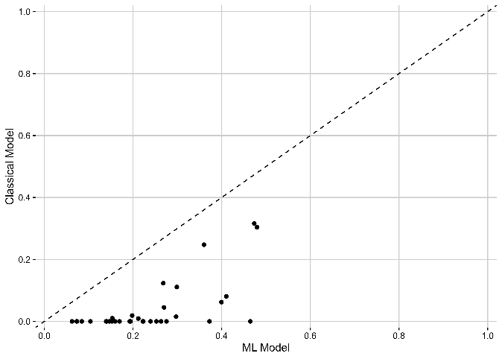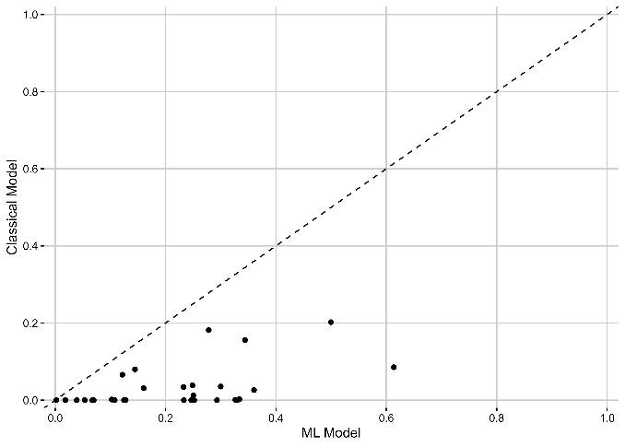
- Health insurance coverage (b) Postnatal check

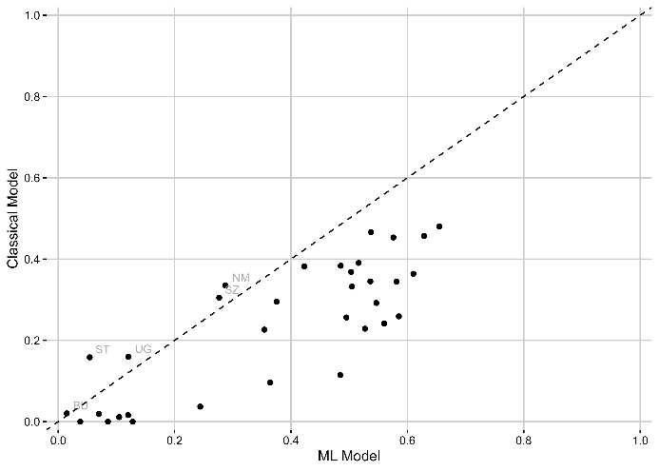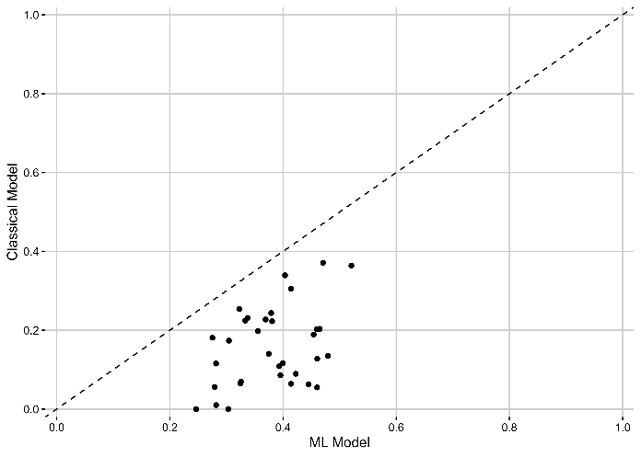
- Facility-based births (d) Visited health facility

Notes: The figures show the predictive power by country for the classical model (consisting of 10 variables most often used by the literature, details see Section 2) and the ML model using a XGBoost model with repeated five-fold cross-validation (consisting of 60-79 variables available in the DHS data, details see Section 2). The performance is measured as Cohen’s Kappa, a measure how often the model correctly predicts the outcome adjusted by the underlining probability to make a correct prediction by chance (more details see Section 3).

Figure A.1: Predictive power of classical models and ML models

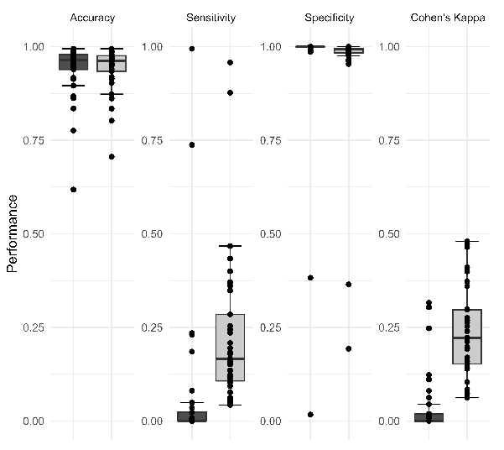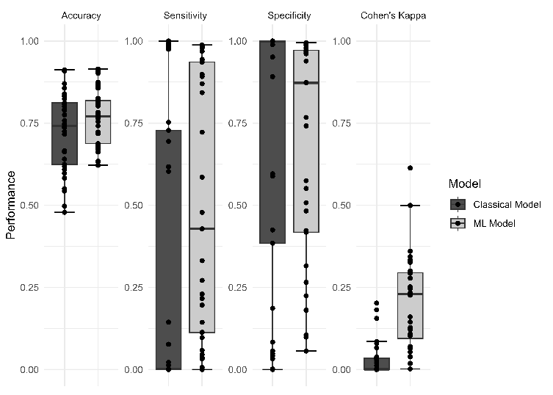
- Health insurance coverage (b) Postnatal check

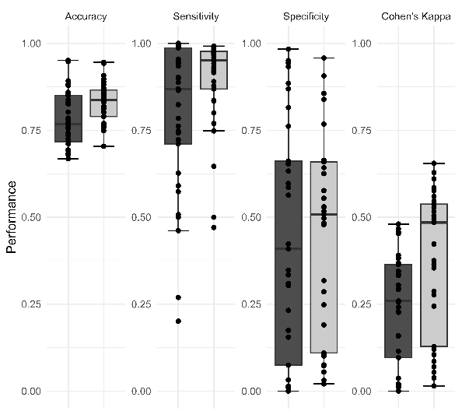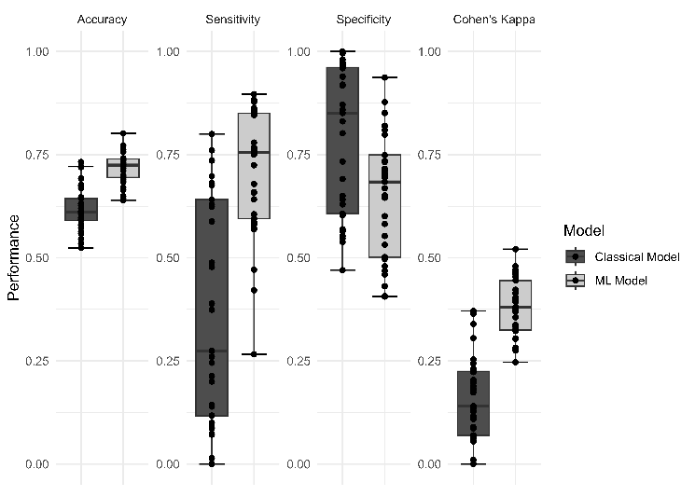
- Facility-based births (d) Visited health facility

Notes: The figures show the predictive power for the classical model (consisting of 10 variables most often used by the literature, details see Section 2) and the ML model using a XGBoost model with repeated five-fold cross-validation (consisting of 60-79 variables available in the DHS data, details see Section 2). The performance values are Accuracy, a measure how often the model correctly predicts the outcome, Cohen’s Kappa, a measure how often the model correctly predicts the outcome adjusted by the underlining probability to make a correct prediction by chance, Sensitivity, a measure to correctly predict true positive cases, and Specificity, a measure to correctly predict true negative cases (more details see Section 3).

Figure A.2: Sensitivity of classical models and ML models

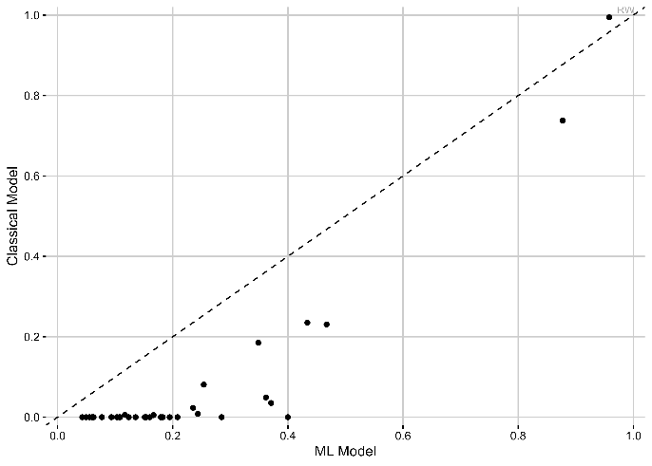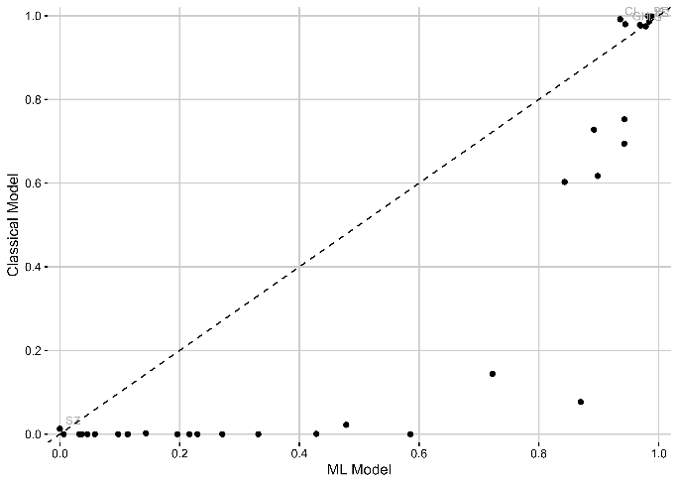
- Health insurance coverage (b) Postnatal check

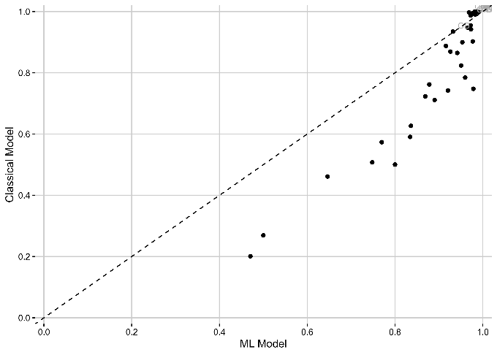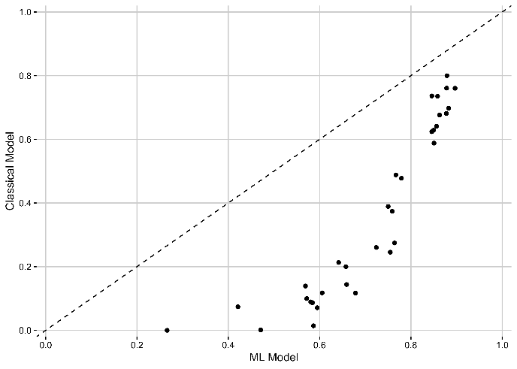
- Facility-based births (d) Visited health facility

Notes: The figures show the predictive power by country for the classical model (consisting of 10 variables most often used by the literature, details see Section 2) and the ML model using a XGBoost model with repeated five-fold cross-validation (consisting of 60-79 variables available in the DHS data, details see Section 2). The performance is measured as Sensitivity, a measure of how often the model correctly predicts the outcome adjusted by the underlining probability to make a correct prediction by chance (more details see Section 3).

Figure 2 shows the top 5 predictors of the ML model for health insurance coverage and take up of health services.
- Numeric variables more important
- Order based on available countries – meaning that e.g. time to get to water 1 out of 1 (100%)
- Classical variables seem to be only relevant for the minority of the countries,
  - e.g. currently working only in top 5 for Namibia, rural only for Sao Tome and Princip, or married for Burundi, exposure to mass media for Liberia
  - except wealth quintile, which is a top 5 predictor for 39% of the countries (13 out of 33); and education for 55% (18 out of 33)
- Some new variables seem correlated with the one form classical model, e.g. has bankaccount ~ wealth, literate ~education, read newspaper ~exposure to mass media & education
- Potential new insights: Number of HH members, female HH members, mosquitonets, ideal number of children, trips women took in last 12 months
- Not included in ML models are if person smokes or if female HH head
- Interestingly, many other new variables such health, cultural (domestic violence, child labor, etc.), ethnicity, and religion variables seem not to significantly contribute as predictors to the model.

Figure 2: Number of times variable was ranked top 5 for ML prediction for health insurance coverage and take up of health services
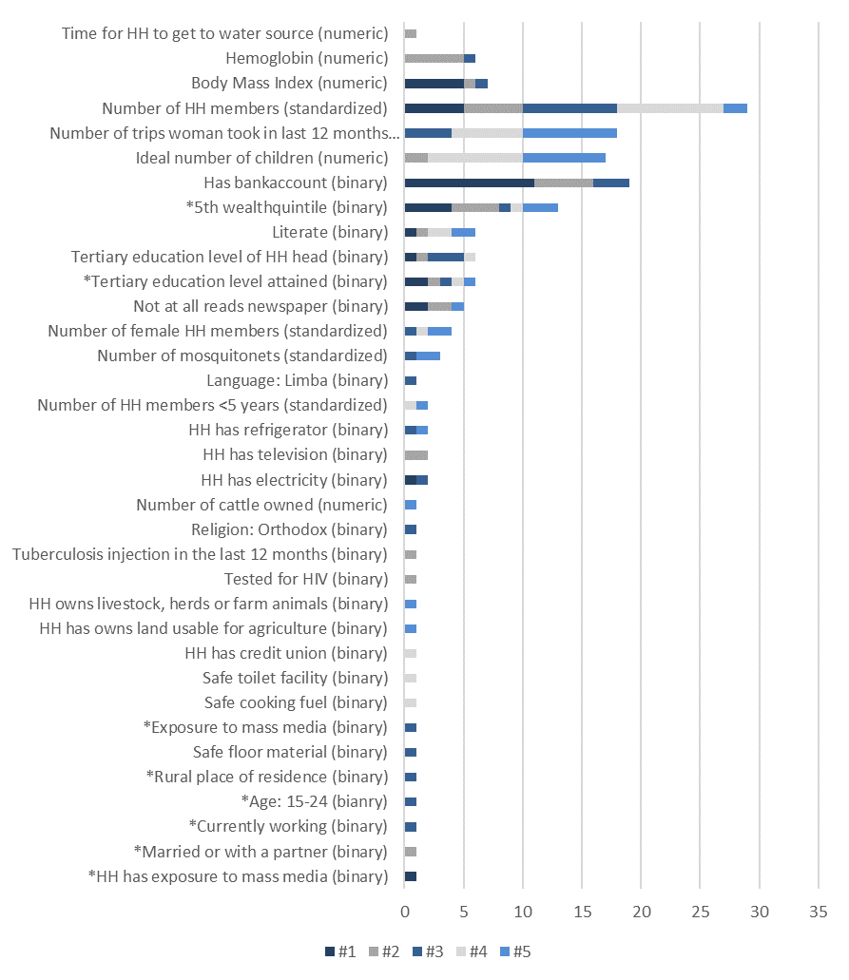
- Health insurance coverage

Notes: Figures show the number of times the ML model used the variables as a top 5 predictor. Variables with a * highlight variables that are included in the classical model.

Figure A.2. hightlights the variables that on average contribute to the highest weight for the prediction. The results for health insruance coverage emphasize that number of HH members and wealth quintile are in overall important predictors, whereas number of trips a women took in the last 12 months, ideal number of children, and HH has a bankaccount only seem to play an important role for some countries.

Figure A.3: Top 15 variables to predict health insurance coverage and take up of health services

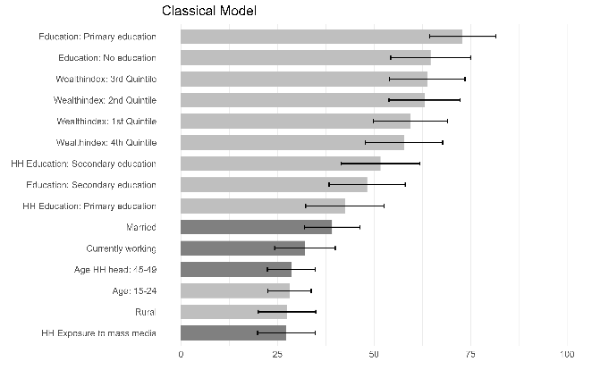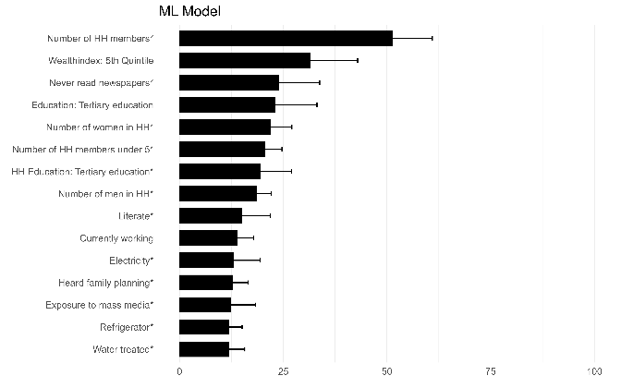
- Health insurance coverage
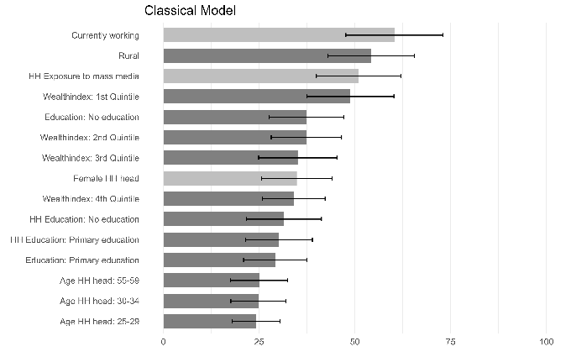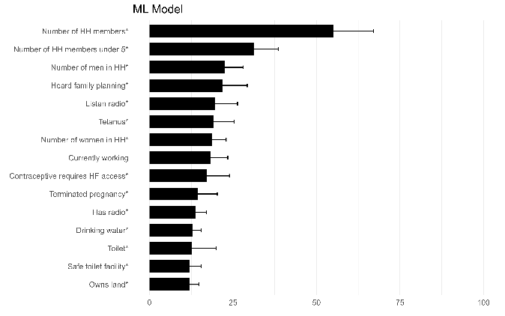
- Postnatal check
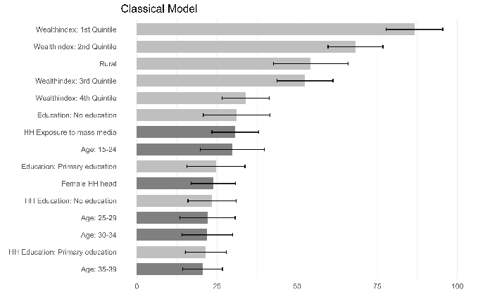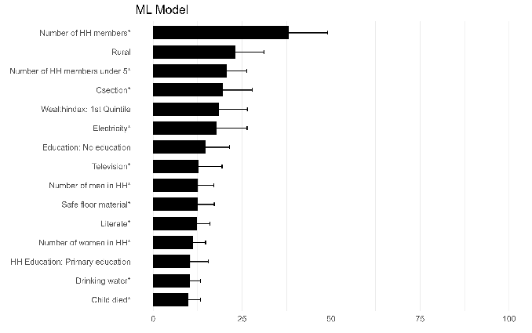
- Location birth
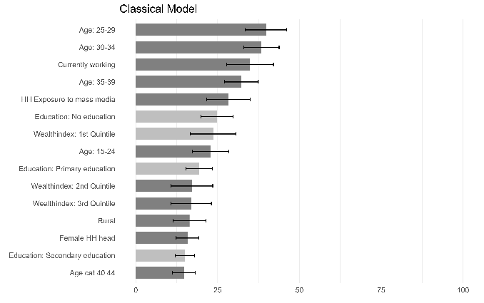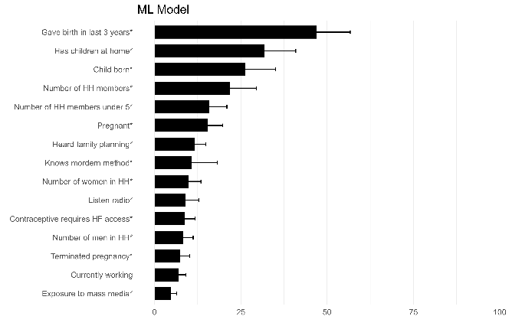
- Visited health facility

Notes: Figures show the variable importance for classical model (left side) and ML model (right side). A predictor’s importance score is defined by the decrease in the classification error that is attributed to all of its splits in a given tree, averaged across all trees and normalized to a range from 0-100. In the figure for the classical model, bars in dark (light) gray correspond to an average positive (negative) coefficient. In the figure for the ML model, variables with a * highlight variables that are not included in the classical model.

