Results
  - Predictors of health insurance coverage and take up of health services
Accurate prediction of health insurance coverage and healthcare utilization is vital for informing policy decisions in Sub-Saharan Africa, where disparities in access remain significant. In this section, we compare the predictive power of classical models against the preferred tree-based ML model, xgboost (see Section 3), across 33 SSA countries with available DHS data. The focus is on enhancing the prediction of health insurance coverage and take up of the three health services, woman visited a health facility at least once a year, last-born child was born in a health facility, and had a postnatal check within the first two weeks.
We then analyze the variable selection in ML models, using a data-driven approach to highlight the differences from classical models.
Figure 1 illustrates that ML models consistently outperform classical models in predictive accuracy. A comparison using Cohen’s Kappa—a accuracy metric that accounts for the imbalanced distribution of the outcome variables—ML models reveal substantial improvements across all 33 countries. Notably, outcomes such as health insurance coverage and postnatal checks often result in a Cohen’s Kappa of 0 for classical models, meaning they fail to correctly identify any cases (Cohen’s Kappa of 1 would be perfect prediction). In contrast, ML models improve prediction performance significantly. On average, Cohen’s Kappa increases by 17 percentage points (p.p.) for health insurance coverage (from 0.01 to 0.18), by 25 p.p. for visits to health facilities (from 0.13 to 0.38), by 25 p.p. for facility-based births (from 0.24 to 0.49), and by 23 p.p. for postnatal checks (from 0.01 to 0.24; see Figure A.1 in the Appendix). These results underscore the robustness of ML models in identifying patterns of health insurance and take up of services.
Appendix Figure A.1 also highlights improvements in Sensitivity (the ability to identify true positives) when using ML models. This metric is particularly crucial given the imbalanced nature of many outcome variables. For example, only 9.4% of the sample, on average, is covered by a health insurance scheme. A model predicting all cases as uninsured could achieve 91% accuracy and 100% Specificity but 0% Sensitivity, failing to identify the insured population. ML models, with their superior Cohen’s Kappa and Sensitivity, are therefore more effective in identifying vulnerable, insured populations.
While ML models generally outperform the classical model in the 33 countries, there are five exceptions regarding the outcome of facility-based births of the last-born child (e.g., in São Tomé and Príncipe, Uganda, Namibia, Eswatini, and Burundi), where Cohen’s Kappa slightly declines (see Figure 1). However, even in these cases, Sensitivity and Accuracy still improve or stays at least the same (see Appendix Figure A.2). For instance, in Namibia, Cohen’s Kappa decreases from 0.36 to 0.3 with the ML model; however, Accuracy remains constant, and Sensitivity increases from 0.96 to 0.97. These results suggest that while ML models may have occasional limitations, they generally offer substantial benefits for predicting health insurance coverage and service uptake across SSA.
Figure 1: Cohen’s Kappa of classical models and ML models for each country

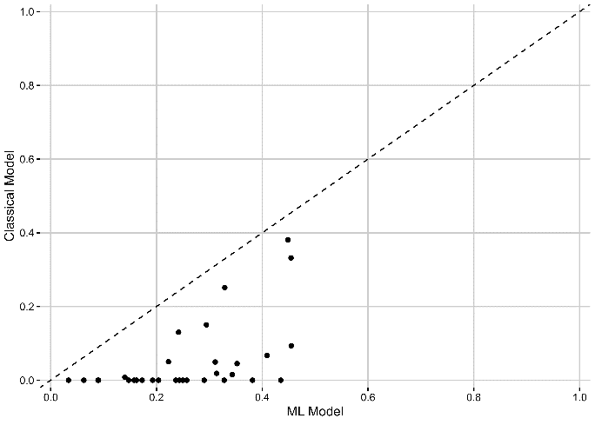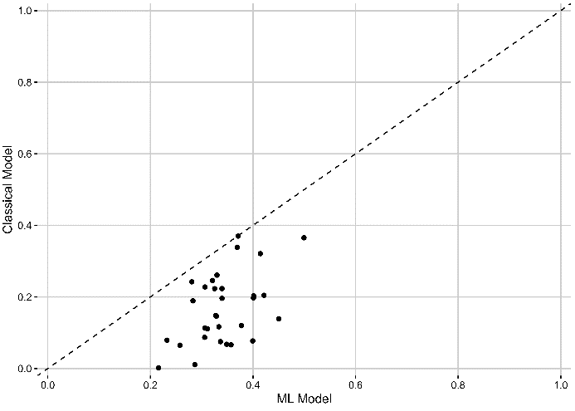

- Health insurance coverage (b) Visited health facility

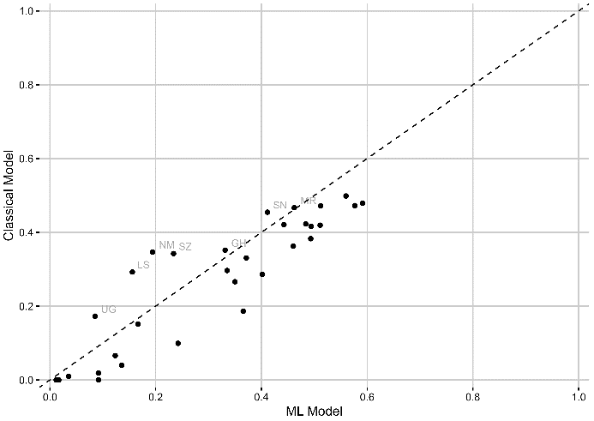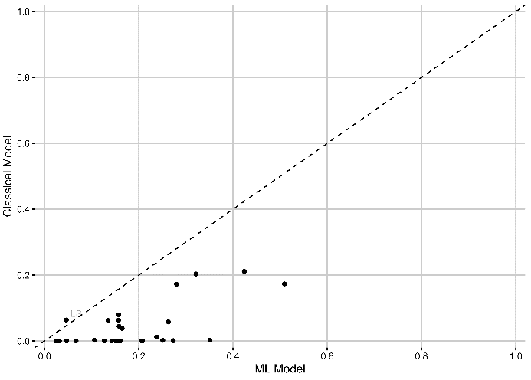
- Facility-based births (d) Postnatal check

Notes: The figures show the predictive power by country for the classical model (consisting of 10 variables most often used by the literature, details see Section 2) and the ML model using a XGBoost model with repeated five-fold cross-validation (consisting of 60-79 variables available in the DHS data, details see Section 2). The performance is measured as Cohen’s Kappa, a measure how often the model correctly predicts the outcome adjusted by the underlining probability to make a correct prediction by chance (more details see Section 3).

Figure A.1: Predictive power of classical models and ML models

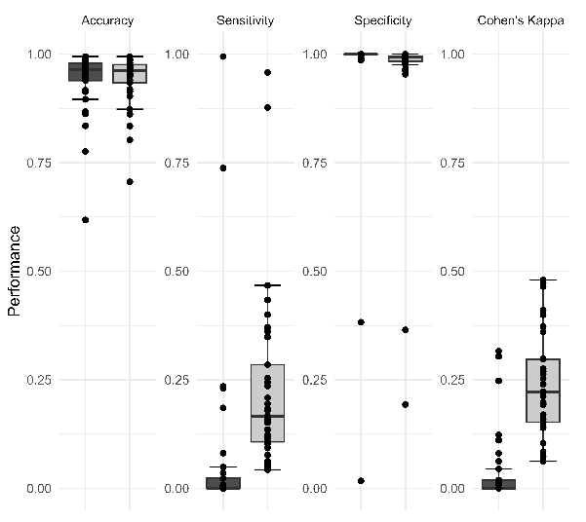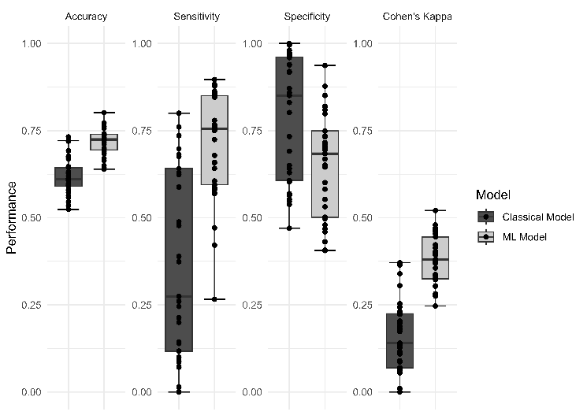

- Health insurance coverage (b) Visited health facility
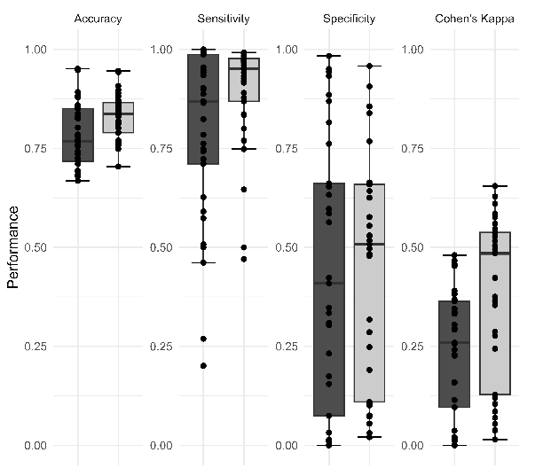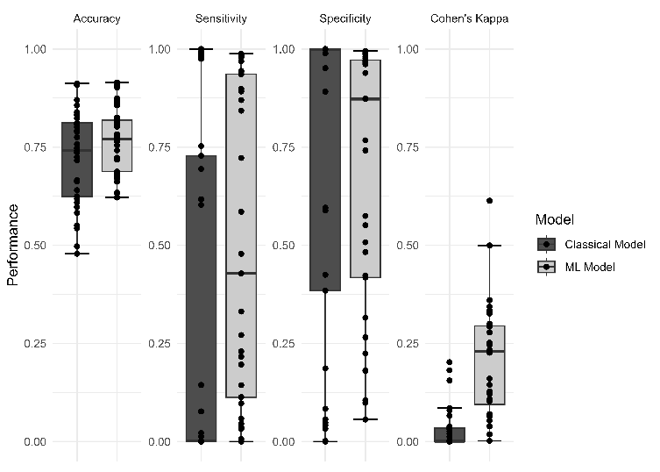
- Facility-based births (d) Postnatal check

Notes: The figures show the predictive power for the classical model (consisting of 10 variables most often used by the literature, details see Section 2) and the ML model using a XGBoost model with repeated five-fold cross-validation (consisting of 60-79 variables available in the DHS data, details see Section 2). The performance values are Accuracy, a measure how often the model correctly predicts the outcome, Cohen’s Kappa, a measure how often the model correctly predicts the outcome adjusted by the underlining probability to make a correct prediction by chance, Sensitivity, a measure to correctly predict true positive cases, and Specificity, a measure to correctly predict true negative cases (more details see Section 3).

Figure A.2: Sensitivity of classical models and ML models
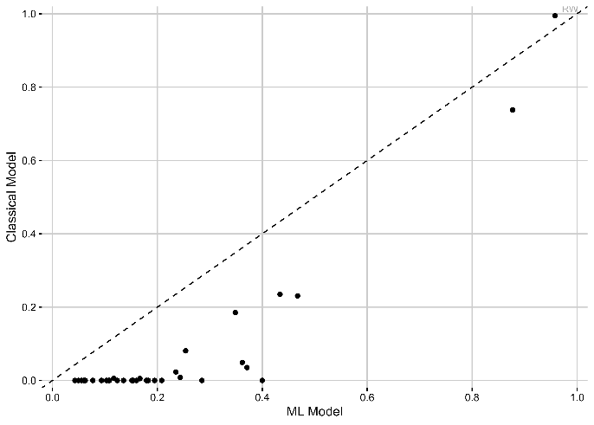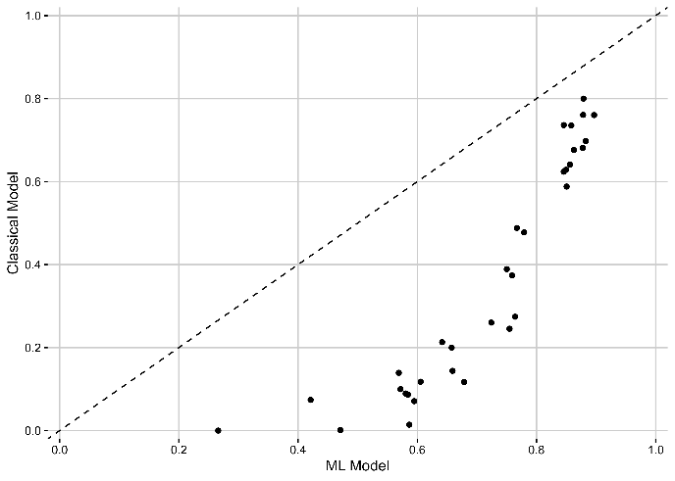

- Health insurance coverage (b) Visited health facility

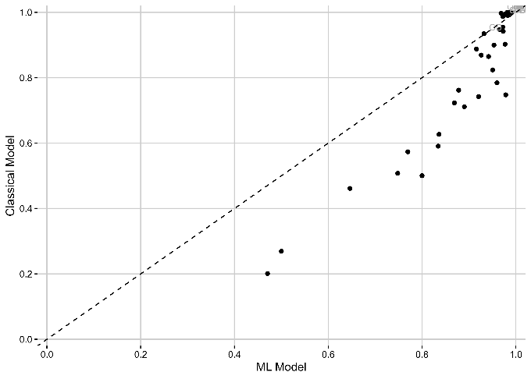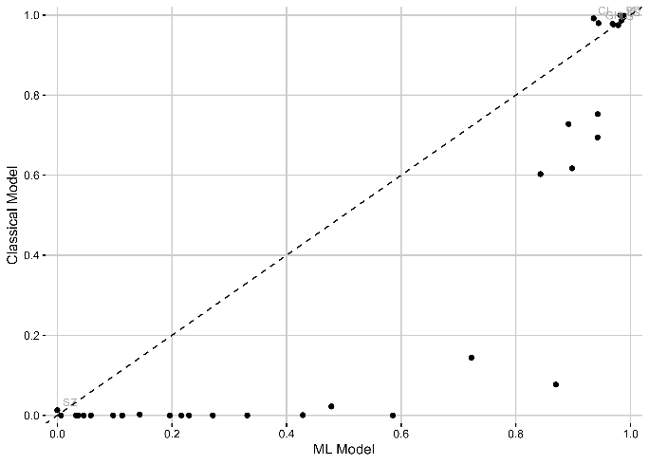
- Facility-based births (d) Postnatal check

Notes: The figures show the predictive power by country for the classical model (consisting of 10 variables most often used by the literature, details see Section 2) and the ML model using a XGBoost model with repeated five-fold cross-validation (consisting of 60-79 variables available in the DHS data, details see Section 2). The performance is measured as Sensitivity, a measure of how often the model correctly predicts the outcome adjusted by the underlining probability to make a correct prediction by chance (more details see Section 3).

Figure 2 shows the top 5 predictors of the ML model for health insurance coverage and take up of health services for each country. In panel (a), the top 5 predictors for health insurance coverage, we find similar to the classical model that socio-economic variables such as wealth or education, or predictors that are highly correlated, such as has a bank account or literate, are strong predictors for the majority of the countries. In contrast, predictors like smoking status or female household headship, often used in classical models, do not rank among the top five in ML models. Only for a few countries used other classical predictors in the top 5, namely rural only for Sao Tome and Principe, and married and age for Burundi (see Table A.2 for detailed predictors per country). Numerical variables, such as the number of household members or the ideal number of children, frequently appear as top predictors, as tree-based ML models can flexibly split these variables. Interestingly, novel predictors, revealed through the data-driven approach of ML models, include mobility (e.g., number of trips taken in the last 12 months used by almost half of the country models), household size (e.g., number of household members used by almost all country models), and Body Mass Index (BMI; used by around 20% of the country models). Nevertheless, many other new potential predictors defined based on the DHS data availability, such as predictors about health, household power structures, culture, language, ethnicity, and religion seem not to significantly contribute as predictors to the models (see Table A.1 for the overview of all available variables).
In Panel (b), we examine the top predictors for whether a woman visited a health facility in the last 12 months. Besides traditional socio-economic factors, predictors related to childbirth or pregnancy frequently emerge as important. For instance, variables such as receiving a tuberculosis injection in the last 12 months, giving birth in the last three years, or being pregnant are key predictors in many countries. Additionally, mobility-related factors, such as the number of trips taken, are highlighted in over half of the countries. In general, the top predictors of each of the 33 countries are very similar. Two exceptions are Ghana and Rwanda, the two SSA countries with the highest insurance coverage rates. Not surprisingly, we see that health insurance coverage is also a top 5 predictor (see Table A.3 for detailed predictors per country).
Panels (c) and (d) focus on maternal health services, specifically health facility-based births and postnatal checks. Similar to the results for general health facility visits, socio-economic factors and recent childbirth are significant predictors. However, health insurance coverage is not a top predictor for these outcomes, likely because many countries provide free maternal and child healthcare services. Unique predictors related to pregnancy and postnatal care—such as receiving a tetanus injection before birth or drugs for intestinal parasites during pregnancy—are prominent in several countries. A greater variety of predictors, including cultural and regional variables, emerge for maternal health outcomes compared to general health service use (see Tables A.4 and A.5 for detailed predictors per country). For instance, in Benin, the model identifies speaking Fon (a language associated with rural areas) as a key predictor, while in Kenya, being part of the Turkana ethnic group (from an underdeveloped region) is essential, highlighting also important regional differences.

Overall, ML models reveal both expected and novel predictors of health insurance coverage and service uptake, offering valuable insights for policy and program design. By adopting a data-driven approach, ML models also reveal novel predictors while capturing contextual nuances like regional or cultural characteristics often overlooked in classical models.

Figure 2: Number of times variable was ranked top 5 for ML prediction for health insurance coverage and take up of health services
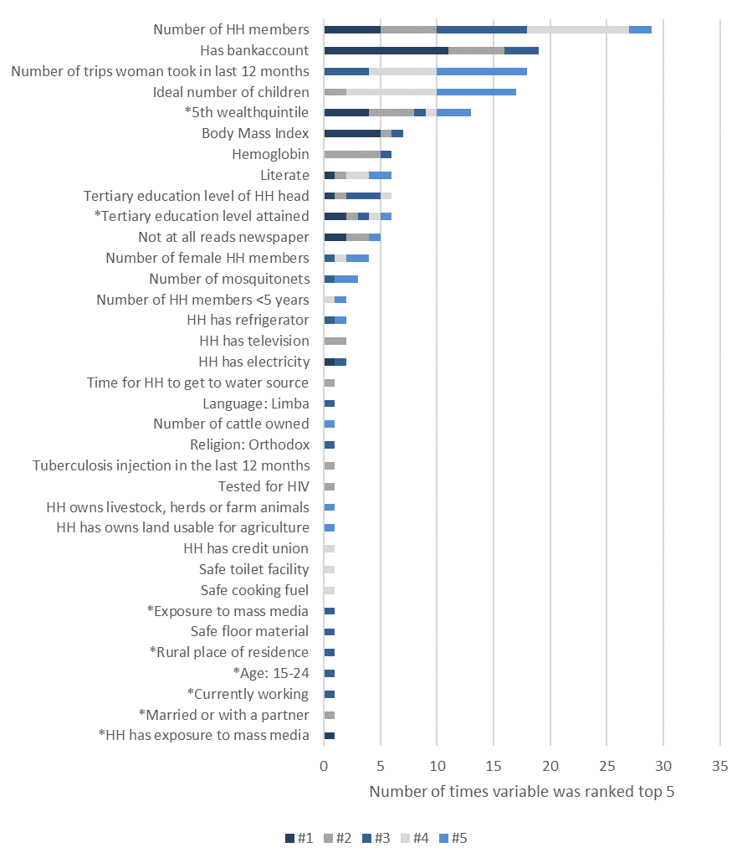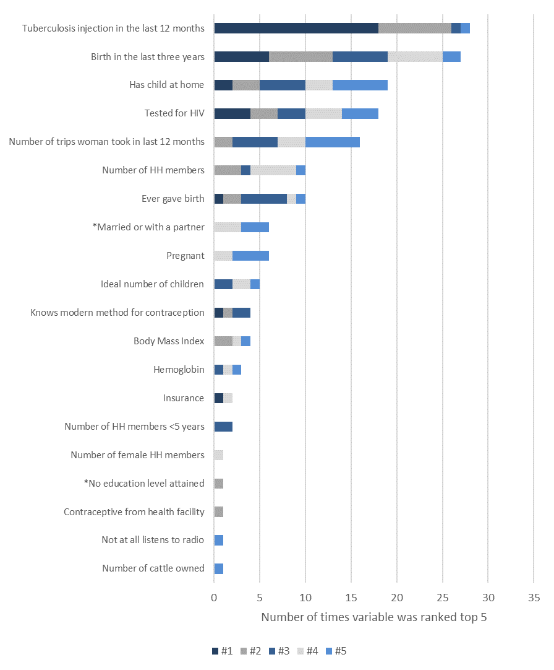
- Health insurance coverage (b) Visited health facility

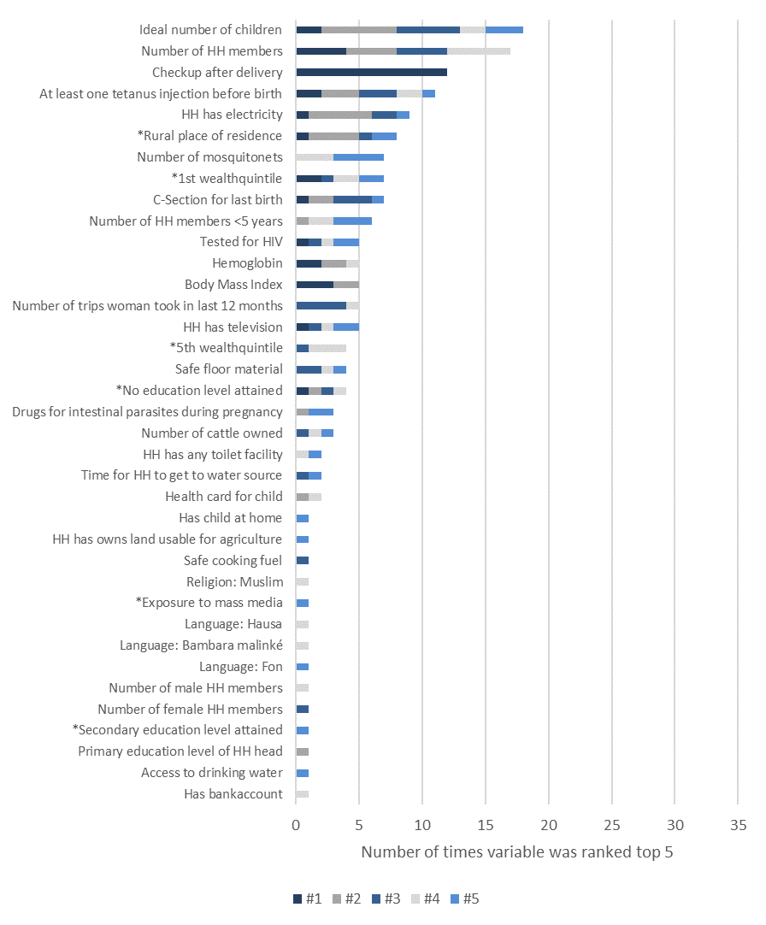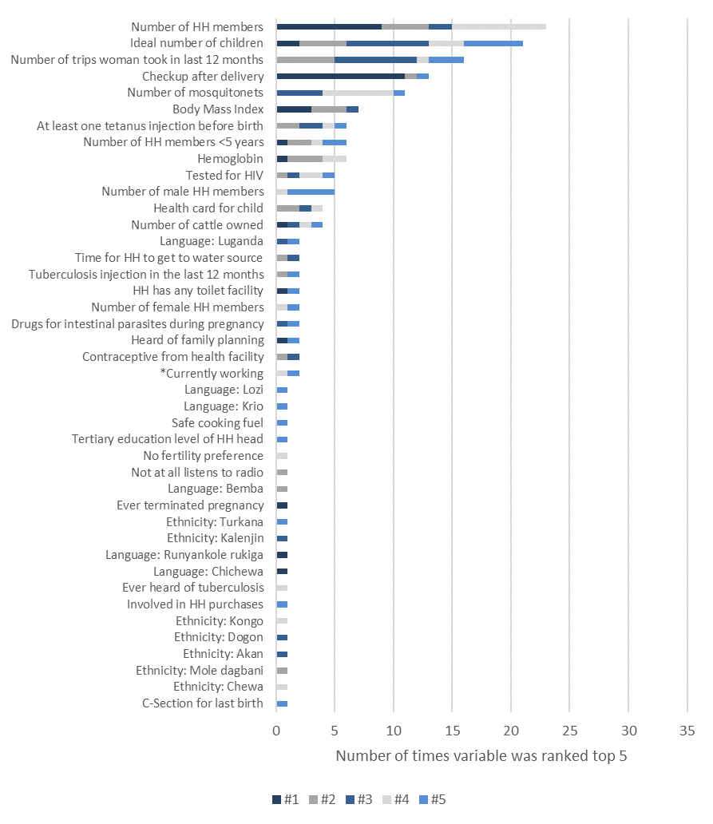
- Facility-based births (d) Postnatal check

Notes: Figures show the number of times the ML model used the variables as a top 5 predictor. Variables with a * highlight variables that are included in the classical model. The total number of times a variable can be ranked as top 5 is 33, since we include 33 countries in the analysis. For some variables, which were not available for all countries based on the selection criteria (see Section 3), the maximum of top 5 predictor is lower than 33. A detailed description of the variables and the availability per country can be found in Appendix Table A.1. The table on country level and with the variable importance score can be found in Appendix Table A.2 – A.4.

Table A.1: Overview of variables
Variables short | Variables description | Number of countries using the variable for the model
member_all_HH | Number of household members (standardized with Z-score normalization)
member_women_HH | Number of eligible women in household (standardized with Z-score normalization)
member_men_HH | Number of eligible men in household (standardized with Z-score normalization)
member_child_under_5 | Number of household members <5 (standardized with Z-score normalization)
region | category, Region
rural | binary, 1 if rural place of residence
safe_drinking_water | binary, 1 if safe drinking water source
water_interrupted | binary, 1 if water was interrupted for a full day or more
safe_toilet_facility | binary, 1 if safe toilet facility
electricity | binary, 1 if household has electricity
radio | binary, 1 if household has radio
television | binary, 1 if household has television
refrigerator | binary, 1 if household has refrigerator
bicycle | binary, 1 if household has bicycle
motorcycle | binary, 1 if household has motorcycle
car | binary, 1 if household has car
safe_floor_material | binary, 1 if safe floor material
female_HH_head | binary, 1 if household head is female
age_HH_head | age of household head (standardized with Z-score normalization)
tel | binary, 1 if household has landline telephone
toilet | binary, 1 if household has any facility
share_toilet | binary, 1 if household shares toilet with other households
safe_cooking_fuel | binary, 1 if household uses safe cooking fuel
mosquitonet | binary, 1 if household uses a mosquitonet for sleeping
child_mosquitonet | binary, 1 if all children sleep under a mosquitonet
soap | binary, 1 if soap present at place for hand washing
mobile | binary, 1 if household has mobile telephone
watch | binary, 1 if household has watch
cart | binary, 1 if household has cart
boat | binary, 1 if household has boat
computer | binary, 1 if household has computer
owns_land | binary, 1 if household has owns land usable for agriculture
owns_livestock | binary, 1 if household owns livestock,herds or farm animals
bankaccount | binary, 1 if household has bankaccount
smoke_inside | binary, 1 if household members smoke inside the house
wealthindex | category, wealth index, combined (in quintiles)
mosquitonets_nr | Number of mosquitonets (standardized with Z-score normalization)
generator | binary, 1 if household has generator
music_system | binary, 1 if household has music system
oven | binary, 1 if household has oven
dvd_player | binary, 1 if household has dvd player
video_recorder | binary, 1 if household has video recorder
internet_connection | binary, 1 if household has internet connection
washing_machine | binary, 1 if household has washing machine
canoe | binary, 1 if household has canoe
credit_union | binary, 1 if household has credit union
safe_trash_disposal | binary, 1 if household has safe trash disposal
safe_sewage_disposal | binary, 1 if household has safe sewage disposal
physical_punishment | binary, 1 if person belives that physical punishment needed to bring up child properly
slept | binary, 1 if person slept last night
female | binary, 1 if female household member
age_cat | categoy, age (15-59 , in 5 year groups)
education | category, highest education level attained (in 4 groups)
education_HH | category, highest education level attained in household (in 4 groups)
married | binary, 1 if person is married or with a partner
married_HH | binary, 1 if someone in household is married or with a partner
migrant | binary, 1 if someone has migrant status
literate | binary, 1 if someone is literate
trad_religion_HH | binary, 1 if household belives in traditional religions (vodoun, autre)
read_newspaper | binary, 1 if women not at all reads newspapers or magazines
listen_radio | binary, 1 if women not at all listens to radio
watch_TV | binary, 1 if women not at all watches television
media | binary, 1 if woman has some exposure to mass media
media_HH | binary, 1 if household has some exposure to mass media
child_born | binary, 1 if women has ever a child born
sondaughterhome | binary, 1 if women has either son or daughter at home
sondaughterdied | binary, 1 if women has either son or daughter who have died
pregnant | binary, 1 if women is pregnant
terminated_pregnancy | binary, 1 if women ever had a terminated pregnancy
birth_last_3y | binary, 1 if women had a birth in the last three years
knows_mordern_method | binary, 1 if women knows modern method for contraception
contraceptive_health_care | binary, 1 if contraceptive requires access to health facility
smokes | binary, 1 if women smokes any cigarette or tobacco
fertility_HH | binary, 1 if household wants to have another baby
currently_working | binary, 1 if women is currently working
female_spend_earnings | binary, 1 if women decides on earnings
female_spend_health_care | binary, 1 if women decides on health care
heard_sti | binary, 1 if women heard of STI
tested_HIV | binary, 1 if women tested for HIV
language | category, Native language of woman
hectares | numeric, Hectares of agricultural land
cattle | Number of cattle owned
bmi | numeric, Body Mass Index
iodine | binary, 1 if salt contains iodine
water_handwash_present | binary, 1 if water is present at handwashing place
water_treated | binary, 1 if Anything done to water to make safe to drink
malaria_mosquito | binary, if respondent thinks malaria contracted via mosquito
malaria_insects | binary, if respondent thinks malaria contracted via other insects
malaria_transfusion | binary, if respondent thinks malaria contracted via blood transfusion
malaria_mother | binary, if respondent thinks malaria contracted via mother
malaria_water | binary, if respondent thinks malaria contracted via drinking water
malaria_sorcery | binary, if respondent thinks malaria contracted via sorcery
beat_child | binary, 1 if respondent thinks Child needs to be physically punished to be brought up properly
religion | category, religion of woman
anemia | binary, has mild, moderate, or severe anemia level
hemoglobin | numeric, hemoglobin level of woman (adjusted for altitude and smoking)
water_time | Time for HH to get to water source (minutes)
trips | Number of trips woman took in last 12 months
ethnicity | category, Ethnicity of woman
decides_health_care | binary, 1 if woman involved in decision about own healthcare
decides_purchases | binary, 1 if woman involved in HH purchases
HIV_witchcraft | binary, 1 if woman believes she can get HIV by witchcraft
safe_source_contracept | binary, 1 if woman used safe source of contraception
heard_family_planning | binary, 1 if woman heard of family planning via any media form
tetanus | binary, 1 if woman has received at least one tetanus injection before birth or pregnancy
checkup_delivery | binary, 1 if woman has received a checkup after delivery
drugs_parasites | binary, 1 if woman took drugs for intestinal parasites during pregnancy
heard_tuberculosis | binary, 1 if woman has ever heard of tuberculosis
injected_tuberculosis | binary, 1 if woman had tuberculosis injection in the last 12 months
health_card | binary, 1 if woman has health card for child
vaccinated | binary, 1 if child has ever been vaccinated
non_numeric_fertility_preference | binary, 1 if woman chose non-numeric response for ideal number of children
ideal_nr_children | numeric, ideal number of children
dom_violence | binary, 1 if women has experienced less severe, severe or sexual violence
child_labor | binary, 1 if child engages in any work activity
child_labor_hours | numeric, number of hours child worked in child labor activities
child_labor_hours_HH | numeric, number of hours child worked in child labor activities in HH
child_labor_HH | binary, 1 if household has child involved in child labor
child_labor_carry_HH | binary, 1 if household has child involved in child labor: carrying heavy loads
child_labor_unsafe_HH | binary, 1 if household has child involved in child labor: activities require working with unsafe tools or operating heavy machinery
drinking_water | binary, Has access to source of drinking water
csection | binary, 1 if C-section for last born child
Notes: Tables shows all variables used for the ML models, using all available variables in the DHS data. For each country all available variables were used, excluding variables that have no variation after creating the sub-sample for the outcome or that generate less than 10% missing data in order to avoid a too small sample (see details for variable selection in Section 3).
Table A.2: Top 5 predictors of the ML model for health insurance coverage
 | Top #1 |  | Top #2 |  |  | Top #3 |  |  | Top #4 |  |  | Top #5
 | Predictor | Variable Importance | Predictor | Variable Importance | Predictor |  | Variable Importance | Predictor |  | Variable Importance | Predictor |  | Variable Importance
Benin | Has bankaccount | 100 | *5th wealthquintile | 43 | Tertiary education level of HH head |  | 38 | Number of HH members |  | 35 | Literate |  | 28
Burkina.Faso | Not at all reads newspaper | 100 | Has bankaccount | 92 | HH has electricity |  | 54 | Number of HH members |  | 37 | Ideal number of children |  | 36
Burundi | Has bankaccount | 100 | *Married or with a partner | 61 | *Age: 15-24 |  | 35 | Number of HH members |  | 24 | Number of trips woman took in last 12 months |  | 22
Cameroon | *5th wealthquintile | 100 | Number of HH members | 54 | Number of trips woman took in last 12 months |  | 54 | Ideal number of children |  | 50 | *Tertiary education level attained |  | 50
Chad | Not at all reads newspaper | 100 | Tested for HIV | 29 | Number of trips woman took in last 12 months |  | 17 | Number of HH members |  | 8 | HH owns livestock, herds or farm animals |  | 8
Comoros | Body Mass Index | 100 | Has bankaccount | 46 | Number of HH members |  | 44 | Number of trips woman took in last 12 months |  | 35 | Number of mosquitonets |  | 34
Cote dIvoire | Has bankaccount | 100 | *5th wealthquintile | 41 | Number of HH members |  | 40 | Literate |  | 32 | Number of trips woman took in last 12 months |  | 25
DRC | *5th wealthquintile | 100 | Time for HH to get to water source | 79 | Safe floor material |  | 61 | Number of HH members |  | 56 | Ideal number of children |  | 52
Eswatini | *5th wealthquintile | 100 | Hemoglobin | 81 | Body Mass Index |  | 65 | Number of trips woman took in last 12 months |  | 40 | Number of HH members |  | 31
Ethiopia | Body Mass Index | 100 | Hemoglobin | 81 | Religion: Orthodox |  | 52 | Ideal number of children |  | 39 | Number of cattle owned |  | 28
Ghana | Number of HH members | 100 | Tuberculosis injection in the last 12 months | 87 | Number of trips woman took in last 12 months |  | 71 | HH has credit union |  | 60 | Ideal number of children |  | 53
Guinea | Has bankaccount | 100 | *5th wealthquintile | 57 | HH has refrigerator |  | 29 | Literate |  | 25 | Number of female HH members |  | 24
Kenya | Body Mass Index | 100 | Has bankaccount | 67 | *Tertiary education level attained |  | 38 | Number of HH members |  | 33 | Ideal number of children |  | 25
Lesotho | Number of HH members | 100 | *Tertiary education level attained | 100 | Number of trips woman took in last 12 months |  | 85 | Safe cooking fuel |  | 74 | *5th wealthquintile |  | 51
Liberia | *Exposure to mass media | 100 | Number of HH members | 79 | *HH has exposure to mass media |  | 73 | Ideal number of children |  | 62 | HH has owns land usable for agriculture |  | 54
Madagascar | Has bankaccount | 100 | HH has television | 73 | *5th wealthquintile |  | 65 | Number of HH members |  | 40 | Ideal number of children |  | 30
Malawi | HH has electricity | 100 | Has bankaccount | 94 | Tertiary education level of HH head |  | 49 | Number of HH members |  | 46 | Not at all reads newspaper |  | 40
Mali | Has bankaccount | 100 | Literate | 54 | Number of HH members |  | 31 | *5th wealthquintile |  | 28 | Number of trips woman took in last 12 months |  | 21
Mauritania | Has bankaccount | 100 | Number of HH members | 31 | Number of female HH members |  | 11 | Number of HH members <5 years |  | 14 | *5th wealthquintile |  | 28
Namibia | *5th wealthquintile | 100 | Number of HH members | 57 | *Currently working |  | 57 | Number of trips woman took in last 12 months |  | 52 | Ideal number of children |  | 46
Niger | Has bankaccount | 100 | HH has television | 54 | Number of HH members |  | 25 | Ideal number of children |  | 21 | HH has refrigerator |  | 19
Nigeria | *Tertiary education level attained | 100 | Tertiary education level of HH head | 71 | Number of HH members |  | 59 | Number of trips woman took in last 12 months |  | 56 | Ideal number of children |  | 52
Republic of the Congo | Has bankaccount | 100 | *5th wealthquintile | 79 | Number of HH members |  | 75 | Ideal number of children |  | 71 | Literate |  | 47
Rwanda | Number of HH members | 100 | Ideal number of children | 73 | Has bankaccount |  | 46 | Number of trips woman took in last 12 months |  | 43 | Number of HH members <5 years |  | 40
Sao Tome & Principe | Body Mass Index | 100 | Hemoglobin | 91 | *Rural place of residence |  | 71 | Ideal number of children |  | 58 | Number of HH members |  | 55
Senegal | Number of HH members | 100 | Has bankaccount | 99 | Number of mosquitonets |  | 84 | Number of female HH members |  | 66 | Number of trips woman took in last 12 months |  | 52
Sierra Leone | Number of HH members | 100 | Ideal number of children | 77 | Language: Limba |  | 54 | Number of trips woman took in last 12 months |  | 53 | Number of mosquitonets |  | 51
Tanzania | Body Mass Index | 100 | Hemoglobin | 62 | Number of HH members |  | 38 | Ideal number of children |  | 31 | Number of trips woman took in last 12 months |  | 20
The Gambia | Literate | 100 | Not at all reads newspaper | 100 | Has bankaccount |  | 95 | Number of HH members |  | 82 | Number of female HH members |  | 59
Togo | Has bankaccount | 100 | Number of HH members | 31 | Tertiary education level of HH head |  | 30 | Safe toilet facility |  | 25 | Number of trips woman took in last 12 months |  | 23
Uganda | Tertiary education level of HH head | 100 | Not at all reads newspaper | 87 | Number of HH members |  | 87 | Ideal number of children |  | 76 | Number of trips woman took in last 12 months |  | 74
Zambia | *Tertiary education level attained | 100 | Hemoglobin | 43 | Has bankaccount |  | 43 | Tertiary education level of HH head |  | 41 | *5th wealthquintile |  | 39
Zimbabwe | Has bankaccount | 100 | Body Mass Index | 52 | Hemoglobin |  | 37 | *Tertiary education level attained |  | 28 | Number of trips woman took in last 12 months |  | 26
Notes: Table show the predictors and the variable importance of the top 5 predictors of the ML model. A predictor’s importance score is defined by the decrease in the classification error that is attributed to all of its splits in a given tree, averaged across all trees and normalized to a range from 0-100. Variables with a * highlight variables that are included in the classical model.

Table A.3: Top 5 predictors of the ML model for take-up of visited a health facility
 | Top #1 |  | Top #2 |  |  | Top #3 |  |  | Top #4 |  |  | Top #5
 | Predictor | Variable Importance | Predictor | Variable Importance | Predictor |  | Variable Importance | Predictor |  | Variable Importance | Predictor |  | Variable Importance
Benin | Tuberculosis injection in the last 12 months | 100 | Birth in the last three years | 27 | Ideal number of children |  | 12 | Number of HH members |  | 10 | Ever gave birth |  | 9
Burkina.Faso | Birth in the last three years | 100 | Tuberculosis injection in the last 12 months | 82 | Has child at home |  | 27 | Tested for HIV |  | 23 | Pregnant |  | 18
Burundi | Has child at home | 100 | Tuberculosis injection in the last 12 months | 53 | Ever gave birth |  | 29 | Birth in the last three years |  | 20 | *Married or with a partner |  | 16
Cameroon | Tuberculosis injection in the last 12 months | 100 | Tested for HIV | 60 | Has child at home |  | 45 | Birth in the last three years |  | 43 | Number of trips woman took in last 12 months |  | 25
Chad | Knows modern method for contraception | 100 | *No education level attained | 30 | Number of trips woman took in last 12 months |  | 19 | Birth in the last three years |  | 18 | Has child at home |  | 16
Comoros | Tuberculosis injection in the last 12 months | 100 | Number of trips woman took in last 12 months | 88 | Birth in the last three years |  | 58 | *Married or with a partner |  | 51 | Body Mass Index |  | 49
Cote dIvoire | Tuberculosis injection in the last 12 months | 100 | Birth in the last three years | 58 | Tested for HIV |  | 23 | Number of trips woman took in last 12 months |  | 88 | Pregnant |  | 11
DRC | Tuberculosis injection in the last 12 months | 100 | Has child at home | 27 | Birth in the last three years |  | 24 | *Married or with a partner |  | 15 | Number of trips woman took in last 12 months |  | 13
Eswatini | Birth in the last three years | 100 | Tuberculosis injection in the last 12 months | 99 | Ever gave birth |  | 37 | Body Mass Index |  | 13 | Has child at home |  | 9
Ethiopia | Tuberculosis injection in the last 12 months | 100 | Tested for HIV | 99 | Ever gave birth |  | 32 | *Married or with a partner |  | 29 | Birth in the last three years |  | 27
Ghana | Tuberculosis injection in the last 12 months | 100 | Birth in the last three years | 47 | Tested for HIV |  | 28 | Insurance |  | 18 | Has child at home |  | 12
Guinea | Tuberculosis injection in the last 12 months | 100 | Knows modern method for contraception | 40 | Birth in the last three years |  | 32 | Number of HH members |  | 29 | Number of trips woman took in last 12 months |  | 27
Kenya | Tuberculosis injection in the last 12 months | 100 | Body Mass Index | 63 | Ideal number of children |  | 47 | Number of trips woman took in last 12 months |  | 45 | Has child at home |  | 42
Lesotho | Tuberculosis injection in the last 12 months | 100 | Tested for HIV | 98 | Ever gave birth |  | 76 | Number of trips woman took in last 12 months |  | 61 | Birth in the last three years |  | 43
Liberia | Tested for HIV | 100 | Birth in the last three years | 70 | Has child at home |  | 68 | Number of HH members |  | 55 | Pregnant |  | 47
Madagascar | Tuberculosis injection in the last 12 months | 100 | Has child at home | 30 | Birth in the last three years |  | 29 | Tested for HIV |  | 19 | Number of HH members |  | 15
Malawi | Tuberculosis injection in the last 12 months | 100 | Ever gave birth | 96 | Has child at home |  | 89 | Birth in the last three years |  | 48 | Tested for HIV |  | 43
Mali | Tuberculosis injection in the last 12 months | 100 | Number of HH members | 28 | Tested for HIV |  | 27 | Birth in the last three years |  | 27 | Number of trips woman took in last 12 months |  | 27
Mauritania | Birth in the last three years | 100 | Number of HH members | 89 | Knows modern method for contraception |  | 72 | Pregnant |  | 65 | Not at all listens to radio |  | 65
Namibia | Tested for HIV | 100 | Tuberculosis injection in the last 12 months | 65 | Number of trips woman took in last 12 months |  | 64 | Number of HH members |  | 62 | Number of cattle owned |  | 45
Niger | Birth in the last three years | 100 | Tuberculosis injection in the last 12 months | 94 | Knows modern method for contraception |  | 35 | Ideal number of children |  | 28 | Has child at home |  | 27
Nigeria | Tuberculosis injection in the last 12 months | 100 | Birth in the last three years | 42 | Number of trips woman took in last 12 months |  | 15 | Number of HH members |  | 13 | Ideal number of children |  | 11
Republic of the Congo | Tuberculosis injection in the last 12 months | 100 | Birth in the last three years | 31 | Has child at home |  | 18 | Pregnant |  | 16 | Tested for HIV |  | 15
Rwanda | Insurance | 100 | Tuberculosis injection in the last 12 months | 92 | Ever gave birth |  | 57 | Has child at home |  | 39 | Tested for HIV |  | 37
Sao Tome & Principe | Tested for HIV | 100 | Has child at home | 67 | Number of HH members <5 years |  | 52 | Birth in the last three years |  | 41 | *Married or with a partner |  | 37
Senegal | Ever gave birth | 100 | Contraceptive from health facility | 24 | Birth in the last three years |  | 23 | Has child at home |  | 23 | Pregnant |  | 22
Sierra Leone | Birth in the last three years | 100 | Tuberculosis injection in the last 12 months | 93 | Number of HH members |  | 72 | Ideal number of children |  | 58 | Number of trips woman took in last 12 months |  | 58
Tanzania | Has child at home | 100 | Tuberculosis injection in the last 12 months | 74 | Birth in the last three years |  | 72 | Ever gave birth |  | 37 | Hemoglobin |  | 23
The Gambia | Birth in the last three years | 100 | Number of HH members | 71 | Number of HH members <5 years |  | 42 | Number of female HH members |  | 40 | Tuberculosis injection in the last 12 months |  | 35
Togo | Tuberculosis injection in the last 12 months | 100 | Birth in the last three years | 32 | Number of trips woman took in last 12 months |  | 18 | Tested for HIV |  | 14 | *Married or with a partner |  | 9
Uganda | Tuberculosis injection in the last 12 months | 100 | Ever gave birth | 61 | Number of trips woman took in last 12 months |  | 57 | Tested for HIV |  | 39 | Has child at home |  | 25
Zambia | Tuberculosis injection in the last 12 months | 100 | Number of trips woman took in last 12 months | 59 | Hemoglobin |  | 58 | Has child at home |  | 49 | Tested for HIV |  | 36
Zimbabwe | Tested for HIV | 100 | Body Mass Index | 72 | Tuberculosis injection in the last 12 months |  | 56 | Hemoglobin |  | 43 | Number of trips woman took in last 12 months |  | 35
Notes: Table show the predictors and the variable importance of the top 5 predictors of the ML model. A predictor’s importance score is defined by the decrease in the classification error that is attributed to all of its splits in a given tree, averaged across all trees and normalized to a range from 0-100. Variables with a * highlight variables that are included in the classical model
Table A.4: Top 5 predictors of the ML model for take-up of health facility-based birth
 | Top #1 |  | Top #2 |  |  | Top #3 |  |  | Top #4 |  |  | Top #5
 | Predictor | Variable Importance | Predictor | Variable Importance | Predictor |  | Variable Importance | Predictor |  | Variable Importance | Predictor |  | Variable Importance
Benin | At least one tetanus injection before birth | 100 | Drugs for intestinal parasites during pregnancy | 58 | Ideal number of children |  | 46 | Number of HH members |  | 38 | Language: Fon |  | 25
Burkina.Faso | Checkup after delivery | 100 | Ideal number of children | 17 | Number of cattle owned |  | 17 | Number of HH members |  | 13 | Time for HH to get to water source |  | 11
Burundi | Number of HH members | 100 | Ideal number of children | 92 | Number of trips woman took in last 12 months |  | 62 | Number of male HH members |  | 54 | Number of HH members <5 years |  | 46
Cameroon | HH has electricity | 100 | *No education level attained | 55 | At least one tetanus injection before birth |  | 54 | Tested for HIV |  | 53 | *Exposure to mass media |  | 19
Chad | Checkup after delivery | 100 | Number of HH members | 29 | At least one tetanus injection before birth |  | 16 | *5th wealthquintile |  | 15 | Number of mosquitonets |  | 16
Comoros | Checkup after delivery | 100 | Body Mass Index | 36 | *No education level attained |  | 25 | Number of HH members |  | 18 | Number of mosquitonets |  | 15
Cote dIvoire | Checkup after delivery | 100 | HH has electricity | 74 | *Rural place of residence |  | 72 | HH has television |  | 34 | Ideal number of children |  | 29
DRC | Checkup after delivery | 100 | Health card for child | 84 | Time for HH to get to water source |  | 74 | At least one tetanus injection before birth |  | 61 | Ideal number of children |  | 55
Eswatini | Hemoglobin | 100 | Body Mass Index | 88 | Number of trips woman took in last 12 months |  | 54 | Number of HH members |  | 50 | Number of cattle owned |  | 33
Ethiopia | Tested for HIV | 100 | *Rural place of residence | 40 | HH has electricity |  | 39 | *5th wealthquintile |  | 33 | At least one tetanus injection before birth |  | 27
Ghana | Checkup after delivery | 100 | *Rural place of residence | 32 | C-Section for last birth |  | 23 | Number of HH members |  | 12 | Access to drinking water |  | 12
Guinea | *Rural place of residence | 100 | At least one tetanus injection before birth | 60 | HH has television |  | 27 | Religion: Muslim |  | 26 | *1st wealthquintile |  | 25
Kenya | *1st wealthquintile | 100 | C-Section for last birth | 49 | Safe floor material |  | 34 | *No education level attained |  | 26 | HH has electricity |  | 24
Lesotho | Checkup after delivery | 100 | C-Section for last birth | 5 | Number of HH members |  | 3 | Has bankaccount |  | 3 | Safe floor material |  | 3
Liberia | Ideal number of children | 100 | Number of HH members | 85 | At least one tetanus injection before birth |  | 64 | Number of HH members <5 years |  | 55 | Number of mosquitonets |  | 46
Madagascar | HH has television | 100 | At least one tetanus injection before birth | 84 | C-Section for last birth |  | 76 | *5th wealthquintile |  | 67 | Drugs for intestinal parasites during pregnancy |  | 60
Malawi | Ideal number of children | 100 | Number of HH members | 87 | Number of trips woman took in last 12 months |  | 57 | Number of mosquitonets |  | 48 | Number of HH members <5 years |  | 41
Mali | At least one tetanus injection before birth | 100 | HH has electricity | 19 | Safe floor material |  | 18 | Language: Bambara malinké |  | 13 | HH has any toilet facility |  | 13
Mauritania | *1st wealthquintile | 100 | HH has electricity | 93 | Safe cooking fuel |  | 83 | At least one tetanus injection before birth |  | 60 | HH has television |  | 53
Namibia | Checkup after delivery | 100 | Ideal number of children | 75 | Number of HH members |  | 63 | Number of cattle owned |  | 45 | *Secondary education level attained |  | 43
Niger | Checkup after delivery | 100 | *Rural place of residence | 29 | HH has electricity |  | 11 | Health card for child |  | 7 | Tested for HIV |  | 5
Nigeria | *No education level attained | 100 | At least one tetanus injection before birth | 57 | Ideal number of children |  | 56 | Language: Hausa |  | 46 | HH has television |  | 38
Republic of the Congo | Checkup after delivery | 100 | Ideal number of children | 35 | Number of HH members |  | 28 | *1st wealthquintile |  | 25 | Drugs for intestinal parasites during pregnancy |  | 22
Rwanda | Number of HH members | 100 | Ideal number of children | 78 | C-Section for last birth |  | 60 | Number of HH members <5 years |  | 48 | Has child at home |  | 45
Sao Tome & Principe | Body Mass Index | 100 | Hemoglobin | 91 | Number of HH members |  | 48 | Ideal number of children |  | 37 | HH has owns land usable for agriculture |  | 33
Senegal | Checkup after delivery | 100 | HH has electricity | 11 | *1st wealthquintile |  | 7 | HH has any toilet facility |  | 7 | *Rural place of residence |  | 6
Sierra Leone | Number of HH members | 100 | Ideal number of children | 77 | Number of trips woman took in last 12 months |  | 58 | Number of mosquitonets |  | 50 | Number of HH members <5 years |  | 44
Tanzania | Body Mass Index | 100 | *Rural place of residence | 87 | Ideal number of children |  | 82 | Hemoglobin |  | 76 | C-Section for last birth |  | 68
The Gambia | Number of HH members | 100 | Number of HH members <5 years | 50 | Number of female HH members |  | 39 | Number of mosquitonets |  | 37 | *1st wealthquintile |  | 34
Togo | Checkup after delivery | 100 | HH has electricity | 32 | Ideal number of children |  | 18 | *1st wealthquintile |  | 18 | Tested for HIV |  | 15
Uganda | C-Section for last birth | 100 | Primary education level of HH head | 84 | *5th wealthquintile |  | 75 | Safe floor material |  | 45 | Ideal number of children |  | 42
Zambia | Hemoglobin | 100 | Number of HH members | 48 | Ideal number of children |  | 45 | Number of trips woman took in last 12 months |  | 23 | Number of mosquitonets |  | 22
Zimbabwe | Body Mass Index | 100 | Hemoglobin | 72 | Tested for HIV |  | 48 | Ideal number of children |  | 38 | *Rural place of residence |  | 36
Notes: Table show the predictors and the variable importance of the top 5 predictors of the ML model. A predictor’s importance score is defined by the decrease in the classification error that is attributed to all of its splits in a given tree, averaged across all trees and normalized to a range from 0-100. Variables with a * highlight variables that are included in the classical model.

Table A.5: Top 5 predictors of the ML model for take-up of postnatal check
 | Top #1 |  | Top #2 |  |  | Top #3 |  |  | Top #4 |  |  | Top #5
 | Predictor | Variable Importance | Predictor | Variable Importance | Predictor |  | Variable Importance | Predictor |  | Variable Importance | Predictor |  | Variable Importance
Benin | Number of HH members | 100 | Ideal number of children | 78 | Number of mosquitonets |  | 69 | Number of HH members <5 years |  | 47 | Number of male HH members |  | 38
Burkina.Faso | Number of cattle owned | 100 | Checkup after delivery | 84 | Time for HH to get to water source |  | 74 | Number of HH members |  | 67 | Ideal number of children |  | 55
Burundi | Number of HH members | 100 | Ideal number of children | 100 | Number of trips woman took in last 12 months |  | 88 | Number of mosquitonets |  | 50 | Number of male HH members |  | 49
Cameroon | Ever terminated pregnancy | 100 | Tested for HIV | 99 | Number of trips woman took in last 12 months |  | 87 | Number of HH members |  | 87 | C-Section for last birth |  | 83
Chad | Checkup after delivery | 100 | Number of HH members | 41 | At least one tetanus injection before birth |  | 26 | Health card for child |  | 23 | Number of HH members <5 years |  | 22
Comoros | Checkup after delivery | 100 | Body Mass Index | 67 | Number of cattle owned |  | 47 | No fertility preference |  | 24 | Tertiary education level of HH head |  | 21
Cote dIvoire | Checkup after delivery | 100 | Health card for child | 14 | Number of trips woman took in last 12 months |  | 12 | Number of HH members |  | 12 | Safe cooking fuel |  | 10
DRC | Checkup after delivery | 100 | Time for HH to get to water source | 68 | Ideal number of children |  | 51 | Number of HH members |  | 50 | Number of trips woman took in last 12 months |  | 23
Eswatini | Body Mass Index | 100 | Hemoglobin | 87 | Number of HH members |  | 60 | Ideal number of children |  | 55 | Number of trips woman took in last 12 months |  | 49
Ethiopia | Body Mass Index | 100 | Hemoglobin | 62 | Tested for HIV |  | 34 | Ideal number of children |  | 34 | Number of HH members |  | 26
Ghana | Checkup after delivery | 100 | Ethnicity: Mole dagbani | 90 | Ethnicity: Akan |  | 74 | Ever heard of tuberculosis |  | 67 | HH has any toilet facility |  | 60
Guinea | Number of HH members | 100 | At least one tetanus injection before birth | 79 | Number of trips woman took in last 12 months |  | 64 | Number of mosquitonets |  | 62 | Number of male HH members |  | 54
Kenya | Checkup after delivery | 100 | Body Mass Index | 90 | Ethnicity: Kalenjin |  | 56 | Ideal number of children |  | 36 | Ethnicity: Turkana |  | 25
Lesotho | Number of HH members | 100 | Number of trips woman took in last 12 months | 74 | Ideal number of children |  | 59 | Number of cattle owned |  | 55 | Checkup after delivery |  | 42
Liberia | HH has any toilet facility | 100 | Ideal number of children | 89 | Contraceptive from health facility |  | 72 | *Currently working |  | 72 | Heard of family planning |  | 64
Madagascar | Heard of family planning | 100 | Not at all listens to radio | 93 | Ideal number of children |  | 46 | Number of HH members |  | 45 | Tested for HIV |  | 42
Malawi | Language: Chichewa | 100 | Tuberculosis injection in the last 12 months | 52 | Number of trips woman took in last 12 months |  | 40 | Ethnicity: Chewa |  | 40 | *Currently working |  | 38
Mali | Number of HH members | 100 | Number of trips woman took in last 12 months | 71 | Ethnicity: Dogon |  | 63 | Number of mosquitonets |  | 57 | Tuberculosis injection in the last 12 months |  | 56
Mauritania | Number of HH members | 100 | Number of HH members <5 years | 44 | Number of mosquitonets |  | 57 | Number of male HH members |  | 30 | Number of female HH members |  | 31
Namibia | Checkup after delivery | 100 | Number of HH members | 78 | Ideal number of children |  | 63 | Number of trips woman took in last 12 months |  | 60 | Number of cattle owned |  | 52
Niger | Checkup after delivery | 100 | Health card for child | 78 | At least one tetanus injection before birth |  | 51 | Tested for HIV |  | 11 | Involved in HH purchases |  | 11
Nigeria | Ideal number of children | 100 | Number of trips woman took in last 12 months | 98 | Number of HH members |  | 92 | Number of mosquitonets |  | 59 | At least one tetanus injection before birth |  | 57
Republic of the Congo | Checkup after delivery | 100 | Number of HH members | 19 | Ideal number of children |  | 18 | Ethnicity: Kongo |  | 11 | Number of mosquitonets |  | 10
Rwanda | Number of HH members | 100 | Ideal number of children | 87 | Number of trips woman took in last 12 months |  | 63 | Number of mosquitonets |  | 57 | Drugs for intestinal parasites during pregnancy |  | 51
Sao Tome & Principe | Hemoglobin | 100 | Body Mass Index | 99 | Number of trips woman took in last 12 months |  | 40 | Number of HH members |  | 34 | Ideal number of children |  | 29
Senegal | Checkup after delivery | 100 | Number of HH members | 18 | Number of mosquitonets |  | 15 | At least one tetanus injection before birth |  | 14 | Number of HH members <5 years |  | 12
Sierra Leone | Number of HH members | 100 | Number of trips woman took in last 12 months | 79 | Ideal number of children |  | 73 | Number of mosquitonets |  | 48 | Language: Krio |  | 48
Tanzania | Number of HH members <5 years | 100 | Contraceptive from health facility | 76 | Body Mass Index |  | 76 | Hemoglobin |  | 71 | Ideal number of children |  | 47
The Gambia | Number of HH members | 100 | Number of HH members <5 years | 69 | Number of mosquitonets |  | 58 | Number of female HH members |  | 55 | Number of male HH members |  | 52
Togo | Checkup after delivery | 100 | At least one tetanus injection before birth | 26 | Health card for child |  | 18 | Tested for HIV |  | 14 | Ideal number of children |  | 11
Uganda | Language: Runyankole rukiga | 100 | Number of trips woman took in last 12 months | 87 | Language: Luganda |  | 72 | Number of HH members |  | 70 | Ideal number of children |  | 67
Zambia | Ideal number of children | 100 | Language: Bemba | 98 | Drugs for intestinal parasites during pregnancy |  | 97 | Hemoglobin |  | 81 | Language: Lozi |  | 76
Zimbabwe | Body Mass Index | 100 | Hemoglobin | 78 | Ideal number of children |  | 31 | Number of HH members |  | 30 | Number of trips woman took in last 12 months |  | 28
Notes: Table show the predictors and the variable importance of the top 5 predictors of the ML model. A predictor’s importance score is defined by the decrease in the classification error that is attributed to all of its splits in a given tree, averaged across all trees and normalized to a range from 0-100. Variables with a * highlight variables that are included in the classical model.
  - Small-Scale predictions of health insurance coverage and take up of health services
Many nationally representative surveys containing important information about health insurance coverage and take up of health services, such as the DHS survey, are only representative on regional level and not on the lower administrative levels. On contrary, large-scale census surveys do not contain health-related information. Based on the improved prediction with ML models, we make in this Section out-of-sample predictions with census data to gain insights on a lower administrative level for the whole population.
Figure 3 shows the

Figure 3: Comparison of average health insurance coverage based on DHS and Census Data
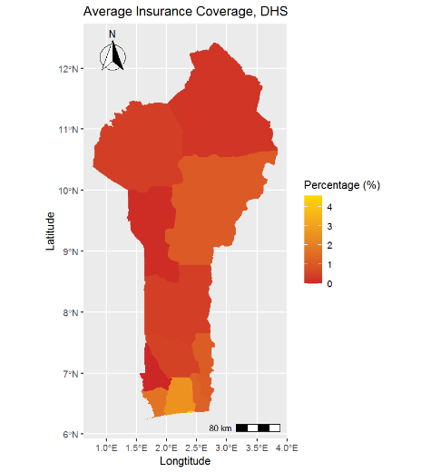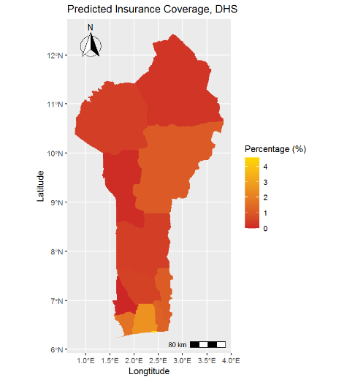
(a) Measured in DHS (b) ML prediction with DHS data
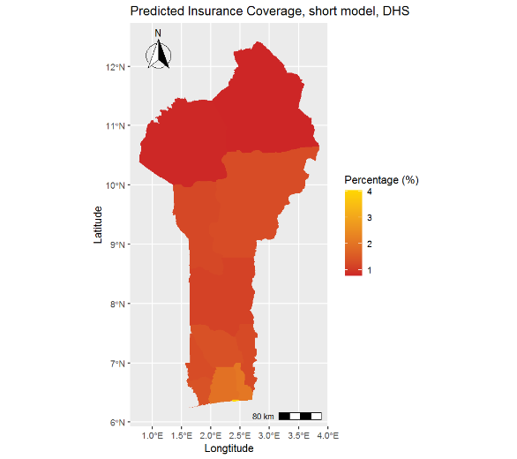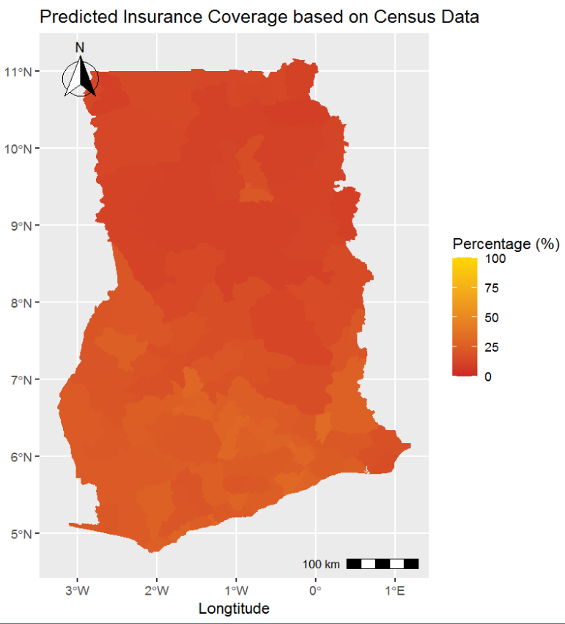
(c) ML prediction with restricted DHS data (d) ML prediction with CENSUS data
Note: The figures show exemplary for the case of Ghana (a) the reported regional (admin 1 level) averages in the DHS data, (b) the predicted district (admin 2 level) averages based on the ML model shown in Section 4.1, (c) the predicted district (admin 2 level) average based on the ML model with restricted number of variables from the DHS data, (d) the predicted district (admin 2 level) average based on the ML model with restricted number of variables from the CENSUS data. Districts with less than 30 observations are labelled as NA.

Figure A.3: Comparison prediction of health insurance coverage based on DHS and Census data
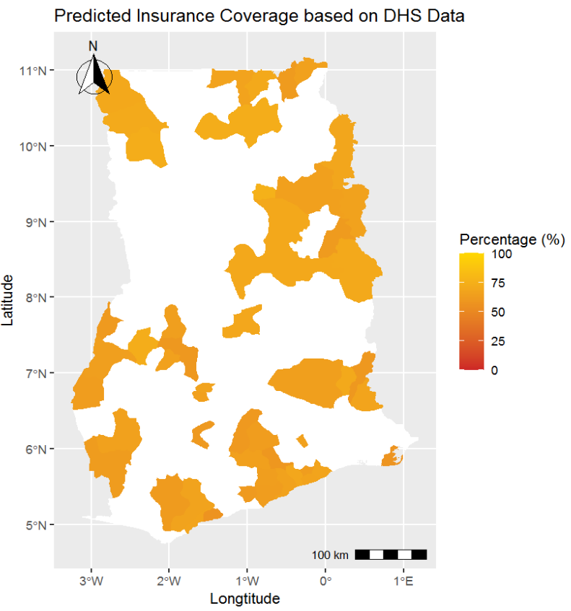
(a) Ghana
Note: The figures show for all 33 SSA counties (left) the reported regional (admin 1 level) averages in the DHS data, (right) the predicted district (admin 2 level) average based on the ML model with restricted number of variables from the CENSUS data.

Figure A.4: Comparison prediction of health insurance coverage based on DHS if no Census data available
(a) Ghana
Note: The figures show for all 33 SSA counties (left) the reported regional (admin 1 level) averages in the DHS data, (right) the predicted district (admin 2 level) average based on the ML model with restricted number of variables.

  - Out-of-sample predictions of health insurance coverage and take up of health services

We found data for country averages for health insurance coverage in administrative reports. Figure A.6. in the Appendix shows that the out-of-sample prediction for health insurance coverage for the six countries that were not covered in DHS shows a similar predicted level of coverage to the rates found in the reports (Baloul & Dahlui, 2014; Basaza, 2017; Goudge et al., 2018; Nundoochan et al., 2019; Mbogo & McGill, 2016; Samauma Consulting, 2021). This indicates that the model works well even for countries where we had no initial information about the outcome. However, there are also two predictions that differ more than 10 p.p. – Botswana and South Africa. For Botswana, we expect from the literature a coverage rate of 17%; however, our model predicts a rate of 38% (Mbogo & McGill, 2016). For South Africa, we expect from the literature a coverage rate of 16%; however, our model only predicts a rate of 36% (Goudge et al., 2018). Thus, the out-of-sample prediction for relatively high values is not reliable because the model has too little information to learn from; – Rwanda with around 85%, Ghana with around 60%, Burundi with around 23%, and Namibia with around 17%, were the only high coverage countries for the learning model (see Figure A.2. in the Appendix). This result also highlights that country-specific implementation, attitudes, and culture also play a crucial role in the level of coverage. As Chemouni (2018) concludes, the high coverage rate in Rwanda was only possible thanks to the political power of the ruling coalition. Unfortunately, our model cannot account for this factor without testing and training data. As a result, the out-of-sample predictions for Botswana and South Africa are less reliable than the prediction for the other countries.

Table 4: Country averages of out-of-sample predictions
 | Predicted health insurance coverage rate (%) | Predicted usage: visited health facility (%) | Predicted usage: birth at health facility (%) | Predicted usage: postnatal check (%)
Sudan | 12 | 16 | 52 | 40
South Africa | 36 | 40 | 56 | 43
Mozambique | 12 | 60 | 60 | 35
Mauritius | 10 | 60 | 61 | 38
South Sudan | 8 | 50 | 66 | 45
Botswana | 38 | 55 | 98 | 44
Note: The best machine learning (ML) model with a restricted set of covariates (Table A.1. in the Appendix) was used for the out-of-sample prediction with the census data.
For the three basic health service outcomes, we found no survey data or administrative reports for the six countries that were not covered in DHS. Thus, the out-of-sample prediction cannot be compared. However, based on the findings presented in Figure A.1. in the Appendix, we assume that the overall reliability will be higher for the two outcomes the last-born child was born in a health facility and visited a health facility at least once within the last year. The predictions for the outcome last-born child had postnatal checks within two weeks after birth is assumed to be lower in reliability (Cohen’s Kappa low) and, therefore, should be interpreted with caution.
Nevertheless, the out-of-sample predictions give a first indication where no other information is available. Figure A.7 in the Appendix maps the district averages for four exemplary countries in detail (Sudan, Congo, South Africa, and South Sudan).

  - Mapping of predictions: within country heterogeneity
In a last step, in Figure 4, we map all the results based on the best model constructed by DHS data for the 33 SSA countries where we have DHS data (see Sections 4.2. and 4.3) and based on the best model constructed by the census data for the six countries where we do not have DHS data (see Section 4.4). The estimates are on an individual level and aggregated to the district level to highlight spatial distributions of health insurance coverage and the usage of the three health services in the 39 SSA countries. Results on the sub-national level are important because they play a crucial role in the organization and management of health care provision.
Figure 4: Map of prediction of health insurance coverage and health service usage
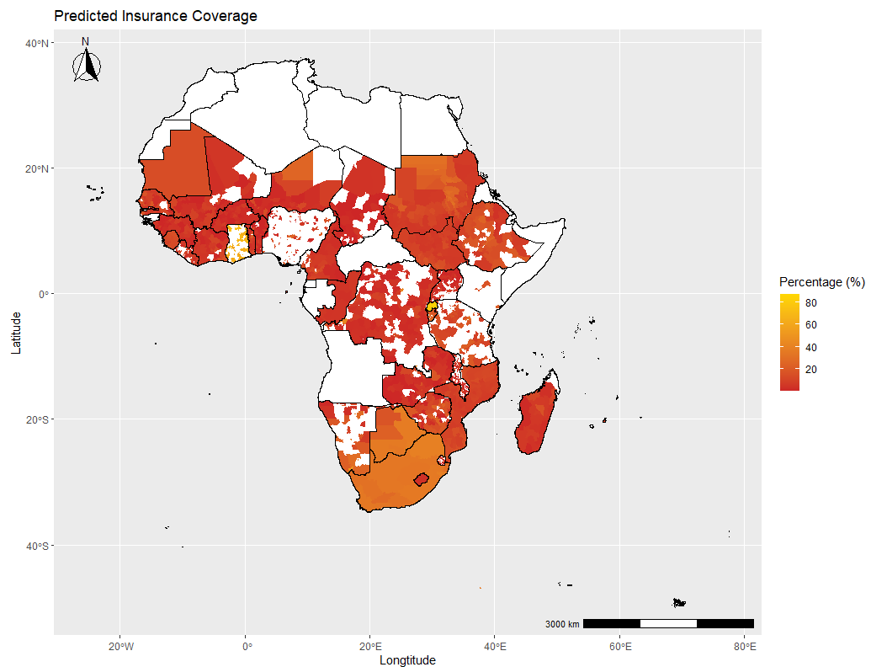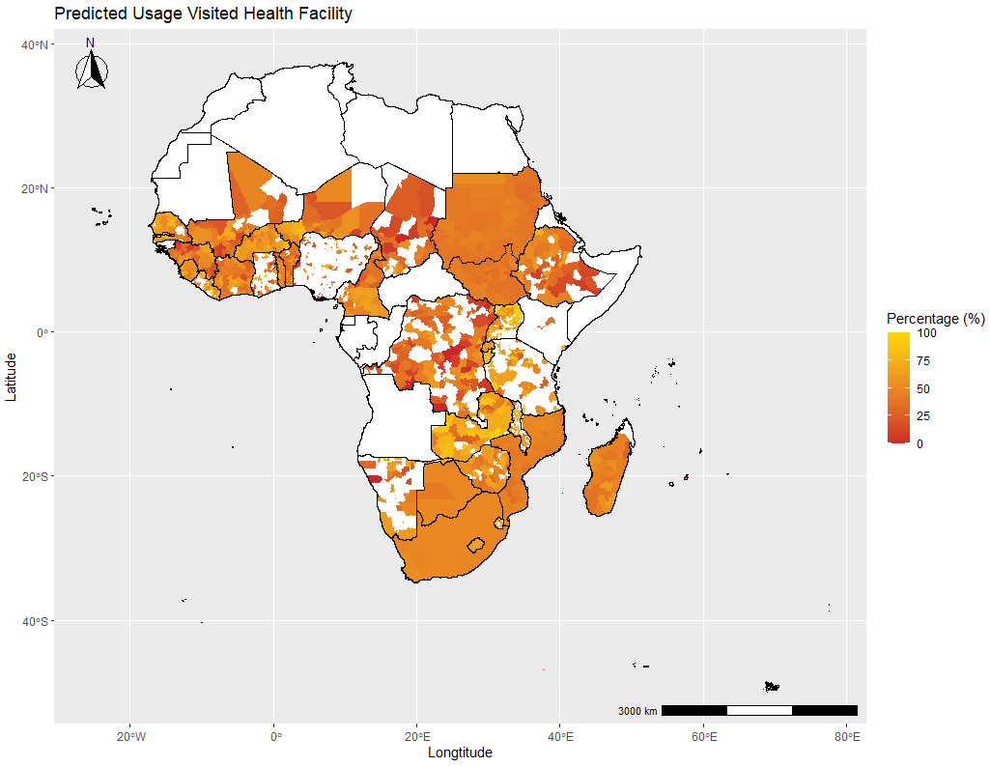
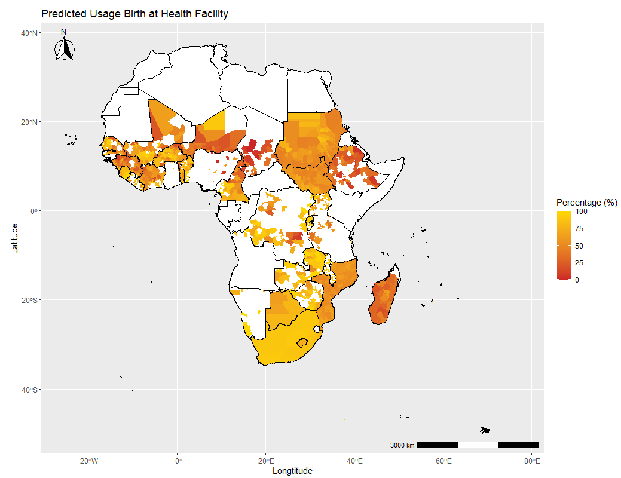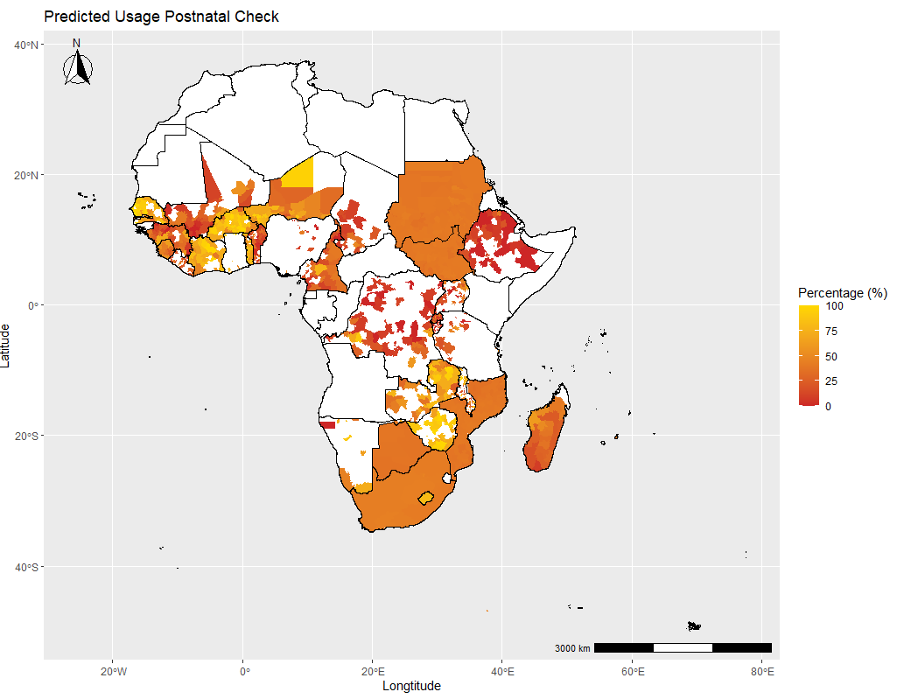
Note: Predictions are based on preferred models discussed in Section 4.1. The upper left figure estimates health insurance coverage based on a neural network model; the upper right figure if a person visited a health facility within the last year based on a neural network model; the lower left figure if the birth was given at health facilities based on a neural network model; and the lower right figure if went for a postnatal check based on a xgboost model. All estimates are done on the individual level and aggregated at the district level. Exceptions are the countries Congo, Mauritania, Sao Tome and Principe, Botswana, Lesotho, and Comoros which were aggregated on a regional level due to missing district information. Districts with less than ten observations for the predictions are left empty (the full map can be found in Appendix Figure A.8. The scale is adjusted for each outcome.

We detect that the three countries with a particularly high within-country variance for the outcomes are Kenya, South Africa, and Nigeria, whereas in Congo, Sierra Leone, and Madagascar we find the lowest within-country variation. Figure A.9 shows the zoomed-in country map of two countries with large within-country variance, Kenya and Nigeria. In both cases, we find that especially the highly populated regions, often the regions of the capital city, have the higher health insurance coverage rates. This result emphasizes that rural regions still face barriers to being financially protected by a health insurance scheme. On the contrary, the district distribution of the three health service outcomes reveal that even though financial protection by a health insurance scheme is different in more rural areas; in some districts, usage of a health services is still high. The examples of Kenya and Nigeria show that the rate was even higher in some rural areas than in more urbanized ones.

Since the census data does not have any information about the four outcomes, we cannot directly validate our estimates.

