CS5237 Phase II

Our team:

Yang Ruijie

Xie Shudong

Sun Bo

Shen Yaoxin

We have implemented the specified functions, as listed follows:

1. The basic functions for Trist.
2. The instructions: DY, AP, OT, IP based on the functions of Trist.
3. Simple zoom in and out. You can zoom in and out by pressing ‘+’ and ‘-’
4. Simple navigation. You can pan the view by pressing ‘↑↓→←’ respectively.
5. IP while right clicking.
6. Read the file and write to file for pressing ‘R/r’ and ‘W/w’

Following are some special features to note.

1. When calling IP, it’s not sure if the point should be added to the PointSet or not before performing the inTri check. But the original inTri check only supports checking a point that has been in the set. So we overload the inTri check to support a point that is outside the set

int PointSet::inTri(int p1Idx, int p2Idx, int p3Idx, MyPoint pd)

1. Since the coordinate of the points can be negative, we shift all the points by a deltaX and deltaY to make the origin point (0, 0) near the center of the drawing panel.

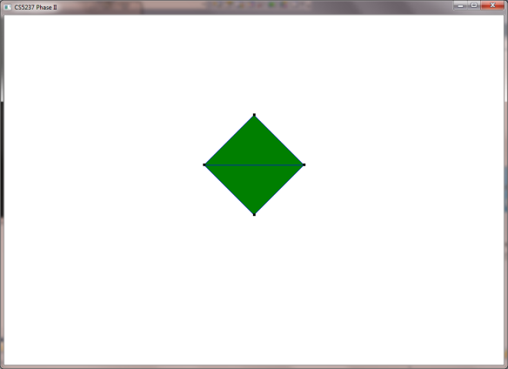

1. After zooming or panning the view, the real coordinate of the points are no longer the same as the coordinate that are drawn. So we keep track of the transformation to compute the displaying coordinate and show the points on correct positions. The feature is also design for right clicking IP. When a right clicking IP happens, we capture the display coordinate and compute the real coordinate by the transformation information.
2. Each time reading the file, we clear all the points and all the triangles. So the ‘R/r’ operation can be treated as an initialization.
3. Since the write to file operation requires only “AP” and “OT” commands, we use another Trist object to store the information without IP and finally write this object to file.