Beatrix Daries 210012528 Group 3B

Question 2

i)

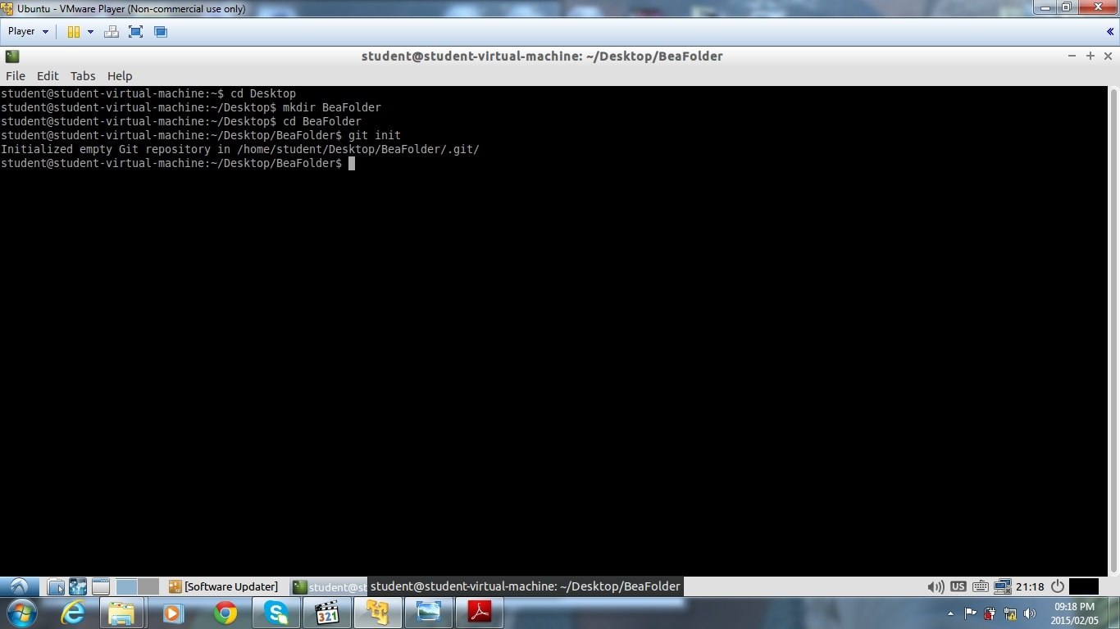

ii)

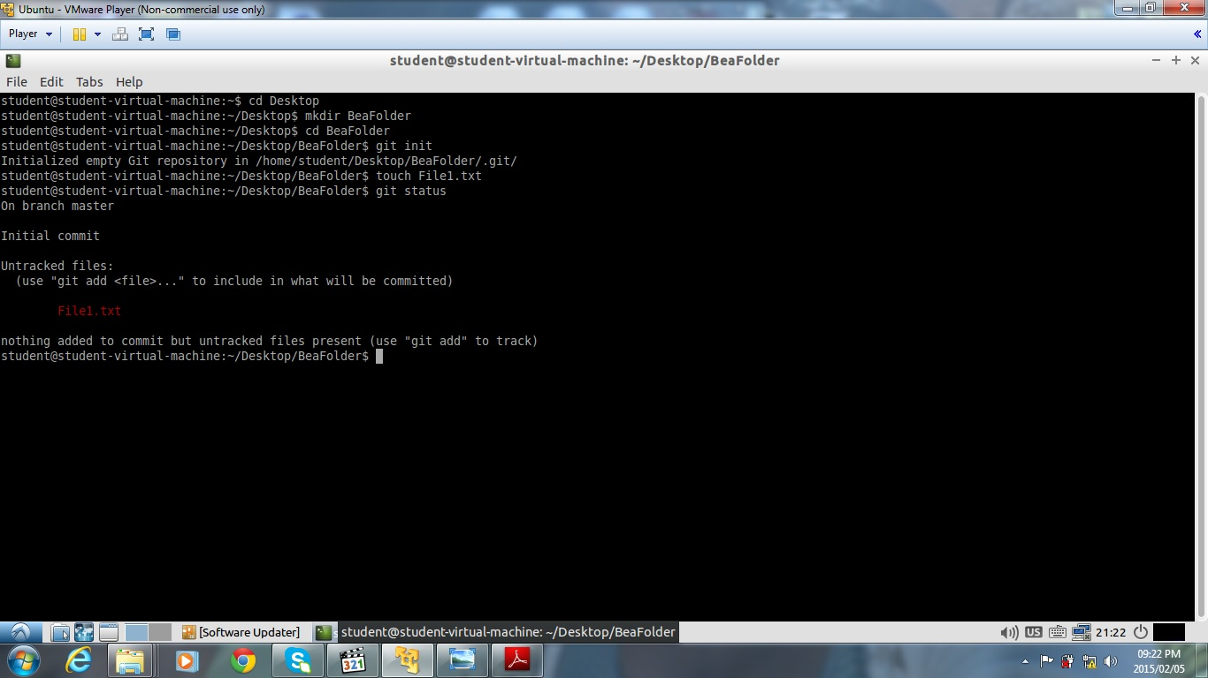

File has been added to the repository. The file name is in red because it is not being tracked

iii)

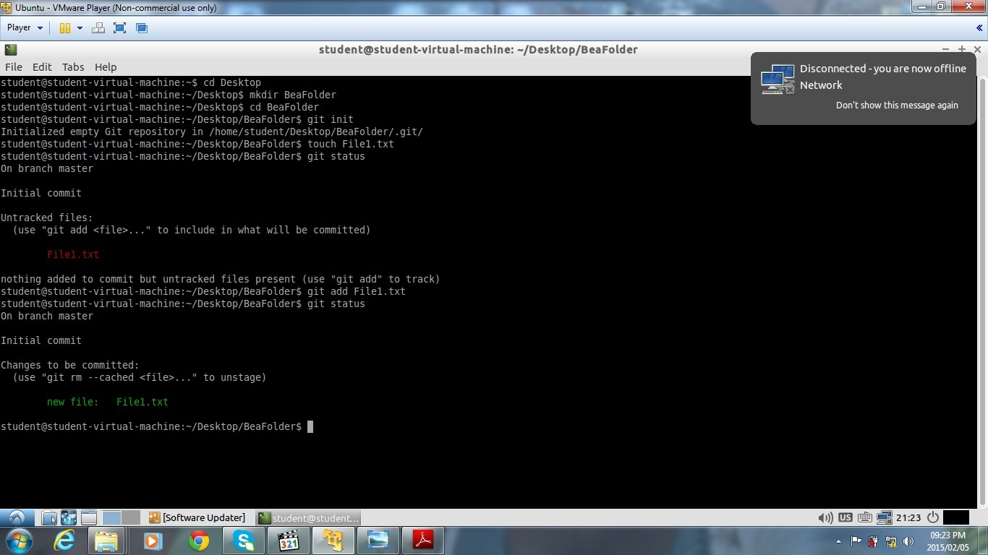

git add *file name* allows you to track the file. The file will then display in green.

iv)

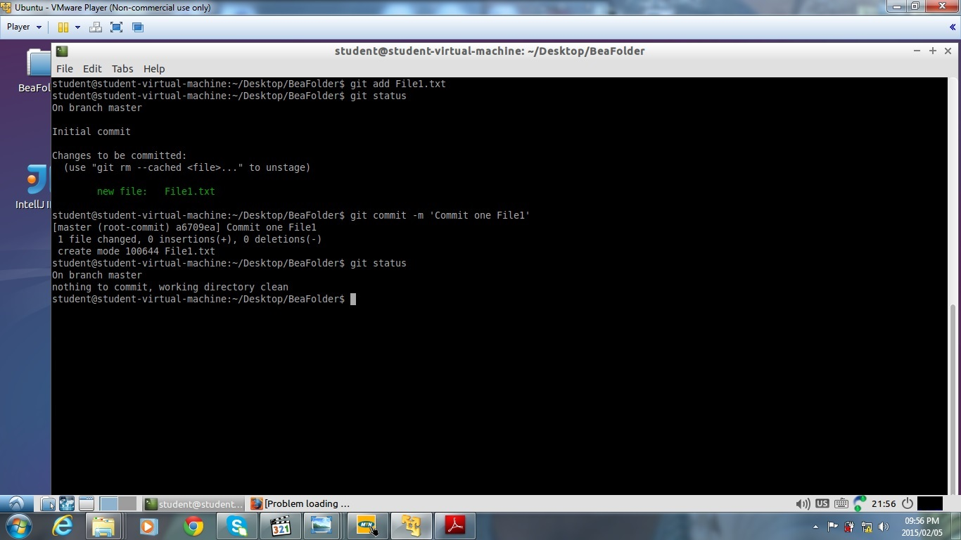

The file has been commited

v)

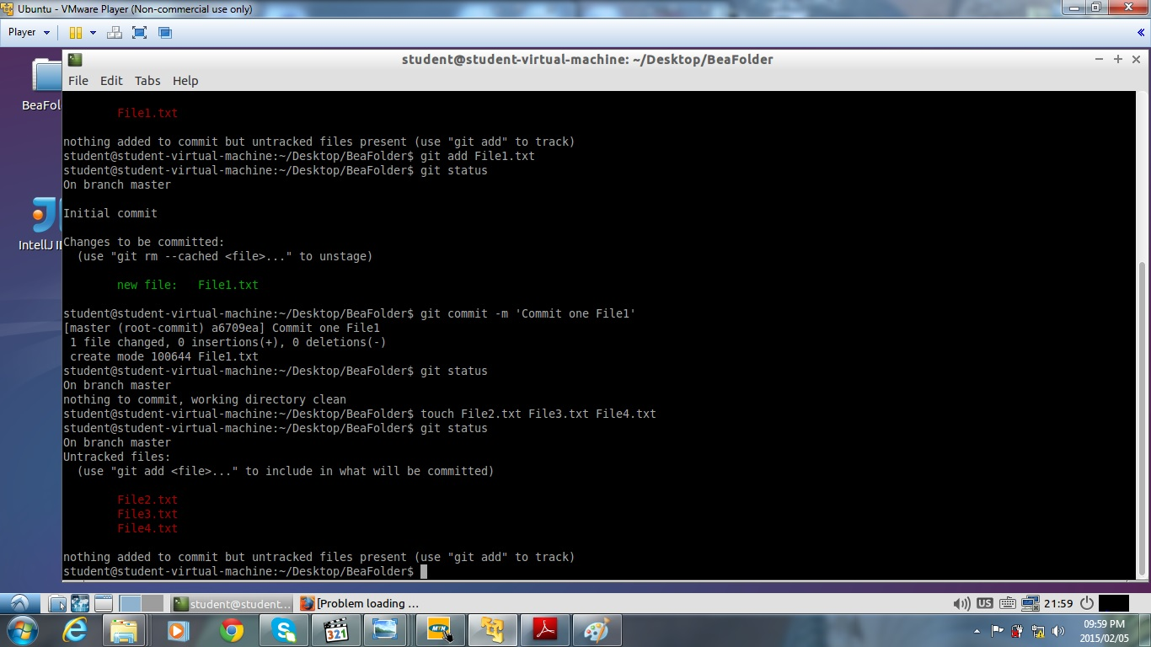

Three more files have been added and displays in red because they are not being tracked.

vi)

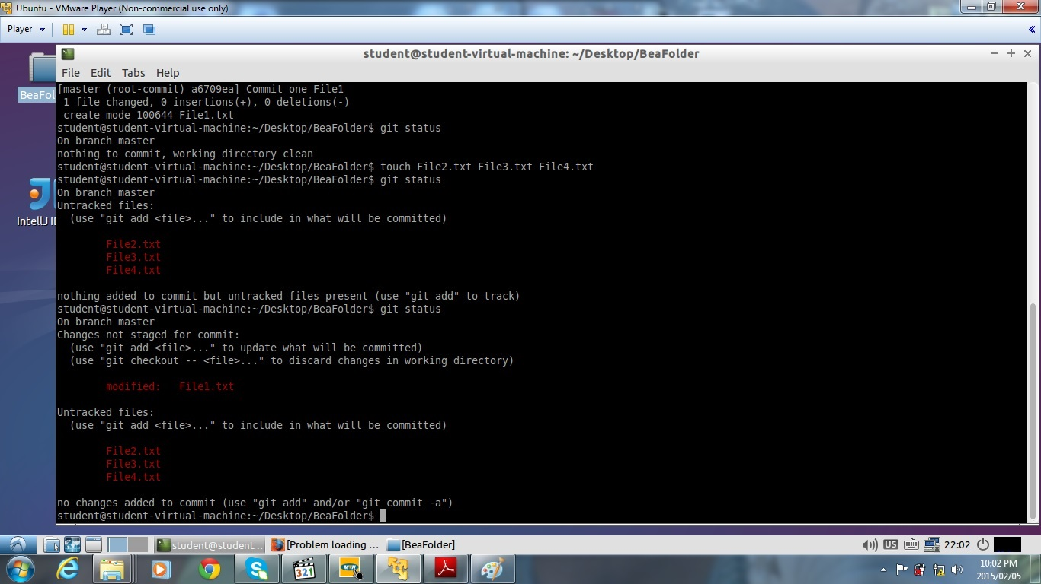

File1.txt displays as modified. The rest of the files are not being tracked.

vii)

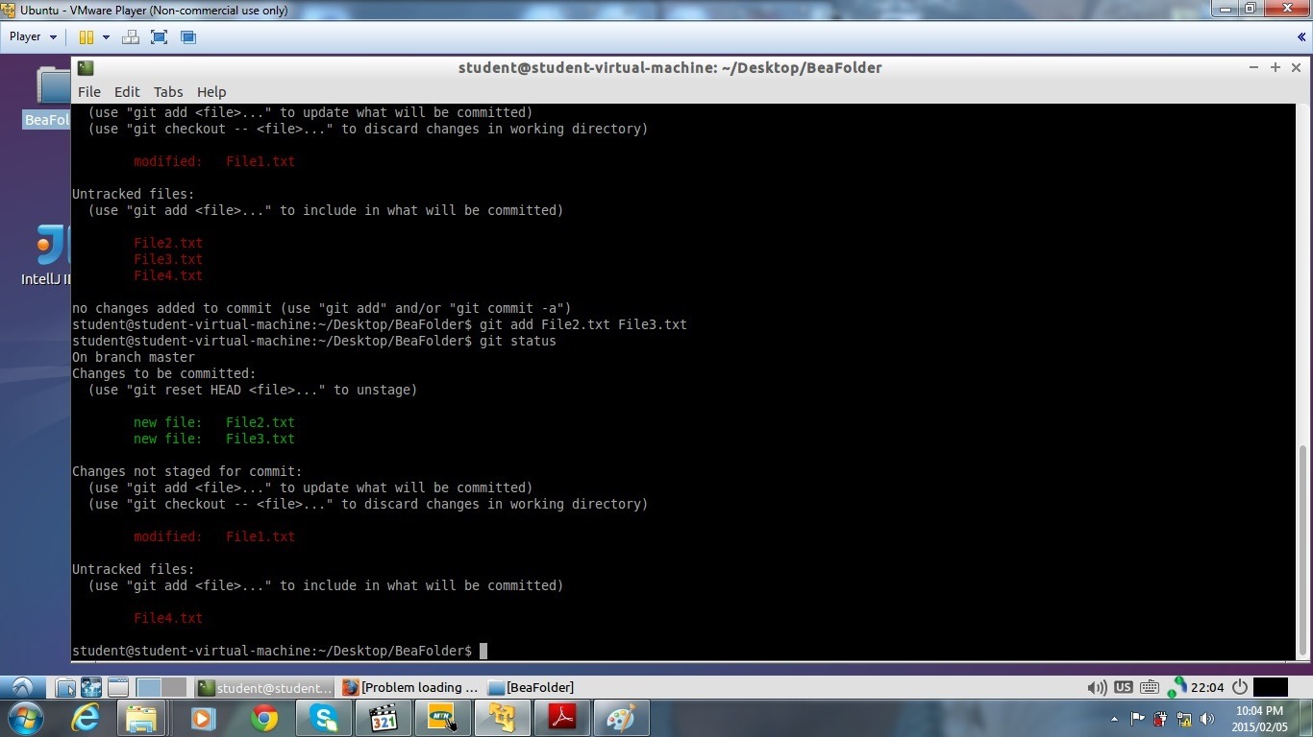

File2 and File3 is being tracked and displays in green. File1 has been modified and File4 is not being tracked.

viii)

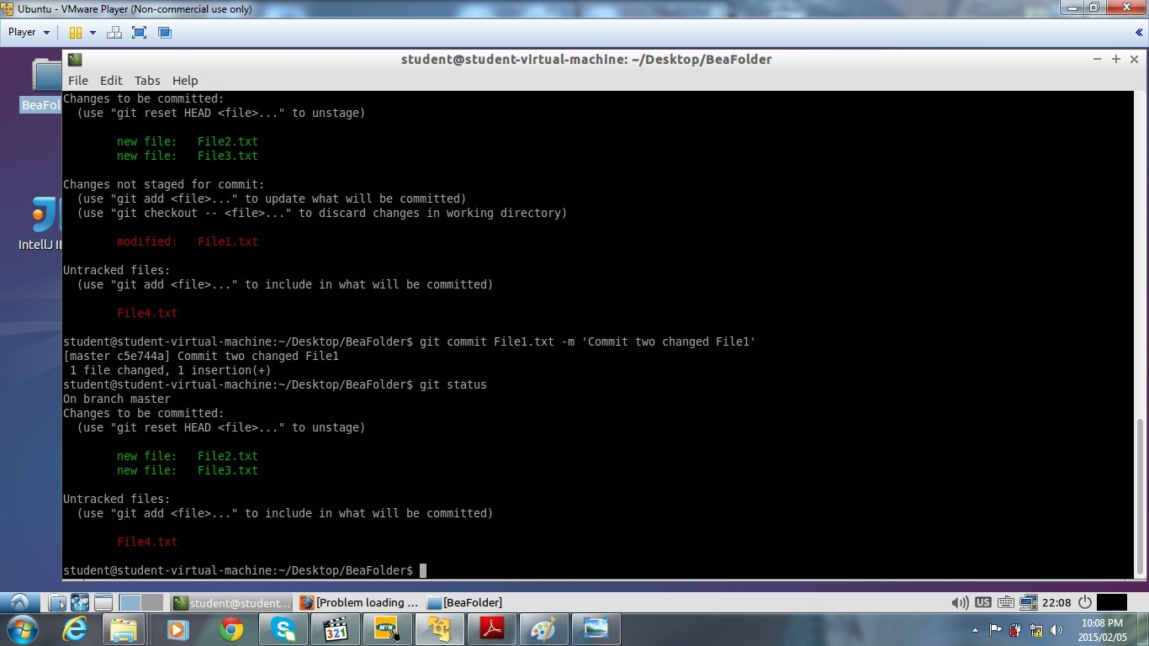

File1 which has been modified no longer displays because it has been commited. File2 and File3 displays in green because they are being tracked. File4 is in red because it is not tracked.

ix)

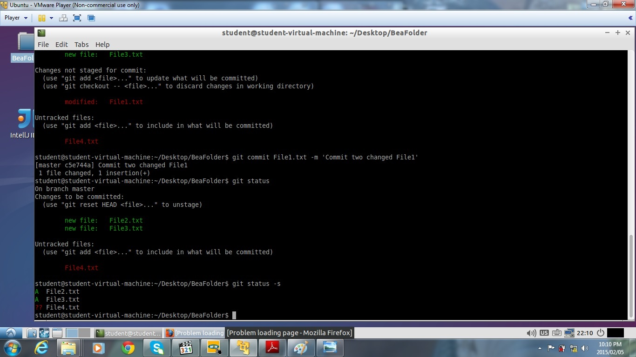

x)

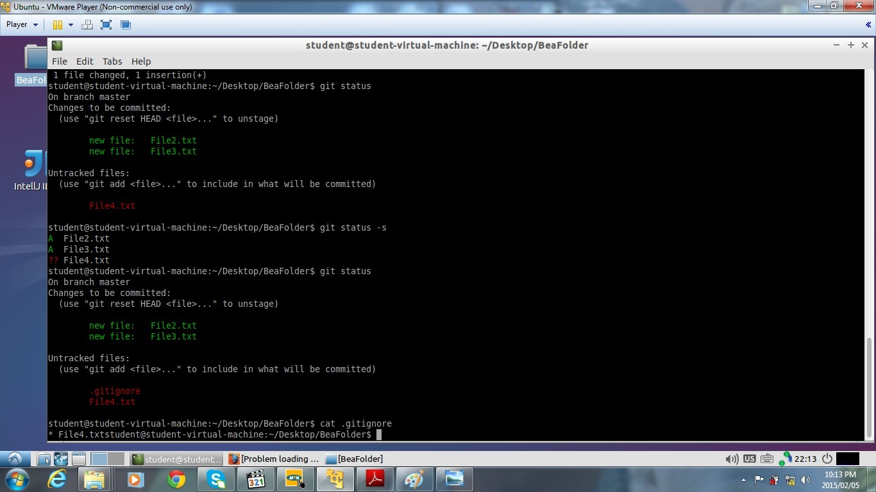

File4 is being ignored.

xii)

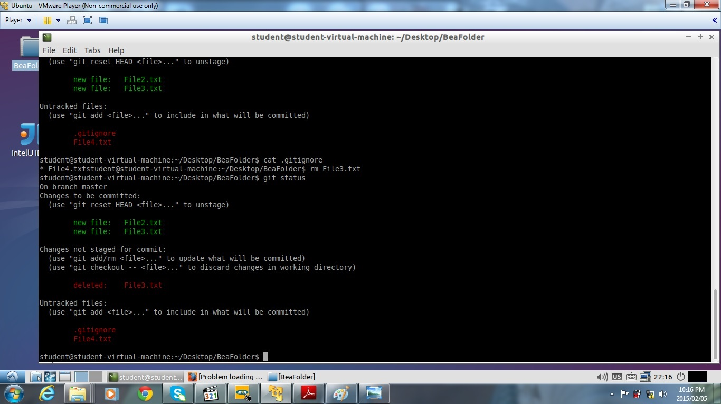

File4 has been deleted by using rm *file name.*

xiii)

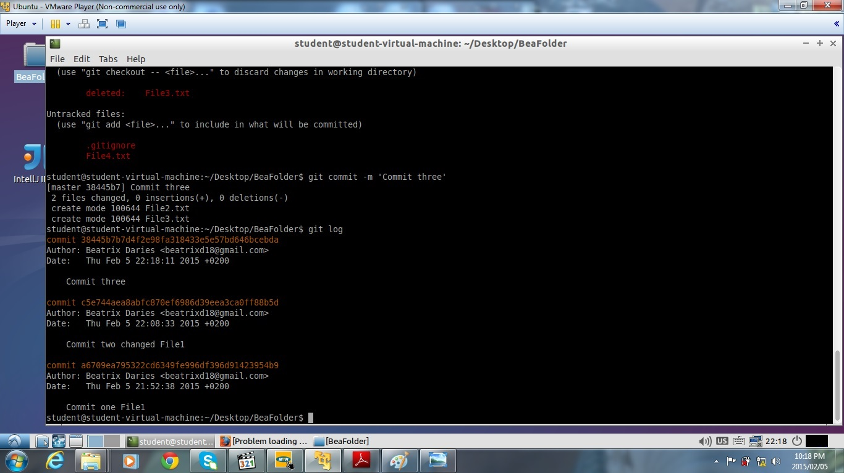

Commit History.

Question 3

i)

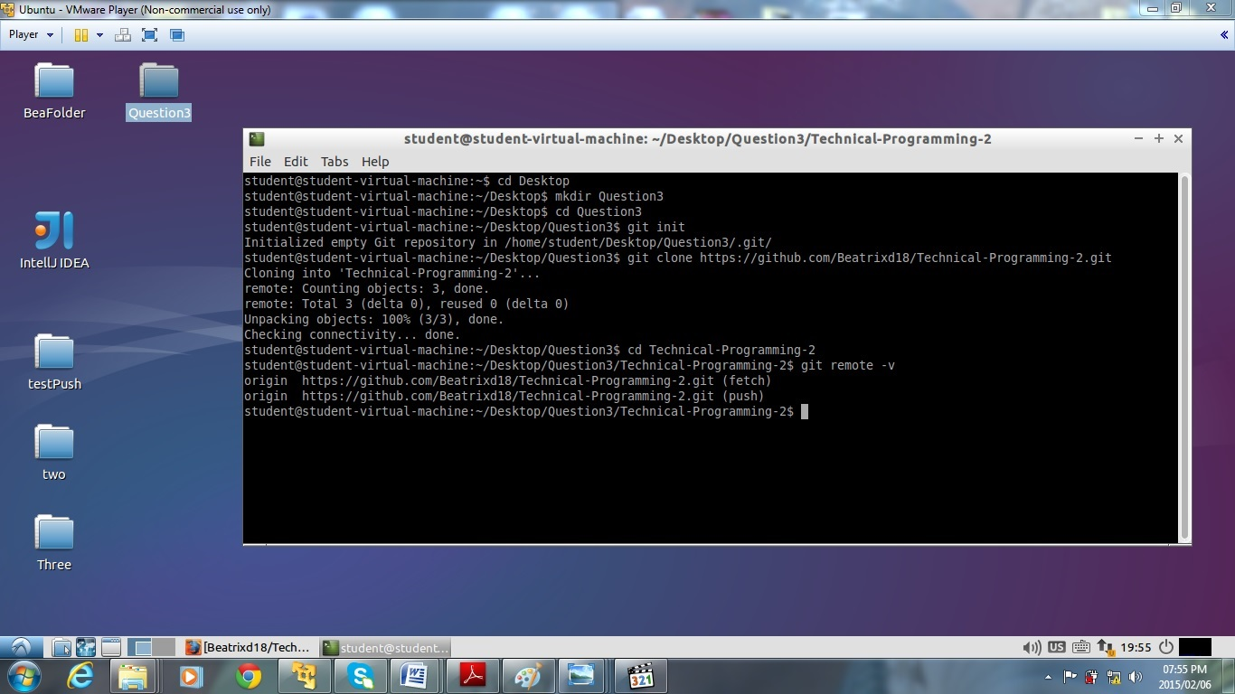

ii)

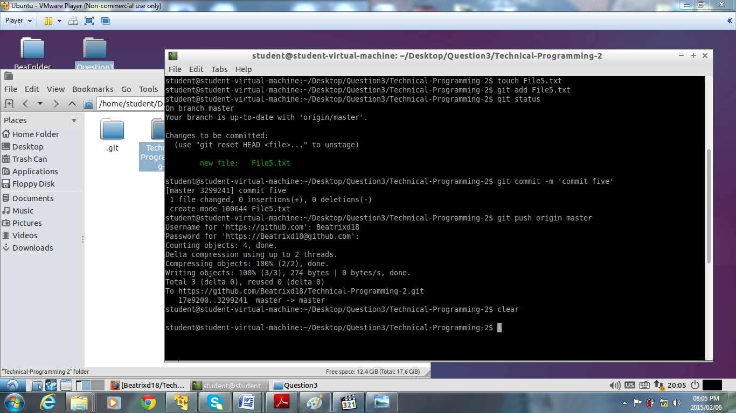

iii)

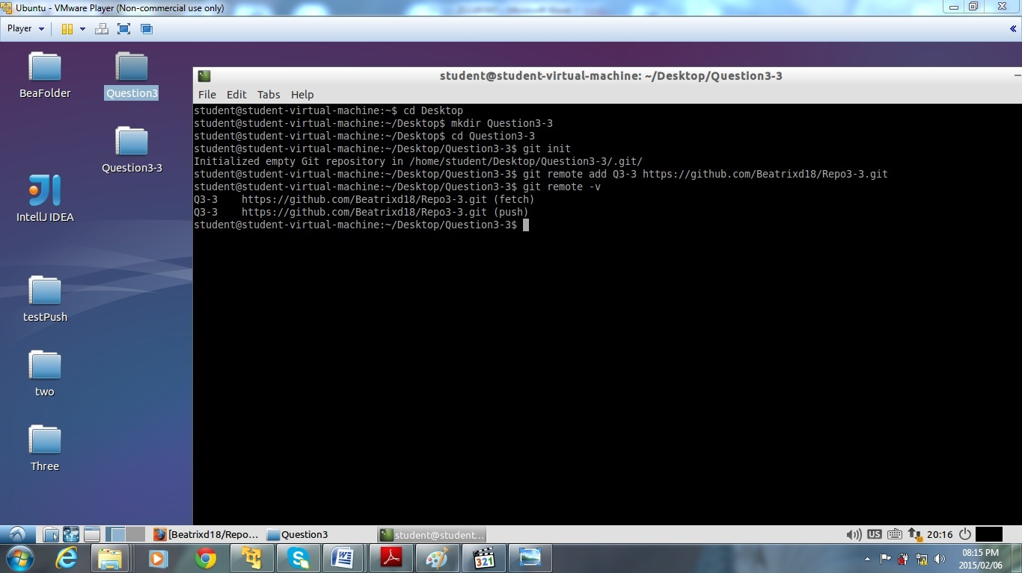

iv)

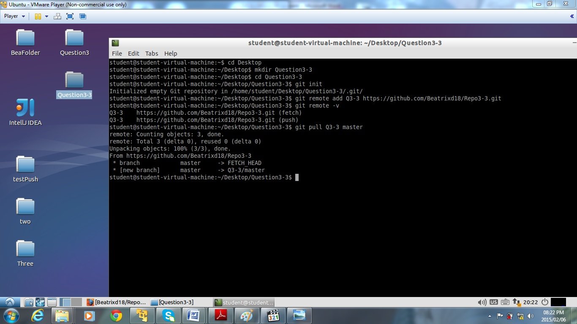

vii)

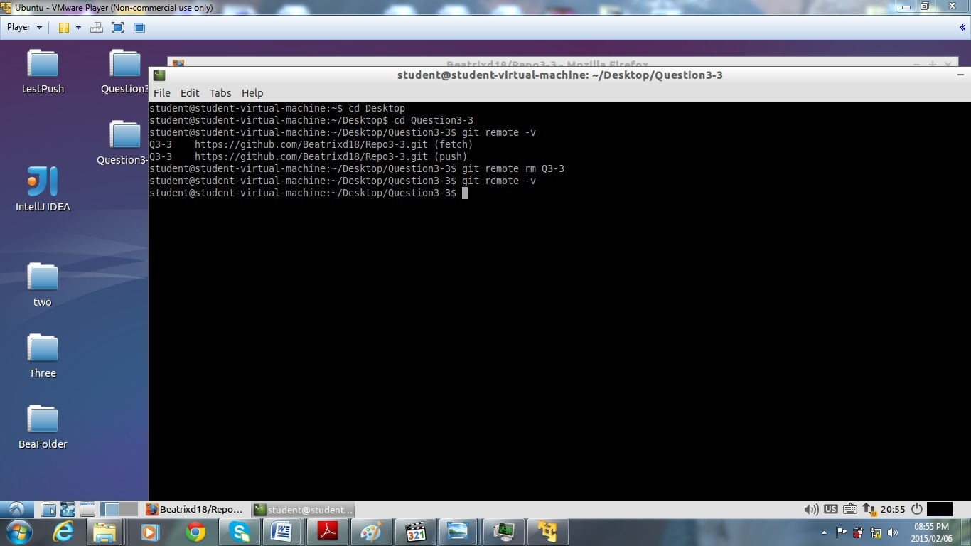

Question 4

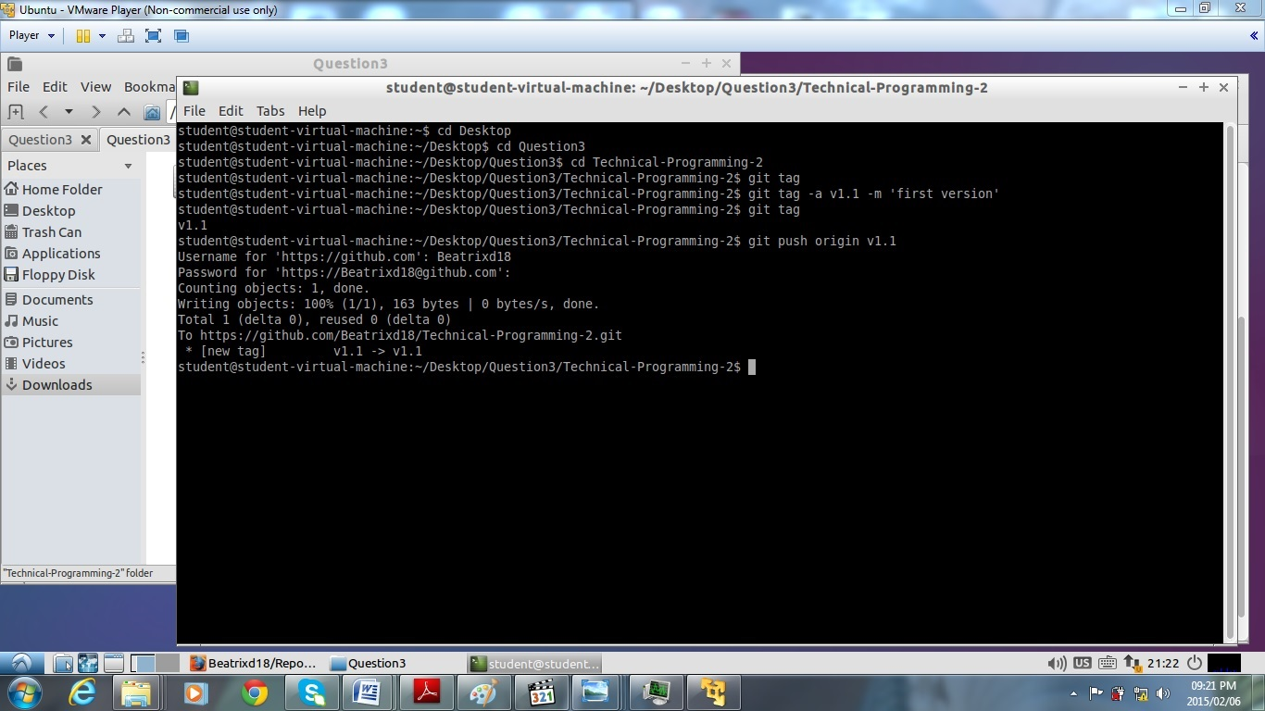

Question 5

