ETEC IRMÃ AGOSTINA
TASTEMATCH: DISCOVER LOCAL FLAVORS. EAT WITH CONFIDENCE.
Pitch Presentation Script
Arthur Teixeira Sthopa
Beatriz Caroline Adriano de Freitas
Eric Cezar Gomes Silva
Gabriela Viviane Herrera Cuentas
Pedro Henrique Diez Camargo

TASTEMATCH: DISCOVER LOCAL FLAVORS. EAT WITH CONFIDENCE.
Academic document prepared for presentation purposes.

SUMMARY

1. Introduction and Problem
2. Solution and User Registration
3. Food Safety
4. Food Discovery and Cultural Tourism
5. User Interface, Competitive Advantages and Future Development
6. Conclusion

1. Introduction and Problem
Imagine arriving in a completely new country. You want to experience authentic local cuisine, but all you can find are tourist-oriented restaurants, menus you cannot understand, and if you have a food allergy, every meal could represent a real risk.
That is exactly the problem we set out to solve with TasteMatch.
Millions of exchange students and travelers face three major challenges: finding authentic food, avoiding tourist traps, and understanding ingredients written in unfamiliar languages. For people with allergies and dietary restrictions, these challenges become health risks.

2. Solution and User Registration
TasteMatch connects travelers with local food culture through authentic and safe recommendations. Users register personal information, emergency contacts, dietary restrictions, and allergy severity levels, allowing the platform to personalize recommendations safely.

3. Food Safety
TasteMatch considers each user's dietary restrictions. If a dish contains potentially harmful ingredients, the system generates clear visual alerts, reducing risks and increasing traveler confidence.

4. Food Discovery and Cultural Tourism
Users access a location-based feed featuring dish photos, ratings, cultural information, and recipe origins. The platform also highlights local restaurants and cultural locations recommended by residents, promoting authentic experiences.

5. User Interface, Competitive Advantages and Future Development
The project is based on three principles: visual appeal, trust, and safety. Competitive advantages include cultural discovery, local recommendations, integrated food safety, and a focus on dishes and their stories. Future plans include AI recommendations, menu translation, local reviews, and international expansion.

6. Conclusion
TasteMatch was created to connect people with a country's culture through its cuisine, making every meal more authentic, safe, and meaningful. More than helping travelers find places to eat, it helps them discover stories, traditions, and experiences through food.

MOBILE PROTOTYPE

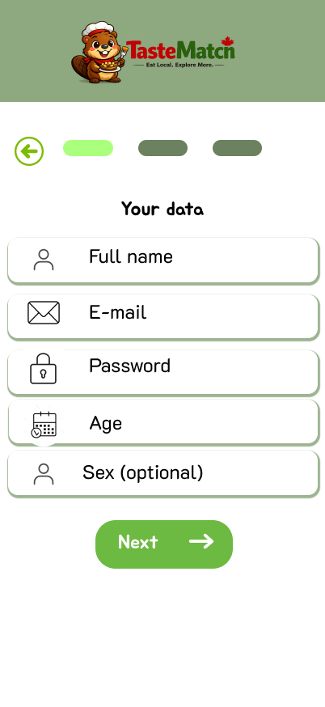
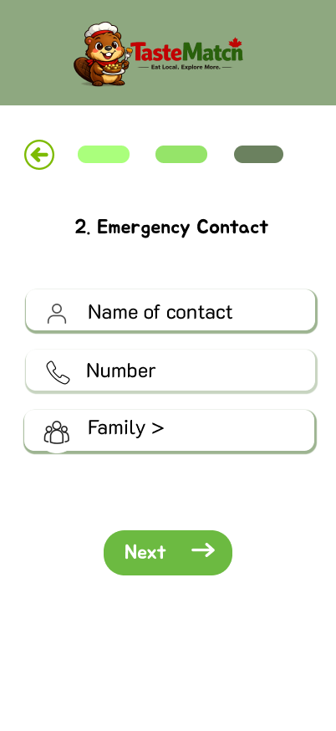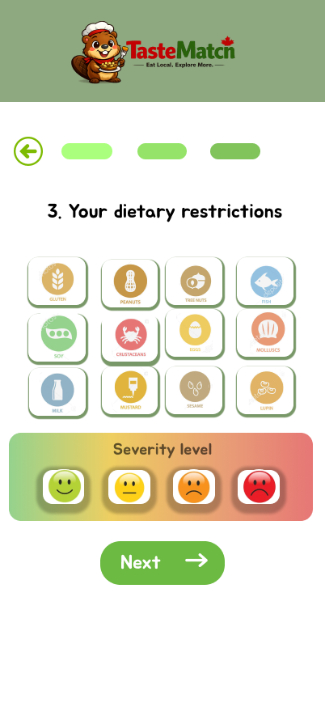


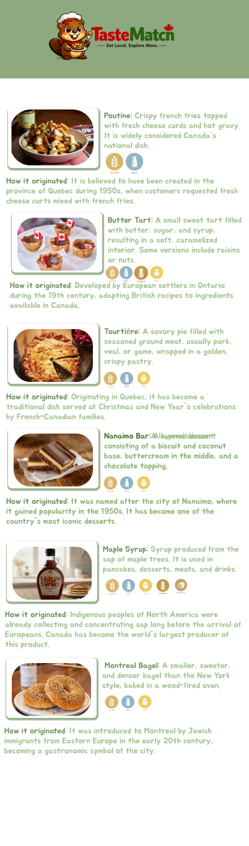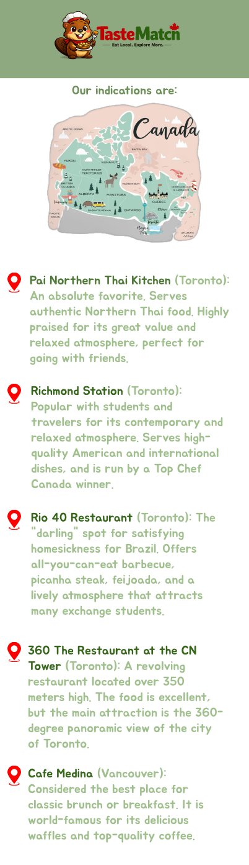

DESKTOP PROTOTYPE

