Beatriz Cifuentes Fernández S274680

EZGAS APPLICATION

EZGas is a crowdsourcing service that allows users to:

* Collect prices of fuels in different gas stations.
* Locate gas stations in an area, along with the prices they practice.

STAKEHOLDERS

* User:
  + Administrator: Uses the application to manage prices of fuels and location of gas stations.
  + Consumer: Volunteers or costumers who don’t use directly the application but provide the information of each gas station to the administrator.
* Buyer:
  + CEO
* Administrator:
  + EzGas application administrator
  + IT administrator: Manages all applications in the gas station
  + Security manager: Responsible for security issues
  + DB administrator: Manages DBMSs on which applications are based
* Analyst:
  + Experts who manage the information
* Developer:
  + Specialist team that creates the application

CONTEXT DIAGRAM AND INTERFACES

* Administrator:
  + Physical level: screen and keyboard
  + Logical: GUI

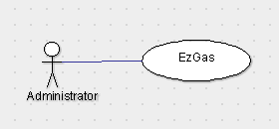

PERSONAS AND STORIES

Peter has created a virtual community where some volunteer or regular customers can collaborate by sending information about the prices of the different types of fuel in a gas station located within the community. Everyone can use this application and keeps informed about the prices. Peter is working on this application every day trying to keep it up to date.

Peter feels kind helping people’s economy and he has under control which days the prices are used to changing. Sometimes, Peter does not have the enough information about all the gas stations and for fixing it, he has to go personally to this gas station and update it. This extra effort is not possible all the times and makes some lack of information in the application.

Vanessa is a customer who wants to know which of the three gas station, which are on her way to work, is the cheapest. She usually checks the application in the morning before work. But one of this gas stations has any information about the prices.

On the other hand, there is Mark, he needed to refuel his car and he stops in one of the three gas station which are on Vanessa’s way to work. In the case that Mark sent the information about the prices of the fuels in this gas station to the application, Vanessa could verify which of the gas stations is the better option. In the other case, she has to opt for one.

SCENARIOS, USER CASE AND USE CASE DIAGTRAM

* Use case
* UC1 - RF3 Record the price list of each fuel

Actors involved: administrator

Precondition: fuels F exists, volunteer V exists, gas station S exists

Post: V.Station.fuelPrice != F.priceList[station] || F.priceList_post != F.priceList_pre

Nominal Scenario: Administrator selects volunteer V, selects gas station S, selects fuel F, deduce the fuel’s price of the volunteer

Variants: ||

* UC2 – RF4 Record the location of gas station, even if there will open soon a new one

Actors involved: administrator

Precondition: volunteer V exists, gas station S exists

Post: V.Station.location != S.location || S.location_post != S.location_pre

Nominal Scenario: Administrator selects volunteer V, selects gas station S, deduce the station of the volunteer

Variants: ||

* UC3 – RF5 Report how many times the price of fuels changes in the same gas station per week

Actors involved: administrator

Precondition: volunteer V exists, gas station S exists, fuel F exists

Post: F.price_pre != F.price_pre

Nominal Scenario: Administrator selects volunteer V, selects gas station S, selects fuel F, defines a time range, application count the different value of each fuel price in the time range

Variants: ||

* Scenarios
* Scenario 1: SC1

Description: Costumer looks for the price of a fuel in the nearest gas station

Precondition: a volunteer offers information about this gas station

Postcondition: fuels Price are updated

Step description:

1. Andministrator selects volunteer’s information
2. Administrator updates database of fuel prices
3. Application offered information about the gas station

* Scenario 2: SC2

Description: Consumer looks for the price of a fuel in the nearest gas station, but this information is not available in the application

Precondition: any volunteer offers information about this gas station

Postcondition: fuels price is updated

Step description:

1. Administrator selects volunteer’s information
2. Administrator updates database of fuel prices
3. Application offered information about the gas station
4. Information not available, issue warning

* Use case diagram

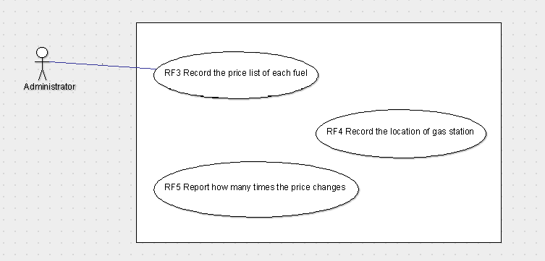

NUMBER FUNCTIONAL REQUIREMENTS

|  |  |
| --- | --- |
| **ID** | **DESCRIPTION** |
| FR1 | Log-in the account |
| FR2 | Log-out the account |
| FR3 | Record the price list of each fuel in each gas station |
| FR4 | Record the location of gas station, even if there will open soon a new one |
| FR5 | Report how many times the price of fuels changes in the same gas station per week |
| FR7 | Manage volunteers and accounts |
| FR8 | Manage types of fuels and prices |

NUMBER NON-FUNCTIONAL REQUIREMENTS

|  |  |  |  |
| --- | --- | --- | --- |
| **ID** | **TYPE** | **DESCRIPTION** | **Refers to** |
| NFR1 | Usability | All people should be able to use the application without any previous knowledge | All FR |
| NRF2 | Efficiency | All functions should update in less than 0.5 sec | All FR |
| NRF3 | Portability | The application should be portable from a PC to mobile phones | All FR |
| NRF4 | Portability | The application runs on mobile phones | All FR |

GLOSSARY

