Project Name: BeatsByDavid

Team Members: Johnson Cheung, Albert Deng, Alexander Ho, Jot Kaur, David Kopala, Jon Oulton

Description: Our app intendeds to help CU students find the optimal study place. By recording historical data, and providing live data of loudness, and temperature, our app will allow CU students to find the optimal study area, as well as plan ahead by predictions provided by our historical data.

Setup: Enter [beats.davidkopala.com](http://beats.davidkopala.com) in any browser url.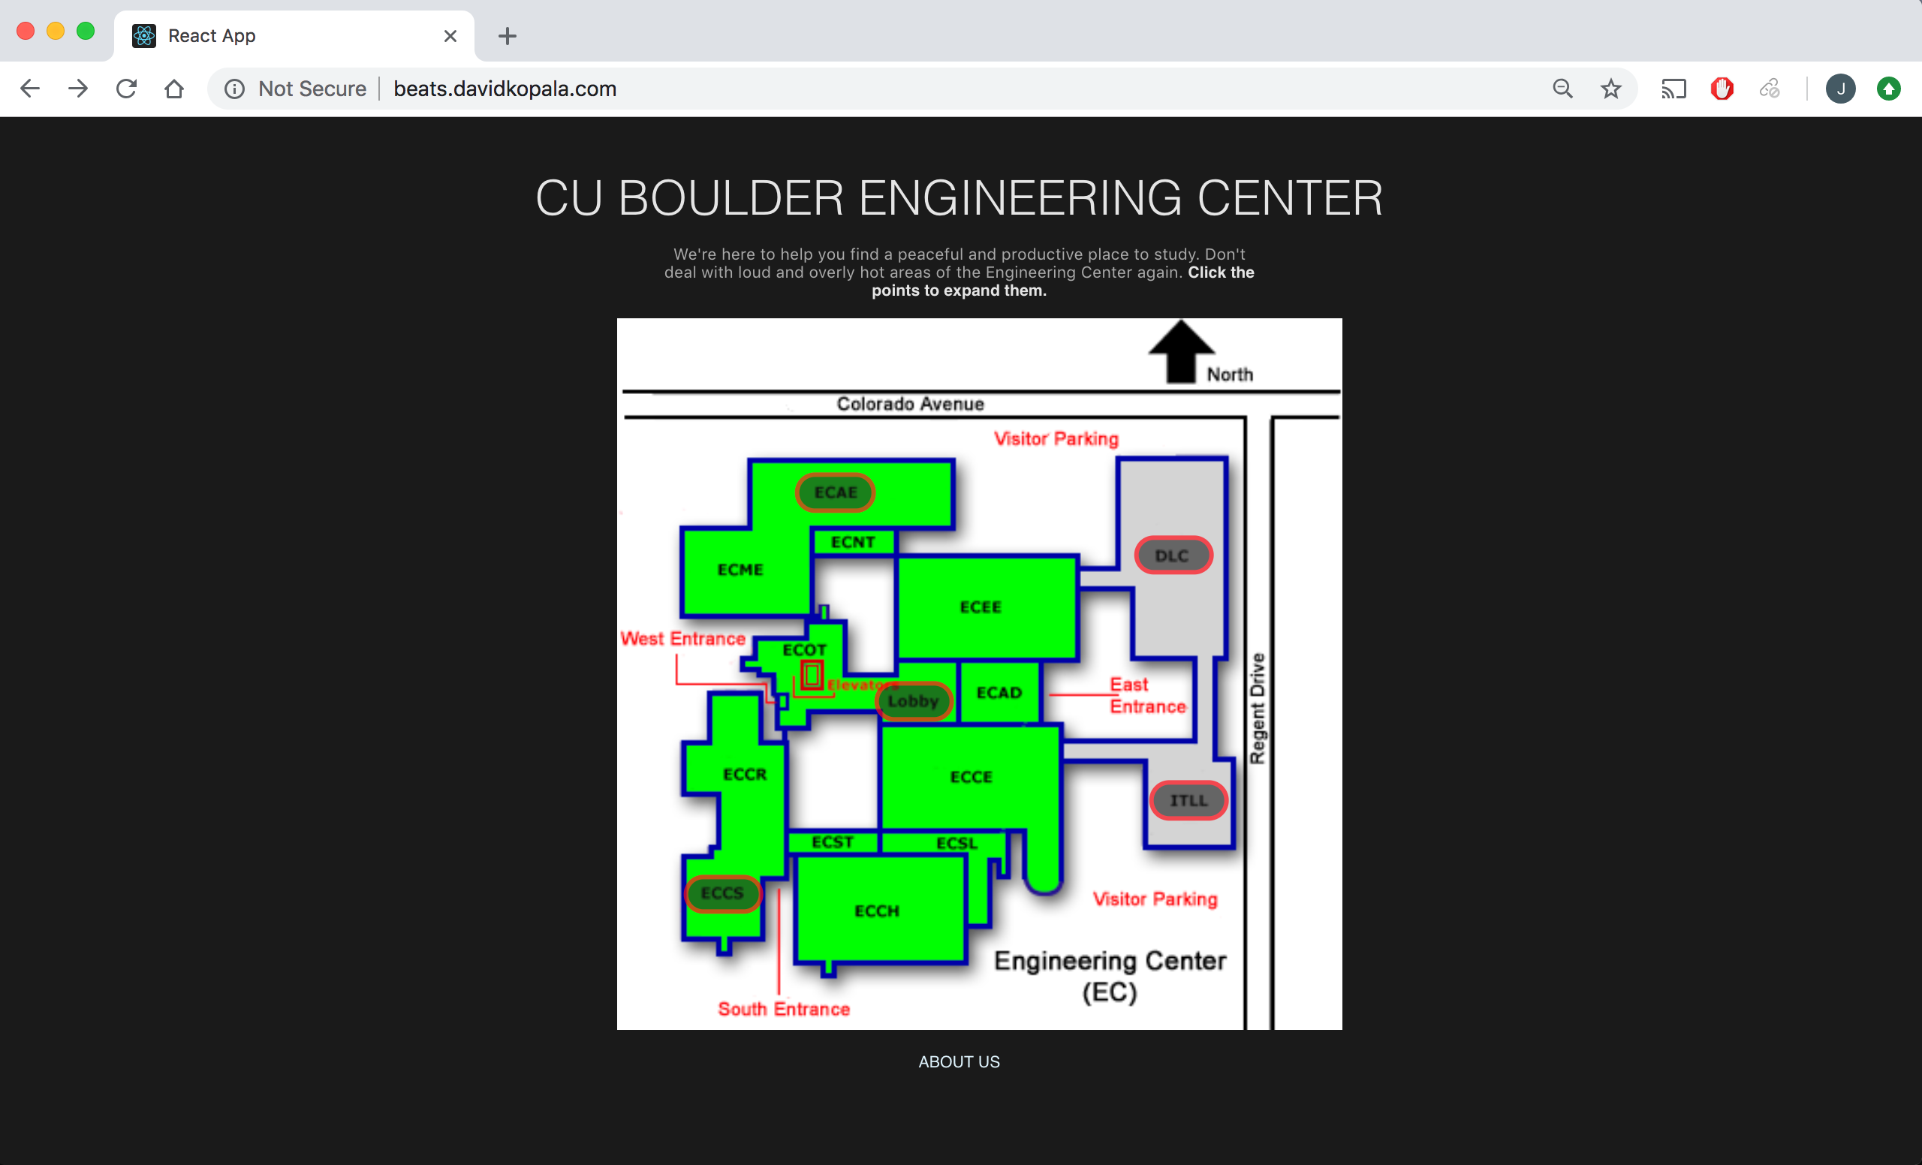

Usage: By mousing over each section, the current temperature and decibel level will appear.

