|  |
| --- |
| Semester IV |
| AC Machines lab report |
| NO-LOAD AND BLOCKED ROTOR TEST ON THREE-PHASE INDUCTION MOTOR and LOAD TEST ON THREE-PHASE INDUCTION MOTOR |

|  |
| --- |
| G. VIJAY PRASANNA  107114029 |
| Date of submission: 8/4/16 |
|  |

**NO-LOAD AND BLOCKED ROTOR TEST ON**

**THREE-PHASE INDUCTION MOTOR**

**AIM**

To determine the equivalent circuit parameters of a three-phase induction motor by conducting No load and Blocked rotor test.

**APPARATUS REQUIRED**

|  |  |  |  |
| --- | --- | --- | --- |
| **Sl. No.** | **Name of the apparatus** | **Range** | **Quantity** |
| 1. | Ammeter | (0-10) A, MI | 1 |
| 2. | Voltmeter | (0-600) V, MI | 1 |
| 3. | Wattmeter | LPF, UPF(double)0 | 2 |
| 4. | Rheostat | - | - |
| 5. | Connecting wires | - | - |

**CIRCUIT DIAGRAM**

R

B

3-Phase

400V

50 Hz

AC

Supply

Y

B

E

C

C

C

B

B

E

E

Three-phase

Induction

Motor

Double element wattmeter

M

L

C

V

M

L

C

V

R

Y

B

T

P

S

T

S

V

A

VL

IL

3Ф

Autotransformer

A1

A2

B1

B2

C1

C2

PANEL BOARD

Fig.1NO-LOAD TEST ON THREE-PHASE INDUCTION MOTOR

**PROCEDURE**

**I. NO LOAD TEST**

1. Make connections as per the circuit diagram.
2. Keep the brake drum in loose condition. (No load).
3. Close the switch TPST and vary the sliding contact of the autotransformer slightly so that the ammeter shows the maximum current reading and comes to steady state current. (i.e., no load current)
4. Now adjust the autotransformer to get rated voltage in the voltmeter.
5. Note down the voltmeter, ammeter and wattmeter at no load as in the table.
6. Bring the auto-transformer sliding contact to its original position.
7. Open the TPST switch and disconnect the circuit.
8. **BLOCKED ROTOR TEST**
9. Make connections as per the circuit diagram.
10. Keep the brake drum in tightly blocked condition. (Blocked).
11. Close the switch TPST.
12. Vary the sliding contact of the autotransformer slightly so that the ammeter shows the rated current reading
13. Note down the voltmeter, ammeter and wattmeter readings as per the table.
14. Bring the auto-transformer sliding contact to its original position (minimum voltage position).
15. Open the TPST switch and disconnect the circuit.

**III. MEASUREMENT OF STATOR RESISTANCE Reff:**

1. Make connections as per the circuit diagram.
2. Close the DPST switch.
3. Vary the rheostat and note down the different sets of readings of voltmeter and ammeter.
4. Calculate the value of Rmean , and hence Reff.
5. Bring the rheostat slider to initial condition.
6. Open the DPST switch and disconnect the circuit.

**FORMULAE TO BE USED**

1. **NO LOAD TEST**
   1. Woc = VocIoc COSoc (W)
   2. COSϕoc = 
   3. Iw =  (A)
   4. Im =  (A)
   5. Xo =  (Ω)
   6. Ro =  (Ω)
2. **BLOCKED ROTOR TEST**
   1. Z01 = 
   2. R01 =  (Ω)
   3. X01 =  (Ω)
   4. R2' = (R01 – Reff ) (Ω)
   5. Reff  =Rmean × 1.6 (Ω)

**III. CALCULATION OF LOSSES AND EFFICIENCY**

1. Cos φNL = WNL / (√3 VNL ×INL)
2. Cos φsc = W sc / (√3 V sc ×I sc)
3. I sc at rated voltage (ISN) = (VNL / V sc) × I sc (A)
4. W sc at rated voltage (WSN) = (VNL / V sc) × W sc (W)

**TABULATION**

Multiplication factor: 8

|  |  |  |  |
| --- | --- | --- | --- |
| Terminal voltage,  Voc (V) | Line current,  Ioc (A) | **WOC** | |
| Observed (div) | Actual (W) |
| 400V | 3.5 A | 85-59 | 208 |

Table.1 TABLE NO LOAD TEST ON THREE-PHASE INDUCTION MOTOR

Multiplication factor: 2

|  |  |  |  |
| --- | --- | --- | --- |
| Terminal voltage  Vsc (V) | Line Current  Isc (A) | Wsc | |
| Observed (div) | Actual (W) |
| 90 | 7.5 | 270 | 540 |

Table.2 TABLE BLOCKED ROTOR TEST ON THREE PHASE INDUCTION MOTOR

|  |  |  |  |
| --- | --- | --- | --- |
| Sl.No | Voltage, V (V) | Current, I (A) | Resistance, R=V/I (Ω) |
| **1.** | 2.2 | 0.25 | 2.558 |
| **2.** | 3.2 | 1.25 | 2.56 |
| **3.** | 3.9 | 1.5 | 2.6 |
| **4.** | 5 | 1.85 | 2.703 |
| 5. | 6 | 2.21 | 2.714 |

Table.3 TABLE MEASUREMENT OF STATOR RESISTANCE Reff

**Rmean = 2.633 Ω**  **Reff** =Rmean\* 1.6 = **4.2128Ω**

Calculated from the above values: **R0 = 198.688 Ω, Xo = 2303.126 Ω.**

**Observation:**

**1) Performance characteristics at 400V vs. 240V**

**1. Efficiency vs. Output power**

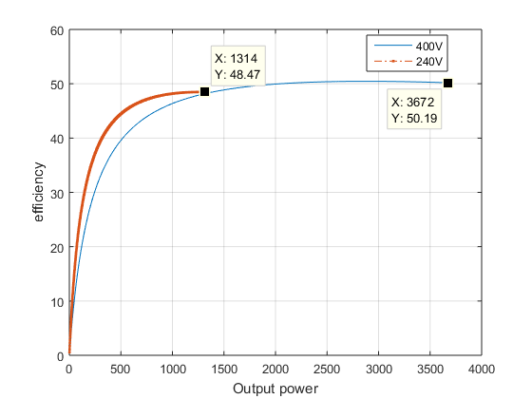

Figure2. Efficiency vs. Output power (W)

**Observation:** The efficiency when running the motor at 240V is higher than when running it at 400V.

|  |  |  |  |
| --- | --- | --- | --- |
| S.No | Voltage | Output Power | Efficiency |
| 1 | 240V | 1314 W | 48.47 A |
| 2 | 400V | 3672 W | 50.19 A |

**Inference:** As the voltage increases the input power also increases, as given by the relation, **Pin** α **VLIL,** so when the voltage increases the efficiency drops due to the increase in the input power. The maximum efficiency is found to be at **48.47% for 240V** and **50.17% for 400V**.

**2. Line current vs. Output power**

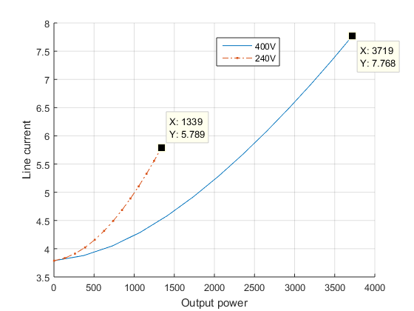

Figure3. Line current (A) vs. Output power (W)

**Observation:** The line current curve for 240V operation is higher than the 400V operation.

|  |  |  |  |
| --- | --- | --- | --- |
| S.No | Voltage | Output Power | Line current |
| 1 | 240V | 1339 W | 7.768 A |
| 2 | 400V | 3719W | 5.789 A |

**Inference:** As the loading increases, the machine has to provide the required power. This results in the increase of line current from the source. With lesser voltage, higher current has to be drawn and hence the 240V curve is higher. The **starting line current is 3.788A for both 400V and 240V** and their respective **maximum values** for the respective critical slip of 0.012 are **5.7A and 7.58A**.

**3. Slip vs. Output power**

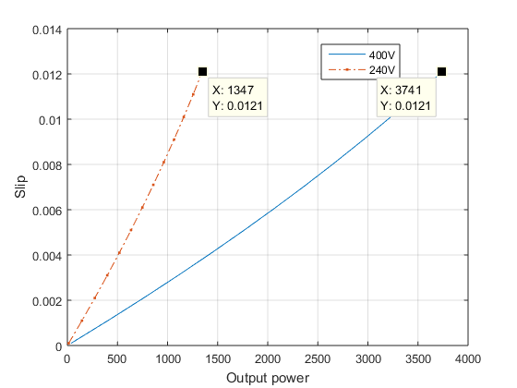

Figure4. Slip vs. Output power (W)

**Observation:** The graph for slip vs. output power is higher for 240V than 400V.

|  |  |  |  |
| --- | --- | --- | --- |
| S.No | Voltage | Output Power | Slip |
| 1 | 240V | 1347 W | 0.0121 |
| 2 | 400V | 3741 W | 0.0121 |

**Inference:** The relation between generated power and voltage is given as, P α s2E2. Therefore as the voltage decreases the value of E2 also decreases due to transformer action. This results in the increase in the value of slip to maintain the same output power. The power at which **240V** operationreaches a **slip of 0.012** is **1347W** and **3700W for 400V** at a slip of **0.012.**

**4. Torque vs. Output Power**

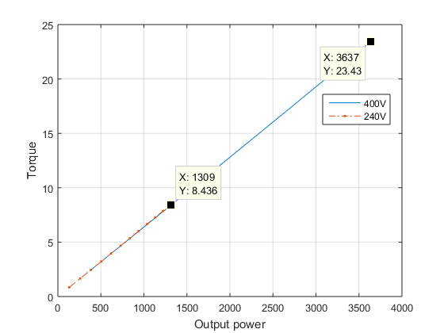

Figure5. Torque (Nm) vs. Output power (W)

**Observation:** The curves for Torque and output power for 240V and 400V overlap.

|  |  |  |  |
| --- | --- | --- | --- |
| S.No | Voltage | Output Power | Torque |
| 1 | 240V | 1309 W | 8.436 Nm |
| 2 | 400V | 3637 W | 23.43 Nm |

**Inference:** As the voltage decreases, the slip is adjusted so that the torque remains the same. The values of critical torque for the full-load slips of 0.012 are **8.436Nm for 240V** and **23.43Nm for 400V**. There is not much variation in the initial operating torques with respect to output voltage.

**5. Speed vs. Output power**

# C:\Users\vijayprasanna\AC_lab\A7\Report\images\speed_power_volt.png

Figure6. Speed (rpm) vs. Output power (W)

**Observation:**  The speed vs. Output power curve for 240V is lower than the 400V one.

|  |  |  |  |
| --- | --- | --- | --- |
| S.No | Voltage | Output Power | Speed |
| 1 | 400V | 1309 W | 1482 rpm |
| 2 | 240V | 3741 W | 1482 rpm |

**Inference:** As voltage decreases, the slip increases to keep the torque constant, therefore the speed of the rotor decreases. The decrease in speed is more rapid for a machine operating at lower voltage. The respective speeds for a full slip of 0.012 are **1482rpm for both 240V and 400V**.

**2) Performance characteristics at 50 Hz vs. 32 Hz**

**1. Efficiency vs. Output power**

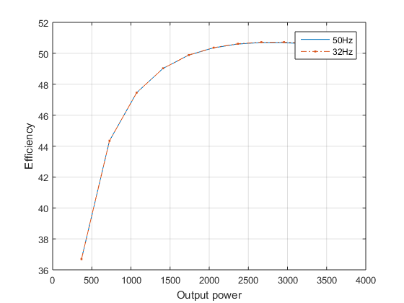

Figure7. Efficiency vs. Output power (W)

**Observation:** the values of the efficiencies match for both frequencies: 50Hz and 32Hz.

**Inference:** As frequency varies the value of the reactance of the stator and the rotor windings will change, the speed of the machine also reduces because of the relation, N α f. These changes due the change in frequency are proportional and balance each other to maintain the torque produced from the machine. Thus the efficiency is remains the same in both cases. Both the graphs (**32Hz and 50Hz**) attain a maximum efficiency of **50.72%** at critical slip of 0.012.

**2. Line current vs. Output power**

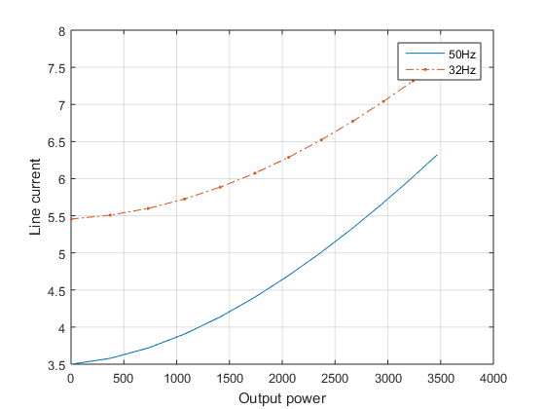

Figure8. Line current (A) vs. Output power (W)

**Observation:** The values of line current are lower for 50Hz than 32Hz operation.

**Inference:** The current will decrease as the overall impedance of the circuit increases for a given voltage. Therefore for lower frequency the current drawn will higher. The line current at critical slip of 0.012 is found to be **7.605A for 32Hz** and **6.321A for 50Hz**

**3. Power factor vs. Output power**

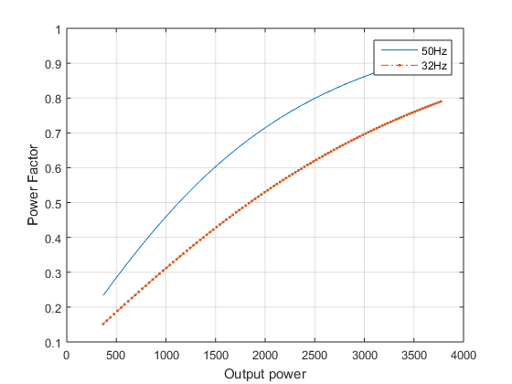

Figure9. Power factor vs. Output power (W)

**Observation:** The power factor is higher for 50Hz than 32Hz.

**Inference:** For higher frequency the reactive impedance of the circuit will be higher, thus increasing the power factor of the circuit. The value of the power factors for the respective operating frequencies **(32 and 50 Hz) at 0.012 is 0.789 and 0.891**.

**4. Slip vs. Output power**

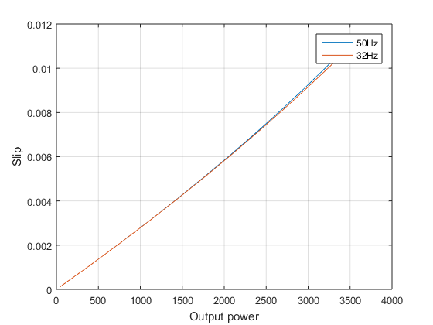

Figure10. Slip vs. Output power (W)

**Observation:** The slip vs. output power for 50Hz and 32Hz overlap each other.

**Inference:** As the load increases slip increases due to decrease in speed. The speed is maintained by the variation of voltage when the frequency changes. The lack of variation in the values of slip is also observed numerically as well, the values of output powers at 0.012 are 3700W for both 32Hz and 50Hz.

**5. Speed vs. Output Power**

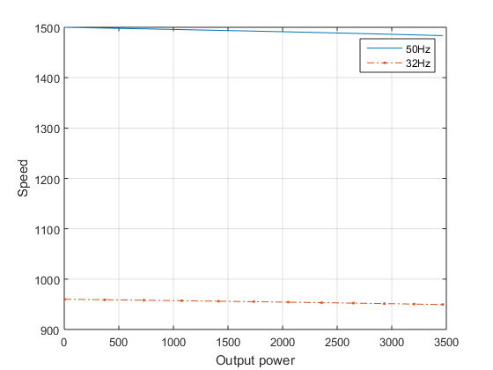

Figure11. Speed(rpm) vs. Output power (W)

**Observation:** The speed vs. output power for 50Hz is higher than the 32Hz range of operation.

**Inference:** The speed of the machine at 32Hz is lower for a given load because the torque developed is directly proportional to frequency and hence it is higher for 50Hz. The value of speed for its range of operation at 50Hz is approximately 1500rpm and 950rpm for 32Hz.

**3) Performance characteristics at 400V, 50 Hz and at 256V, 32 Hz**

**1. Efficiency vs. Output power**

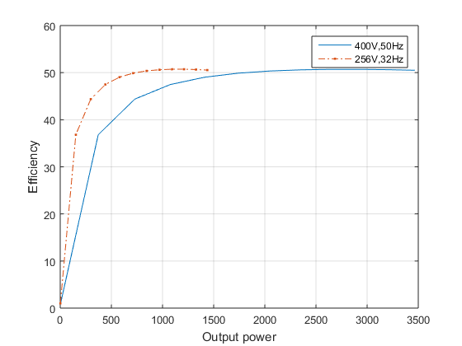

Figure12. Efficiency vs. Output power (W)

**Observation:** The efficiency of the 256V, 32Hz is higher than 400V, 50Hz.

**Inference:** The power factor of the first set of operating conditions is higher than the other. Therefore more real power is being converted as output and hence, efficiency increases. The efficiency of the machine at 0.012 slip value is **50.04% for 256V, 32Hz** and **50.5% for 400V, 50Hz**. Both the values start to saturate at common value at higher operating output power.

**2. Line current vs. Output power**

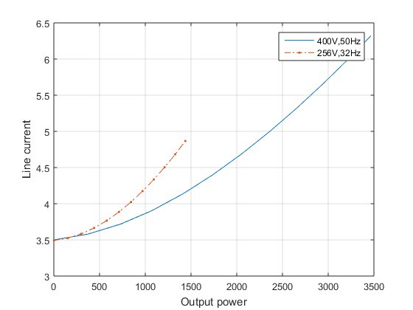

Figure13. Line current (A) vs. Output power (W)

**Observation:** The line current is lower for 400V 50Hz than when the machine operates at 256V 32 Hz.

**Inference:** The inductive reactance is significantly lesser as the frequency decreases hence increasing the line current from the stator side. This change more than compensates the increase in voltage as well.

**3. Power factor vs. Output power**

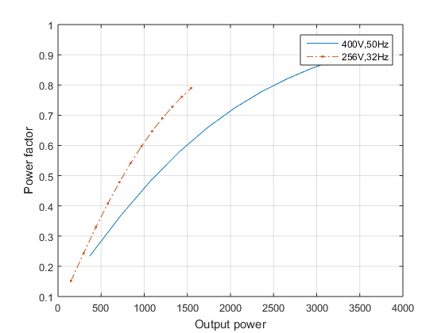

**Observation:** The power factor for the 400V and 50Hz is found to be lower than 256V and 32HZ

**Inference:** the inductive reactance of the circuit is lower for lower frequency of operation, hence the power factor angle considering the overall circuit impedance. Hence it is higher for 32Hz than 50Hz.

**4. Slip vs. Output power**

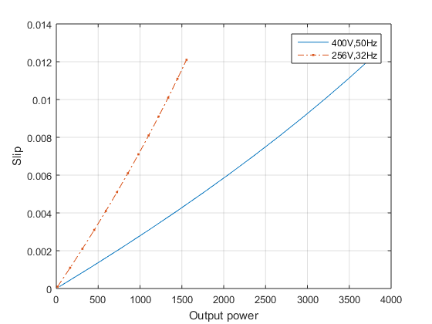

**Observation:** The slip vs. Output power curve for the 256V 32Hz is significantly higher that the 400V 50Hz.

**Inference:** The increase of load on the rotor decreases the speed which in turn causes the slip to increase. This effect is seen rapidly when the machine operated at a lower operating voltage.

**4) Performance characteristics for rotor resistance of 1.286 ohms and 1.9 times its values**

**1. Efficiency vs. Output power**

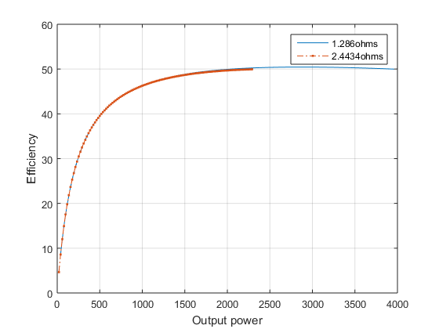

**Observation:** The value of efficiencies at various output powers for both values of resistances remains the same.

**Inference:** The value of R2 directly affects the value of the non-shunt branch current, as it increases the current through it decreases. This effect is balanced by the increase in the value of R2. Hence the output is the same value of R2. Therefore, the efficiency is the same.

**2. Line current vs. Output power**

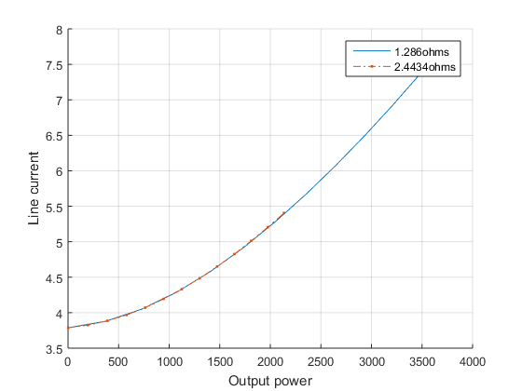

**Observation:** The value of line current is nearly the same for both values of R2.

**Inference:** The increase in the R2 decreases the value of line current but in such a way that the output power is same for two different values of R2. This causes the line current to remain the same for a given output power for varying values of R2.

**3. Power factor vs. Output power**

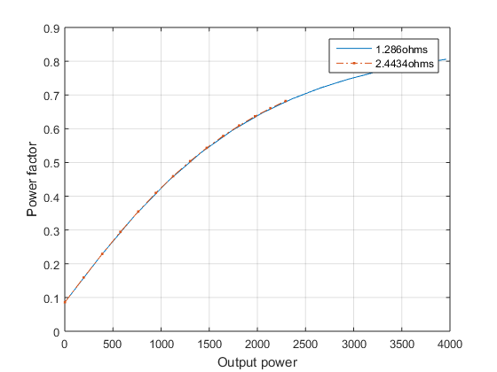

**Observation:** the value of power factor remains the same with respect output power for varying R2 values.

**Inference:** As the value of R2 increases there is corresponding output power. For this output power, the power factor is a given value that does not change with varying values of R2.

**4. Slip vs. Output power**

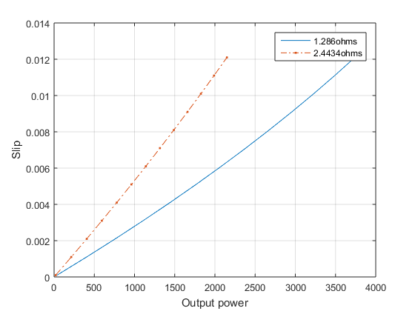

**Observation:** the value of slip for higher R2 is higher.

**Inference:** By increasing the value of R2, the resistance of the rotor circuit increases. This leads to increase in the torque and hence speed decreases. With decrease in speed, the value of slip increases.

**5. Speed vs. Output power**

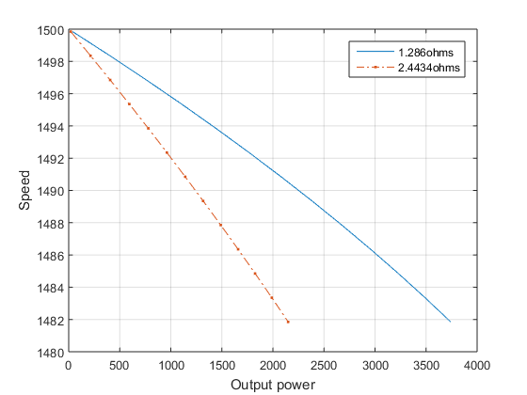

**Observation:** the value of speed is lower for higher values of R2.

**Inference:** increase in the value of R2 causes the current to drop in the rotor circuit and hence leads to the drop in the speed in the rotor.

**6. Torque vs. Output power**

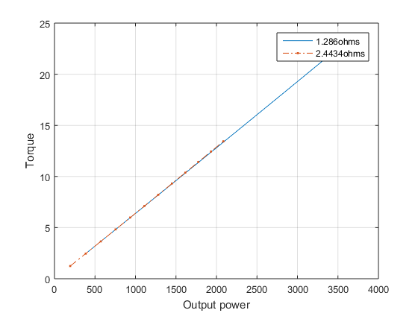

**Observation:** the torque remains constant with respect to output power for varying values of R2.

**Inference:** the torque varies linearly with output power and the value R2 does not affect their ratio.

**Result**

The various graphs were plotted and studied.

**Inference**

With the values from the no load and blocked rotor test we are able to predetermine the operation of the machine for varying loads.

**Load test on three-phase induction motor**

**AIM**

To conduct load test on three-phase Induction motor and obtain its performance characteristics.

**APPARATUS REQUIRED**

|  |  |  |  |
| --- | --- | --- | --- |
| **Sl. No.** | **Name of the apparatus** | **Range** | **Quantity** |
|  | Ammeter | (0-10) A, MI | 1 |
|  | Voltmeter | (0-600) V, MI | 1 |
|  | Wattmeter | UPF (double) | 1 |
|  | Connecting wires | - | - |

**CIRCUIT DIAGRAM – LOAD TEST ON THREE-PHASE INDUCTION MOTOR**

Brake

Drum

S2

R

B

3-Phase

400V

50 Hz

AC

Supply

Y

B

E

C

C

C

B

B

E

E

Three-phase

Induction

Motor

Double element wattmeter

M

L

C

V

M

L

C

V

R

Y

B

#

T

P

S

T

S

V

A

VL

IL

3Ф

Autotransformer

A1

A2

B1

B2

C1

C2

S1

PANEL BOARD

**PROCEDURE**

1. Make the connections as per the circuit diagram.
2. Keep the brake drum in loose condition. (No load).
3. Close the switch TPST and vary the sliding contact of the autotransformer slightly so that the ammeter shows the maximum current reading and comes to steady state current. (i.e., no load current)
4. Now adjust the autotransformer to get rated voltage in the voltmeter.
5. Note down the no load readings.
6. Then load the motor gradually in steps using the brake drum arrangement and note down the corresponding ammeter, voltmeter, wattmeter and spring balance readings. Also note down the speed.
7. Continue the procedure up to the point when the ammeter reads the rated current of the motor.
8. Tabulate all the readings for each and every value of load up to the rated value of current.
9. Remove the loads by loosening the brake drum belt.
10. Bring the auto-transformer sliding contact to its original position (minimum voltage).
11. Open the TPST switches and disconnect the circuit.

**TABLE – LOAD TEST ON THREE-PHASE INDUCTION MOTOR**

|  |  |  |  |  |  |  |  |  |  |  |  |  |  |
| --- | --- | --- | --- | --- | --- | --- | --- | --- | --- | --- | --- | --- | --- |
| **S.No.** | **Line Voltage**  **VL (V)** | **Line Current**  **IL (A)** | **Speed**  **N (rpm)** | ***Spring Balance Readings (kg)*** | | | ***Torque***  ***T***  ***(Nm)*** | **Power**  **factor**  **Cos ф** | **Input**  **Power Pin** | | **Output**  **Power**  **Po (Watts)** | **% Slip** | **% Efficiency**  **η** |
| **S1**  **(kg)** | **S2**  **(kg)** | **S1 ~ S2**  **(kg)** | **Observed**  **(div)** | **Actual**  **(W)** |
|  | **400** | **3.7** | **1495** | **0** | **0** | **0** | **0** | **0.1170** | **150** | **300** | **0** | **0.33** | **0** |
|  | **400** | **4.5** | **1475** | **5.5** | **12** | **6.5** | **9.392** | **0.6735** | **1050** | **2100** | **1450.7** | **1.66** | **69.08** |
|  | **400** | **5.5** | **1465** | **6.2** | **15** | **8.8** | **12.716** | **0.734** | **1400** | **2800** | **1950.81** | **2.34** | **72.43** |
|  | **400** | **6** | **1459** | **7** | **17.5** | **10.5** | **15.172** | **0.7694** | **1600** | **3200** | **2318.07** | **3.2** | **73.23** |
|  | **400** | **7** | **1446** | **9** | **22** | **13** | **18.785** | **0.824** | **2000** | **4000** | **2844.51** | **3.6** | **71.11** |
|  | **400** | **7.5** | **1440** | **7.5** | **23** | **15.5** | **22.397** | **0.866** | **2250** | **4500** | **3377.38** | **4.0** | **75.052** |

**Multiplication factor :\_\_\_\_\_2\_\_\_\_\_\_\_\_\_\_\_\_\_\_\_\_\_\_**

**FORMULAE TO BE USED**

1. Torque, T = 9.81× (S1~S2) ×R (N-m)

2. Output power, P0 =  (W)

3. Input power, Pin =  (W)

4. % efficiency,  = 

5. Power Factor,  = 

6. Synchronous speed, Ns =  (rpm)

7. Percentage slip, %s = 

8. Multiplication Factor = 

where S1 and S2 are the readings of spring balance (Kg)-R is the radius of the brake drum (m)

N is the speed of the motor (rpm), Pin is the input power (W), P0 is the output power (W), VL is the line voltage (V), IL is the line current (A), *f* is the frequency of the input supply (Hz), p is the number of poles

**Observation:**

**1) Performance characteristics vs. experimental values**

1. **Torque vs. Slip**

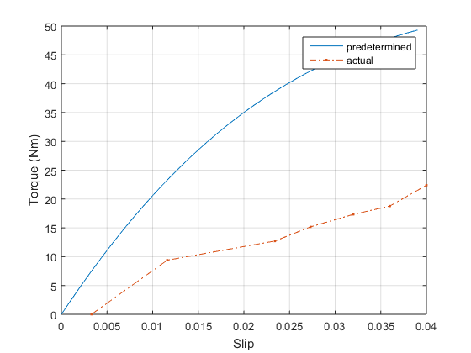

**Observation:** The torque is found to be linearly increasing for lower values of slip. The observed torque is found to be lesser than the predetermined torque.

**Inference:** An induction motor is to be run from no-load to full load. For this range the motor has to supply the nessacary torque and this torque is dependent on slip as loading the motor affects its speed. The relation between torque and slip is as follows (under constant voltage):

**T α sR2/(R2­­2+(sX)2)**

Under small slip, the torque produced is directely propotional to s, **T α s.** This explains the linear increase in the torque with respect to slip as seen in the graph. The deviation from the actual value may be attributed to non-inclusion of mechanical losses at the shaft.

1. **Efficiency vs. Output power**

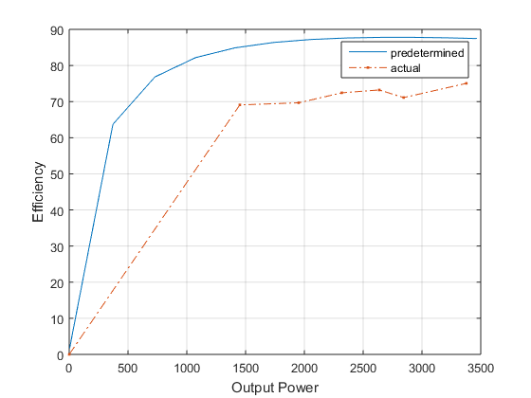

**Observation:** The efficiency is found to be increasing as power increases and then saturates at value after a certain point. The predetermined saturation efficiency is higher than the observed one.

**Inference:** As the output of the machine increases, the motor has to draw more input. At lower output, the power drawn for magnetizing is less and the copper loss is proportional to the current drawn. But as the load increases the magnetizing current saturates and further increase in the output is proportional to the increase in the input power being drawn. Hence it is almost constant after some point. There is a difference between the actual load test values and predetermined ones because the in predetermined we do not have prior knowledge about the mechanical losses, which are found only during load test.

1. **Line current vs. Output power**

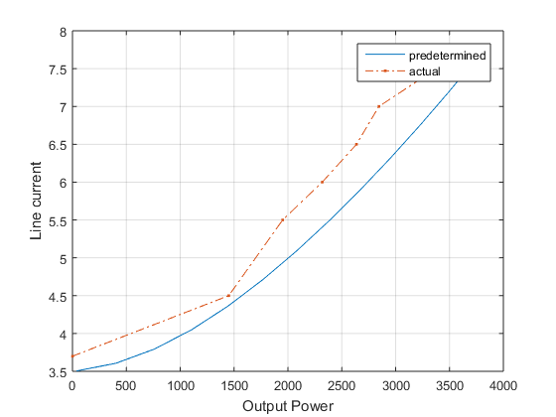

**Observation:** The line current in found to increase almost linearly with increase in output power. The predetermined curve is found to be lower than the one plotted with actual load test values.

**Inference:** When the machine is increasingly loaded, the current in the rotor circuit increases. This increase in the rotor current is directly linked to the increase in the stator current, **Is α Ir.** This is because the power required to balance the load on the rotor end ahs to come from the only source to the machine – stator. Hence, the line current increases as a result of increase in ouput power. The observed values are higher than predetermined values because the load test values also include the current drawn for compensating the mechnical losses at the same power as the predetermined one.

1. **Power factor vs. Output power**

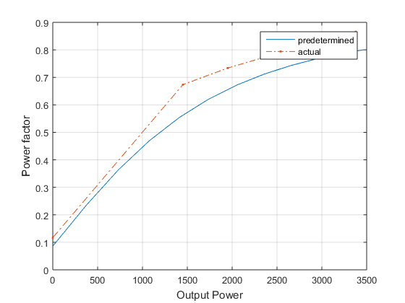

**Observation:** The power factor is found to increase with increase in output power and saturates at value of approximately 0.8. The load test power factor curve is slightly higher than the predetermined one.

**Inference:** The value of power factor increases as output increases because as we load the machine the amount of reactive or magnetizing current drawn by the stator increases to balance the proportional increase in the rotor current. But after a certain point of loading, the power factor of the machine attains its maximum value. The value of actual is higher because here the mechanical losses make it more resistive and hence power factor increases.

1. **Slip vs. Output power**

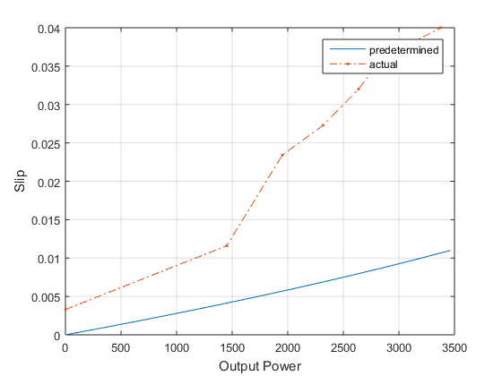

**Observation:** The slip increases linearly as the machine loaded. The value of the actual load test slip-power curve is higher than the predetermined value.

**Inference:** When the machine is being loaded, the speed of the rotor decreases. This causes the difference in the value of Ns ­ and Nr to increase. This results in increase in the value of slip.

1. **Speed vs. Output power**

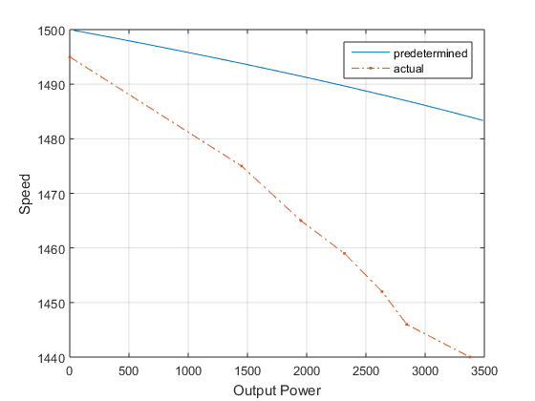

**Observation:** Speed decreases as the value of the output power value increases. The actual load test curve is lesser than the predetermined one.

**Inference:** The dip in the value of speed is caused by the increase in the mechanical load on the rotor. This in turn causes increase in the value of slip.

1. **Torque vs. Output power**

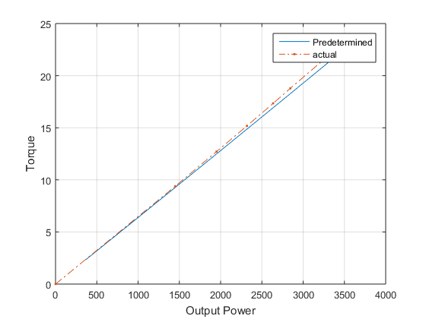

**Observation:** The graph between torque and output power is linearly increasing. There exists very little deviation between the actual and the predetermined values.

**Inference:** As the load increases the machine provides equal amount of torque to balance the load. The relation between output power and torque is given as,

**P = 2πNsT**

Clearly it is seen that torque is proportional to the output power.

**Result**

The performance of the machine was observed and studied during load test.

**Inference**

The load test performance characteristics reflect the actual working of the motor under loaded as clearly seen from the graphs plotted and compared against predetermined readings.