DISTRIBUTION:
Master Copy / CDE

REVISIONS:
Page | Rev. # | By  (Dept.) | Date | Initial | Nature Of Revision
All | 0 | NZ | 9/01/98 | PD | Original
ORIGINATOR: Sammy Taylor  NZ/US2  CONFIDENTIALITY CODE: D2 |  |  | APPROVAL: Mitch Holcombe Author: Mitch Holcombe at _AND1PO1  Date: 9/1/98 6:35 AM Priority: Normal  TO: Philip Doker  Subject: Routed: DN CHIPPER DRIVE BELT REPLACEMENT PROCEDURE  ------------------------------- Message Contents ------------------------------  APPROVED: MH 1 SEPT 98  REVIEWER: Phil Doker PD 1 Sep 98

- PURPOSE / SCOPE / RESPONSIBILITY
  - These instructions are for the NZ Troubleshooters to replace the DN Chipper drive belts at the Z/ZP site.
- WORK CONDITIONS
  - Operator Position
- Standing

  - Shift
- N/A

  - Safety Equipment
- Safety shoes
- Safety glasses
- Gloves
- Personal lock and tag (with picture identification)

  - Tools
- Sockets (36, 46, 55, and 65mm 3/4” drive)
- Ratchet, 3/4” drive
- Knock wrench, 55mm
- Air impacts, 3/4” drive, 1/2” drive
- Allen socket, 17mm
- Pin removal jig
- Hydraulic nut with porta power
- Eye bolts, 22mm
- Chokers
- Shackles
- Pettybone

  - Machine/Equipment Characteristics
- DN chipper drive belts

  - Product Characteristics
- N/A

  - Post Layout
- N/A

  - Special Conditions which influence the job
- N/A

  - Definitions
- N/A

- WORK DESCRIPTION
  - Remove belts
- Lock out chipper motor in the substation.
- Remove cages from drive belts and pulley.
- Loosen bolts securing drive unit and remove belt tension.
- Remove belts from large pulley.
- Remove coupling covers and the grid.
- Remove small pulley shaft pillow block bearing caps.
- Remove spacer in pillow block on coupling side.
- Fold belts to side from top of small pulley.
- Remove small pulley shaft from pillow blocks.
- Remove old belts.
  - Replace belts
- Put new belts between pillow blocks with top of belts folded to the side.
- Put small pulley shaft back in the bearing housings.
- Replace spacer in pillow block on coupling side.
- Add grease to bearings.
- Reinstall pillow block bearing caps.
- Put coupling grid back on coupling.
- Grease coupling with Syntrel 91N grease (JN/PDR 75B36X).
- Reinstall coupling covers.
- Remove inside and outside plates on the pedestal bearing.
- Remove pedestal bearing cap.
- Remove bearing adjustment plate and locking plate.
- Remove nut from the tapered sleeve.
- Using the hydraulic nut, remove tapered sleeve from bearing.
- Remove bearing.
- Loosen pedestal mount bolts.
- Using pin removal jig, remove the two dowel pins.
- Remove outside base bolts.
- Loosen pedestal jack bolts.
- Remove pedestal mount bolts.
- Remove the pedestal.
- Install the drive belts on the large pulley.

  - Set pedestal bearing clearance (spherical roller)
- Reinstall the pedestal (bolts and dowel pins).
- Replace the outside base bolts.
- Measure the bearing bench clearance.
- Put the bearing back on the shaft.
- Put tapered sleeve on shaft and into the bearing.
- Push tapered sleeve and bearing back until against sleeve on shaft.
- Put bearing cap back on.
- Screw nut on the tapered sleeve until both are flush.
- Back the nut off a half a turn.
- Put locking plate and bearing adjustment plate back on.
- Tighten adjustment plate bolts until locking plate hits the shaft.
- Measure bearing clearance and check table on page 5.
- Loosen adjustment plate bolts and back nut off 1/4 turn.
- Tighten adjustment plate bolts until proper bearing clearance is obtained. (Nut may have to be loosened and the bearing adjustment plate tightened several times to get correct bearing clearance. Rotate bearing before each clearance check.)
- Secure locking plate to the nut when correct clearance is obtained.
- Grease pedestal bearing.
- Replace inside and outside pedestal bearing plates.
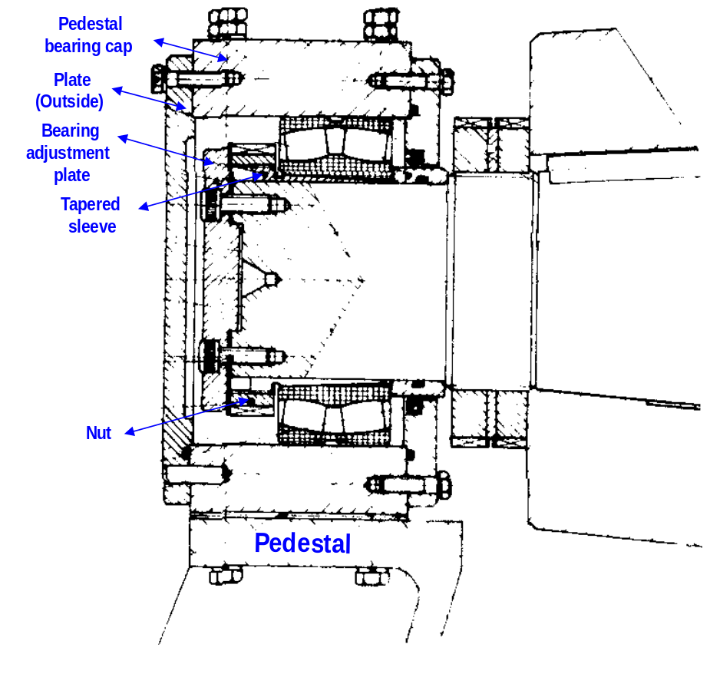
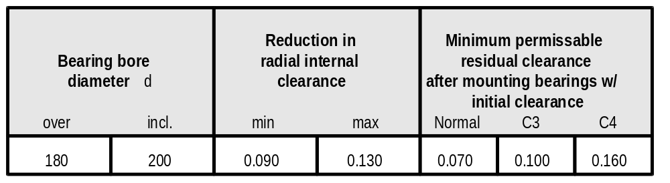
3.4. Tighten drive belts
- Using a 25 kg weight, tighten the belts until a 40 to 45 mm deflection is obtained on the inside and outside belt sets.
- Tighten drive base bolts and jack bolts.
- Replace cages.
- Unlock chipper drive motor.

- QUALITY REQUIREMENTS
  - Remove all tools and parts when work is complete.
  - Clean area when work is complete.

- SAFETY REQUIREMENTS
  - Lock out the equipment if necessary
  - Observe all safety rules and regulations.

- MISCELLANEOUS DUTIES
  - N/A

- PRODUCT ACCEPTANCE CONDITIONS
  - N/A

- PRODUCTION RECORDING
  - N/A

- REFERENCES
9.1 N/A

