|  |  |  |  |  |
| --- | --- | --- | --- | --- |
| Student Name | Beau White | Student Number | | 474538124 |
| Unit Code/s & Name/s | ICTDBS506 Design databases | | | |
| Cluster Name  *If applicable* | N/A | | | |
| Assessment Name | Database / website design project portfolio | Assessment Task No. | | 2 of 2 |
| Assessment Due Date |  | Date Submitted | | 6/11/2024 |
| Assessor Name | David Hunt | | | |
| **Student Declaration:** I declare that this assessment is my own work. Any ideas and comments made by other people have been acknowledged as references. I understand that if this statement is found to be false, it will be regarded as misconduct and will be subject to disciplinary action as outlined in the TAFE Queensland Student Rules. I understand that by emailing or submitting this assessment electronically, I agree to this Declaration in lieu of a written signature. | | | | |
| Student Signature | B.White | | Date | 6/11/2024 |
| **PRIVACY STATEMENT:** TAFE Queensland is collecting your personal information on this form for the purpose of assessment. In accordance with the Information Privacy Act 2009 (Qld), your personal information will only be accessed by staff employed by TAFE Queensland for the purposes of conducting assessment. Your information will not be provided to any other person or agency unless you have provided TAFE Queensland with permission, if authorised under our Privacy Policy (available at <https://tafeqld.edu.au/global/privacy-policy.html>) or disclosure is otherwise permitted or required by law. Your information will be stored securely. If you wish to access or correct any of your information, discuss how it has been managed or have a concern or complaint about the way the information has been collected, used, stored, or disclosed, please contact the TAFE Queensland Privacy Officer at [privacy@tafeqld.edu.au](mailto:privacy@tafeqld.edu.au) | | | | |

|  |  |
| --- | --- |
| Instructions to Student | Using the scenario provided, you are required to complete nine (9) tasks. Task 1 involves working in a group but the other eight (8) tasks you will be working alone or as directed by your teacher. These tasks are:  Meeting with a client  Technical requirements  Conceptual model  Logical data model  Business rules and constraints  User interface  Physical design  Access and security  Client receipt, feedback checklist, sign off sheet |

|  |  |
| --- | --- |
|  | The project involves the creation of a front-end website supported by a back-end database to implement an online shop.  Customers will be able to view and order products online. The website must be responsive to different screen sizes. No gateway payment is included in this project. Details of the client’s background, data requirements are supplied below.  Materials to be supplied:  Case Scenario  Excel file for data dictionary  Access to a computer with:  Internet access  Web browser  Microsoft office  Database provider(MySQL/PhpMyAdmin)  Suggested applications are:  inVision  MockFlow or similar  Work, Health and Safety:  The environment should be assessed for safety prior to class. Special considering should be taken regarding potential ICT related hazards such as tripping hazards, electromagnetic radiation, ergonomics and posture.  TAFE Queensland health and safety policies and procedures should be followed at all times.  Details of Location:  TAFE will provide simulated work environment in the classroom all practical activities should be completed in the classroom with teacher/tutor assistance; however, it is possible to complete these tasks on a home computer with internet access, web browser and office suits or similar.  Time Restrictions:  This is a portfolio assessment designed to take place over 8 weeks. The student is expected to attend in class for 7 hours per week (this includes theory sessions) and should be able to commit up to 3 hours per week in their own time. |

|  |  |
| --- | --- |
|  | Level of Assistance Permitted:  Teachers and tutors should be available in class, and accessible by email for students working from home. Staff cannot directly show students answers but guide them to where to go to complete tasks individually. Students with disability will receiver reasonable adjustments.  If you are unable to attend assessment you must notify your teacher before the assessment and supply a doctor’s certificate and approval from the team manager for extension. Reasonable adjustments will be made for students as and when appropriate, after consultation with the Disability and Counselling team. Extra time may be given for Language literacy and numeracy (LLN) or extenuating circumstances - you must see your teacher prior to assessment regarding this.  RPL (Recognition of Prior Learning) is available for this unit. Speak to your teacher/assessor to check if you qualify for RPL.  Assessment Criteria:  To achieve a satisfactory result, your assessor will be looking for your ability to demonstrate the following key skills/tasks/knowledge to an acceptable industry standard:  Meeting with a client  Technical requirements  Conceptual model  Logical data model  Business rules and constraints  User interface  Physical design  Access and security  Client receipt |
| Submission details (if relevant) | Insert your details on page 1 and sign the Student Declaration. Include this form with your submission.  **Due Date:**  You need to submit three files in a zipped folder:  Assessment document (this word file)  SQL file of your database  Excel file with data dictionary |

|  |  |
| --- | --- |
|  | Your assignment must be saved with your  surname_student number_unit/cluster_AssessmentNumber.zip.  For example:  **surname_123456789_ICTDBS506_2.zip**  For re-submissions, an “R” must be added to the file name. For example:  **surname_123456789_ICTDBS506_2_R.zip**  Submit your assessment to the allocated Dropbox in Connect or to the allocated network folder. Your teacher will provide all the details for the submission system or network.  **Connect details:**  TAFE Queensland Learning Management System (Connect): [*https://connect.tafeqld.edu.au/d2l/login*](https://connect.tafeqld.edu.au/d2l/login)  **Username:** 9 digit student number  **For Password:** Reset password go to: [*https://passwordreset.tafeqld.edu.au/default.aspx*](https://passwordreset.tafeqld.edu.au/default.aspx) |
| Instructions to Assessor | Specifications of Assessment:  To be judged competent in this assessment item the student is required to demonstrate competence in all indicators shown in the marking guide.  Depending on the delivery mode and/or timetable constraints, the Study Guide and the Study Schedule must be customised to suit the mode.  Select project scenario or case study from the resources folder.  **Information / Materials provided:**  Case Scenario  Excel file for data dictionary  Access to a computer with:  Internet access  Web browser  Microsoft office  Database provider(MySQL/PhpMyAdmin)  Specialisation specific project requirements  Suggested applications are inVision, MockFlow or similar. |

|  |  |
| --- | --- |
|  | Assessment Location:  Computer lab that simulates an ICT workplace environment.  Time Restrictions:  This is a portfolio assessment designed to take place over 8 weeks. The student is expected to attend in class for 3 hours per week (this includes theory sessions), and also should be able to commit up to 3 hours per week in their own time.  Level of Assistance Permitted:  Teachers and tutors should be available in class, and accessible by email for students working from home. Staff cannot directly show students answers but guide them to where to go to complete tasks individually. Students with disability will receive reasonable adjustments.  Work Health and Safety:  The environment should be assessed for safety prior to class. Special considering should be taken regarding potential ICT related hazards such as tripping hazards, electromagnetic radiation, ergonomics and posture.  TAFE Queensland health and safety policies and procedures should be followed at all times.  Interactions:  Teamwork skills are essential in the IT industry therefore you should work in teams to consult and collaborate on the practical activities. Students need to perform Task 1 in group, and other tasks individually and will be required to show their work (unless indicated).  Contingencies:  Reasonable adjustments can be made for students who require variations to assessment conditions.  If Microsoft Word is not available; other word processing software may be used, given that the items produced can still be exported to a format accepted by Microsoft Word.  Students can use MySQL, PhpMyAdmin or similar Database provider.  inVision, MockFlow or similar program may be used, given that it supports and same features and functionality as the suggested programs. |

|  |  |
| --- | --- |
|  | Assessment Conditions:  Skills in this unit must be demonstrated in a workplace or simulated environment where the conditions are typical of those in a working environment in this industry.  This includes access to:  industry standard equipment and materials  industry standard database software  network and other systems required for remote or multi-user access  organisational requirements and deliverables  computer-aided software engineering (CASE) or diagramming software. |
| Note to Student | *An overview of all Assessment Tasks relevant to this unit is located in the Unit Study Guide.* |

# Scenario: Queensland Sunnies business requirements

## Client Background

Queensland Sunnies (QLDS) is a fictitious company that specialises on selling modern, fashionable, and unconventional sunglasses mostly to young people. The company started one year ago and has small stores in four major shopping centres in the Brisbane and Gold Coast area. This year the company has decided to expand their business to national and international markets.

### Project Scope

The project involves the creation of a front-end website supported by a back-end database to implement an online shop for Queensland Sunnies. Customers will be able to view and order products online. The website must be responsive to different screen sizes. No gateway payment is included in this project.

### Data Requirements

The purpose of this assessment item is to identify and fully document the database data requirements for the project. The database must be able to store information about:

* Products
* Customers details
* Registration (creation of customer accounts)
* Customer login
* Admin login
* Shopping cart
* Sales records (The permanent records that you must keep for accounting and taxation purposes)

The product information must be stored in the database. Images of the products must also be displayed in the website from the image path stored in the database.

Customers can add products to their shopping cart, view the shopping cart and also change quantity or delete cart products.

Customers can purchase products as guests or they can create an account and become site members.

Once they proceed to the checkout, they are asked to login or provide guest details. Once this step is done, an invoice will be displayed on the screen.

The role of the admin users in the system is to be able to add new products and modify existing ones (e.g. updating prices or deleting products). There are two level of privileges amongst the admin users. The admin manager can create new admin user accounts while the admin users cannot.

### Reports, screens and automated queries

The following reports and screens must be created and must be supported by the corresponding MySQL queries:

* Login screen
* Registration screen
* Display products (all products)
* Display products by category
* Display shopping cart screen
* Invoice report
* Permanent sales records for a specific date and/or date range
* Permanent sales records by customer

### Security Requirements

The following security requirements must be met:

* Authentication
* Password encryption/hashing
* Multi-user access control
* Backup and restore strategy

## Task 1: Meeting with client

1. This part consists of group work. Group size will depend on class numbers. Around four (4) people per group is an appropriate number. As a group, review the given scenario and collaboratively create a list of around 20-30 relevant questions. Questions should be categorised as follow:

* Hardware
* Software
* Data requirements
* People – roles, access, etc.
* Processes/business activities
* Business rules
* Security

1. Provide evidence of communication between the student group/developer and the client/teacher. Send an email to the client/teacher requesting a mutually suitable time for a meeting. In a second email, once the meeting time has been agreed to, send the meeting agenda prior to the meeting.

[davidHunt@Gmail.com](mailto:davidHunt@Gmail.com)

Subject –Meeting Request For QLD Sunnies business requirements

Dear David

I am Beau, a software engineer at Uptown. I am writing to schedule a group discussion with you to discuss the project and the business requirements in greater detail. I would love to further elaborate on what we do and how we can help your business expand.

Thank you for your time, and look forward to hearing from you

Yours Sincerely

Beau White

Uptown

[beauWhite@Gmail.com](mailto:beauWhite@Gmail.com)

[beauWhite@Gmail.com](mailto:beauWhite@Gmail.com)

**Subject: Meeting Agenda for QLD Sunnies business requirements on 25/10/2024**

Dear Beau White

I hope this email finds you well.

Following our agreement on the meeting time, I am writing to share the agenda for our upcoming meeting on 25/10/2024

Meeting Agenda:

Group Discussion on Business Expansion Globe wide and on:

* Hardware
* Software
* Data requirements
* People – roles, access, etc.
* Processes/business activities
* Business rules
* Security

Please let me know if you have any questions or require any additional information prior to our meeting.

Looking forward to a productive discussion

Best regards,

David Hunt

1. Each group will have a meeting with the teacher/facilitator who will be playing the role of the client - a non-technical business executive. The meeting will either be recorded or documented as an observation checklist (by the teacher) as evidence to demonstrate that you have:

* met with the client to conduct the user-needs analysis
* negotiated and understood the client’s requirements for the functionality of the website
* used active listening, communicating in plain English, and summarising the client’s key points to understand their requirements.

1. A meeting is a good way of identifying user needs. List and explain four (4) methods that can be used to identify user needs. Outline the advantages and disadvantages of each method.

**Brainstorming/Focus Group –**

Advantages:

Bigger group dynamics can generate more ideas, discussions from many different perspectives.

Able to gather multiple opinions in a single session.

Can uncover new ideas and many insights through group discussions.

Disadvantages:

Peers may solely only focus on the dominant opinion of the group.

Facilitators’ influence may affect the discussion outcomes.

**Interviews –**

Advantages:

Allows for detailed exploration of the users needs and feelings.

Interviewers can adapt questions based on responses to gather more information.

Disadvantages:

Going through interviews can be very time consuming.

Interviews requires skilled interviewers on both parties.

**Observation –**

Advantages:

Oberserving the users can provide genuine insights into their behaviour and needs.

Helps understand the context which the users can interact with a product or service.

Can be done without interrupting the user’s workflow.

Disadvantages:

Requires significant time investment to gather sufficient data.

May not catch all aspects of user needs, especially those not outwardly visible.

**Questionnaires/Surveys –**

Advantages:

Can be distributed to a large number of people at a reasonable low cost.

Respondents may feel more comfortable in providing honest feedback.

They can provide a large amount of quantitative data that can be statistically analysed.

Disadvantages:

Doesn’t provide deep insights into the users needs.

It can be difficult to get a high response rate.

## Task 2: Technical requirements

Based on the answers received as a result of the client meeting, recommend specific technical requirements for the database/website project.

You will also be required to research the technical requirements and include references to where you sourced your information from.

Document the technical requirements (500-800 words). The document must include:

* technical requirements negotiated with the client/teacher during the meeting
* referenced sources of technical information you have obtained in preparing the technical requirements.

**Key database technical requirements**

User management:

**Guest** and users can browse without logging into, to encourage impulse purchases.

**Customer accounts** are to be required to make purchases, using email as a unique identifier (which cannot be changed later)

**Administration roles**

We will have some **administrative roles** and also **super administrative roles**. Super admins will have full access and full control of the database, and website. Regular admins will be able to add, remove, update products and customer details.

**Product categories:**

**ProductID** which is the primary key (Unique) for each and every product, **Name** of the product will be the main title for the product to be displayed into the database. The **price** of the product will also be a key displaying title for the product to be displayed. The **category** of the product will be the is split up in four categories, such as men’s sunglasses, women’s sunglasses, kid boy’s sunglasses, and kid girl’s sunglasses, **frame type** comes with many different variations such as stainless steel, aluminium, titanium, gold, silver, platinum, TR90, Acetate, wood and plastic, and also comes in different shapes such as Rectangle, Square, round and cat-eye sunglasses. **Description** of the product will display a brief introduction and information on how the it looks, form of protective eyewear designed to prevent bright sunlight and uv rays from damaging or discomforting the eyes, and also indicated whether if it is polarized or regular,

**Customers** will be able to filter options for categories such as price, (eg below $100) and demographic such as men, women, boy, girl. **TRIGGERS & REGEX**

**Shopping Cart and Order Management:**

**Carts** will then transition into orders, after the customer has made a purchased on the product. A field will be mark the status of the order, to keep it in track such as **(carted, ordered, shipped, delivered)**

**Orders will have limitations of up to 50 items max per order. CONSTRAINT**

**Orders are to be timestamped and retained for 7+ years for legislative compliance. TIMESTAMP**

**MySQL** itself is very well scalable, and can handle over 1000 concurrent users, however the database will also be implemented with load balancers just in case, and also will encourage on having cloud servers and network servers just in case.

QLD SUNNIES will require **global accessibility,** which will take place for cloud hosting with geographic distribution with **AWS Amazon web servers** which is compatible with MySQL. We will deploy the database across into many data centres global wide, such as countries like, North America, Europe and Asia to reduce latency for international customers.

We will also be **storing timestamps in UTC** in to the database and convert them to the user’s local time zone in the application.

**Currency conversion** is also another factor to keep in mind, maintaining a currency field in the products table, which will allow dynamic conversion on the user’s location or selected currency.

**Regional data Compliance is very important to keep in mind, especially for GDPR in Europe. Certain data may need to be stored only in certain countries, which can be managed with data partitioning or hybrid cloud setup for the European region.**

**End to end encryption will be put in place, especially sensitive data, such as personal information and user accounts to be stored, ensuring compliance with privacy regulations.**

**User passwords are to be hashed and encrypted within the database for security purposes and compliance purposes.**

**Automated Backups** will take place with storage in multiple regions to safeguard data. The cloud providers offers cross-region backups to minimize downtime and cost of resources. Also enabling the point-in recovery for the primary database to restore the data quickly to a precise moment just in case.

**Current-timestamped sales** and reports will be generated for management.

References:

YouTube

Google

ChatGPT

Microsoft CoPilot

Learner Guide

GeekForGeeks

Several other Websites

AWS

## Task 3: Conceptual model

Design a conceptual model using Visual Paradigm (or similar). The conceptual model will take the form of an entity relationship diagram (ERD).

The conceptual model submitted with your evidence must include:

* the completed conceptual model for the database - first draft ERD
* feedback from the client, incorporated as amendments in the model - provide evidence of communication between you and the client/teacher (exchange of e-mails)
* content written in plain English language which a non-technical client would understand.

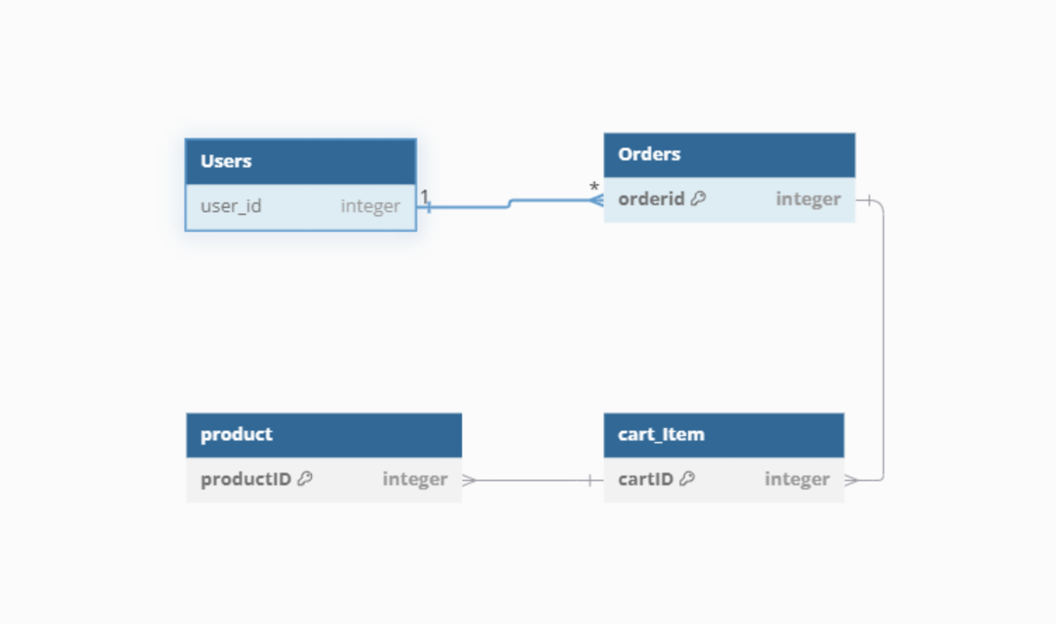

## Task 4: Logical data model

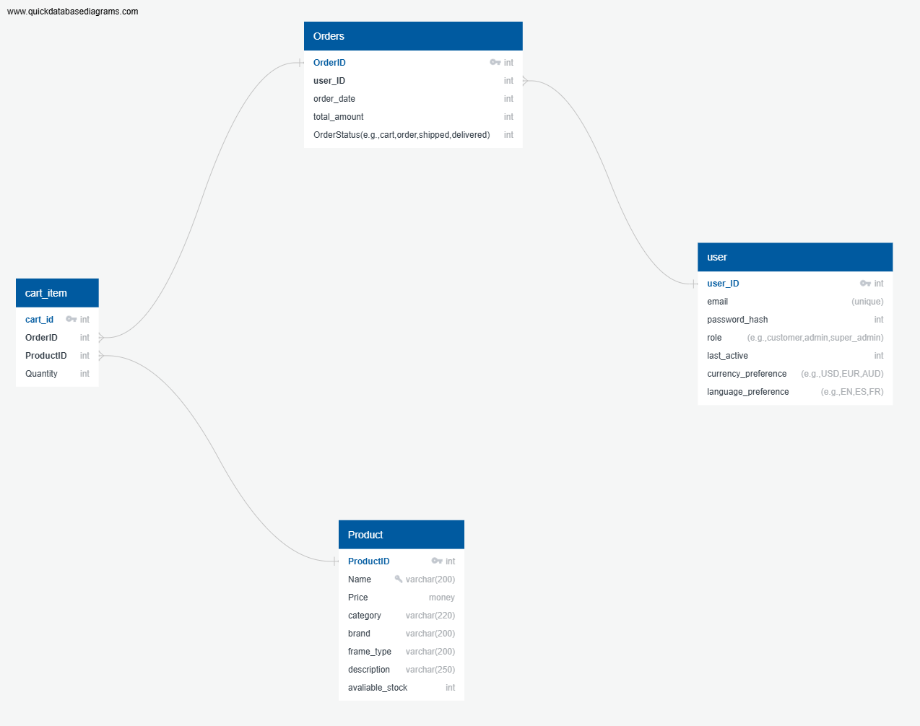

1. Perform normalisation process to at least third normal form (3NF) showing the results for each step.
2. Update the ERD after normalisation. Ensure that the cardinality ratio is displayed.
3. Develop a data dictionary that clearly indicates the data types and precision parameters for each field (size, range and nullability), primary and foreign keys for tables, data validation and business constraints (checks or triggers). Template provided.

The logical data model submitted with your evidence must include:

* normalisation documentation (step-by-step)
* final ERD
* data dictionary
* approval of the logical data model to the client (exchange of e-mails).
* 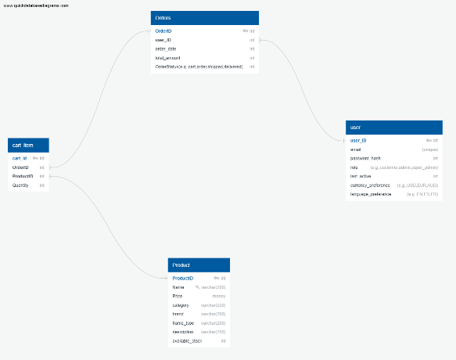 A diagram of a product

  Description automatically generated with medium confidence
* 1. Added the other attributes in each table into the database ERD
* 2. Added Foreign Keys refencing the neighbouring table of each table.
* 3. Adding datatypes to each column.

To [davidH@gmail.com](mailto:davidH@gmail.com)

Subject: Approval request for Logical Data Model

Dear David Hunt

I hope this message finds you well,

I am writing to inform you that we have successfully developed the logical data model based on the approved Conceptual Data Model for qld_sunnies. The Logical Data Model includes details of other relevant attributes with each table, align it with each primary key, and the data types of each attribute.

Please find attached the Logical data model for your review. We kindly request your approval to proceed with this model. Your feedback and approval are essential to ensure that the model aligns with your requirements and expectations. If you have any questions or need further clarification, please feel free to contact me.

Thank you for your continued support and collaboration.

Best regards,

Beau White

To [beauW@gmail.com](mailto:beauW@gmail.com)

Subject: Approval of the Logical Data Model

Dear Beau

Thank you for sharing the Logical Data Model for the qld_sunnies. I have reviewed the details and am pleased to inform you that the Logical Data Model meets our requirements and expectations.

You have my approval to proceed with the next steps, including the development of the Physical Data Model and the subsequent implementation.

If there are any further details or additional information needed, please feel free to contact me.

Best regards,

David Hunt

## Task 5: Business rules and constraints

1. Business rules - Identify a minimum of five (5) business rules that apply to the database/website project.

**Account Creation and Unique Identification**

* Each customer account must have a unique email address, which serves as the primary identifier and cannot be changed once registered. If a customer wants to change their email, they must create a new account.

**Order Quantity Limits**

* Customers can order a maximum of 50 items per order and a minimum of 1 item. Attempting to place an order outside these limits will result in an error.

**Password Requirements**

* Passwords must be at least 10 characters long and include at least one uppercase letter, one number, and one special character. This ensures strong security for customer and admin accounts.

**Data Retention for Sales Records**

* Sales records must be timestamped and retained for seven years for compliance purposes. After this period, records may be archived or deleted as per business and legal requirements.

**Shopping Cart Persistence and Order Finalization**

* Items in a customer's shopping cart can be edited (added/removed) until the order is placed. Once an order is finalized, the cart contents become locked and cannot be modified. If an item goes out of stock, it cannot be added to the cart or ordered.

1. Integrity constraints – Primary and foreign keys have been identified. Also identified in the data dictionary.
2. Referential integrity constraints - Identify and set all referential integrity constraints. Use the table below to document the referential integrity constraints by indicating the rules and actions that apply to each foreign key.

|  |  |  |  |  |
| --- | --- | --- | --- | --- |
| TABLE and FOREIGN KEY (FK) | TABLE & PRIMARY KEY it REFEENCES (PK) | REFERENTIAL INTEGRITY COSTRAINTS | | REFERENTIAL ACTIONS |
| RULE 1 | RULE 2 |
| FK has the same declaration (data type and domain) that the PK it references | FK value is equal to value in PK or NULL |
| Orders,  (FK)user_ID | User  (PK)user_ID | Yes | Yes | ON DELETE CASCADE,  ON UPDATE CASCADE |
| cart_item,  (FK)OrderID | Orders  (PK)OrderID | Yes | Yes | ON DELETE CASCADE,  ON UPDATE CASCADE |
| Cart_item,  (FK)ProductID | Product  (PK) ProductID | Yes | Yes | ON DELETE CASCADE,  ON UPDATE CASCADE |

1. Semantic and other constraints - These can take the form of validation rules, check constraints and triggers. Keep in mind that MySQL does not support check constraints and triggers must be created to implement some checks. These have been included in the data dictionary. Review and update this section the data dictionary until you are sure that all semantic constraints have been identified.
2. Indexes - Identify which table column will benefit from indexing and create the indexes. You can use the table below to record the indexing.

|  |  |  |  |  |
| --- | --- | --- | --- | --- |
| INDEX NAME | COLUMN NAME | TABLE | INDEX TYPE  (e.g. HASH or B-Tree) | SEARCH BENEFITS |
| UQ_users_email | email | User | Unique | Enforces unique email addresses, improving login and lookup performance. |
| IX_products_category_price | Category,  Price | Products | B-Tree | Improves filtering and sorting of products by category and price. |
| IX_orders_orders_date | Orders_date | Orders | B-Tree | Optimizes retrieval of orders by date, useful for generating date-based sales reports. |
| FK_orders_user_id | User_id | Orders | Foreign Key | Speeds up joins and retrievals for user-specific order data. |

1. Provide an estimation of the approximate size of the completed database. Explain how you have reached the estimate.

**1. Orders Table**

OrderID (INT): 4 bytes

user_ID (INT): 4 bytes

order_date (INT or TIMESTAMP): 4 bytes

total_amount (INT or DECIMAL): 4 bytes

OrderStatus (VARCHAR): 10 bytes

Row Size = 4 + 4 + 4 + 4 + 10 = 26 bytes

Total Size for 10 Rows = 26 bytes * 10 = 260 bytes

**2. User Table**

user_ID (INT): 4 bytes

email (VARCHAR): 50 bytes

password (Password): 40 bytes

role (VARCHAR): 10 bytes

last_active (TIMESTAMP): 4 bytes

Row Size = 4 + 50 + 40 + 10 + 4 + = 108 bytes

Total Size for 10 Rows = 108 bytes * 10 = 1,080 bytes

**3. Product Table**

ProductID (INT): 4 bytes

Name (VARCHAR): 50 bytes

Price (DECIMAL or MONEY): 8 bytes

category (VARCHAR): 20 bytes

brand (VARCHAR): 20 bytes

frame_type (VARCHAR): 20 bytes

description (VARCHAR, assuming average 100 characters): 100 bytes

available_stock (INT): 4 bytes

Row Size = 4 + 50 + 8 + 20 + 20 + 20 + 100 + 4 = 226 bytes

Total Size for 10 Rows = 226 bytes * 10 = 2,260 bytes

**4. Cart_Item Table**

cart_id (INT): 4 bytes

OrderID (INT): 4 bytes

ProductID (INT): 4 bytes

Quantity (INT): 4 bytes

Row Size = 4 + 4 + 4 + 4 = 16 bytes

Total Size for 10 Rows = 16 bytes * 10 = 160 bytes

## Task 6: User interface

Using inVision, MockFlow or similar program, design a user interface for the required database/website project including menus, input forms, and reports. The number of screens and reports depends on the case study or scenario used for the project.

The queries necessary to display the required reports will be completed in Task 7.

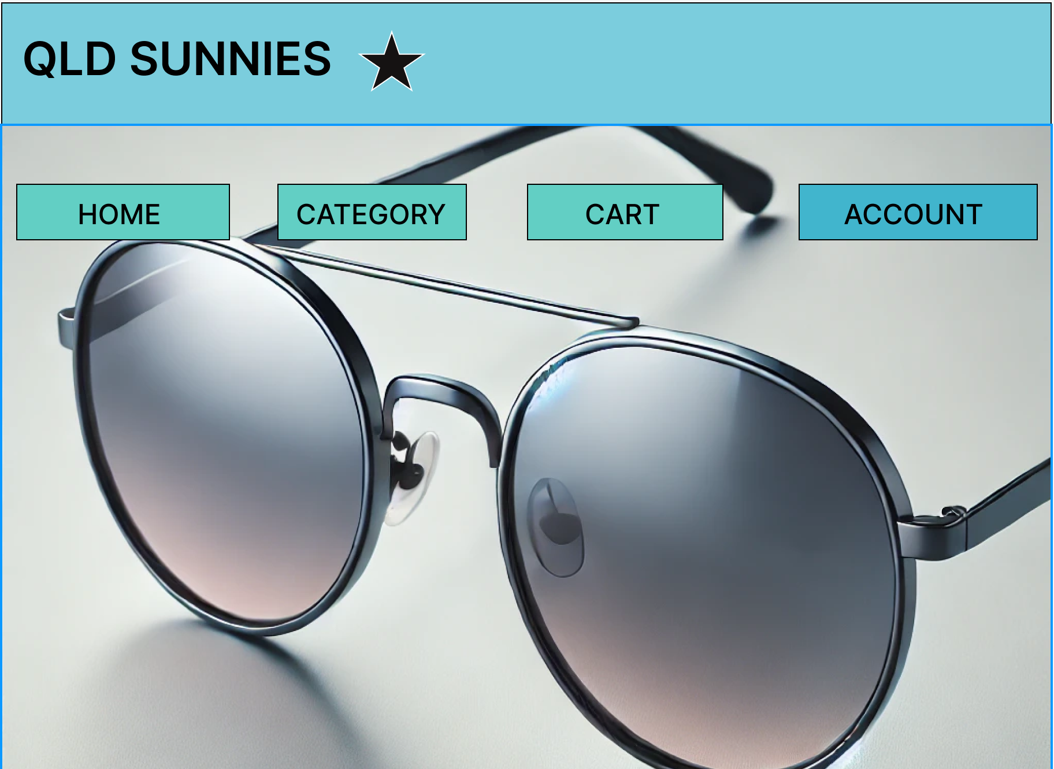

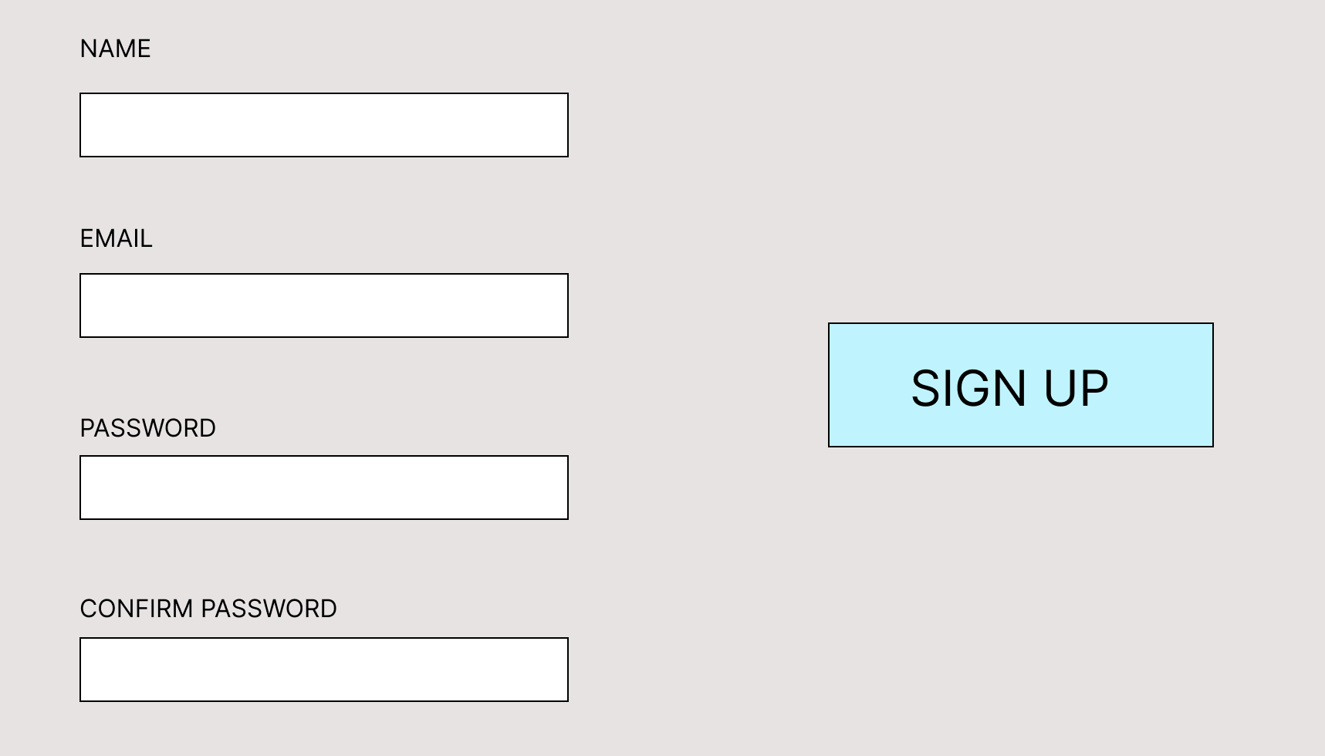

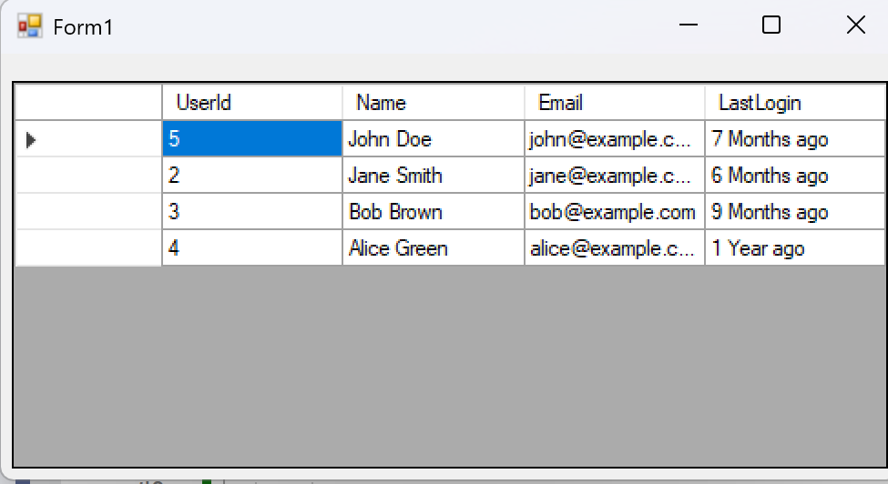

## Task 7: Physical design

1. Create a database prototype following the blueprint or structure outlined in the data dictionary created in Task 4. Export or dump the database structure. Submit the SQL file as evidence of database implementation. Apply the constraints identified in Task 5 to the database and document which constraints were applied.
2. Compare conceptual model and technical requirement with the actual database created and list and explain the differences. Make sure to make changes to the database, as necessary, while performing this review.
3. Populate the database with appropriate testing data – sufficient to run the queries.
4. Create and run the necessary queries to display the reports outlined in the case study or scenario project requirements. Provide screenshots of your queries and results. Remember that these queries are run on the database prototype and their purpose is to ascertain that the database structure is sufficient to produce the desired results.

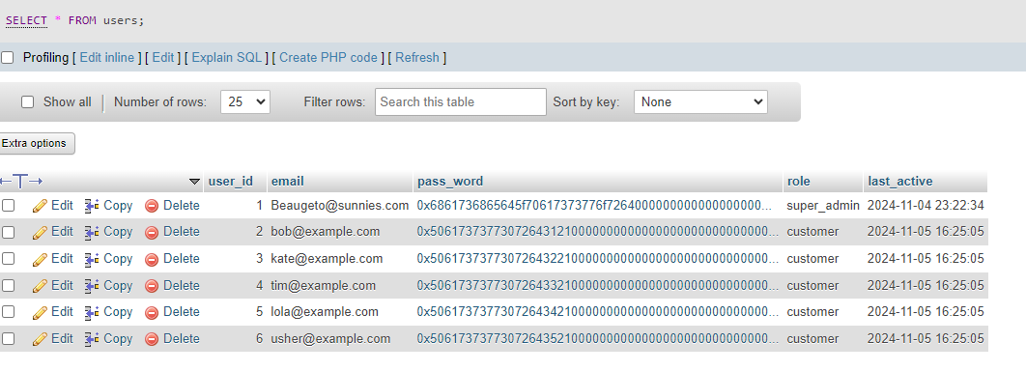

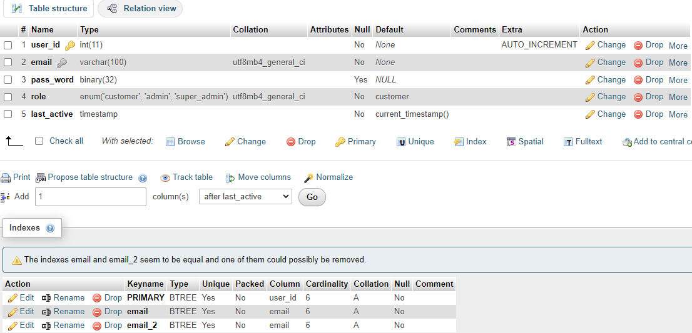

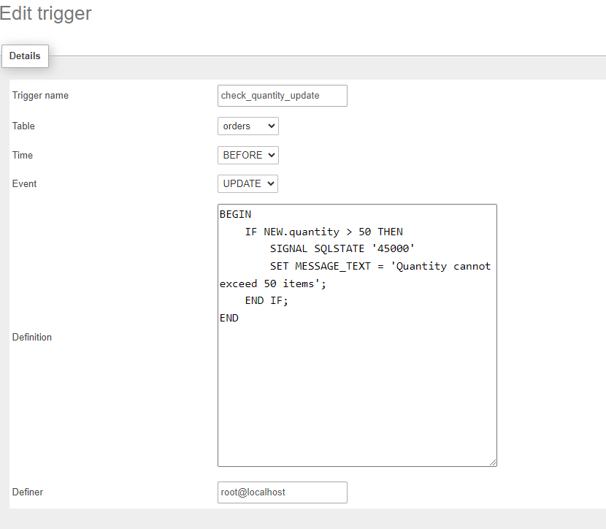

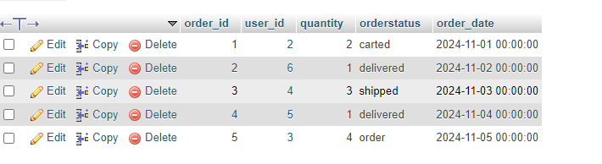

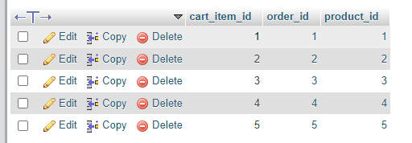

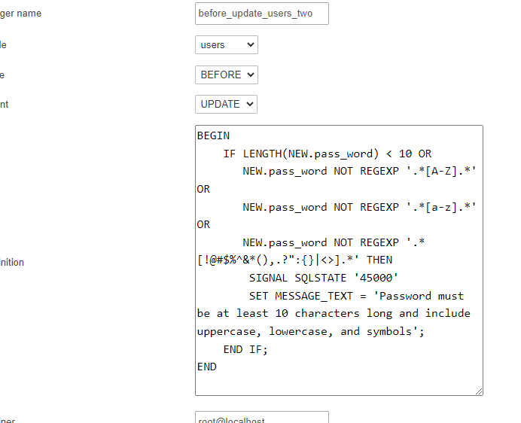

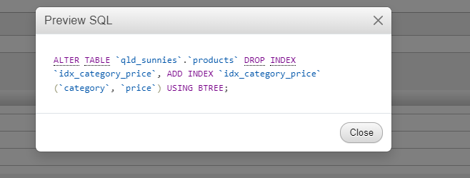

1. Outline a plan to backup and restore the database remembering that at this stage it is just a prototype.

Using System Scheduler to backup and restore the database qld_sunnies.sql, on going backing up every night 7 days a week.

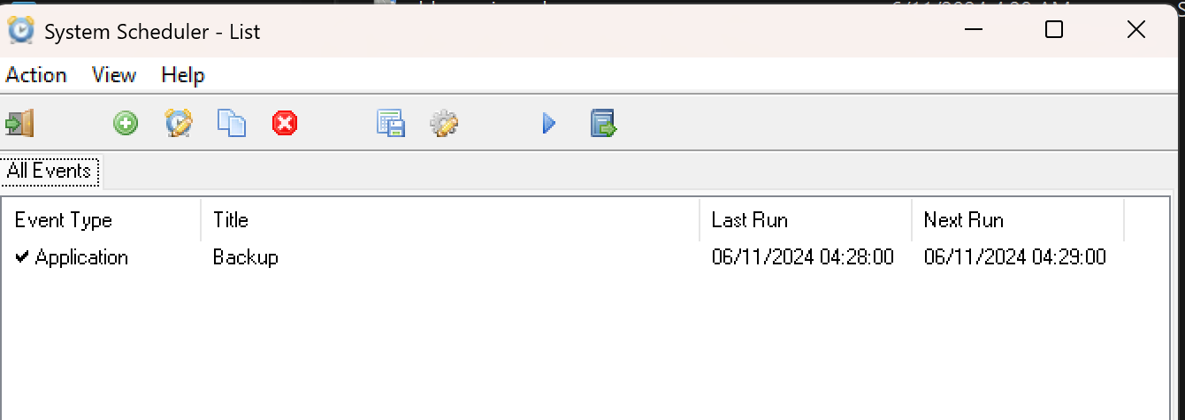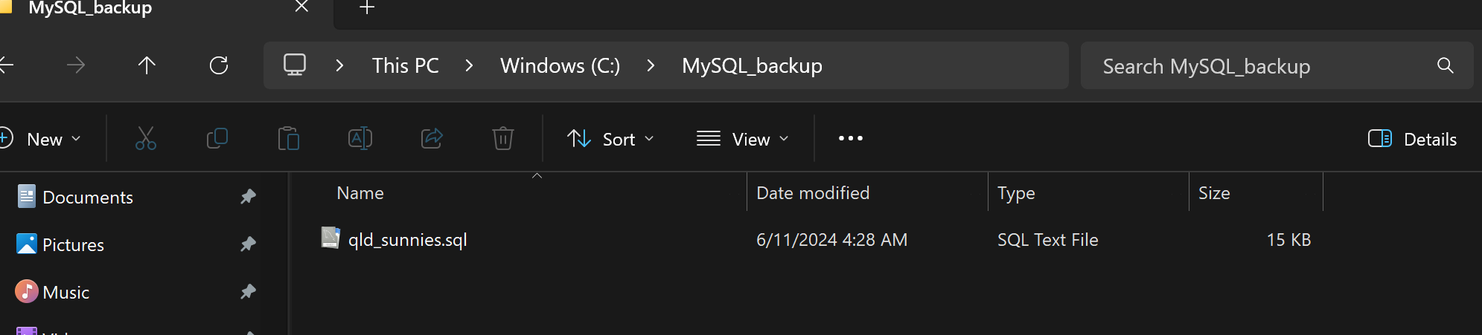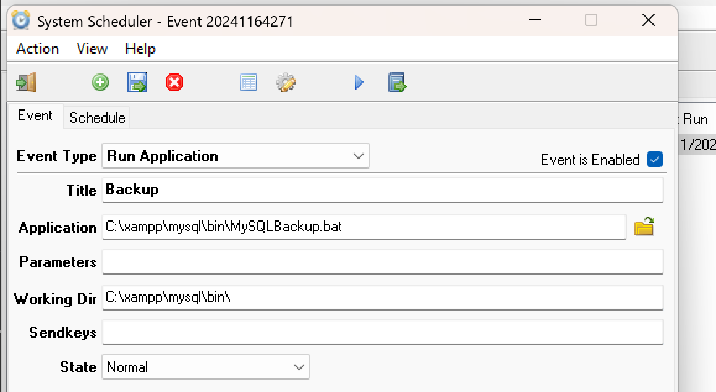

Plan to restore is to go into MySQL_Backup folder

Download and restore into the database

## Task 8: Access and security

Review the business security requirements for the case study/scenario. The points below may help you clarify these requirements.

* How the users will gain access.
* How the password will be stored securely.
* Who will be authorised to access the database.
* What permissions will be given
* The different permission levels.

At this stage, you are ready to document the access and security requirements (500-800 words). The document must ensure that:

* Security design meets the requirements of the business security requirements.
* The password access system for the database including encryption/hashing details.
* The different user groups and their access requirements and privileges.
* User access profiles.

**Authentication user\role access based accounts**

* Database in mySQL has been programmed by implementing a constraint and a trigger. When a user signs up for qld_sunnies online store, they will require their email and a password. Their email will be unique and cannot use the same email to sign up for multiple accounts. Another requirement is that their password must be at least 10 characters long, must include an upper case, lower case and a symbol. Their password will be hashed by the datatype using BINARY(32) so even if someone gets into the database, no one will be able to see what the password is. The CONSTRAINT code for :
* ALTER TABLE `users`
* ADD PRIMARY KEY (`user_id`),
* ADD UNIQUE KEY `email` (`email`),
* ADD UNIQUE KEY `email_2` (`email`);

The SQL code for a TRIGGER requiring the password to be at least 10+ characters long and with an upper case, lower case and a symbol. :

* DELIMITER $$
* CREATE TRIGGER `before_insert_users_two` BEFORE INSERT ON `users` FOR EACH ROW BEGIN
* IF LENGTH(NEW.pass_word) < 10 OR
* NEW.pass_word NOT REGEXP '.*[A-Z].*' OR
* NEW.pass_word NOT REGEXP '.*[a-z].*' OR
* NEW.pass_word NOT REGEXP '.*[!@#$%^&*(),.?":{}|<>].*' THEN
* SIGNAL SQLSTATE '45000'
* SET MESSAGE_TEXT = 'Password must be at least 10 characters long and include uppercase, lowercase, and symbols';
* END IF;
* END
* $$
* DELIMITER ;
* DELIMITER $$
* CREATE TRIGGER `before_update_users_two` BEFORE UPDATE ON `users` FOR EACH ROW BEGIN
* IF LENGTH(NEW.pass_word) < 10 OR
* NEW.pass_word NOT REGEXP '.*[A-Z].*' OR
* NEW.pass_word NOT REGEXP '.*[a-z].*' OR
* NEW.pass_word NOT REGEXP '.*[!@#$%^&*(),.?":{}|<>].*' THEN
* SIGNAL SQLSTATE '45000'
* SET MESSAGE_TEXT = 'Password must be at least 10 characters long and include uppercase, lowercase, and symbols';
* END IF;
* END
* $$
* DELIMITER ;

If the password does not meet at least 10 characters, with also at least one upper case, one lower case and a symbol.

* The password is to be hashed within the built in function using SHA(256) into the database.
* 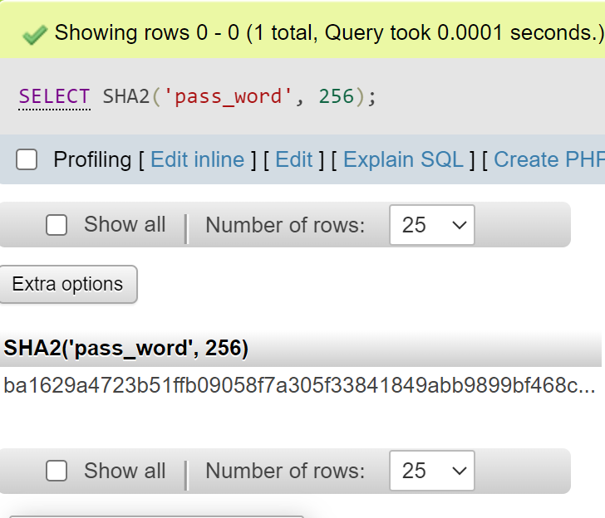

**Users based role access privileges on super_admins, admins and customer roles, visitors/guests.**

* **Super admins** will be granted All privileges on the database qld_sunnies, such as all Data features including the following SELECT, INSERT, UPDATE, DELETE, FILE. Structure features such as the following CREATE, ALTER, INDEX, DROP, CREATE TEMPORARY TABLE, SHOW VIEW, CREATE ROUTINE, ALTER ROUTINE, EXECUTE, CREATE VIEW, EVENT, TRIGGER. And lastly administration privileges such as the following GRANT, SUPER, PROCESS, RELOAD, SHUTDOWN, SHOW DATABASES, LOCK TABLES, REFERENCES, REPLICATION CLIENT, REPLICATION SLAVE, CREATE USER.
* **Admins** will be granted Data features privileges on the database qld_sunnies, such as the following SELECT, INSERT, UPDATE, DELETE, FILE. So on the qld_sunnies online store they will be able to add products, remove products, delete products, adjust their price, product_name, category, description. Along with users details, order details and cart_item details. However they won’t have Structure features nor Administration features.
* **Customers** after they have signed up for an account, they won’t have access to the actual database but just the store, let alone they won’t have any privileges over anything in the database. They can add products to their cart item list, order products, but they cannot order any more than 50 items per order. They also won’t be able to delete their orders or account for at least 7 sevens to meet legal requirements.
* **Visitors or guests** will be able to view the qld sunnies online store to check and compare prices and such, But they won’t be able to make a purchase without signing up for an account. Let alone having any access to the database.

## Task 9: Client receipt

Create a checklist to seek feedback from the client/teacher, change according to given feedback.

Write and email to the client/teacher to obtain sign off via communicating your intention to submit the completed database design documentation. Include this email with your submission with sign off sheet.

Upload your completed database portfolio (zipped folder) to Connect which include:

* Assessment document (this word file)
* SQL file of your database
* Excel file with data dictionary.

**Checklist Format for seeking feedback and feedback response.**

To : [David@gmail.com](mailto:David@gmail.com)

Subject: Request Sign Off on completed Database Design Documentation

Attached files : qld_sunnies.zip

Dear David

I hope this email finds you well

I am writing to inform you that I have completed the database design documentation, incorporating the feedback provided. I have also attached the finalized documentation for you to review.

Please review the attached document and confirm your approval, Your sign off will allow me to proceed with the submission of the completed database design documentation.

Thank you for your time and assistance

Yours sincerely

Beau White

**End of Assessment**