REACT INVENTORY
User Manual
This guide covers day-to-day use of React Inventory: login, stock documents, purchase requisitions, reports, settings, and company configuration.

1. Getting started

1.1 Login
Each session is tied to one outlet. Stock documents, balances, and lists always apply to the outlet you choose at login. If your company has an HQ branch (for example DRAGON HEALTH HQ), log in as that outlet when you need to approve purchase requisitions or receive transfers at HQ.
1. Open the app link provided by your company.
2. Select your Outlet, enter username and password, then click Login.
3. You arrive on the Dashboard for that outlet.
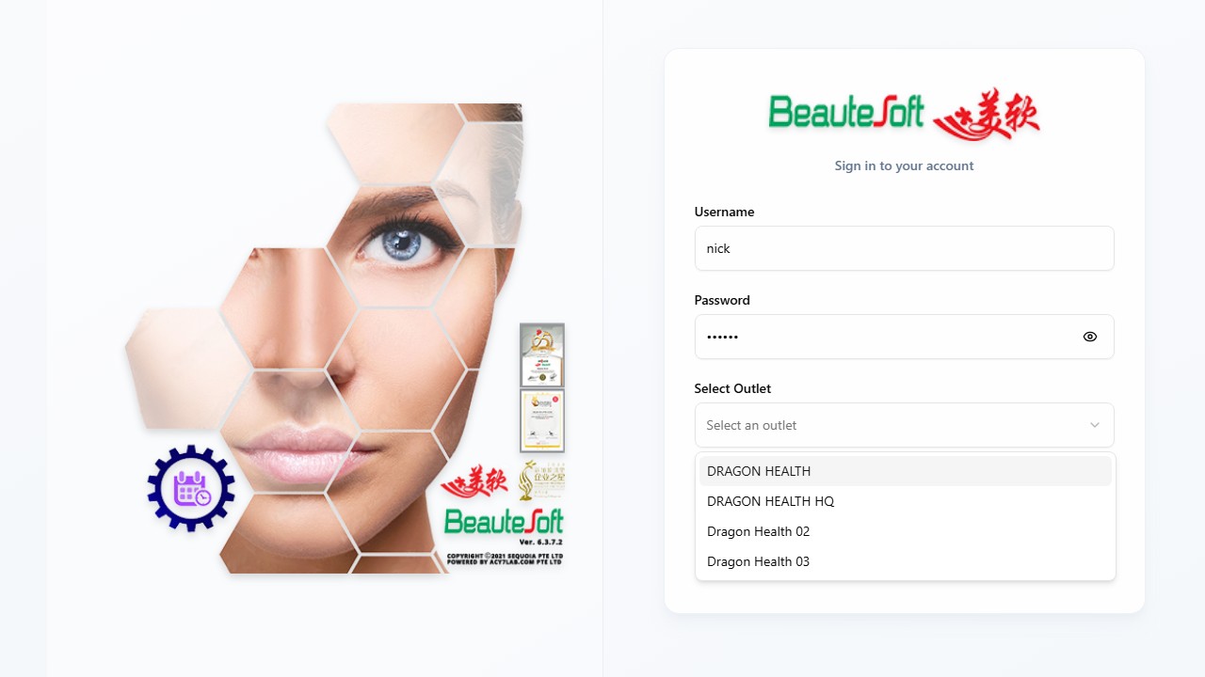
Always choose the correct outlet before working — switching outlets requires logout and login again.

1.2 Menus
The left sidebar groups the main areas of the system. Your administrator controls which menus you can see; if a menu is missing, ask for access rather than assuming the feature is unavailable.
• Dashboard — quick overview for your site.
• Stock Control — documents (GRN, transfers, PR, Stock Take, Item Master, and others).
• Reports — Stock Balance, Stock Movement, Replenishment.
• Settings — menu access for users (administrators only). Company batch, expiry, and auto-post options are set at login, not on this screen — see section 6.2.
• Logout — ends your session.
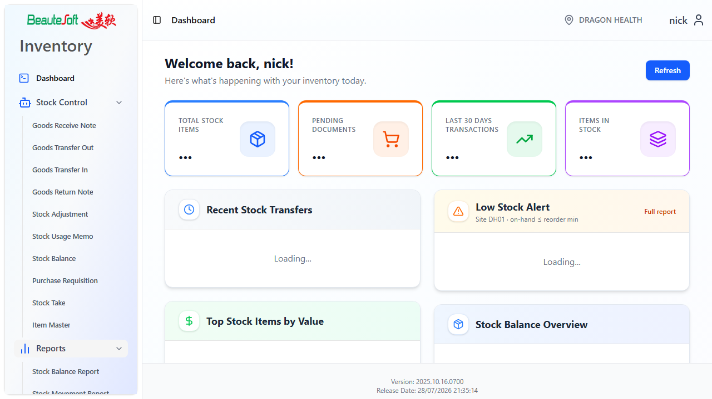
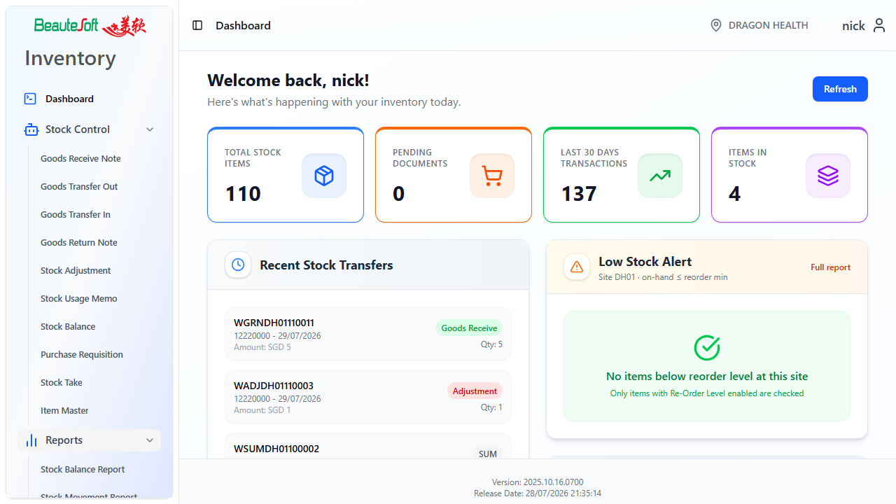

2. Save and Post
Most Stock Control documents share the same lifecycle. Open means you can still edit. Posted means the document is final and stock has been updated (for stock-moving documents).
1. Open the module → Create New (or open an existing Open document).
2. Fill the header (references, supplier or destination, dates, remarks), then add item lines.
3. If the item uses batches, assign a new or existing batch before you Save or Post.
Save — keeps the document Open so you can edit later. Stock is not updated yet.
Post — finalises the document and updates stock. Post only when details are correct.
Use a clear Remarks or Ref value for test documents (for example E2E_TEST) so they are easy to find and clean up in the database later.
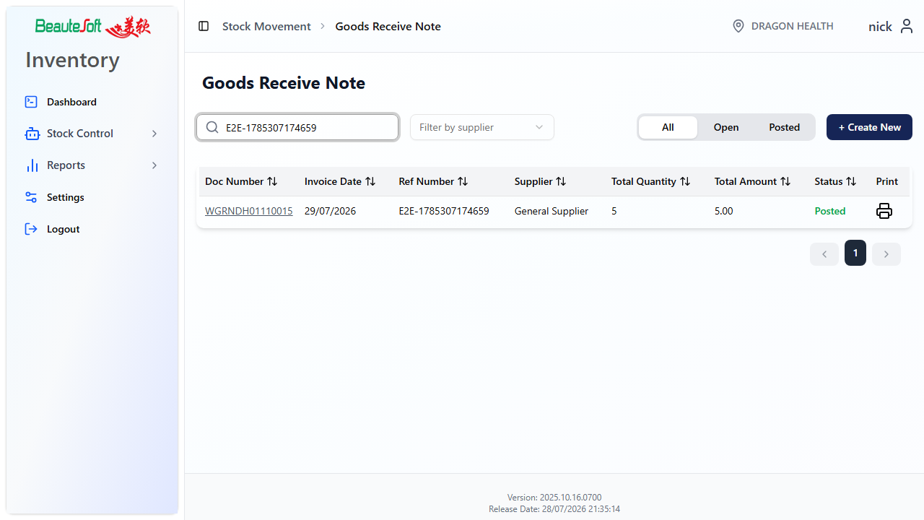
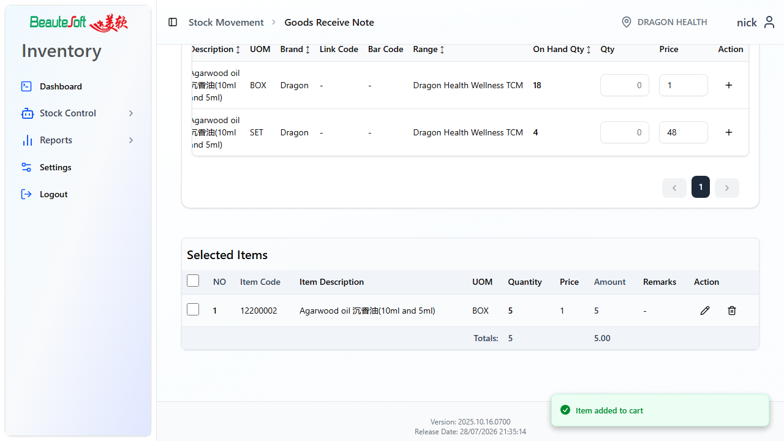
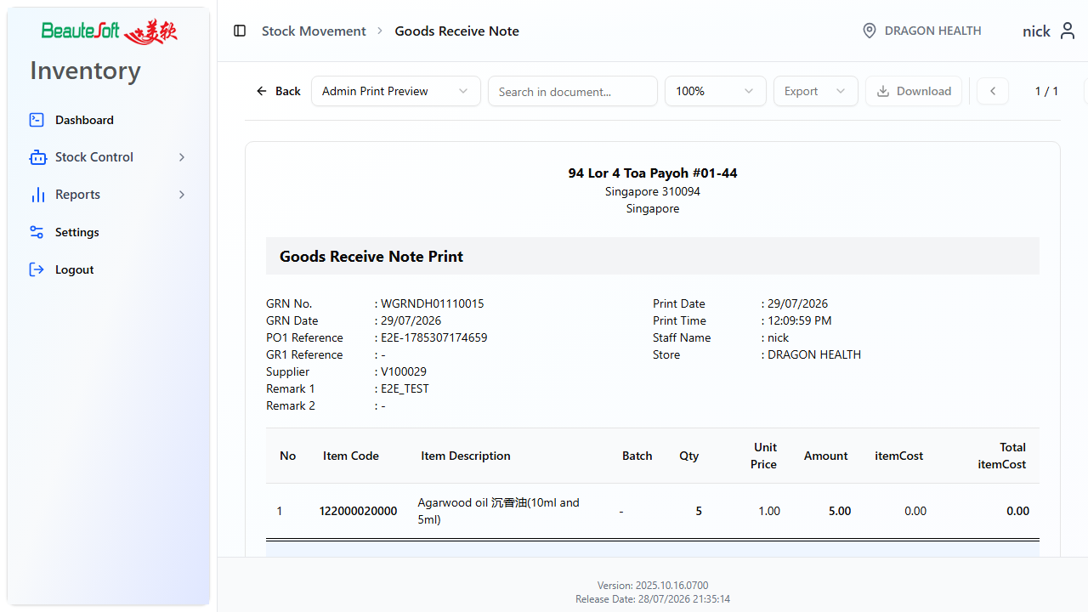

3. Stock Control

3.1 Goods Receive Note (GRN)
Use GRN when goods arrive from a supplier into the outlet you are logged into. Posting a GRN increases on-hand stock. If Batch No is on for your company (section 6.2), create a new batch (or select an existing one when appropriate) on the line before posting. If Expiry Date is also on, enter expiry before you Save or Post.
1. Stock Control → Goods Receive Note → Create New.
2. Enter Ref, select Supply No (supplier), Delivery Date, Term, and Remarks.
3. Search items, enter quantity (and price if shown), add to Selected Items.
4. Assign batch details if prompted.
5. Save to keep Open, or Post when the receipt is confirmed.

3.2 Goods Transfer Out (GTO)
Use GTO to send stock from your outlet to another site. For Dragon Health, transfers to head office typically use To Store = DRAGON HEALTH HQ. You must select To Store before items become available. Posting reduces stock at the sending outlet.
1. Create GTO → select To Store (for example DRAGON HEALTH HQ) → add items.
2. Choose an existing batch with available quantity.
3. Save → Post. Stock is reduced at the sending site.
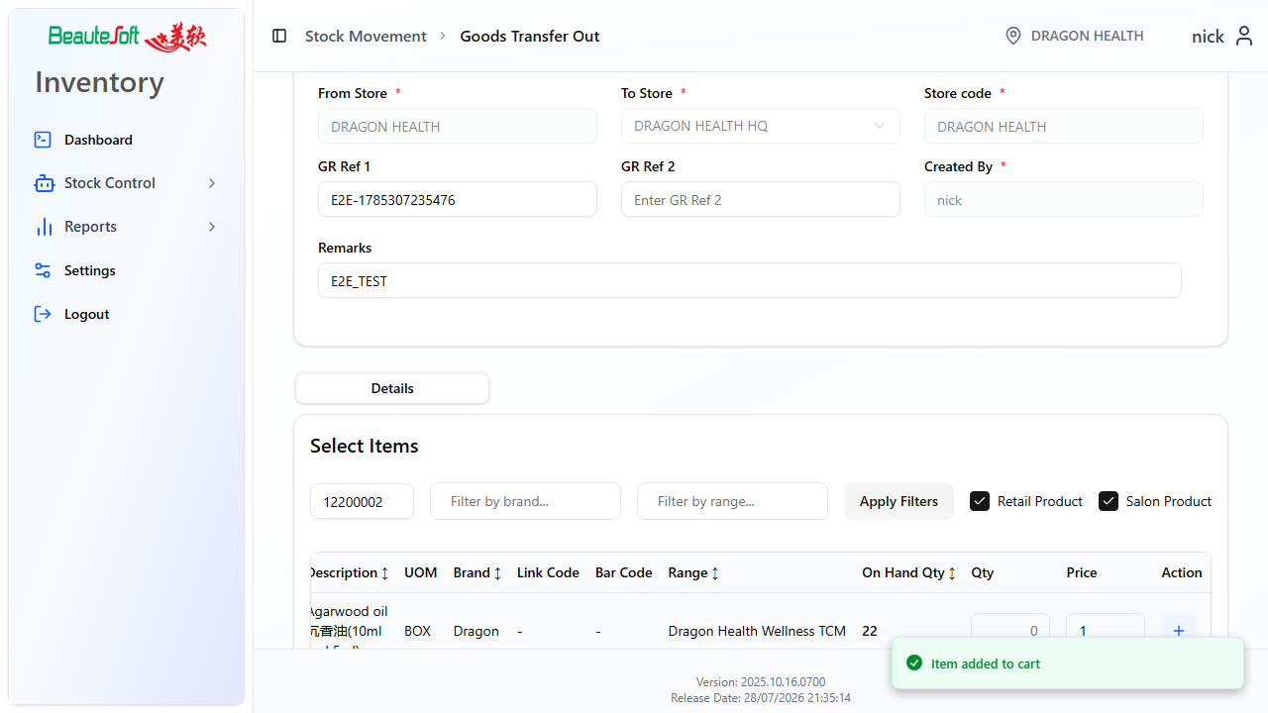
If Auto Post is on (section 6.2), destination stock can update when you Post the GTO. If Auto Post is off, the receiving site must complete a Goods Transfer In (GTI).

3.3 Goods Transfer In (GTI)
GTI receives stock that was transferred into this outlet. Open GTI documents may appear after a GTO from another site, or after HQ approves a Purchase Requisition that requested stock from HQ (see section 4). If Auto Post is on, stock may already update at the destination when GTO is posted — still open GTI when your process requires a receive document.
1. Log in at the receiving outlet (for Dragon Health HQ transfers, use DRAGON HEALTH HQ).
2. Open an Open GTI, or Create New → select From Store → add items.
3. Confirm lines and batches → Save → Post to increase on-hand stock.
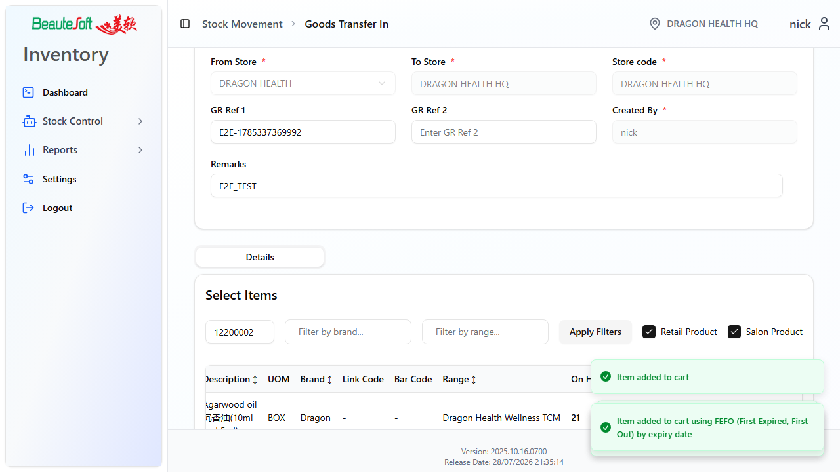
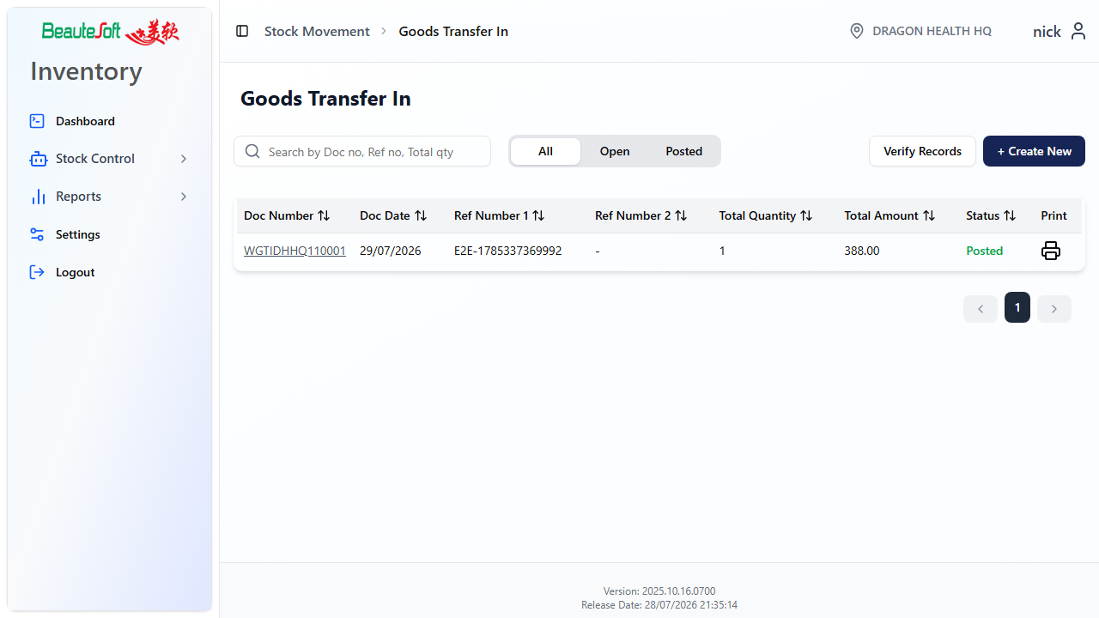

3.4 Goods Return Note (RTN)
Use RTN when returning stock to a supplier. Posting decreases on-hand stock. Select the supplier, add return quantities, and pick an existing batch that still has stock.
1. Create RTN → select Supply No → add return lines.
2. Assign existing batches → Save → Post.
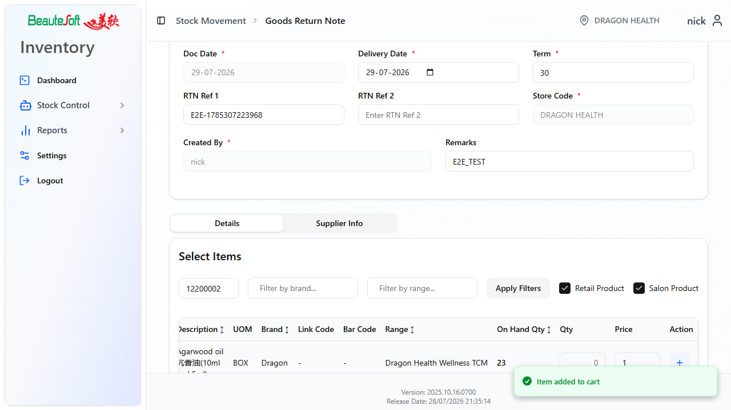

3.5 Stock Adjustment (ADJ)
Use ADJ to correct quantities when stock does not match the system (for example damage, found stock, or counting corrections). Positive quantities increase stock; negative quantities decrease it. Enter the signed quantity carefully and Post only after checking the reason in Remarks.
1. Create ADJ → enter Ref and Remark → add lines with the adjustment quantity.
2. Assign batch as required → Save → Post.
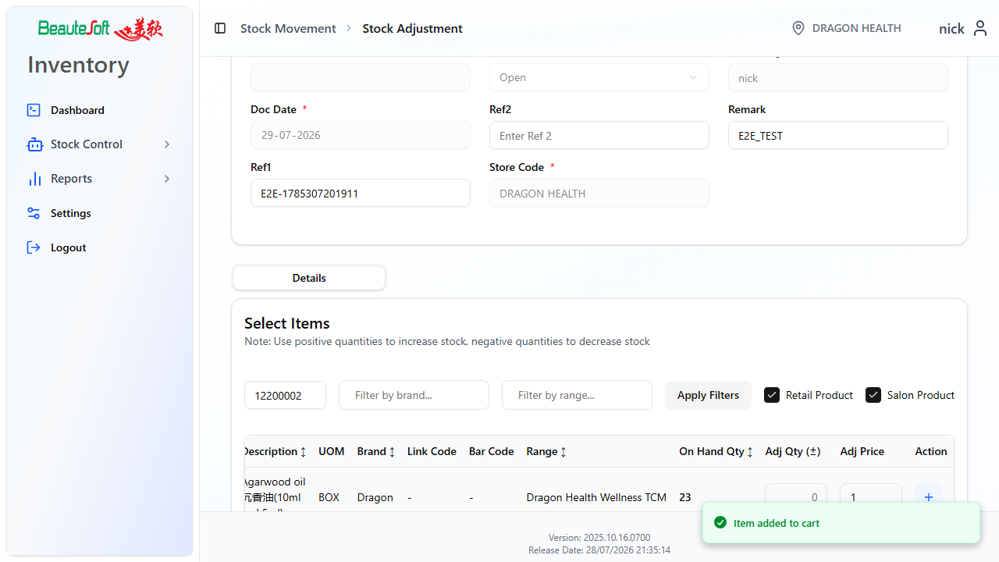

3.6 Stock Usage Memo (SUM)
Use SUM to issue stock for internal use (clinic use, samples, consumption) without returning it to a supplier. Posting decreases on-hand stock from an existing batch.
1. Create SUM → enter Ref and Remark → add items and quantities.
2. Select existing batch → Save → Post.
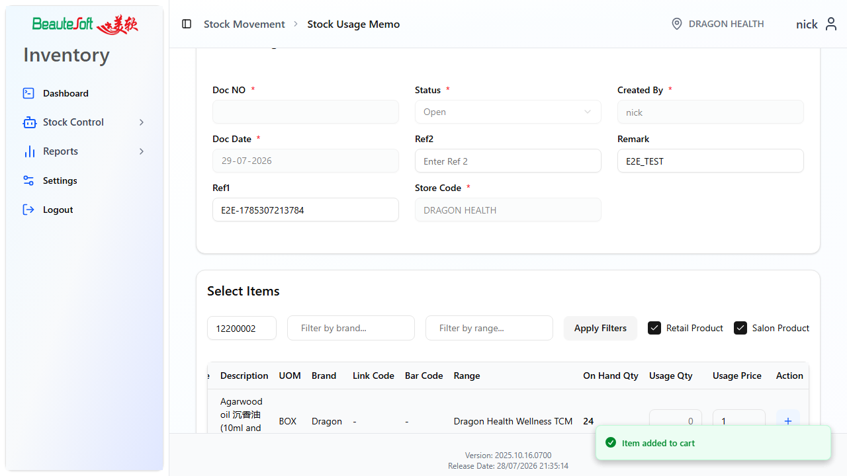

3.7 Stock Take
Stock Take records physical counts against system quantity. Work carefully: select items (Step 1), enter counted quantities and confirm each line (Step 2), then Post. Posting writes stock transactions (type TKE) and adjusts on-hand only where counted differs from system quantity.
1. Create Stock Take → select items → Next.
2. Enter counted quantities, tick Confirm Update on each line.
3. Save while counting if needed; Post when the count is finished.
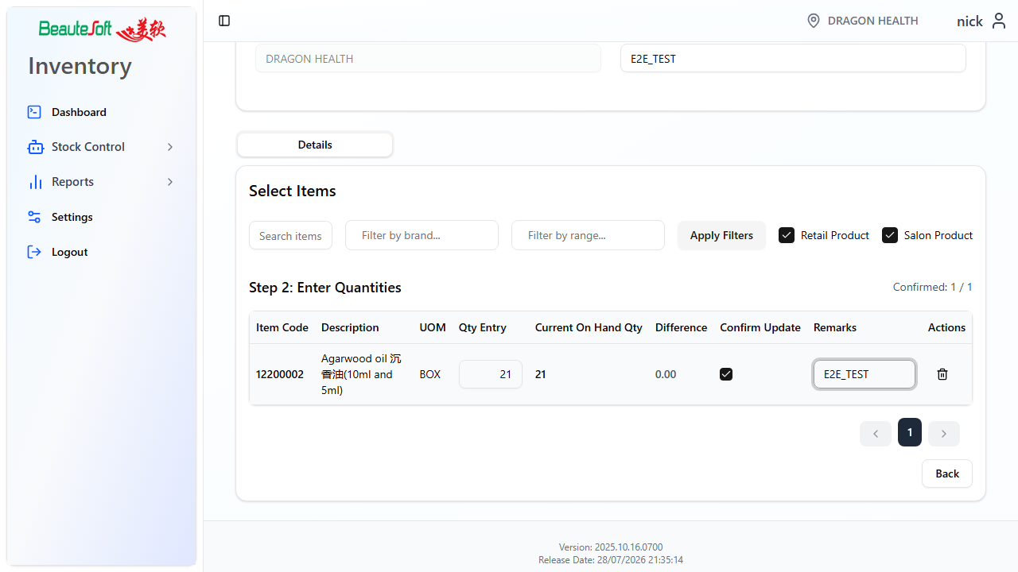
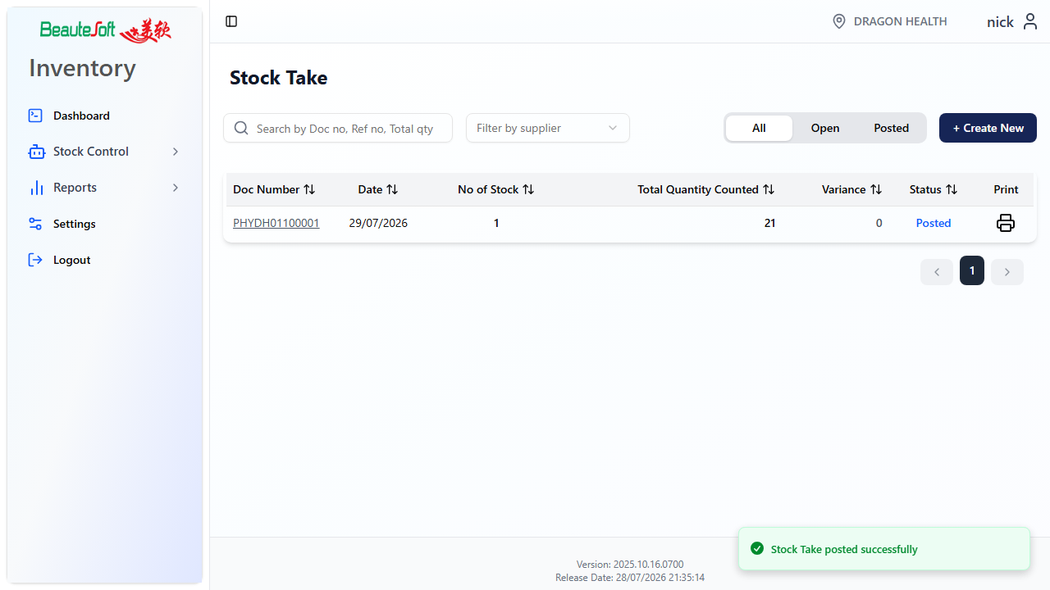

3.8 Stock Balance (live)
Live Stock Balance shows current on-hand for the logged-in outlet. It is for enquiry only — it does not create or post documents. Use reports when you need a dated snapshot or export.
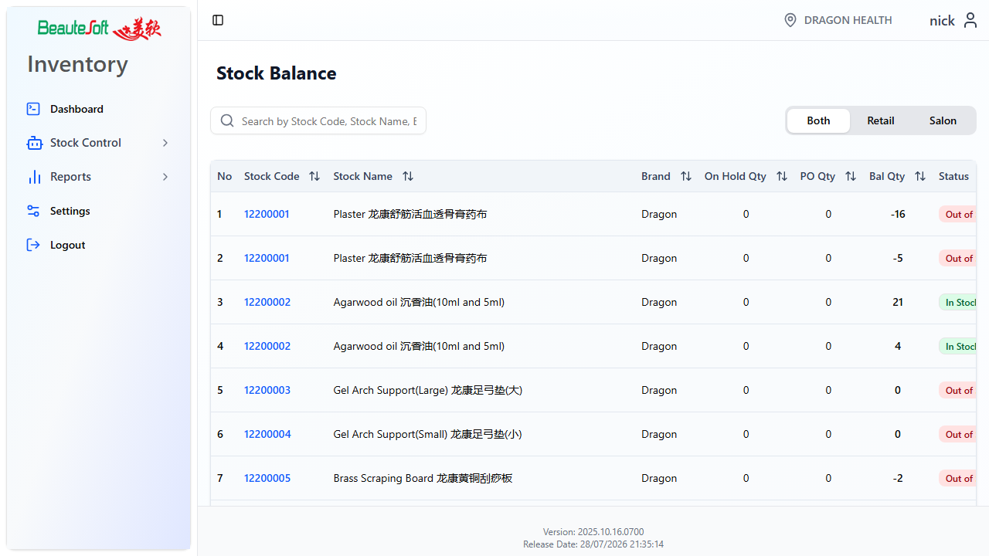

3.9 Item Master
Item Master maintains the catalog used on documents and reports (codes, descriptions, UOM, packages, prices, and related options). Change master data carefully — wrong UOM or stock type settings affect every document that uses the item.
1. Open Item Master → Create New or open an existing item.
2. Enter description, classification, UOM, and prices as required → Save.
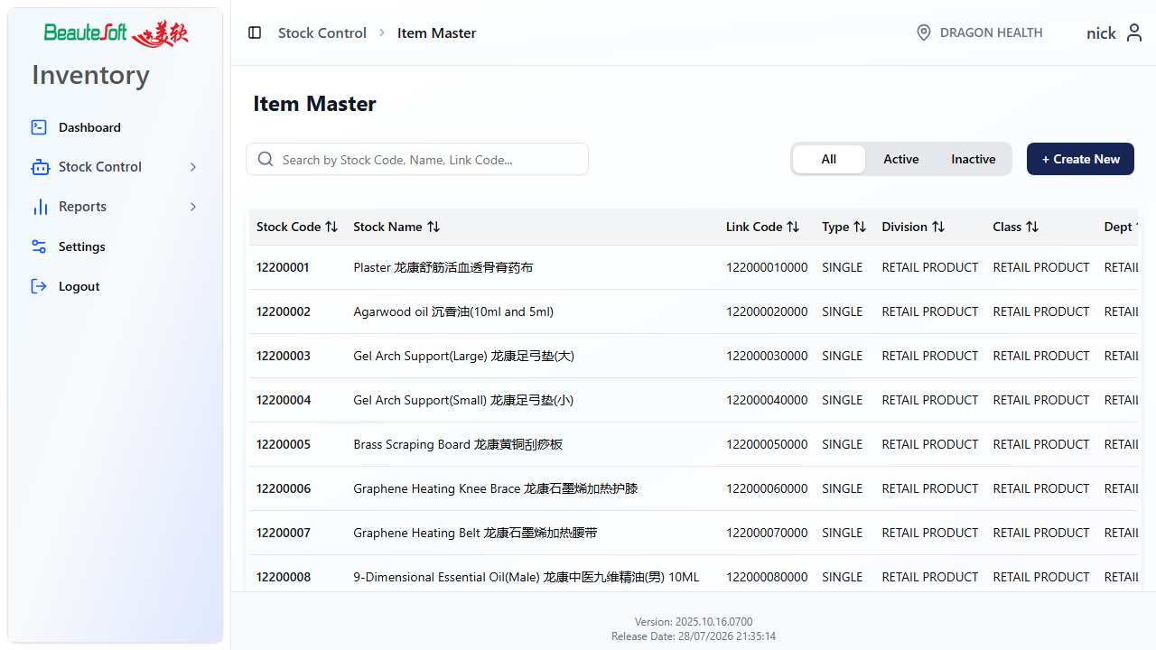
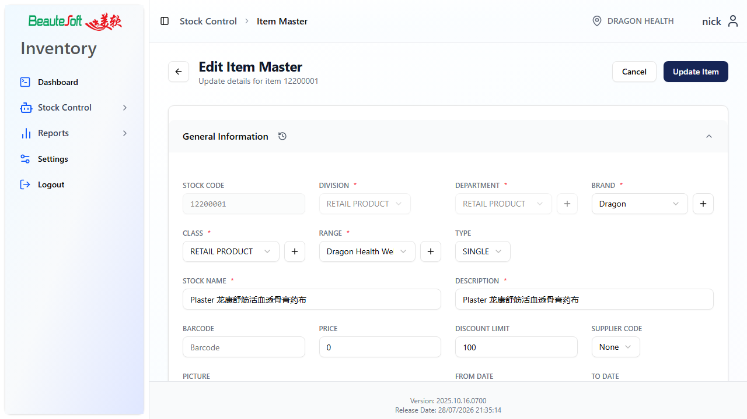

4. Purchase Requisition (PR)
Use PR when a site requests stock. Choosing a supplier (or HQ) when you create the PR does not move stock by itself and does not create a GTI. Stock only moves after the correct approve / receive steps below.

4.1 Outlet — create and post
1. Create PR → select who to request from (HQ, or another supplier).
2. Add items and quantities → Save, then Post when ready for review.
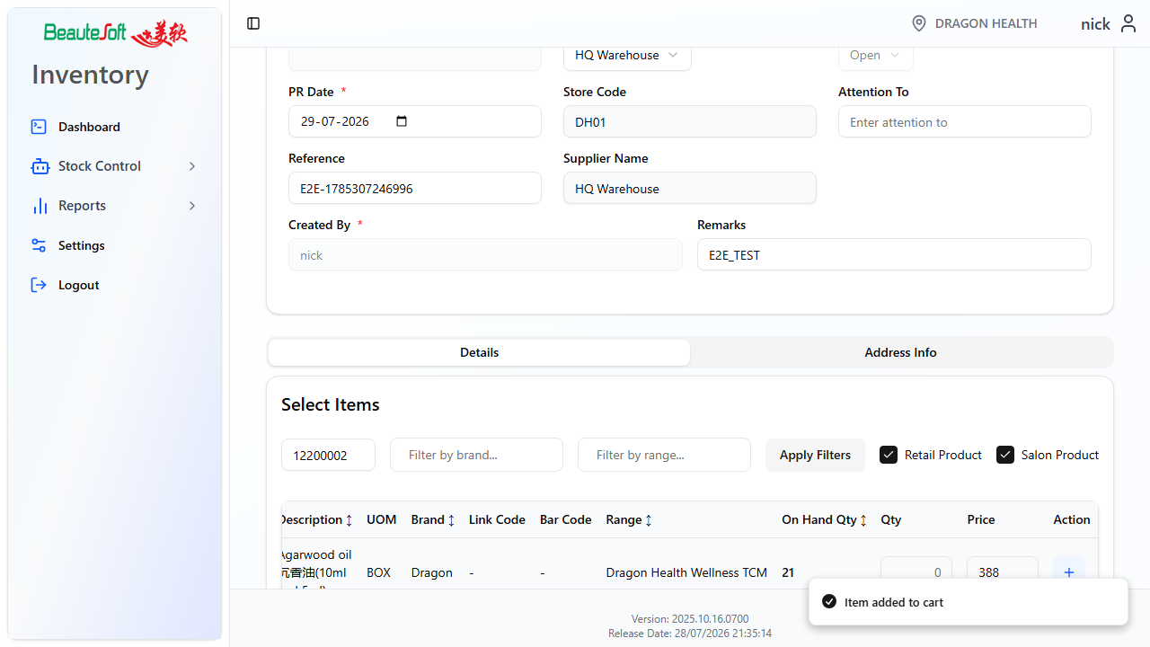
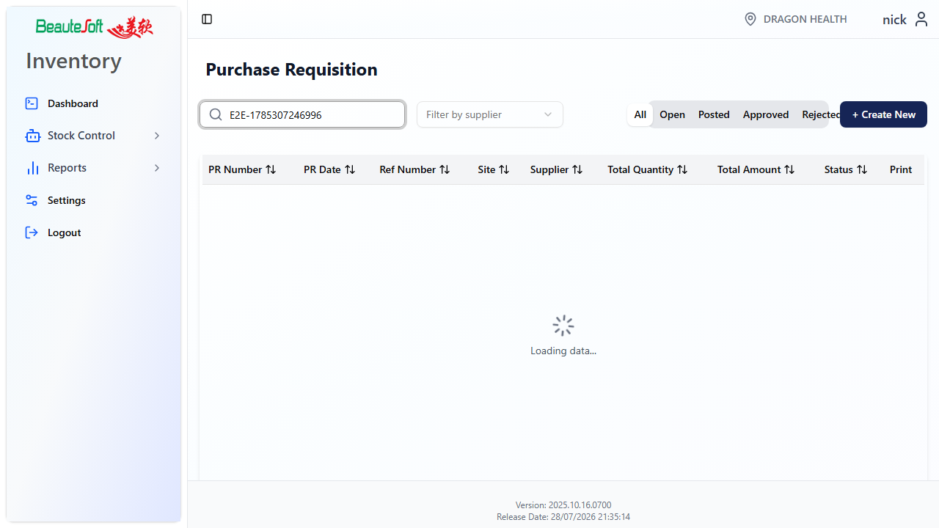

4.2 HQ — approve or reject
An HQ user logs in as the HQ outlet (DRAGON HEALTH HQ) to review Posted PRs. Approve or Reject after checking lines and approved quantities.
1. Log in as DRAGON HEALTH HQ (or your company HQ outlet).
2. Open a Posted PR → review lines.
3. Approve or Reject.
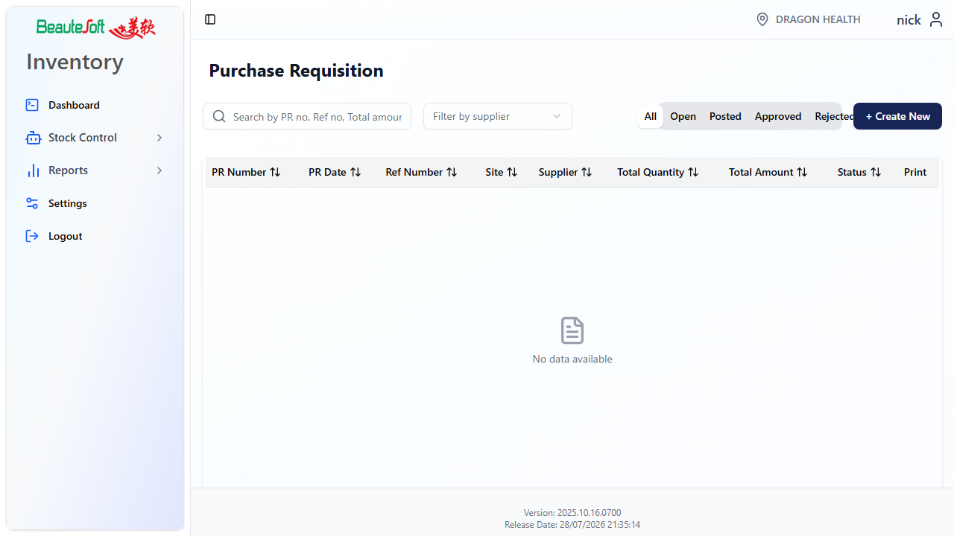

4.3 When a GTI is created
• GTI is created only when HQ Approves and the PR Request To is HQ.
• An Open GTI then appears at the requesting outlet — open it, confirm lines, and Post to receive stock.
• If the PR was requested from another supplier (not HQ), Approve does not create a GTI.

5. Reports
Open Reports from the sidebar. Set filters (dates, item, brand, and so on) → Generate → review on screen → export if your company uses Excel/PDF export.
• Stock Balance Report — on-hand for a date / filters.
• Stock Movement Report — stock in and out over a period.
• Replenishment Report — items at or below reorder level.
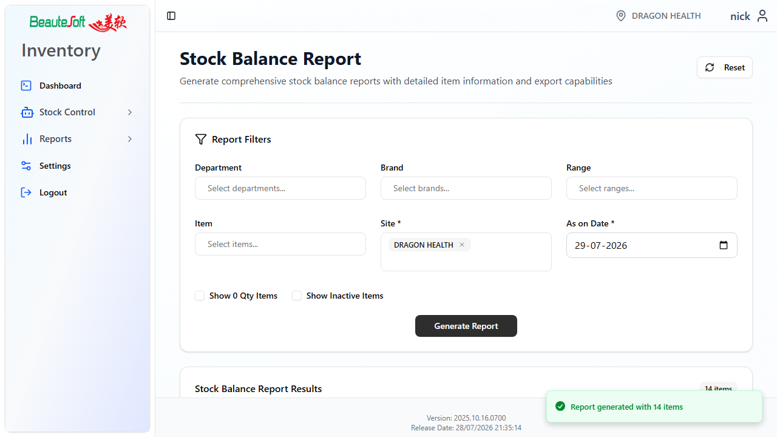

6. Settings and configuration

6.1 User authorization
Administrators use Settings to turn menu access on or off for each user. Select the user, set access for the menus they need, then save. Users only see menus they are allowed to open. The Settings menu itself appears only when Settings access is enabled for that login.
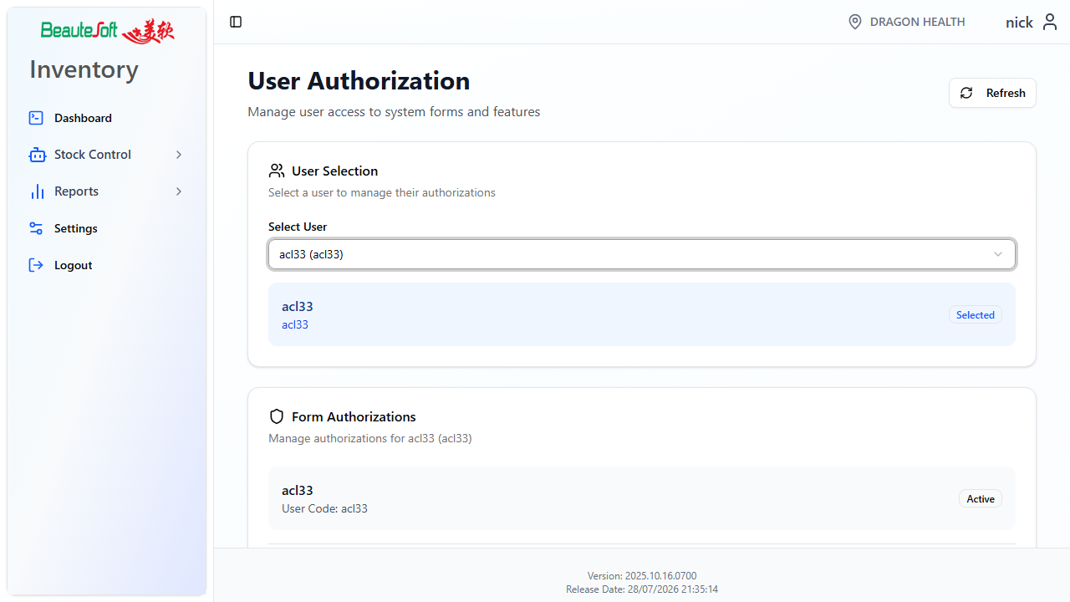

6.2 Company configuration
Batch, expiry, auto-post, and related options are applied at login for your company. You cannot change them on the Settings screen. They control which columns and steps appear on stock documents. If a field you expect is missing, check this list with your administrator rather than assuming the screen is broken.
Stock and batch options
Setting | When on | When off
Batch No | Batch columns appear on GRN, GTO, GTI, RTN, ADJ, SUM, Stock Take, and PR. Assign a batch before Save or Post. | Documents use quantity only. No batch prompt.
Expiry Date | Expiry is required when creating or selecting a batch (used with Batch No). | Expiry is not collected on the line.
Default expiry days | New batches pre-fill expiry as today plus this number of days (often 365). | Uses the company default if none is set.
Manual batch selection | On GTO, GTI, RTN, ADJ, and SUM you can pick a specific batch instead of FEFO (first expired, first out). | The system assigns batches automatically (FEFO when Batch No is on).
Auto Post | Posting a GTO can update destination stock immediately. GTI may still be used as a receive document. | The receiving outlet must Post GTI before destination stock increases.
Batch serial (SNo) | Serial batch records are saved when posting transfers and returns (backend tracking). | No extra serial batch save on post.

User permission flags (also from login)
Setting | When on | When off
Settings access | Settings appears in the sidebar. Administrators can change menu access for users. | Settings is hidden.
View price | Price and amount columns show on stock documents. | Price and amount are hidden.
View cost | Cost columns show where the screen supports them. | Cost is hidden.
Change posted price | Price can be edited on a posted document. | Posted prices are locked.

Note: These flags come from the login response for your company. They override the local app defaults. Ask an administrator if Batch No, Expiry, or Auto Post do not match how your site works.
How this looks in daily work
• GRN / Stock Take with Batch No on — extra Batch (and Expiry) columns; you cannot Post a line without a batch.
• GTO / GTI / RTN / SUM / ADJ with Manual batch selection on — choose Specific batch or leave FEFO.
• GTO with Auto Post on — destination on-hand can move when the sending site Posts; still complete GTI if your process requires it.
• View price off — the same form opens, but price and amount columns are not shown.

— End of User Manual —

