

Beauty Hub Booking and POS

Management system

**Members:** Owethu Lushozi :223046815 **Tech Trail Blazers** Nonkanyiso Ngwezi :222017932 **Group:14**

Yolanda Mdletshe :222005568

Nqobani Zibane :222002892

Erika Naidoo :223021524

Problem statement

The chosen client is *Beauty Hub*, a spa that currently manages its appointments and customer records manually. The receptionist writes appointments in a physical book, cancellations are crossed out, and customer history is recorded in handwritten logs. While this manual system has supported the business operations for several years, it introduces significant limitations. The paper-based approach is vulnerable to human error, creating challenges in three key areas: maintaining accurate appointment records, implementing real-time schedule updates, and ensuring efficient customer data management. Additionally, the lack of a structured digital system increases the risk of double bookings and reduces the business’s ability to offer a seamless customer experience.

The absence of a digital Point-of-Sale (POS) system provides unnecessary business struggles with sales tracking, inventory management for beauty products, and generating reports for financial analysis.

To improve operational efficiency and enhance customer service, we propose implementing a **Digital Booking and POS System**. This system will allow for:

* **Efficient appointment management** – enabling appointment bookings for cosmetic services, reducing scheduling conflicts, and ensuring better efficiency.
* **Automated record-keeping** – storing customer and staff details securely, tracking appointment history, and allowing quick data retrieval.
* **Point-of-Sale (POS) integration** – tracking sales and managing financial records efficiently.
* **Inventory tracking** – helping the spa monitor stock levels for beauty products , reducing the chances of running out of essential items.
* **Reporting and business insights** – generating automated monthly reports on revenue, customer trends, and peak booking times, allowing for better decision-making.

By transitioning from a paper-based system to a digital solution, *Beauty* Spa will significantly reduce human error, enhance the customer experience, and improve financial management. The proposed system will reduce risks of human error and provide a more efficient way of managing the business.

|  |
| --- |
| **Background information** |

# Client Information:

**Business Name:** Beauty Hub

**Physical Address:** West Street, Durban, KwaZulu-Natal, South Africa

West Walk Arcade

8th floor office number 823

**Contact Details:**

📞 Phone Number: [ +27 61 444 0199 ]

📧 Email Address: [cosmetologistsskincare@gmail.com]

🌍 Website/social media: [<https://www.tiktok.com/@beauty_hub4>]

**Contact Person:**

👤 Name: [Mpume Mphumelelo Mthsali]

📞 Direct Phone Number: [+27 65 555 2265]

📧 Email: [mpumehmpumelelo0@gmail.com]

📌 Position: Admin/Clerk

# Business Area:

*Beauty Hub* is a wellness and skincare service provider specializing in facial/ beauty treatments and beauty product sales. Operating in the beauty and personal care industry, the spa caters to diverse clientele seeking skincare solutions, relaxation, and rejuvenation services. In addition to providing facial treatments, the business also generates revenue through the sale of skincare products.

Currently, the spa operates on a first-come, first-served basis, as it previously discontinued appointment bookings due to previous operational challenges. Payments are accepted via cash and card, and customers pay only after completing their treatment.

By implementing this **Booking and POS System**, Beauty Spa will modernize its business operations, improve service efficiency, enhance potential for customer satisfaction. This digital transformation will enable the spa to **reintroduce appointment scheduling**, streamline sales, and manage its business more effectively.

# Context level diagram

Context-Level DFD Narrative:

The diagram represents the Beauty Hub Booking and POS System as a single Process (Process 0). It interacts with three key external entities: **Customer**, **Manager**, and **Cosmetologist**.

**CUSTOMER:**

*SYSTEM TO CUSTOMER*: The system provides product details do the customer can choose which product to buy, the services that the business currently offers along with the available date and times that they have for their particular service of interest, appointment confirmation and receipt details are all provided for the customer. There are promotions for both services and products that could be offered.

*CUSTOMER TO SYSTEM*: The customer in interacting with the system, provides the details of the products they wish to purchase and an appointment request for their service of interest, along with their customer details. Towards the end of the interaction with the system, their payment details are provided

**MANAGER:** The manger provides the system with all the services that are offered by the business, The details related to the products that they sell, along with the promotions and discounts that the business will provide. The manager also provides the system with the staff details for and of the businesses working staff, and the manager request report details which the system provides for the manager

**COSMOTOLOGIST:** provides their available date and time slots and receives appointment information based on their available slot. The system also provides the cosmetologist with reminders for their confirmed appointments

In summary the system collects, manages, and distribute all operational data relevant to bookings, staff details, customer profiles, services, inventory, and payment. So the system works effectively

# Level 0 dfd

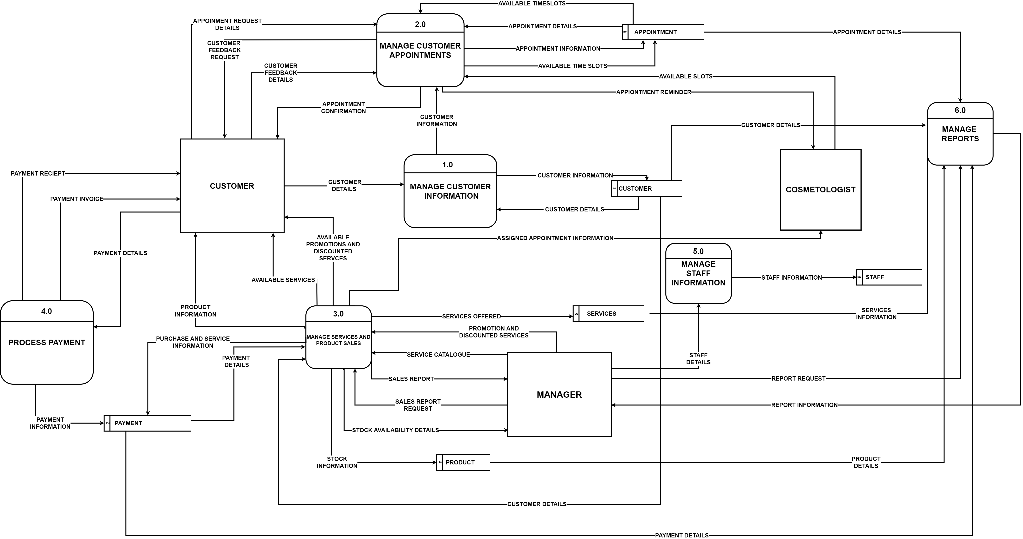

**Level-0 DFD Narrative: Beauty Hub Booking and POS System**

The Level-0 Data Flow Diagram (DFD) for the Beauty Hub Booking and POS System consists of:

* **3 external entities**: *Customer, Cosmetologist* and *Manager*
* **6 main processes**: *1.0 Manage Customer Information, 2.0 Manage Customer Appointments, 3.0 Manage Services and Product Sales, 4.0 Process Payment, 5.0 Manage Staff Information,* and *6.0 Manage Reports*
* **6 data stores**: *Customer, Product, Services, Payment* and *Staff*

1. **Manage Customer Information**

The Manage Customer Information process is responsible for registering new customers or updating existing customer records. When a customer interacts with the system, they provide their personal information, which is captured and stored in the system. New customer details are added to the data store, while returning customers’ information is retrieved and updated if necessary. This data is also forwarded to other processes like Manage Appointments and Manage Reports to support appointment scheduling and reporting.

1. **Manage Customer Appointments**

This process handles the scheduling and management of customer appointments. It receives appointment requests and details from the customer and checks the availability of time slots. It then sends appointment confirmation and reminders back to the customer. Appointment details are shared with the Cosmetologist and are also used in generating reports. This process interacts closely with the Customer, Appointment, and Cosmetologist entities and relies on customer details provided by the Manage Customer Information process

1. **Manage Services and Product Sales**

The Manage Services and Product Sales process allows customers to view available services and products, including promotions and discounted services. When a customer chooses a product or service, the system checks stock availability and stores the purchase details. The process sends product and sales information to the Payment data store and receives payment updates. It also shares product and service information with the Manager for reports. The manager can apply discounts and promotions, update the service offerings, and request stock or sales data to support business decisions.

1. **Process Payment**

This process deals with all payment transactions. It receives payment details from the customer and updates the system accordingly. The customer receives a payment invoice and receipt. The process updates payment records and relays information to the Manage Services and Product Sales process. It also provides the customer with confirmation of payment and interacts with the Payment data store to ensure transaction tracking and future referencing.

1. **Manage Staff Information**

The Manage Staff Information process is responsible for managing details of staff members. It captures and stores staff data, updates roles and links to appointment processes to schedule staff members for services.

1. **Manage Reports**

The Manage Reports process takes data from across the system like, customer details, payment records, services, and product details to generate business reports. The Manager can request specific reports to monitor business performance. The system responds by compiling the necessary information and producing reports that aid in strategic decision-making and operational improvements.

**External Entities Interaction Summary**

**Customer**: Interacts with processes 1.0, 2.0, 3.0, and 4.0 to provide personal details, schedule appointments, purchase products/services, and make payments.

**Manager**: Requests sales reports, provides service catalogs, applies promotions/discounts, and oversees stock availability and staff schedules via processes 3.0, 5.0, and 6.0.

**Cosmetologist**: Accesses appointment details and customer information via process 2.0 and 1.0.

# ERD

ERD Narrative: Beauty Hub Booking and POS System

**Customer:**

When a customer is registered in the system, their **FirstName**, **LastName**, **Email**, **PhoneNumber**, and **Active** status are stored. Each customer is assigned a unique identifier, **CustomerID**(primary key)

*RELATIONSHIPS:* Make multiple **Appointments**, Be associated with multiple **Sales** and Make multiple **Payments**

**Appointment:**

When a customer books an appointment, the system captures the **AppointmentDate**, **AppointmentTime**, **Status**, **Comments**, **Rating**, and **Duration**. Each appointment is uniquely identified by an **AppointmentID** (primary key) *RELATIONSHIPS*: Is made by one **Customer**, Is handled by one **Staff** member, Can include multiple **Services** via ServiceItem

**Staff:**

The system stores staff information such as **FirstName**, **LastName**, **Role**, **Email**, **PhoneNumber**, **Username**, **Password**, and **Active** status. Each staff member is uniquely identified by **StaffID** (primary key).

*RELATIONSHIPS*: Can take multiple **Appointments**

**Service:**

Each service has a unique **ServiceID** (primary key) and includes **ServiceName**, **Duration**, **Price**, **Description**, **Promotion**, and **PromotionPrice**.

*RELATIONSHIPS*: Can be included in multiple **Appointments**

**ServiceItem:**

This junction table links Appointment and Service, allowing many-to-many relationships. Each record includes the **AppointmentID** and **ServiceID** as a composite primary key, along with a **Price**. This structure allows the system to track which services have been included in a specific appointment.

**Sale:**

The system records each product sale transaction in the Sale table. For each sale, it stores a unique **SaleID** (primary key), the associated **CustomerID** (foreign key), the **SalePrice**, and the **SaleDate**.

*RELATIONSHIPS*: Belongs to one **Customer**, Can include multiple **Products** via SaleItem

**Product:**

Products are stored in the Product entity. The attributes include **Name**, **Price**, **QuantityInStock**, **Description**, **Active** status, **PromotionPrice**, and **Promotion**. Each product is uniquely identified by **ProductID** (primary key).

*RELATIONSHIPS*: Can be part of multiple **Sales**, Products are linked to sales via the SaleItem table.

**SaleItem:**

This is a junction table connecting Sale and Product, enabling many-to-many relationships. Each record has a composite key of **SaleID** and **ProductID**, and stores the **Quantity** and **Price** of the product sold in that particular transaction.

**Payment:**

The system records all payment transactions in the Payment table. Each payment is uniquely identified by a **PaymentID** (primary key). The table includes foreign keys: **CustomerID**, **AppointmentID**, and **SaleID**, linking the payment to the related entities. The attributes stored include **PaymentDate**, **PaymentStatus**, **TotalPrice**, and **PaymentMethod**. This design supports tracking payments for both appointments and product sales.

*RELATIONSHIPS*: Is linked to a **Customer**, May be linked to a **Sale** or an **Appointment**

|  |
| --- |
| appendix 1 |

Group Contribution

|  |  |  |  |  |
| --- | --- | --- | --- | --- |
| No | Group Member’s  Student Numbers | Group Member’s Name & Surname | % Estimated Contribution to M2 | Signature |
| 1 | 223046815 | Owethu Lushozi | 20% |  |
| 2 | 222017932 | Nonkanyiso Ngwezi | 20% |  |
| 3 | 222005568 | Yolanda Mdletshe | 20% |  |
| 4 | 222002892 | Nqobani Sibongakonke Zibane | 20% |  |
| 5 | 223021524 | Erika Naidoo | 20% |  |

TOTAL = 100%

FEATURE LIST

|  |
| --- |
| appendix 2 |

|  |  |  |  |
| --- | --- | --- | --- |
| FEATURE DESCRIPTION | USER PROFILE | PRIORITY | DEVELOPMENT TIME |
| Password protected login to the system | Staff | High | 1 days |
| Add/ View/ Update/ Archive all products on sale | Staff | High | 4 day |
| Add/View customer appointment | Staff | High | 2 days |
| Cancel /Reschedule appointment | Staff | High | 1 days |
| View / create / Update / Archive customer details | Staff | High | 4 days |
| View booking history | Staff | Medium | 1 day |
| View staff schedule | Staff | High | 2 days |
| Assign staff schedule | Manager | High | 2 days |
| Add/ Update/Archive spa services | Manager | High | 4 days |
| View spa services | Staff | High | 1 day |
| View monthly report on total bookings, busiest times, and revenue | Manager | High | 3 days |
| Send reminders for booked appointments to staff and customer via email/SMS | System | Medium | 1 days |
| Add / View payment details | Staff | Medium | 2 days |
| Issue receipt of payment for appointment and/or services | Staff | High | 3 days |
| View customer feedback | Staff | Low | 1 days |
| View/ update skincare sale products stock levels | Staff | High | 2 days |

TOTAL= 34 days

# user case stories

|  |  |  |  |
| --- | --- | --- | --- |
| FEATURE DESCRIPTION | USER PROFILE | PRIORITY | DEVELOPMENT TIME |
| Add/View customer appointment | Staff | High | 5 days |
| **As a** staff member, **I want to** book an appointment for a cosmetic service for a customer. | | | |

|  |  |  |  |
| --- | --- | --- | --- |
| FEATURE DESCRIPTION | USER PROFILE | PRIORITY | DEVELOPMENT TIME |
| Add/ Update/ View/ Archive spa services | Manager | High | 4 days |
| **As a** manager, **I want to** add, update, or remove spa services from the system, **so that** the service catalogue stays up to date. | | | |

|  |  |  |  |
| --- | --- | --- | --- |
| FEATURE DESCRIPTION | USER PROFILE | PRIORITY | DEVELOPMENT TIME |
| View/ update skincare sale products stock levels | Staff | High | 3 days |
| **As a** manager, **I want to** monitor product stock levels and receive restock alerts, **so that** we never run out of essential skincare products. | | | |

|  |  |  |  |
| --- | --- | --- | --- |
| FEATURE DESCRIPTION | USER PROFILE | PRIORITY | DEVELOPMENT TIME |
| Send reminders for booked appointments to staff and customer via email/SMS | System | Medium | 1 days |
| **As a** staff member, **I want to** capture payment details and issue receipts via the system, **so that** transactions are accurate and well-documented | | | |

|  |  |  |  |
| --- | --- | --- | --- |
| FEATURE DESCRIPTION | USER PROFILE | PRIORITY | DEVELOPMENT TIME |
| Issue receipt of payment for appointment and/or services | Staff | High | 4 days |
| **As a** staff member, **I want to** receive automated reminders before my appointment session, **so that** I don’t forget and prepare properly. | | | |

|  |
| --- |
| appendix 3 |

# menu system screenshots

Login in form where all staff members can securely enter the system

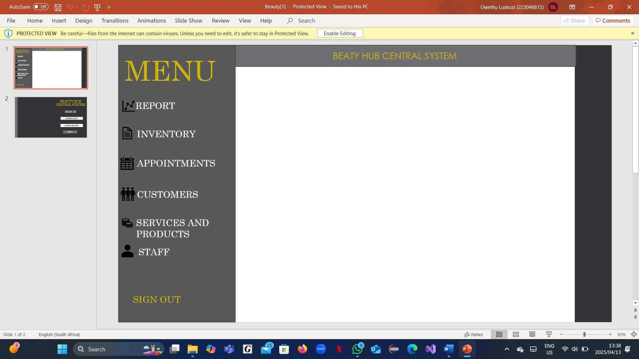

Menu, where staff can navigate the system

## Appendix 4 - Plans for version control

GitHub is an online platform that enables the tracking and managing of changes in code when developing a system. With reference to developing the Booking and Point of Sale System. GitHub offers the following features:

* Collaboration between team members that allows members to make changes and keep track of changes in the system and code development.
* Team members can review and comment on other people's code, add comments and suggest changes.
* GitHub also has a feature that enables the assignment of tasks to different users.
* GitHub is a version control system which means it saves all the different versions of the code which means that every version can be accessed at any time.

Once the base code has been updated onto the groups GitHub repository, each member will have access to the code. They will be able to download the updated code to their workspace; adapt it themselves; and upload their updated version to the repository, to which everyone will then have access.

