**COLLEGE OF BUSINESS EDUCATION**



**DODOMA CAMPUS**

*Student’s Name:* **RAHAB SEVERIN MSIGALA**

Reg no: **03.2961.01.02.2023**

***Course* : BIT**

***Lecturer*:madam ATUPELE CAIRO MWAITETE**

***Subject:* PROGRAMMING IN JAVA**

***Nature of Work:* INDIVIDUAL ASSIGNMENT**

**Question.**

You are required to create a small Java application that addresses an everyday challenge faced by individuals or communities in Tanzania with a theme of **"Digital Solutions for Everyday Challenges in Tanzania"**. Each student should select a specific challenge and provide a software-based solution.

**Report on Cafe Management System**

**1. Introduction**

**Background:** This project focuses on the development of a Cafe Management System designed to streamline ordering and payment processes. The system is tailored to support both walk-in and booking customers by handling their orders, which consist of various food items, efficiently. The primary aim is to ensure smooth operations while enhancing the customer experience.

**Objective:** The main goal of the system is to simplify customer orders, generate costs, and calculate deposits efficiently. Additionally, the system incorporates visual interactions through food item images and facilitates payments based on customer deposits.

**2. Features Implemented**

**Customer Type Selection:** The system provides options for two customer types: Walk-in and Booking. Booking customers can input their details (name, location, phone number) and are assigned a unique booking ID for confirmation.

**Food Items and Quantity Selection:** Customers can choose from a variety of food items such as rice, ugali, tea, and chapati. The system displays prices and allows customers to input the quantity of each item. It then calculates the total cost based on the selected items and quantities.

**Image Display:** To enhance the user experience, each food item is associated with an image. These images are dynamically loaded from a folder and resized for better display.

**Price Calculation and Order Summary:** The system computes the total cost based on selected items and displays an order summary, ensuring customers are informed of the total price.

**Deposit and Payment Calculation:** Customers are prompted to enter their deposit amount after the total cost is calculated. The system determines whether the deposit is sufficient, calculates any balance or change, and provides appropriate feedback.

**Error Handling and Validation:** Input validation ensures that customers provide valid quantities and amounts. Invalid inputs (e.g., negative or non-numeric values) are flagged, prompting users to make corrections.

**Order Sorting:** To improve presentation, order items are sorted alphabetically before being displayed in the summary.

**3. Screenshots and Project Interface**

This section includes screenshots of the user interface at various stages of the program. Screenshots include:

* The initial customer type selection window.

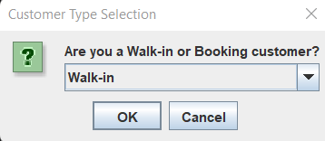

* The food item selection window showing images and quantity input fields.

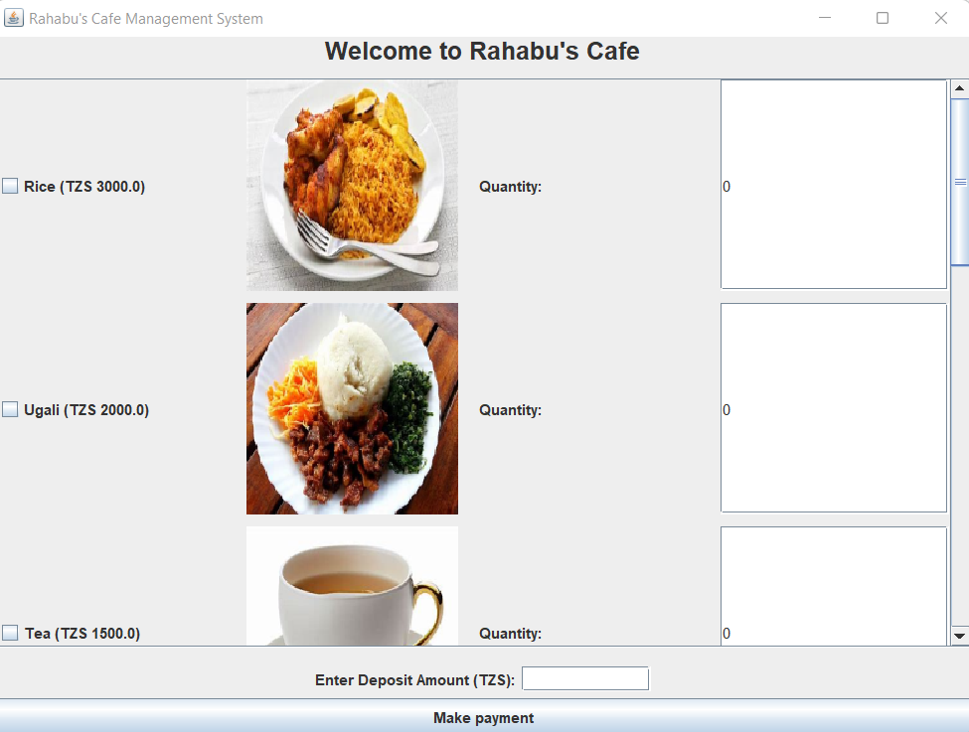

* The order summary window displaying total costs, deposits, and any changes.

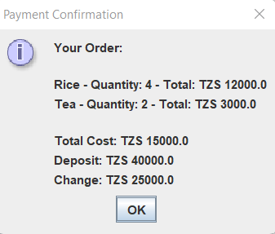

* Error messages for invalid input.

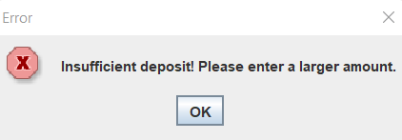

**4. Challenges Faced During Development**

**Challenge 1: Image Handling** Displaying food images dynamically from a folder required careful management of file paths and resizing images to fit the UI appropriately.

**Challenge 2: Input Validation** Ensuring users provided valid numeric quantities and amounts posed a challenge. Handling edge cases, such as negative or non-numeric values, was necessary to maintain program stability.

**Challenge 3: Customer Experience and User Interface Design** Creating a user-friendly interface required arranging food items and images neatly using a grid layout and ensuring all UI elements were accessible and readable.

**Challenge 4: Sorting and Displaying Order Items** Sorting order items alphabetically before displaying the summary required additional logic to ensure consistent presentation.

**5. Solutions to the Challenges**

**Solution 1: Image Handling** Java’s ImageIcon class was used to manage images effectively. File paths were dynamically constructed, and the getScaledInstance method was applied to resize images for proper display.

**Solution 2: Input Validation** Error handling mechanisms were implemented to catch invalid inputs (e.g., non-numeric or negative values). Exceptions like NumberFormatException were used to notify users of errors and request corrections.

**Solution 3: User Interface Design** A GridLayout was used to display food items, ensuring clarity and neatness. A scroll pane accommodated the large number of food items, enhancing usability.

**Solution 4: Sorting and Displaying Order Items** An ArrayList was used to store order items, which were sorted using Collections.sort() based on item names. This ensured the order summary was presented in an organized manner.

**6. Code Explanation**

This section provides an in-depth breakdown of the program’s core components:

* The GUI is structured using JFrame, JPanel, JCheckBox, JTextField, and JLabel components.
* Event listeners are employed to handle button clicks, such as the calculateButton for calculating total costs and payments.
* Order items are stored in an OrderItem class and calculated dynamically based on user input.

**7. Future Improvements**

**User Authentication:** A login feature can be added for regular customers, allowing the system to track order history.

**Database Integration:** Integrating a database (e.g., MySQL) would enable the storage of customer and order details for future reference.

**Receipt Generation:** A receipt generation feature can be implemented to provide printable receipts for customers.

**Mobile Application:** The system can be extended to a mobile platform, allowing customers to place orders conveniently from their phones.

**8. Conclusion**

The Cafe Management System provides an intuitive and efficient way to handle customer orders and payments. Despite challenges like input validation and UI design, the project successfully meets its objectives. It offers real-time price calculation, deposit handling, and a user-friendly interface, making it a valuable tool for streamlining cafe operations.