Q1-1: How many packets did the client send in total?

5 packets

Q1-2a: Open the PCAP files using Wireshark. From the timestamps of packets at the client, what is the round trip time (RTT) as seen by the client?

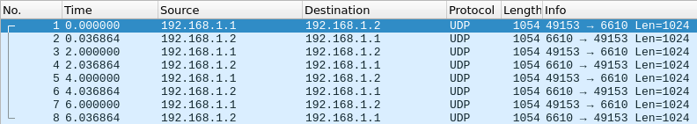

RTT: 0.036864 seconds

Q1-2b: What is the relationship between the RTT and the P2P link delay?

RTT is a measure from the source to destination and back. P2P Link Delay is one-way, so RTT should be twice as long as P2P Delay.

Q1-3a: What is the data (content) in the payload of each packet?

1024 bytes of 0

Q1-3b: How many bytes did each layer (UDP, IP, PPP) add to the payload?

PPP : 2 bytes

IP: 20 bytes

UDP: 8 bytes

Q1-4: This is impossible, because the server only responds after it receives the packet from the client. This is also a 2-node network, not a shared medium.

Q2-1: What is the configured application data rate at the client?

100Mbps

Q2-1b: What is the final (total) average throughput (printed as Average throughput after every simulation) achieved? Is there a difference? If yes, why?

Average throughput: 32.3634 Mbit/s

Yes there is a difference, this is because of the channel and the use of TCP which uses handshakes and congestion control which add latency to the transmission. This configuration appears to be using 16-QAM with an MCS index of 3 or 4. The maximum distance is somewhere greater than 150m. At 150m the average throughput is 4Mbits/s.

Q2-2: When does throughput drop to 0?

165m apart i.e. AP (0,0,0) -> STA (165,0,0)

Q2-3:



Q2-4:

The first frame from the STA is an Association request that is triggered by a broadcast Beacon frame from the AP.



Q3-1

When RTS is enabled the throughput drops from ~31Mbits/s to ~27Mbits/s, the reason of this is because RTS/CTS requires and extra 2 frames, which obviously would add overhead to the transmission.

Q3-2

165m

Q3-4

Instead of each STA being in constant communication with the AP, they both constantly send CTS/RTS Packets to verify that they wont collide and mangle packets with STA that are outside of their range. This mitigates the hidden node by having the AP let each STA know that it’s communicating with either STA.

Q3-5:

With A-MPDU enabled the effects of RTC/CTS on throughput aren’t as drastic. It seems like it more reasonable to use RTS/CTS while A-MPDU is also enabled.