FallDown Description

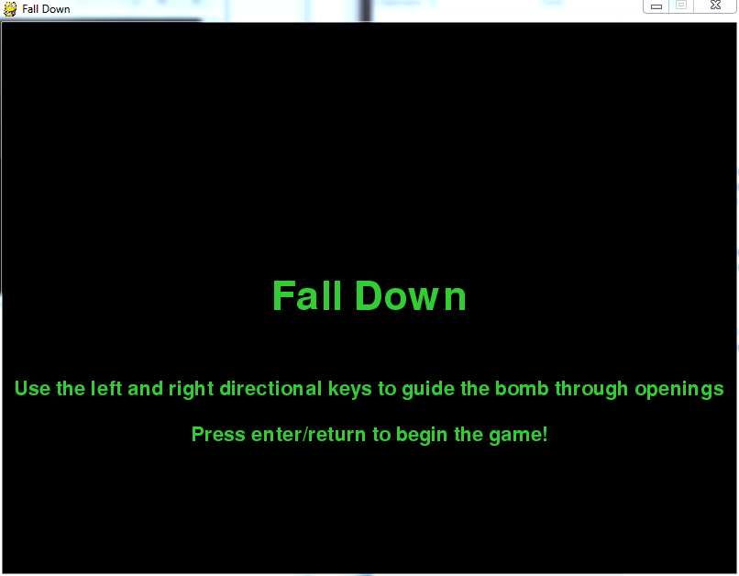

**Goal:**

The purpose of this game is in the title. The player must navigate through openings in the platforms in order to keep falling down. If too slow and the bomb touches the top of the screen, the player explodes and the game is lost.

**Characters:**

There is but one character in this game, and it is the bomb the player controls. As mentioned above, the player must fall as long as possible to get a higher score. The player will continue to fall until he/she loses.

**Levels:**

The game occurs in the same themed level, a stone built tower. The platforms are randomly generated to ensure each instance of the game is unique from the others. 