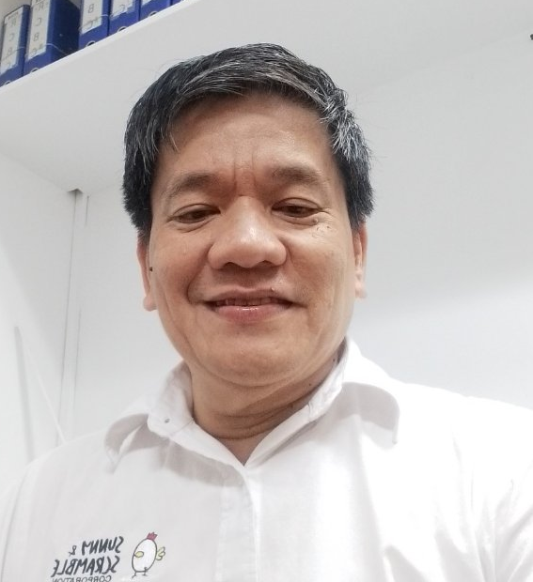

ENRIQUE P. MEGINO
B4 L12, Philomena, SFHCS Landayan, San Pedro Laguna/ B5 L36 Richmond Park, Navarro, Gen Trias Cavite
Globe & Viber 0915 662 6110/ Email: ricky_megino@yahoo.com / epm2367@gmail.com

CAREER TRACK RECORD

SUNNY & SCRAMBLE CORP. (RIZAL POULTRY AND LIVESTOCK ASSOC INC. - INTEGRATOR)
Malanday, San Mateo Rizal. Poultry Products Wholesale/Retail Industry: Finance and Accounting Manager. February 2023 to Current.

Financial Management. Preparing, monitoring, and managing budgets. Cash flow management and liquidity planning. Expense tracking and cost control. Optimizing capital allocation and investment strategies.

Financial Planning and Analysis. Creating financial forecasts and models – 5 yr plan. Conducting variance analysis between budgeted and actual figures. Providing insights for strategic decision-making. Cost analysis per product. Evaluating the financial feasibility of new projects or initiatives like Depot, Commissary, Storage and new Stores.

Accounting and Reporting. Preparing financial statements (balance sheet, income statement, cash flow statement). Ensuring compliance with accounting standards. Conducting internal audits including inventory of 3 storages & retails Stores. Tax preparation, filing, and compliance, in coordination with Tax & legal consultant.

Treasury Management. Managing corporate finances, like disbursements (short & long term accounts) money placement, fund transfer, daily ADB, Stores short/over deposits, and related transactions for 4 bank accounts. Optimizing working capital. Overseeing debt and financing arrangements.

Compliance and Governance. Ensuring adherence to financial regulations and legal standards. Implementing internal financial controls and policies. Managing ethical practices related to finance and investments.

Technology and Financial Systems. Implementing financial software and tools – Odoo Accounting. Automating financial reporting and processes.

Feel Good Food Group Inc./ Shanzhen Food Corp & Kungfu Master Cooking Inc. / Dingfun Construction (Freelance). Restaurant/Construction: Finance Manager/Freelance Accountant/
July 2018 to February 2023

Job Description:
Plans, organizes and leads in the execution of prescribed systems and procedures in Acceng,
Warehouse and Purchasing ensuring that control measures and forms are complied with and
the costs are within budget.

Collaborates with management team in laying corporate direction, establishing performance targets and budget for operations. Keeps track of sales vs. forecast, consumption vs. budget, analyzes variances and takes appropriate action in consultation with dept/section heads. Prepares the manning guide, in consultation with department heads, ensuring that labor cost does not exceed budget. Establishes/reviews existing policies and procedures on Purchasing and Finance, recommends changes as maybe deemed necessary to improve operations. Oversees bookkeeping and recording of all financial transactions. Monitors the accuracy and timeliness of financial statements, inventory summary. Audit reports and other related documents. Oversees payroll payments and management of receivables and collectibles.

NOODLERAMA GROUP INC. (RAMEN NAGI)- 5484 Osmena Highway, Bangkal, Makati City. Commissary & Restaurant: Finance Controller. February 2017 to August 2018

Job Description:
Manage Accounting, & Finance and monitor internal controls. Handles banking and finance activities, proper reporting and payment to all taxing authorities, business partners, suppliers, and corporate documentation. Provides financial information, reports to & works directly with Executive Management team. Deal with Finance, Accounting, Marketing, Purchasing, Personnel, Commissary and Operations to ensure that the business is profitable and there are proper internal controls. Provides leadership for the overall organization, direction, and administration of the financial unit, including payroll and capital expenditures/ investments. Prepares budget, analyzes and reviews financial data. Identifies and manages financial and operational risks.

LA LUZ RESORTS & HOTEL, INC., Barangay Hugom, San Juan Batangas. Restaurant & Hotel: Finance Manager. September 2015 to December 2016

Job Description:
Prepares daily cash position report& monitors capital expenditures versus budget. Reviews and audits payroll, cash advance liquidation, petty cash replenishment, reimbursement of expenses, collection deposits and check vouchers. Reviews and monitors Kitchen’s consumption & production costs, wastage and leftovers, level of food inventories. Audit of cash sales, A/R, monthly inventory and related par stocking requirement and monthly purchases volume. Oversees closing of books activities which include, preparation of financial statements, review of trial balance and related financial schedules/subsidiary ledgers, validates adjusting journal entries, and related activities; Handles and coordinates matters related to banks, external auditor, legal office and monthly compliance with BIR

BIG MOUTH FOOD SERVICES, 7188 Marcelo Ave., Marcelo Green Village, Paranaque City. Canteen Concessionaire/Caterer: Operations/Finance Head.
September 2012 to June 2015

Job Description:
Prepares sales target & budget, control system & procedures related to achieving financial goals. Collaborates with Store OICs to increase or improve sales and maintain operation related costs within budget. Sourcing of prospective client companies, prepares documentation and other requirements for bid proposal, & represents management through actual bidding process. Prepares sales & cost control analysis, inventory control & valuation, product movement & availability, cash management & audit, & other reportorial requirements. Heads procurement department in supplier accreditation, supplies requirement, terms & condition, and product evaluation & sourcing. Preparation of daily cash position, cash flow report, financial statements, food cost analysis & other related reports. Lead Accounting/Finance department in executing policies related to recording of transactions, cash disbursement, cash & assets control, Store audit & evaluation, inventory control, FS preparation and internal controls.

Retainer & Outsourcing Projects – Cost Mgt and Accounting. Freelance Accountant/Consultancy Project. August 2009 to June 2012

Got involved as retainer accountant for RZJ Trading, BNM Great Gifts, Inc., and outsourced accounting & cost control projects with BAHRR, Queen Jeniffer Hotel (Isabela), St Agatha Resorts (Bulacan), Hokaben Food Services Corp., Master Caterers (UCPB) & Chicka Rue Restaurant & Events Place.

THE URBAN CHEF Km 23 West Service Road, Cupang, Muntinlupa City. Restaurant/Commissary: Accounting Head. February 2002 to July 31, 2009

Job Description:
Lead Accounting/Finance department in executing policies related to recording of transactions, cash disbursement, cash & assets control, Store audit & evaluation, inventory control, FS preparation and internal controls. Review and re-alignment of accounting and internal control systems. Preparation of sales forecast and budget worksheets, design of accounting and internal control tools, systems and procedures. Tracking of sales, budget and inventory variances and working out remedies to correct said variances. Audit and reconciliation of financial records, tracking down possible anomalies and questionable transactions. Oversees preparation of month-end, quarter-end and year-end Financial Statements. Review of month-end closing activities, consolidation of financial, capital expenditures, and cash flow budgets. Update of budget templates and guidelines to facilitate preparation and consolidation of financial, capital expenditures, and cash flow. Oversees cash flow planning and ensures availability of funds, updates daily cash position report, & prepares bank reconciliation.

EMCO PLYWOOD CORPORATION, Emco Building, Aguirre St., Legaspi Village, Makati City. Manufacturing/Trading: Senior Accountant. August1998 to December 2001

Job Description:
Processes payment of importation related fees, & charges, like, customs duties, freight charges, demurrage, & storage fees. Handles fixed assets lapsing schedule & does reconciliation between records & actual assets on hand. Initiate entries on amortization of fixed assets, & advances, expense portion of various supplies inventories. Prepare periodic billings to affiliated companies on advances transactions. Maintains schedules & subsidiary ledgers for various advances, & supplies inventories accounts. Conducts audit of logs & other raw materials, disposes of variances accounted between records & quantity on hand. Helps enhance, & customize accounting & inventory system.

UNION BANK OF THE PHILS., SSS Bldg., Ayala Ave cor. Rufino St., Legaspi Village, Makati City
Banking/Financial Services: Accounting Officer
July 1997 to August 1998

Job Description:
Reviews, verifies & validates details & summary of bank’s daily transactions, such as dollar & peso cash & check deposits & withdrawals, RCOCI, ATM withdrawals & deposits, paid & accrued interest expenses, unearned & earned interest income, & related taxes transactions. Initiates corresponding accounting entries for all related transactions, & updates the same to bank Systematics Bank System. Reviews general ledger accounts on a daily basis, & ensures accuracy & matches balances with corresponding subsidiary ledgers. Disposes of & coordinates with branch float items, & other concerns before closing in transactions for the day.

CITYTRUST /BPI, BPI Bldg, Ayala Ave. cor. Paseo de Roxas, Makati City
Banking/Financial Services: Branch Accountant
August 1995 to July 1997

Job Description:
Reviews, verifies & validates details & summary of bank’s daily transactions, such as dollar & peso cash & check deposits & withdrawals, paid & accrued interest expenses, unearned & earned interest income, & related taxes transactions. Initiates corresponding accounting entries for all related transactions, & updates the same to bank general ledger system. Reviews general ledger accounts on a daily basis, & ensures accuracy & matches balances with corresponding subsidiary ledgers. Disposes of & coordinates with branch float items, & other concerns before closing in transactions for the day.

BANKARD, INC., 24th Floor Tektite Tower, Ortigas Complex, Pasig City
Banking/Financial Services: Disbursement Accountant
April 1990 to July 1995

Job Description:
Handles processing of disbursements related to suppliers, government remittances, & credit card agents’ commissions. Reviews & verifies all payment requests, and ensures accurate amount is paid, authorized signatories observed & all related deductions applied. Coordinates departmental budgets, and ensures all expenditures are within company’s mandated set limits. Handles bank transactions like, monthly employee payroll & related benefits, direct crediting of agents’ commission, company board of directors per diem, & loan interest payment. Disposes of periodic general accounting functions like, maintenance of cash disbursement book, preparation & review of end-of-month accounting journal entries, accruals & other related concerns.

PERSONAL BACKGROUND:

Birthday: August 23, 1967
College: Jose Rizal College, Bachelor of Commercial Science, Major in Accounting,
Professional Exams Taken & Passed: 1992 CPA Exams, Civil Service – Professional
Computer Knowledge: MS Office, Powerpoint, Excel & Word, Mysoft Accounting System, Sure Accounting System, Calculated Menu System, AMES, Systematics (Bank System), Quickbooks, Xero Accounting Software, QNE & background on SAP

