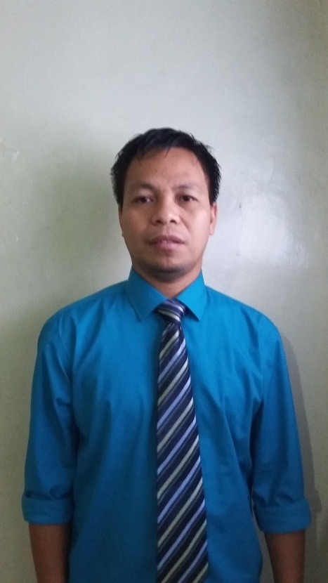

GOTHARD P.RUMIAS, CMA MBA
29 Pasong Goma Street, Purok V, Malanday, Marikina City
Cellphone Nos. (0945) 159 – 4221/ (0966) 795 – 5916
e-mail address: gothardprumias3@gmail.com

Desired Position : __________________________________

Professional Summary: I am a pro – active, self – starter and assertive person. who have more than twenty (20) years solid and fruitful experiences in all facets of General Accounting, Internal Auditing, Cost Accounting, Cash Flow Management, Inventory Management, Fixed Assets Accounting, Tax Administration, Financial Reporting & Analysis, Financial & Tax Consultancy, and Management & Supervision of personnel. Very familiar with recent Tax Laws (TRAIN and CREATE LAWS) and have also the ability to establish and maintain harmonious working relationships with co – workers, as well as with internal and external company affiliations and can work effectively in a professional environment.

Career Objective :To impart my knowledge and experiences and contribute my ideas & skills in an organization with a diverse working environment, challenging opportunities and room for a professional development.

PROFESSIONAL EXPERIENCES

PURPLE FASHION WORLD
61 Malaya Street, Malanday, Marikina City
(October 13, 2022 to September 30, 2024)

Position: Accounting Manager
Duties and Responsibilities:
Prepare the monthly, quarterly and annual financial reports of the company and discuss these with the owner and her partners. Monitors Weekly Cash Flows of the company and supervises the preparation of Weekly Cash Flow Report by the personnel in-charged.
Manage and prepare all tax returns related to the company (e.g. Monthly and Quarterly VAT, Quarterly ITRs, etc.). Coordinates with the external auditor of the company and discuss with them all tax matters and concerns.
Set – up internal control policies and procedures of the company, and in –charged also in the annual renewal of business permits and licenses with the LGU.

JC MERCHANDISE AND TRADING CO.
Rosalia Village 2, Tandang Sora, Quezon City
(July 7, 2015 – August 31, 2022)
This is a trading company which involves in buying and selling construction materials, PVC pipes
(Neltex, Moldex, Omega & other brands), trading rice & palay, and other agricultural products from
our province in Cagayan, where I was one of the part – owner/partner and officer.

Position:Financial Controller
Duties and Responsibilities:
Works hand in hand with the General Manager and Operations Head and provides all financial information relating to the company’s operations and financial status. In- charged in preparations of all government related reports particularly all BIR MONTHLY, QUARTERLY and ANNUAL TAX RETURNS, as well as renewals of Annual Business Permits & Licenses. Initiated the company practices in the preparation of annual expenses budgets and projections of revenues derived from all business projects/activities and compare to the actual results thereafter. Trained and guide staffs in their day to day office activities

KEORIM HOLDINGS, INC.
1506 Atlanta Center, 31 Annapolis Street,
Greenhills, San Juan City
(December 17, 2012 – June 19, 2015)
This is a management, holding and investment company with shared services activities to subsidiary and affiliated companies under it, which composed of Group of Restaurants with the following brands: PEPPERLUCNH, TAMPOPO RED MANGO; Renewable Energy Company, Manpower Services Company, Construction Company and Foundation

Position: Group Finance Head
(Member: Management Committee)
Duties and responsibilities:
Directly reporting to the Group Managing Director. Prepare monthly and quarterly financial reports of the (mother) company and its subsidiaries. Review and consolidate monthly financial reports of all companies done and submitted by subordinates and provides analyses thereof. In-charge in monitoring, preparing and submission of all monthly, quarterly and yearly government reportorial requirements (BIR Returns, SSS, Phil health and HDMF remittances).
Managed the day to day activities of the Finance and Accounting team. Acted as the pinpoint person of external auditors during audit season and in-charge of preparing the groups’ General Information Sheets (GIS) required by SEC annually as well as all legal matters that financially affects the group especially on taxation laws.
Formulated and implemented finance and accounting procedures within the group and its subsidiaries and affiliated companies. Managed and conducted training of personnel on the current issues and standards related to sound accounting practices to help the top management in increasing employee efficiency across the Organization. Provides personal tax advisory to all stockholders, including managers and employees in accordance with existing Philippine Tax Laws.
Introduced annual operational budgeting among the group and discussed the same among members of the Management Committee (ManCom).

PHIL. SHINPOONG PHARMA, INC.
106 Perea Street, Greenbelt Mansion,
LegaspiVillage, MakatiCity
(October 25, 2006 – November 30, 2012)
Position :Administration and Finance Manager(Member: Management Committee)
Duties and responsibilities:
Directly reporting to the Country General Manager. Provides the management a timely financial reports, various schedules of travel and transportation expenses, products sales analyses, inventories movement and collection performance reports of Medical Representatives and District Managers’ groups; Implement disciplinary actions and/or sanctions to erring employees. Attended hearings at National Labor Relations Commission (NLRC) as a company representative. Conducts orientation to newly hired personnel. Issue memoranda and/or information in relation to new company policies, house rules, etc. in accordance with the Philippine Labor Laws. Reviewed company House Rules and proposed changes and revisions on those in accordance with existing laws.

ASIA PACIFIC CATERING SERVICES AND RESTAURANT, INC. (Tamayo’s)
M. De la Fuente Street (Trabajo Market), Sampaloc, Manila
(November 2, 2005 – October 15, 2006)
Position: Accounting Manager(Member: Management Committee)
Duties and responsibilities:
This is a group of companies which involves in catering business, operations of restaurants on a concessionaire bases, wedding stores/boutiques and management of 3 – star hotels, pensions and transient houses, where I was directly reporting to the President/Owner in which I managed the Accounting Department.Designed various accounting policies and control procedures in accordance with Philippine Accounting Standards (PAS) and monitor its strict implementation and compliance. Prepares Financial Reports of the group and discuss on a monthly basis before the Management Committee.

CRL ENTERTAINMENT GROUP, INC.(Dish Bar and Entertainment Venue)
ELJ Tower, ABS – CBN Compound, Mother Ignacia Street,
South Triangle, Quezon City
(September 25, 2003 – October 31, 2005)
Position: Finance Manager(Member: Management Committee)
Duties and responsibilities:
Directly reporting to the President and Finance Director. Providing the management monthly financial reports, various schedules of expenses, products sales analyses, inventories movement and weekly cash position report. Devised accounting and internal auditing policies and implement the same across the organization; Released talent fee payment checks to various Filipino Artists, Singers and Bands.

CABALEN MANAGEMENT CO., INC. (Cabalen Restaurant )
54 J. P. Rizal cor. Aguado Street,
Project 4, Quezon City
(June 7, 1999 – September 15, 2003)
Positions Held: Cost Assistant / Bookkeeper / Property Accountant
Duties and responsibilities:
Reports directly to the Chief Accountant; Responsible in maintaining purchase books, cash receipts & cash disbursement books, general journal and general ledger; Prepare the monthly financial statements of three (3) branches of the company. Assist in the preparation of annual capital expenditures budget.

Cabañero, Katigbak, Clemente & Co., CPA’s
4/F Saville Bldg., Sen. Gil Puyat cor. Paseo de Roxas Aves.
MakatiCity, Metro Manila
(February 1997 – June 1998)
Position: Staff Auditor
Duties and responsibilities:
Participate in the auditing of the financial statements of various clients; Prepare schedules of input taxes, VAT returns, SSS & Pag – ibig remittances, quarterly taxes, etc; do bookkeeping services and financial statements preparation to some clients; Register clients’ books of accounts to the different government agencies (e.g. Bureau of Internal Revenue, Securities and Exchange Commission, etc.); Exposed in fixed assets audit, cash & inventory audit Recommend internal control & procedures to some clients;

SKILLS/KNOWLEDGE

Machines Operated:
Typewriter, Personal Computer, Fax Machine

Software knowledge and Operation:
Windows base : MS Word, MS Excel, MS PowerPoint, MS Outlook
Accounting Software: Quick Books, Peach Tree, MYOB, Knowledgeable in SAP Business One
Accumatica Financial Accounting Systems, Gr8Books Accounting Software

SEMINARS ATTENDED

Webinar on R.A.11354, Corporate Recovery and Tax Incentives for Enterprise (CREATE) Law
Held on April 19, 2021 and conducted by Bureau of Internal Revenue (BIR)

Seminar on the Implementing Rules and Regulations (IRR) of the TRAIN LAW (R.A.10963)
Held on March 18, 2019 at Fisher Mall, Quezon Ave.,Quezon City

Seminar on Revenue Memorandum Order 5 – 2012, Implementing the “BIR Benchmarking Program”
Held on March 29, 2012 at Crossroad Convenarium, Mo. Ignacia Street, Quezon City

Seminar on “A Comprehensive Study of the Vital Provisions of the Labor Code of the Philippines”
Conducted by Global Mode Consultancy on June 26, 2003 at New World Renaissance Hotel
Pasay Road, Makati City

EDUCATIONAL ATTAINMENT

Post Graduate : The Institute of Certified Management Accountants
CMA Training Philippines
2502b TektiteEastTower Bldg., PSECenter,
Ortigas Complex, PasigCity
Course : Certified Management Accountant (CMA)
International Professional Certification
May 2008

National College of Business and Arts
Aurora Blvd., Project 4, Quezon City
Course : Master in Business Administration
Major: Financial Management
November 2005

College : Manuel L. Quezon University
916 R. Hidalgo Street, Quiapo, Manila
Course : Bachelor of Laws (3rdyear - irregular)

Bachelor of Science in Accountancy
Year Graduated: April 1999

High School : Northern CagayanAcademy
Ballesteros,Cagayan
Year Graduated: March 1990

ACHIEVEMENTS/AWARDS

First Place
1999 Accounting Quiz Bowl
MLQU Chapter

First Place
1997 Accounting Quiz Bowl
MLQU Chapter

ORGANIZATIONS/AFFILIATIONS

Music Director, Worship Ministry

Gethsemane Covenant Global Church

Malanday, MarikinaCity

November 2003 – December 2008

Former Committee Head

Committee on Education and Research

Junior Philippine Institute of Accountants

MLQU Chapter

September 1998 – September 1999

Alumnus Member, Beta Kappa Fraternity

(Former Master Initiator)

Mars Cromwell Chapter

Character references are available upon request.

