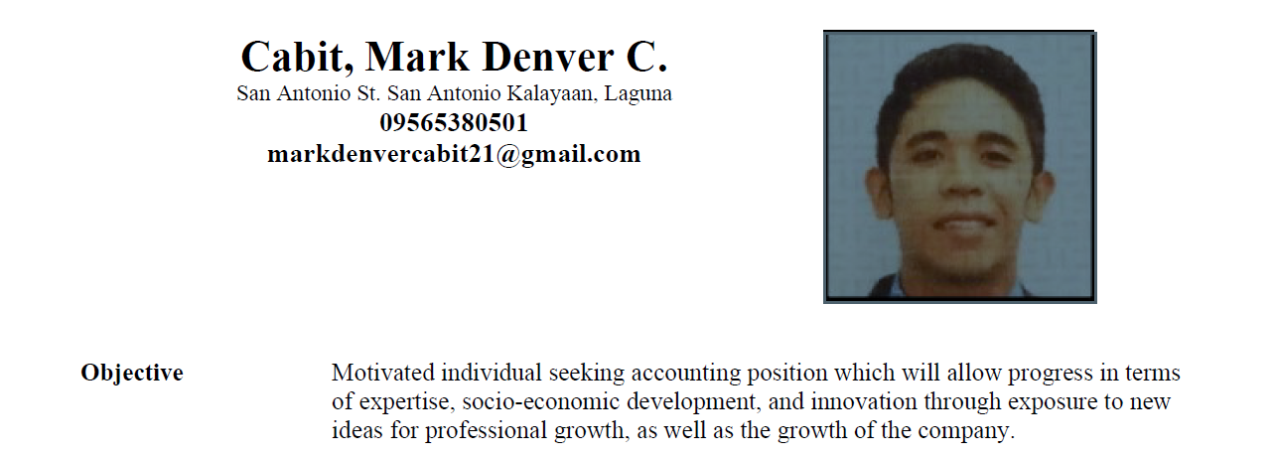

Skills
    - Inventory analysis
    - General ledger
    - Accruals
    - Balance sheet
    - Financial report
    - Balance sheet reconciliation
    - Bank reconciliation

Experienced Senior Accountant (February 9, 2025 – Present)
Creativesparx Incorporated
8101 Pearl Plaza Building, Pearl Drive, Pasig City.

Audit In-charge (Supervisor) (July 1, 2023 – February 9, 2025)
Punongbayan and Araullo (P&A) Grant Thornton
The Enterprise Center Tower 1, Ayala Ave., Makati, City

Experienced Junior Auditor (Jan 28, 2022 – June 30, 2023)
Punongbayan and Araullo (P&A) Grant Thornton
The Enterprise Center Tower 1, Ayala Ave., Makati, City

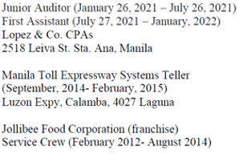

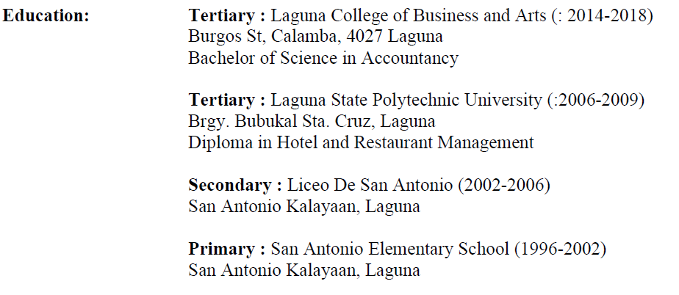

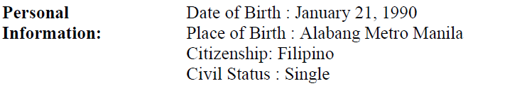

Mark Denver C. Cabit
Applicant

