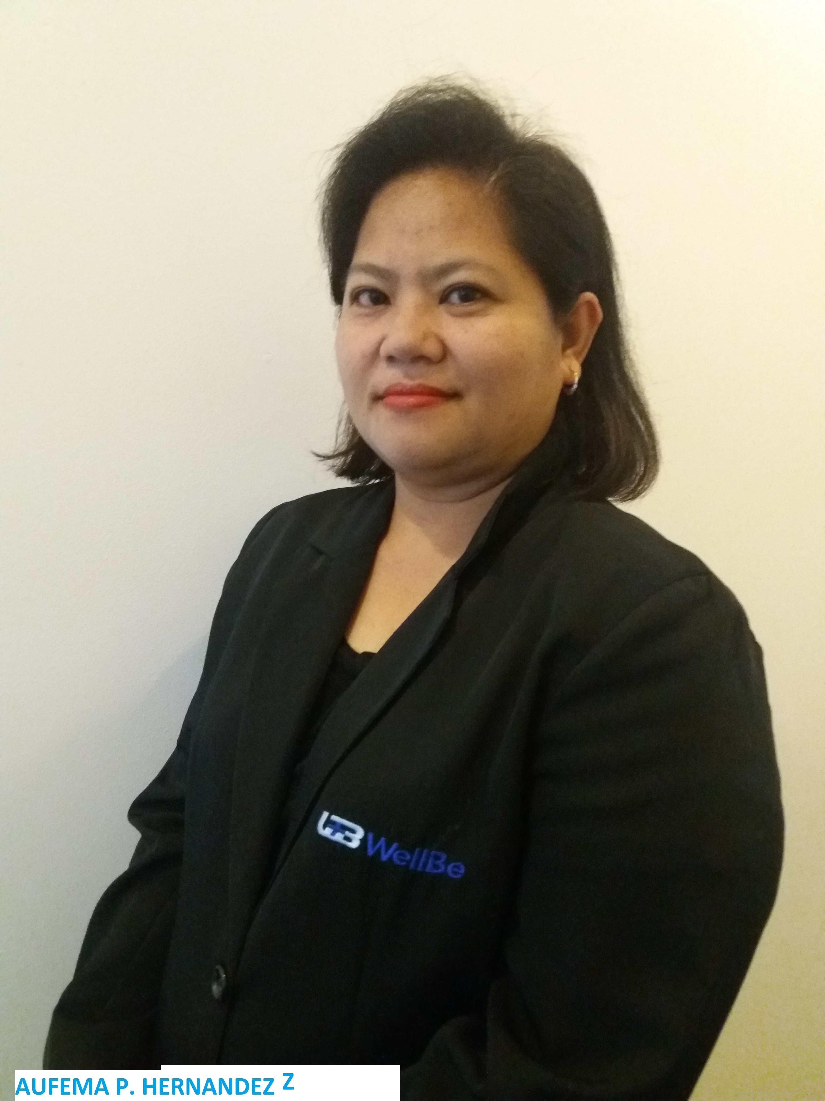
AUFEMA P. HERNANDEZ
2-B8, Atis St., Admiral Subd., Talon Tres
Las Piñas City, Metro Manila PHILIPPINES 1013
Contact No. 09171926213
E-mail Address: phem.services@gmail.com

PERSONAL PROFILE:

I am responsible and dedicated in my chosen career and I love to work with different kinds of people. I am hard-working, valuable team player and have a good sense of leadership. I have full knowledge in Finance and Accounting. I have more than 20 years working experienced in Accounting, Bookkeeping, Financial Management, Taxation, Admin, HR, Data Protecting Officer (DPO), Licensed in Non-Life and Life Insurance. Experienced both Desktop and Online Accounting Software like QuickBooks, Xero, GL Customized Software. I am willing to share and contribute my own knowledge and experience to the Company.

EDUCATIONAL BACKGROUND:

MASTER IN BUSINESS MANAGEMENT (MBM) SY 2016-2017
Saint Francis of Assisi College
Admiral, Talon Tres, Las Pinas City

BACHELOR OF SCIENCE IN ACCOUNTANCY (BSA) SY October 2000
West Negros University
Bacolod City, Negros Occidental

Ramon Torres National High School SY 1993-1994
Bago City, Negros Occidental

Calumangan Elementary School SY 1990-1991
Calumangan, Bago City, Negross Occ,

WORKING EXPERIENCE:

SCHOLARSHIP PROGRAM: (WORKING STUDENT)

Director of Nursing Office Student Assistant
LN Agustin Memorial Hospital for almost 2 years
Mandalagan, Bacolod City
Negros Occidental

Vice President for Academic Affairs Office Student Assistant
West Negros College for almost 1 year
Bacolod City, Negros Occidental

General Maintenance Office Secretary
West Negros College for 9 months
Bacolod City, Negros Occidental

PROFESSIONAL:

WELLBE MEDIC AND INSURANCE AGENCY (PHILIPPINES) INC. January 5, 2015 – September 15, 2025
One Global Place, BGC, Taguig City

FINANCE AND ADMIN MANAGER/HR/DPO/TREASURER/DIRECTOR

BENMARK GROUP HOLDINGS, INC. March 6, 2012 – December 31, 2014
(Pepper Lunch)
155 Panay Ave., 3rd Flr. Manta Bldg., Quezon Ave., Quezon City

GENERAL ACCOUNTING OFFICER

E-BINGGAY SERVICE, INC. July 16, 2008-November 30, 2011
(Red Ribbon Bakeshop, Inc) 20 Stores Franchise
Alabang-Zapote Road, Las Piñas City

GENERAL ACCOUNTING STAFF

GINA PASCUAL, CPA July 17, 2004 – June 30, 2008
Accounting Services/Firm (I’m Holding 30 Corporate Clients)
San Antonio St., Makati City

GENERAL ACCOUNTING STAFF – HANDLING ALMOST 30 CORPORATE CLIENT

OKACHI NEON MANUFACTURING, INC Feb. 14, 2002-July 15, 2004
Outdoor Advertising
Forth Estate, Parañaque City

PURCHASER & ACCOUNTING STAFF

Dermhaus Trading, Inc. May 2, 2001-February 2, 2002
Distributor – Beauty Skin Care
137 Yakal St., Makati City

ACCOUNTING STAFF

LICENSES:

- Non-Life Insurance
- Life Insurance (Variable and Traditional)

TRAININGS AND SEMINARS:

PERSONAL INFORMATION:

Date of Birth : March 11, 1977
Place of Birth : Silay City, Negros Occidental
Height : 5’2’
Weight : 144 lbs
Status : Married
Citizenship : Filipino
Languages Spoken : Ilonggo, Tagalog, English & Basic Nihongo
Special Skills : Accounting Software/Programs (QuickBooks, GL Customize Software and Xero Online Accounting Software)

