Bernadette Y. Dy Bunteng BSN, RN, MBA
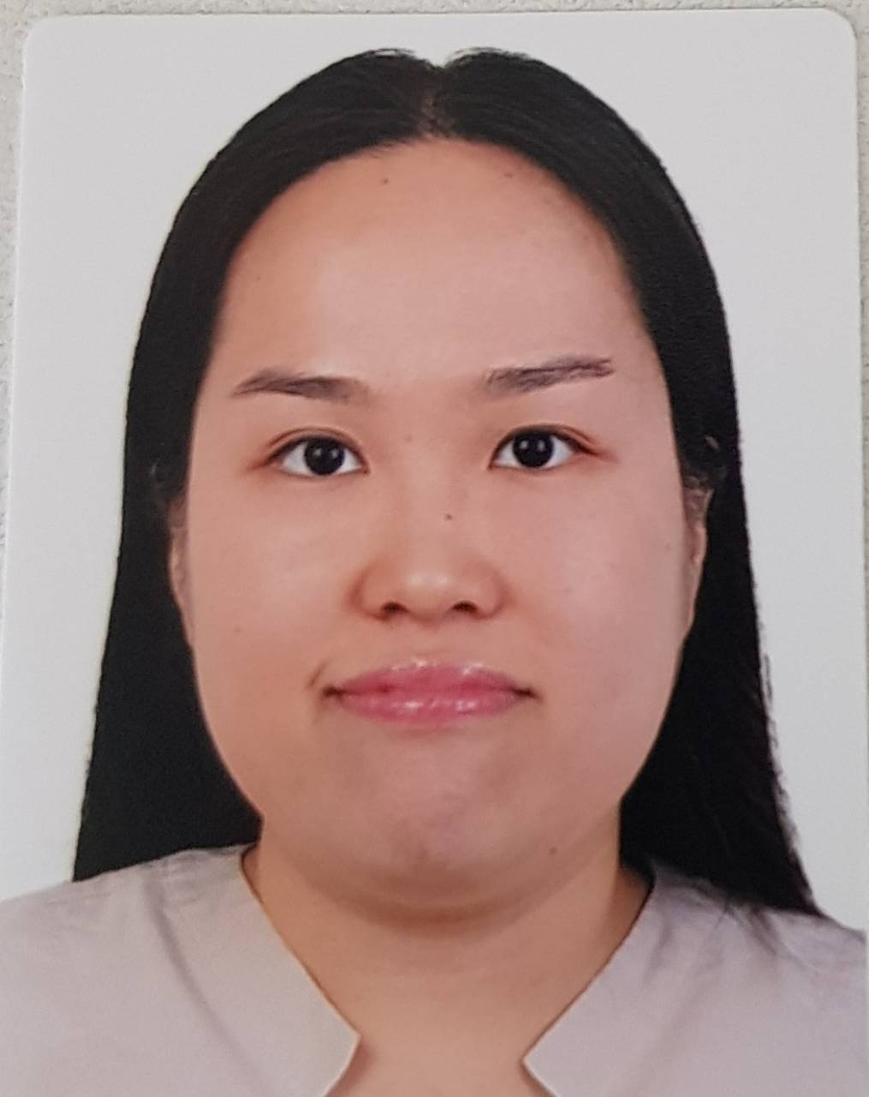

Present Address : Unit 318 Fullerton Suites Cond. Orchard City South Forbes, Brgy Puting Kahoy,
Silang Cavite 4117
Phone Number : (+63) 2-88151103
Mobile Number : (+63) 917-5868252
E-mail : bernadette_tiu_yao@yahoo.com
Area of Expertise:
- Audit and Internal Controls
- Financial Reporting
- Financial Data Analysis
- Cash Management
- Project Management and Leadership Skills

Key Qualifications:
- Currently performs various finance functions related to financial reporting, company analytics and risk management.
- Involved in the formulation and development of pioneering projects in Asia.
- Significant exposures in the financial industry (banks, microfinance, capital markets, and other financial institutions).
- Experienced in leading and supporting key engagements critical to the growth and development of the firm.

Professional Experience

Senior Finance Manager/Treasurer
Advance Vision Philippines Inc. (April 2024 – Present)
- Ensures Proper credit control function from receivables to payables and identifying credit risk ensuring that revenues are maximized without jeopardizing company’s operations
- Prepares Financial Reports and reports to the stakeholders the company’s financial standing
- Leads on the Financial Audit processes to ensure that the company is compliant with IFRS Accounting Standards
- Takes major role on corporate taxations by directly coordinating with concerned units
- Generates financial data thru SAP and prepares corresponding schedules and analytical reports

Finance Manager
Senti Techlabs Inc (Jan 2022 to March 2024)
- Prepares and reviews financial budget for all department for final reporting to the CEO and Stockholders
- Supervise and Monitor Account Receivables and Account Payables of the company
- Takes major role on corporate taxations by directly coordinating with concerned units
- Generates financial data thru QuickBooks ERP Accounting Software and prepares corresponding schedules and analytical reports
- Prepare Financial and Income Statement, filing and reporting to BIR.

Credit & Collection Head
Bifido Health Marketing Corporation – Yakult Batangas (March 2020 – December 2021)

  - Performed an active role in audit planning including preparations of audit approach, budgets and staff forecasting
  - Prepared payables to all company suppliers
  - Performed overall financial statements analysis, computation of financial ratios and trend analysis
  - Coordinates and assists external auditors on concerns/requirements for annual audit

Finance Manager/Treasurer
Royal Air Charter Service Inc (Jan 2019 to Sept 2019)
- Ensures Proper credit control function from receivables to payables and identifying credit risk ensuring that revenues are maximized without jeopardizing company’s receivable
- Prepares and reviews financial budget for all department for final reporting to the CEO and Stockholders
- Supervise and Monitor Account Receivables and Account Payables of the company
- Takes major role on corporate taxations by directly coordinating with concerned units
- Generates financial data thru ORACLE Netsuite ERP Accounting Software and prepares corresponding schedules and analytical reports

Finance Consultant
Royal Air Charter Service Inc (August 2017 to December 2018)
- Perform financial analysis for internal reporting
- Prepares the company’s financial budget forecast and adjust it accordingly based on the historical data present
- Prepares the international remittances and coordinate with the international suppliers for credit terms application
- Prepares various industry analyses and project proposals/presentations for management reporting as well for external meetings/conferences and other purposes

Accounting Manager & Admin Officer (Inbound and Outbound)
Luxury Vacation Holidays & Tours Inc (Continental Travel Group) August 2012 to December 2018

Responsibility:
(Accounting Manager)
      - Performs financial analysis and review of financial statements for quarter/annual reporting
      - Coordinates and assists external auditors on concerns/requirements for annual audit
      - Coordinate with intercompany counterparts to comply with internal and external audit requirements
      - Takes major role on corporate taxations by directly coordinating with concerned units
      - Prepares employee’s payroll (Local & International branches)
      - Collect and records payments from agents (Local and International clients)

(Admin Officer)
- Coordinates with various internal departments on their progress on daily activity to reservations and airline ticketing
- Takes major role on planning, organizing, and implementing company’s annual target

Accounting Officer (Inbound and Outbound Account)
Kingstar Holidays & Tours April 2011 – July 2012

Responsibility:
  - Performed an active role in audit planning including preparations of audit approach, budgets and staff forecasting
  - Prepared payables to all company suppliers
  - Performed overall financial statements analysis, computation of financial ratios and trend analysis
  - Coordinates and assists external auditors on concerns/requirements for annual audit

Educational Background

Certification Course Track in Harvard for (Specialization in Accounting and Finance)

Strategic Financial Analysis, February 2026 - Present
Harvard Business School, Harvard Business School, Soldier’s Field Boston, Massachusetts, USA

Leading with Finance, October 2019 – December 2019
Harvard Business School, Soldier’s Field Boston, Massachusetts, USA

Masters:
Master’s in Business Administration, May 2016 – November 2019
Ateneo De Manila University, Graduate School of Business, Hidalgo Drive, Rockwell, Makati City

Tertiary:
Bachelor of Science in Nursing, June 2006 – March 2010
Manila Doctors College, Pres. Diosdado Macapagal Boulevard, Pasay City

Trainings

- Airline Revenue Management (IATA)
Montreal, Canada – March 2019
- Business Plan Development Certification
Harvard Manage Mentor – Harvard Business School, Massachusetts, USA, November 28, 2018
- Airline Finance and Accounting Management (IATA) - Passed
Montreal, Canada March 2018

Languages:

- English – speaks fluently and read/write with high proficiency
- Chinese – Specifically Mandarin and Fookien, speaks fluently and read/write basic proficiency
- Filipino – speaks fluently and read/write with high proficiency

Personal Information

Date of Birth: February 10, 1989
Citizenship: Filipino
Marital Status: Married

