MILLER A. BALUYUT, CPA, MBA
(+63) 977-831-1378
miller_bal2006@yahoo.com.ph, millerbal2006@gmail.com
Olympia, Makati City, Metro Manila, Philippines

Age : 40 years old
Years of experience : 18+ years
Current Position : Finance Manager
Current Employer : Czark Mak Group of Companies
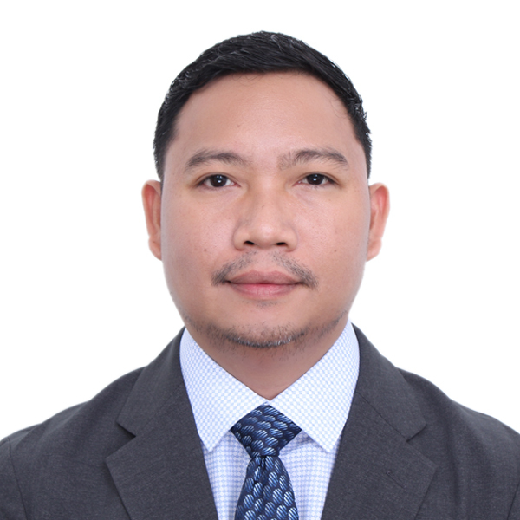
Miller Baluyut
miller_bal2006@yahoo.com.ph
+63 9778311378
Summary CPA and MBA-qualified Accounting Manager with over 18 years of progressive experience in finance, general accounting, payroll, audit, taxation, and government compliance. Skilled in leading finance, accounting, tax, and payroll teams; managing end-to-end finance, accounting, and payroll operations; and implementing process improvements to enhance accuracy and efficiency. Strong background in regulatory reporting and internal controls, with a commitment to integrity, compliance and operational excellence. Trusted leader and strategic partner in driving sound financial decisions and supporting organizational growth.
Career History

Finance Manager
Czark Mak Group of Companies
Dec 2025 – Mar 2026 (3 months)

- Prepares and analyzes financial statements: profit and loss reports, balance sheets, and cash flow statements to inform decision-making and strategic planning

- Develops, implements, and monitors budgets, forecasts, and financial plans aligned with organizational goals

- Ensures adherence to legal, regulatory, and accounting standards, and implement internal controls to mitigate financial risks

- Advises senior management on financial decisions, cost reduction strategies, and long-term financial goals
- Supervises finance and accounting teams, including accounts payable, accounts receivable, and general ledger operations, fostering collaboration and professional development

- Works with other departments to align financial planning with operational objectives and business initiatives

Finance Manager
Paragon Communications Corp.
Aug 2025 – Nov 2025 (3 months)

- Analyzes financial data to provide insights that support strategic decision-making

- Prepares accurate and timely reports, including monthly, quarterly, and annual financial statements

- Analyzes financial data to identify trends, variances, and opportunities for improvement.

- Assists in the preparation of financial forecasts and budgets

- Ensures compliance with financial regulations, accounting standards, and internal policies

- Assists in the development and maintenance of internal controls to safeguard company assets

- Supports internal audit processes by providing required documentation and explanations

- Monitors cash flow and ensure adequate liquidity to meet operational needs

- Reviews the work of staff to ensure accuracy and compliance with policies

Finance Manager
Freelancer.com Philippines, Inc.
Feb 2015 – Aug 2025 (10 years and 6 months)

        - Head of accounting and payroll in the Philippines
        - Reports to the CFO in Australia
        - Ensures compliance with BIR, SEC, PEZA and LGU
        - Liaise with the external auditor, banks and legal counsel
        - Oversee the end-to-end accounting operations.
        - Manages the end-to-end payroll operations. Ensures accurate and on time release of payroll and remittance/reporting to SSS, PhilHealth, Pag-IBIG, and BIR.
        - Prepares financial statements in accordance with the applicable accounting framework
        - Prepares the monthly, quarterly, and annual tax returns
        - Prepares the monthly, quarterly and annual reports for PEZA
        - Assists the external auditors during the year-end audit
        - Maintains accounting controls by establishing a chart of accounts; defining accounting policies and procedures
        - Guides other departments by researching and interpreting accounting policy; applying observations and recommendations to operational issues
        - Maintains financial security by establishing internal controls
        - Avoids legal challenges by understanding current and proposed legislation; enforcing accounting regulations; recommending new procedures
        - Protects organization's value by keeping information confidential
        - Updates job knowledge by attending seminars and participating in professional organizations
        - Accomplishes accounting and organization mission by completing related results as needed
        - Supervises and reviews the work of staff
        - Evaluates and reviews the performance of the staff and discusses with them their areas of improvement
        - Interviews job applicants and recommends the hiring of staff

Audit Assistant Manager
R.G. Manabat & Co. (KPMG Philippines)
Nov 2014 - Feb 2015 (4 months)

        - Directs audit engagements in accordance with auditing and accounting standards
        - Represents the Firm to the staff and its clients
        - Prepares proposals that is responsive to clients’ requirements
        - Oversees supervisors and staff in the conduct of audit
        - Reviews audit working papers, financial statements and annual income tax returns and ensures that they are prepared in accordance with auditing and accounting standards and tax regulations, as applicable
        - Ensures that billings are issued on time and follows up collections
        - Trains the staff
        - Evaluates and reviews the performance of the staff and discusses with them their areas of improvement
        - Interviews job applicants and recommends the hiring of staff
        - Performs other administrative tasks such as preparation of weekly forecast of staff's assignment and review of staff's time reports

Accounting Manager
Business Outsourcing Solutions and Services, Inc. (BOSS, Inc.)
Jun 2013 - Nov 2014 (1 year and 6 months)

        - Manages accounting and tax compliance engagements in accordance with accounting standards and tax regulations
        - Represents the Company to the staff and its clients
        - Prepare proposals that is responsive to clients’ requirements
        - Manages and controls the execution of accounting and tax compliance engagements
        - Reviews the monthly/quarterly/annual financial statements/reports package and tax returns and ensures that they are prepared in accordance with accounting policies, standards and tax regulations
        - Ensures that billings are issued timely and follows up collections
        - Trains the staff
        - Evaluates and reviews the performance of the staff and discusses with them their areas of improvement
        - Interviews job applicants and recommends the hiring of staff
        - Meets assigned revenue target
        - Performs administrative tasks such as preparation of monthly reports of acquired, lost and prospective clients and review of staff's time reports
        - Other Specific Tasks to Clients:
          - Assist clients in attending to BIR's letter notices and tax assessments
          - Ensures the on-time renewal of business permits/registration
          - Act as signatory on checks of a certain client
          - Review of checks and check vouchers, cash position report, and cash forecast prepared for a certain client

Senior Auditor / Senior Associate / Audit Associate
PKF R. S. Bernaldo & Associates
Nov 2009 - Jun 2013 (3 years and 7 months)

Senior Auditor
Jul 2012 - Jun 2013 (1 year)
        - Handles audit engagements in accordance with auditing and accounting standards
        - Represents the Company to the staff and its clients
        - Prepare proposals that is responsive to clients’ requirements
        - Supervises junior and senior audit associates in conducting audit engagements in accordance with auditing and accounting standards
        - Reviews audit working papers, financial statements and annual income tax returns and ensures that they are prepared in accordance with auditing and accounting standards and tax regulations, respectively
        - Ensures that billings are issued timely and follows up collections
        - Trains the staff
        - Evaluates and reviews the performance of the staff and discusses with them their areas of improvement
        - Interviews job applicants and recommends the hiring of staff
        - Performs other administrative tasks such as preparation of weekly forecast of staff's assignment and review of staff's time reports
        - Assist clients in attending to BIR's tax assessments thru preparation of ICPA Report
Senior Audit Associate
Jul 2011 - Jun 2012 (1 year)
        - Supervises junior audit associates in conducting audit fieldworks
        - Reviews audit working papers, draft financial statements and annual income tax returns prepared by staff
        - Conducts audit fieldwork and prepares audit working papers based on audit work program
        - Prepares draft financial statements and draft annual income tax returns for higher level’s review
Audit Associate
Nov 2009 - Jun 2011 (1 year and 7 months)
        - Conducts audit fieldwork and prepares audit working papers based on audit work program
        - Prepares draft financial statements and draft annual income tax returns for higher level’s review

Production Planning and Control Staff
International Wiring Systems (Phils.) Corporation
May 2007 - Apr 2009 (2 years)
        - Receives, checks, and confirms Customer Purchase Orders
        - Prepares and ensures that customer orders are translated into Production Schedule, and Delivery Schedule
        - Ensures that bookings are made in advance for the quantity of containers needed for delivery/ship-out
        - Prepares Pro-forma Invoices/Shipping Plan
        - Monitors the status of customer orders from the point of production up to shipment

Skills NetSuite, Quickbooks, eAudIT, SAP ByD, Financial Statement Preparation, Accounting and Finance, FP&A, Auditing, Payroll, Taxation, Government compliance, MS Office, Google Workspace, ADP
Languages English, Filipino

Education Master of Business Administration (MBA)
Nexford University
Finished 2023
Professional License - Certified Public Accountant (CPA) Philippine Professional Regulation Commission - Board of Accountancy
Passed 2009
Bachelor of Science in Accountancy (BSA)
Tarlac State University, Philippines
Finished 2007

