# WDC-GroupProject

#### Research - OpenTable.com

Home:

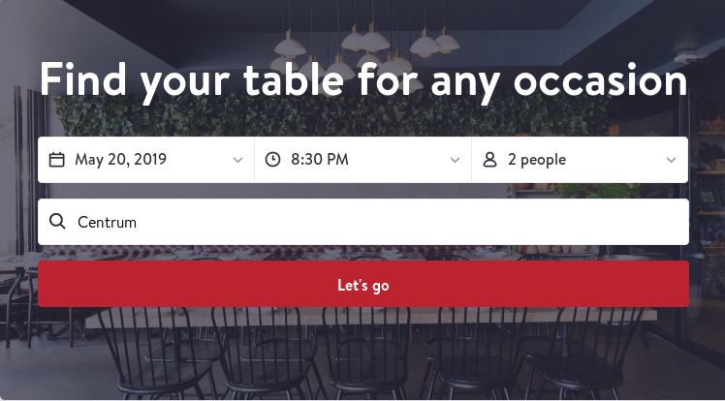

This looks very clean . I especially like how the filters on the top bar are presented as one unit mirroring the search bar and submit button below. It’d be even better with a cuisine filter.



As we learned in lecture 17 it’s a good idea to present recommendations and what they’ve done here is great. It looks good and it’s helpful. It even makes up for the missing cuisine filter in the search area

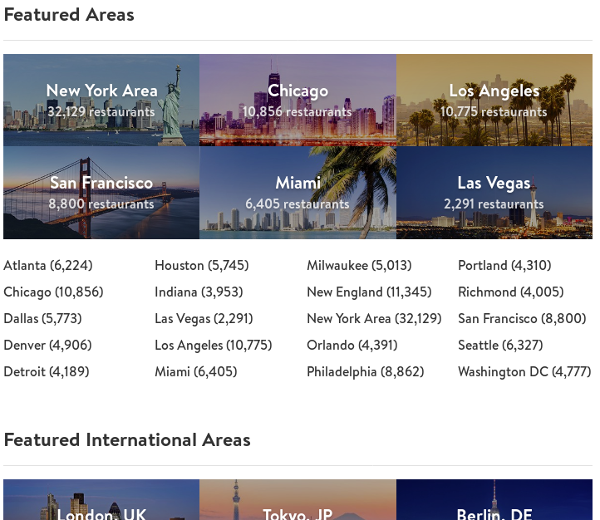

Whilst t’s a good idea to present information on the home screen, this is going way to far. It’s not that there’s too much there, but rather that they appear to have put little to no effort into it. Airbnb has even more information on their home screen, but it’s presented in a far more attractive manner. Overall from here on down, they’ve missed the mark.

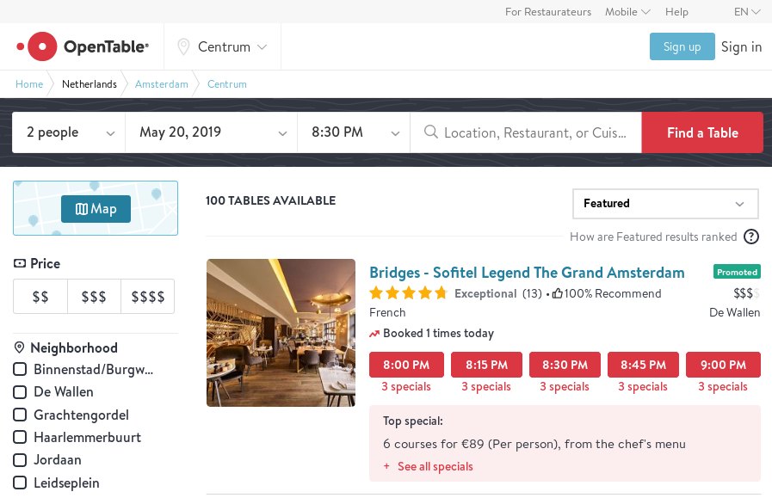

Here the’ve done excellent work with all the components. I love the round pink time buttons, the top search bar and especially the little tick boxes. The real win here is that there is a consistent ‘feel’ that is carried out through the entire page. Unfortunately that sense of constancy does not necessarily carry through to the rest of the site (see above). Also It feels like there’s too much here. In addition to the navbar, there’s breadcrumbs, a search bar and some weird sundry bar. Whilst Ian would argue that the breadcrumbs are a great idea, I’d say that in the name of aesthetic sensibilities, they need to rationalise.

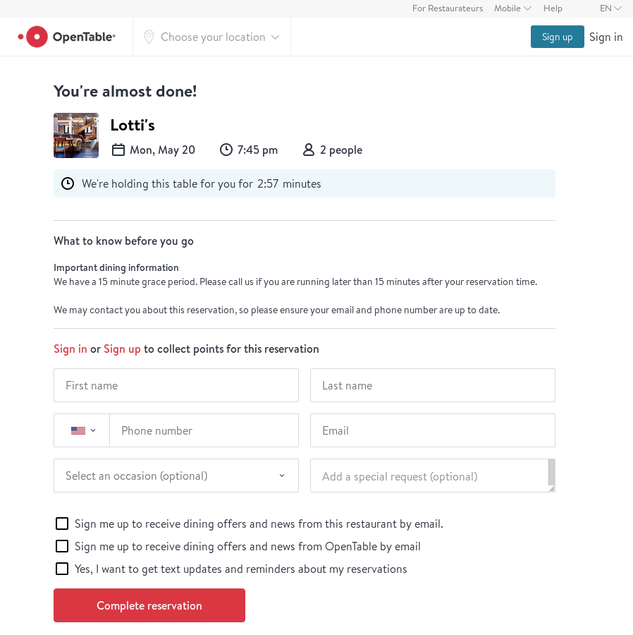

This is great, page. No ugly 400px nav bar sandwich up top, and lots of sweet curvy components. I also like how you don’t have to create an account to reserve a table; great UX.

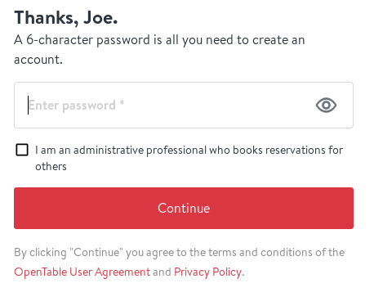

Right after reserving we’re hit with this popup. Whist it is vaguely annoying, it probably drives the majority of new registrations and makes business sense.

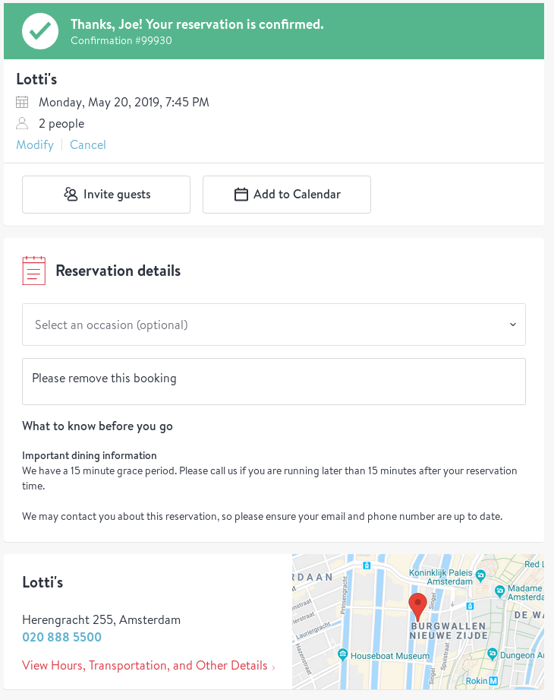

This is probably my favourite screen on the entire site. It’s got a heap of useful information and features but it still looks great. The giant green tick is super satisfying and the map and phone number down the bottom is a nice touch.