**HtmlTask:**

**1.What is HTML? Give basic structure of the HTML page.**

HTML stands for Hyper Text Markup Language. HTML is the standard markup language for creating Web pages. HTML describes the structure of a Web page.

**Structure of Html:**

<!DOCTYPE html>

<html lang="en">

<head>

<meta charset="UTF-8">

<meta http-equiv="X-UA-Compatible" content="IE=edge">

<meta name="viewport" content="width=device-width, initial-scale=1.0">

<title>tittle of webpage</title>

</head>

<body>

</body>

</html>

**2.Difference between inline and block level element.**

* Block elements cover space from left to right as far as it can go.
* Inline elements only cover the space as bounded by the tags in the HTML element.
* Block elements have top and bottom margins.
* Inline elements don't have a top and bottom margin.

**CSS_Task**

**1.Explain the different ways in which CSS can be applied to HTML, what is the preferred way and why**

1. Inline - by using the style attribute inside HTML elements.
2. Internal - by using a <style> element in the <head> section.
3. External - by using a <link> element to link to an external CSS file.

.

**2.What are different CSS selectors, with example explain Element, Class and Id selectors.**

## **The CSS element Selector**

The element selector selects HTML elements based on the element name.

example.

h1 {

text-align: center;

color: red;

}

## **The CSS id Selector**

The id selector uses the id attribute of an HTML element to select a specific element.

The id of an element is unique within a page.

To select an element with a specific id, write a hash (#) character, followed by the id of the element.

The CSS rule below will be applied on HTML element with id="paragraph1":

#paragraph1 {

text-align: center;

color: red;

}

## **The CSS class Selector**

The class selector selects HTML elements with a specific class attribute.

To select elements with a specific class, write a period (.) character, followed by the class name.

### Example

In this example all HTML elements with class="class1" will be red .

.class1 {

color: red;

}

## The CSS Universal Selector

The universal selector (*) selects all HTML elements on the page.

### Example

* {

color: blue;

}

## The CSS Grouping Selector

The grouping selector selects all the HTML elements with the same style definitions.

h1, h2, p {

color: red;

}

**3.With the help of a diagram explain CSS Box Model.**

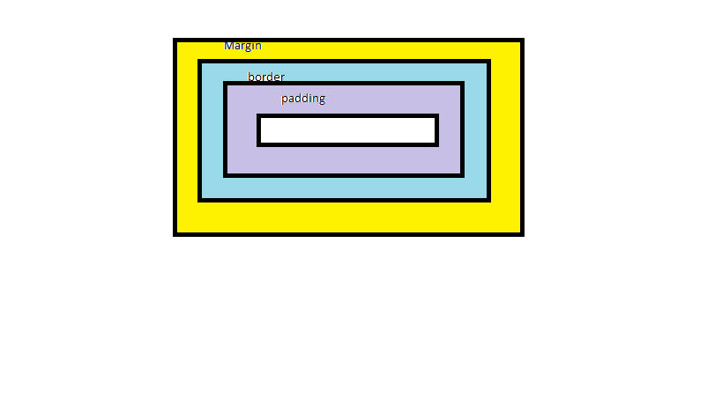

The CSS box model is essentially a box that wraps around every HTML element. It consists of: margins, borders, padding, and the actual content.

* Content - The content of the box, where text and images appear
* Padding - Clears an area around the content.
* Border - A border that goes around the padding and content.
* Margin - Clears an area outside the border.

**JavaScript_Task**

1.List down ways in which JavaScript command can be added to a webpage, what is the preferred way.

1. Embedding code
2. Inline code
3. External file

Embedding the JavaScript code between a pair of <script> and </script> tag. Creating an external JavaScript file with the . js extension and then load it within the page through the src attribute of the <script>