RESEARCH ARTICLE
Received: 14 March 2019
Revised: 11 May 2019
Accepted: 4 June 2019
DOI: 10.1002/fam.273
9

Effect of compression on thermal protection of firefighting protective clothing under flame exposure
Yun Su^{1,2} | Jie Yang^{3,4} | Rui Li⁴ | Guowen Song⁴ | Jun Li^{1,2}
Summary
The applied compression on firefighting protective clothing affects the physical properties of the designed system, which in return the thermal protective performance (TPP) could be changed. A modified TPP tester was proposed to investigate the effect of compression on performance of protective clothing. Three stages of heat exchange during firefighting, including heat exposure, heat discharge, and skin cooling, were defined to examine contribution of each stage to skin burn injury. Additionally, the influence of compression on thermal protection was compared under planar and cylindrical configurations. The results demonstrated that the applied compression significantly exacerbated skin burn injuries, while the further increase of the pressure had no significant effect on skin burn injuries. The thermal energy during heat discharge ranged from 42.2% to 64.5% of the maximum thermal energy, highly depending on the fabric properties, the applied compression, the heat discharge time, and the body configuration. The decrease of thermal energy during skin cooling stage only composed a small portion of total absorbed thermal energy, which was increased by the applied compression. The conclusions from this study could contribute to understanding the principle of thermal protection in different firefighting stages for reducing skin burn injury.
KEYWORDS
compression, firefighting protective clothing, heat discharge, thermal protection

- College of Fashion and Design, Donghua
University, Shanghai, China
- Key Laboratory of Clothing Design and
Technology, Ministry of Education, Donghua University, Shanghai, China
- College of Safety Science and Engineering,
Xi'an University of Science and Technology,
Xi'an Shannxi, China
- Department of Apparel, Event and Hospitality
Management, Iowa State University, Ames,
Iowa

Correspondence
Yun Su, College of Fashion and Design, Donghua University, No. 1882, West Yan‐An Road, Shanghai 200051, China.
Email: swen150@hotmail.com
Guowen Song, Iowa State University, Ames, Iowa 50010.
Email: gwsong@iastate.edu
Jun Li, Key Laboratory of Clothing Design and
Technology, Ministry of Education, Donghua University, Shanghai 200051, China.
Email: lijun@dhu.edu.cn

Funding information
Shanghai Sailing Program, Grant/Award Number: 19YF1400600; National Nature Science Foundation of China, Grant/Award Number: 51576038; Fundamental Research Funds for the Central Universities; Initial Research Funds for Young Teachers of Donghua University
Fire and Materials
. 2019;1
–
9.
© 2019 John Wiley & Sons, Ltd.
wileyonlinelibrary.com/journal/fa
m
1

| INTRODUCTION
Firefighting protective clothing is an effective protective equipment to minimize skin burn and provide time to get out of the fire safely.¹ The thermal protective performance (TPP) of clothing directly affects the operation safety of firefighters. Some studies demonstrated that the TPP of clothing was determined by various factors, such as clothing style,^{2,3} fabric properties,⁴ and air gap size.^{5,6}
However, some studies in recent years reported that the clothing presents the hazardous effect on wearer when it should be providing thermal protection.⁷ This is due to the fact that the thermal energy stored in the clothing is discharged to human body after heat exposure, thus exacerbating skin burn injury.^{8,9} There are two ways to discharge the stored thermal energy, including natural and compressive discharge. Most studies on the stored thermal energy of clothing focused on natural heat release after heat exposure.⁸⁻¹¹ It was found that the release of thermal stored energy depended on the thickness, density, and optical properties of fabric.
But actually, the stored thermal burn was mostly caused by the applied compression due to body movement and the contact with objects.⁹ Most test approaches did not consider the effect of compression on the TPP of clothing. Some preliminary efforts have been done to explore the effect of compression. Neal et al¹² developed an improved apparatus with the compressive equipment, while ignoring the existence of air gap between the clothing and human body. A new test apparatus called stored thermal energy test (SET) apparatus¹³ was reported by ASTM F2731‐11 to evaluate transmitted and stored thermal energy in firefighter turnout composites against low‐level radiant heat exposures and high‐intensity contact with compression after radiant heat exposure.¹⁴ A compression with a pressure of 2 psi was selected in previous studies for investigating the discharge of stored thermal energy. It was clear that the applied compression increased the influence of stored thermal energy on skin burn injury. However, there has no standard to characterize the compressively discharge of stored thermal energy in high‐intensity heat exposure. The high‐intensity and short‐duration heat exposure increased the percentage of stored thermal energy resulting in skin burn injury.^{7,9} Therefore, this study will further examine the effect of compression on the stored thermal energy and the skin burn injury in high‐intensity heat exposure.
Additionally, considering the discharge of stored thermal energy, the cooling process of clothing and human body system after heat exposure consists of two phases: clothing heat discharging (clothing cooling) and skin cooling periods. The skin cooling period in previous studies started at the end of heat exposure. However, the actual skin cooling phase should be after the end of discharging of stored thermal energy. Therefore, it is critical to redefine the heat exposure and cooling phases of firefighters and investigate the difference of heat transfer in each stages and their contributions to skin burn injuries. The objective of the present research is to examine the effect of compression applied to firefighting protective clothing on skin burn injuries in radiative and convective heat exposure. The thermal energy absorbed by skin in heat exposure, heat discharge, and cooling phases is calculated to investigate its contributions to skin burn injuries. The understanding of compressive heat transfer obtained from this work will assist the engineering of protective materials that provides higher the TPP and the development of new test standard.

| EXPERIMENTAL

| Materials
Structural features of the selected fabrics used for typical firefighting protective clothing are showed in Table 1. The thickness of test specimens was measured in accordance with standard ASTM D1777‐96.¹⁵ The mass per unit area was tested on the basis of an electronic scale tester, conformed with standard ASTM D3776‐96.¹⁶ The air permeability of test specimens was measured under a pressure drop of 200 Pa using a Frazier Air Permeability Tester, according to EN ISO 9237.¹⁷ Single‐layer fabrics were assembled into double‐layer and
TABLE 1 Structural features of single‐layer fabrics
Fabric Code | Fiber Content | Fabric Structure | Mass, g/m²
A | Nomex/Kevlar | Plain | 248.03
B | Bicomponent ePTFE+PBI/Kevlar | PTFE laminated on a twill substrate | 187.48
C1 | Nomex/Kevlar+Nomex | Needle punched nonwoven with woven face cloth | 242.61
C2 | Nomex/Kevlar+FR/Kevlar/Nylon | Needle punched nonwoven with woven face cloth | 270.52
multilayer fabric systems, which helps to comprehensively investigate the TPP of protective clothing. The physical properties of test specimens are given in Table 2.

| Test apparatus and methods

| TPP test
The TPP tester has been widely used for characterizing the protective performance of flame‐resistant fabric, as required by some international standards, such as NFPA 1971,¹⁸ ASTM F2700‐13,¹⁹ and ISO 17492.²⁰ The schematic diagram of test apparatus is showed in Figure 1A. The heat source consists of two Meker burners and a bank of nine electrically heated quartz tubes to produce a nominal heat flux of 84 kW/m² with 50% radiative and 50% convective heat transfer. The angle of the Meker burners is kept at 45° to make sure that the flame converges at the center of the specimen. The temperature rise at the rear of the specimen is measured with a standard copper calorimeter. A 6.4 mm spacer is introduced between the specimen and the copper calorimeter. The specimen is insulated from heat sources before the test by using an automatic water‐cooled shutter to ensure accurate time exposures. After the heat exposure, the transfer tray connected with the copper calorimeter and specimen holder are moved together from heating position to cooling position, which can be used to simulate the natural cooling process of clothed body after the exposure. The thermal responses of skin surface during the cooling are also recorded in order to study the release of stored thermal energy within protective clothing.
The previous TPP test apparatus does not measure the heat discharge due to the external compression. Therefore, a compressive system is designed by Labs for Functional Textiles and Protective Clothing (Iowa State University, USA) for evaluating the effect of compression on the TPP (see Figure 1B). The compressor assembly consists of a compressor block, air cylindrical, air regulator, and a framework that rigidly holds the system in place. The compressor
TABLE 2 Physical properties of test specimens
Assemble  Code | Fabric  Assembly  Description | Thickness,  mm | Mass, g/m² | Air  Permeability, dm³/s
S | A | 0.54 | 248.03 | 0.33
D1 | A + C1 | 1.98 | 490.64 | 0.28
D2 | A + C2 | 2.33 | 518.55 | 0.29
M1 | A + B + C1 | 2.25 | 678.12 | 0
M2 | A + B + C2 | 2.60 | 706.03 | 0
wileyonlinelibrary.com]
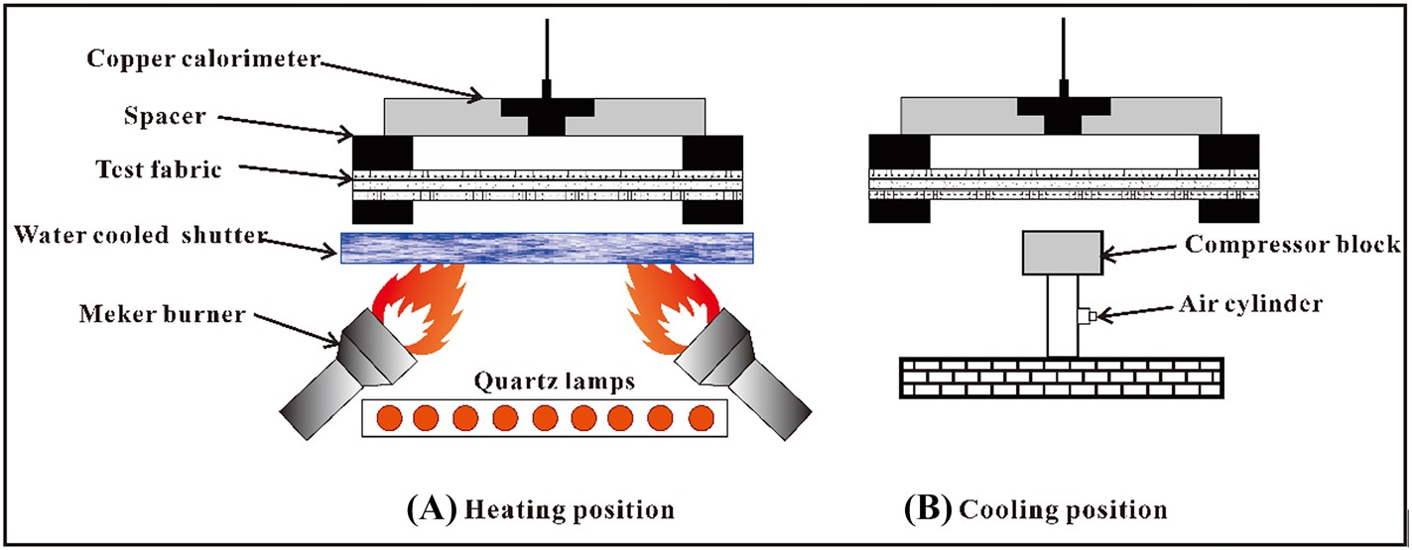
FIGURE 1 Schematic diagram of thermal protective performance (TPP) tester with a compressive system [Colour figure can be viewed at
block is made from Marinite with thermal conductivity (0.12 W/m/K), specific heat capacity (0.92 J/g °C), and the density (880 kg/m³). When activated, the regulated air with a pressure ranging from 1.2 to 3.1 psi can push the piston and force the circular heat‐resistant block to be against the sample and copper calorimeter. As soon as the transfer tray is moved over the heating source, the data acquisition system begins collecting data. The exposure times for single‐layer, double‐layer, and triple‐layer fabric system are 10, 20, and 30 seconds, respectively. At the end of exposure, the transfer tray is moved away from the heating source and over the compressor, while the data acquisition system continues to collect data. The total acquisition time for single‐layer, double‐layer, and triple‐layer fabric system are 60, 120, and 120 seconds, respectively. Three samples of each fabric system were measured, and the results were given as mean values. 2.2.2 | Dynamical fabric thickness test
The applied compression to the fabric affected the physical properties of fabric. The thickness of test specimens was measured with a compression tester under a maximum load of 5 kPa (KES‐FB3‐A, Japanese). The compressor with a 2 cm² compressive area was moved in a velocity of 0.2 mm/s. The fabric thickness was recorded during the movement. Each specimen was tested three times.

| Skin burn injury prediction
The measured skin temperature was used to predict second and third degree skin burn injuries under heat and flame exposure. The predictive method was based on skin bioheat transfer model and Henriques
burn integral model. According to standard ASTM F1930‐00,²¹ the skin bioheat transfer model that considered the enhanced heat transfer due to changing blood flow in the dermis and subcutaneous layers is written as follows:
∂T ∂ ∂T
ðρc_{p}Þskin _{x}k_{skin}þw_{b}ðρc_{p}ÞbðT_{b} − TÞ; (1)
∂
t
¼
∂
where ρ_{skin} and (c_{p})_{skin} are the density and specific heat of each layer skin tissue, ρ_{b} and (c_{p})_{b} are the density and specific heat of blood, respectively, w_{b} is the rate of blood perfusion at dermis layer and subcutaneous tissue, and T_{b} is the blood temperature. The properties and parameters of each skin layer in skin heat transfer model are obtained from standard ASTM F1930‐00.²¹ The temperature histories versus time in basal and dermal layers were calculated by Equation (1). The calculated temperature was input to Henriques burn integral model for predicting times to cause skin burn injuries.²² The burn integral model is given by
Ω ¼ ∫^{t}₀P exp −^{Δ}_{RT}^{E} dt; (2)
where Ω is a quantitative measure of burn damage at the basal layer or at any depth in the dermis, P is frequency factor, R is universal gas constant (8.31 J/mol °C), ΔE is activation energy for skin, T is basal layer temperature for second degree burn and dermal base temperature for third degree burn calculations, and t is the total time for which T is above 317.15 K.

| Thermal energy absorbed by skin in different phases
The occurrence of skin burn injuries was dependent on the increased skin temperature and the heat exposure duration. Thus, the accumulative thermal energy absorbed by skin was a function of temperature and time. In accordant with standard ASTM F2700‐13,¹⁹ the measured sensor temperature was used to calculate the accumulative thermal energy over time. The calculative equation is written as follows:
Q ¼ mCsðTiþ1 − TiÞ; (3)
A
where m and C_{s} are the mass (18 g) and the average heat capacity of the copper disk, respectively, T_{i+1} and T_{i} are the temperature of the cooper disk at time interval of interest and initial time, respectively, and A is the area of the exposed copper disk (12.57 cm²).
The changing curve of accumulative thermal energy during the whole heat exposure is illustrated in Figure 2. According to the curve of accumulative thermal energy, three stages were defined to precisely investigate the effect of compression on TPP: (a) heat exposure stage (t_{exp})—the fabric system can store thermal energy at the
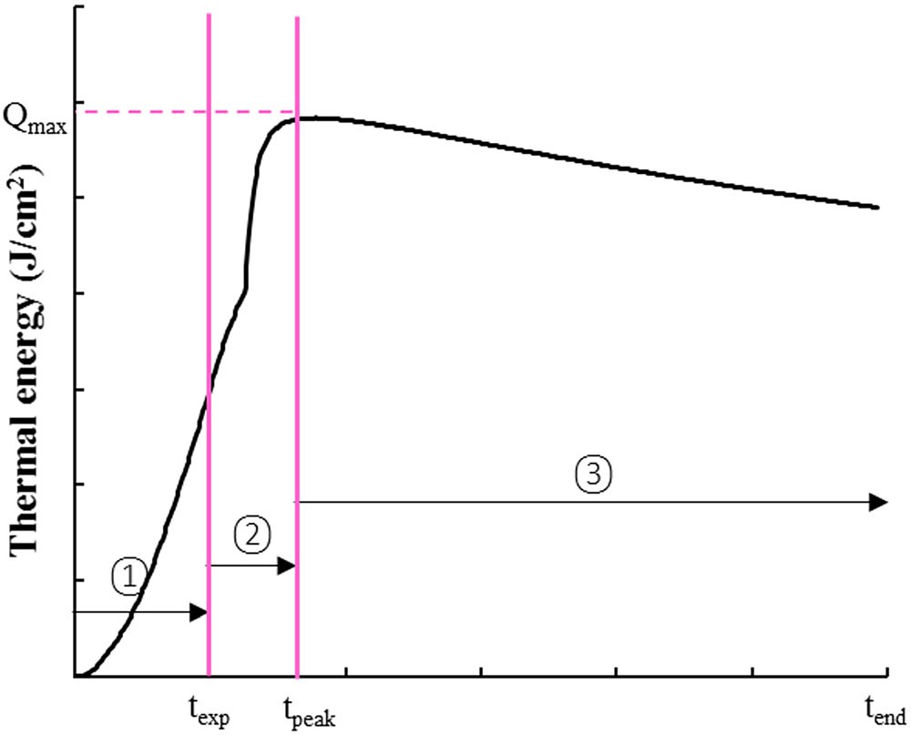
FIGURE 2 Change of accumulative thermal energy during the whole heat exposure [Colour figure can be viewed at wileyonlinelibrary.com]
beginning, and then thermal energy keeps a constant increasing rate; (b) heat discharge (clothing cooling) stage (t_{peak} − t_{exp})—fabric system discharges thermal energy to skin surface in natural or compressive ways, thus continually increasing the thermal energy absorbed by skin; (c) skin cooling stage (t_{cool} = t_{end} − t_{peak})—skin begins to transfer the thermal energy to the surrounding environment. It was clear that the maximum accumulative thermal energy (Q_{max}) was equal to the sum of first and second stages. The thermal energy absorbed by skin in each stage presented different contributions to the skin burn injury. Thus, this will help to analyze the corresponding protective measures and examine the effect of compression on heat transfer in different stages.

| RESULTS AND DISCUSSION

| Effect of compression on skin burn injuries
Figure 3 shows the change of times to second and third degree skin burn in fabric system with applied pressure. It was found that time to second degree skin burn presented no significant difference between three applied pressures. This was because second degree skin burns with different fabric systems were caused during heat exposure stage without the contribution of applied compression. Different from second degree skin burn, third degree skin burn occurred after the end of heat exposure owing to the discharge of stored thermal energy. For fabric systems D1 and D2, the heat discharge without compression was insufficient to result in third degree skin burn. When the compression was applied to the fabric systems, third degree skin burn was caused quickly. A significant difference of time to third degree skin burn between 0 and 1.5 psi pressures was observed (P < .05). Except for fabric systems D1 and D2 without third degree skin burn, the maximum difference for third degree burn time was 43.6%, found in fabric system S. This indicates that the applied compression has a significant effect on third degree skin burn.
However, when the applied pressure increased to 3 psi, the time to third degree skin burn presented a slight decrease comparing to that under a pressure of 1.5 psi. The difference of skin burn time between two pressures ranged from 1.0% to 2.3%, which was statistically significant (P < .05). The existence of air gap between fabric system and skin surface increases the temperature difference between them.²³ This means that the fabric system can be treated as heat source. For no compression, the air gap between fabric system and skin surface become the only protective medium. When the external pressure was exerted to the fabric system, the skin contacted the heated fabric system and the thermal energy stored in fabric transferred directly to the skin. The temperature difference between the fabric's backside and the skin surface caused heat transfer and determined the contribution of compression to skin burn injuries. The temperature difference showed a decrease with an increase of fabric thickness.⁸ This was why single‐layer fabric showed a larger difference between 0 and 1.5 psi pressures. Therefore, the existence of compression can sharply increase skin temperature due to the temperature gratitude. That is to say, as long as the applied pressure is enough to make the fabric system contact skin, the effect of compression on skin burn injury will be significant.
It was found from the experimental measurement that the skin contacted the fabric system under the applied compression, both 1.5 and 3 psi. The difference of skin burn between two pressures was caused by the change of fabric properties due to compression, not by the temperature difference between the fabric system and the skin surface. The change of the fabric thickness over different pressures was presented in Figure 4. It was clear that the increase of the applied pressure reduced the fabric thickness. The fitting equations and the coefficients of determination were given in Figure 4. The fabric thicknesses under pressures 1.5 and 3 psi were calculated according to the fitting equations (see Table 3). The fabric thickness for these single‐layer fabrics under pressures of 1.5 and 3 psi showed 4.73% to 9.01% difference. Besides, the increase of the applied pressure decreased the air content within the fabric system.²⁴ Thus, there was a decrease in thermal contact resistance of the fabric system with the applied pressure. Although the fabric system with different applied pressures after heat exposure had same temperature, the heat transfer rate from the fabric system to skin surface was greater when the fabric system was compressed with a higher pressure of 3 psi. But the effect due to change of fabric properties on skin burn injuries was obviously less than that due to the temperature difference between the fabric system and skin surface. This was also because the change of fabric thickness due to compression mainly occurred in less pressure, and the increase of applied pressure from 1.5 to 3 psi had little effect on the fabric thickness.
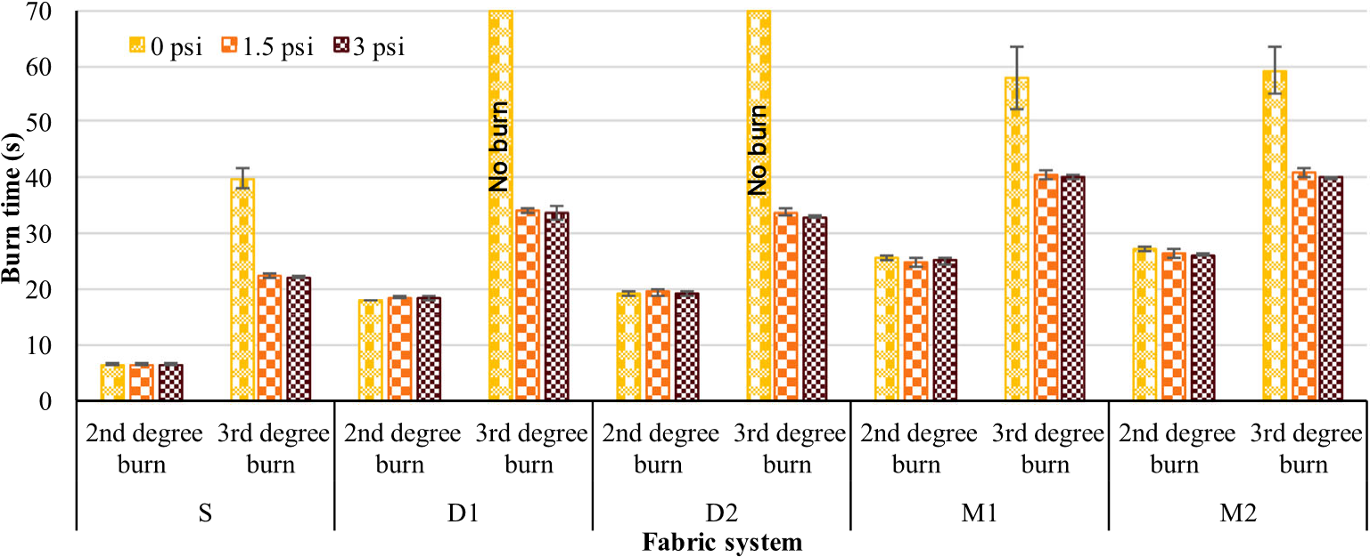
FIGURE 3 Predicted time to cause skin burn with different applied pressures [Colour figure can be viewed at wileyonlinelibrary.com]

| Effect of compression on thermal energy
The change of accumulative thermal energy due to applied compression over time is compared in Figure 5: (a) fabric system S; (b) fabric system D1 and D2; and (c) fabric system M1 and M2. The thermal energy absorbed by skin presented a similar trend for all selected fabric systems. An obvious difference of thermal energy while applying compression was presented in the second phase. As demonstrated, the applied pressure greatly increased the thermal energy. The fabric system with a pressure of 3 psi showed a slightly higher thermal energy than that with a pressure of 1.5 psi. The difference was more
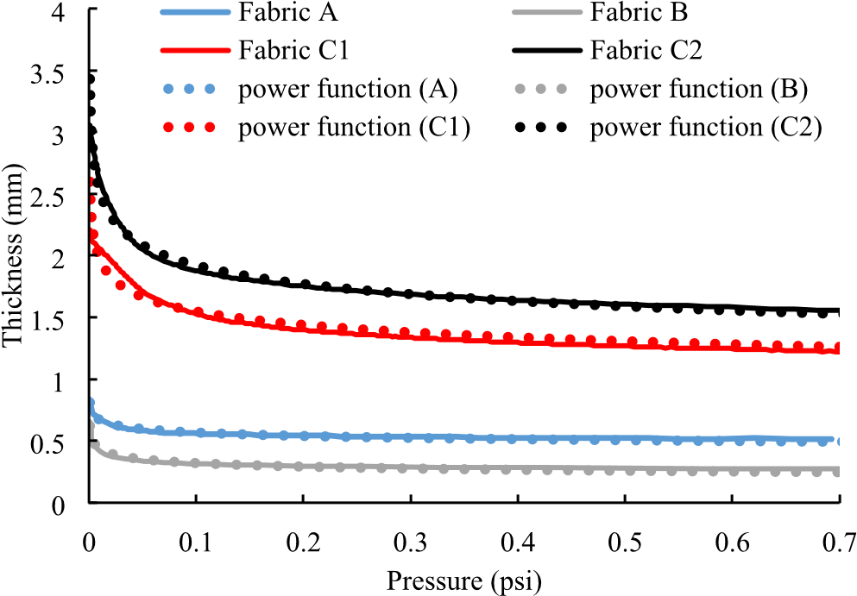
FIGURE 4 Change of fabric thickness over different pressures [Colour figure can be viewed at wileyonlinelibrary.com]
TABLE 3 Fabric thickness under pressures of 1.5 and 3 psi
Fabric  Code | Fabric Thickness with Different Pressures,  mm  1.5 psi 3 psi | Relative  Difference,  %
Fabric A 0.465 0.443 4.73
Fabric B | 0.222 | 0.202 | 9.01
Fabric C1 | 1.164 | 1.082 | 7.04
Fabric C2 | 1.397 | 1.287 | 7.87
obvious for thicker fabric system, since the fabric thickness improved the storing capacity of thermal energy.⁸ After the end of heat discharge, the thermal energy absorbed by skin decreased, indicating an initial of skin cooling. It should note that the decreasing rate of thermal energy changed with the increased pressure. Actually, the increase of applied compression reduced the fabric thickness and air content, thus enhancing heat transfer from the skin to the surrounding environment.²⁴
As shown in Figure 5, the applied compression influenced the heat discharge and skin cooling times. The calculated t_{peak} and t_{cool} are given in Table 4. The larger t_{peak} indicates that the skin absorbs thermal energy for a longer time. The time for absorbing thermal energy (t_{peak}) under no compression was obviously larger than that under pressures of 1.5 and 3 psi. The maximum difference of t_{peak} between different pressures was around 2.1 times for the fabric system D1. This indicated that the compression reduced the heat discharge time. However, the same fabric system could store the equal amount of thermal energy during heat exposure. The decrease of heat discharge time meaned the increase of heat discharge rate, thus aggravating skin burn injuries. In addition, the t_{peak} showed an increase with the increase of fabric layer, which was related to the thickness of fabric system and the total heat exposure time. The rising of fabric thickness and exposure time both increased the total thermal energy stored in fabric system,^{8,25} which increased the amount of heat discharge after the exposure. For double‐layer fabric system, the t_{peak} for D1 with less thickness under the same compression was greater than that for D2. The reason might be that the thermal liner C1 has a larger surface roughness than the thermal liner C2, thus increasing the thermal contact resistance with the skin surface.²⁶ Therefore, the thermal liner C1 has lower rate of heat discharge. The difference due to fabric system was also observed for multilayer fabric system.
In addition, Table 3 shows the change of t_{cool} and the percentage of skin cooling time that accounts for total time after the exposure (t_{after}). According to the test procedure, the preset cooling time after heat exposure for single‐layer, double‐layer, and multilayer fabric systems were 50, 100 and 90 seconds, respectively. But the actual cooling time was significantly less than the preset cooling time, especially for the fabric system without compression. A portion of cooling time was replaced by the heat discharge of the fabric system. The percentage of the actual cooling time for the fabric system without compression ranged from 22.5% to 42.4%, which was far more than the fabric system with pressures of 1.5 and 3 psi. The fabric
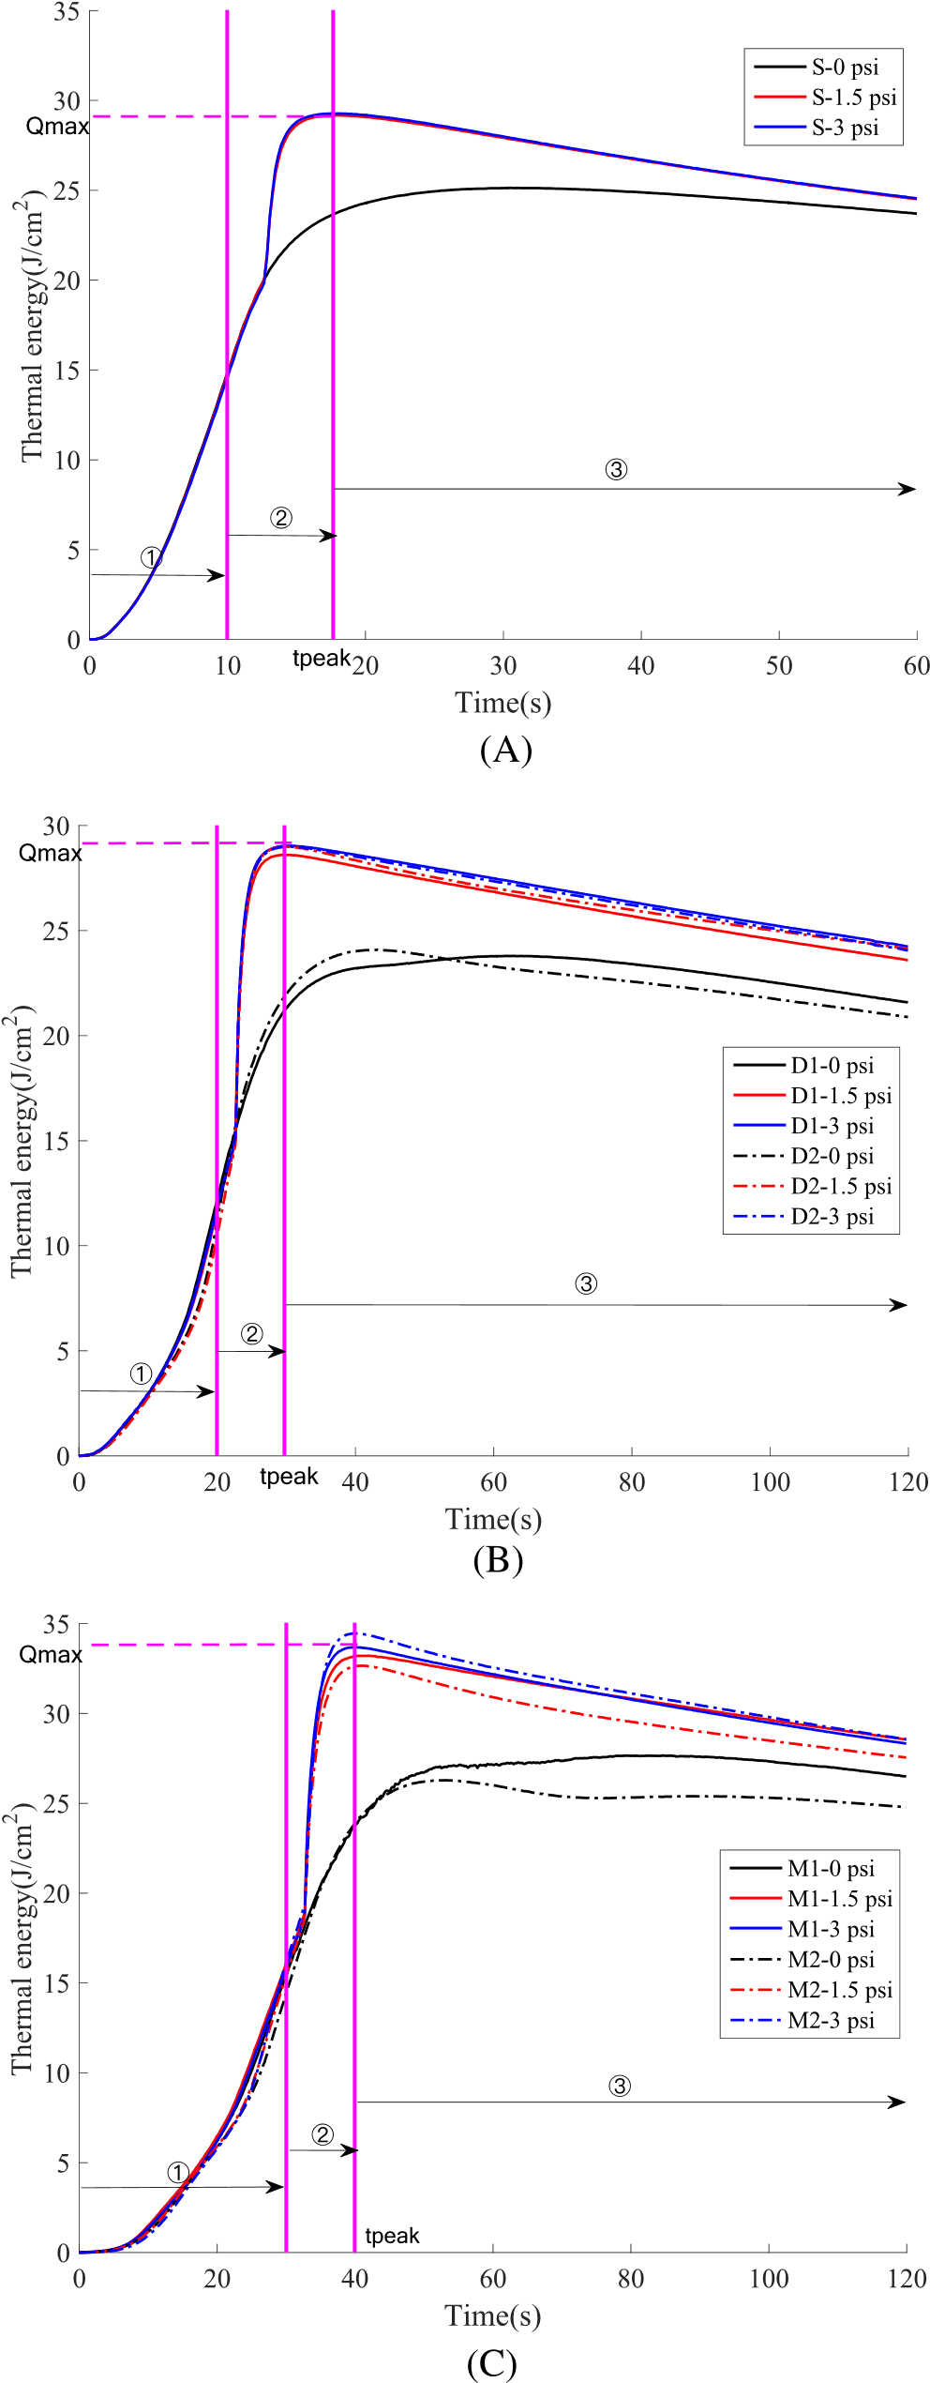
FIGURE 5 Thermal energy absorbed by skin over time and applied pressure: A, Single‐layer fabric system S. B, Double‐layer fabric system D1 and D2. C, Triple‐layer fabric system M1 and M2. Note: ① heat exposure stage; ② heat discharge stage; ③ skin cooling stage[Colour figure can be viewed at wileyonlinelibrary.com] [Colour figure can be viewed at wileyonlinelibrary.com]
TABLE 4 Distribution of duration in each stage over applied pressure
Fabric  System | Compression, psi | t_{peak}, s | t_{cool}, s | Percentage tafter −t_{cool}  ( × 100%)  tafter
S 0 30.47 (0.45) 29.53 40.9%
1.5 17.73 (0.09) 42.27 15.5%
3 17.60 (0.57) 42.40 15.2%
D1 | 0 | 62.37 (0.69) | 57.63 | 42.4%
 | 1.5 | 29.77 (0.61) | 90.23 | 9.8%
 | 3 | 29.90 (0.29) | 90.10 | 9.9%
D2 0 42.50 (0.64) 77.50 22.5% 1.5 29.70 (0.85) 90.30 9.7%
3 29.83 (0.58) 90.17 9.8%
M1 | 0 | 63.10 (10.96) | 56.90 | 36.8%
 | 1.5 | 41.10 (1.04) | 78.90 | 12.3%
 | 3 | 39.74 (0.53) | 80.26 | 10.8%
M2 0 53.03 (0.50) 66.97 25.6%
1.5 40.47 (0.83) 79.53 11.6%
3 40.10 (0.45) 79.90 11.2%

system D1 presented the largest difference for the percentage of cooling time between different pressures. For double‐layer fabric system D1 and D2, the only difference is the change of thermal liner (C1 and C2). However, the t_{cool} of fabric system D1 under no compression was less than that of fabric system D2, while two fabric systems had approximate equal t_{cool} for 1.5 and 3 psi pressures. This indicated that the fabric system D1 with the rough thermal liner C1 had slower heat discharge rate for no compression. The existence of compression reduced the difference of heat discharge rate from the fabric system to the skin surface. The results were also observed for multilayer fabric system that was determined by the type of thermal liner. Therefore, the thermal liner C1 reduced the thermal energy discharging to the skin surface under no compression and provided higher thermal protection.
The maximum thermal energy (Q_{max}) absorbed by skin consists of thermal energy during heat exposure and thermal energy (Q_{discharge}) during heat discharge that totally determines the skin burn injury.
Figure 6 shows the Q_{max}, Q_{discharge} and its percentage accounting for the Q_{max}. It was clear that the Q_{max} increased gradually with the rising of the applied pressure. A highly positive correction was observed between the Q_{max} and the Q_{discharge} (r = 0.778, P < .05), indicating that the Q_{discharge} strongly determined the change of the Q_{max}. The percentage of the Q_{discharge} for the fabric system without compression ranged from 42.2% to 54.4%. Therefore, almost half of thermal energy absorbed by skin came from the heat discharge of fabric system during the second stage, meaning that the heat discharge posed a severe threat on health and safety of firefighter. When the compression was applied to the fabric system, the percentage of the Q_{discharge} showed an increase. The maximum percentage was 64.5% for fabric system D2 with a pressure of 1.5 psi. The result demonstrated that the compression increased the thermal energy discharging to the skin surface. Although the same fabric system with different pressures stored the equal thermal energy during heat exposure, the stored viewed at wileyonlinelibrary.com] thermal energy was transmitted to the surrounding ambience and the skin. The increase of heat discharge to the skin indicated the decrease of heat discharge to the surrounding ambience. The correlation analysis was employed to study the relationship between the Q_{discharge} and the t_{peak}. A negative correction was found (r = −0.245, P = .378), indicating that the increase of heat discharge time decreased the amount of heat discharge and its percentage.
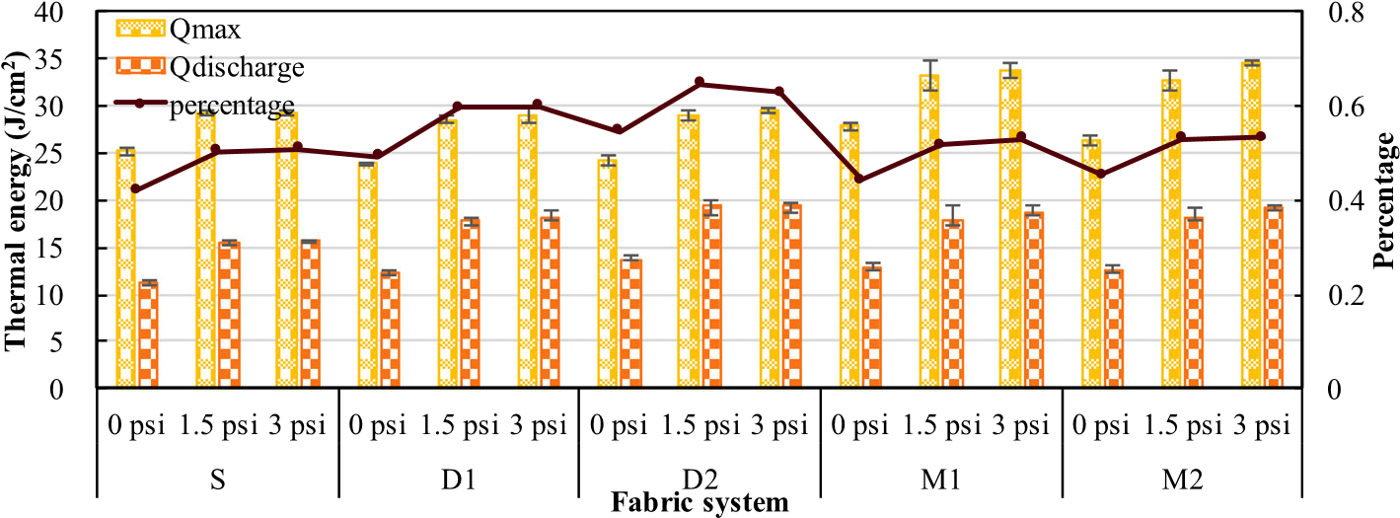
FIGURE 6 Thermal energy absorbed by skin and percentage of discharging thermal energy with different applied pressures [Colour figure can be
Due to the existence of heat discharge after the end of heat exposure, the skin cooling time was reduced. Thus, the decreased thermal energy during the skin cooling phase was the heat loss of skin to the surrounding ambience. Figure 7 illustrates the cooling thermal energy (Q_{cooling}), and its percentage in maximum absorbed thermal energy (Q_{max}). The Q_{cooling} for all fabric systems was far less than the Q_{max}. The percentage of Q_{cooling} ranged from 5.6% to 17.1%, indicating that the firefighter did not get out of danger for the preset cooling time. Actually, the measured skin temperature after the end of cooling phase was still above 44°C, which could continue to cause skin burn.²² In addition, the Q_{cooling} for fabric system with 1.5 and 3 psi pressures was larger than that for fabric system without compression. Thus, the applied compression increased the cooling effect of skin. The compression increased the temperature of skin surface, thus quickening up heat transfer from the skin to the surrounding ambience due to the increased temperature difference between the fabric and the skin surface. Besides, the compression increased the thermal conductivity of fabric system owning to the decrease of fabric thickness and air content within the fabric system. According to Fourier's law,²⁷ the rising of thermal conductivity could increase heat transfer rate. Additionally, the Q_{cooling} was related to the t_{cool}. The correction coefficient between Q_{cooling} and t_{cool} was 0.568 (P < .05), meaning that the larger t_{cool} increased the cooling effect of skin.

| Effect of compression in a cylindrical configuration
The TPP of clothing was usually evaluated in a planar configuration (see Figure 1). However, previous study demonstrated that the body geometry had an important effect on the TPP of clothing.²⁸ Based on the developed test apparatus in previous study,²⁸ the effect of compression on TPP was evaluated in a cylindrical configuration. The times required to second and third degree skin burn for multilayer fabric system M1 and M2 are showed in Figure 8. The results demonstrated that the change of third degree burn time in a cylindrical configuration was greatly less than that in a planar configuration. The applied compression had a significant effect on skin burn time with fabric system without compression in a cylindrical configuration (P < .05), while the further increase of the pressure had no obvious effect (P > .05). The reason might be that the fabric system in a cylindrical configuration presented an obvious shrinkage during the exposure, thus decreasing the air gap size between the fabric system and the skin. The decrease of air gap size reduced the TPP of clothing and the stored thermal energy within the clothing.²³ These factors might contribute to the fact that the second degree skin burn time obtained in a cylindrical configuration was less than that in a planar configuration. The changed air gap also reduced the temperature difference between the fabric backside and the skin surface. Actually, the temperature difference and the amount of stored thermal energy strongly determined the effect of the compression on skin burn time. Therefore, the cylindrical configuration could decrease the time to skin burn and weaken the contribution of compression on skin burn injury.
Figure 9 shows the absorbed thermal energy in a cylindrical configuration with different applied pressures. Compared to the planar
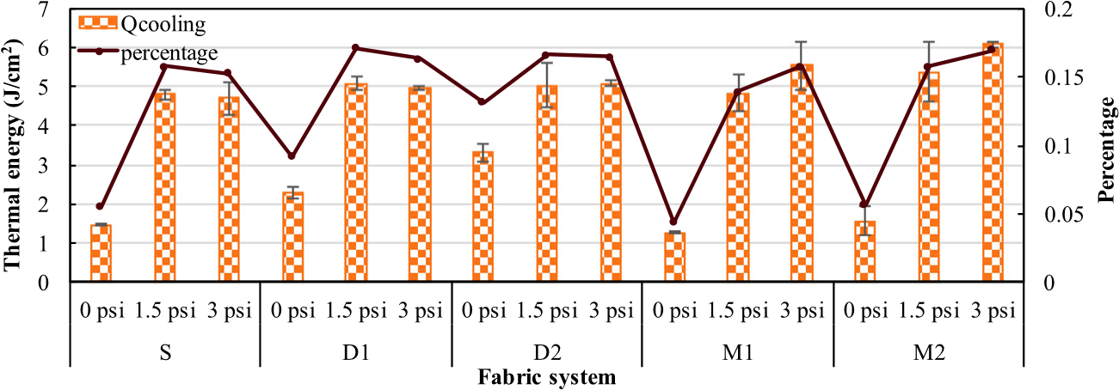FIGURE 7 Cooling thermal energy and its percentage in total absorbed energy with applied pressure [Colour figure can be viewed at wileyonlinelibrary.com]
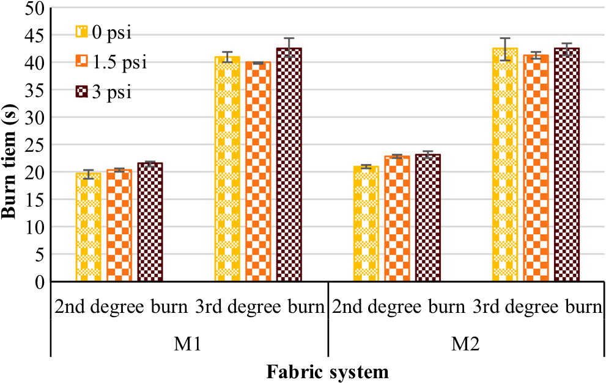
FIGURE 8 Predicted time to cause skin burn with different applied pressures in a cylindrical configuration [Colour figure can be viewed at wileyonlinelibrary.com]
configuration (see Figure 5C), an obvious difference for the thermal energy was observed. For the same fabric system, the absorbed thermal energy during the heat exposure in a cylindrical configuration was greater than that in a planar configuration. During heat discharge stage, the thermal energy due to compression in a cylindrical configuration showed no sharp increase. The increased thermal energy in a cylindrical configuration ranged from 14.61 to 16.23 J/cm², while the increased thermal energy in a planar configuration ranged from 17.88 to 19.08 J/cm². This was because the temperature difference between the fabric backside and the skin surface was reduced because of the thermal shrinkage of fabric system in high‐intensity heat exposure. Additionally, there had the longer time (t_{peak}) to reach the peak thermal energy for a cylindrical configuration, indicating that the cylindrical configuration had lower heat discharge rate comparing with a planar configuration. This was attributed to the fact that the fabric system did not totally contact to the cylindrical skin, since the compressor block is planar in shape. The incomplete contact could result in the increase of thermal contact resistance of fabric system,
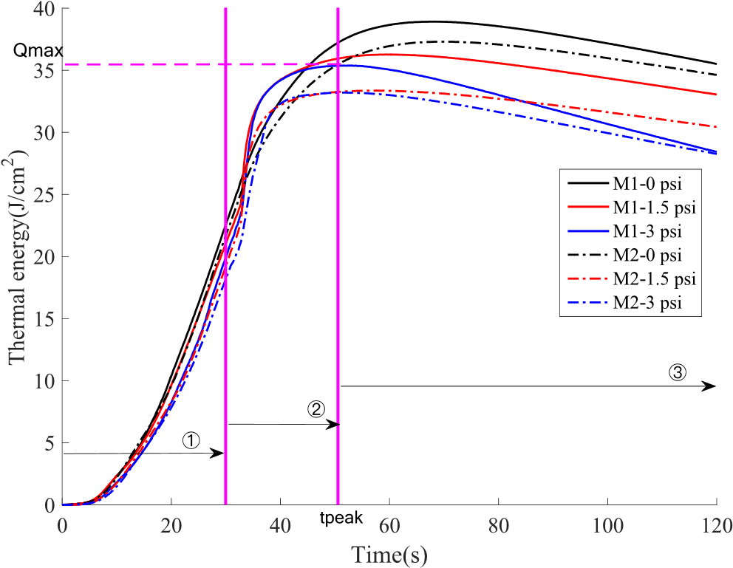
FIGURE 9 Thermal energy absorbed by skin over time and applied pressure in a cylindrical configuration [Colour figure can be viewed at wileyonlinelibrary.com]
which reduced the heat discharge rate. For fabric system without compression, the peak thermal energy (Q_{max}) was larger than that for fabric system with 1.5 and 3 psi pressures. This indicated that the compression in a cylindrical configuration increased the thermal energy discharging to the surrounding ambience. For the skin cooling phase, the total time was less than that in a planar configuration. But the decreasing rate of thermal energy in a cylindrical configuration was higher and showed an increase with the applied pressure. Therefore, the compression could improve the cooling effect of skin.

| CONCLUSIONS
The influence of the applied compression on skin burn injury in planar and cylindrical simulant‐body configurations was investigated using a modified test device under an 84 kW/m² heat exposure. The findings show that the applied compression greatly decreases the TPP of protective clothing. This strongly depends on the temperature difference between the fabric backside and the skin surface. However, the change of physical properties with the pressure from 1.5 to 3 psi has no significant effect on skin burn injury. Additionally, the skin absorbs thermal energy from the heat source and the fabric system for the first two stages, and the absorbed thermal energy during the second stage accounts for 42.2% to 54.4% of the maximum thermal energy for no compression. The percentage of absorbed thermal energy is further increased with the applied compression, while the percentage is decreased for the cylindrical configuration during the second stage. For the third stage, the decreased thermal energy due to skin cooling accounts for 5.6% to 17.1% of the total absorbed thermal energy, which is enhanced by the applied compression and reduced in a cylindrical configuration. The actual cooling time is shortened by heat discharge of fabric system, thus, insufficient to protect firefighter from danger. Therefore, the thermal protection for firefighter should be provided not only for the heat exposure stage but also for the heat discharge stage. Based on the findings obtained from this study, future study should be developed to explore means to reduce the thermal energy of protective clothing discharging to skin and resist compressive heat transfer.

ACKNOWLEDGEMENTS
This work was sponsored by Shanghai Sailing Program (grant no. 19YF1400600), National Nature Science Foundation of China (grant no. 51576038), the Fundamental Research Funds for the Central Universities, the Initial Research Funds for Young Teachers of Donghua University, and the Shanghai Municipal Natural Science Foundation, China.

ORCID
Yun Su https://orcid.org/0000-0001-8697-4284

REFERENCES
1. Song G. Modeling thermal protection outfits for fire exposures. Diss Abstr Int, Volume: 64‐10, Section: B, page: 5196; Co‐Chairs: Roger L.
Bar, (2002).

