Advanced Materials Research Vols. 821-822 (2013) pp 233-236
Online available since 2013/Sep/18 at www.scientific.net © (2013) Trans Tech Publications, Switzerland doi:10.4028/www.scientific.net/AMR.821-822.233
Thermal Protection Evaluation of Fire Fighter Ensembles using a Flame Manikin Test System
Xiao-hui Li1, 2, a, Min Wang1, 2, b and Jun Li1, 2, c 1 Protective Clothing Research Center, Fashion Institute, Donghua University, Shanghai 200051, China 2 Key Laboratory of Clothing Design and Technology, Donghua University, Shanghai 200051, China
a b c
eelxh@126.com, minmin1202@dhu.edu.cn, lijun@dhu.edu.cn
Keywords: thermal protective performance, fire fighter ensembles, flame manikin
Abstract. Objective and quantitative evaluation of garment thermal protective performance should be based on the simulation of human in actual thermal environments as realistic as possible. In this paper, by using a new type of flame manikin which can rotate and make different postures, the dynamic scene where a firefighter wearing fire protective ensembles rescue in the flash fire was simulated. The skin burn prediction result showed that the total burn percent suffered by the manikin was 7.76%, of which the 2nd degree burn and the 3rd degree burn was 5.12% and 2.64% respectively. This indicated that the firefighter ensembles exhibited relatively good thermal protective performance. It can provide enough protection for the firefighter in 8s dynamic exposure while more protection should be added to the head.

Introduction
Fire fighters always encounter the threat of both high temperature and flash fire while executing the rescue task, therefore they must wear fire protective clothing to avoid or minimize skin burn injury [1].The fireproof clothing should meet many requirements, such as flame resistant, thermally insulating, integrity maintenance, et al [2]. Therefore, thermal protection evaluation is of great significance in the development of fire protective material and clothing.
Bench-scale test such as TPP (thermal protective performance) test, RPP (radiant protective performance) test can only evaluate the performance of fiber and fabric materials. As the efficiency of protective clothing depends not only on the individual layers but also on the cut and design of the garment, as well as additional features such as belts and the number and placement of retro-reflective stripes, testing the whole garment in a close to reality situation with an instrumented manikin is necessary[3,4]. There are only a few such manikin systems in the word, and the most well-known are the Thermo-Man from Du Pont, the Pyro-Man from North Carolina State University, and the Instrumented Mannequin from the University of Alberta [5].
The principle to evaluate clothing thermal protective property based on a manikin is as follows [6,7].1) the manikin is equipped with thermal sensors all over the surface; 2) a fire scene with controlled exposure time, heat flux and flame distribution is simulated; 3) the sensors embedded into the manikin will record the heat flux transferred to the skin of the clothed manikin during and after the exposure; 4) based on the heat flux record, the skin subjected second- and third-degree burn was predicted. According to the skin burn prediction result, the property of the clothing can be evaluated.
Most of the flame manikins in the world are in an upright still posture, however, the firefighter has to move instead of standing still when doing the rescue job. The motion might change the wearing state of the garment and cause a different test result. To capture the effect of movement and make the test more close to reality, in this paper, a posture adjustable manikin who can rotate was used. The overall protective performance of typical Chinese firefighter ensembles based on a 8s exposure was evaluated.

All rights reserved. No part of contents of this paper may be reproduced or transmitted in any form or by any means without the written permission of TTP, www.ttp.net. (ID: 131.151.244.7, Missouri University of Science and Technology, Columbia, USA-16/08/14,10:15:59)

234 Advances in Textile Engineering and Materials III

Experimental detail
Test apparatus. In this paper, the newly developed flame manikin (Fig.1) in Donghua University was employed. It fully conforms to the technical requirements specified both in and ASTM F 1930-00 [6] and ISO 13506-2008[7]. The manikin was 5.74 inch tall with the body size of the Chinese adult male. There are 135 heat flux sensors distributed over the manikin surface, including torso, head, hand and foot. Therefore, this manikin can not only be applied to test the garment but also the accessories such as helmet, glove and boots, providing the possibility to evaluate the performance of a complete ensemble of fire protective equipment. Several joints are designed in the shoulder, elbow, hip, knee and ankle to make different postures. Combined with the traversing system, this manikin system can simulate different motion levels in real-life flash fire scene. There are six propane torches around the manikin to produce an average heat flux of 84kW/m². The heat flux sensor on the flame manikin records the heat flux generated in the combustion process and the second and third degree burn area are predicted based on the Henriques Burn Integral.

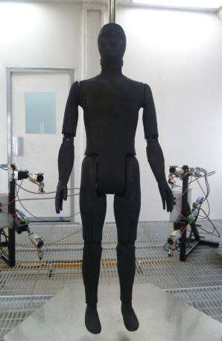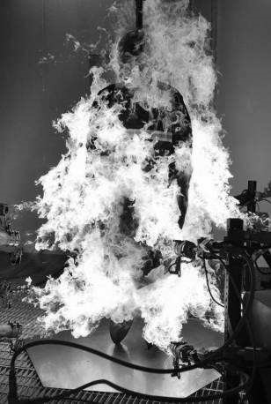

（a） (b)
Fig.1.Donghua flame testing manikin (a) and the burn scene (b)

Test ensemble. The ensemble evaluated in this paper was the standard Chinese fire fighter ensemble. It consisted of a helmet, a pair of Nomex III glove, a pair of fireproof boot, a flame-resistant girdle and a dark blue three layer suit with a two- piece style composed by trousers and coat. The protective suit itself consisted of Nomex III outer shell, PTFE laminated Nomex scrim moisture barrier, Nomex thermal barrier and FR cotton lining. Fig.2 (a) demonstrates the clothed manikin in preparation for testing.

Test protocol. The test was conducted in the flame manikin test laboratory. Before the test, the heat flux was calibrated to 84±4kW/m² as required by the flame manikin test standard of ASTM F 1930-00 and ISO 13506-2008. The exposure time is 6s. The manikin was in a running posture. It begins to rotate around the axis suspended to the ceiling immediately when the fire was ignited, and then stand still in the fire till the exposure is over. The video was used to record the combustion process. The percentage of the manikin surface subjected to second- and third-degree burn injury was predicted by the evaluation model of the flame manikin test system.

Result and discussion
Fig. 2 shows the appearance of the protective ensemble before and after the exposure. The test ensemble keeps relative good integrity after the exposure because the outer shell didn’t break or split open when exposed to flames. The carbonization of the fabric generated protective layer and no melt was observed. However, there was slight shrinkage and large area color fading after the exposure.
Advanced Materials Research Vols. 821-822 235

According to the video record, large amount of smoke generated after the exposure and there was an average 1.7s after flame.

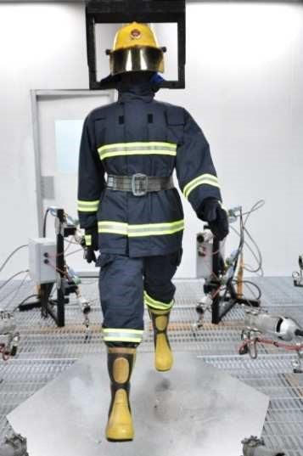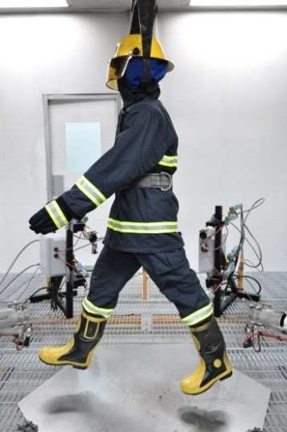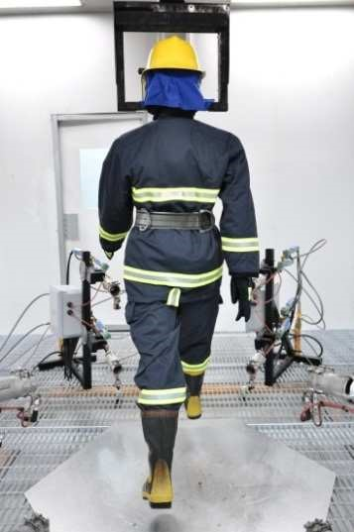
(a)
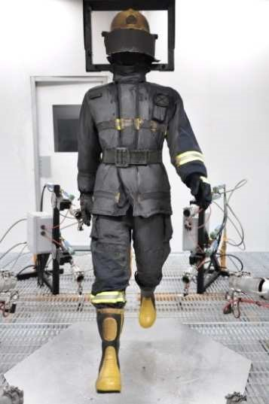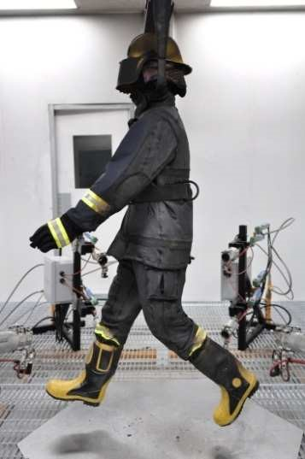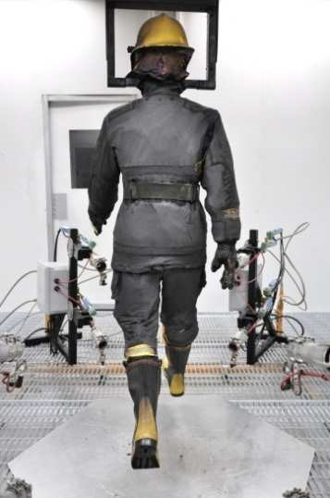
(b)
Fig. 2 The protective ensemble before the exposure (a) and after the exposure (b)

Table 1 shows the skin burn prediction result. The total surface area of the manikin was 1.816 m². The total burn percent suffered by the manikin was 7.76%, of which the 2nd degree burn and the 3rd degree burn was 5.12% and 2.64% respectively. Besides, there was 1.27% 1st burn, which was not included in the statistics of the total burn. The total incident energy absorbed by the manikin was 74.01kJ.

Table 1 Result of skin burn test
Total surface area (m²) | Total incident energy(kJ) |  | Percent burn area (%)
Total surface area (m²) | Total incident energy(kJ) | 1st burn | 2nd burn 3rd burn | Total burn
1.816 | 74.01 | 1.2 | 5.12 2.64 | 7.76

Fig. 3 shows the burn distribution map. The head of the manikin suffered the most serious burn including both 2nd and 3rd degree burn. The 2nd degree burn was observed on the right upper arm and inside of left thigh, which may be related to the flame distribution and the manikin posture. The back of right hand suffered 1st burn. The result indicates that this protective ensemble can provide enough protection during the 8s test except the helmet.

236 Advances in Textile Engineering and Materials III

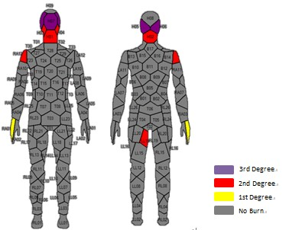
Fig.3 Skin burn distribution map

Summary
This paper presents an evaluation test on the typical Chinese firefighter ensemble based on the newly developed flame manikin in Donghua University. The total percent burn suffered by the manikin was 7.76%, indicating that the protective ensemble can provide at least 8s protection for the firefighter in a dynamic condition. However, the protection at head should be improved. In the future study, more real-life test conditions can be realized by this flame manikin test system.

Acknowledgements
This work was financially supported by the Fundamental Research Funds for the Central Universities (13D110720 &13D210701) and Doctoral Program of Higher Education of China (20110075120009/20110075110005).

References
- J. Li, Y.H. Lu and X. H. Li: Textile Research Journal Vol.83 (2012), p. 1235
- C.M.J. Sawcyn, D.A. Torvi: Textile Research Journal Vol. 79(2009), p.632
- G. Havenith, R. Heus: Applied Ergonomics Vol.35 (2004), p. 3
- I.Y. Kim, C. Lee, P. Li, B.D. Corner, S. Paquette: Fire and Materials Vol. 26(2002), p. 121
- M.A. Camenzind, D.J. Dale, R. M. Rossi: Fire and Materials Vol. 31 (2007), p. 285
- ASTM F1930-00,Standard Test Method for Evaluation of Flame Resist ant Clothing for Protection Against Flash Fire Simulations Using an Instrumented Manikin, American Society for Testing and Materials ,2000.
- ISO 13506-2008. Protective Clothing against Heat and Flame Test Method for Complete Garments Prediction of Burn Injury Using an Instrumented Manikin, International Organization for Standardization, 2008.

Advances in Textile Engineering and Materials III
10.4028/www.scientific.net/AMR.821-822

Thermal Protection Evaluation of Fire Fighter Ensembles Using a Flame Manikin Test System 10.4028/www.scientific.net/AMR.821-822.233

DOI References
- C.M.J. Sawcyn, D.A. Torvi: Textile Research Journal Vol. 79(2009), p.632. http://dx.doi.org/10.1177/0040517508093415
- G. Havenith, R. Heus: Applied Ergonomics Vol. 35 (2004), p.3. http://dx.doi.org/10.1016/j.apergo.2003.11.001
- I.Y. Kim, C. Lee, P. Li, B.D. Corner, S. Paquette: Fire and Materials Vol. 26(2002), p.121. http://dx.doi.org/10.1002/fam.790
- M.A. Camenzind, D.J. Dale, R. M. Rossi: Fire and Materials Vol. 31 (2007), p.285.
http://dx.doi.org/10.1002/fam.938

